Experiment Number : 10 Date: 25/02/2026

Implementation of Access Modifiers in Java

Aim:
Write a Java program to implement different access modifiers.

PRE LAB EXERCISE
QUESTIONS
- What are the 4 access modifiers available in Java?
The four access modifiers in Java are:
- public
- private
- protected
- default (no keyword)

- Which access modifiers can be used in Java to control access to class members?
The following access modifiers are used to control access to class members (variables and methods):
public → Accessible everywhere
private → Accessible only within the same class
protected → Accessible within the same package and subclasses
default → Accessible only within the same package

IN LAB EXERCISE
Objective
To demonstrate different access modifiers such as Default, Private, Protected and Public using Java programs.
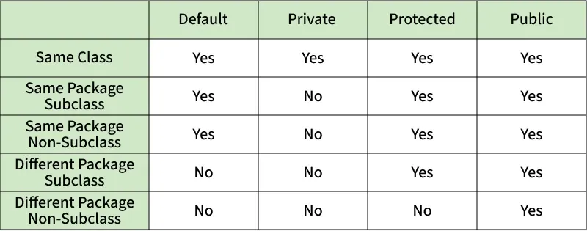
Fig: Comparison table of Access Modifiers in Java
Source Code
// Default Access modifier
class Car {
String model; // default access
}
public class Main {
public static void main(String[] args){
Car c = new Car();
c.model = "Tesla"; // accessible within the same package
System.out.println(c.model);
}
}
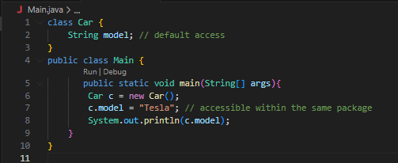
Output:
Tesla

//Private Access Modifier
class Person {
// private variable
private String name;
public void setName(String name) {
this.name = name; // accessible within class
}
public String getName() {
return name;
}
}
public class Geeks {
public static void main(String[] args)
{
Person p = new Person();
p.setName("Alice");

// System.out.println(p.name);
// Error: 'name'
// has private access
System.out.println(p.getName());
}
}
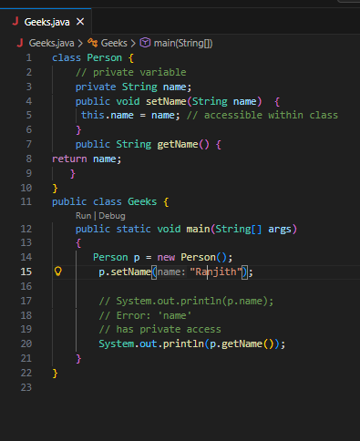
Output
Alice

//Protected Access Modifier
class Vehicle {
protected int speed; // protected member
}
class Bike extends Vehicle {
void setSpeed(int s)
{
speed = s; // accessible in subclass
}
int getSpeed()
{
return speed; // accessible in subclass
}
}
public class Main {
public static void main(String[] args){
Bike b = new Bike();
b.setSpeed(100);
System.out.println("Access via subclass method: "+ b.getSpeed());
Vehicle v = new Vehicle();
System.out.println(v.speed);
}
}
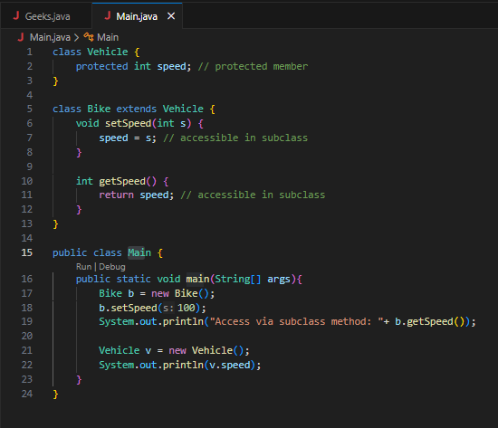
Output
Access via subclass method: 100
0
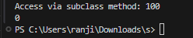

//Public Access Modifier
class MathUtils {
public static int add(int a, int b) {
return a + b;
}
}
public class Main {
public static void main(String[] args) {
System.out.println(MathUtils.add(5, 10)); // accessible anywhere
}
}
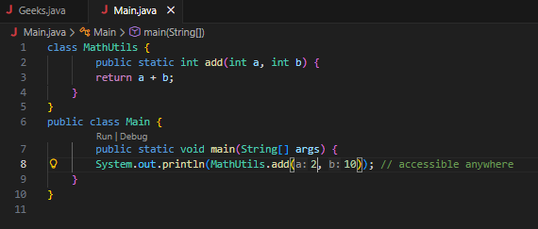
Output
15


POST LAB EXERCISE
  - Write a Java program to implement Default access modifier which has a default class within the same package and a default class from a different package.
Default Access Modifier Program
- A default class (without public) is accessible only within the same package.
- It cannot be accessed from a different package.
Example (Same Package – Works)
class Car {
void display() {
System.out.println("Car Details");
}
}
public class Main {
public static void main(String[] args) {
Car c = new Car();
c.display();
}
}
Runs successfully because both classes are in the same package.

Different Package – Not Accessible
If we try to use the default class in another package, it gives a compile-time error.

  - Which access modifier provides the highest level of access?
public
Because it allows access:
- Within the same class
- Within the same package
- In subclasses
- In different packages

ASSESSMENT

Description | Max Marks | Marks Awarded
Pre Lab Exercise | 5
In Lab Exercise | 10
Post Lab Exercise | 5
Viva | 10
Total | 30
Faculty Signature

