Experiment Number :11 Date: 25/02/2026

Implementation of multiple inheritance in Java using Interface

Aim:
Write a Java program to implement multiple inheritance using Interface.

PRE LAB EXERCISE
QUESTIONS
- Why Java does not support multiple inheritance using classes like that of C?
Java does not support multiple inheritance using classes to avoid ambiguity problems (Diamond Problem).
If a class inherits from two parent classes having the same method, the compiler cannot decide which method to use.
To avoid this confusion and complexity, Java does not allow multiple inheritance through classes.
Instead, Java supports multiple inheritance using interfaces.

- What is the primary purpose of an interface in Java?
- To store data using instance variables
- To define a contract of methods a class must implement
- To allow creation of objects
- To improve runtime performance
Correct Answer: B
B. To define a contract of methods a class must implement
Explanation:
An interface defines method declarations without implementation. Any class that implements the interface must provide the implementation of those methods.

IN LAB EXERCISE
Objective
To demonstrate how an interface in Java defines constants and abstract methods, which are implemented by a class.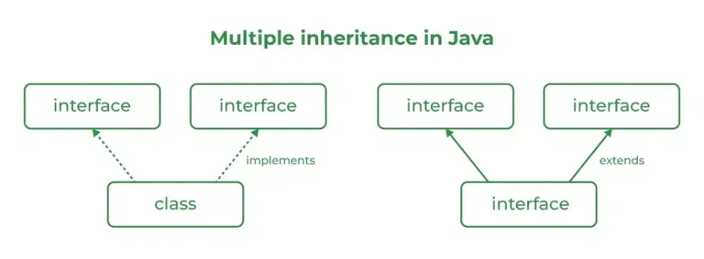

Source Code
import java.io.*;
// Add interface
interface Add{
int add(int a,int b);
}
// Sub interface
interface Sub{
int sub(int a,int b);
}
// Calculator class implementing Add and Sub
class Cal implements Add , Sub
{
// Method to add two numbers
public int add(int a,int b){
return a+b;
}
// Method to sub two numbers
public int sub(int a,int b){
return a-b;
}
}
class Example{
// Main Method
public static void main (String[] args){

// instance of Cal class
Cal x = new Cal();
System.out.println("Addition : " + x.add(2,1));
System.out.println("Substraction : " + x.sub(2,1));
}
}
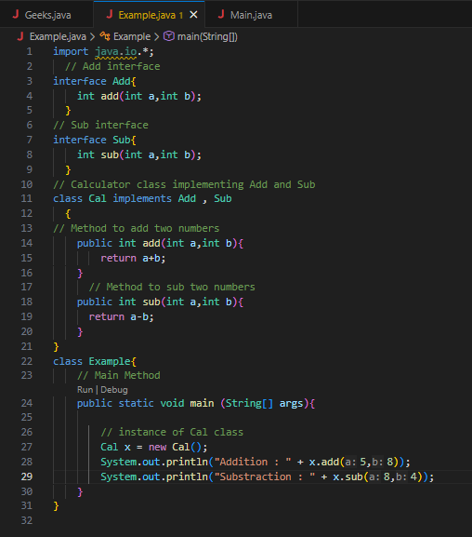
Outputs
Addition : 3
Subtraction : 1
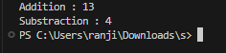
POST LAB EXERCISE
  - Can a functional interface extend another interface?
Yes, a functional interface can extend another interface only if it still contains exactly one abstract method.
If extending another interface adds more abstract methods, then it will no longer remain a functional interface.

  - Which feature was introduced in interfaces starting from Java 8?
- Constructors
- Private methods
- Default and static methods
- Final classes
Correct Answer: C
C. Default and static methods
Explanation:
From Java 8 onwards, interfaces can have:
- Default methods (with method body)
- Static methods
This allows adding new functionality without breaking existing implementations.

ASSESSMENT

Description | Max Marks | Marks Awarded
Pre Lab Exercise | 5
In Lab Exercise | 10
Post Lab Exercise | 5
Viva | 10
Total | 30
Faculty Signature

