Experiment Number : 12 Date:

Implementation of exception handling in Java
Aim:
Write a java program to implement exception handling.

PRE LAB EXERCISE
QUESTIONS
- What is exception handling in Java?
Exception handling in Java is a mechanism used to handle runtime errors so that the normal flow of the program is not interrupted.
It prevents program termination due to unexpected errors.

- What is the purpose of using try-catch blocks in exception handling?
The try-catch block is used to:
- Place risky code inside the try block
- Handle the error inside the catch block
- Prevent program crash
- Maintain normal program execution

IN LAB EXERCISE
Objective
To understand and implement exception handling through try-catch and finally blocks.
Source Code
import java.util.InputMismatchException;
import java.util.Scanner;
public class ExceptionHandlingExample {
public static void main(String[] args) {
Scanner scanner = new Scanner(System.in);
try {
System.out.print("Enter an integer: ");
int num = scanner.nextInt();
int result = 10 / num;
System.out.println("Result: " + result);
} catch (InputMismatchException e) {
System.out.println("Invalid input! Please enter an integer.");
} catch (ArithmeticException e) {
System.out.println("Cannot divide by zero!");
} finally {
scanner.close();
System.out.println("Program execution completed.");
} }
}
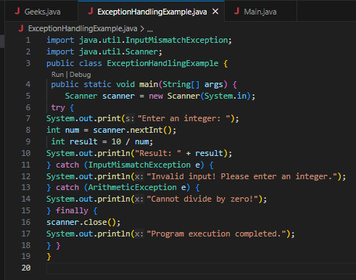
Outputs
Output 1 (Valid Input - Non-zero Integer):
Enter an integer: 5
Result: 2
Program execution completed.
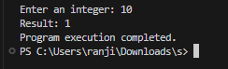

Output 2 (Valid Input - Zero):
Enter an integer: 0
Cannot divide by zero!
Program execution completed.
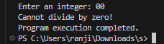

Output 3 (Invalid Input - Non-integer):
Enter an integer: abc
Invalid input! Please enter an integer.
Program execution completed.
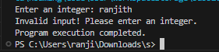

POST LAB EXERCISE
- What is the purpose of the Scanner object in the Java program?
The Scanner object is used to take input from the user during program execution.
It reads different types of input such as:
- Integers
- Strings
- Floats
- Doubles

- What exceptions are expected to be thrown in the code within the try block? Why?
Common exceptions that may occur inside a try block are:
- ArithmeticException → When dividing a number by zero.
- InputMismatchException → When user enters wrong input type (e.g., string instead of integer).
- ArrayIndexOutOfBoundsException → When accessing an invalid array index.
- NullPointerException → When accessing a null object.
These exceptions occur due to invalid input, incorrect operations, or logical errors in the program.

ASSESSMENT

Description | Max Marks | Marks Awarded
Pre Lab Exercise | 5
In Lab Exercise | 10
Post Lab Exercise | 5
Viva | 10
Total | 30
Faculty Signature

