Experiment Number : 13 Date: 26/02/2026

Implementation of User-defined Exception in Java

Aim:
Write a java program to implement User-defined Exception.

PRE LAB EXERCISE
QUESTIONS
- What is Java custom exception?
A custom exception is a user-defined exception created by extending the Exception or RuntimeException class.

It is used to define application-specific error conditions.

- What are the two types of custom exceptions in Java?
There are two types:
- Checked Custom Exception
  - Extends Exception
  - Must be handled using try-catch or declared using throws
- Unchecked Custom Exception
  - Extends RuntimeException
  - No need to handle explicitly

IN LAB EXERCISE
Objective
To understand and implement Checked and Unchecked custom exceptions.
Source Code
Ex 1: // Custom Checked Exception
class InvalidAgeException extends Exception {
public InvalidAgeException(String m) {
super(m);
}
}
// Using the Custom Exception
public class AgeCheck{
public static void validate(int age)
throws InvalidAgeException {
if (age < 18) {
throw new InvalidAgeException("Age must be 18 or above.");
}
System.out.println("Valid age: " + age);
}
public static void main(String[] args) {
try {
validate(12);
} catch (InvalidAgeException e) {
System.out.println("Caught Exception: " + e.getMessage());
}
}
}
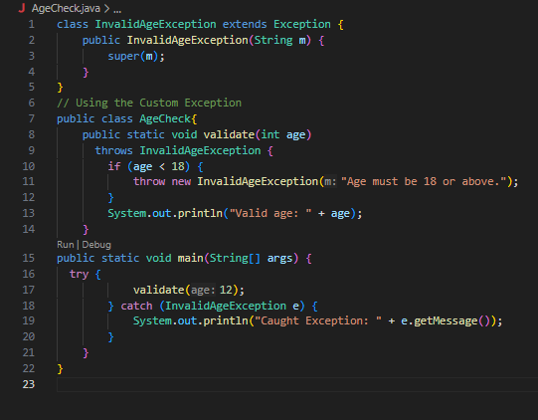
Output 1
Caught Exception: Age must be 18 or above.


Ex 2: // Custom Unchecked Exception
class DivideByZeroException extends RuntimeException {
public DivideByZeroException(String m) {
super(m);
}
}
// Using the Custom Exception
public class TestSample {
public static void divide(int a, int b) {
if (b == 0) {
throw new DivideByZeroException("Division by zero is not allowed.");
}
System.out.println("Result: " + (a / b));
}
public static void main(String[] args) {
try {
divide(10, 0);
} catch (DivideByZeroException e) {
System.out.println("Caught Exception: " + e.getMessage());
}
}
}
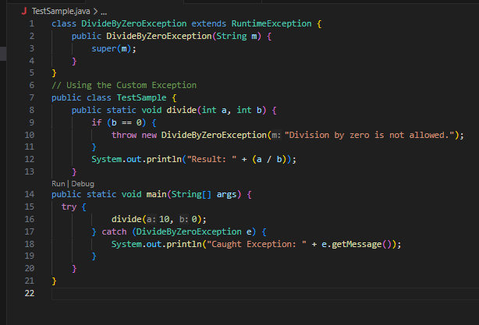

Output 2
Caught Exception: Division by zero is not allowed.
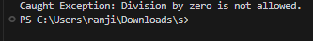

POST LAB EXERCISE
- What is required to create a custom exception in Java?
- Extend the Object class
- Extend the Throwable class
- Extend Exception or RuntimeException
- Implement the Serializable interface

Correct Answer: C
C. Extend Exception or RuntimeException
Explanation:
To create a custom exception, we create a class that extends either:
- Exception → for checked custom exception
- RuntimeException → for unchecked custom exception

- List some use cases for the checked and unchecked exceptions.
Checked Exceptions (Must be handled)

Used when the error is recoverable.
Examples:
- File handling errors (IOException)
- Database connection errors (SQLException)
- Network errors
Used when programmer must handle the exception.

Unchecked Exceptions (Runtime Exceptions)

Used for programming errors.
Examples:
- Divide by zero (ArithmeticException)
- Null object access (NullPointerException)
- Invalid array index (ArrayIndexOutOfBoundsException)
Used when error occurs due to logical mistake in code.

ASSESSMENT

Description | Max Marks | Marks Awarded
Pre Lab Exercise | 5
In Lab Exercise | 10
Post Lab Exercise | 5
Viva | 10
Total | 30
Faculty Signature

