Experiment Number : 8 Date: 25/02/2026

Implementation of Packages in Java

Aim:
Write a Java program to implement built-in, user-defined packages and accessing all classes in a package.

PRE LAB EXERCISE
QUESTIONS
- What is java.util package and what collection framework does it contain?
java.util package: It is a package in Java that contains utility classes such as collections, date/time facilities, random number generators, and more. It includes the Collection Framework, which has interfaces like List, Set, Queue, and Map, along with their implementations like ArrayList, HashSet, LinkedList, and HashMap.
What are the two types of packages in Java?
Two types of packages in Java:
Built-in packages: Predefined classes and interfaces provided by the Java API (e.g., java.util, java.io).
User-defined packages: Packages created by users to organize their custom classes and interfaces.

IN LAB EXERCISE
Objective
To understand and implement the concepts of built-in, user-defined packages and accessing all classes in a package in Java.
Built-in Packages comprise a large number of classes that are part of the Java API. Some of the commonly used built-in packages are:
- java.lang: Contains language support classes(e.g, classes that define primitive data types, math operations). This package is automatically imported.
- java.io: Contains classes for supporting input/output operations.
- java.util: Contains utility classes that implement data structures such as Linked Lists and Dictionaries, as well as support for date and time operations.
- java.applet: Contains classes for creating Applets.
- java.awt: Contains classes for implementing the components for graphical user interfaces (like buttons, menus, etc).
Source Code
import java.util.Random; // built-in package
public class Sample{
public static void main(String[] args) {
// using Random class
Random rand = new Random();
// generates a number between 0–99
int number = rand.nextInt(100);
System.out.println("Random number: " + number);
}
}

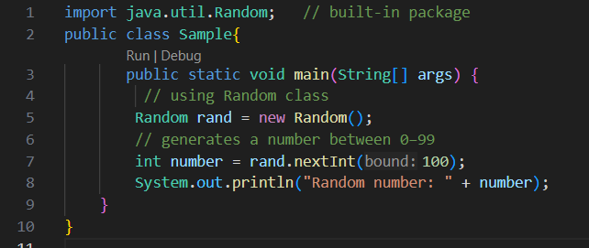
Output
Random number: 49


User-defined Packages are the packages that are defined by the user.
Source code
package com.myapp;
public class Helper {
public static void show() {
System.out.println("Hello from Helper!");
}
}
==To use this in another class==
import com.myapp.Helper;
public class Test {
public static void main(String[] args) {
Helper.show();
}
}
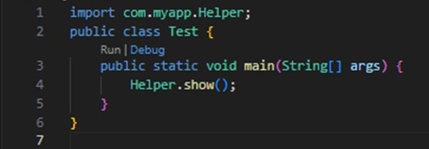
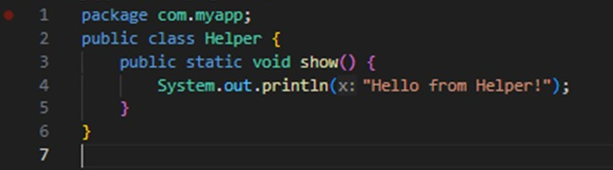

Output:
Hello from Helper!



//Importing all classes from a package.
Source code
import java.util.Vector;
public class Coders {
public Coders() {
// java.util.Vector is imported, We are able to access it directly in our code.
Vector v = new Vector();
java.util.ArrayList l = new java.util.ArrayList();
l.add(3);
l.add(5);
l.add(7);
System.out.println(l);
}
public static void main(String[] args) {
new Coders();
}
}
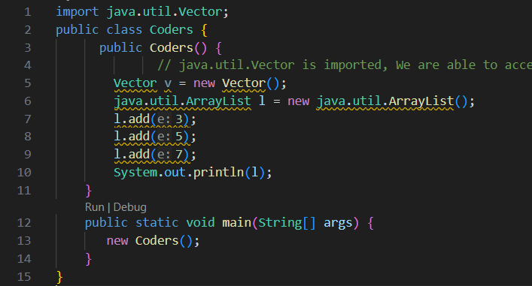
Output
[3,5,7]
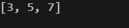
POST LAB EXERCISE
- What will happen if two classes in different packages have the same name and are imported in a Java file?
If two classes with the same name are imported: You will get a compilation error because Java can't differentiate between the two classes with the same name. To resolve this, you can use the fully qualified name (package + class name) or import one of the classes with an alias.
- What is the purpose of using packages in Java?

Purpose of using packages in Java:
- Organize code: Helps group related classes, interfaces, and sub-packages for better code management.
- Avoid naming conflicts: Packages provide a namespace for classes, avoiding name clashes.
- Access control: Allows controlling access with access modifiers (e.g., public, protected).

- Which built-in Java package would you use if you want to create a GUI window and display a message?
java.awt: This package contains classes for creating graphical user interfaces (GUI), including Frame, Button, and Label, which are used to create a GUI window and display messages.

ASSESSMENT

Description | Max Marks | Marks Awarded
Pre Lab Exercise | 5
In Lab Exercise | 10
Post Lab Exercise | 5
Viva | 10
Total | 30
Faculty Signature

