Experiment Number : 9 Date: 12.02.2026

Implementation of a Java Program to import packages using different methods

Aim:
Write a Java program to import packages using different methods for different use cases.

PRE LAB EXERCISE
QUESTIONS
- How to import a single class and multiple classes from a package in Java?

In Java, classes from another package can be accessed using the import keyword. To import a single specific class from a package, the full package name followed by the class name is written. For example, import java.util.Scanner; imports only the Scanner class from the java.util package. If multiple classes from the same package are required, the wildcard symbol * can be used. For example, import java.util.*; imports all classes available in the java.util package. Importing specific classes is generally recommended because it improves readability and avoids unnecessary class loading.

- Which package is always imported by default in every Java class?

The java.lang package is automatically imported by default in every Java program. This means programmers do not need to explicitly import it. The java.lang package contains fundamental classes such as String, System, Math, Integer, Object, and many others that are essential for basic Java programming. Because these classes are frequently used, Java automatically makes them available to all programs without requiring an import statement.

IN LAB EXERCISE
Objective
To understand and implement the Java packages using different methods and import them.
Problem
Define a package named ‘useFul’ with a class names ‘UseMe’ having following methods:
1) area()- To calculate the area of given shape.
2) salary()- To calculate the salary given basic Salary,da,hRA.
3) percentage()-To calculate the percentage given total marks and marks obtained.
4) Develop a program named ‘Package Use’ to import the above package ‘useFul’ and use the method area().
5) Develop a program named ‘manager’
Source Code
//Package Creation:
package useFull;
import java.util.*;
public class UseMe
{
Scanner obj=new Scanner(System.in);
public static void area()
{
class method{
void aos(int a)
{
System.out.print("\nArea of square with length "+a+" is "+(a*a));
}
void aor(int a,int b)
{
System.out.print("\nArea of reactangle with dimensions "+a+" & "+b+" is "+(a*b));
}
void aoc(int r)
{
double a=3.14*r*r;
}
System.out.print("\nArea of circle with radius "+r+" is "+a);
}
void aot(int a,int b)
{
float ar=(a*b)/2;
System.out.print("\nArea of triangle with dimensions "+a+" &"+b+" is "+ar);
} }
Scanner obj=new Scanner(System.in);
method m=new method();
System.out.print("\n1.Square\n2.Rectangle\n3.Circle\n4.Triangle\nSelect the shape\n");
int ch=obj.nextInt();
UseMe u=new UseMe();
switch(ch)
{
case 1:System.out.print("\nEnter the length of side of square : ");
int s=obj.nextInt();m.aos(s);
break;
case 2:System.out.print("\nEnter the dimensions of rectangle : ");
int l=obj.nextInt();
int b=obj.nextInt();
m.aor(l,b);
break;
case 3:System.out.print("\nEnter the radius of circle : ");
int r=obj.nextInt();
m.aoc(r);
break;
case 4:System.out.print("\nEnter the dimensions of triangle : ");
int ba=obj.nextInt();
int w=obj.nextInt();
m.aot(ba,w);
break; } }
public void salary()
{
int ba,da,hra;
System.out.print("\nEnter the basic salary : ");
ba=obj.nextInt();
System.out.print("\nEnter the dearness allowance :");
da=obj.nextInt();
System.out.print("\nEnter the house rent allowance : ");
hra=obj.nextInt();
System.out.print("\nThe total Gross salary of employee is : "+(ba+da+hra));
}
public void percentage()
{
int n,sum=0;
float p;
System.out.print("\nEnter the total number of subjects : ");
n=obj.nextInt();
int m[]=new int[n];
System.out.print("\nEnter the marks of "+n+" subjects : ");
for(int i=0;i<n;i++)
{
m[n]=obj.nextInt();
}
for(int i=0;i<n;i++)
{
sum=sum+m[i];
}
p=sum/n;
{
System.out.print("\nPercentahe of student : "+p);
}
}
}
//Package Implementation-1:
import useFull.UseMe;
class packageUse
{
public static void main(String args[])
{
UseMe o=new UseMe();o.area();
}
}

Output
javac packageUse.java
java packageUse
- Square
- Rectangle
- Circle
- Triangle
Select the shape
2

Enter the dimensions of the rectangle: 10 15
Area of the rectangle with dimensions 10&15 is 150
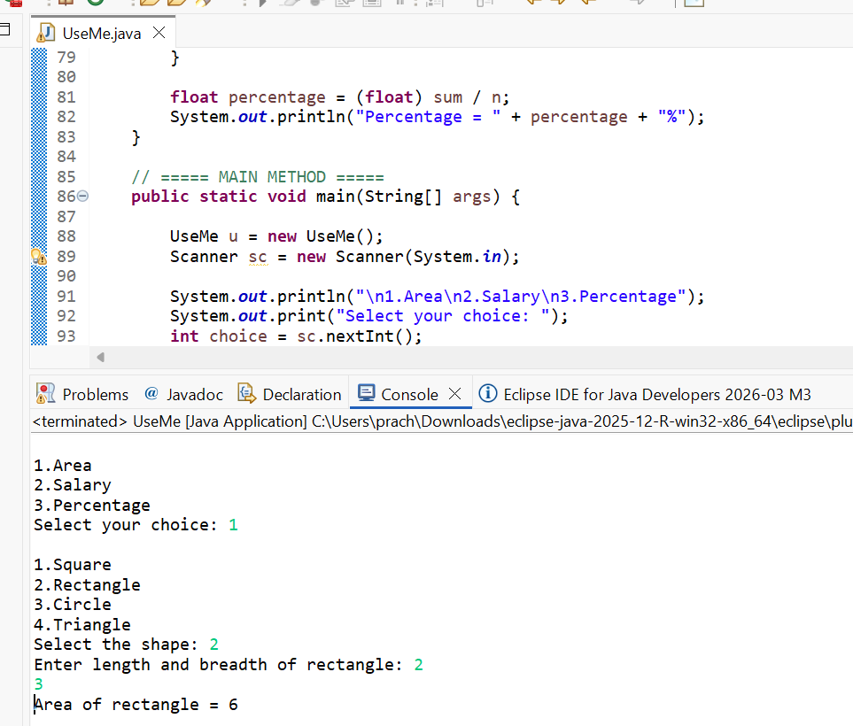
//Package Implementation-2:
import useFull.UseMe;
class manager
{
public static void main(String args[])
{
UseMe obj=new UseMe();obj.salary();
}
}

Output
javac manager.java
java manager

Enter the basic salary: 100000
Enter the dearness allowance: 5000
Enter the house rent allowance: 2000
The total Gross salary of employee is: 107000
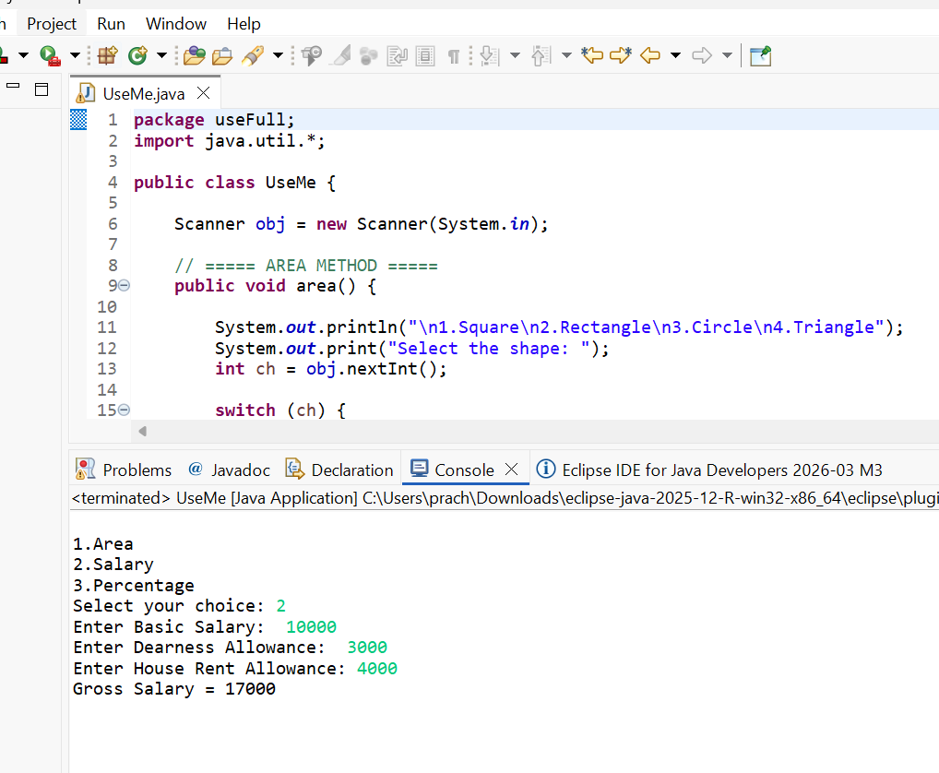

POST LAB EXERCISE
- Find the key differences between java.util and java.lang packages.
The java.lang package is a core package in Java that is automatically imported into every Java program by default. It contains fundamental classes required for basic programming such as String, Math, System, Integer, Double, Thread, and Object. Since it is automatically available, programmers do not need to explicitly import it.
On the other hand, the java.util package is not imported by default and must be imported manually using import java.util.*;. It contains utility classes and the Collection Framework such as ArrayList, LinkedList, HashMap, HashSet, Scanner, Date, Random, and Collections. The main difference is that java.lang provides basic language support classes, while java.util provides utility and data structure-related classes.

- List some of the subpackages of java.util
The java.util package contains several important subpackages that provide additional functionality. Some of the commonly used subpackages are java.util.concurrent (used for multithreading and concurrent programming), java.util.function (contains functional interfaces used in lambda expressions), java.util.logging (used for logging and application tracking), java.util.regex (used for regular expressions and pattern matching), java.util.stream (used for stream processing and functional-style operations), and java.util.zip (used for file compression and decompression). These subpackages extend the utility capabilities of Java and support advanced programming features.

ASSESSMENT

Description | Max Marks | Marks Awarded
Pre Lab Exercise | 5
In Lab Exercise | 10
Post Lab Exercise | 5
Viva | 10
Total | 30
Faculty Signature

