Experiment Number : 9 Date: 24.02.2026

Implementation of a Java Program to import packages using different methods

Aim:
Write a Java program to import packages using different methods for different use cases.

PRE LAB EXERCISE
QUESTIONS
- How to import a single class and multiple classes from a package in Java?
Single class import:
import java.util.ArrayList;
---Imports only ArrayList class.---
Multiple classes import (entire package):
import java.util.*;
Imports all classes from java.util package.

- Which package is always imported by default in every Java class?
java.lang package is automatically imported.
It contains fundamental classes like String, Math, System, Object, etc., so you don’t need to import it manually.

IN LAB EXERCISE
Objective

To understand and implement the Java packages using different methods and import them.
Problem
Define a package named ‘useFul’ with a class names ‘UseMe’ having following methods:
1) area()- To calculate the area of given shape.
2) salary()- To calculate the salary given basic Salary,da,hRA.
3) percentage()-To calculate the percentage given total marks and marks obtained.
4) Develop a program named ‘Package Use’ to import the above package ‘useFul’ and use the method area().
5) Develop a program named ‘manager’
Source Code
//Package Creation:
package useFull;
import java.util.*;
public class UseMe
{
Scanner obj=new Scanner(System.in);
public static void area()
{
class method{
void aos(int a)
{
System.out.print("\nArea of square with length "+a+" is "+(a*a));
}
void aor(int a,int b)
{
System.out.print("\nArea of reactangle with dimensions "+a+" & "+b+" is "+(a*b));
}
void aoc(int r)
{
double a=3.14*r*r;
}
System.out.print("\nArea of circle with radius "+r+" is "+a);
}
void aot(int a,int b)
{
float ar=(a*b)/2;
System.out.print("\nArea of triangle with dimensions "+a+" &"+b+" is "+ar);
} }
Scanner obj=new Scanner(System.in);
method m=new method();
System.out.print("\n1.Square\n2.Rectangle\n3.Circle\n4.Triangle\nSelect the shape\n");
int ch=obj.nextInt();
UseMe u=new UseMe();
switch(ch)
{
case 1:System.out.print("\nEnter the length of side of square : ");
int s=obj.nextInt();m.aos(s);
break;
case 2:System.out.print("\nEnter the dimensions of rectangle : ");
int l=obj.nextInt();
int b=obj.nextInt();
m.aor(l,b);
break;
case 3:System.out.print("\nEnter the radius of circle : ");
int r=obj.nextInt();
m.aoc(r);
break;
case 4:System.out.print("\nEnter the dimensions of triangle : ");
int ba=obj.nextInt();
int w=obj.nextInt();
m.aot(ba,w);
break; } }
public void salary()
{
int ba,da,hra;
System.out.print("\nEnter the basic salary : ");
ba=obj.nextInt();
System.out.print("\nEnter the dearness allowance :");
da=obj.nextInt();
System.out.print("\nEnter the house rent allowance : ");
hra=obj.nextInt();
System.out.print("\nThe total Gross salary of employee is : "+(ba+da+hra));
}
public void percentage()
{
int n,sum=0;
float p;
System.out.print("\nEnter the total number of subjects : ");
n=obj.nextInt();
int m[]=new int[n];
System.out.print("\nEnter the marks of "+n+" subjects : ");
for(int i=0;i<n;i++)
{
m[n]=obj.nextInt();
}
for(int i=0;i<n;i++)
{
sum=sum+m[i];
}
p=sum/n;
{
System.out.print("\nPercentahe of student : "+p);
}
}
}
//Package Implementation-1:
import useFull.UseMe;
class packageUse
{
public static void main(String args[])
{
UseMe o=new UseMe();o.area();
}
}

Output
javac packageUse.java
java packageUse
- Square
- Rectangle
- Circle
- Triangle
Select the shape
2

Enter the dimensions of the rectangle: 10 15
Area of the rectangle with dimensions 10&15 is 150
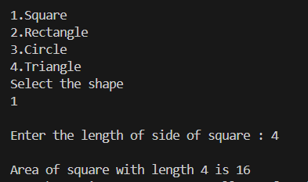

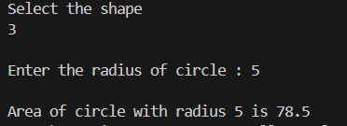

//Package Implementation-2:
import useFull.UseMe;
class manager
{
public static void main(String args[])
{
UseMe obj=new UseMe();obj.salary();
}
}

Output
javac manager.java
java manager

Enter the basic salary: 100000
Enter the dearness allowance: 5000
Enter the house rent allowance: 2000
The total Gross salary of employee is: 107000
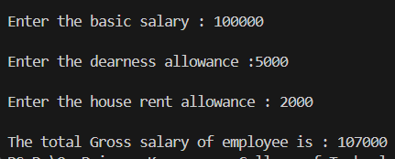

POST LAB EXERCISE
- Find the key differences between java.util and java.lang packages.

Feature | java.lang | java.util
Import | Imported automatically | Must be imported manually
Purpose | Core language classes | Utility and collection classes
Examples | String, System, Math, Object | ArrayList, HashMap, Scanner, Date
Usage | Fundamental Java operations | Data structures & utilities
Dependency | Required for every program | Used only when needed

- List some of the subpackages of java.util

- java.util.concurrent → Multithreading utilities
- java.util.function → Functional interfaces (used in lambdas)
- java.util.logging → Logging framework
- java.util.regex → Regular expressions
- java.util.stream → Stream API for data processing
- java.util.zip → ZIP compression utilities

ASSESSMENT

Description | Max Marks | Marks Awarded
Pre Lab Exercise | 5
In Lab Exercise | 10
Post Lab Exercise | 5
Viva | 10
Total | 30
Faculty Signature

