Experiment Number : 10 Date: 28/02/2026

Implementation of Access Modifiers in Java

Aim:
Write a Java program to implement different access modifiers.

PRE LAB EXERCISE
QUESTIONS
- What are the 4 access modifiers available in Java?
Java provides four access modifiers to control visibility:
public
protected
default (no modifier specified)
private
These modifiers define where a class, method, or variable can be accessed.

- Which access modifiers can be used in Java to control access to class members?
For class members (variables, methods, constructors), all four access modifiers can be used:
Access Modifier | Same Class | Same Package | Subclass (Other Package) | Other Packages
public | ✅ Yes | ✅ Yes | ✅ Yes | ✅ Yes
protected | ✅ Yes | ✅ Yes | ✅ Yes | ❌ No (except via inheritance)
default | ✅ Yes | ✅ Yes | ❌ No | ❌ No
private | ✅ Yes | ❌ No | ❌ No | ❌ No

IN LAB EXERCISE
Objective
To demonstrate different access modifiers such as Default, Private, Protected and Public using Java programs.
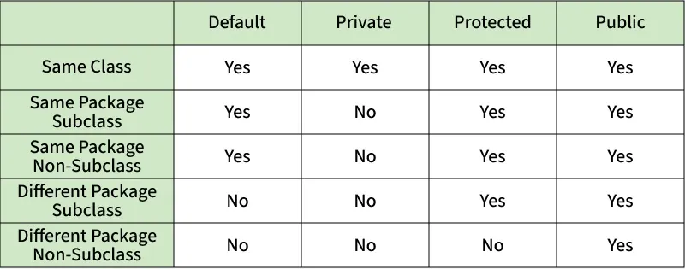
Fig: Comparison table of Access Modifiers in Java
Source Code
// Default Access modifier
class Car {
String model; // default access
}
public class Main {
public static void main(String[] args){
Car c = new Car();
c.model = "Tesla"; // accessible within the same package
System.out.println(c.model);
}
}
Output:
Tesla
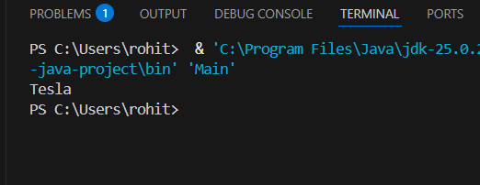

//Private Access Modifier
class Person {
// private variable
private String name;
public void setName(String name) {
this.name = name; // accessible within class
}
public String getName() {
return name;
}
}
public class Geeks {
public static void main(String[] args)
{
Person p = new Person();
p.setName("Alice");

// System.out.println(p.name);
// Error: 'name'
// has private access
System.out.println(p.getName());
}
}
Output
Alice
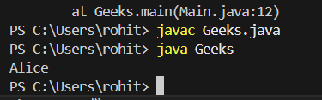

//Protected Access Modifier
class Vehicle {
protected int speed; // protected member
}
class Bike extends Vehicle {
void setSpeed(int s)
{
speed = s; // accessible in subclass
}
int getSpeed()
{
return speed; // accessible in subclass
}
}
public class Main {
public static void main(String[] args){
Bike b = new Bike();
b.setSpeed(100);
System.out.println("Access via subclass method: "+ b.getSpeed());
Vehicle v = new Vehicle();
System.out.println(v.speed);
}
}
Output
Access via subclass method: 100
0
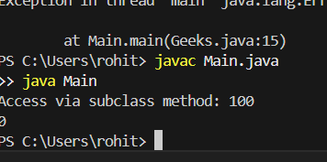

//Public Access Modifier
class MathUtils {
public static int add(int a, int b) {
return a + b;
}
}
public class Main {
public static void main(String[] args) {
System.out.println(MathUtils.add(5, 10)); // accessible anywhere
}
}
Output
15
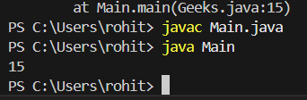

POST LAB EXERCISE
  - Write a Java program to implement Default access modifier which has a default class within the same package and a default class from a different package.
Java Program to Implement Default Access Modifier
🔹 Important Points About Default Access:
- No keyword is used (just leave it blank).
- Accessible only within the same package.
- Not accessible from a different package
Default Class Within Same Package
package mypackage;

class DefaultClass { // Default access (no modifier)
void display() {
System.out.println("Default class accessed within same package");
}
}
package mypackage;

public class TestSamePackage {
public static void main(String[] args) {
DefaultClass obj = new DefaultClass();
obj.display(); // Accessible (same package)
}
}
Default Class From Different Package
package otherpackage;

import mypackage.DefaultClass; // ❌ Error

public class TestDifferentPackage {
public static void main(String[] args) {
DefaultClass obj = new DefaultClass(); // Not Accessible
obj.display();
}
}
  - Which access modifier provides the highest level of access?
public
- Accessible within the same class
- Accessible within the same package
- Accessible in subclass
- Accessible from different packages

ASSESSMENT

Description | Max Marks | Marks Awarded
Pre Lab Exercise | 5
In Lab Exercise | 10
Post Lab Exercise | 5
Viva | 10
Total | 30
Faculty Signature

Experiment Number :11 Date: 28/02/2026

Implementation of multiple inheritance in Java using Interface

Aim:
Write a Java program to implement multiple inheritance using Interface.

PRE LAB EXERCISE
QUESTIONS
- Why Java does not support multiple inheritance using classes like that of C?
Java does not support multiple inheritance using classes to avoid ambiguity problem (Diamond Problem).
If two parent classes have the same method, the child class will not know which method to inherit.
To avoid this confusion and complexity, Java does not allow multiple inheritance with classes.
Instead, Java supports multiple inheritance using interfaces.

- What is the primary purpose of an interface in Java?
- To store data using instance variables
- To define a contract of methods a class must implement
- To allow creation of objects
- To improve runtime performance

B. To define a contract of methods a class must implement
An interface defines method declarations, and any class that implements it must provide the method implementation.

IN LAB EXERCISE
Objective
To demonstrate how an interface in Java defines constants and abstract methods, which are implemented by a class.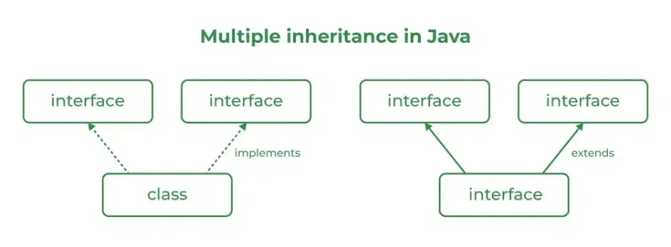

Source Code
import java.io.*;
// Add interface
interface Add{
int add(int a,int b);
}
// Sub interface
interface Sub{
int sub(int a,int b);
}
// Calculator class implementing Add and Sub
class Cal implements Add , Sub
{
// Method to add two numbers
public int add(int a,int b){
return a+b;
}
// Method to sub two numbers
public int sub(int a,int b){
return a-b;
}
}
class Example{
// Main Method
public static void main (String[] args){

// instance of Cal class
Cal x = new Cal();
System.out.println("Addition : " + x.add(2,1));
System.out.println("Substraction : " + x.sub(2,1));
}
}

Outputs
Addition : 3
Subtraction : 1
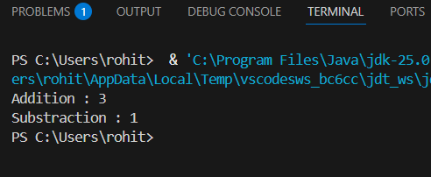

POST LAB EXERCISE
  - Can a functional interface extend another interface?
Yes, a functional interface can extend another interface.
But it must still have only one abstract method in total.
If extending another interface adds more abstract methods, then it will not remain a functional interface.

  - Which feature was introduced in interfaces starting from Java 8?
- Constructors
- Private methods
- Default and static methods
- Final classes

C. Default and static methods
Java 8 introduced:
- Default methods (with method body)
- Static methods inside interfa

ASSESSMENT

Description | Max Marks | Marks Awarded
Pre Lab Exercise | 5
In Lab Exercise | 10
Post Lab Exercise | 5
Viva | 10
Total | 30
Faculty Signature

Experiment Number : 12 Date: 28/02/2026

Implementation of exception handling in Java
Aim:
Write a java program to implement exception handling.

PRE LAB EXERCISE
QUESTIONS
- What is exception handling in Java?
Exception handling in Java is a mechanism to handle runtime errors so that the program does not crash and continues execution normally.
It is done using:
- try
- catch
- finally
- throw
- throws

- What is the purpose of using try-catch blocks in exception handling?
The try block contains code that may cause an exception.
The catch block handles the exception if it occurs.
Purpose:
- To prevent program termination
- To handle errors gracefully
- To maintain normal program flow

IN LAB EXERCISE
Objective
To understand and implement exception handling through try-catch and finally blocks.
Source Code
import java.util.InputMismatchException;
import java.util.Scanner;
public class ExceptionHandlingExample {
public static void main(String[] args) {
Scanner scanner = new Scanner(System.in);
try {
System.out.print("Enter an integer: ");
int num = scanner.nextInt();
int result = 10 / num;
System.out.println("Result: " + result);
} catch (InputMismatchException e) {
System.out.println("Invalid input! Please enter an integer.");
} catch (ArithmeticException e) {
System.out.println("Cannot divide by zero!");
} finally {
scanner.close();
System.out.println("Program execution completed.");
} }
}
Outputs
Output 1 (Valid Input - Non-zero Integer):
Enter an integer: 5
Result: 2
Program execution completed.
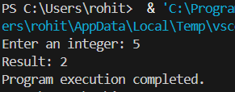

Output 2 (Valid Input - Zero):
Enter an integer: 0
Cannot divide by zero!
Program execution completed.
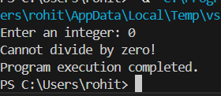

Output 3 (Invalid Input - Non-integer):
Enter an integer: abc
Invalid input! Please enter an integer.
Program execution completed.
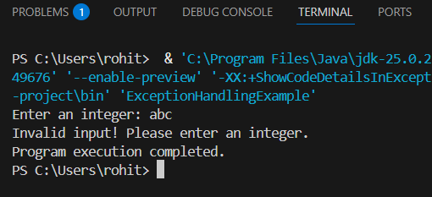

POST LAB EXERCISE
- What is the purpose of the Scanner object in the Java program?
The Scanner object is used to take input from the user (keyboard).
Example:
- nextInt() → read integer
- nextLine() → read string
- nextDouble() → read decimal
It helps in reading user input during program execution.

- What exceptions are expected to be thrown in the code within the try block? Why?
Common exceptions when using Scanner:
- InputMismatchException
  - Thrown when user enters wrong data type
  - Example: typing a string instead of an integer
- ArithmeticException
  - Thrown during mathematical errors
  - Example: division by zero
These exceptions occur due to invalid input or incorrect operations inside the try block.

ASSESSMENT

Description | Max Marks | Marks Awarded
Pre Lab Exercise | 5
In Lab Exercise | 10
Post Lab Exercise | 5
Viva | 10
Total | 30
Faculty Signature

Experiment Number : 13 Date: 28/02/2026

Implementation of User-defined Exception in Java

Aim:
Write a java program to implement User-defined Exception.

PRE LAB EXERCISE
QUESTIONS
- What is Java custom exception?
A custom exception is a user-defined exception created by extending the Exception or RuntimeException class.
It is used to handle application-specific errors.

- What are the two types of custom exceptions in Java?
Checked Custom Exception
Extends Exception
Must be handled using try-catch or throws
Unchecked Custom Exception
Extends RuntimeException
Handling is optional

IN LAB EXERCISE
Objective
To understand and implement Checked and Unchecked custom exceptions.
Source Code
Ex 1: // Custom Checked Exception
class InvalidAgeException extends Exception {
public InvalidAgeException(String m) {
super(m);
}
}
// Using the Custom Exception
public class AgeCheck{
public static void validate(int age)
throws InvalidAgeException {
if (age < 18) {
throw new InvalidAgeException("Age must be 18 or above.");
}
System.out.println("Valid age: " + age);
}
public static void main(String[] args) {
try {
validate(12);
} catch (InvalidAgeException e) {
System.out.println("Caught Exception: " + e.getMessage());
}
}
}

Output 1
Caught Exception: Age must be 18 or above.
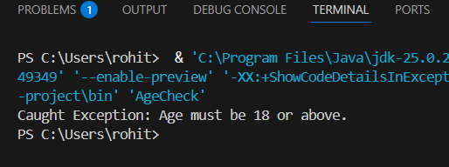

Ex 2: // Custom Unchecked Exception
class DivideByZeroException extends RuntimeException {
public DivideByZeroException(String m) {
super(m);
}
}
// Using the Custom Exception
public class TestSample {
public static void divide(int a, int b) {
if (b == 0) {
throw new DivideByZeroException("Division by zero is not allowed.");
}
System.out.println("Result: " + (a / b));
}
public static void main(String[] args) {
try {
divide(10, 0);
} catch (DivideByZeroException e) {
System.out.println("Caught Exception: " + e.getMessage());
}
}
}

Output 2
Caught Exception: Division by zero is not allowed.
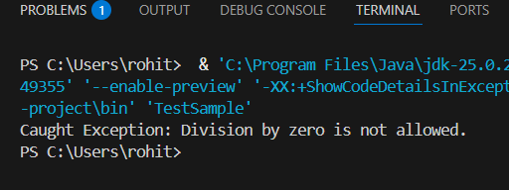

POST LAB EXERCISE
- What is required to create a custom exception in Java?
- Extend the Object class
- Extend the Throwable class
- Extend Exception or RuntimeException
- Implement the Serializable interface
C. Extend Exception or RuntimeException
To create a custom exception, you must extend:
- Exception → for checked exception
- Runtime Exception → for unchecked exception

- List some use cases for the checked and unchecked exceptions.
Checked Exceptions (Compile-time checked)
Used when the error is recoverable.
Examples:
- File handling (File not found)
- Database connection errors
- Network issues
Must be handled using try-catch or throws.

ASSESSMENT

Description | Max Marks | Marks Awarded
Pre Lab Exercise | 5
In Lab Exercise | 10
Post Lab Exercise | 5
Viva | 10
Total | 30
Faculty Signature

