Experiment Number : 8 Date: 24.02.2026

Implementation of Packages in Java

Aim:
Write a Java program to implement built-in, user-defined packages and accessing all classes in a package.

PRE LAB EXERCISE
QUESTIONS
- What is java.util package and what collection framework does it contain?
The java.util package is a core Java package that provides utility classes for data handling, date and time, and other helper functions.
It contains the Java Collection Framework (JCF), which provides classes and interfaces to store and manage groups of objects efficiently.
Collection Framework Includes:
Interfaces:
- List
- Set
- Queue
- Map
Classes:
- ArrayList
- LinkedList
- HashSet
- TreeSet
- HashMap
- TreeMap
- PriorityQueue
- Vector
- Stack
The java.util package is mainly used for storing, retrieving, and manipulating data in Java programs.

- What are the two types of packages in Java?
There are two types of packages in Java:
- Built-in Packages (Predefined Packages)
  - Already available in Java.
  - Example: java.lang, java.util, java.io
- User-defined Packages
  - Created by the programmer using the package keyword.
  - Used to organize classes and interfaces.

IN LAB EXERCISE
Objective
To understand and implement the concepts of built-in, user-defined packages and accessing all classes in a package in Java.
Built-in Packages comprise a large number of classes that are part of the Java API. Some of the commonly used built-in packages are:
- java.lang: Contains language support classes(e.g, classes that define primitive data types, math operations). This package is automatically imported.
- java.io: Contains classes for supporting input/output operations.
- java.util: Contains utility classes that implement data structures such as Linked Lists and Dictionaries, as well as support for date and time operations.
- java.applet: Contains classes for creating Applets.
- java.awt: Contains classes for implementing the components for graphical user interfaces (like buttons, menus, etc).
Source Code
import java.util.Random; // built-in package
public class Sample{
public static void main(String[] args) {
// using Random class
Random rand = new Random();
// generates a number between 0–99
int number = rand.nextInt(100);
System.out.println("Random number: " + number);
}
}
Output
Random number: 49
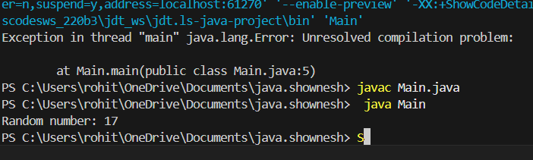

User-defined Packages are the packages that are defined by the user.
Source code
package com.myapp;
public class Helper {
public static void show() {
System.out.println("Hello from Helper!");
}
}
==To use this in another class==
import com.myapp.Helper;
public class Test {
public static void main(String[] args) {
Helper.show();
}
}

Output:
Hello from Helper!
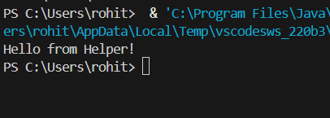
//Importing all classes from a package.
Source code
import java.util.Vector;
public class Coders {
public Coders() {
// java.util.Vector is imported, We are able to access it directly in our code.
Vector v = new Vector();
java.util.ArrayList l = new java.util.ArrayList();
l.add(3);
l.add(5);
l.add(7);
System.out.println(l);
}
public static void main(String[] args) {
new Coders();
}
}
Output
[3,5,7]
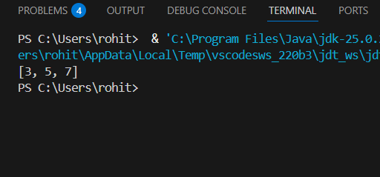
POST LAB EXERCISE
- What will happen if two classes in different packages have the same name and are imported in a Java file?
If two classes with the same name from different packages are imported in the same Java file, it will cause a compile-time error due to ambiguity.
The compiler will not know which class to use.
Use the fully qualified class name instead of importing both:
package1.Sample obj1 = new package1.Sample();
package2.Sample obj2 = new package2.Sample();
This removes confusion and tells the compiler exactly which class to use.

- What is the purpose of using packages in Java?
Packages in Java are used to:
- Organize related classes and interfaces into groups
- Avoid naming conflicts
- Improve code readability and maintenance
- Provide access protection
- Support reusability of code
Thus, packages help in better project management and structured programming.

- Which built-in Java package would you use if you want to create a GUI window and display a message?
- java.util
- java.sql
- java.awt
- java.net

The correct answer is:
C. java.awt
The java.awt package (Abstract Window Toolkit) is used to create GUI applications, such as windows, buttons, labels, and dialogs.

ASSESSMENT

Description | Max Marks | Marks Awarded
Pre Lab Exercise | 5
In Lab Exercise | 10
Post Lab Exercise | 5
Viva | 10
Total | 30
Faculty Signature

7

Experiment Number : 9 Date: 24.02.2026

Implementation of a Java Program to import packages using different methods

Aim:
Write a Java program to import packages using different methods for different use cases.

PRE LAB EXERCISE
QUESTIONS
- How to import a single class and multiple classes from a package in Java?
To import only one specific class from a package, use:
import packageName.ClassName;
Example:
import java.util.Scanner;
This imports only the Scanner class from the java.util package.
To import all classes from a package, use the wildcard * symbol:
import packageName.*;
Example:
import java.util.*;
This imports all classes available in the java.util package.

- Which package is always imported by default in every Java class?
The package that is automatically imported by default in every Java program is:
java.lang
It contains fundamental classes such as:
- String
- System
- Math
- Integer
- Object
Because java.lang is automatically imported, we do not need to write:
import java.lang.*;

IN LAB EXERCISE
Objective
To understand and implement the Java packages using different methods and import them.
Problem
Define a package named ‘useFul’ with a class names ‘UseMe’ having following methods:
1) area()- To calculate the area of given shape.
2) salary()- To calculate the salary given basic Salary,da,hRA.
3) percentage()-To calculate the percentage given total marks and marks obtained.
4) Develop a program named ‘Package Use’ to import the above package ‘useFul’ and use the method area().
5) Develop a program named ‘manager’
Source Code
//Package Creation:
package useFull;
import java.util.*;
public class UseMe
{
Scanner obj=new Scanner(System.in);
public static void area()
{
class method{
void aos(int a)
{
System.out.print("\nArea of square with length "+a+" is "+(a*a));
}
void aor(int a,int b)
{
System.out.print("\nArea of reactangle with dimensions "+a+" & "+b+" is "+(a*b));
}
void aoc(int r)
{
double a=3.14*r*r;
}
System.out.print("\nArea of circle with radius "+r+" is "+a);
}
void aot(int a,int b)
{
float ar=(a*b)/2;
System.out.print("\nArea of triangle with dimensions "+a+" &"+b+" is "+ar);
} }
Scanner obj=new Scanner(System.in);
method m=new method();
System.out.print("\n1.Square\n2.Rectangle\n3.Circle\n4.Triangle\nSelect the shape\n");
int ch=obj.nextInt();
UseMe u=new UseMe();
switch(ch)
{
case 1:System.out.print("\nEnter the length of side of square : ");
int s=obj.nextInt();m.aos(s);
break;
case 2:System.out.print("\nEnter the dimensions of rectangle : ");
int l=obj.nextInt();
int b=obj.nextInt();
m.aor(l,b);
break;
case 3:System.out.print("\nEnter the radius of circle : ");
int r=obj.nextInt();
m.aoc(r);
break;
case 4:System.out.print("\nEnter the dimensions of triangle : ");
int ba=obj.nextInt();
int w=obj.nextInt();
m.aot(ba,w);
break; } }
public void salary()
{
int ba,da,hra;
System.out.print("\nEnter the basic salary : ");
ba=obj.nextInt();
System.out.print("\nEnter the dearness allowance :");
da=obj.nextInt();
System.out.print("\nEnter the house rent allowance : ");
hra=obj.nextInt();
System.out.print("\nThe total Gross salary of employee is : "+(ba+da+hra));
}
public void percentage()
{
int n,sum=0;
float p;
System.out.print("\nEnter the total number of subjects : ");
n=obj.nextInt();
int m[]=new int[n];
System.out.print("\nEnter the marks of "+n+" subjects : ");
for(int i=0;i<n;i++)
{
m[n]=obj.nextInt();
}
for(int i=0;i<n;i++)
{
sum=sum+m[i];
}
p=sum/n;
{
System.out.print("\nPercentahe of student : "+p);
}
}
}
//Package Implementation-1:
import useFull.UseMe;
class packageUse
{
public static void main(String args[])
{
UseMe o=new UseMe();o.area();
}
}

Output
javac packageUse.java
java packageUse
- Square
- Rectangle
- Circle
- Triangle
Select the shape
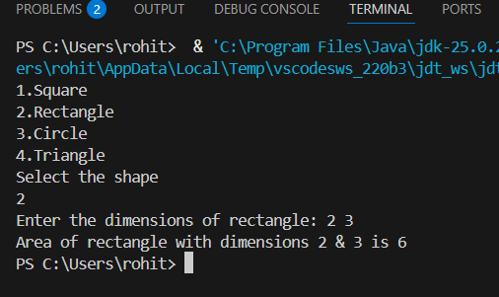
2

Enter the dimensions of the rectangle: 10 15
Area of the rectangle with dimensions 10&15 is 150
//Package Implementation-2:
import useFull.UseMe;
class manager
{
public static void main(String args[])
{
UseMe obj=new UseMe();obj.salary();
}
}

Output
javac manager.java
java manager

Enter the basic salary: 100000
Enter the dearness allowance: 5000
Enter the house rent allowance: 2000
The total Gross salary of employee is: 107000
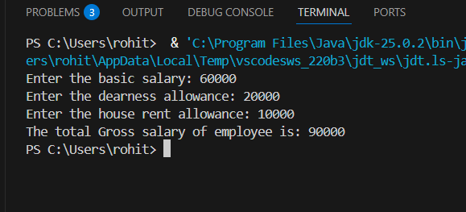

POST LAB EXERCISE
- Find the key differences between java.util and java.lang packages.

Feature | java.lang | java.util
Default Import | Automatically imported | Must be imported explicitly
Purpose | Provides basic language support classes | Provides utility classes and data structures
Usage | Core functionality of Java | Collections, date-time, random, etc.
Examples of Classes | String, System, Math, Integer, Object | Scanner, Random, ArrayList, HashMap, Date

- List some of the subpackages of java.util
Some important subpackages of java.util are:
- java.util.concurrent
- java.util.function
- java.util.logging
- java.util.stream
- java.util.regex
- java.util.zip
- java.util.jar
These subpackages provide support for concurrency, functional programming, logging, streams, regular expressions, compression, and JAR file handling.

ASSESSMENT

Description | Max Marks | Marks Awarded
Pre Lab Exercise | 5
In Lab Exercise | 10
Post Lab Exercise | 5
Viva | 10
Total | 30
Faculty Signature

