Experiment Number : 8 Date:

Implementation of Packages in Java

Aim:
Write a Java program to implement built-in, user-defined packages and accessing all classes in a package.

PRE LAB EXERCISE
QUESTIONS
- What is java.util package and what collection framework does it contain?
java.util is a built-in Java package that provides utility classes. It mainly contains the Collection Framework, which includes:
- List Interface → ArrayList, LinkedList , Vector
- Set Interface → HashSet, TreeSet
- Map Interface → HashMap, TreeMap
- Utility classes like Collections, Random, Date, Scanner
The Collection Framework helps store, retrieve, and manipulate groups of objects efficiently.

- What are the two types of packages in Java?
There are two types of packages:
- Built-in Packages (Java API packages)
Example: java.lang, java.util, java.io, java.awt
- User-defined Packages
Created by programmers to organize their own classes.

IN LAB EXERCISE
Objective
To understand and implement the concepts of built-in, user-defined packages and accessing all classes in a package in Java.
Built-in Packages comprise a large number of classes that are part of the Java API. Some of the commonly used built-in packages are:
- java.lang: Contains language support classes(e.g, classes that define primitive data types, math operations). This package is automatically imported.
- java.io: Contains classes for supporting input/output operations.
- java.util: Contains utility classes that implement data structures such as Linked Lists and Dictionaries, as well as support for date and time operations.
- java.applet: Contains classes for creating Applets.
- java.awt: Contains classes for implementing the components for graphical user interfaces (like buttons, menus, etc).
Source Code
import java.util.Random; // built-in package
public class Sample{
public static void main(String[] args) {
// using Random class
Random rand = new Random();
// generates a number between 0–99
int number = rand.nextInt(100);
System.out.println("Random number: " + number);
}
}
Output
Random number: 49
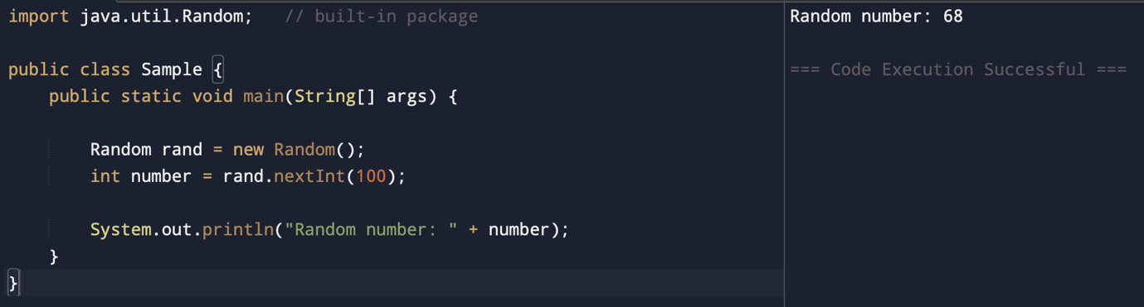

User-defined Packages are the packages that are defined by the user.
Source code
package com.myapp;
public class Helper {
public static void show() {
System.out.println("Hello from Helper!");
}
}
==To use this in another class==
import com.myapp.Helper;
public class Test {
public static void main(String[] args) {
Helper.show();
}
}

Output:
Hello from Helper!
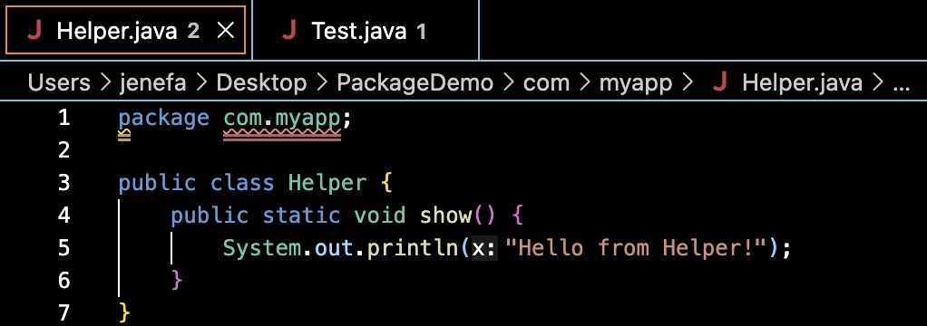
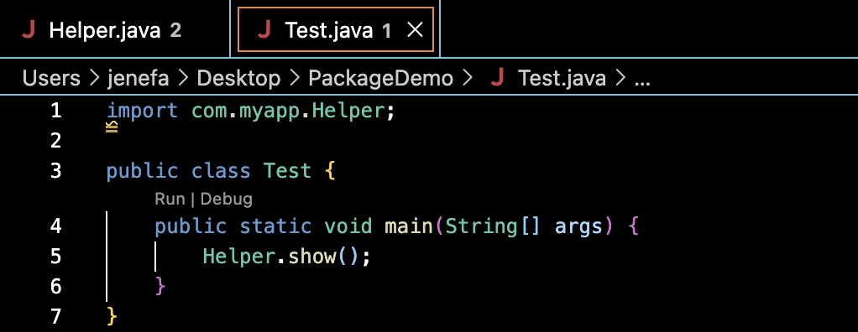
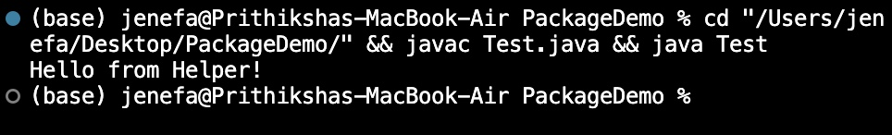

//Importing all classes from a package.
Source code
import java.util.Vector;
public class Coders {
public Coders() {
// java.util.Vector is imported, We are able to access it directly in our code.
Vector v = new Vector();
java.util.ArrayList l = new java.util.ArrayList();
l.add(3);
l.add(5);
l.add(7);
System.out.println(l);
}
public static void main(String[] args) {
new Coders();
}
}
Output
[3,5,7]
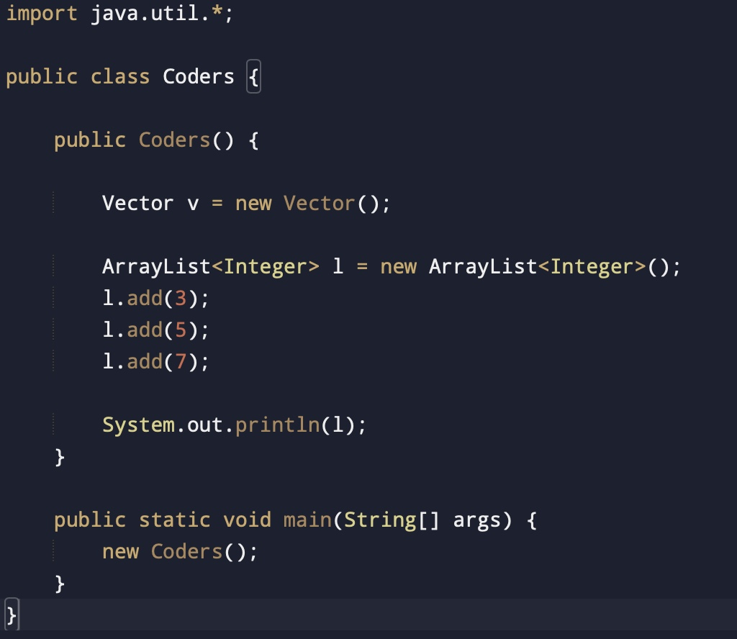
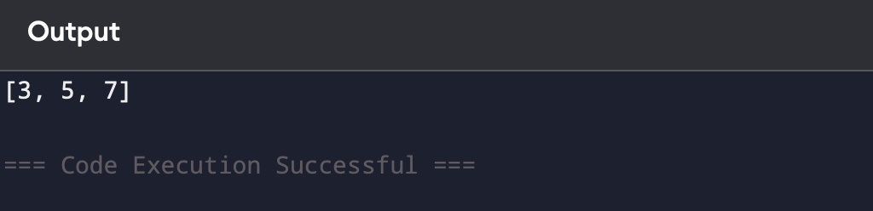
POST LAB EXERCISE
- What will happen if two classes in different packages have the same name and are imported in a Java file?
If two classes with the same name are imported from different packages:
- The compiler will generate an ambiguity error
- You must use the fully qualified class name

- What is the purpose of using packages in Java?

Packages are used to:
- Organize related classes and interfaces
- Avoid name conflicts
- Improve code reusability
- Provide access protection
- Make large projects manageable

- Which built-in Java package would you use if you want to create a GUI window and display a message?
- java.util
- java.sql
- java.awt
- java.net
Correct Answer: C. java.awt
java.awt contains classes for building graphical user interfaces such as buttons, frames, labels, etc.

ASSESSMENT

Description | Max Marks | Marks Awarded
Pre Lab Exercise | 5
In Lab Exercise | 10
Post Lab Exercise | 5
Viva | 10
Total | 30
Faculty Signature

