Experiment Number : 8 Date: 23.02.2026

Implementation of Packages in Java

Aim:
Write a Java program to implement built-in, user-defined packages and accessing all classes in a package.

PRE LAB EXERCISE
QUESTIONS
- What is java.util package and what collection framework does it contain?
java.util is a standard Java package that provides utility classes for data handling and common operations. It contains the Collection Framework, which helps store and manage groups of objects efficiently. It includes interfaces like List, Set, Queue, Map and implementation classes such as ArrayList, LinkedList, HashSet, TreeSet, HashMap, PriorityQueue, along with utility classes like Collections (sorting, searching) and Arrays.
- What are the two types of packages in Java?
Built-in packages: Predefined packages supplied by Java API (e.g., java.lang, java.util, java.io). They provide ready-made classes for common tasks.
User-defined packages: Packages created by programmers using the package keyword to organize classes, avoid naming conflicts, and improve code reusability.

IN LAB EXERCISE
Objective
To understand and implement the concepts of built-in, user-defined packages and accessing all classes in a package in Java.
Built-in Packages comprise a large number of classes that are part of the Java API. Some of the commonly used built-in packages are:

- java.lang: Contains language support classes(e.g, classes that define primitive data types, math operations). This package is automatically imported.
- java.io: Contains classes for supporting input/output operations.
- java.util: Contains utility classes that implement data structures such as Linked Lists and Dictionaries, as well as support for date and time operations.
- java.applet: Contains classes for creating Applets.
- java.awt: Contains classes for implementing the components for graphical user interfaces (like buttons, menus, etc).

Source Code
import java.util.Random; // built-in package
public class Sample{
public static void main(String[] args) {
// using Random class
Random rand = new Random();
// generates a number between 0–99
int number = rand.nextInt(100);
System.out.println("Random number: " + number);
}
}
Output
Random number: 49


User-defined Packages are the packages that are defined by the user.
Source code
package com.myapp;
public class Helper {
public static void show() {
System.out.println("Hello from Helper!");
}
}
==To use this in another class==
import com.myapp.Helper;
public class Test {
public static void main(String[] args) {
Helper.show();
}
}
Output:
Hello from Helper!
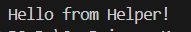

//Importing all classes from a package.
Source code
import java.util.Vector;
public class Coders {
public Coders() {
// java.util.Vector is imported, We are able to access it directly in our code.
Vector v = new Vector();
java.util.ArrayList l = new java.util.ArrayList();
l.add(3);
l.add(5);
l.add(7);
System.out.println(l);
}
public static void main(String[] args) {
new Coders();
}
}
Output
[3,5,7]

POST LAB EXERCISE
- What will happen if two classes in different packages have the same name and are imported in a Java file?

If two classes with the same name from different packages are imported, Java will show a compile-time ambiguity error when you try to use that class name. To resolve it, you must use the fully qualified class name (package + class name).

- What is the purpose of using packages in Java?

Packages are used to:
- Organize related classes and interfaces
- Avoid naming conflicts
- Provide access protection (access modifiers)
- Improve code reusability and maintainability

- Which built-in Java package would you use if you want to create a GUI window and display a message?
- java.util
- java.sql
- java.awt
- java.net

ANSWER : C. java.awt
It provides classes for GUI components like windows, buttons, labels, etc.

ASSESSMENT

Description | Max Marks | Marks Awarded
Pre Lab Exercise | 5
In Lab Exercise | 10
Post Lab Exercise | 5
Viva | 10
Total | 30
Faculty Signature

Experiment Number : 9 Date: 24.06.2026

Implementation of a Java Program to import packages using different methods

Aim:
Write a Java program to import packages using different methods for different use cases.

PRE LAB EXERCISE
QUESTIONS
- How to import a single class and multiple classes from a package in Java?
Single class import:
import java.util.ArrayList;
---Imports only ArrayList class.---
Multiple classes import (entire package):
import java.util.*;
Imports all classes from java.util package.

- Which package is always imported by default in every Java class?
java.lang package is automatically imported.
It contains fundamental classes like String, Math, System, Object, etc., so you don’t need to import it manually.

IN LAB EXERCISE
Objective
To understand and implement the Java packages using different methods and import them.
Problem
Define a package named ‘useFul’ with a class names ‘UseMe’ having following methods:
1) area()- To calculate the area of given shape.
2) salary()- To calculate the salary given basic Salary,da,hRA.
3) percentage()-To calculate the percentage given total marks and marks obtained.
4) Develop a program named ‘Package Use’ to import the above package ‘useFul’ and use the method area().
5) Develop a program named ‘manager’
Source Code
//Package Creation:
package useFull;
import java.util.*;
public class UseMe
{
Scanner obj=new Scanner(System.in);
public static void area()
{
class method{
void aos(int a)
{
System.out.print("\nArea of square with length "+a+" is "+(a*a));
}
void aor(int a,int b)
{
System.out.print("\nArea of reactangle with dimensions "+a+" & "+b+" is "+(a*b));
}
void aoc(int r)
{
double a=3.14*r*r;
}
System.out.print("\nArea of circle with radius "+r+" is "+a);
}
void aot(int a,int b)
{
float ar=(a*b)/2;
System.out.print("\nArea of triangle with dimensions "+a+" &"+b+" is "+ar);
} }
Scanner obj=new Scanner(System.in);
method m=new method();
System.out.print("\n1.Square\n2.Rectangle\n3.Circle\n4.Triangle\nSelect the shape\n");
int ch=obj.nextInt();
UseMe u=new UseMe();
switch(ch)
{
case 1:System.out.print("\nEnter the length of side of square : ");
int s=obj.nextInt();m.aos(s);
break;
case 2:System.out.print("\nEnter the dimensions of rectangle : ");
int l=obj.nextInt();
int b=obj.nextInt();
m.aor(l,b);
break;
case 3:System.out.print("\nEnter the radius of circle : ");
int r=obj.nextInt();
m.aoc(r);
break;
case 4:System.out.print("\nEnter the dimensions of triangle : ");
int ba=obj.nextInt();
int w=obj.nextInt();
m.aot(ba,w);
break; } }
public void salary()
{
int ba,da,hra;
System.out.print("\nEnter the basic salary : ");
ba=obj.nextInt();
System.out.print("\nEnter the dearness allowance :");
da=obj.nextInt();
System.out.print("\nEnter the house rent allowance : ");
hra=obj.nextInt();
System.out.print("\nThe total Gross salary of employee is : "+(ba+da+hra));
}
public void percentage()
{
int n,sum=0;
float p;
System.out.print("\nEnter the total number of subjects : ");
n=obj.nextInt();
int m[]=new int[n];
System.out.print("\nEnter the marks of "+n+" subjects : ");
for(int i=0;i<n;i++)
{
m[n]=obj.nextInt();
}
for(int i=0;i<n;i++)
{
sum=sum+m[i];
}
p=sum/n;
{
System.out.print("\nPercentahe of student : "+p);
}
}
}
//Package Implementation-1:
import useFull.UseMe;
class packageUse
{
public static void main(String args[])
{
UseMe o=new UseMe();o.area();
}
}

Output
javac packageUse.java
java packageUse
- Square
- Rectangle
- Circle
- Triangle
Select the shape
2

Enter the dimensions of the rectangle: 10 15
Area of the rectangle with dimensions 10&15 is 150
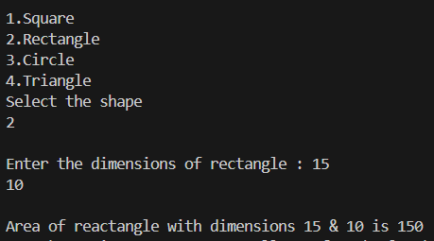

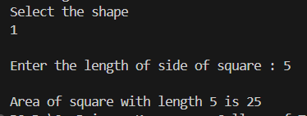
//Package Implementation-2:
import useFull.UseMe;
class manager
{
public static void main(String args[])
{
UseMe obj=new UseMe();obj.salary();
}
}

Output
javac manager.java
java manager

Enter the basic salary: 100000
Enter the dearness allowance: 5000
Enter the house rent allowance: 2000
The total Gross salary of employee is: 107000
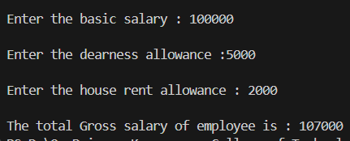

POST LAB EXERCISE
- Find the key differences between java.util and java.lang packages.

Feature | java.lang | java.util
Import | Imported automatically | Must be imported manually
Purpose | Core language classes | Utility and collection classes
Examples | String, System, Math, Object | ArrayList, HashMap, Scanner, Date
Usage | Fundamental Java operations | Data structures & utilities
Dependency | Required for every program | Used only when needed

- List some of the subpackages of java.util

- java.util.concurrent → Multithreading utilities
- java.util.function → Functional interfaces (used in lambdas)
- java.util.logging → Logging framework
- java.util.regex → Regular expressions
- java.util.stream → Stream API for data processing
- java.util.zip → ZIP compression utilities

ASSESSMENT

Description | Max Marks | Marks Awarded
Pre Lab Exercise | 5
In Lab Exercise | 10
Post Lab Exercise | 5
Viva | 10
Total | 30
Faculty Signature

Experiment Number : 10 Date: 04.03.2026

Implementation of Access Modifiers in Java

Aim:
Write a Java program to implement different access modifiers.

PRE LAB EXERCISE
QUESTIONS
- What are the 4 access modifiers available in Java?
Java provides four access modifiers to control visibility of classes, methods, variables, and constructors:
- public
- protected
- default (no keyword – also called package-private)
- private
These modifiers define where the member can be accessed from.

- Which access modifiers can be used in Java to control access to class members?
Class members include:
- Variables (fields)
- Methods
- Constructors
- Inner classes
All four access modifiers can be used to control access to class members.

Modifier | Same Class | Same Package | Subclass (Different Package) | Outside Package
public | ✅ Yes | ✅ Yes | ✅ Yes | ✅ Yes
protected | ✅ Yes | ✅ Yes | ✅ Yes | ❌ No
default | ✅ Yes | ✅ Yes | ❌ No | ❌ No
private | ✅ Yes | ❌ No | ❌ No | ❌ No

IN LAB EXERCISE
Objective
To demonstrate different access modifiers such as Default, Private, Protected and Public using Java programs.
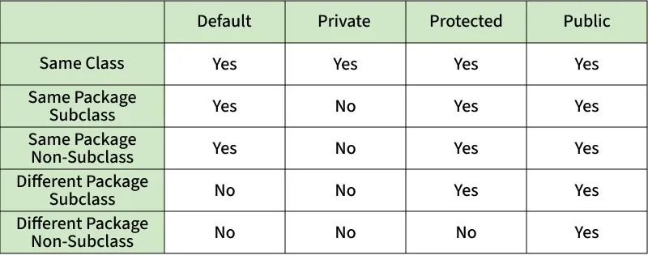
Fig: Comparison table of Access Modifiers in Java
Source Code
// Default Access modifier
class Car {
String model; // default access
}
public class Main {
public static void main(String[] args){
Car c = new Car();
c.model = "Tesla"; // accessible within the same package
System.out.println(c.model);
}
}
Output:
Tesla


//Private Access Modifier
class Person {
// private variable
private String name;
public void setName(String name) {
this.name = name; // accessible within class
}
public String getName() {
return name;
}
}
public class Geeks {
public static void main(String[] args)
{
Person p = new Person();
p.setName("Alice");

// System.out.println(p.name);
// Error: 'name'
// has private access
System.out.println(p.getName());
}
}
Output
Alice

//Protected Access Modifier
class Vehicle {
protected int speed; // protected member
}
class Bike extends Vehicle {
void setSpeed(int s)
{
speed = s; // accessible in subclass
}
int getSpeed()
{
return speed; // accessible in subclass
}
}
public class Main {
public static void main(String[] args){
Bike b = new Bike();
b.setSpeed(100);
System.out.println("Access via subclass method: "+ b.getSpeed());
Vehicle v = new Vehicle();
System.out.println(v.speed);
}
}
Output
Access via subclass method: 100
0
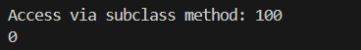

//Public Access Modifier
class MathUtils {
public static int add(int a, int b) {
return a + b;
}
}
public class Main {
public static void main(String[] args) {
System.out.println(MathUtils.add(5, 10)); // accessible anywhere
}
}
Output
15


POST LAB EXERCISE
  - Write a Java program to implement Default access modifier which has a default class within the same package and a default class from a different package.

Default access modifier (also called package-private) allows access only within the same package. It does not allow access from outside the package.

Package 1:
File 1: DefaultClass.java
package package1;
class DefaultClass { // Default access class
void display() { // Default access method
System.out.println("Inside DefaultClass - Same Package");
}
}
File 2: TestSamePackage.java
package package1;
public class TestSamePackage {
public static void main(String[] args) {
DefaultClass obj = new DefaultClass();
obj.display();
}
}
Output:
Inside DefaultClass - Same Package

Explanation:
Since both classes are in the same package (package1), the default class and method are accessible.

Package 2:
File 3: TestDifferentPackage.java
package package2;
import package1.DefaultClass;
public class TestDifferentPackage {
public static void main(String[] args) {
DefaultClass obj = new DefaultClass(); // Compilation Error
obj.display(); // Compilation Error
}
}
Error:
DefaultClass is not public in package1; cannot be accessed from outside package

Conclusion:
• Default access modifier allows access only within the same package.
• It restricts access from outside the package.
• It is also called package-private access.

  - Which access modifier provides the highest level of access?
public
Why?
Because public members:
- Can be accessed inside the same class
- Inside the same package
- In subclasses
- From different packages
- From anywhere in the program
So,
public provides the highest (widest) level of access.

ASSESSMENT

Description | Max Marks | Marks Awarded
Pre Lab Exercise | 5
In Lab Exercise | 10
Post Lab Exercise | 5
Viva | 10
Total | 30
Faculty Signature

Experiment Number :11 Date: 04.03.2026

Implementation of multiple inheritance in Java using Interface

Aim:
Write a Java program to implement multiple inheritance using Interface.

PRE LAB EXERCISE
QUESTIONS
1.Why Java does not support multiple inheritance using classes like that of C?
Java does not support multiple inheritance using classes to avoid ambiguity and complexity, especially the Diamond Problem.
Diamond Problem Explanation:
If a class inherits from two parent classes that have the same method, the compiler cannot decide which method to use.
Example (Problem in C++):
If:
- Class A has method display()
- Class B and Class C inherit A
- Class D inherits B and C
Now, when D calls display(), it becomes ambiguous whether it should use B’s or C’s version.
This creates confusion and complexity.

2. What is the primary purpose of an interface in Java?
- To store data using instance variables
- To define a contract of methods a class must implement
C. To allow creation of objects
- To improve runtime performance

B. To define a contract of methods a class must implement

Explanation:
An interface in Java is used to:
- Declare abstract methods
- Force implementing classes to provide method definitions
- Achieve abstraction
- Support multiple inheritance
It acts like a contract.
If a class implements an interface, it must implement all the methods declared in that interface.

IN LAB EXERCISE
Objective
To demonstrate how an interface in Java defines constants and abstract methods, which are implemented by a class.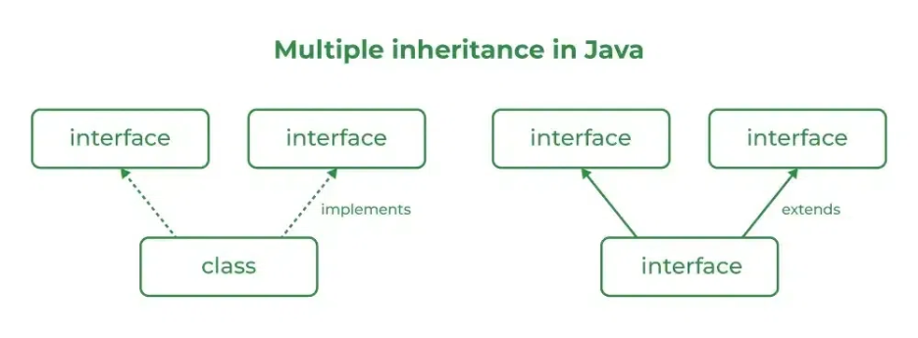

Source Code
import java.io.*;
// Add interface
interface Add{
int add(int a,int b);
}
// Sub interface
interface Sub{
int sub(int a,int b);
}
// Calculator class implementing Add and Sub
class Cal implements Add , Sub
{
// Method to add two numbers
public int add(int a,int b){
return a+b;
}
// Method to sub two numbers
public int sub(int a,int b){
return a-b;
}
}
class Example{
// Main Method
public static void main (String[] args){

// instance of Cal class
Cal x = new Cal();
System.out.println("Addition : " + x.add(2,1));
System.out.println("Substraction : " + x.sub(2,1));
}
}

Outputs
Addition : 3
Subtraction : 1

POST LAB EXERCISE
1.Can a functional interface extend another interface?
Yes, a functional interface can extend another interface.
However, there is an important condition:
A functional interface must have only one abstract method.
If it extends another interface:
- The total number of abstract methods (including inherited ones) must be exactly one.
- Otherwise, it will not remain a functional interface.

2. Which feature was introduced in interfaces starting from Java 8?
- Constructors
- Private methods
- Default and static methods
- Final classes

Correct Answer:
C. Default and static methods

Explanation:
Before Java 8:
- Interfaces could only have abstract methods.
Starting from Java 8:
- Interfaces can have default methods (with method body).
- Interfaces can have static methods (with method body).
This was introduced to:
- Support backward compatibility
- Allow method implementation inside interfaces

ASSESSMENT

Description | Max Marks | Marks Awarded
Pre Lab Exercise | 5
In Lab Exercise | 10
Post Lab Exercise | 5
Viva | 10
Total | 30
Faculty Signature

Experiment Number : 12 Date: 05.03.2026

Implementation of exception handling in Java
Aim:
Write a java program to implement exception handling.

PRE LAB EXERCISE
QUESTIONS
- What is exception handling in Java?
Exception handling in Java is a mechanism used to handle runtime errors so that the normal flow of the program can be maintained.
An exception is an unwanted or unexpected event that occurs during the execution of a program and disrupts its normal flow.
Java provides built-in keywords to handle exceptions such as:
- try
- catch
- finally
- throw
- throws

- What is the purpose of using try-catch blocks in exception handling?
The try-catch block is used to handle exceptions safely.
try Block:
The code that may cause an exception is written inside the try block.
catch Block:
The catch block handles the exception if it occurs.

IN LAB EXERCISE
Objective
To understand and implement exception handling through try-catch and finally blocks.
Source Code
import java.util.InputMismatchException;
import java.util.Scanner;
public class ExceptionHandlingExample {
public static void main(String[] args) {
Scanner scanner = new Scanner(System.in);
try {
System.out.print("Enter an integer: ");
int num = scanner.nextInt();
int result = 10 / num;
System.out.println("Result: " + result);
} catch (InputMismatchException e) {
System.out.println("Invalid input! Please enter an integer.");
} catch (ArithmeticException e) {
System.out.println("Cannot divide by zero!");
} finally {
scanner.close();
System.out.println("Program execution completed.");
} }
}
Outputs
Output 1 (Valid Input - Non-zero Integer):
Enter an integer: 5
Result: 2
Program execution completed.
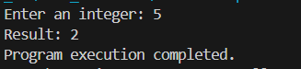

Output 2 (Valid Input - Zero):
Enter an integer: 0
Cannot divide by zero!
Program execution completed.
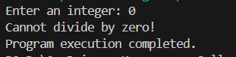

Output 3 (Invalid Input - Non-integer):
Enter an integer: abc
Invalid input! Please enter an integer.
Program execution completed.
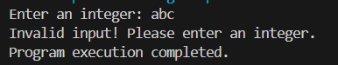

POST LAB EXERCISE
- What is the purpose of the Scanner object in the Java program?
The Scanner object is used to take input from the user during program execution.
It is part of the java.util package and is commonly used to read:
• Integers
• Floating-point numbers
• Strings
• Characters
• Boolean values

Scanner sc = new Scanner(System.in);
→ Creates a Scanner object to read input from the keyboard.
sc.nextInt();
→ Reads an integer value entered by the user.

2) What exceptions are expected to be thrown in the code within the try block? Why?
The exceptions depend on the operations performed inside the try block.
Common exceptions when using Scanner and arithmetic operations include:

InputMismatchException
Why?
Thrown when the user enters input of the wrong data type.
Example:
int num = sc.nextInt();
If the user enters a string instead of an integer, this exception occurs.

ArithmeticException
Why?
Thrown when an illegal arithmetic operation is performed, such as dividing by zero.
Example:
int result = 10 / 0;
This causes:
java.lang.ArithmeticException: / by zero

NumberFormatException (if parsing is used)
Why?
Thrown when converting a string into a numeric type fails.
Example:
int num = Integer.parseInt("abc");

ASSESSMENT

Description | Max Marks | Marks Awarded
Pre Lab Exercise | 5
In Lab Exercise | 10
Post Lab Exercise | 5
Viva | 10
Total | 30
Faculty Signature

Experiment Number : 13 Date: 05.03.2026

Implementation of User-defined Exception in Java

Aim:
Write a java program to implement User-defined Exception.

PRE LAB EXERCISE
QUESTIONS
- What is Java custom exception?
A custom exception in Java is a user-defined exception created by the programmer to handle specific application-related errors.
Java provides many built-in exceptions (like ArithmeticException, NullPointerException), but sometimes we need to create our own exception to represent special error conditions in a program.
Custom exceptions are created by:
Extending the Exception class
or
Extending the RuntimeException class

- What are the two types of custom exceptions in Java?
Checked Custom Exception
Created by extending the Exception class
Checked at compile time
Must be handled using try-catch or declared using throws
Example:
class MyCheckedException extends Exception {
}

Unchecked Custom Exception
Created by extending the RuntimeException class
Checked at runtime
Handling is optional

Example:
class MyUncheckedException extends RuntimeException {
}

IN LAB EXERCISE
Objective
To understand and implement Checked and Unchecked custom exceptions.
Source Code
Ex 1: // Custom Checked Exception
class InvalidAgeException extends Exception {
public InvalidAgeException(String m) {
super(m);
}
}
// Using the Custom Exception
public class AgeCheck{
public static void validate(int age)
throws InvalidAgeException {
if (age < 18) {
throw new InvalidAgeException("Age must be 18 or above.");
}
System.out.println("Valid age: " + age);
}
public static void main(String[] args) {
try {
validate(12);
} catch (InvalidAgeException e) {
System.out.println("Caught Exception: " + e.getMessage());
}
}
}

Output 1
Caught Exception: Age must be 18 or above.

Ex 2: // Custom Unchecked Exception
class DivideByZeroException extends RuntimeException {
public DivideByZeroException(String m) {
super(m);
}
}
// Using the Custom Exception
public class TestSample {
public static void divide(int a, int b) {
if (b == 0) {
throw new DivideByZeroException("Division by zero is not allowed.");
}
System.out.println("Result: " + (a / b));
}
public static void main(String[] args) {
try {
divide(10, 0);
} catch (DivideByZeroException e) {
System.out.println("Caught Exception: " + e.getMessage());
}
}
}

Output 2
Caught Exception: Division by zero is not allowed.

POST LAB EXERCISE
- What is required to create a custom exception in Java?
- Extend the Object class
- Extend the Throwable class
- Extend Exception or RuntimeException
- Implement the Serializable interface
Correct Answer:
C. Extend Exception or RuntimeException
Explanation:
To create a custom exception in Java, we must extend either:
• Exception → for checked exceptions
• RuntimeException → for unchecked exceptions
These classes are part of Java’s exception hierarchy and allow the programmer to define application-specific errors.

2)List some use cases for the checked and unchecked exceptions.

Checked Exceptions (Compile-Time Exceptions)
Checked exceptions must be handled using try-catch or declared using throws.

Common Use Cases:
• File handling errors (FileNotFoundException)
• Database connection issues (SQLException)
• Network-related errors (IOException)
• Invalid user input that must be validated
• Business rule violations that require mandatory handling
Used when the programmer wants to force handling of the error.

Unchecked Exceptions (Runtime Exceptions)
Unchecked exceptions occur at runtime and are not checked at compile time.

Common Use Cases:
• Programming errors (NullPointerException)
• Logical mistakes (ArithmeticException – divide by zero)
• Invalid method arguments (IllegalArgumentException)
• Array index out of bounds errors
• When validation is optional
Used when the error is due to programmer mistake or incorrect logic.

ASSESSMENT

Description | Max Marks | Marks Awarded
Pre Lab Exercise | 5
In Lab Exercise | 10
Post Lab Exercise | 5
Viva | 10
Total | 30
Faculty Signature

