Experiment Number : 8 Date: 25.02.2026

Implementation of Packages in Java

Aim:
Write a Java program to implement built-in, user-defined packages and accessing all classes in a package.

PRE LAB EXERCISE
QUESTIONS
- What is java.util package and what collection framework does it contain?
- The java.util package provides utility classes for data structures and other helper functions.
- It contains the Java Collections Framework, which includes interfaces like List, Set, Queue, and Map (e.g., ArrayList, HashSet, HashMap) to store and manage data efficiently.
- What are the two types of packages in Java?
- Built-in Packages – Provided by Java (e.g., java.lang, java.util).
- User-defined Packages – Created by programmers using the package keyword.

IN LAB EXERCISE
Objective
To understand and implement the concepts of built-in, user-defined packages and accessing all classes in a package in Java.
Built-in Packages comprise a large number of classes that are part of the Java API. Some of the commonly used built-in packages are:
- java.lang: Contains language support classes(e.g, classes that define primitive data types, math operations). This package is automatically imported.
- java.io: Contains classes for supporting input/output operations.
- java.util: Contains utility classes that implement data structures such as Linked Lists and Dictionaries, as well as support for date and time operations.
- java.applet: Contains classes for creating Applets.
- java.awt: Contains classes for implementing the components for graphical user interfaces (like buttons, menus, etc).
Source Code
import java.util.Random; // built-in package
public class Sample{
public static void main(String[] args) {
// using Random class
Random rand = new Random();
// generates a number between 0–99
int number = rand.nextInt(100);
System.out.println("Random number: " + number);
}
}
Output
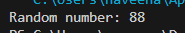

User-defined Packages are the packages that are defined by the user.
Source code
package com.myapp;
public class Helper {
public static void show() {
System.out.println("Hello from Helper!");
}
}
==To use this in another class==
import com.myapp.Helper;
public class Test {
public static void main(String[] args) {
Helper.show();
}
}

Output:

//Importing all classes from a package.
Source code
import java.util.Vector;
public class Coders {
public Coders() {
// java.util.Vector is imported, We are able to access it directly in our code.
Vector v = new Vector();
java.util.ArrayList l = new java.util.ArrayList();
l.add(3);
l.add(5);
l.add(7);
System.out.println(l);
}
public static void main(String[] args) {
new Coders();
}
}
Output
POST LAB EXERCISE
- What will happen if two classes in different packages have the same name and are imported in a Java file?
If two classes with the same name from different packages are imported, it causes a compile-time ambiguity error.
To resolve this, you must use the fully qualified class name (package name + class name).

- What is the purpose of using packages in Java?
Packages are used to:
- Organize related classes and interfaces
- Avoid naming conflicts
- Improve code reusability and maintainability
- Provide access protection

- Which built-in Java package would you use if you want to create a GUI window and display a message?
- java.util
- java.sql
- java.awt
- java.net
Answer: C. java.awt
It contains classes for creating graphical user interface components like windows, buttons, and labels.

ASSESSMENT

Description | Max Marks | Marks Awarded
Pre Lab Exercise | 5
In Lab Exercise | 10
Post Lab Exercise | 5
Viva | 10
Total | 30
Faculty Signature
Experiment Number : 9 Date: 25.02.2026

Implementation of a Java Program to import packages using different methods

Aim:
Write a Java program to import packages using different methods for different use cases.

PRE LAB EXERCISE
QUESTIONS
- How to import a single class and multiple classes from a package in Java?
- Single class import:
import java.util.ArrayList;
- Multiple classes import (entire package):
import java.util.*;
- Which package is always imported by default in every Java class?
- The java.lang package is automatically imported in every Java program, so we do not need to import it explicitly
- It contains essential classes like String, System, and Math that are commonly used in Java programs.

IN LAB EXERCISE
Objective
To understand and implement the Java packages using different methods and import them.
Problem
Define a package named ‘useFul’ with a class names ‘UseMe’ having following methods:
1) area()- To calculate the area of given shape.
2) salary()- To calculate the salary given basic Salary,da,hRA.
3) percentage()-To calculate the percentage given total marks and marks obtained.
4) Develop a program named ‘Package Use’ to import the above package ‘useFul’ and use the method area().
5) Develop a program named ‘manager’
Source Code
//Package Creation:
package useFull;
import java.util.*;
public class UseMe
{
Scanner obj=new Scanner(System.in);
public static void area()
{
class method{
void aos(int a)
{
System.out.print("\nArea of square with length "+a+" is "+(a*a));
}
void aor(int a,int b)
{
System.out.print("\nArea of reactangle with dimensions "+a+" & "+b+" is "+(a*b));
}
void aoc(int r)
{
double a=3.14*r*r;
}
System.out.print("\nArea of circle with radius "+r+" is "+a);
}
void aot(int a,int b)
{
float ar=(a*b)/2;
System.out.print("\nArea of triangle with dimensions "+a+" &"+b+" is "+ar);
} }
Scanner obj=new Scanner(System.in);
method m=new method();
System.out.print("\n1.Square\n2.Rectangle\n3.Circle\n4.Triangle\nSelect the shape\n");
int ch=obj.nextInt();
UseMe u=new UseMe();
switch(ch)
{
case 1:System.out.print("\nEnter the length of side of square : ");
int s=obj.nextInt();m.aos(s);
break;
case 2:System.out.print("\nEnter the dimensions of rectangle : ");
int l=obj.nextInt();
int b=obj.nextInt();
m.aor(l,b);
break;
case 3:System.out.print("\nEnter the radius of circle : ");
int r=obj.nextInt();
m.aoc(r);
break;
case 4:System.out.print("\nEnter the dimensions of triangle : ");
int ba=obj.nextInt();
int w=obj.nextInt();
m.aot(ba,w);
break; } }
public void salary()
{
int ba,da,hra;
System.out.print("\nEnter the basic salary : ");
ba=obj.nextInt();
System.out.print("\nEnter the dearness allowance :");
da=obj.nextInt();
System.out.print("\nEnter the house rent allowance : ");
hra=obj.nextInt();
System.out.print("\nThe total Gross salary of employee is : "+(ba+da+hra));
}
public void percentage()
{
int n,sum=0;
float p;
System.out.print("\nEnter the total number of subjects : ");
n=obj.nextInt();
int m[]=new int[n];
System.out.print("\nEnter the marks of "+n+" subjects : ");
for(int i=0;i<n;i++)
{
m[n]=obj.nextInt();
}
for(int i=0;i<n;i++)
{
sum=sum+m[i];
}
p=sum/n;
{
System.out.print("\nPercentahe of student : "+p);
}
}
}
//Package Implementation-1:
import useFull.UseMe;
class packageUse
{
public static void main(String args[])
{
UseMe o=new UseMe();o.area();
}
}

Output
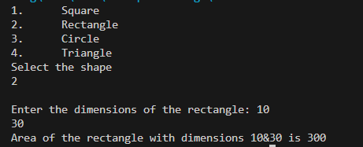

//Package Implementation-2:
import useFull.UseMe;
class manager
{
public static void main(String args[])
{
UseMe obj=new UseMe();obj.salary();
}
}

Output
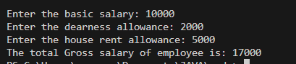
POST LAB EXERCISE
- Find the key differences between java.util and java.lang packages.
- java.lang is automatically imported in every Java program and contains fundamental classes like String, System, Math, and Object.
- java.util must be imported explicitly and contains utility classes like ArrayList, HashMap, Scanner, Date, and other data structure classes.

- List some of the subpackages of java.util
Some important subpackages of java.util are:
- java.util.concurrent
- java.util.function
- java.util.logging
- java.util.regex
- java.util.stream
These subpackages provide support for concurrency, functional programming, logging, regular expressions, and streams.

ASSESSMENT

Description | Max Marks | Marks Awarded
Pre Lab Exercise | 5
In Lab Exercise | 10
Post Lab Exercise | 5
Viva | 10
Total | 30
Faculty Signature
Experiment Number : 10 Date: 26.02.2026

Implementation of Access Modifiers in Java

Aim:
Write a Java program to implement different access modifiers.

PRE LAB EXERCISE
QUESTIONS
- What are the 4 access modifiers available in Java?
The four access modifiers in Java are:
- public
- protected
- default (no modifier)
- private

- Which access modifiers can be used in Java to control access to class members?
To control access to class members (variables, methods, constructors), Java uses: public, protected, default, and private — depending on the required level of accessibility.
IN LAB EXERCISE
Objective
To demonstrate different access modifiers such as Default, Private, Protected and Public using Java programs
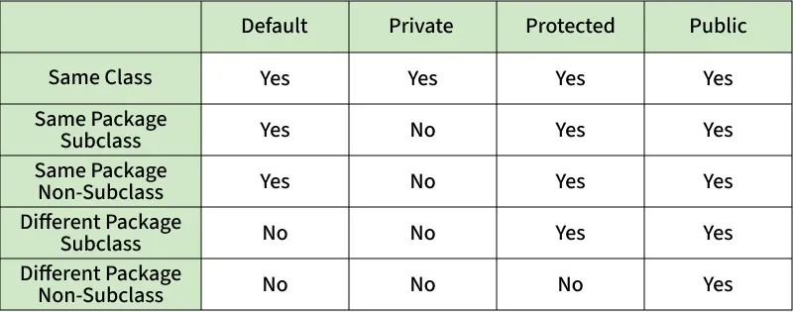
Fig: Comparison table of Access Modifiers in Java
Source Code
// Default Access modifier
class Car {
String model; // default access
}
public class Main {
public static void main(String[] args){
Car c = new Car();
c.model = "Tesla"; // accessible within the same package
System.out.println(c.model);
}
}
Output:
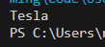

//Private Access Modifier
class Person {
// private variable
private String name;
public void setName(String name) {
this.name = name; // accessible within class
}
public String getName() {
return name;
}
}
public class Geeks {
public static void main(String[] args)
{
Person p = new Person();
p.setName("Alice");

// System.out.println(p.name);
// Error: 'name'
// has private access
System.out.println(p.getName());
}
}
Output
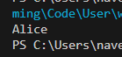

//Protected Access Modifier
class Vehicle {
protected int speed; // protected member
}
class Bike extends Vehicle {
void setSpeed(int s)
{
speed = s; // accessible in subclass
}
int getSpeed()
{
return speed; // accessible in subclass
}
}
public class Main {
public static void main(String[] args){
Bike b = new Bike();
b.setSpeed(100);
System.out.println("Access via subclass method: "+ b.getSpeed());
Vehicle v = new Vehicle();
System.out.println(v.speed);
}
}
Output
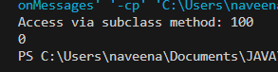

//Public Access Modifier
class MathUtils {
public static int add(int a, int b) {
return a + b;
}
}
public class Main {
public static void main(String[] args) {
System.out.println(MathUtils.add(5, 10)); // accessible anywhere
}
}
Output
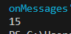
POST LAB EXERCISE
  - Write a Java program to implement Default access modifier which has a default class within the same package and a default class from a different package.
- Case 1: Default class in the same package (Accessible)
Code:
class Car {
String model = "Tesla";
}
public class Main {
public static void main(String[] args) {
Car c = new Car();
System.out.println(c.model);
}
}
Output:
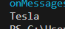

- Case 2: Default class from a different package (Not Accessible)
Code:
package vehicle;
class Car {
String model = "Tesla";
}
import vehicle.Car;
public class Test {
public static void main(String[] args) {
Car c = new Car();
}
}
Result:
Compile-time Error
(Default classes are not accessible outside their package.)
Conclusion
Default access modifier allows access only within the same package, not from different packages.

  - Which access modifier provides the highest level of access?
- The public access modifier provides the highest level of access.
- It allows the class or member to be accessed from anywhere (inside or outside the package).

ASSESSMENT

Description | Max Marks | Marks Awarded
Pre Lab Exercise | 5
In Lab Exercise | 10
Post Lab Exercise | 5
Viva | 10
Total | 30
Faculty Signature

Experiment Number :11 Date: 26.02.2026

Implementation of multiple inheritance in Java using Interface

Aim:
Write a Java program to implement multiple inheritance using Interface.

PRE LAB EXERCISE
QUESTIONS
  - Why Java does not support multiple inheritance using classes like that of C?
- Java does not support multiple inheritance using classes to avoid ambiguity problems (Diamond Problem), where it becomes unclear which parent class method should be inherited.
- To solve this, Java supports multiple inheritance through interfaces instead of classes.
  - What is the primary purpose of an interface in Java?
- To store data using instance variables
- To define a contract of methods a class must implement
- To allow creation of objects
- To improve runtime performance
Correct Answer: B. To define a contract of methods a class must implement
An interface defines a set of methods that a class must implement, ensuring consistency and abstraction.

IN LAB EXERCISE
Objective
To demonstrate how an interface in Java defines constants and abstract methods, which are implemented by a class.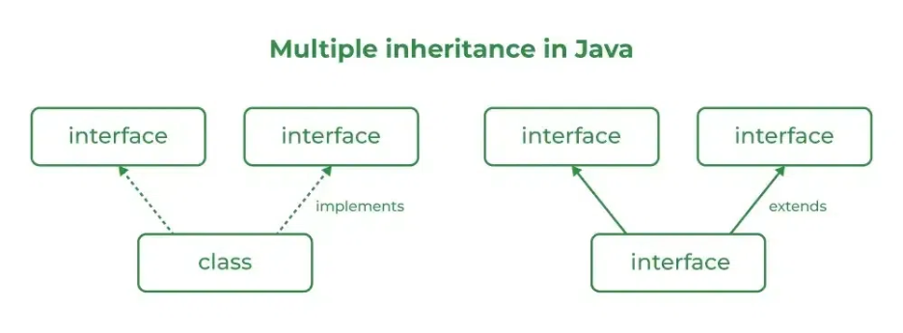

Source Code
import java.io.*;
// Add interface
interface Add{
int add(int a,int b);
}
// Sub interface
interface Sub{
int sub(int a,int b);
}
// Calculator class implementing Add and Sub
class Cal implements Add , Sub
{
// Method to add two numbers
public int add(int a,int b){
return a+b;
}
// Method to sub two numbers
public int sub(int a,int b){
return a-b;
}
}
class Example{
// Main Method
public static void main (String[] args){

// instance of Cal class
Cal x = new Cal();
System.out.println("Addition : " + x.add(2,1));
System.out.println("Substraction : " + x.sub(2,1));
}
}

Outputs
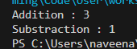

POST LAB EXERCISE
  - Can a functional interface extend another interface?
Yes, a functional interface can extend another interface only if it still has exactly one abstract method. If it has more than one abstract method, it is no longer a functional interface.

  - Which feature was introduced in interfaces starting from Java 8?
- Constructors
- Private methods
- Default and static methods
- Final classes
Correct Answer: C. Default and static methods
Java 8 introduced default and static methods in interfaces, allowing method implementation inside interfaces.

ASSESSMENT

Description | Max Marks | Marks Awarded
Pre Lab Exercise | 5
In Lab Exercise | 10
Post Lab Exercise | 5
Viva | 10
Total | 30
Faculty Signature

Experiment Number : 12 Date: 26.02.2026

Implementation of exception handling in Java
Aim:
Write a java program to implement exception handling.

PRE LAB EXERCISE
QUESTIONS
- What is exception handling in Java?
Exception handling in Java is a mechanism used to handle runtime errors so that the normal flow of the program is not interrupted. It is done using keywords like try, catch, finally, throw, and throws.

- What is the purpose of using try-catch blocks in exception handling?
- The try block is used to write code that may cause an exception, and the catch block is used to handle the exception.
- This prevents the program from crashing and allows it to continue execution properly.

IN LAB EXERCISE
Objective
To understand and implement exception handling through try-catch and finally blocks.
Source Code
import java.util.InputMismatchException;
import java.util.Scanner;
public class ExceptionHandlingExample {
public static void main(String[] args) {
Scanner scanner = new Scanner(System.in);
try {
System.out.print("Enter an integer: ");
int num = scanner.nextInt();
int result = 10 / num;
System.out.println("Result: " + result);
} catch (InputMismatchException e) {
System.out.println("Invalid input! Please enter an integer.");
} catch (ArithmeticException e) {
System.out.println("Cannot divide by zero!");
} finally {
scanner.close();
System.out.println("Program execution completed.");
} }
}
Outputs
Output 1 (Valid Input - Non-zero Integer):
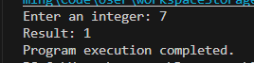
Output 2 (Valid Input - Zero):
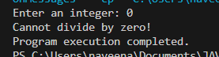
Output 3 (Invalid Input - Non-integer):
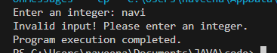

POST LAB EXERCISE
- What is the purpose of the Scanner object in the Java program?
The Scanner object is used to take input from the user. It reads different types of data such as integers, strings, and doubles from the keyboard.
- What exceptions are expected to be thrown in the code within the try block? Why?
Common exceptions that may be thrown are:
- InputMismatchException – if the user enters data of the wrong type (e.g., string instead of integer).
- ArithmeticException – if an illegal arithmetic operation occurs (e.g., division by zero).
These exceptions occur due to invalid input or incorrect operations during program execution.

ASSESSMENT

Description | Max Marks | Marks Awarded
Pre Lab Exercise | 5
In Lab Exercise | 10
Post Lab Exercise | 5
Viva | 10
Total | 30
Faculty Signature

Experiment Number : 13 Date: 26.02.2026

Implementation of User-defined Exception in Java

Aim:
Write a java program to implement User-defined Exception.

PRE LAB EXERCISE
QUESTIONS
- What is Java custom exception?
A custom exception in Java is a user-defined exception created by extending the Exception or RuntimeException class. It is used to handle application-specific errors.
- What are the two types of custom exceptions in Java?
The two types of custom exceptions are:
- Checked Custom Exception – Extends the Exception class and must be handled or declared using throws.
- Unchecked Custom Exception – Extends the RuntimeException class and does not require mandatory handling.

IN LAB EXERCISE
Objective
To understand and implement Checked and Unchecked custom exceptions.
Source Code
Ex 1: // Custom Checked Exception
class InvalidAgeException extends Exception {
public InvalidAgeException(String m) {
super(m);
}
}
// Using the Custom Exception
public class AgeCheck{
public static void validate(int age)
throws InvalidAgeException {
if (age < 18) {
throw new InvalidAgeException("Age must be 18 or above.");
}
System.out.println("Valid age: " + age);
}
public static void main(String[] args) {
try {
validate(12);
} catch (InvalidAgeException e) {
System.out.println("Caught Exception: " + e.getMessage());
}
}
}

Output 1
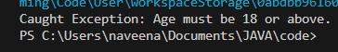

Ex 2: // Custom Unchecked Exception
class DivideByZeroException extends RuntimeException {
public DivideByZeroException(String m) {
super(m);
}
}
// Using the Custom Exception
public class TestSample {
public static void divide(int a, int b) {
if (b == 0) {
throw new DivideByZeroException("Division by zero is not allowed.");
}
System.out.println("Result: " + (a / b));
}
public static void main(String[] args) {
try {
divide(10, 0);
} catch (DivideByZeroException e) {
System.out.println("Caught Exception: " + e.getMessage());
}
}
}

Output 2

POST LAB EXERCISE
- What is required to create a custom exception in Java?
- Extend the Object class
- Extend the Throwable class
- Extend Exception or RuntimeException
- Implement the Serializable interface
Correct Answer: C. Extend Exception or RuntimeException
To create a custom exception, we need to create a class that extends either the Exception class (for checked exceptions) or the RuntimeException class (for unchecked exceptions).

- List some use cases for the checked and unchecked exceptions.
Checked Exceptions (must be handled):
- File handling errors (e.g., file not found)
- Database connection issues
- Network-related problems
Unchecked Exceptions (runtime errors):
- Division by zero (ArithmeticException)
- Null reference access (NullPointerException)
- Invalid array index (ArrayIndexOutOfBoundsException)

ASSESSMENT

Description | Max Marks | Marks Awarded
Pre Lab Exercise | 5
In Lab Exercise | 10
Post Lab Exercise | 5
Viva | 10
Total | 30
Faculty Signature

