Test
Marks: 60 marks (2 marks each)
Time: 2.5 hrs.
- The area of a rectangular field is 1600 sqm. If the length of the field is 80 m, find the perimeter of the field?
- Perimeter of a square and a rectangle is same.If a side of the square is 15 cm and one side of the rectangle is 18cm, find the area of the rectangle.
- Ram wants to cover the floor of her bedroom whose length is 5m by 4m by square tiles. If each square tile is of side is 20 cm, then find the number of tiles required to cover the floor ?
- Find the cost of the flooring the verandah at the rate of Rs. 12 per square metre if the length and breadth of verandah are in the ratio 3:2 and its perimeter is 40m.
- The length of a rectangular field is thrice its breadth. If the perimeter of this field is 800 m , find the length of the field .
- Give expressions in the following cases.
(a) 11 added to 2m
(b) 11 subtracted from 2m
(c) 5 times y to which 3 is added
- Write a statement to represent to represent given expressions :-
- 4x – 3
- 8 + y
- 6p ÷ 2
- 7q + 1
- Express following as instructed by using decimal:
(a) 850 paise (in ₹)
(b) 62 m (in km)
(c) 7 g (in kg)
- Mr. Ranjan purchased 15.500 kg rice, 25.750 kg flour and 3.250 kg sugar. Find the total weight of his purchases. Is it 50 kg or less? If less, how much less?
- Write as fractions in lowest form.
(a) 0.05
(b) 20.25
- Represent 1.3,3.8 and 4.1 on the number line.
- What fraction of a day is 8 hours?
- Kanchan dyes dresses. She had to dye 30 dresses. She has so far finished 20 dresses. What fraction of dresses has she finished?
- Draw number lines and locate the points on them:
(a) 1 / 2, 1 / 4, 3 / 4, 4 / 4
(b) 1 / 8, 2 / 8, 3 / 8, 7 / 8
- Express the following as mixed fractions:
(a) 20 / 3
(b) 11 / 5
(c) 17 / 7
(d) 28 / 5
- Replace ☐ in each of the following by the correct number:
(a) 2 / 7 = 8 / ☐
(b) 5 / 8 = 10 / ☐
(c) 3 / 5 = ☐ / 20
(d) 45 / 60 = 15 / ☐
- Find the equivalent fraction of 36 / 48 with
(a) numerator 9
(b) denominator 4
- A man spends 1/3 of his salary on food, and 1/4 of the remainder on travelling. If his salary is Rs.15000, how much will be left over after the above expenses?
- Jaidev takes minutes to walk across the school ground. Rahul takes 7 / 4 minutes to do the same. Who takes less time and by what fraction?
- Naina was given piece of cake and Najma was given piece of cake. Find the total amount of cake given to both of them.
- The number of milk teeth in human beings is 20 and the number of permanent teeth is 32. Find the ratio of the number of milk teeth to the number of permanent teeth.
- Ramesh earns Rs 28000 per month. His wife Rama earns Rs 36000 per month. Find the ratio of (a) Ramesh’s earnings to their total earnings (b) Rama’s earnings to their total earnings.
- A car can travel 240km in 15 litres of petrol. How much distance will it travel in 25 litres of petrol?
- Bachhu Manjhi earns Rs 24000 in 8 months. At this rate, (a) how much does he earn in one year? (b) in how many months does he earn Rs 42000?
- On a shelf, books with green cover and that with brown cover are in the ratio 2:3. If there are 18 books with green cover, then the number of books with brown cover is
- Magan Bhai sells kites at Jamnagar. Six shopkeepers from nearby villages come to purchase kites from him. The number of kites he sold to these six shopkeepers is given below-
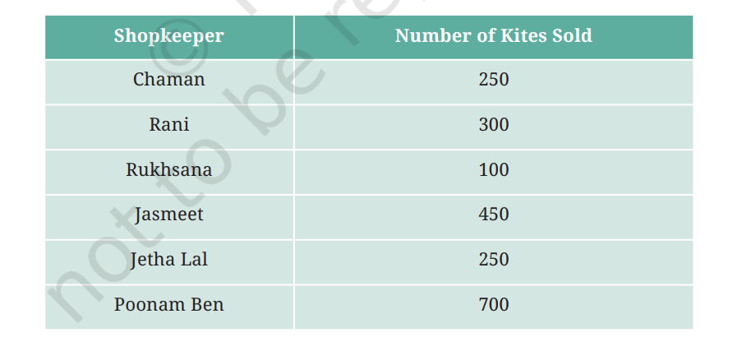
Prepare a pictograph using the symbolto represent 100 kites.
Answer the following questions:
(a) How many symbols represent the kites that Rani purchased?
(b) Who purchased the maximum number of kites?
(c) Who purchased more kites, Jasmeet or Chaman?
(d) Rukhsana says Poonam Ben purchased more than double the number of kites that Rani purchased. Is she correct? Why?
- The table shows the number of vehicles passing a road in one hour.
Vehicle | Number
Cars | 30
Buses | 10
Bikes | 50
Trucks | 15
Questions:
1️⃣ Draw a bar graph for the above data.
2️⃣ Which vehicle passes the road the most?
3️⃣ How many more bikes than buses passed the road?
- The following figures relate the weekly wages (in Rs.) of 15 workers in a factory:
300, 250, 200, 250, 200, 150, 350, 200, 250, 200, 150, 300, 150, 200, 250
Prepare a Tally chart.
(i) What is the range in wages (in Rs)?
(ii) How many Workers are getting Rs 350?
(iii) How many workers are getting the minimum wages?
- Following is the choice of sweets of 30 students of class VI: Ladoo, Barfi, Ladoo, Jalebi, Ladoo, Rasgulla, Jalebi, Ladoo, Barfi, Rasgulla, Ladoo, Jalebi, Jalebi, Rasgulla, Ladoo, Rasgulla, Jalebi, Ladoo, Rasgulla, Ladoo, Rasgulla, Jalebi, Ladoo, Rasgulla, Ladoo, Ladoo, Barfi, Rasgulla, Rasgulla, Ladoo.
(i) Arrange the names of sweets in a table using tally marks.
(ii) Which sweet is preferred by most of the students?
- The weight of 45 folding chairs is 18 kg. How many such chairs can be loaded on a truck having a capacity of carrying 4000 kg load?

