Siri Chandana Katari (4/1/2026)
What are functions in sql?
They are tools that perform a specific operation on data and return a result.
Built-in Functions/ Predefined
These are already provided by SQL; you just use them.
Custom Functions/ User-Defined
These are the functions you create yourself when built-in functions aren’t enough.
We will focus on built-in right now
Built-in functions
Aggregate functions – Work on multiple rows and return one vale
SUM, AVG, COUNT, MIN, MAX, MEDIAN, MODE
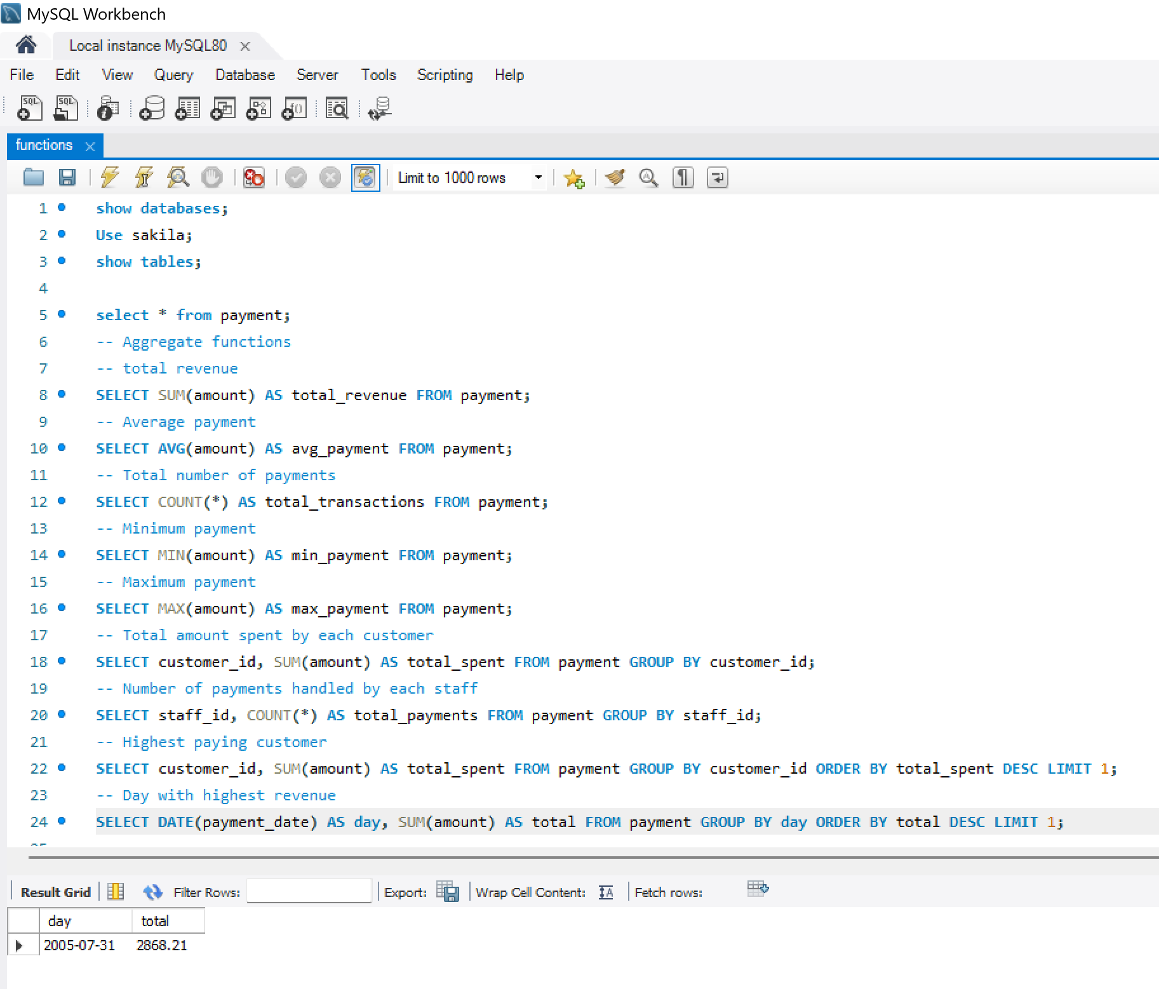
String functions – Work on text
Length, Concat, Upper, Lower, Initcap, Substring, Trim, Ltrim, Rtrim, Reverse, Padding, Rpad, Lpad, Replace, Ascii, Position/Instr, left, right, char_length, format, concat_ws, find_in_set, lcase, locate, mid, repeat, space, strcmp
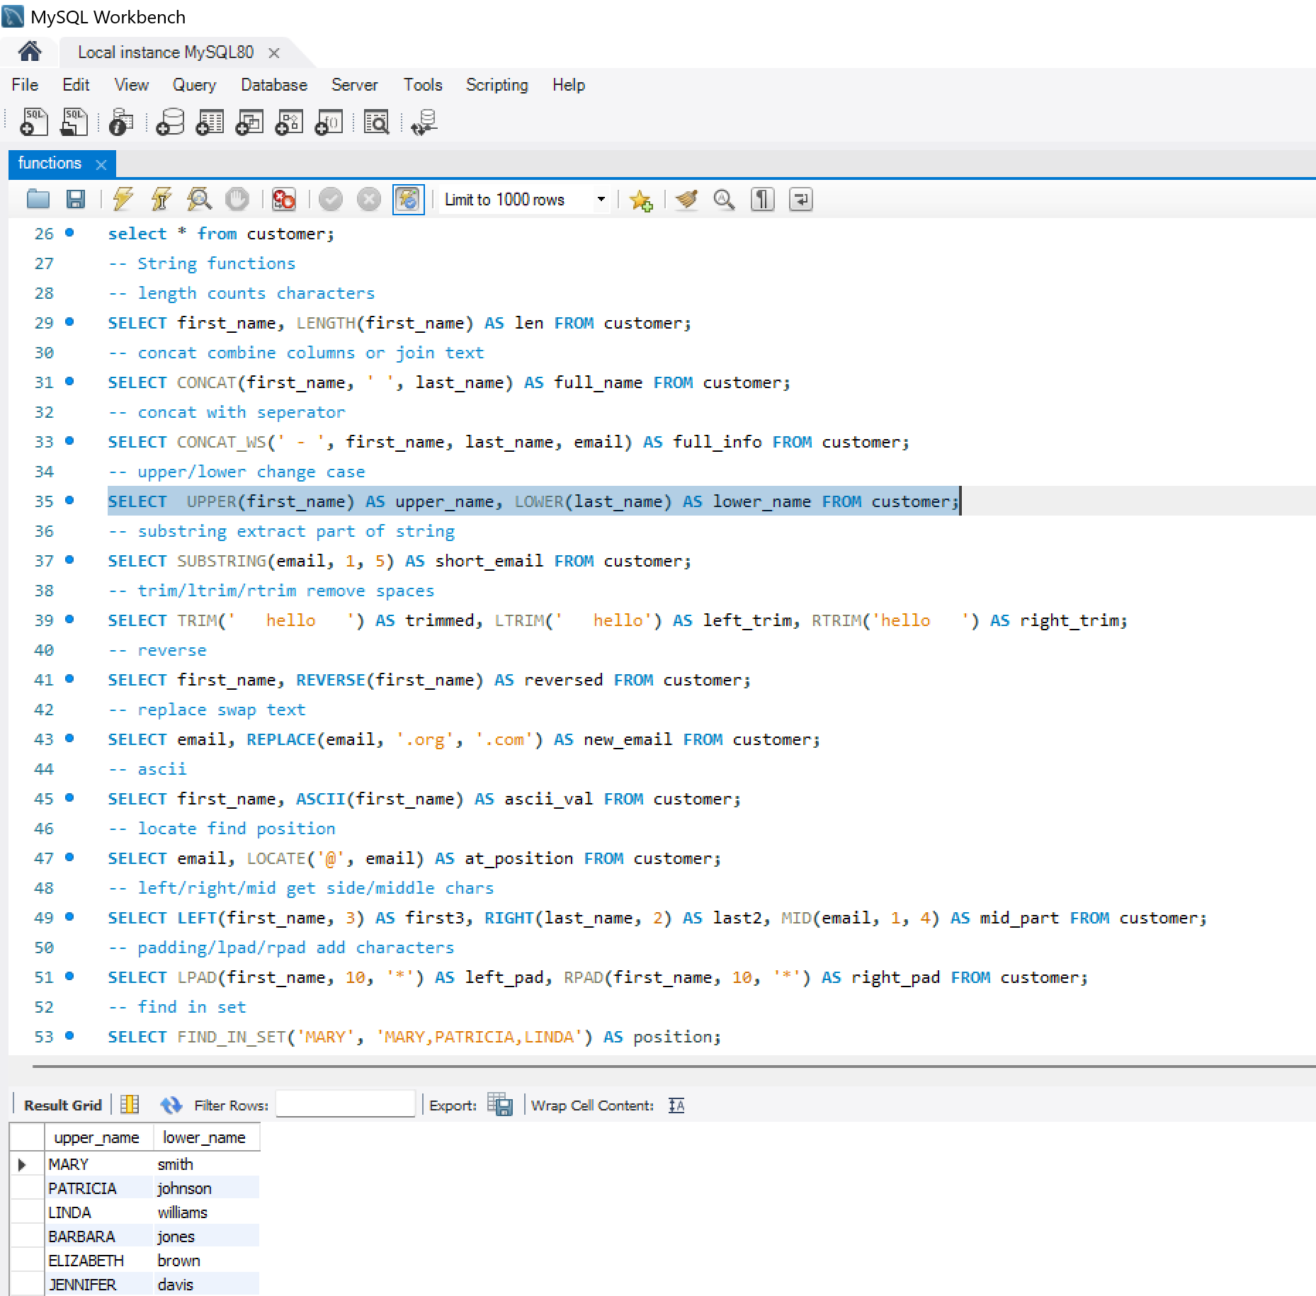
SELECT email, SUBSTRING(email, LOCATE(‘@’, email) +1) AS domain FROM sakila.customer;
SELECT email, substring(SUBSTRING(email, LOCATE(‘@’, email) +1), ‘.’, -1) AS domain FROM sakila.customer;
SELECT email, substring(SUBSTRING(email, LOCATE(‘@’, email) +1), ‘.’, +1) AS domain FROM sakila.customer;
Select title, upper(title), lower(title) from sakila.film where upper(title) like %LOVELY%’ or upper(title) LIKE %MAN’
Math/ Numeric functions – Work on numbers
Power of (^) or POWER, sqrt, COUNT, SUM, AVG or SUM/COUNT, DECIMAL, Rand, round, FLOOR, Ceil, MOD, ABS, Truncate, Log, Exp, Sign, Log, Min, Max, pi, greatest, least
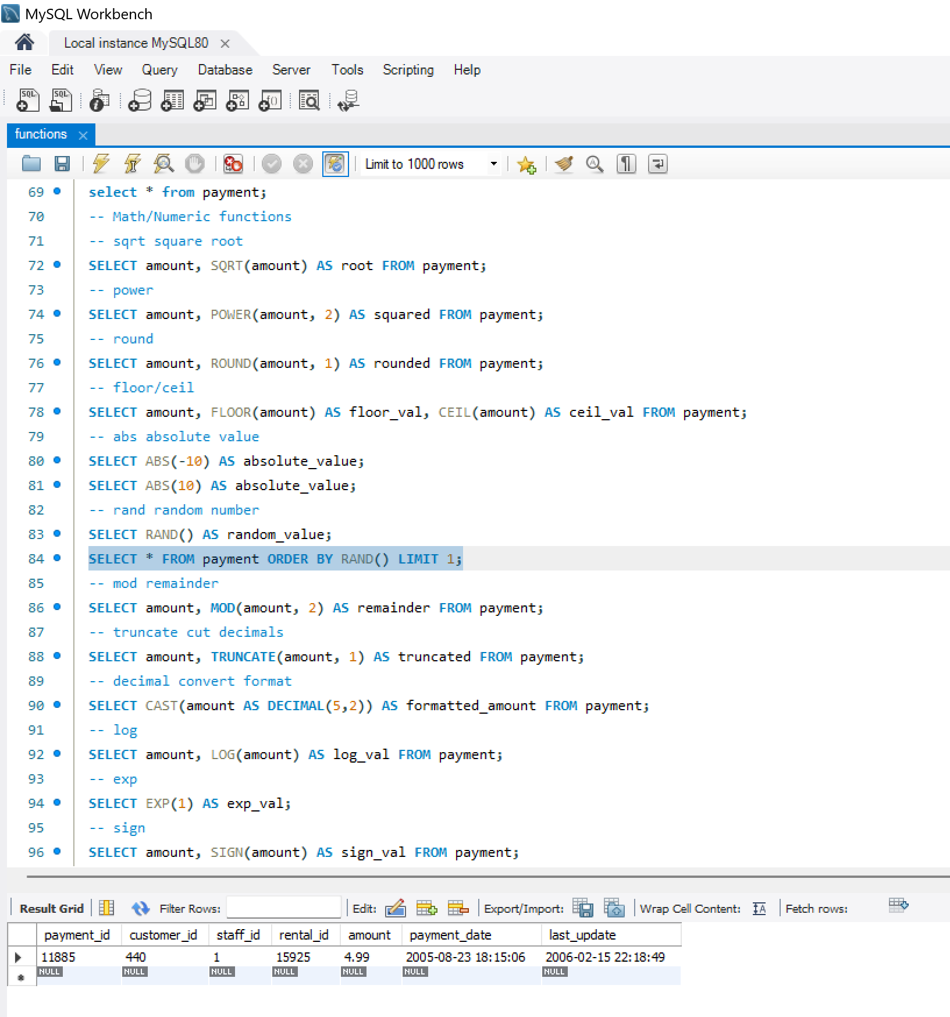
Date & Time functions – Work with dates and time
Year, Month, Dayofweek, Date, time, Now, Curdate, Curtime, Getdate, Sysdatetime, Datename, Datediff, extract, date_add, date_sub, date_format, adddate, addtime, timestamp, isdate
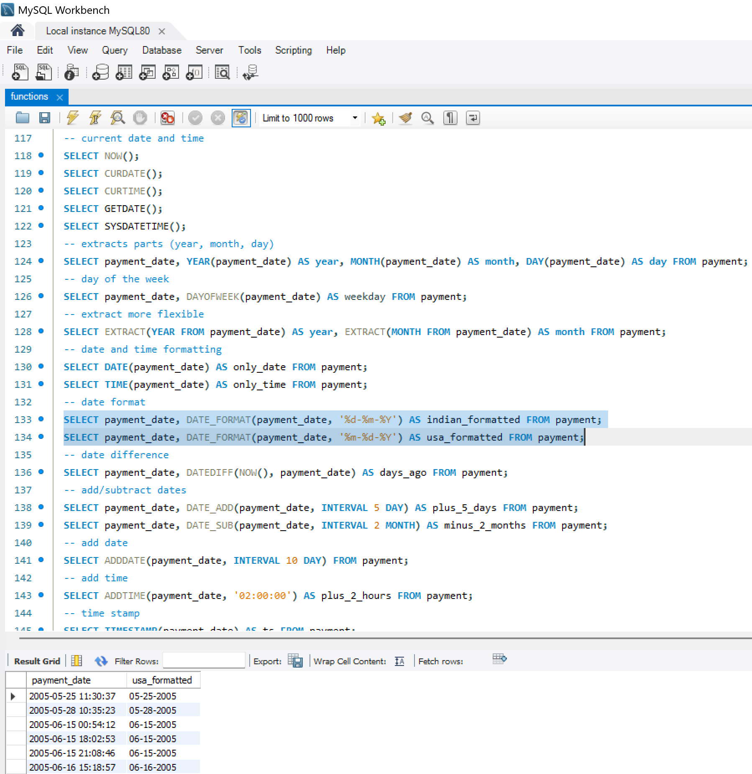
Conditional functions – Apply logic (like IF/CASE)
Case when then end
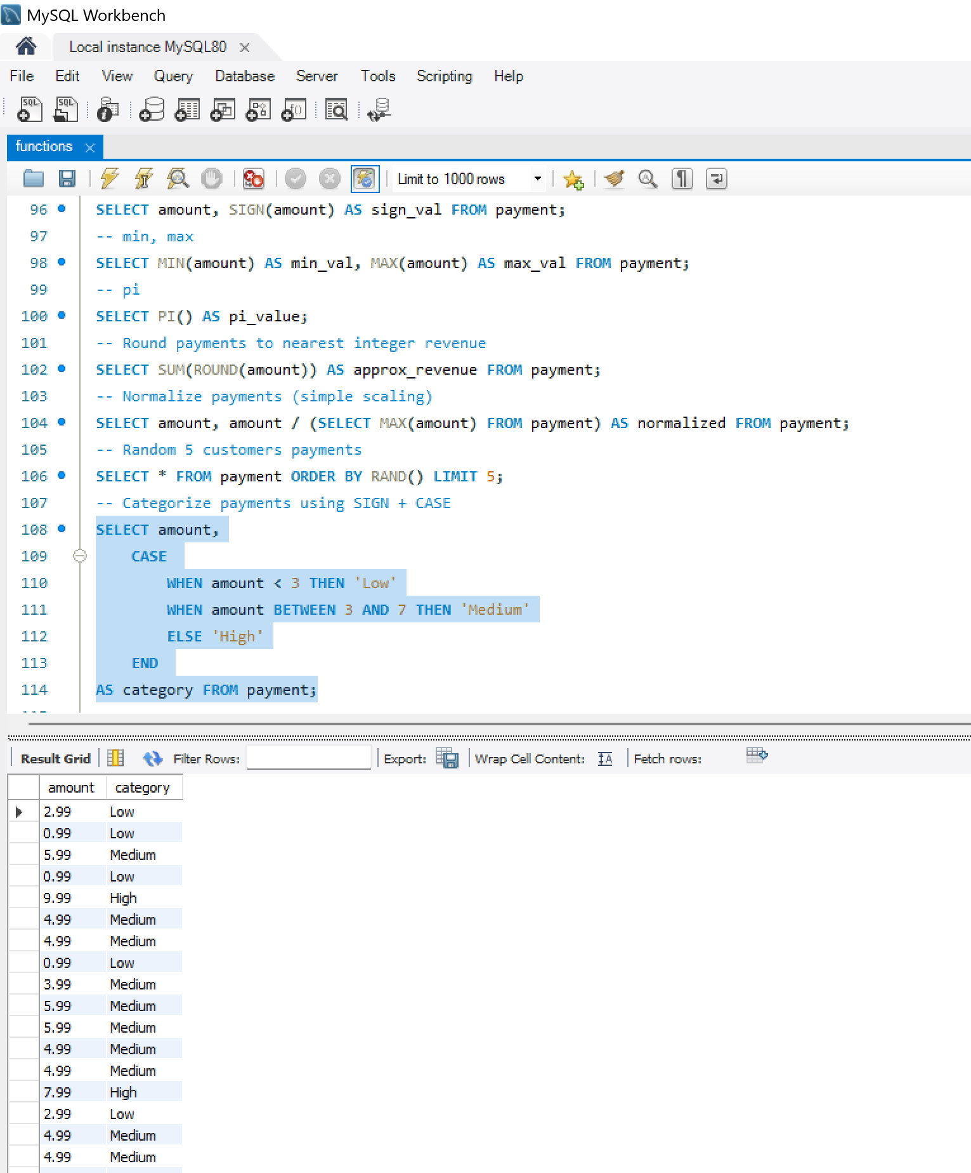
Not Regexp last name not contains 3 consecutive vowels [^aeiouAEIOU]{3}
Regexp last name ends with vowels [aeiouAEIOU]$
