Max-cut problem with pure genetic algorithm

|  |  |  |  |  |  |  |
| --- | --- | --- | --- | --- | --- | --- |
| 수하루 | | | | | | |
|  | 2021-11111 | 2021-11112 | 2021-11113 | 2021-11114 | 2021-11115 |  |
|  | 김서아 | 김이서 | 김지안 | 김하윤 | 김지아 |  |

# 대제목1

내용을 쓰세요.

# 대제목2

## 소제목1

내용을 쓰세요.

## 소제목2

내용을 쓰세요.

Table 3: Comparison between samples.

|  |  |
| --- | --- |
| Sample | Height (cm) |
| Plant one | 50 |
| Plant two | 58 |

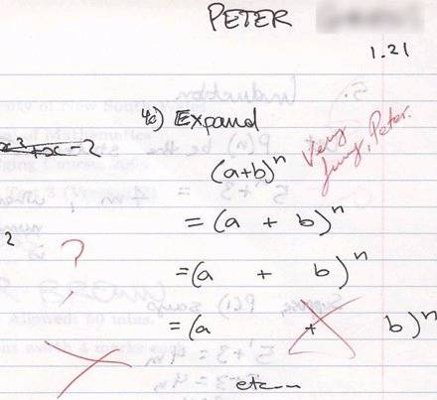

Figure 1: An unusual answer to a question.

REFERENCES

Banks, J., J. S. Carson, B. L. Nelson, and D. M. Nicol. 2000. *Discrete-Event System Simulation*. 3rd ed. Upper Saddle River, New Jersey: Prentice-Hall, Inc.

Cheng, R. C. H. 1994. “Selecting Input Models”. In *Proceedings of the 1994 Winter Simulation Conference*, edited by J. D. Tew, M. Manivannan, D. A. Sadowski, and A. F. Seila, 184–191. Piscataway, New Jersey: Institute of Electrical and Electronics Engineers, Inc.

Chien, C. 1989. “Small Sample Theory for Steady State Confidence Intervals”. Technical Report No. 37, Department of Operations Research, Stanford University, Stanford, California.

Gupta, S. S., K. Nagel, and S. Panchapakesan. 1973. “On the Order Statistics from Equally Correlated Normal Random Variables”. *Biometrika* 60(2):403–413.

Hammersley, J. M., and D. C. Handscomb. 1964. *Monte Carlo Methods*. London: Methuen.

Law, A. M., and W. D. Kelton. 2000. *Simulation Modeling & Analysis.* 3rd ed. New York: McGraw-Hill, Inc.

Powell, J. H., and N. Mustafee. 2017. “Widening Requirements Capture with Soft Methods: An Investigation of Hybrid M&S Studies in Healthcare”. *Journal of the Operational Research Society* 68(10):1211-1222.

Rabe, M., F. Dross, and A. Wuttke. 2017. “Combining a Discrete-event Simulation Model of a Logistics Network with Deep Reinforcement Learning”. In *Proceedings of the MIC and MAEB 2017 Conferences*, July 4th-7th, Barcelona, Spain, 765-774.

Schruben, L. W. 1979. “Designing Correlation Induction Strategies for Simulation Experiments”. In *Current Issues in Computer Simulation*, edited by N. R. Adam and A. Dogramaci, 235–256. New York: Academic Press.

Sharon Parq Associates. 2018. WordTips: Numbering Equations. <http://word.tips.net/Pages/T000273_Numbering_Equations.html>, accessed 15th April.

Steiger, N. M. 1999. *Improved Batching for Confidence Interval Construction in Steady-State Simulation*. Ph.D. thesis, Department of Industrial Engineering, North Carolina State University, Raleigh, North Carolina. <http://www.lib.ncsu.edu/resolver/1840.16/4713>, accessed 12th February 2019.

The University of Chicago Press 2010. *The Chicago Manual of Style*. 16th ed. Chicago: The University of Chicago Press. <http://www.chicagomanualofstyle.org>.

WSC 2023. “Winter Simulation Conference”. Accessed 12nd January 2023.