Register.test.js:
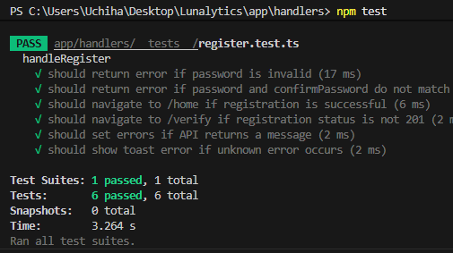
Login.test.js:
Monitor.test.js:
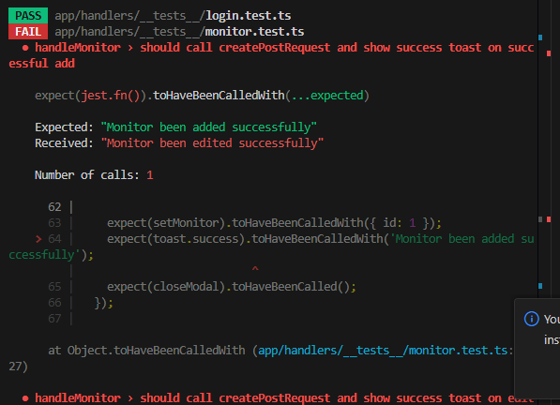
monitor failed because of toast.success(`Monitor been ${isEdit ? 'added' : 'edited'} successfully`);
setup.test.ts:
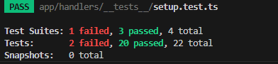
DATABASE:
certificate.js:
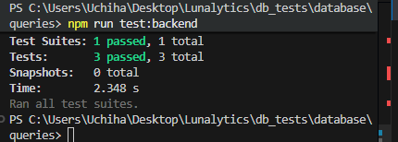
Connection.test.js:
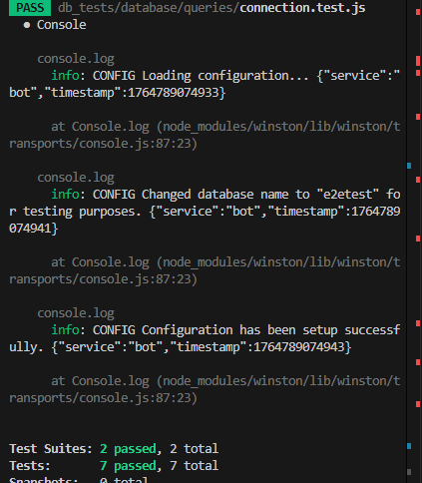
Heartbeat.test.js:
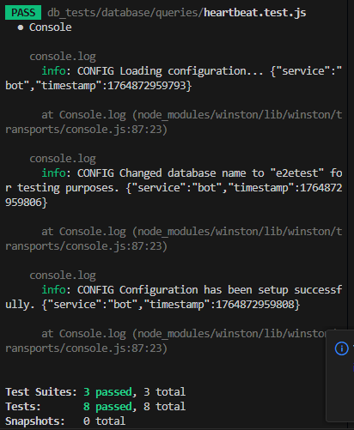
Incident.test.js:
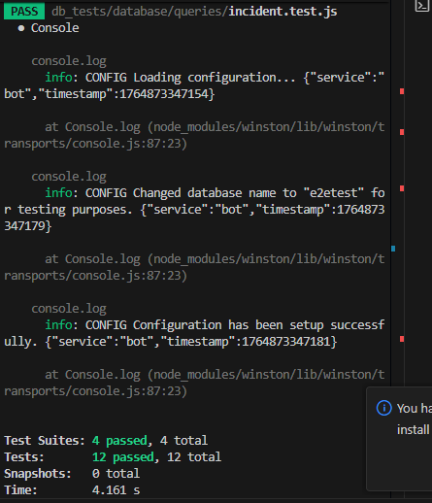
Invite.test.js:
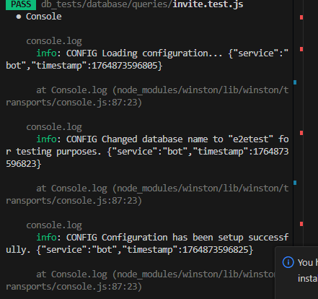
Monitor.test.js:
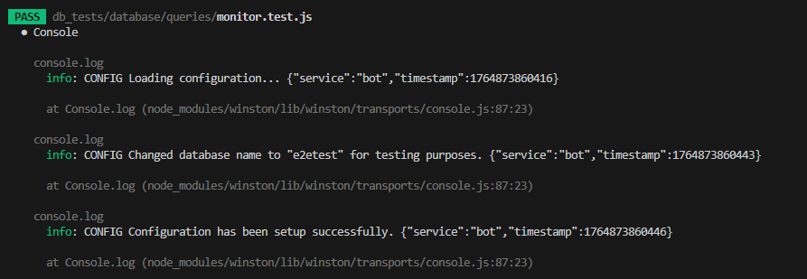
Notification.test.js:
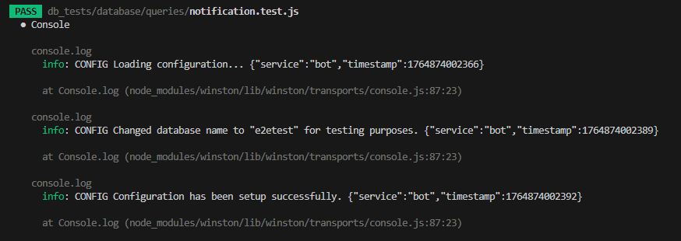
Provider.test.js:
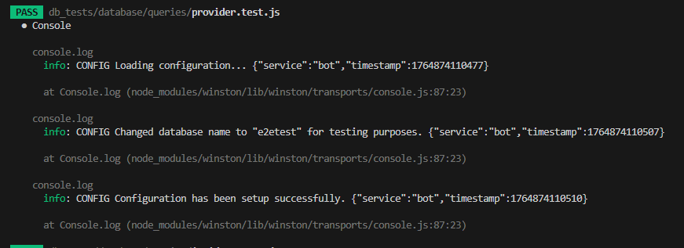
Session.test.js:
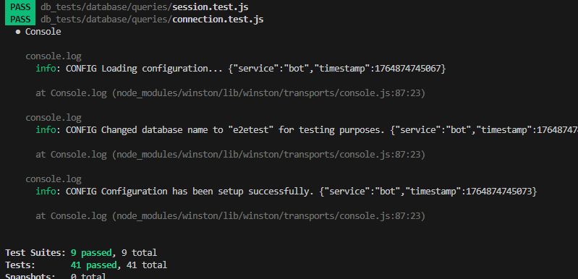
Status.test.js:
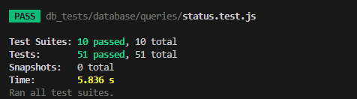
Tokens.test.js:
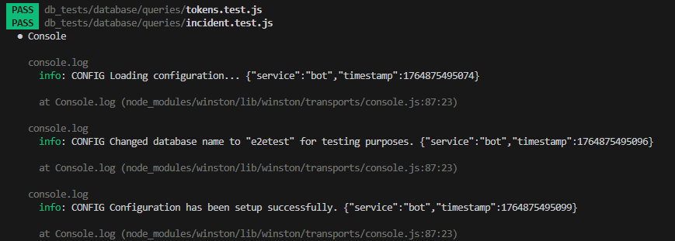
User.test.js
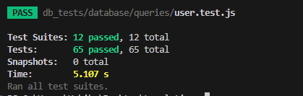

server\notifications\__tests__\apprise.test.js
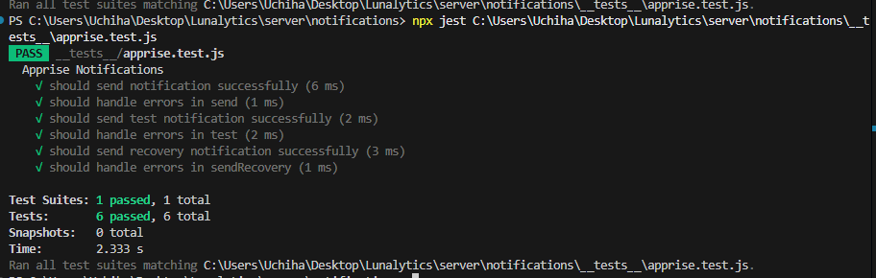
server\notifications\__tests__\base.test.js
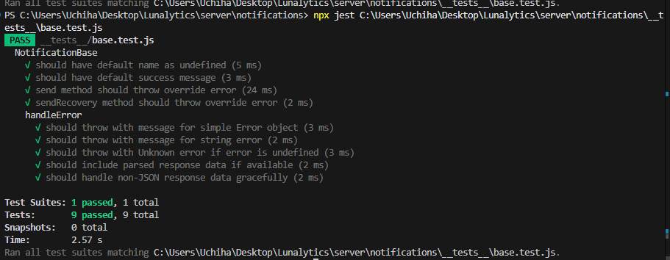
\server\notifications\__tests__\discord.test.js:
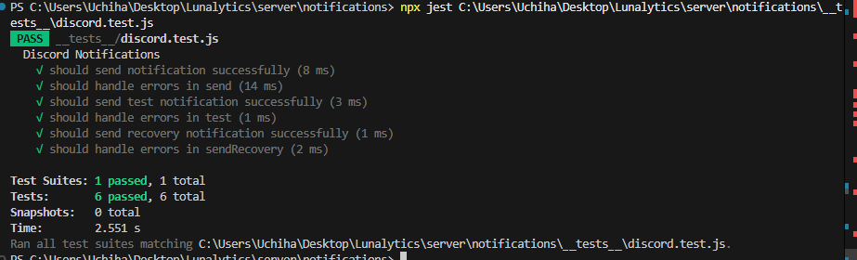
server\notifications\__tests__\email.test.js:
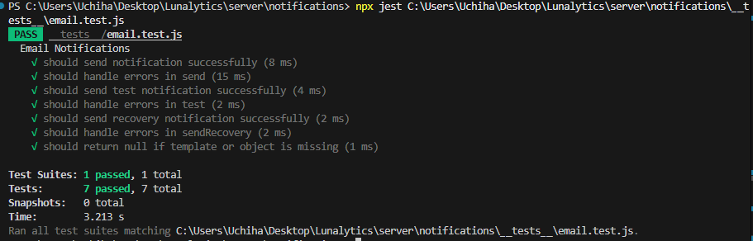
server\notifications\__tests__\index.test.js:
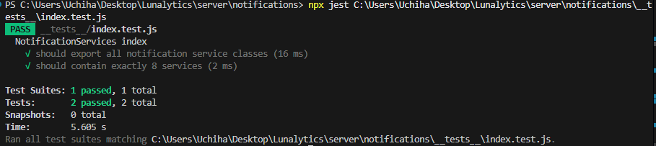
server\notifications\__tests__\pushover.test.js:
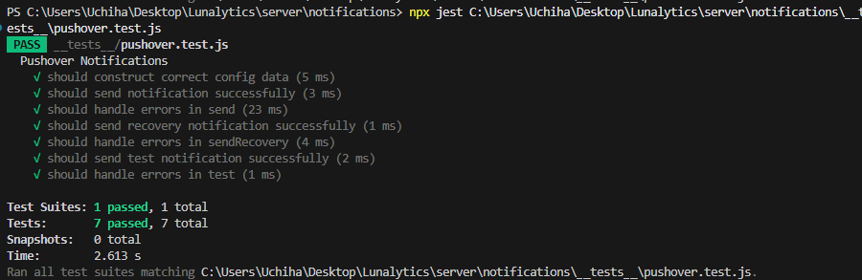
server\notifications\__tests__\slack.test.js:
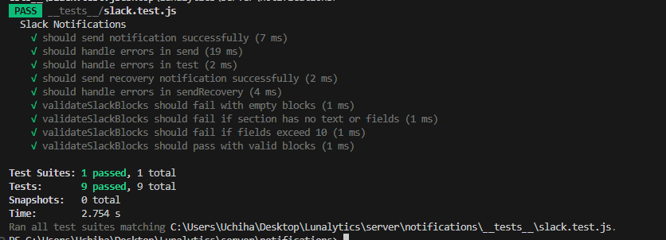
server\notifications\__tests__\telegram.test.js:
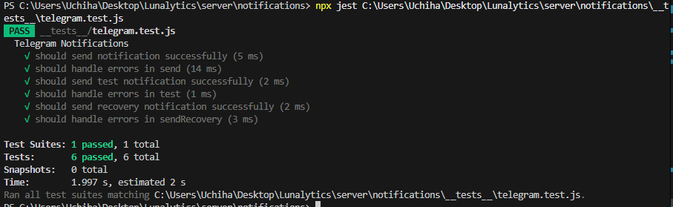
server\notifications\__tests__\webhook.test.js:
