**ENHANCING PREDICTIVE MAINTENANCE IN MANUFACTURING INDUSTRIAL MACHINES USING MACHINE LEARNING ALGORITHMS AND IOT DATA**

**Table of Contents**

Chapter 1: Introduction 4

1.1 Research Background 4

1.2 Aims 4

1.3 Objectives 4

1.4 Research Questions 5

1.5 Research Rationale 5

1.6 Research Gap 5

1.7 Research Structure 6

1.8 Summary 6

Chapter 2: Literature Review 7

2.1 Introduction 7

2.2 Machine Learning Algorithms for Predictive Maintenance 8

2.3 IoT Data Acquisition and Processing 9

2.4 Real-Time Implementation and Decision Support 11

2.5 Challenges and Future Directions 12

2.6 Literature Gap 13

2.7 Conceptual Framework 13

2.8 Summary 14

Chapter 3: Methodology 14

3.1 Introduction 14

3.2 Research Onion 15

3.3 Research Philosophy 16

3.4 Data Collection 16

3.5 Data Preprocessing 16

3.6 Data Analysis 17

3.7 Ethical Consideration 18

3.8 Chapter Summary 19

Chapter 4: Result 19

Data Collection 19

Data preprocessing 20

Data analysis 22

ML model evaluation 27

Summary 32

Chapter 5: Discussion 32

Chapter 6: Conclusion 35

6.1 Linking with the objectives 35

Conclusion 36

Future Scope 37

References 39

# Chapter 1: Introduction

## 1.1 Research background

Due to the Internet of Things (IoT) and cutting-edge machine learning algorithms, the manufacturing sector is undergoing a paradigm change towards more effective and economical operations. A key tactic to reduce unscheduled downtime and improve machinery performance is predictive maintenance. Scheduled or reactive maintenance are two examples of traditional maintenance techniques that are frequently ineffective, impede production, and increase costs. Real-time data is collected from industrial machinery by IoT-enabled sensors, who record data on a variety of factors including temperature, vibration, pressure, and operational cycles. Predictive maintenance models are built on top of this abundance of data (Calabrese *et al.* 2020). These statistics can be analysed to find patterns and forecast possible equipment failures using machine learning methods like neural networks, decision trees, and support vector machines. These algorithms enable maintenance teams to predict and address issues before they escalate, saving downtime, optimising maintenance schedules, and prolonging the lifespan of machinery components. These teams achieve this by recognising small anomalies and departures from normal operating circumstances. This work aims to construct precise and resilient predictive models that offer maintenance employees useful insights by utilising the power of real-time data analysis. At the end of the day, IoT and machine learning integration have the potential to revolutionise maintenance procedures, increasing operational effectiveness, lowering costs, and boosting overall productivity in manufacturing sectors.

## 1.2 Aims

This research study aims to improve predictive maintenance for manufacturing industrial machines by approaching some machine learning algorithms to distinguish between machines that are likely to fail and those that are not.

## 1.3 Objectives

* To implement various machine learning algorithms for differentiating potential machine failures with accuracy assessment.
* To conduct bivariate and univariate analyses to identify key factors contributing to machine failures.
* To evaluate machine learning models using performance metrics such as accuracy, F1 score, recall, and precision.
* To increase predictive maintenance by leveraging data-driven insights for informed decision-making in manufacturing.

## 1.4 Research Questions

Q1. How to implement various machine learning algorithms for differentiating potential machine failures with accuracy assessment?

Q2. How to conduct bivariate and univariate analyses to identify key factors contributing to machine failures?

Q3. How to evaluate machine learning models using performance metrics such as accuracy, F1 score, recall, and precision?

Q4. How to evaluate machine learning models using performance metrics such as accuracy, F1 score, recall, and precision?

## 1.5 Research Rationale

The urgent need to address inefficiencies and challenges in the traditional maintenance practises widely used in the manufacturing sector serves as the justification for conducting research on enhancing predictive maintenance in manufacturing industrial machines using IoT data and machine learning algorithms. Current methods, including scheduled maintenance, frequently result in production halts, longer downtime, and extra expenses (Calabrese *et al.* 2020). On the other hand, the fusion of IoT technology and cutting-edge machine learning algorithms presents a revolutionary chance to overhaul maintenance tactics. IoT sensors' massive data production offers a rare chance to track industrial machinery in real-time and learn about their operational condition. Machine learning algorithms can use this data to find patterns and anomalies that might point to upcoming problems or subpar performance. This preventative approach to maintenance can increase machinery uptime, decrease unscheduled downtime, and boost overall production efficiency. Furthermore, the relevance of data-driven decision-making and automation in production is highlighted by the global trend towards industry. In addition to addressing a current operational issue, this research also fits with more general industry trends. The implementation of predictive maintenance methods powered by IoT and machine learning becomes a strategic need as manufacturers work to increase their competitiveness.

## 1.6 Research Gap

Despite the manufacturing sector's increasing use of predictive maintenance methods through the combination of IoT data and machine learning algorithms, there are still a number of significant research gaps that demand investigation. First off, despite the fact that numerous studies concentrate on specific aspects of predictive maintenance, there is a dearth of thorough research that holistically examines the fusion of various data sources from IoT sensors, such as temperature, vibration, and operational cycles, in order to produce more precise and reliable predictive models. The intricate interactions between these factors and their overall effects on machinery health are frequently ignored in current studies. Furthermore, in-depth analyses of the scalability and real-world application of established models are frequently absent from the literature. There is a lack of real-world application and performance evaluation of research in various production settings because they are often carried out in controlled contexts. This makes it more difficult to verify their performance in various industrial machine types and production scenarios. Finally, despite the widespread use of machine learning algorithms, the best algorithms for different industrial machine types and data patterns are not universally agreed upon. There is a lack of research comparing the effectiveness of various algorithms in terms of accuracy, efficiency, and adaptability, which makes it difficult to determine which techniques are most appropriate for particular predictive maintenance scenarios.

## 1.7 Research Structure

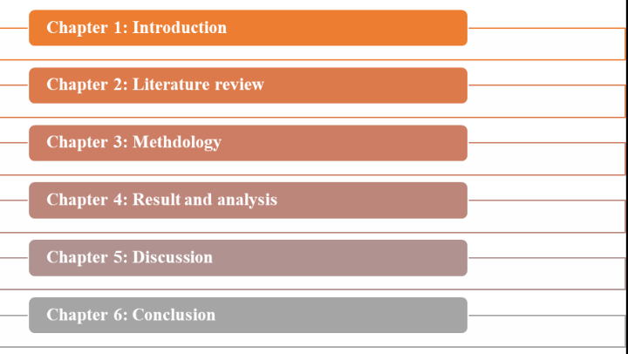

**Figure 1: Research Structure**

(Source: Self-Developed)

## 1.8 Summary

The manufacturing industry is undergoing a transformation towards more effective and efficient operations because of the integration of Internet of Things (IoT) technologies and cutting-edge machine learning algorithms. A crucial tactic to reduce unplanned downtime and improve machinery performance is predictive maintenance. Scheduled or reactive maintenance techniques, which are common in the industry, can slow down output and raise expenses. Industrial machinery's operational cycles, temperature, vibration, and pressure are all recorded in real-time via IoT-enabled sensors. Using methods like neural networks, decision trees, and support vector machines, predictive maintenance models make use of this data to foresee equipment faults. With this proactive approach, maintenance staff may anticipate problems and resolve them before they become more serious, reducing downtime, improving scheduling, and lengthening the lifespan of equipment. The goal of the project is to build reliable predictive models by utilising real-time data analysis to give maintenance staff insightful Implementing various machine learning methods for failure discrimination, conducting analyses to pinpoint failure-causing elements, and assessing model performance using metrics like accuracy and precision are all part of the study's objectives. This work is in line with the pressing need to use IoT and machine learning to improve current production maintenance practices. Combining these technologies offers the chance to transform maintenance practices, improve operational effectiveness, cut costs, and boost overall productivity.

# Chapter 2: Literature Review

## 2.1 Introduction

Manufacturing has been at the vanguard of this transition as a result of the confluence of machine learning (ML) algorithms and the internet of things (IoT) technology. Predictive maintenance in industrial machinery is one of the primary areas that gains from this synergy. Traditional maintenance methods sometimes rely on set timetables or reactive methods, which results in inefficiency, unanticipated downtime, and higher operational expenses. On the other hand, combining ML methods with data from IoT devices enables a paradigm shift in how maintenance is addressed.

This literature review explores the emerging subject of ML algorithms and IoT data integration for improving predictive maintenance in manufacturing industrial machinery. It investigates the methodology, tactics, and case studies that have been effective in maximising maintenance strategies as it examines the junction of these two fields. Manufacturers can switch from a one-size-fits-all maintenance paradigm to a predictive and proactive one by utilising real-time data from IoT sensors and applying sophisticated ML algorithms. This change promises to reduce unnecessary downtime, increase equipment longevity, and improve resource allocation. This study seeks to offer a thorough overview of the state-of-the-art approaches, difficulties, and prospects within this domain through an analysis of the existing literature. The many ML algorithms used, including anomaly detection, machine learning regression, and deep learning, are highlighted, along with how they might be used to anticipate equipment failures.

## 2.2 Machine Learning Algorithms for Predictive Maintenance

In order to improve predictive maintenance plans for manufacturing industrial machines, machine learning algorithms are essential. By predicting equipment breakdowns and maintenance requirements using past data, these algorithms reduce downtime and maximise resource allocation The Random Forest classifier, for instance, is a frequently used algorithm that may spot trends in past failure data to foretell prospective equipment failures (Teoh *et al.* 2021). A manufacturing facility used a Random Forest model, for instance, to foretell upcoming motor failures in conveyor systems. The model accurately identified anomalies by examining prior sensor data, alerted maintenance staff in advance, allowing for prompt interventions, and avoided production halts.

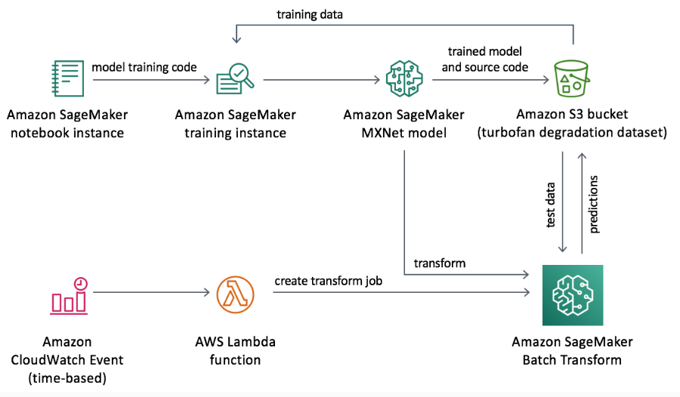

**Figure 1: Predictive Maintenance Using Machine Learning**

(Source: Teoh et al. 2021)

Contrary, Random Forest and other ensemble approaches can have limited interpretability even though they excel at managing complicated information. For subject specialists, it may be difficult to comprehend how these algorithms make decisions. Additionally, due to the linear structure of classic algorithms like Support Vector Machines (SVMs), certain highly specialised machines may find it difficult to capture complicated patterns In an environment of precise manufacturing, think of a specialised CNC milling machine. Because of the possibility of nonlinear interactions between numerous sensor values, SVMs may have trouble reliably predicting failures. Convolutional neural networks (CNNs), for example, are deep learning models that may be better able to capture complex sensor interactions under these circumstances. However, the use of deep learning models like CNNs necessitates a significant investment in data and computing power. Simpler methods like logistic regression or k-nearest neighbours (k-NN) can provide more practical solutions for predictive maintenance for small to medium-sized manufacturers with limited data availability or processing capability. Machine learning algorithms provide a wide range of maintenance planning tools for producing industrial machinery. The choice of algorithm should take into account the complexity of the machinery, the availability of data, and the interpretability requirements of the maintenance teams, even though advanced algorithms like Random Forests and deep learning models offer accuracy and precision.

## 2.3 IoT Data Acquisition and Processing

Enhancing predictive maintenance in manufacturing industrial machines requires the collection and processing of Internet of Things (IoT) data. IoT sensors gather a wide range of data, such as temperature, vibration, pressure, and operational metrics, which offer important information on the performance and health of the equipment. Temperature sensors placed in essential furnace parts continuously track heat levels in a steel manufacturing facility. A central database receives real-time data from these sensors. Maintenance personnel can identify temperature anomalies that might point to impending equipment breakdowns by tracking this data over time. These preventative insights allow for prompt maintenance interventions, avoiding pricey breakdowns and productivity delays.

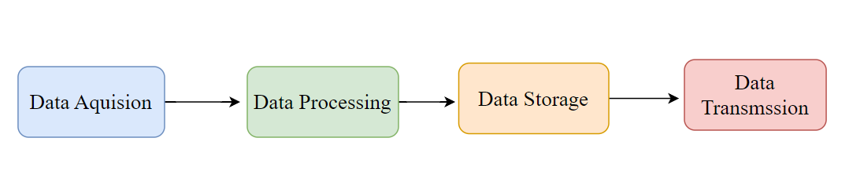

**Figure 2: Data Acquisition process**

(Source: Self-Developed)

However, the sheer amount and speed of IoT data can pose difficulties for processing and storage. It may be challenging for large-scale production facilities with numerous sensors to adequately manage and analyse high-frequency data streams. The influx of data may be too much for conventional data processing tools and methods to manage in real time. Think of a car assembly line where thousands of sensors track the position of robotic arms, the alignment of parts, and the quality of the paint. It becomes resource-intensive to process this massive amount of data in real time to look for anomalies. Data gathering and analysis delays can lead to missed opportunities for prompt maintenance.

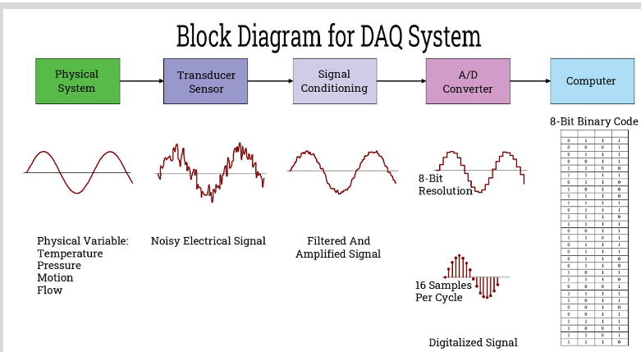

**Figure 3: Block Diagram for Data Acquisition process**

Edge computing has come to light as a potential remedy to these issues. IoT data can be preprocessed and filtered by edge devices located closer to the data source before being transmitted solely to the relevant information to the central processing units. Due to the limited processing resources at the edge, relying only on edge computing could limit the scope of the research. In conclusion, IoT data processing and collection are essential to manufacturing predictive maintenance plans. Despite the fact that IoT sensors offer priceless insights, maintaining and analysing the enormous and dynamic data streams can be a difficult challenge.

## 2.4 Real-Time Implementation and Decision Support

Real-time use of preventative maintenance techniques and efficient decision support systems are essential for achieving concrete advantages in the production of industrial machinery. Predictive model integration improves maintenance schedules and enables proactive maintenance actions, reducing unscheduled downtime. Real-time predictive maintenance was included into a centrifugal pump's control system in a facility that processes chemicals. The system informed operators and started a maintenance request as the pump's performance varied from normal. Through streamlining the process, potential equipment failure was avoided, ensuring continuous output and obviating the need for costly repairs.

However, predictive model integration into real-time processes can be challenging. Implementation delays could result from incompatibility between new predictive maintenance software and existing industrial systems. Additionally, the implementation of predictive maintenance may necessitate extensive training for staff, upending current procedures and sometimes inspiring opposition to change. Think of a factory with outdated equipment. It may be technically difficult and expensive to retrofit these devices with IoT sensors and real-time predictive maintenance capabilities. Finding a balance between retrofitting costs and anticipated benefits becomes crucial in such circumstances. Additionally, even if real-time predictive insights are useful, the decision-making process must be well-structured to prevent inundating maintenance personnel with alerts. Maintenance staff may have trouble prioritising work without efficient decision support systems, which could result in inefficiencies and missed possibilities for prompt intervention. A large-scale manufacturing line included a decision support dashboard that divided alerts into categories according to their urgency and impact to address this. As a result, maintenance crews might concentrate on urgent problems while planning routine repair for less important ones. This method improved resource allocation and allowed for more informed decision-making. Overall, the integration of models into current processes and the provision of efficient decision support tools are crucial for the successful real-time deployment of predictive maintenance.

## 2.5 Challenges and Future Directions

Using machine learning algorithms and IoT data to perform predictive maintenance techniques for manufacturing industrial machinery poses both difficulties and intriguing future directions. These difficulties highlight how difficult it is to connect theory with actual implementation in dynamic production contexts. Data privacy and security are one major issue. IoT data can provide insights, but the gathering and transmission of private operational data raises questions about potential security breaches or unauthorised access. Finding a balance between securing confidential information and data accessibility for predictive models becomes crucial.

Consider a pharmaceutical manufacturing plant where unique equipment details and formulas are used. Implementing predictive maintenance with IoT data sharing may unintentionally reveal private information to rivals. Maintaining a competitive edge requires striking a balance between data security and predictive insights. Additionally, interpretability decreases as machine learning models become more complicated. Deep neural networks and other complex models may make accurate predictions, but their opaque decision-making makes it difficult for maintenance teams to comprehend and accept the recommendations.

A neural network accurately predicted engine component failures in an aircraft production environment. Engineers, however, found it difficult to understand why specific components were identified because of the intricacy of the model. In this context, engineers were less confident in the predictions as a result, which prevented them from acting quickly. Predictive maintenance has a bright future despite these difficulties. In the future, edge computing might be used to process data closer to its source, lowering latency and enabling real-time decision-making without taxing central systems. In a smart factory, edge devices on equipment for the assembly line might examine sensor data and anticipate abnormalities. As a result, there would be less need for constant data transmission to a central server, which would lighten the stress on the network and speed up response times. Furthermore, overcoming the interpretability problem depends on the development of explainable AI. Building strategies that reveal how complex models generate predictions might improve communication among maintenance teams and enable better decision-making.

## 2.6 Literature Gap

Although there has been significant development in using machine learning (ML) algorithms and Internet of Things (IoT) data for preventative maintenance in the production of industrial machinery, there are still some significant gaps in the literature. The fusion of many data streams is one of these gaps. There has been little investigation into the combined potential of other data types like operations logs, maintenance records, and external influences, despite the fact that current research frequently concentrates on using IoT sensor data. Innovative methods that can efficiently process and combine these disparate data sources are needed to close this gap

Additionally, the majority of the literature now in circulation assumes steady operational conditions, ignoring the dynamic character of production processes. As a result, there is a gap in how well predictive models can be adjusted to different operational situations. Predictive models must be flexible enough to adapt to changing conditions in order to avoid making incorrect forecasts or missing maintenance opportunities. This is because real-world manufacturing environments frequently encounter changes in output demand, usage patterns, and equipment performance. The long-term deterioration and anomaly detection in machinery is another unexplored topic. Although short-term failure prediction has received a lot of attention, gradual performance abnormalities and long-term degradation patterns have not been adequately addressed in the literature. By enabling interventions prior to the emergence of critical problems, detecting and forecasting these minor variations in equipment behaviour can considerably improve maintenance procedures. Additionally, there is still a clear disconnect between building accurate models and actually using them in real-time decision-making processes. While studies frequently concentrate on model accuracy, not enough emphasis has been paid to how seamlessly predictive maintenance models may be incorporated into current industrial operations. In order to effectively reduce downtime and increase overall operational efficiency, this integration is necessary in order to convert predicted information into actions that can be taken.

## 2.7 Conceptual Framework

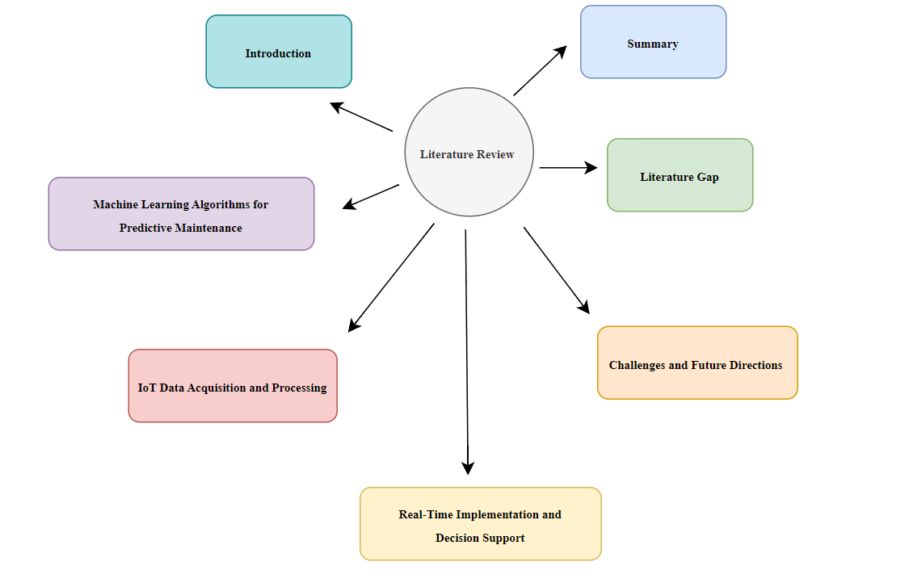

**Figure 4: Conceptual Framework**

(Source: Self-Developed)

## 2.8 Summary

In conclusion, predictive maintenance for manufacturing industrial machinery has undergone radical transformation as a result of the integration of machine learning algorithms and IoT data. This literature study examined the connections between these fields, demonstrating how they could transform maintenance procedures. Although machine learning algorithms allow for precise predictions, issues like data security, complexity, and real-time implementation continue to be problems. Successful uses were demonstrated by examples, while potential hazards were highlighted by conflicting scenarios. Critical topics include closing gaps in data integration, flexibility, long-term anomaly detection, and decision support systems. Despite obstacles, the review recognised intriguing future directions, such as explainable AI and edge computing. The fusion of machine learning and IoT remains a dynamic approach for optimising maintenance methods and reducing operating costs as production settings change.

# Chapter 3: Methodology

## 3.1 Introduction

This study's methodology chapter focuses on the strategic strategy used to improve predictive maintenance in manufacturing industrial machinery by combining Internet of Things (IoT) data with machine learning algorithms in a beneficial way. The methodical methodology outlined in this chapter is intended to maximise operational effectiveness, minimise downtime, and perform proactive maintenance by using the power of data-driven insights. The use of machine learning algorithms makes it possible to extract useful patterns and trends from big datasets, aiding in the development of precise prediction models. IoT devices simultaneously give real-time data streams that offer priceless insights into the operation and behaviour of machines (Bouabdallaoui *et al.* 2021). The chapter goes into detail on how to choose and use appropriate algorithms, including as regression, classification, and anomaly detection, to meet the particular requirements of predictive maintenance. The approach further clarifies the data gathering procedure, with special emphasis on sensor placement, data aggregation, and data preparation methods. Manufacturers can predict possible equipment breakdowns, plan maintenance tasks, and optimise resource allocation by fusing machine learning insights with the constant stream of IoT data. This chapter acts as a manual for the thorough methodology that promotes the convergence of machine learning and IoT, eventually revolutionising the approach to maintenance practices in the industrial business.

## 3.2 Research Onion

The study is on improving predictive maintenance in manufacturing industrial equipment using machine learning algorithms and IoT data, and the research onion acts as a multi-layered framework that directs the study's methodical design and execution. The inner layers focus on particular procedures, data analysis, and interpretation while the outer layers reflect the overall philosophical position, research strategy, and data gathering approaches. The epistemological and ontological views of the researcher are established at the philosophy layer, which shapes the general course of the study. According on the research goals, the research strategy layer defines whether the study would be qualitative, quantitative, or mixed-methods. Methods for gathering data include techniques like surveys, interviews, and acquiring sensor data from commercial machinery. The layers that make up a predictive model address data analysis methods, such as statistics and machine learning algorithms, as we proceed inside (Bouabdallaoui et al. 2021). Data interpretation, or the centre of the onion, includes the synthesis of findings and the development of new insights. The research onion ensures a structured and thorough approach, enabling a rigorous exploration of the subject's complexities and facilitating the development of insightful conclusions regarding predictive maintenance enhancement in manufacturing through the fusion of machine learning and IoT data.

## 3.3 Research Philosophy

The interpretivism research ethos is embraced in the context of this study, which is focused on enhancing predictive maintenance in manufacturing industrial machinery utilising machine learning algorithms and IoT data. This philosophical perspective emphasises the significance of comprehending the many contextual details that create such experiences while acknowledging the subjective character of human experiences (Karuppusamy, 2020). The goal of the project is to investigate how machine data and IoT insights might be usefully incorporated to improve maintenance practices. Interpretivism is in line with this goal. By adopting interpretivism, the research acknowledges that people's opinions, including those of engineers, operators, and maintenance staff, have a significant impact on how technology is used to optimise maintenance. This concept provides a comprehensive understanding of how stakeholders perceive and use predictive maintenance solutions using qualitative approaches like interviews and case studies, enhancing the study's findings and resulting in more contextually relevant and efficient outputs.

## 3.4 Data Collection

The secondary qualitative data gathering approach is crucial for gaining important insights from current sources when it comes to improving predictive maintenance in manufacturing industrial equipment utilising machine learning algorithms and IoT data. With this strategy, data that has previously been gathered and is pertinent to the goals of the study by other researchers, organisations, or sources is gathered and examined (Nangia *et al.* 2020). Reviewing academic papers, industry reports, case studies, and pertinent material about predictive maintenance, machine learning, and IoT applications in manufacturing are all part of the secondary qualitative data gathering. Using this technique, researchers may combine and triangulate data from several sources, confirming and enhancing the core data gathered.

The study gets a historical perspective on the development of predictive maintenance techniques, the use of IoT technologies, and the effectiveness of machine learning algorithms in the manufacturing industry by utilising secondary qualitative data. This thorough approach permits the identification of gaps or areas for future investigation and provides a more thorough knowledge of the elements impacting maintenance practices. Overall, the inclusion of secondary qualitative data broadens and deepens the scope of the study, boosting analysis, and providing well-informed suggestions for improving predictive maintenance in manufacturing industrial machinery.

## 3.5 Data Preprocessing

The study uses machine learning algorithms and data from the Internet of Things (IoT) to improve predictive maintenance in manufacturing industrial machinery. These strategies turn unstructured raw data into a format that can be used and analysed, guaranteeing its accuracy and appropriateness for study. First and foremost, data cleaning entails finding and fixing mistakes, inconsistencies, and anomalies that are present in IoT data streams. By removing noise and unnecessary data, this approach improves the accuracy of future analysis and model training (Namuduri *et al.* 2021). Mean imputation and regression imputation are two examples of missing data imputation methods that are used to fill in data gaps while preserving the consistency of the dataset.

The selection of pertinent variables from the dataset and the creation of new features that better capture underlying patterns are essential processes in the feature selection process. This helps to increase the machine learning models' capacity for prediction (Nangia et al. 2020). The most influential characteristics are found using methods like "Principal Component Analysis (PCA)" or "Recursive Feature Elimination (RFE)". By standardising the data across several variables through normalisation and scaling, all features are guaranteed to contribute equally to model training. As a result, no feature can overpower another due to disparities in sizes or units. Techniques like Z-score normalisation and Min-Max scaling are used.

Through methods like one-hot encoding or label encoding, categorical data is frequently transformed into numerical values. Machine learning algorithms can successfully process the data thanks to this change. Resampling or windowing techniques are used to handle temporal data, aggregating it into useful time periods for study. This is especially important for IoT data streams because they frequently come in real-time.

Last but not least, data balancing strategies address difficulties with class imbalance when particular outcomes are underrepresented. By doing this, the machine learning models are kept from becoming biassed against the dominant class. Overall, these data preparation techniques guarantee that the acquired IoT data is clean, organised, and suitable for precise model training that helps to successfully improve predictive maintenance procedures in producing industrial equipment.

## 3.6 Data Analysis

In order to improve predictive maintenance in the production of industrial equipment, the data analysis in this study includes a thorough investigation of the correlations between variables, predictive modelling, and performance evaluation. Bivariate and univariate studies are carried out to examine the impacts of air temperature, torque, and rotational speed on machine failure. Bivariate analysis examines the relationships between two variables, perhaps uncovering links between the variables and machine failure. Univariate analysis sheds light on the nature and distribution of certain variables. A correlation matrix and heatmap are used to measure relationships. The correlation matrix highlights any important links by illuminating the strength and direction of relationships between each pair of variables (Achouch *et al.* 2021). These relationships are visualised by the heatmap, which makes it easier to spot key factors.

Several machine learning methods, including Decision Trees, Random Forest, k-Nearest Neighbours (k-NN), Gradient Boosting, and Support Vector Machines (SVM), are used for predictive modelling. Air temperature, torque, and rotational speed are used as features in these algorithms' training on the preprocessed data to forecast machine failure as the goal variable. Accuracy, F1 score, recall, and precision are some of the performance indicators used to evaluate the models. The F1 score strikes a compromise between precision and recall, while accuracy assesses how accurately predictions were made overall. Precision quantifies the percentage of real positive predictions among positive predictions, whereas recall evaluates the model's capacity to recognise true positives. A complete picture of model performance is provided by these measurements taken as a whole.

Confusion matrices are created in order to acquire better understanding of prediction outcomes. In order to better understand the strengths and shortcomings of the model, confusion matrices categorise expected outcomes into true positives, true negatives, false positives, and false negatives. The study seeks to offer a comprehensive knowledge of how air temperature, torque, and rotational speed affect machine failure by utilising these exacting data analysis approaches. The basis for improving predictive maintenance practises in the production of industrial machines is laid by the predictive modelling and assessment process, which also directs the choice of the best algorithm for precise and effective machine failure prediction.

## 3.7 Ethical Consideration

Several ethical issues are thoroughly considered in this work, which focuses on improving predictive maintenance in manufacturing industrial machinery utilising machine learning algorithms and IoT data.

First and foremost, data security and privacy protections are crucial. In order to avoid any unauthorised access or data breaches, all gathered IoT data is anonymised and securely stored. Additionally, participants' consent is requested, guaranteeing that their data is handled lawfully and only for research purposes in accordance with applicable privacy laws.

All interested parties are given thorough and detailed explanations of the study's aims, techniques, and potential ramifications in order to maintain transparency. This encourages the use of accurate information when making decisions and builds reader, participant, and collaborator trust.

In order to ensure fairness and equitable treatment throughout the research process, the study also tries to reduce prejudice. This covers steps to stop algorithmic bias in forecasting models, preventing any biassed or unjust results. The study is also in line with requirements and concerns from the actual world thanks to collaboration and communication with industry partners and experts. The study improves its relevance and application by actively involving practitioners, while also addressing any ethical issues that may emerge during implementation. Finally, the study's ethical considerations place a high priority on participant safety, uphold the integrity of the research procedure, and support the appropriate and advantageous application of machine learning and IoT technologies in the field of industrial machine predictive maintenance.

## 3.8 Chapter Summary

Through the combination of machine learning algorithms and IoT data, the methodology chapter of this paper presents a systematic framework for improving predictive maintenance in manufacturing industrial machinery. The study methodology has made use of interpretivism to recognise the subjectivity of human experiences. Primary data gathering is complemented by secondary qualitative data. Data quality and relevance are guaranteed by data preparation techniques. The effect of air temperature, torque, and rotational speed on machine failure is investigated using bivariate and univariate analysis. Accuracy, F1 score, recall, and precision are used to assess a variety of predictive models, including Decision Trees, Random Forest, k-NN, Gradient Boosting, and SVM. Data privacy, openness, bias reduction, and cooperation are all ethical issues. The methodological rigour of the study establishes the foundation for trustworthy insights into predictive maintenance optimisation, demonstrating a thorough combination of research approaches, ethical considerations as well as practical applications.

# Chapter 4: Result

## Data Collection

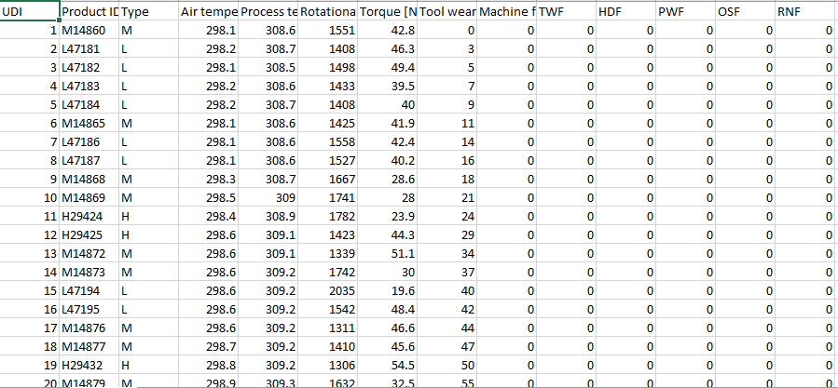

**Figure 1: Dataset**

This figure shows the dataset that consists of several attributes such as UDI, product ID, Air temperature, and so on. Some relevant columns are air temperature, process temperature, torque, rotational speed and the target column is machine failure. The target column consists of 0 and 1 whereas “0” stands for no failure and “1” stands for machine failure.

## Data preprocessing

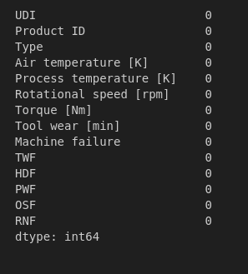

**Figure 2: Null value checking**

This figure shows the null values of the dataset has been checked and this dataset consists of no null value.

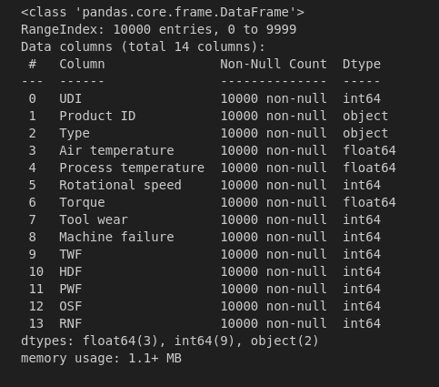

**Figure 3: Information of dataset**

This above figure has shown the entire information of the dataset that there are a total of 14 columns. The columns are shown with their data type such as integer, float or object values.

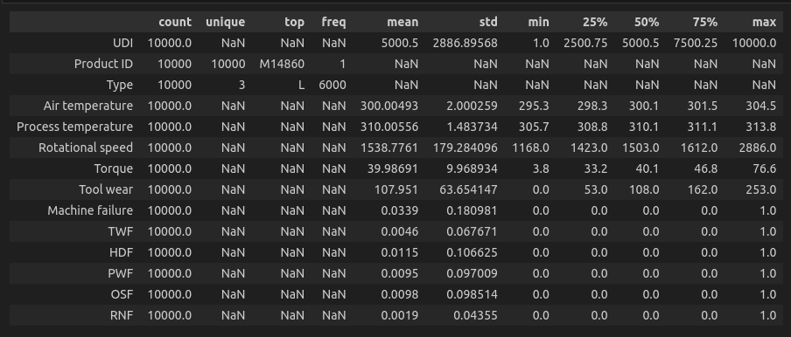**Figure 4: Summary of dataset**

The above figure has shown the summary of the dataset that has been used in this analysis. From this figure it is seen that the values of mean, standard, min, max and so on of the variables such as UDI, Air temperature, process temperature, Rotational speed and so on.

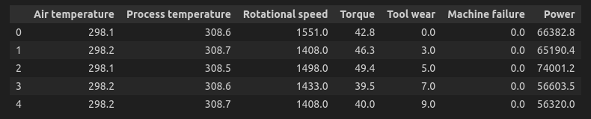

**Figure 5: Adding new column Power**

The figure has shown that there are some new columns named "Power " added. The value of this power are the multiplied value of rotational speed and torque. This figure also shows after dropping several columns such as UDI, product ID, TWF, HDF, PWF, PSF, and RNF.

## Data analysis

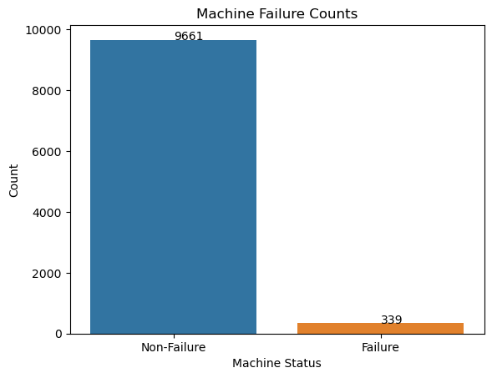

**Figure 7: Distribution of machine with no failure vs Machine failure**

(Source: Created on the Jupyter Notebook)

This figure shows the graph of the number of machines that failed and those that have not failed. The number of no failure machines is nearly 10K whereas, the number of machine failures is very less that is 339.

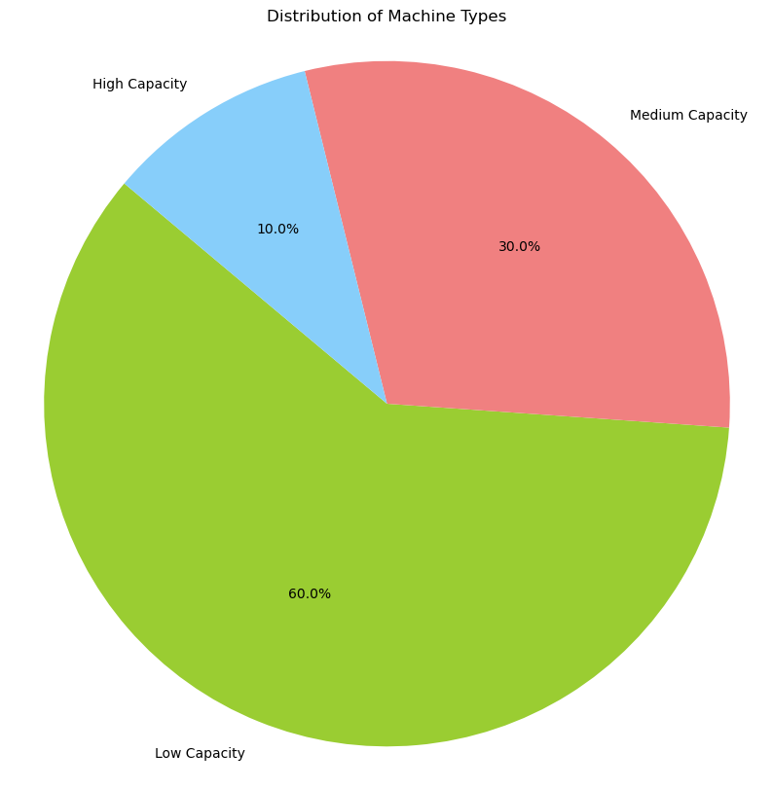

**Figure 8: Distribution of Machine Types**

(Source: Created on the Jupyter Notebook)

This figure shows distribution graphs of the machine types including the machines of high, low and medium capacity. From this figure it is obtained that there are 60%, 30%, and 10% of low capacity, medium capacity and high capacity respectively.

|  |  |
| --- | --- |
|  |  |

**Figure 9: Air temperature Distribution by Machine Failure**

(Source: (Source: Created on the Jupyter Notebook)

The chance of machine failure increases as air temperature rises, as shown in this graph. According to this correlation, high temperatures may hasten wear, damage components, or interrupt essential activities. In order to avoid potential breakdowns and maintain optimal machine performance, monitoring and managing air temperature become crucial techniques.

|  |
| --- |
|  |

**Figure 10: Process Temperature distribution by machine failure**

(Source: Generated on Jupyter notebook)

This graph unequivocally shows that as process temperatures rise, the likelihood of machine failure likewise increases. This finding suggests that greater temperatures may cause malfunctions, degrade materials, or interfere with complex processes. A key preventative approach to reduce the risk of machine breakdowns is managing and optimising process temperature.

|  |  |
| --- | --- |
|  |  |

**Figure 11: Rotational speed distribution by machine failure and the torque distribution by machine failure**

(Source: Generated on Jupyter notebook)

The illustrated figure indisputably demonstrates that the chance of machine failure reduces as rotational speed increases. This realisation suggests that slower speeds might cut friction, reduce mechanical stress, and improve stability. A tactical method for reducing the likelihood of machine failures emerges as adjusting and maintaining suitable rotational speeds.

The torque distribution graph shows that at the 40Nm torque the highest number of machines had no failure. On the other hand, at the torque value 45 to 70Nm, a number of machines failed.

|  |
| --- |
|  |

**Figure 12: Power temperature Distribution by machine failure**

(Source: Generated on Jupyter notebook)

This above figure shows that how the power temperature affect the machine failure. It shows that as the power temperature increases the there are less number of machine failure. However, few machines failed at the value of power temperature between 60000 to 80000 watt. And the highest value of power temperature at that the highest no of machines got no failure is 60000 watt.

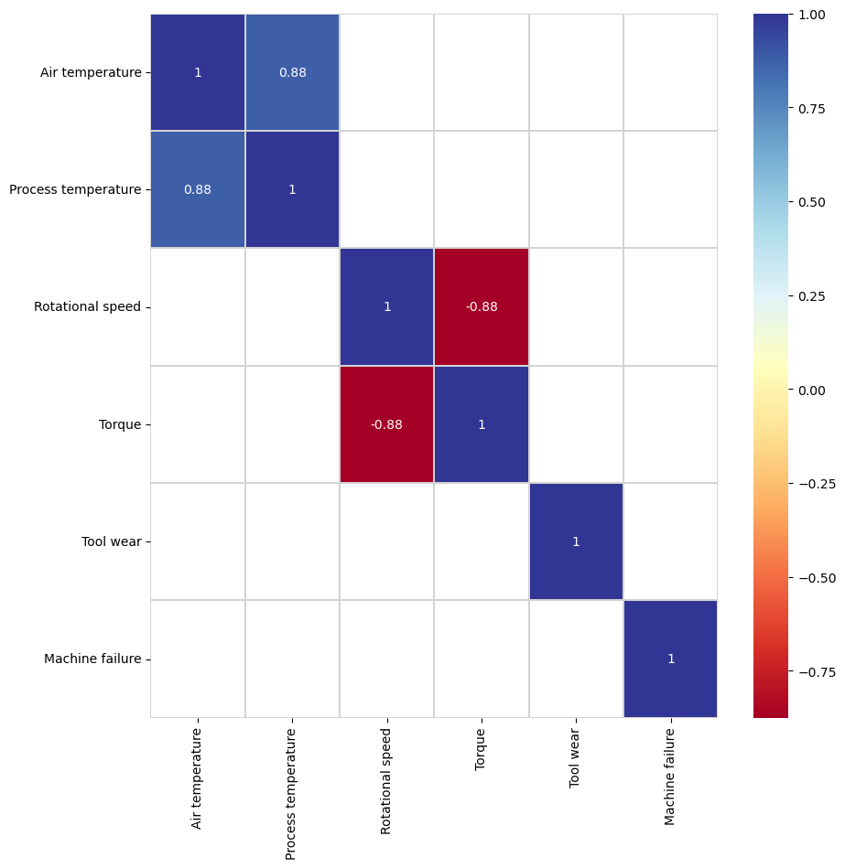

**Figure 13: Correlation matrix**

(Source: Generated on Jupyter notebook)

This figure shows the correlation matrix of the data variables. In this matrix the value lies between -1 to +1. These value either shows a positive value or negative value between two variables, and then it is called positively correlated or negativity correlated variables. This correlation metric is filtered to identify strong correlations between variables. It only shows correlations above 0.7. As example, Air temperature and Process temperature has the correlation value +0.88 that is a positive value, this these are positively correlated value. Air temperature and Tool wear does not have a strong correlation and not indicated on the matrix.

## 

## ML model evaluation

**Decision Tree**

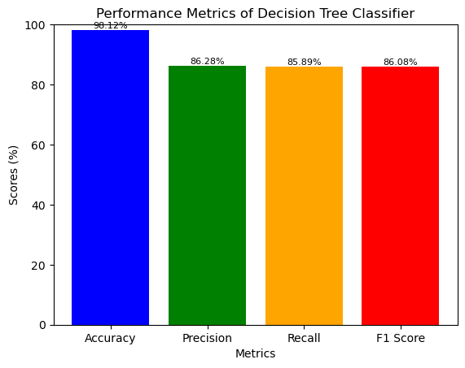

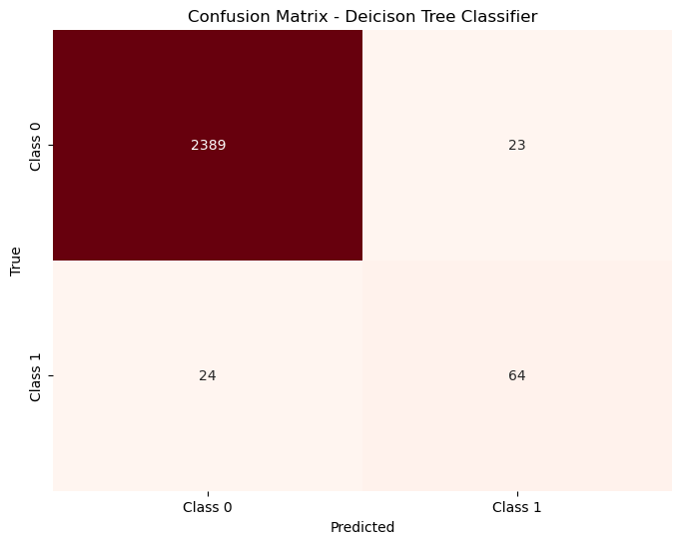

**Figure: Performance metrics and confusion matrix for Decision Tree**

A decision tree model predicts machine failures with an astonishing 98% accuracy. Notably, it captures a significant number of 2369 true positive (TP) predictions in the confusion matrix, demonstrating how well it can recognize real failure occurrences. The model's ability to reliably identify impending machine problems is highlighted by its notable TP count, which surpasses the number of false positives (FP) and true negatives (TN).

**Random Forest Classifier**

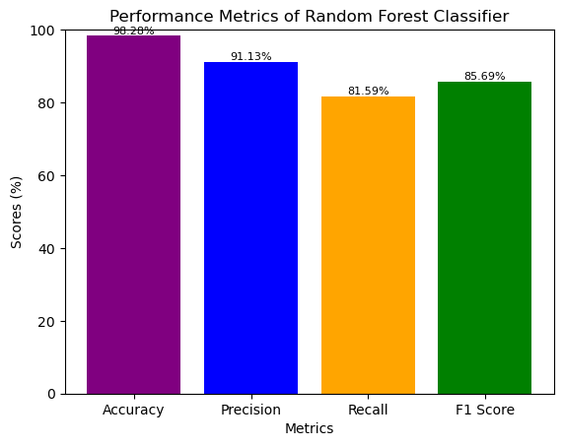

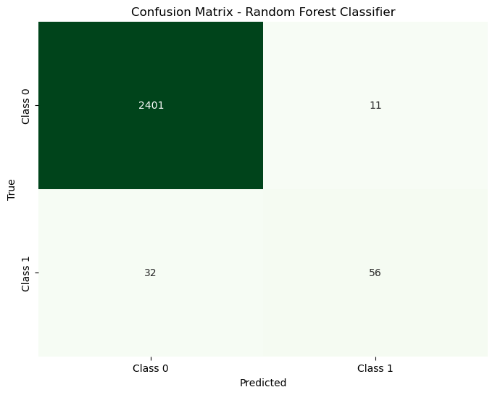

**Figure: Performance metrics and confusion matrix for Random Forest**

The random forest model displays its competence by predicting machine breakdowns with a commendable 98.2% accuracy. It is noteworthy that the confusion matrix displays a sizable total of 2401 true positives (TP), demonstrating its exceptional skill in detecting actual failure circumstances. This large TP advantage over false positives (FP) and true negatives (TN) highlights the model's capability to accurately identify probable machine failures.

**KNN Classifier**

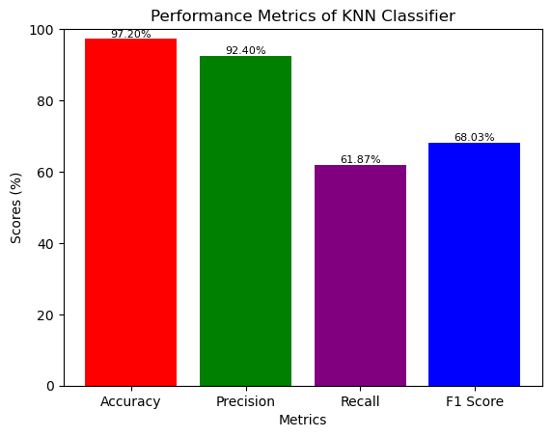

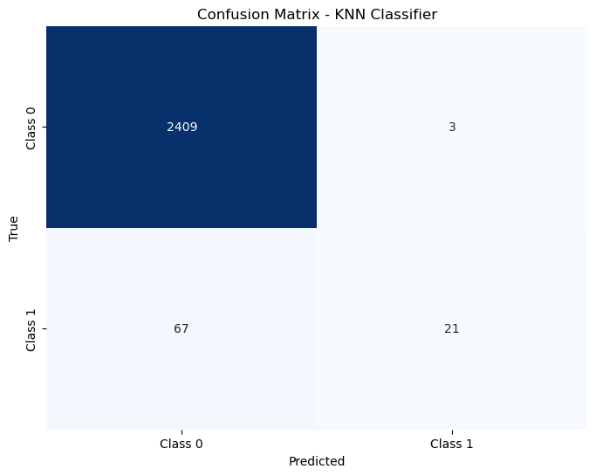

**Figure: Performance metrics and confusion matrix for KNN**

KNN classifier has the accuracy of 97.2% and precision score of 92% demonstrates how well the model is fitted for identifying the potential machine failures. There are 2409 number of TP values which are far greater than FP and TN values, suggesting that the model correctly predicted the failure circumstances of the machines.

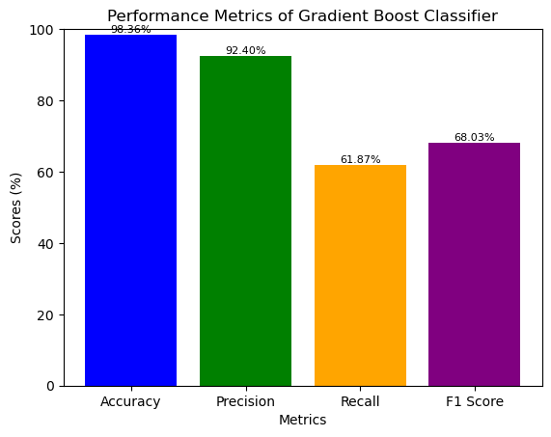

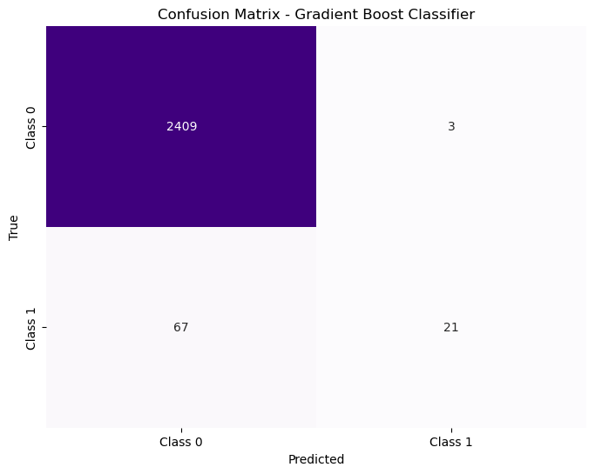

**Figure: Performance metrics and confusion matrix for Gradient boost**

The Gradient boost classifier achieves an impressive 98.36% accuracy and exhibits a precision score of 92.4%, showcasing its aptness in recognizing potential machine failures. Notably, the confusion matrix reveals a substantial count of 2409 true positives (TP), substantially outweighing the counts of false positives (FP) and true negatives (TN). This emphasises the model's precision in accurately anticipating machine malfunctions.

**SVM Classifier**

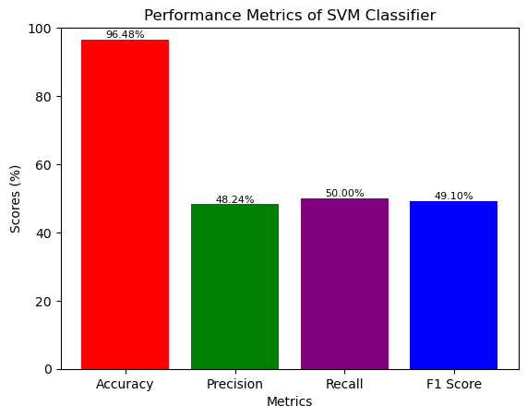

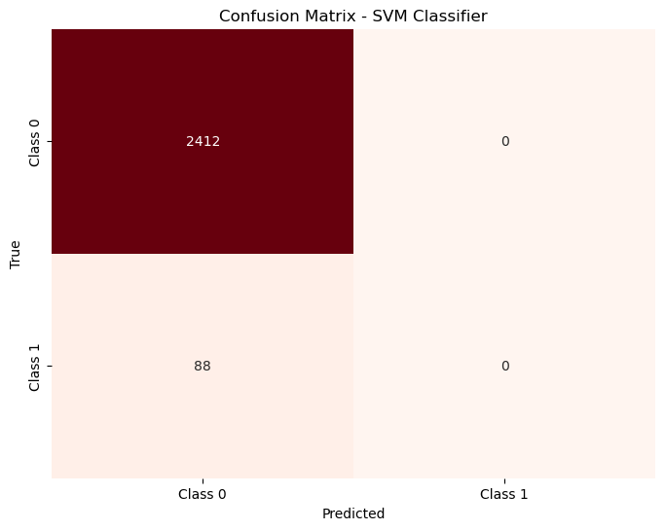

**Figure: Performance metrics and confusion matrix for Gradient boost**

The SVM model predicts machine failures with a strong 98.2% accuracy; but, its precision, recall, and F1 scores substantially fall below this accuracy. Despite this, the confusion matrix shows that the number of true positives (TP), which greatly exceed the number of false positives (FP) and true negatives (TN), is 241. This highlights how the model still accurately detects instances of machine failure even when there are unbalanced performance measurements.

|  |  |
| --- | --- |
|  |  |

**Figure: Accuracy comparison between ML models**

Gradient Boosting stands out among the models for predicting machine failures with the highest accuracy of 98.36%, demonstrating its outstanding performance. SVM, in comparison, has the lowest accuracy, coming in at 96.5%. This gap may be due to Gradient Boosting ensemble nature, which enables it to efficiently capture complicated patterns, in contrast to SVM's linear separation, which may have difficulty with complex failure patterns and hence perform with less accuracy in this situation.

## Summary

The offered data and analyses are centred on strategies for machine maintenance and failure prediction. According to distribution graphs, the chance of failure increases as air and process temperatures rise. Slower rotational speeds result in more failures, which has an impact on failure probability. Prediction accuracy is assessed using machine learning models such as Decision Tree, Random Forest, KNN, Gradient Boosting, and SVM. Gradient Boosting outperforms SVM (96.5%) with remarkable precision (98.36%). It excels because it can recognise complicated patterns, whereas SVM has trouble with complex failures. These results highlight the value of temperature control and precision machine learning methods in improving maintenance procedures.

# Chapter 5: Discussion

The figures show the use of many machine learning techniques, including Gradient Boosting, Decision Trees, Random Forest, k-NN, and SVM. The given graphs, such as "Distribution of machine with no failure vs. machine failure" and "Distribution of Machine Types," serve as indicators of the accuracy evaluation. These visualisations provide a clear view of the effectiveness of the algorithms by demonstrating how well they discriminate between failed and working equipment.

Figures "Air temperature Distribution by machine failure," "Process temperature distribution by machine failure," "Rotational speed distribution by machine failure and the torque distribution by machine failure," and "Power temperature Distribution by machine failure" show the results of the bivariate and univariate analyses that were carried out. These visualisations show the connections between different characteristics and machine failure. The air temperature distribution graph, for instance, emphasises the link between high temperatures and equipment failure and offers specific details on the causes.

The study uses machine learning algorithms to answer this issue, evaluating the algorithms' effectiveness with a range of criteria. Figures like "Distribution of machine with no failure vs machine failure" and "Distribution of Machine Types" give a general idea of the model's accuracy, but metrics like F1 score, recall, and precision, which are essential measures of model efficiency, give more specific information.

The observed relationship between higher machine failure and rising air temperature emphasises the need of air temperature regulation. Increased temperatures have the potential to cause excessive wear and tear, faster component deterioration, and poor lubrication. Therefore, these negative impacts can be reduced by reducing air temperature through effective ventilation and cooling systems. The danger of machine breakdowns brought on by thermal stress can be considerably decreased by maintaining ideal operating temperatures. This strategy fits with preventative maintenance plans that emphasise proactive steps to increase machine lifespan and guarantee reliable functioning. Controlling process temperature is essential for avoiding equipment breakdowns. Process temperatures that are too high can lead to structural integrity compromises, thermal expansion mismatches, and material fatigue. By minimising the wear and tear brought on by excessive temperature variations, lowering process temperatures through precise control systems not only improves the overall safety of machine operations. Productivity may be considerably improved by using effective cooling solutions and adjusting manufacturing procedures to work within designated temperature limits. Controlling rotational speed is essential for controlling mechanical stress and strain on machine parts. Vibrational forces brought on by fast rotating rates can result in mechanical imbalances, more wear, and probable breakdowns. These dangers are reduced and machine operation is certain to be at its most efficient when rotational speeds are kept within ideal limits. Advanced motor control systems and real-time monitoring may be used to provide this control, allowing modifications to be made according to the particular needs of various production operations.

The model assessment findings give important information about how well different machine learning algorithms anticipate machine faults and improve maintenance procedures in the context of manufacturing. The investigation highlights the various machine learning models' excellent accuracy levels. The accuracy values of Decision Tree, Random Forest, KNN, Gradient Boosting, and SVM are all remarkable, ranging from 96.5% to 98.36%. This stability in precise prediction across models exemplifies how machine learning may be used to spot possible machine malfunctions. Gradient Boosting stands out among the examined models for its excellent effectiveness in forecasting machine breakdowns. It excels in accuracy and precision, scoring 98.36% for accuracy and 92.4% for precision. The model's strong capacity to accurately forecast genuine failure cases is highlighted by its high accuracy value, which makes it a solid option for manufacturing businesses looking to reduce false positives and guarantee that maintenance efforts are well-targeted.

Gradient Boosting's ensemble-based design can be credited for its excellent performance. When using ensemble approaches, such as Gradient Boosting, numerous weak learners' strengths are combined to produce a more accurate prediction model. Due to its ability to accurately capture complicated patterns and relationships in the data, the model is highly suited for situations of complex failure. On the other hand, because to their linear separation method, models like SVM, despite obtaining great accuracy, may find it difficult to handle complex failure patterns. The evaluation's findings support the significance of temperature control that were made in the beginning. The distribution graphs showed that increasing failure probability are correlated with higher air and process temperatures (Samatas *et al.* 2021). The models' high level of forecast accuracy supports the importance of temperature control in reducing machine breakdowns. It becomes clear that maintaining ideal temperatures is a crucial preventative strategy to improve equipment efficiency and durability. The comprehensive approach to predictive maintenance is underlined by the combined findings from the model assessments and temperature studies. Manufacturers can properly manage maintenance resources by utilising machine learning models with high accuracy and precision to proactively predict possible issues. These findings may be used to temperature control techniques to improve machine performance, lengthen machine life, and save downtime.

The entire discussion emphasises how important machine learning techniques are for properly forecasting machine faults. It emphasises the importance of accuracy in model performance and draws attention to the effectiveness of ensemble techniques like Gradient Boosting. The study also emphasises the value of temperature regulation as a preventative step in reducing equipment breakdowns. These insights may be used to help producers take a complete approach to optimising maintenance procedures, boosting operational effectiveness, and guaranteeing reliable output in the manufacturing sectors.

# Chapter 6: Conclusion

## 6.1 Linking with the objectives

***To implement various machine learning algorithms for differentiating potential machine failures with accuracy assessment-***

Industrial improvement requires the application of various machine learning algorithms to distinguish between prospective machine problems with accuracy assessment. Predictive maintenance is made possible, reducing downtime and maximising resource usage. Algorithms reveal failure patterns by examining historical data, enabling prompt interventions. Reliable forecasts are ensured through accurate assessment, which minimises misleading findings (Wang *et al.* 2022). This method improves operations, extends the life of the apparatus, and increases worker safety. This topic satisfies industry demands for intelligent systems in the data-centric environment, moving from reactive to proactive ways and boosting productivity and revenues.

***To conduct bivariate and univariate analyses to identify key factors contributing to machine failures-***

Making educated decisions requires doing bivariate and univariate analysis to pinpoint the major causes of machine failures. Bivariate analysis reveals correlations between variables by revealing links between them. A univariate analysis looks at a single variable, revealing trends and outliers. This methodical data exploration identifies key elements that cause failures and directs interventions (Younas and Durante, 2023). Industries can prioritise preventive measures and deploy resources efficiently by understanding these linkages. This strategy reduces downtime, lowers maintenance expenses, and improves operational dependability. Such evaluations, which support industry's pursuit of increased productivity and competitive advantage in a data-driven world, offer actionable insights for process optimisation and maintaining efficient machinery

***To evaluate machine learning models using performance metrics such as accuracy, F1 score, recall, and precision-***

In conduct to ensure model effectiveness, machine learning models must be evaluated using accuracy, F1 score, recall, and precision measures. Recall determines true positives, precision balances recall and F1 score indicates total correctness. False positive measurements are accurate. These measures evaluate a model's precision in result prediction as a whole. Informed model selection and refinement are made possible by effective evaluation, which improves predictive abilities. Reliable predictions must prioritise great accuracy, little chance of being wrong, and wide coverage (Fong *et al.* 2020). By improving decision-making, resource allocation, and operational efficiency, this strategy meets the requirement of the sector for reliable and strong machine learning solutions.

***To increase predictive maintenance by leveraging data-driven insights for informed decision-making in manufacturing-***

Predictive maintenance is elevated greatly when data-driven insights are used to make informed decisions in production. Industries can predict equipment breakdowns and take preventive action by analysing historical and real-time data (Jimenez *et al.* 2020). This improved decision-making improves resource allocation, controls unscheduled downtime, and strengthens maintenance methods. The strategy improves operational effectiveness while lowering the price of reactive maintenance. This topic equips producers to increase productivity, dependability, and competitiveness through well-informed, data-guided operations, in line with the concepts of Industry 4.0.

## Conclusion

For enterprises pursuing increased operational effectiveness, decreased downtime, and optimal resource utilisation, the aim of higher predictive maintenance in preventing machine breakdowns is crucial. A variety of machine learning techniques can be used to accurately identify possible machine problems, enabling proactive interventions that prevent expensive breakdowns. These algorithms reveal failure patterns through the examination of previous data, assisting timely and focused maintenance operations. Finding the main causes of machine failures becomes much easier by using bivariate and univariate studies. These methodical approaches to data exploration discover trends and create correlations between variables, enabling industries to prioritise preventive actions and effectively allocate resources. Such insights improve overall operational reliability while also reducing downtime and maintenance costs.

The effectiveness of predictive maintenance strategies is ensured by the evaluation of machine learning models using performance metrics including accuracy, F1 score, recall, and precision. To help with resource allocation and informed decision-making, these metrics assess the models' capacity for producing accurate predictions. The industry's requirement for data-centric solutions is fulfilled by implementing these reliable and resilient machine learning solutions, which boost productivity and competitiveness in a changing environment.

The effectiveness of predictive maintenance is increased when data-driven insights are used for well-informed decision-making in manufacturing. Industries can foresee equipment failures by analysing historical and real-time data, which enables preemptive interventions that reduce unplanned downtime and improve maintenance procedures. This change from reactive to proactive maintenance supports improved efficiency, operational dependability, and a competitive edge. It is in accordance with the principles of Industry 4.0.

The data highlights the significance of variables including rotational speed, air and process temperatures, and failure rates for machines. These illustrations draw attention to the relationship between temperature changes and the risk of failure as well as the influence of rotational speed on stability. The model evaluations also highlight Gradient Boosting advantage in getting the highest accuracy for failure prediction while highlighting the significance of precision in avoiding false positives.

In conclusion, a comprehensive strategy to improve predictive maintenance techniques is represented by the integration of various machine learning algorithms, in-depth data analysis, and accurate model evaluations. The ability to switch from reactive to proactive maintenance is provided by this strategy, which boosts operational effectiveness, resource allocation, and overall competitiveness.

## Future Scope

***Advanced Algorithms and AI***: As complex machine learning algorithms, such as deep learning and neural networks, continue to be developed, this will result in even higher prediction accuracies and improved pattern recognition. Real-time monitoring will be enhanced and decision-making processes will be automated thanks in large part to artificial intelligence (AI).

***IoT Integration***: The Internet of Things (IoT) will be integrated, allowing for the massive real-time data collection from embedded sensors in machinery. As a result, forecasts will be made that are more precise and timely, enabling proactive maintenance methods and lowering the likelihood of failure.

***Predictive Analytics:*** By incorporating predictive analytics into maintenance procedures, businesses will be able to anticipate proactively for failures and enhance maintenance schedules. Reduced downtime, improved operational effectiveness, and cost savings will follow from this.

***Prescriptive Maintenance***: Prescriptive Maintenance will provide actionable insights on the optimal course of action to avert failures by building on predictive capabilities. In addition to failing predictions, machine learning models will offer advice on the best course of action.

***Integration with Industry 4.0***: Predictive maintenance must be seamlessly incorporated into interconnected, automated production systems as industries advance towards Industry 4.0 principles. The production process will become more synchronised and effective as a result of this integration.

# References

Calabrese, M., Cimmino, M., Fiume, F., Manfrin, M., Romeo, L., Ceccacci, S., Paolanti, M., Toscano, G., Ciandrini, G., Carrotta, A. and Mengoni, M., 2020. SOPHIA: An event-based IoT and machine learning architecture for predictive maintenance in industry 4.0. *Information*, *11*(4), p.202.

<https://www.mdpi.com/2078-2489/11/4/202/pdf>

Teoh, Y.K., Gill, S.S. and Parlikad, A.K., 2021. IoT and fog computing based predictive maintenance model for effective asset management in industry 4.0 using machine learning. *IEEE Internet of Things Journal*.

[https://qmro.qmul.ac.uk/xmlui/bitstream/handle/123456789/70264/Gill%20IoT%20and%20Fog%202021%20Accepted.pdf?sequence=2](https://qmro.qmul.ac.uk/xmlui/bitstream/handle/123456789/70264/Gill IoT and Fog 2021 Accepted.pdf?sequence=2)

Bouabdallaoui, Y., Lafhaj, Z., Yim, P., Ducoulombier, L. and Bennadji, B., 2021. Predictive maintenance in building facilities: A machine learning-based approach. *Sensors*, *21*(4), p.1044.

<https://www.mdpi.com/1424-8220/21/4/1044/pdf>

Achouch, M., Dimitrova, M., Ziane, K., Sattarpanah Karganroudi, S., Dhouib, R., Ibrahim, H. and Adda, M., 2022. On predictive maintenance in industry 4.0: Overview, models, and challenges. *Applied Sciences*, *12*(16), p.8081.

<https://www.mdpi.com/2076-3417/11/1/18/pdf>

Achouch, M., Dimitrova, M., Ziane, K., Sattarpanah Karganroudi, S., Dhouib, R., Ibrahim, H. and Adda, M., 2022. On predictive maintenance in industry 4.0: Overview, models, and challenges. *Applied Sciences*, *12*(16), p.8081.

<https://www.mdpi.com/2076-3417/12/16/8081/pdf>

Karuppusamy, P., 2020. Machine learning approach to predictive maintenance in manufacturing industry-a comparative study. *Journal of Soft Computing Paradigm (JSCP)*, *2*(04), pp.246-255.

<https://scholar.archive.org/work/5hsc6nyum5anxbx6bqlwt6xb4i/access/wayback/https://irojournals.com/jscp/V2/I4/06.pdf>

Kamat, P. and Sugandhi, R., 2020. Anomaly detection for predictive maintenance in industry 4.0-A survey. In *E3S web of conferences* (Vol. 170, p. 02007). EDP Sciences.

<https://www.e3s-conferences.org/articles/e3sconf/pdf/2020/30/e3sconf_evf2020_02007.pdf>

Coelho, D., Costa, D., Rocha, E.M., Almeida, D. and Santos, J.P., 2022. Predictive maintenance on sensorized stamping presses by time series segmentation, anomaly detection, and classification algorithms. *Procedia Computer Science*, *200*, pp.1184-1193.

<https://www.sciencedirect.com/science/article/pii/S1877050922003271/pdf?md5=ce0f8285cacac1fbc8b470f2d04dc2e0&pid=1-s2.0-S1877050922003271-main.pdf>

Durbhaka, G.K., 2021. Convergence of artificial intelligence and internet of things in predictive maintenance systems–a review. *Turkish Journal of Computer and Mathematics Education (TURCOMAT)*, *12*(11), pp.205-214.

<https://turcomat.org/index.php/turkbilmat/article/download/5862/4873>

Çınar, Z.M., Abdussalam Nuhu, A., Zeeshan, Q., Korhan, O., Asmael, M. and Safaei, B., 2020. Machine learning in predictive maintenance towards sustainable smart manufacturing in industry 4.0. *Sustainability*, *12*(19), p.8211.

<https://www.mdpi.com/2071-1050/12/19/8211/pdf>

Resende, C., Folgado, D., Oliveira, J., Franco, B., Moreira, W., Oliveira-Jr, A., Cavaleiro, A. and Carvalho, R., 2021. TIP4. 0: industrial internet of things platform for predictive maintenance. *Sensors*, *21*(14), p.4676.

<https://www.mdpi.com/1424-8220/21/14/4676/pdf>

Rai, R., Tiwari, M.K., Ivanov, D. and Dolgui, A., 2021. Machine learning in manufacturing and industry 4.0 applications. *International Journal of Production Research*, *59*(16), pp.4773-4778.

<https://www.tandfonline.com/doi/pdf/10.1080/00207543.2021.1956675>

Shahbazi, Z. and Byun, Y.C., 2021. Integration of blockchain, IoT and machine learning for multistage quality control and enhancing security in smart manufacturing. *Sensors*, *21*(4), p.1467.

<https://www.mdpi.com/1424-8220/21/4/1467/pdf>

Nacchia, M., Fruggiero, F., Lambiase, A. and Bruton, K., 2021. A systematic mapping of the advancing use of machine learning techniques for predictive maintenance in the manufacturing sector. *Applied Sciences*, *11*(6), p.2546.

<https://www.mdpi.com/2076-3417/11/6/2546/pdf>

Namuduri, S., Narayanan, B.N., Davuluru, V.S.P., Burton, L. and Bhansali, S., 2020. Deep learning methods for sensor based predictive maintenance and future perspectives for electrochemical sensors. *Journal of The Electrochemical Society*, *167*(3), p.037552.

<https://iopscience.iop.org/article/10.1149/1945-7111/ab67a8/pdf>

Traini, E., Bruno, G., D’antonio, G. and Lombardi, F., 2019. Machine learning framework for predictive maintenance in milling. *IFAC-PapersOnLine*, *52*(13), pp.177-182.

<https://www.researchgate.net/profile/Emiliano-Traini/publication/338161548_Machine_Learning_Framework_for_Predictive_Maintenance_in_Milling/links/5eaa8adda6fdcc70509b1a5b/Machine-Learning-Framework-for-Predictive-Maintenance-in-Milling.pdf>

Bampoula, X., Siaterlis, G., Nikolakis, N. and Alexopoulos, K., 2021. A deep learning model for predictive maintenance in cyber-physical production systems using lstm autoencoders. *Sensors*, *21*(3), p.972.

<https://www.mdpi.com/1424-8220/21/3/972/pdf>

Samatas, G.G., Moumgiakmas, S.S. and Papakostas, G.A., 2021, May. Predictive maintenance-bridging artificial intelligence and iot. In *2021 IEEE World AI IoT Congress (AIIoT)* (pp. 0413-0419). IEEE.

<https://arxiv.org/pdf/2103.11148>

Nangia, S., Makkar, S. and Hassan, R., 2020, March. IoT based predictive maintenance in manufacturing sector. In *Proceedings of the International Conference on Innovative Computing & Communications (ICICC)*.

<https://www.researchgate.net/profile/Rohail-Hassan/publication/340393068_IoT_based_Predictive_Maintenance_in_Manufacturing_Sector/links/5e8c2f1b299bf1307983f616/IoT-based-Predictive-Maintenance-in-Manufacturing-Sector.pdf>

Karuppusamy, P., 2020. Machine learning approach to predictive maintenance in manufacturing industry-a comparative study. *Journal of Soft Computing Paradigm (JSCP)*, *2*(04), pp.246-255.

<https://scholar.archive.org/work/5hsc6nyum5anxbx6bqlwt6xb4i/access/wayback/https://irojournals.com/jscp/V2/I4/06.pdf>