Kleefstra Syndrome Disease Concept Model

Team Members - Wuge Li, Maysen Pagan, Amie Thomas

Teaching Fellow - Minh Thu Bui

Supervisor - Professor Masanao Yajima

# Project Background and Objectives

This project aims to create visualizations of references to concepts and impacts mentioned by caregivers of individuals with Kleefstra Syndrome (KS). In the survey interviews, caregivers referenced the ages of individuals with KS ranging from under two to 17 years old. References were counted for mentions of KS-defining concepts like motor or neurological concepts, KS individual impacts like social or health impacts, and caregiver impacts like financial or emotional impacts. The visualizations aim to help inform the effects of KS on the lived experience of the individuals and their caregivers, which can help medical health professionals prioritize intervention strategies and certain concepts at different ages.

The first objective in Section 2.1 was to create a plot similar to Figure 1 in the following [paper](https://www.ncbi.nlm.nih.gov/pmc/articles/PMC10235567/) that portrays the total references to concepts, impacts, and ages in a horizontal bar plot. The second objective was to create a plot displaying the frequency of references to compare the most mentioned concepts and impacts across different age groups. Two proposed plots for this objective can be found in Section 2.2 and Section 2.3.

# Visualizations

## Total References Bar Plot

A bar chart is the most effective method for displaying the total number of references for every concept or impact. This visual representation includes four distinct categories: “KS Defining Concepts,” “KS Individual Impact,” “Caregiver Impact,” and “Age,” each depicted with varying colors to differentiate between them. Additionally, the data is organized in descending order to enable a more explicit comparison of the references across different categories.

### Analysis

Figure 1 shows that the most referenced KS-defining concept across all age groups was “communication.” The most referenced KS Individual Impact was “health” compared to “emotional” being the most referenced caregiver impact across all age groups. The Age bar plot allows one to observe that caregivers most often referenced their children between the ages of 5 and 11 in their interviews.

Figure 1: Total references bar chart.

## Age Group Symptoms Frequencies Heatmap

Heatmaps are a great way to reveal relationships between variables. By representing numerical values with colors, heatmaps make it easier to identify areas of high and low values. For Figure 2, the frequency of each symptom/impact was calculated by dividing the number of references to each symptom/impact by the total number of references for that age group. For example, Frequency of Symptom A = Number of references to Symptom A / Total number of references to all symptoms in Age Group X. This normalizes the data so that the different response sizes are no longer an issue, making the age groups comparable.

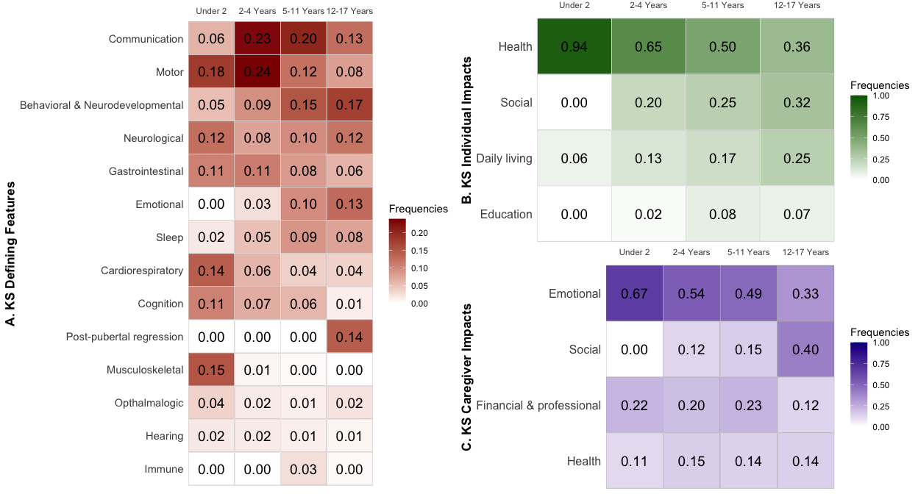

Figure 2: Heatmap of references frequencies.

### Analysis

Interpreting the graph can be done like the following. For “KS Caregiver Impacts” heatmap (bottom right) we can see that the emotional impacts were mentioned at a higher frequency than all other impacts for the Under 2 category. Emotional impact continues to be the most talked about for ages 2-4 and 5-11. Then comes second place to social impacts for age category 12-17.

The “KS Defining Concepts” (left) heatmap is an a scale from 0.00-0.25, whereas the “KS Caregiver Impacts” and “KS Caregiver Impacts” (upper right) are on a 0.00-1.00 scale. The reasoning is that the symptom most mentioned in interviews had a frequency of 0.24. Putting the heatmap on a 0.00-1.00 scale made it less visually effective for comparison purposes.

## Age Group Frequencies Bar Plot

Another visualization that allows you to observe changes in the frequencies of references over different age groups is a stacked bar plot. Figure 3 shows stacked bar plots for the frequencies of referenced KS Defining Concepts, KS Individual Concepts, and KS Caregiver Impacts. The different colors in each plot represent different concepts or impacts and the labeled frequencies represent the most referenced concept or impact for that age group.

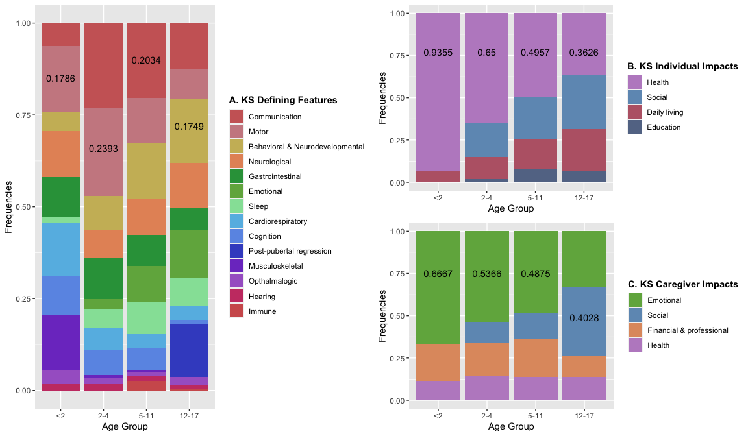

Stacked bar plot of references frequencies. Labeled frequencies represent the most frequent concept or impact for that age group.

### Analysis

These stacked bar plots are a great way to observe changes in the frequency of references across different age groups at a high level. For example, in stacked bar plot B (upper right), it is clear to see that health is the most referenced individual impact for children under the age of 2. However, as the age groups increase, the references to health decreases. A similar pattern can be seen in bar plot C (bottom right). As the age groups increase in age, the frequencies of references to emotional caregiver impacts decreases while social impacts increase.

There is a challenge with the interpretability of stacked bar plots. While the patterns mentioned above are clear to see looking at the plots, there is a difficulty in comparing concepts or impacts when they do not start at a common baseline. For example, in bar plot A (left), comparing the references to gastrointestinal concepts between the age groups of less than 2 and 2 to 4-year-olds is hard. Additionally, due to the stacked nature of the bar plots, it is also challenging to determine the exact frequency of the referenced concept or impact unless it is the bottom bar.

# Conclusion

The horizontal bar plot is a great visualization to observe patterns in the overall count of references to certain concepts, impacts, and age groups. The heatmap and stacked bar plot both are visualizations that allow one to compare the frequencies of references to concepts and impacts across different age groups. Line graphs or area graphs would not be representative of the data as the x-axis for line graphs and area graphs are continuous. The x-axis for the data provided is categorical as the ages of the children are divided into groups. As a result, a heatmap or stacked bar plot is the categorical alternative to area graphs. It is important to note that the cells of the heatmap provide the exact frequencies of each reference, a characteristic that the stacked barplot does not have.