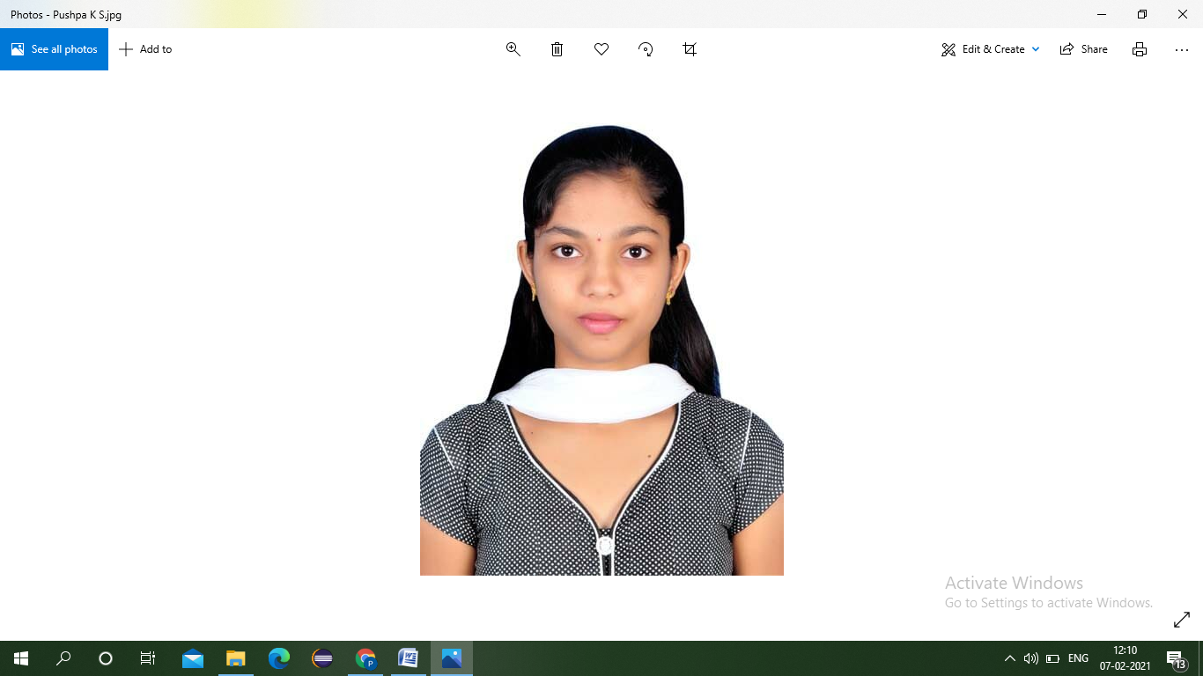sssss

**CONTACT DETAILS**

Pushpa.KS@cognizant.com

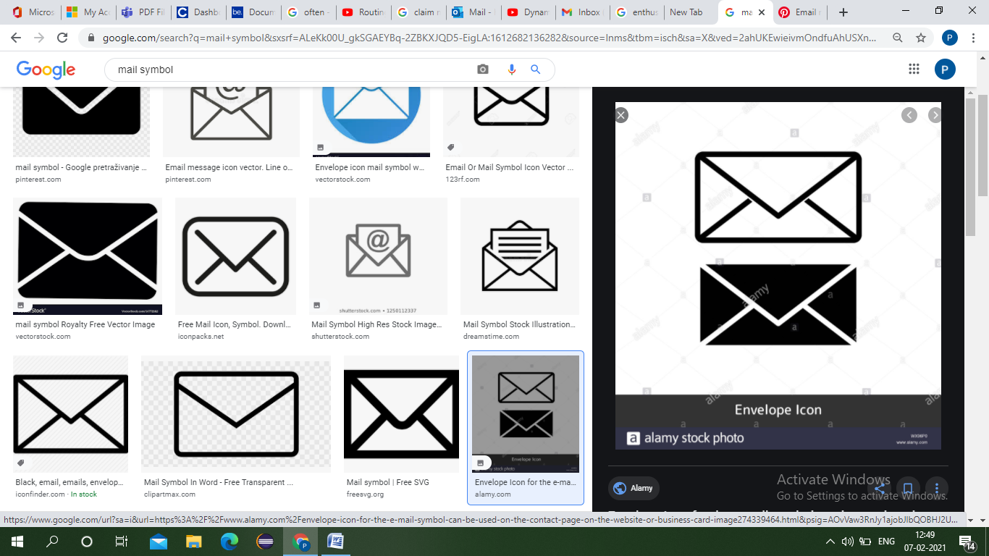

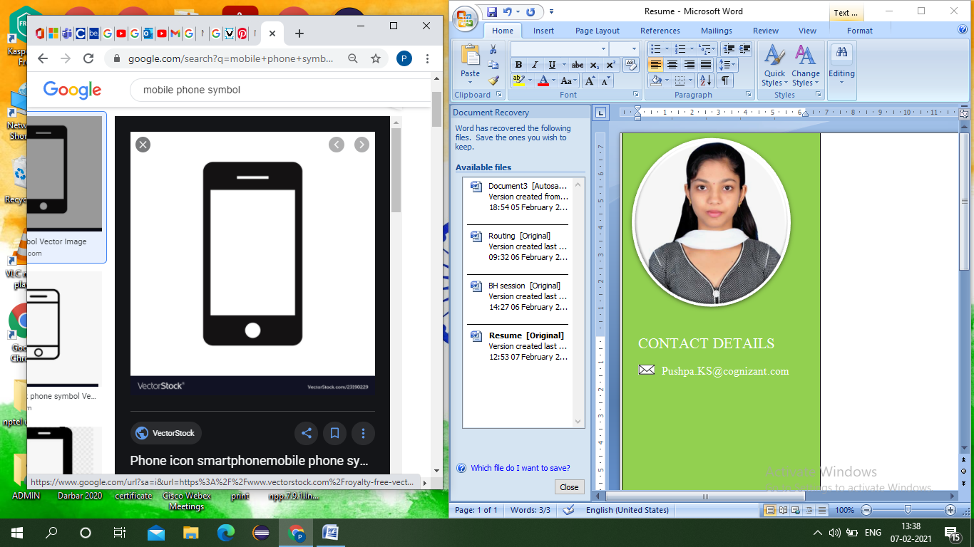 +917975181841

**EXPERTISE**

HTML, CSS, JS, SQL and CORE JAVA.

**INTERESTS**

Projects working towards Flex

PLM.

**PUSHPA K S**

**ASSOCIATE ID : 889055**

**COGNIZANT TECHNOLOGY SOLUTION INDIA PVT LTD.**

Plot No: 129 to 132, APHB Colony, Lords Conference Hall, 8th Floor, Phase-3(Block-1), DLF Building, Opp to Old CMC Office, Gachibowl, Hyderabad-500032.

**PERSONAL PROFILE**

I have a sharp knowledge in technical skills and I am looking forward to take projects, that provides a challenging and progressive career that will recognize my talents and utilize my skills, there by contributing the company’s growth and enhance my technical abilities. **WORK EXPERIENCE**

Programmer Analyst Trainee

Cognizant Technology Solutions | Nov 2020 – Present

* Trained rigorously with the GenC Academy for 3 months.
* Created numerous static as well as responsive webpages using HTML and CSS.
* Learnt SQL which is used to perform tasks such as update data on a database, or retrieve data from a database.
* Trained with the concepts of JavaScript to build single page client applications.

* **EDUCATIONAL HISTORY**
* Visvesvaraya technological university Bachelor of technology in Telecommunication Engineering | Aug 2016 –Aug 2020.

**CGPA: 7.5**

* Vidhyadri PU college | May 2014 – May 2016 **Percentage: 79**

**VOLUNTEER EXPERIENCE OR LEADERSHIP**

Volunteering in **Summer** **Internship Programme Of TBRP** (Technology Barrier Reduction Program).

* Have successfully participated in the **E-Step Start-up Boot-Camp** conducted by K-tech Innovation Hub NAIN Centre.
* Had organized **TECH-TALK** on internships and learning platforms.
* Volunteering in **NSS** (National Social Service).
* Participated in **State Level Cultural Activity** held at Karnataka state open university in Mysore.