DBMS - Mini Project

Auto-Spare-Parts-Management

Submitted By: Sujan Rao R

PES2UG20CS468

V Semester Section H

# Short Description and Scope of the Project

This is a web-based application. CSS and PHP are the major components of this project. It contains a login page where the user can enter the web-site. They can make purchases in the spare-parts section. The admin can make sure that the customers can buy their respective materials.

SCOPE:

With the advancement in technology, it is very hard to maintain automobile spare parts. With this system the customers can buy whatever they want in a very secure, easy and risk free-way. The customers get their bills on spot. The transaction details are available on spot so they can use it as a reference as for future transactions. One can add new supplier, customer, employee etc.

**ER Diagram**

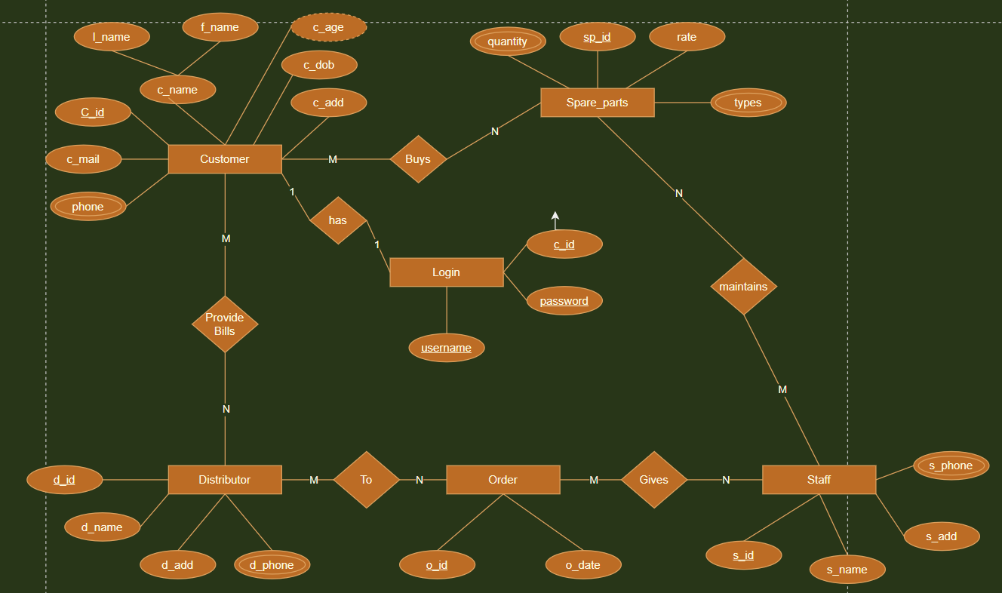

# Relational Schema

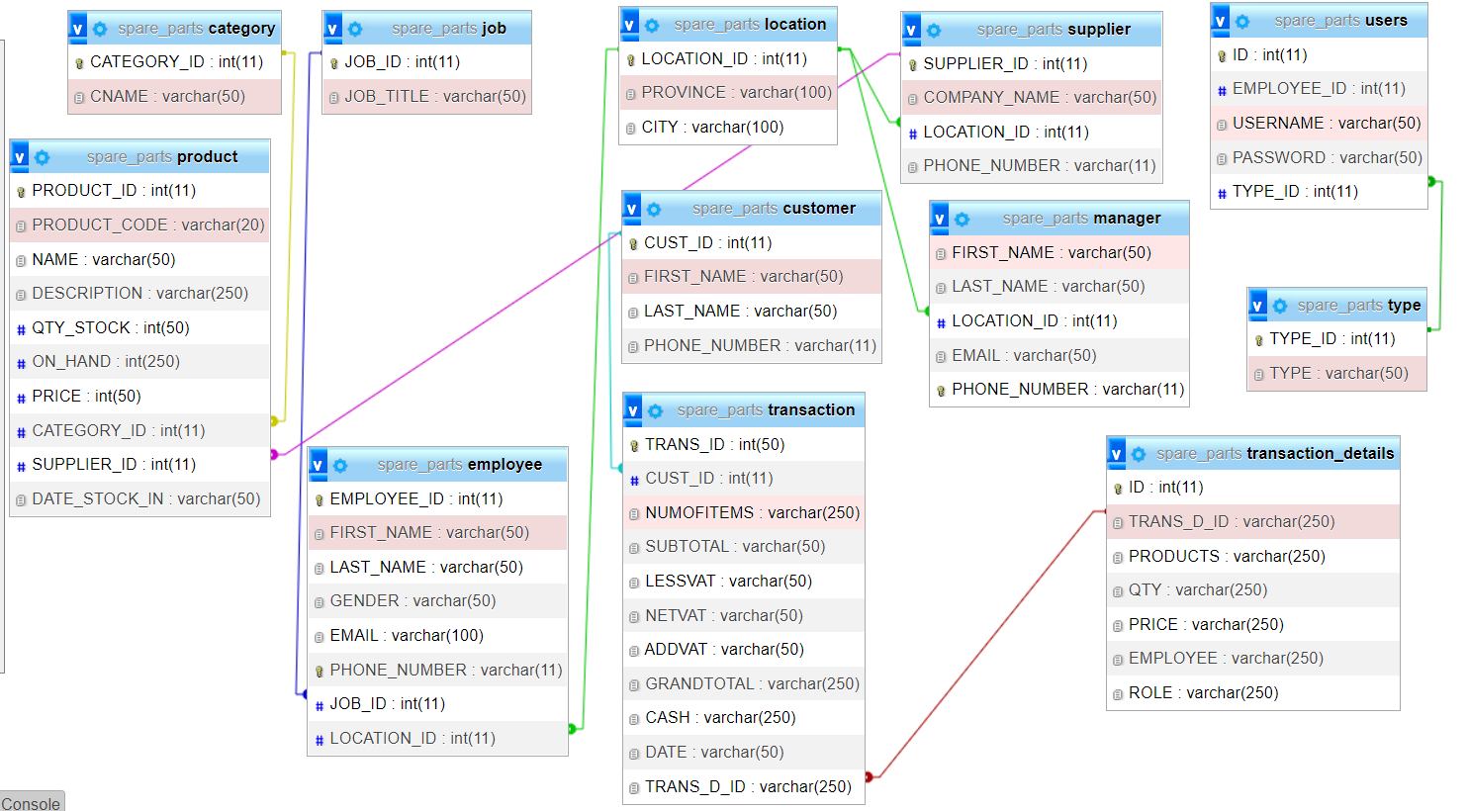

**DDL statements - Building the database**

CREATE TABLE `category` (

  `CATEGORY_ID` int(11) NOT NULL,

  `CNAME` varchar(50) DEFAULT NULL

)

CREATE TABLE `customer` (

  `CUST_ID` int(11) NOT NULL,

  `FIRST_NAME` varchar(50) DEFAULT NULL,

  `LAST_NAME` varchar(50) DEFAULT NULL,

  `PHONE_NUMBER` varchar(11) DEFAULT NULL

)

CREATE TABLE `employee` (

  `EMPLOYEE_ID` int(11) NOT NULL,

  `FIRST_NAME` varchar(50) DEFAULT NULL,

  `LAST_NAME` varchar(50) DEFAULT NULL,

  `GENDER` varchar(50) DEFAULT NULL,

  `EMAIL` varchar(100) DEFAULT NULL,

  `PHONE_NUMBER` varchar(11) DEFAULT NULL,

  `JOB_ID` int(11) DEFAULT NULL,

  `LOCATION_ID` int(11) DEFAULT NULL

)

CREATE TABLE `job` (

  `JOB_ID` int(11) NOT NULL,

  `JOB_TITLE` varchar(50) DEFAULT NULL

)

CREATE TABLE `location` (

  `LOCATION_ID` int(11) NOT NULL,

  `PROVINCE` varchar(100) DEFAULT NULL,

  `CITY` varchar(100) DEFAULT NULL

)

CREATE TABLE `manager` (

  `FIRST_NAME` varchar(50) DEFAULT NULL,

  `LAST_NAME` varchar(50) DEFAULT NULL,

  `LOCATION_ID` int(11) NOT NULL,

  `EMAIL` varchar(50) DEFAULT NULL,

  `PHONE_NUMBER` varchar(11) DEFAULT NULL

)

CREATE TABLE `product` (

  `PRODUCT_ID` int(11) NOT NULL,

  `PRODUCT_CODE` varchar(20) NOT NULL,

  `NAME` varchar(50) DEFAULT NULL,

  `DESCRIPTION` varchar(250) NOT NULL,

  `QTY_STOCK` int(50) DEFAULT NULL,

  `ON_HAND` int(250) NOT NULL,

  `PRICE` int(50) DEFAULT NULL,

  `CATEGORY_ID` int(11) DEFAULT NULL,

  `SUPPLIER_ID` int(11) DEFAULT NULL,

  `DATE_STOCK_IN` varchar(50) NOT NULL

)

CREATE TABLE `supplier` (

  `SUPPLIER_ID` int(11) NOT NULL,

  `COMPANY_NAME` varchar(50) DEFAULT NULL,

  `LOCATION_ID` int(11) NOT NULL,

  `PHONE_NUMBER` varchar(11) DEFAULT NULL

)

CREATE TABLE `transaction` (

  `TRANS_ID` int(50) NOT NULL,

  `CUST_ID` int(11) DEFAULT NULL,

  `NUMOFITEMS` varchar(250) NOT NULL,

  `SUBTOTAL` varchar(50) NOT NULL,

  `LESSVAT` varchar(50) NOT NULL,

  `NETVAT` varchar(50) NOT NULL,

  `ADDVAT` varchar(50) NOT NULL,

  `GRANDTOTAL` varchar(250) NOT NULL,

  `CASH` varchar(250) NOT NULL,

  `DATE` varchar(50) NOT NULL,

  `TRANS_D_ID` varchar(250) NOT NULL

)

CREATE TABLE `transaction_details` (

  `ID` int(11) NOT NULL,

  `TRANS_D_ID` varchar(250) NOT NULL,

  `PRODUCTS` varchar(250) NOT NULL,

  `QTY` varchar(250) NOT NULL,

  `PRICE` varchar(250) NOT NULL,

  `EMPLOYEE` varchar(250) NOT NULL,

  `ROLE` varchar(250) NOT NULL

)

CREATE TABLE `type` (

  `TYPE_ID` int(11) NOT NULL,

  `TYPE` varchar(50) DEFAULT NULL

)

CREATE TABLE `users` (

  `ID` int(11) NOT NULL,

  `EMPLOYEE_ID` int(11) DEFAULT NULL,

  `USERNAME` varchar(50) DEFAULT NULL,

  `PASSWORD` varchar(50) DEFAULT NULL,

  `TYPE_ID` int(11) DEFAULT NULL

)

ALTER TABLE `category`

  ADD PRIMARY KEY (`CATEGORY_ID`);

ALTER TABLE `customer`

  ADD PRIMARY KEY (`CUST_ID`);

ALTER TABLE `employee`

  ADD PRIMARY KEY (`EMPLOYEE_ID`),

  ADD UNIQUE KEY `EMPLOYEE_ID` (`EMPLOYEE_ID`),

  ADD UNIQUE KEY `PHONE_NUMBER` (`PHONE_NUMBER`),

  ADD KEY `LOCATION_ID` (`LOCATION_ID`),

  ADD KEY `JOB_ID` (`JOB_ID`);

ALTER TABLE `job`

  ADD PRIMARY KEY (`JOB_ID`);

ALTER TABLE `location`

  ADD PRIMARY KEY (`LOCATION_ID`);

ALTER TABLE `manager`

  ADD UNIQUE KEY `PHONE_NUMBER` (`PHONE_NUMBER`),

  ADD KEY `LOCATION_ID` (`LOCATION_ID`);

ALTER TABLE `product`

  ADD PRIMARY KEY (`PRODUCT_ID`),

  ADD KEY `CATEGORY_ID` (`CATEGORY_ID`),

  ADD KEY `SUPPLIER_ID` (`SUPPLIER_ID`);

ALTER TABLE `supplier`

  ADD PRIMARY KEY (`SUPPLIER_ID`),

  ADD KEY `LOCATION_ID` (`LOCATION_ID`);

ALTER TABLE `transaction`

  ADD PRIMARY KEY (`TRANS_ID`),

  ADD KEY `TRANS_DETAIL_ID` (`TRANS_D_ID`),

  ADD KEY `CUST_ID` (`CUST_ID`);

\

ALTER TABLE `transaction_details`

  ADD PRIMARY KEY (`ID`),

  ADD KEY `TRANS_D_ID` (`TRANS_D_ID`) USING BTREE;

ALTER TABLE `type`

  ADD PRIMARY KEY (`TYPE_ID`);

ALTER TABLE `users`

  ADD PRIMARY KEY (`ID`),

  ADD KEY `TYPE_ID` (`TYPE_ID`),

  ADD KEY `EMPLOYEE_ID` (`EMPLOYEE_ID`);

ALTER TABLE `category`

  MODIFY `CATEGORY_ID` int(11) NOT NULL AUTO_INCREMENT, AUTO_INCREMENT=10;

ALTER TABLE `customer`

  MODIFY `CUST_ID` int(11) NOT NULL AUTO_INCREMENT, AUTO_INCREMENT=22;

ALTER TABLE `employee`

  MODIFY `EMPLOYEE_ID` int(11) NOT NULL AUTO_INCREMENT, AUTO_INCREMENT=8;

ALTER TABLE `location`

  MODIFY `LOCATION_ID` int(11) NOT NULL AUTO_INCREMENT, AUTO_INCREMENT=166;

ALTER TABLE `product`

  MODIFY `PRODUCT_ID` int(11) NOT NULL AUTO_INCREMENT, AUTO_INCREMENT=665;

ALTER TABLE `supplier`

  MODIFY `SUPPLIER_ID` int(11) NOT NULL AUTO_INCREMENT, AUTO_INCREMENT=21;

ALTER TABLE `transaction`

  MODIFY `TRANS_ID` int(50) NOT NULL AUTO_INCREMENT, AUTO_INCREMENT=15;

ALTER TABLE `transaction_details`

  MODIFY `ID` int(11) NOT NULL AUTO_INCREMENT, AUTO_INCREMENT=24;

ALTER TABLE `users`

  MODIFY `ID` int(11) NOT NULL AUTO_INCREMENT, AUTO_INCREMENT=10;

ALTER TABLE `employee`

  ADD CONSTRAINT `employee_ibfk_1` FOREIGN KEY (`LOCATION_ID`) REFERENCES `location` (`LOCATION_ID`),

  ADD CONSTRAINT `employee_ibfk_2` FOREIGN KEY (`JOB_ID`) REFERENCES `job` (`JOB_ID`);

ALTER TABLE `manager`

  ADD CONSTRAINT `manager_ibfk_1` FOREIGN KEY (`LOCATION_ID`) REFERENCES `location` (`LOCATION_ID`);

ALTER TABLE `product`

  ADD CONSTRAINT `product_ibfk_1` FOREIGN KEY (`CATEGORY_ID`) REFERENCES `category` (`CATEGORY_ID`),

  ADD CONSTRAINT `product_ibfk_2` FOREIGN KEY (`SUPPLIER_ID`) REFERENCES `supplier` (`SUPPLIER_ID`);

ALTER TABLE `supplier`

  ADD CONSTRAINT `supplier_ibfk_1` FOREIGN KEY (`LOCATION_ID`) REFERENCES `location` (`LOCATION_ID`);

ALTER TABLE `transaction`

  ADD CONSTRAINT `transaction_ibfk_3` FOREIGN KEY (`CUST_ID`) REFERENCES `customer` (`CUST_ID`),

  ADD CONSTRAINT `transaction_ibfk_4` FOREIGN KEY (`TRANS_D_ID`) REFERENCES `transaction_details` (`TRANS_D_ID`);

ALTER TABLE `users`

  ADD CONSTRAINT `users_ibfk_3` FOREIGN KEY (`TYPE_ID`) REFERENCES `type` (`TYPE_ID`);

COMMIT;

# Populating the Database

INSERT INTO `category` (`CATEGORY_ID`, `CNAME`) VALUES

(1, 'Electric_parts'),

(2, 'Metal_parts'),

(3, 'Rubber_parts'),

(4, 'Tranmission_parts');

INSERT INTO `customer` (`CUST_ID`, `FIRST_NAME`, `LAST_NAME`, `PHONE_NUMBER`) VALUES

(17, 'Andrew', 'Tate', '9873635464'),

(18, 'George', 'Soros', '8934827482'),

(19, 'Arnab', 'Goswami', '9876478974'),

(21, 'Narendra', 'Modi', '7865346734'),

(23, 'TRISTAN', 'Tate', '7894123560');

INSERT INTO `employee` (`EMPLOYEE_ID`, `FIRST_NAME`, `LAST_NAME`, `GENDER`, `EMAIL`, `PHONE_NUMBER`, `JOB_ID`, `LOCATION_ID`) VALUES

(1, 'Sujan', 'Rao', 'Male', 'Sujan@gmail.com', '9876567865', 1, 113),

(5, 'Tarun', 'S', 'Male', 'Tarun@gmail.com', '89763546334', 1, 163),

(6, 'Darshan', 'Jain', 'Male', 'Darshan@gmail.com', '9874657834', 2, 164),

(7, 'Vidhu', 'Niranjan', 'Male', 'Vidhu@gmail.com', '7894653125', 2, 165);

INSERT INTO `job` (`JOB_ID`, `JOB_TITLE`) VALUES

(1, 'Manager'),

(2, 'Cashier');

INSERT INTO `location` (`LOCATION_ID`, `PROVINCE`, `CITY`) VALUES

(113, 'Karnataka', 'Mangluru'),

(159, 'Karnataka', 'Bengaluru'),

(160, 'Karnataka', 'Mysore'),

(161, 'Kerala', 'Kochin'),

(162, 'Kerala', 'Munnar'),

(163, 'Kerala', 'Kannur'),

(164, 'Maharastra', 'Mumbai'),

(165, 'Maharastra', 'Pune');

INSERT INTO `manager` (`FIRST_NAME`, `LAST_NAME`, `LOCATION_ID`, `EMAIL`, `PHONE_NUMBER`) VALUES

('Sujan', 'Rao', 113, 'Sujan@gmail.com', '9876567865'),

('Tarun', 'S', 159, 'Tarun@gmail.com', '89763546334');

INSERT INTO `product` (`PRODUCT_ID`, `PRODUCT_CODE`, `NAME`, `DESCRIPTION`, `QTY_STOCK`, `ON_HAND`, `PRICE`, `CATEGORY_ID`, `SUPPLIER_ID`, `DATE_STOCK_IN`) VALUES

(28, '1', 'wires', '', 1, 1, 300, 4, 19, ''),

(29, '1', 'wires', '', 1, 1, 300, 4, 19, ''),

(30, '1', 'wires', '', 1, 1, 300, 4, 19, ''),

(31, '1', 'wires', '', 1, 1, 300, 4, 19, ''),

(32, '1', 'wires', '', 1, 1, 300, 4, 19, ''),

(33, '1', 'wires', '', 1, 1, 300, 4, 19, ''),

(40, '2', 'headlights', '', 1, 1, 2500, 1, 17, ''),

(41, '2', 'headlights', '', 1, 1, 2500, 1, 17, ''),

(42, '2', 'headlights', '', 1, 1, 2500, 1, 17, ''),

(43, '2', 'headlights', '', 1, 1, 2500, 1, 17, ''),

(44, '2', 'headlights', '', 1, 1, 2500, 1, 17, ''),

(45, '2', 'headlights', '', 1, 1, 2500, 1, 17, ''),

(50, '2', 'headlights', '', 1, 1, 2500, 1, 17, ''),

(62, '3', 'starters', '', 1, 1, 500, 1, 18, ''),

(63, '3', 'starters', '', 1, 1, 500, 1, 18, ''),

(64, '3', 'starters', '', 1, 1, 500, 1, 18, ''),

(65, '3', 'starters', '', 1, 1, 500, 1, 18, ''),

(66, '3', 'starters', '', 1, 1, 500, 1, 18, ''),

(67, '3', 'starters', '', 1, 1, 500, 1, 18, ''),

(68, '3', 'starters', '', 1, 1, 500, 1, 18, ''),

(69, '3', 'starters', '', 1, 1, 500, 1, 18, ''),

(102, '4', 'fuel injection pipes', '', 1, 1, 700, 3, 17, ''),

(103, '4', 'fuel injection pipes', '', 1, 1, 700, 3, 17, ''),

(104, '4', 'fuel injection pipes', '', 1, 1, 700, 3, 17, ''),

(105, '4', 'fuel injection pipes', '', 1, 1, 700, 3, 17, ''),

(106, '4', 'fuel injection pipes', '', 1, 1, 700, 3, 17, ''),

(107, '4', 'fuel injection pipes', '', 1, 1, 700, 3, 17, ''),

(108, '4', 'fuel injection pipes', '', 1, 1, 700, 3, 17, ''),

(112, '4', 'fuel injection pipes', '', 1, 1, 700, 3, 17, ''),

(140, '5', 'gears', '', 1, 1, 3500, 4, 19, ''),

(141, '5', 'gears', '', 1, 1, 3500, 4, 19, ''),

(142, '5', 'gears', '', 1, 1, 3500, 4, 19, ''),

(143, '5', 'gears', '', 1, 1, 3500, 4, 19, ''),

(144, '5', 'gears', '', 1, 1, 3500, 4, 19, ''),

(145, '5', 'gears', '', 1, 1, 3500, 4, 19, ''),

(146, '5', 'gears', '', 1, 1, 3500, 4, 19, ''),

(147, '5', 'gears', '', 1, 1, 3500, 4, 19, ''),

(170, '5', 'U-J cross', '', 1, 1, 1500, 4, 17, ''),

(171, '5', 'U-J cross', '', 1, 1, 1500, 4, 17, ''),

(172, '5', 'U-J cross', '', 1, 1, 1500, 4, 17, ''),

(173, '5', 'U-J cross', '', 1, 1, 1500, 4, 17, ''),

(174, '5', 'U-J cross', '', 1, 1, 1500, 4, 17, ''),

(175, '5', 'U-J cross', '', 1, 1, 1500, 4, 17, ''),

(176, '5', 'U-J cross', '', 1, 1, 1500, 4, 17, ''),

(177, '5', 'U-J cross', '', 1, 1, 1500, 4, 17, ''),

(178, '5', 'U-J cross', '', 1, 1, 1500, 4, 17, ''),

(179, '5', 'U-J cross', '', 1, 1, 1500, 4, 17, ''),

(180, '5', 'U-J cross', '', 1, 1, 1500, 4, 17, ''),

(205, '6', 'Engine mountings', '', 1, 1, 1200, 3, 19, ''),

(206, '6', 'Engine mountings', '', 1, 1, 1200, 3, 19, ''),

(207, '6', 'Engine mountings', '', 1, 1, 1200, 3, 19, ''),

(208, '6', 'Engine mountings', '', 1, 1, 1200, 3, 19, ''),

(209, '6', 'Engine mountings', '', 1, 1, 1200, 3, 19, ''),

(210, '6', 'Engine mountings', '', 1, 1, 1200, 3, 19, ''),

(211, '6', 'Engine mountings', '', 1, 1, 1200, 3, 19, ''),

(212, '6', 'Engine mountings', '', 1, 1, 1200, 3, 19, ''),

(213, '6', 'Engine mountings', '', 1, 1, 1200, 3, 19, ''),

(214, '6', 'Engine mountings', '', 1, 1, 1200, 3, 19, ''),

(215, '6', 'Engine mountings', '', 1, 1, 1200, 3, 19, ''),

(245, '7', 'Nuts', '', 1, 1, 150, 2, 18, ''),

(246, '7', 'Nuts', '', 1, 1, 150, 2, 18, ''),

(247, '7', 'Nuts', '', 1, 1, 150, 2, 18, ''),

(248, '7', 'Nuts', '', 1, 1, 150, 2, 18, ''),

(249, '7', 'Nuts', '', 1, 1, 150, 2, 18, ''),

(250, '7', 'Nuts', '', 1, 1, 150, 2, 18, ''),

(251, '7', 'Nuts', '', 1, 1, 150, 2, 18, ''),

(252, '7', 'Nuts', '', 1, 1, 150, 2, 18, ''),

(253, '7', 'Nuts', '', 1, 1, 150, 2, 18, ''),

(254, '7', 'Nuts', '', 1, 1, 150, 2, 18, ''),

(255, '7', 'Nuts', '', 1, 1, 150, 2, 18, ''),

(256, '7', 'Nuts', '', 1, 1, 150, 2, 18, ''),

(257, '7', 'Nuts', '', 1, 1, 150, 2, 18, ''),

(258, '7', 'Nuts', '', 1, 1, 150, 2, 18, ''),

(259, '7', 'Nuts', '', 1, 1, 150, 2, 18, ''),

(260, '7', 'Nuts', '', 1, 1, 150, 2, 18, ''),

(261, '7', 'Nuts', '', 1, 1, 150, 2, 18, ''),

(262, '7', 'Nuts', '', 1, 1, 150, 2, 18, ''),

(263, '7', 'Nuts', '', 1, 1, 150, 2, 18, ''),

(264, '7', 'Nuts', '', 1, 1, 150, 2, 18, ''),

(265, '7', 'Nuts', '', 1, 1, 150, 2, 18, ''),

(266, '7', 'Nuts', '', 1, 1, 150, 2, 18, ''),

(267, '7', 'Nuts', '', 1, 1, 150, 2, 18, ''),

(268, '7', 'Nuts', '', 1, 1, 150, 2, 18, ''),

(269, '7', 'Nuts', '', 1, 1, 150, 2, 18, ''),

(270, '7', 'Nuts', '', 1, 1, 150, 2, 18, ''),

(271, '7', 'Nuts', '', 1, 1, 150, 2, 18, ''),

(272, '7', 'Nuts', '', 1, 1, 150, 2, 18, ''),

(273, '7', 'Nuts', '', 1, 1, 150, 2, 18, ''),

(546, '8', 'T-bolts', '', 1, 1, 130, 2, 17, ''),

(547, '8', 'T-bolts', '', 1, 1, 130, 2, 17, ''),

(548, '8', 'T-bolts', '', 1, 1, 130, 2, 17, ''),

(549, '8', 'T-bolts', '', 1, 1, 130, 2, 17, ''),

(550, '8', 'T-bolts', '', 1, 1, 130, 2, 17, ''),

(551, '8', 'T-bolts', '', 1, 1, 130, 2, 17, ''),

(552, '8', 'T-bolts', '', 1, 1, 130, 2, 17, ''),

(553, '8', 'T-bolts', '', 1, 1, 130, 2, 17, ''),

(554, '8', 'T-bolts', '', 1, 1, 130, 2, 17, ''),

(555, '8', 'T-bolts', '', 1, 1, 130, 2, 17, ''),

(556, '8', 'T-bolts', '', 1, 1, 130, 2, 17, ''),

(557, '8', 'T-bolts', '', 1, 1, 130, 2, 17, ''),

(558, '8', 'T-bolts', '', 1, 1, 130, 2, 17, ''),

(559, '8', 'T-bolts', '', 1, 1, 130, 2, 17, ''),

(560, '8', 'T-bolts', '', 1, 1, 130, 2, 17, '');

INSERT INTO `supplier` (`SUPPLIER_ID`, `COMPANY_NAME`, `LOCATION_ID`, `PHONE_NUMBER`) VALUES

(17, 'TATA', 159, '9873647484'),

(18, 'TOYOTA', 160, '9873654783'),

(19, 'Mahindra', 161, '8765904753'),

(20, 'Suzuki', 162, '8973645632');

INSERT INTO `transaction` (`TRANS_ID`, `CUST_ID`, `NUMOFITEMS`, `SUBTOTAL`, `LESSVAT`, `NETVAT`, `ADDVAT`, `GRANDTOTAL`, `CASH`, `DATE`, `TRANS_D_ID`) VALUES

(14, 19, '2', '', '', '', '', '2,800.00', '2800', '<br />\r\n<b>Notice</b>:  Undefined variable: today ', '111151334'),

(15, 19, '2', '', '', '', '', '3,800.00', '3800', '<br />\r\n<b>Warning</b>:  Undefined variable $today', '1120110801'),

(16, 18, '2', '', '', '', '', '2,650.00', '2650', '<br />\r\n<b>Warning</b>:  Undefined variable $today', '1120113522'),

(17, 19, '2', '', '', '', '', '31,300.00', '31300', '<br />\r\n<b>Warning</b>:  Undefined variable $today', '1120114240'),

(18, 17, '2', '', '', '', '', '8,600.00', '9000', '<br />\r\n<b>Warning</b>:  Undefined variable $today', '1120124246'),

(19, 21, '4', '', '', '', '', '7,100.00', '7100', '<br />\r\n<b>Warning</b>:  Undefined variable $today', '1120134613'),

(20, 19, '1', '', '', '', '', '500.00', '500', '<br />\r\n<b>Warning</b>:  Undefined variable $today', '1120183415');

INSERT INTO `transaction_details` (`ID`, `TRANS_D_ID`, `PRODUCTS`, `QTY`, `PRICE`, `EMPLOYEE`, `ROLE`) VALUES

(21, '111141641', 'headlights', '1', '2500', 'Sujan', 'Manager'),

(22, '111151334', 'wires', '1', '300', 'Sujan', 'Manager'),

(23, '111151334', 'headlights', '1', '2500', 'Sujan', 'Manager'),

(24, '1120110801', 'wires', '1', '300', 'Sujan', 'Manager'),

(25, '1120110801', 'gears', '1', '3500', 'Sujan', 'Manager'),

(26, '1120113522', 'headlights', '1', '2500', 'Sujan', 'Manager'),

(27, '1120113522', 'Nuts', '1', '150', 'Sujan', 'Manager'),

(28, '1120114240', 'headlights', '12', '2500', 'Sujan', 'Manager'),

(29, '1120114240', 'T-bolts', '10', '130', 'Sujan', 'Manager'),

(30, '1120124246', 'T-bolts', '20', '130', 'Tarun', 'Manager'),

(31, '1120124246', 'Engine mountings', '5', '1200', 'Tarun', 'Manager'),

(32, '1120134613', 'wires', '5', '300', 'Darshan', 'Cashier'),

(33, '1120134613', 'Engine mountings', '3', '1200', 'Darshan', 'Cashier'),

(34, '1120134613', 'Nuts', '10', '150', 'Darshan', 'Cashier'),

(35, '1120134613', 'starters', '1', '500', 'Darshan', 'Cashier'),

(36, '1120183415', 'starters', '1', '500', 'Sujan', 'Manager');

INSERT INTO `type` (`TYPE_ID`, `TYPE`) VALUES

(1, 'Admin'),

(2, 'User');

INSERT INTO `users` (`ID`, `EMPLOYEE_ID`, `USERNAME`, `PASSWORD`, `TYPE_ID`) VALUES

(1, 1, 'admin1', 'abcd', 1),

(2, 5, 'admin2', '1234', 1),

(3, 6, 'admin3', 'abcd', 2),

(4, 7, 'admin4', '1234', 2);

**Join Queries**

Showcase at least 4 join queries

Write the query in English Language, Show the equivalent SQL statement and also a screenshot of the query and the results

1)

SELECT location.PROVINCE,location.CITY,

manager.FIRST_NAME, manager.LAST_NAME

from location LEFT JOIN manager on

location.LOCATION_ID = manager.LOCATION_ID;

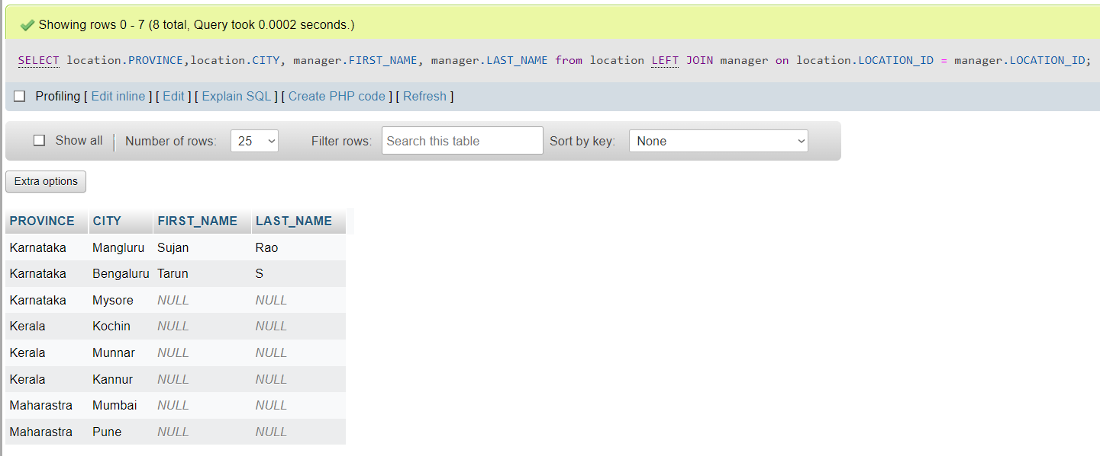

2)

SELECT customer.FIRST_NAME, customer.LAST_NAME,

transaction.GRANDTOTAL from customer RIGHT JOIN

transaction on customer.CUST_ID=transaction.CUST_ID;

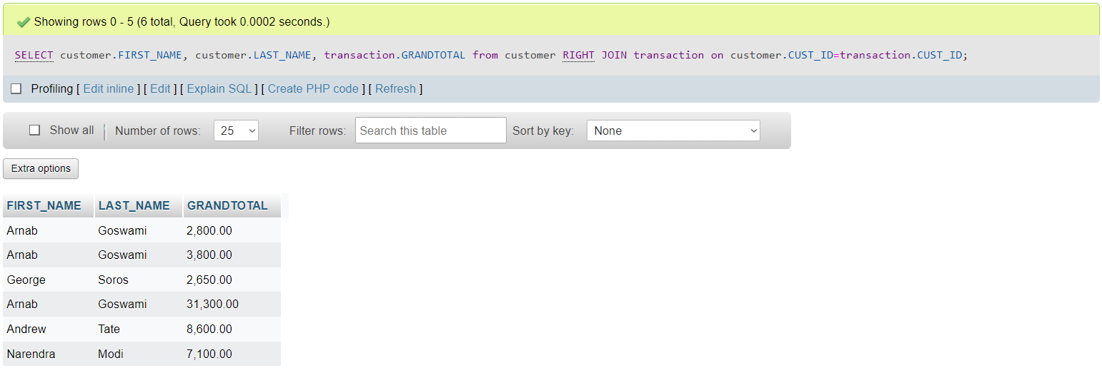

3)

SELECT employee.GENDER, employee.PHONE_NUMBER,

job.JOB_TITLE from employee INNER JOIN job

on employee.JOB_ID=job.JOB_ID; 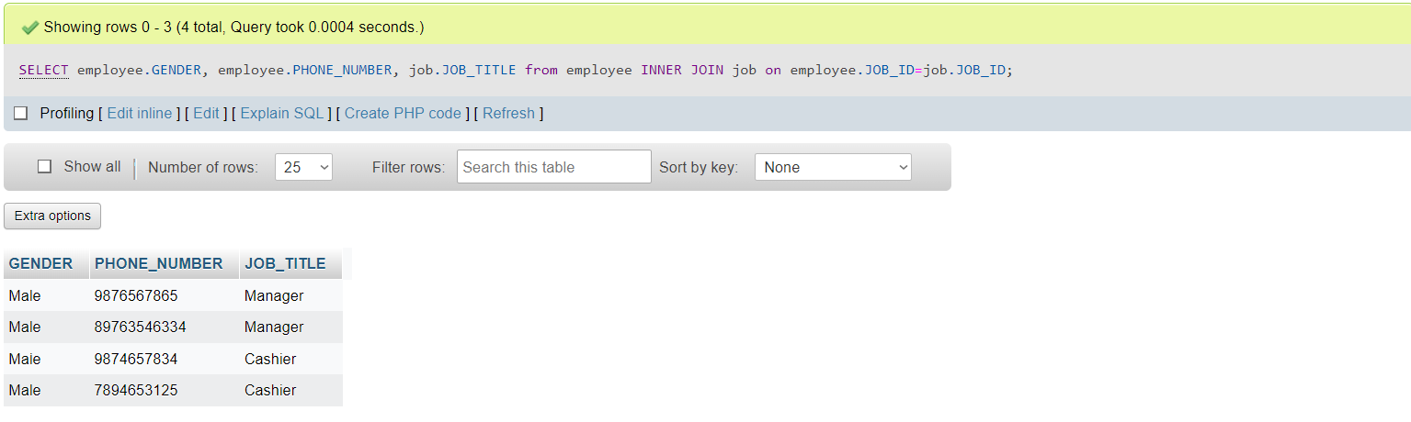

4)

SELECT supplier.SUPPLIER_ID, supplier.COMPANY_NAME, location.CITY, location.PROVINCE from supplier LEFT JOIN location on supplier.LOCATION_ID = location.LOCATION_ID

UNION SELECT supplier.SUPPLIER_ID, supplier.COMPANY_NAME, location.CITY, location.PROVINCE from supplier RIGHT JOIN location on supplier.LOCATION_ID = location.LOCATION_ID;

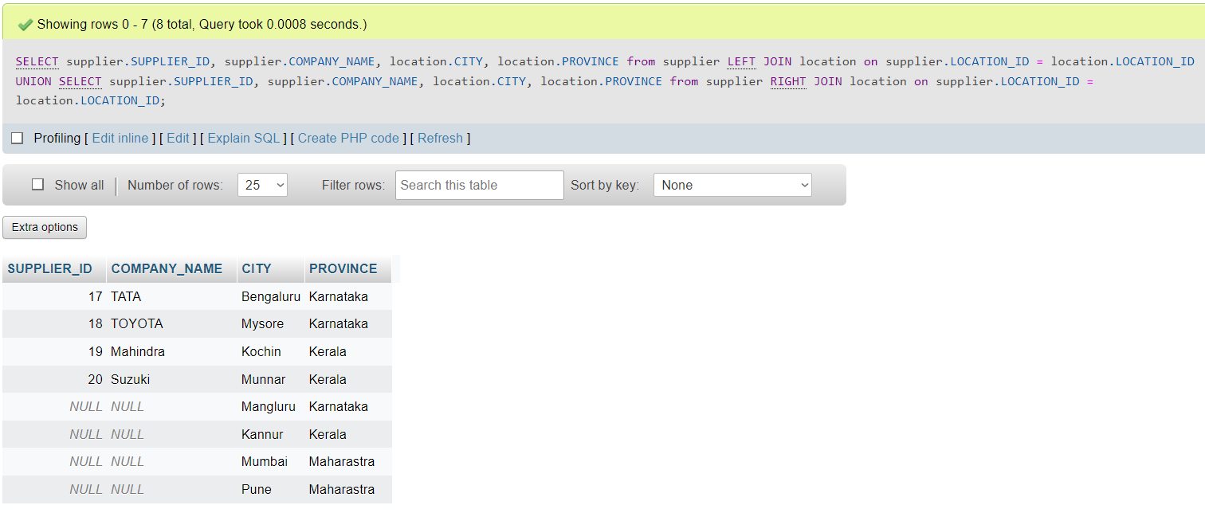

# Aggregate Functions

Showcase at least 4 Aggregate function queries

Write the query in English Language, Show the equivalent SQL statement and also a screenshot of the query and the results

1)

SELECT avg(PRICE) from transaction_details where EMPLOYEE = "Sujan";

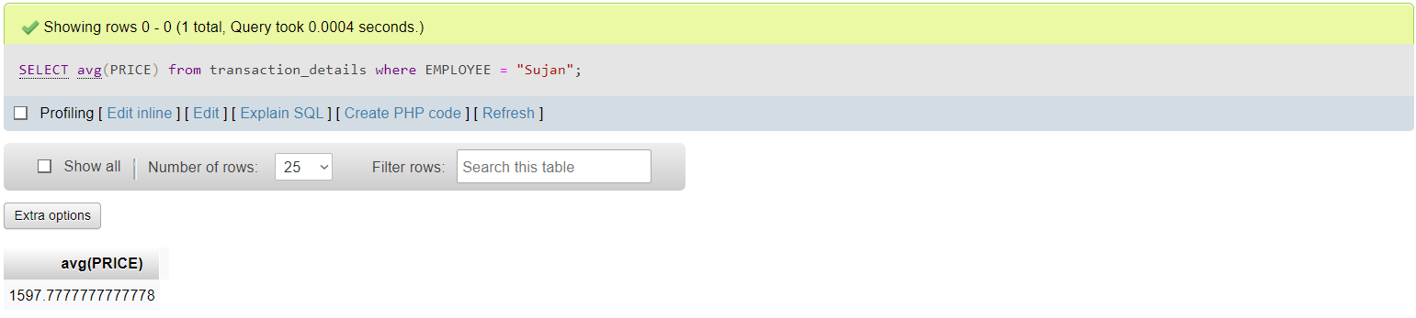

2)

SELECT max(GRANDTOTAL) from transaction where CUST_ID=19;

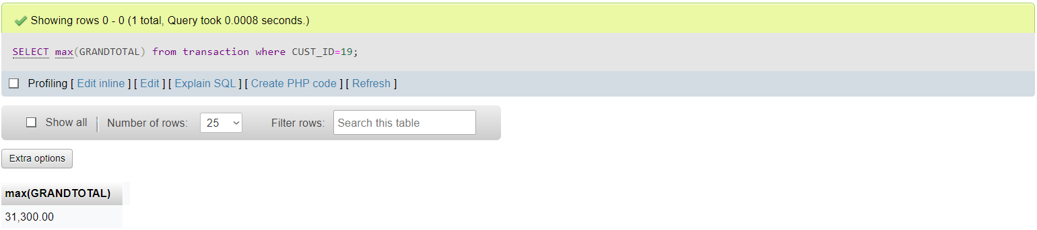

3)

SELECT COUNT(CITY) from location where PROVINCE="Karnataka";

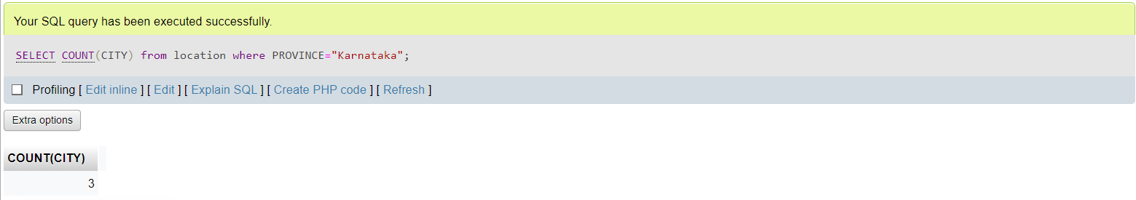

4)

SELECT SUM(QTY) from transaction_details where ROLE="Manager";

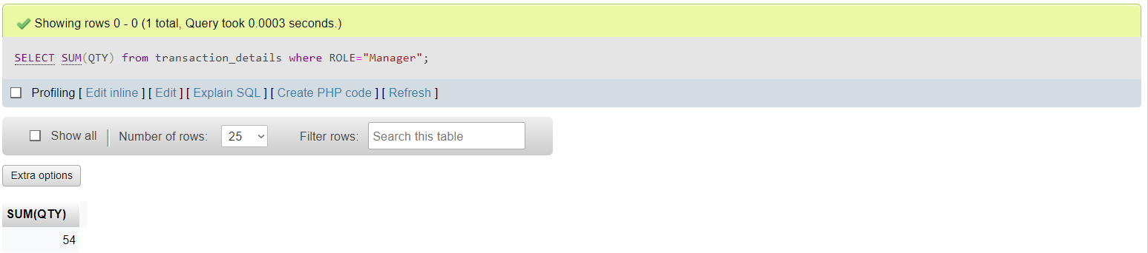

# Set Operations

Showcase at least 4 Set Operations queries

Write the query in English Language, Show the equivalent SQL statement and also a screenshot of the query and the results

1)

SELECT FIRST_NAME from employee UNION SELECT EMPLOYEE from transaction_details; 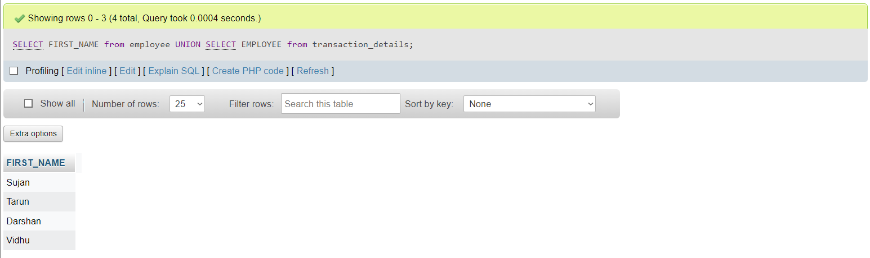

2)

SELECT LOCATION_ID from location INTERSECT SELECT LOCATION_ID from supplier;

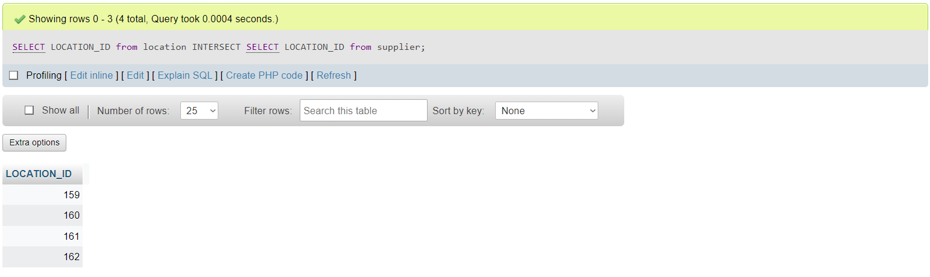

3)

SELECT LOCATION_ID from manager UNION ALL SELECT LOCATION_ID from location;

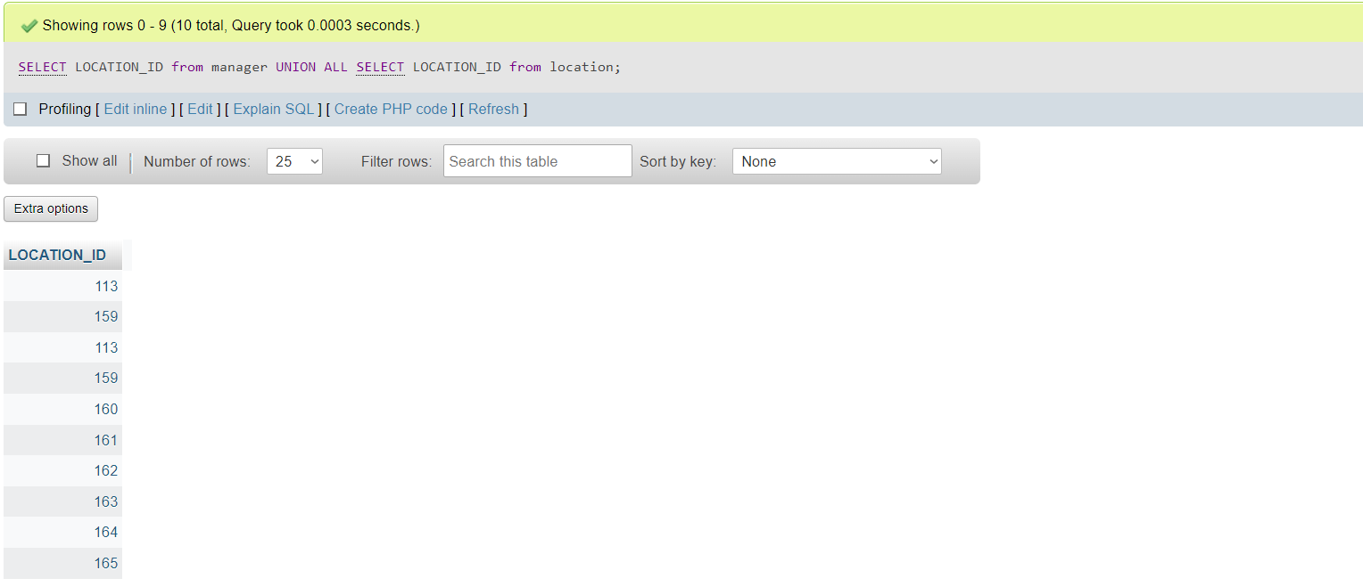

4)

SELECT EMAIL from employee UNION SELECT EMAIL from manager;

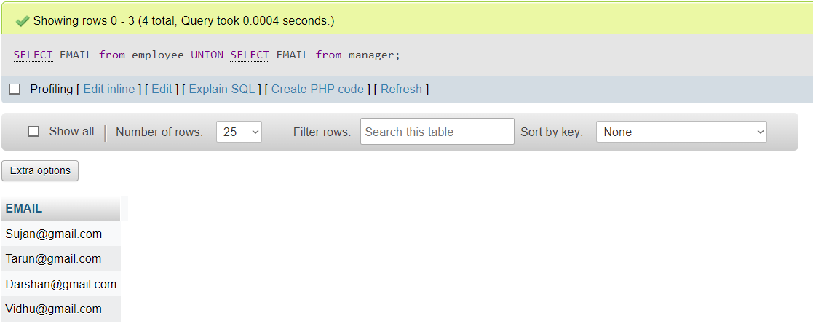

# Functions and Procedures

Create a Function and Procedure. State the objective of the function / Procedure. Run and display the results.

1)Function

The function returns the product_id when you enter the product’s name.

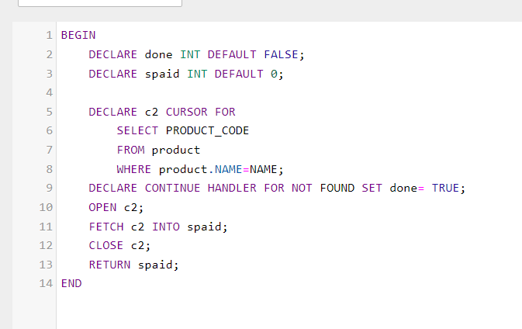

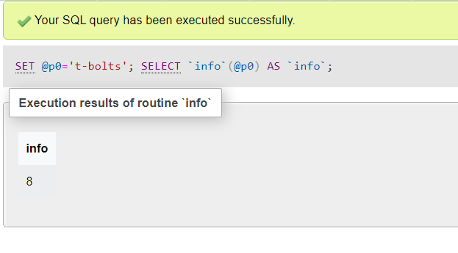

2)Procedure

The procedure returns the transaction details about the transaction which happened under a particular employee when you enter his name.

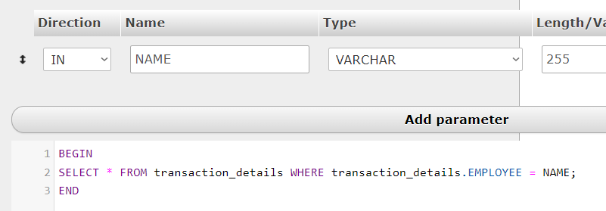

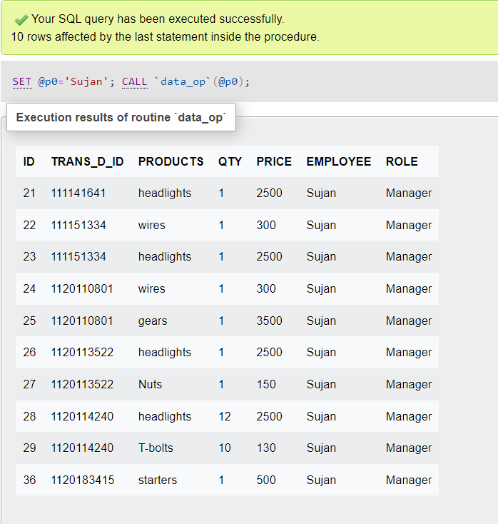

# Triggers and Cursors

Create a Trigger and a Cursor. State the objective. Run and display the results.

1. Trigger

The trigger automatically inserts the customer in uppercase when one enters them in the front-end

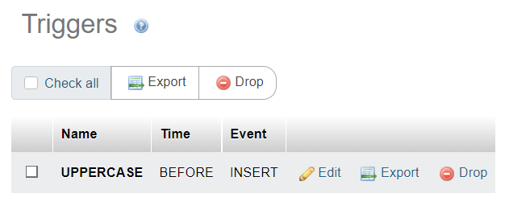

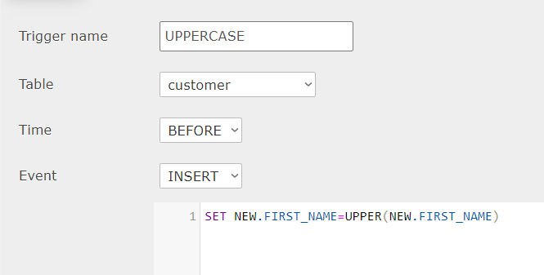

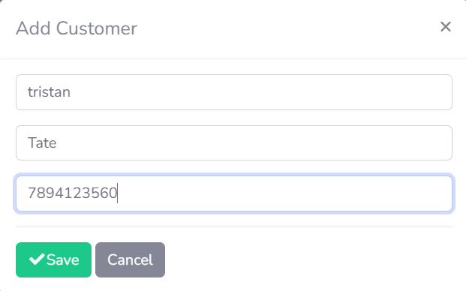

In database:

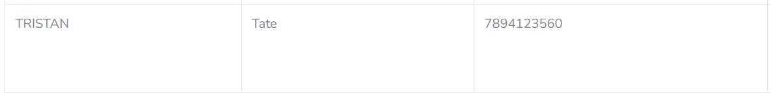

1. Cursor: The cursor is already present in the function. It returns the product_id when you enter the product’s name.

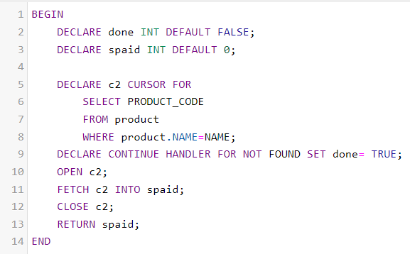

# Developing a Frontend

The frontend should support

1. Addition, Modification and Deletion of records from any chosen table

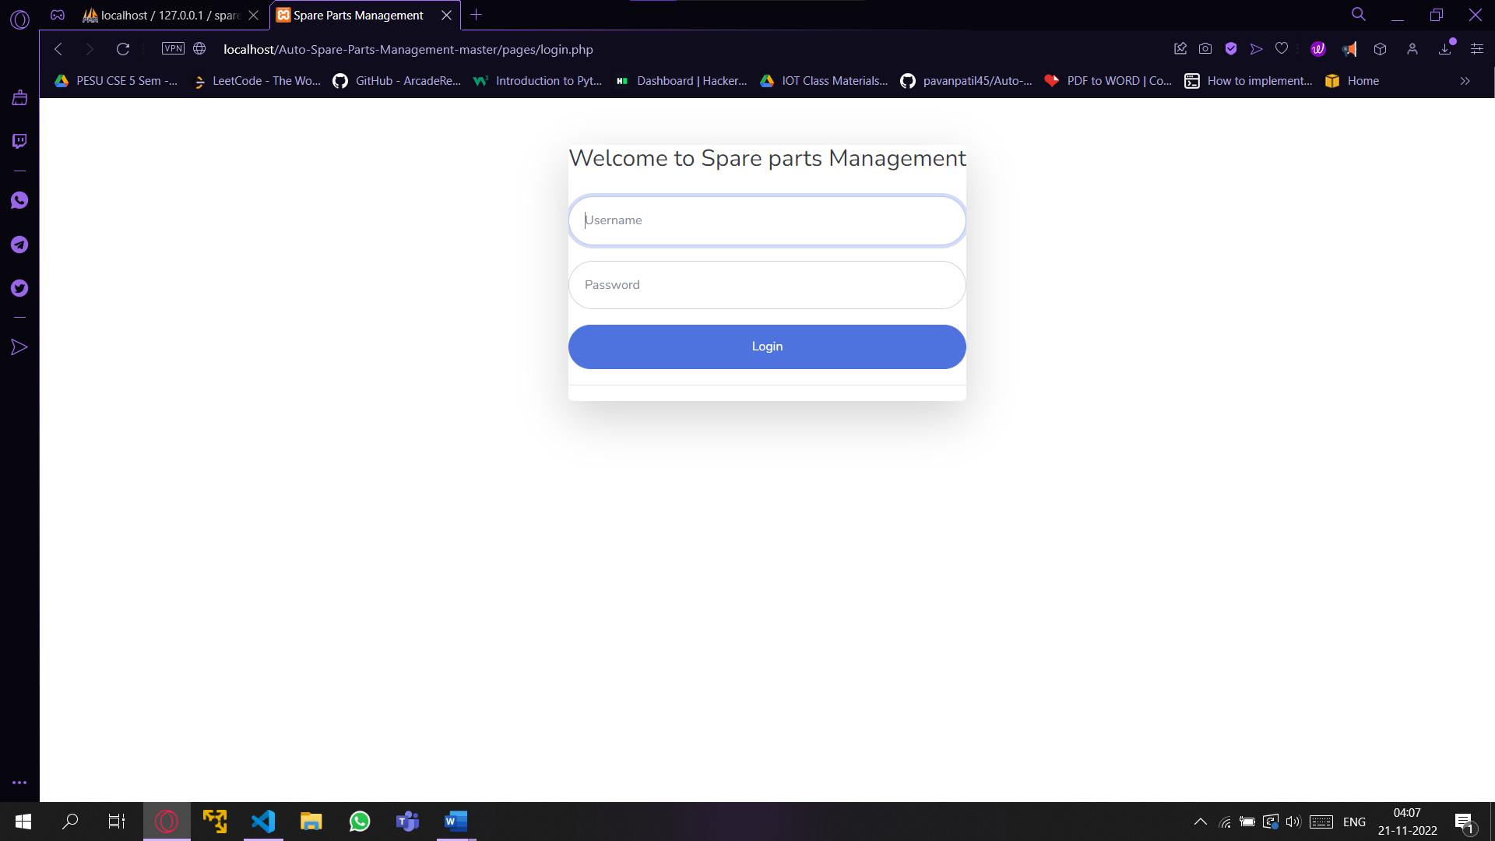

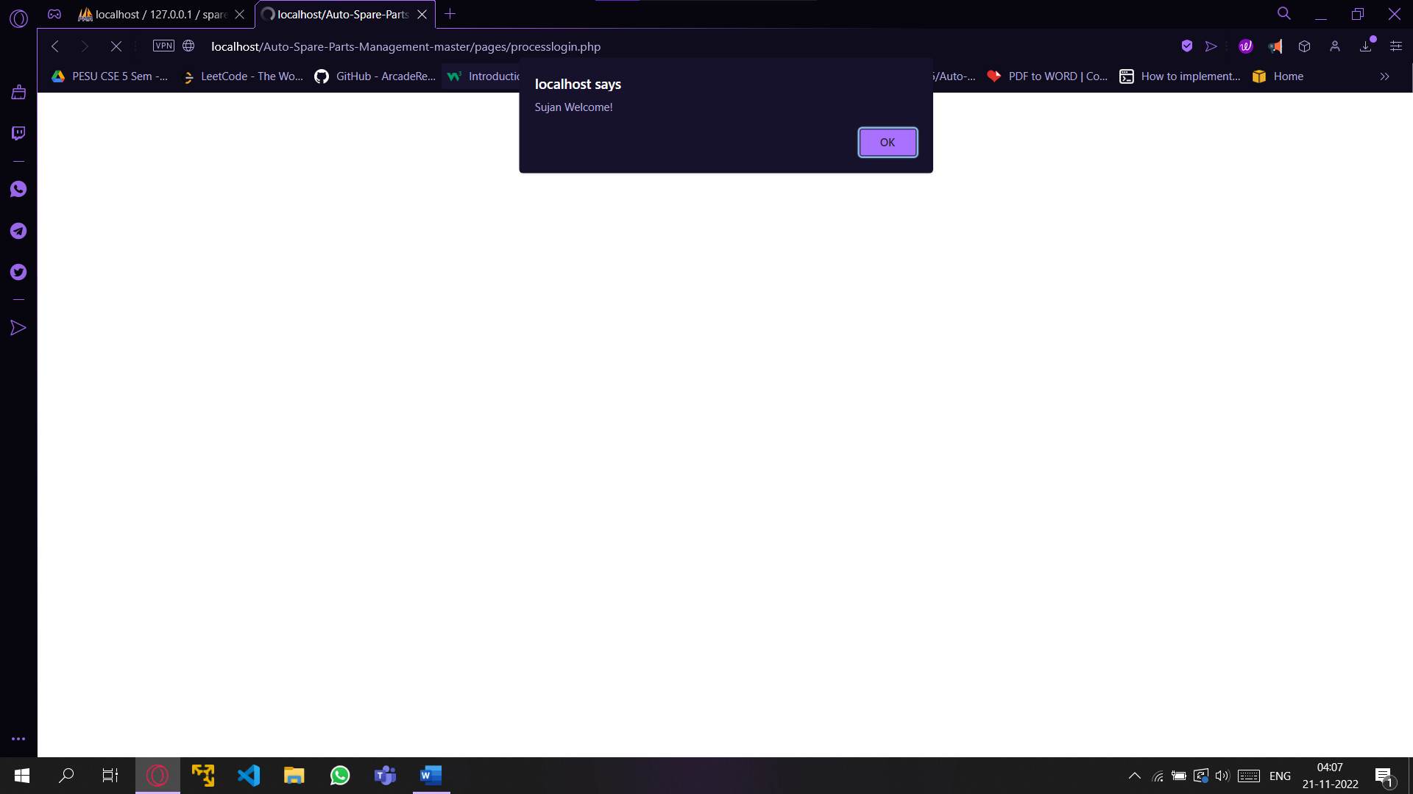

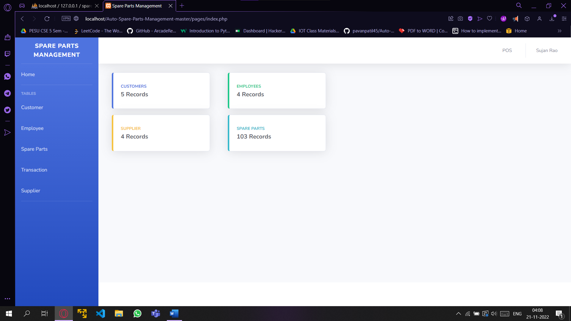

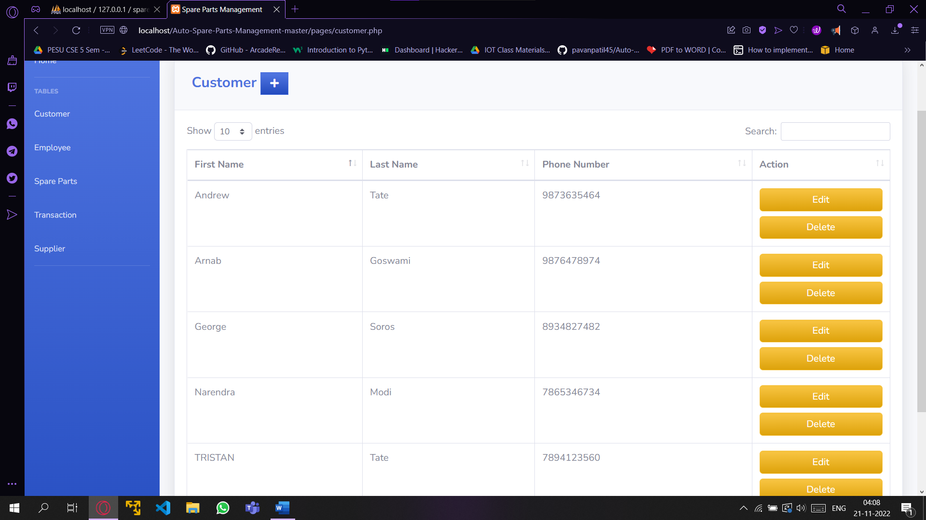

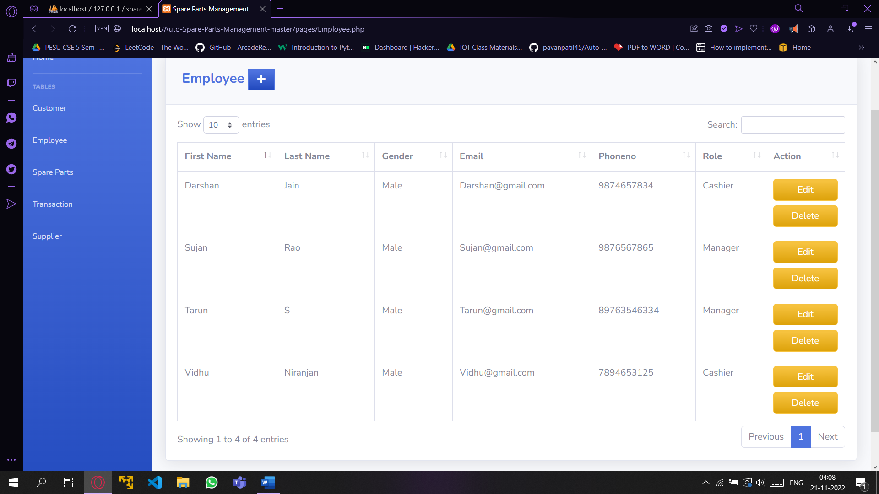

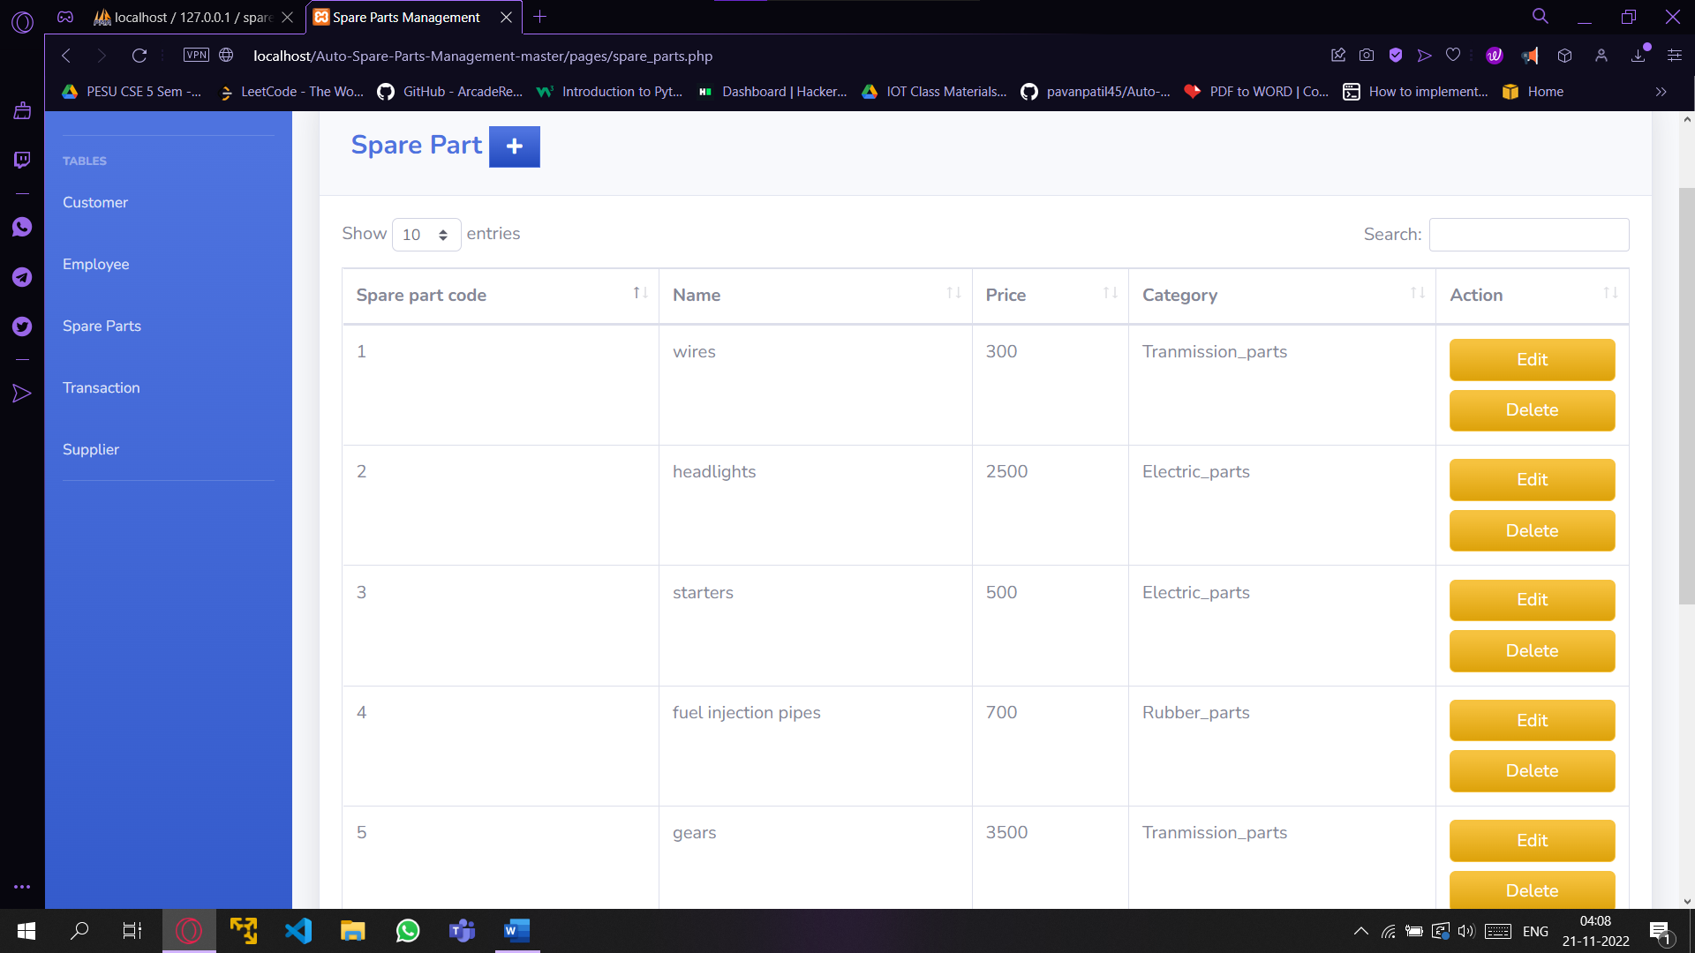

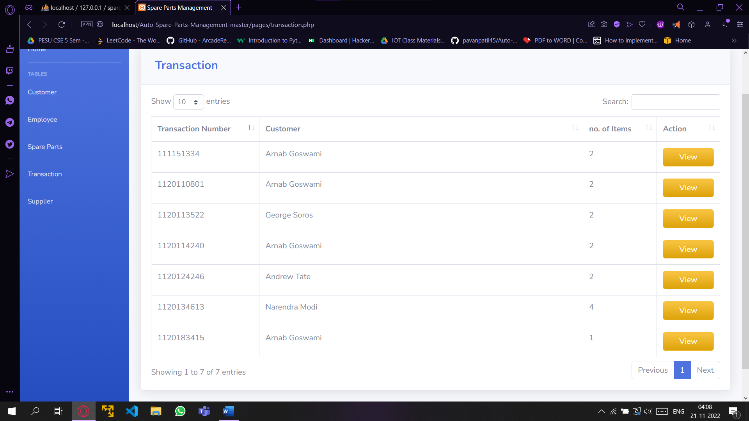

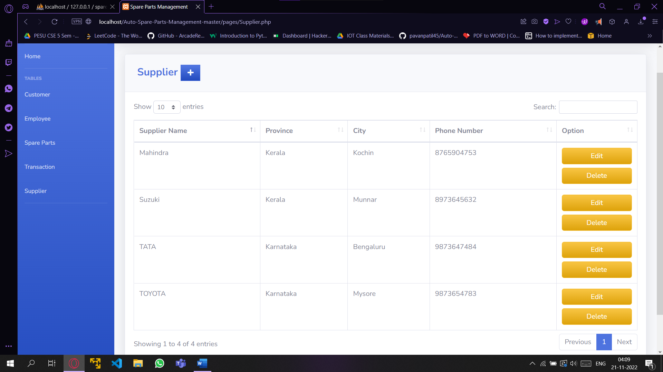

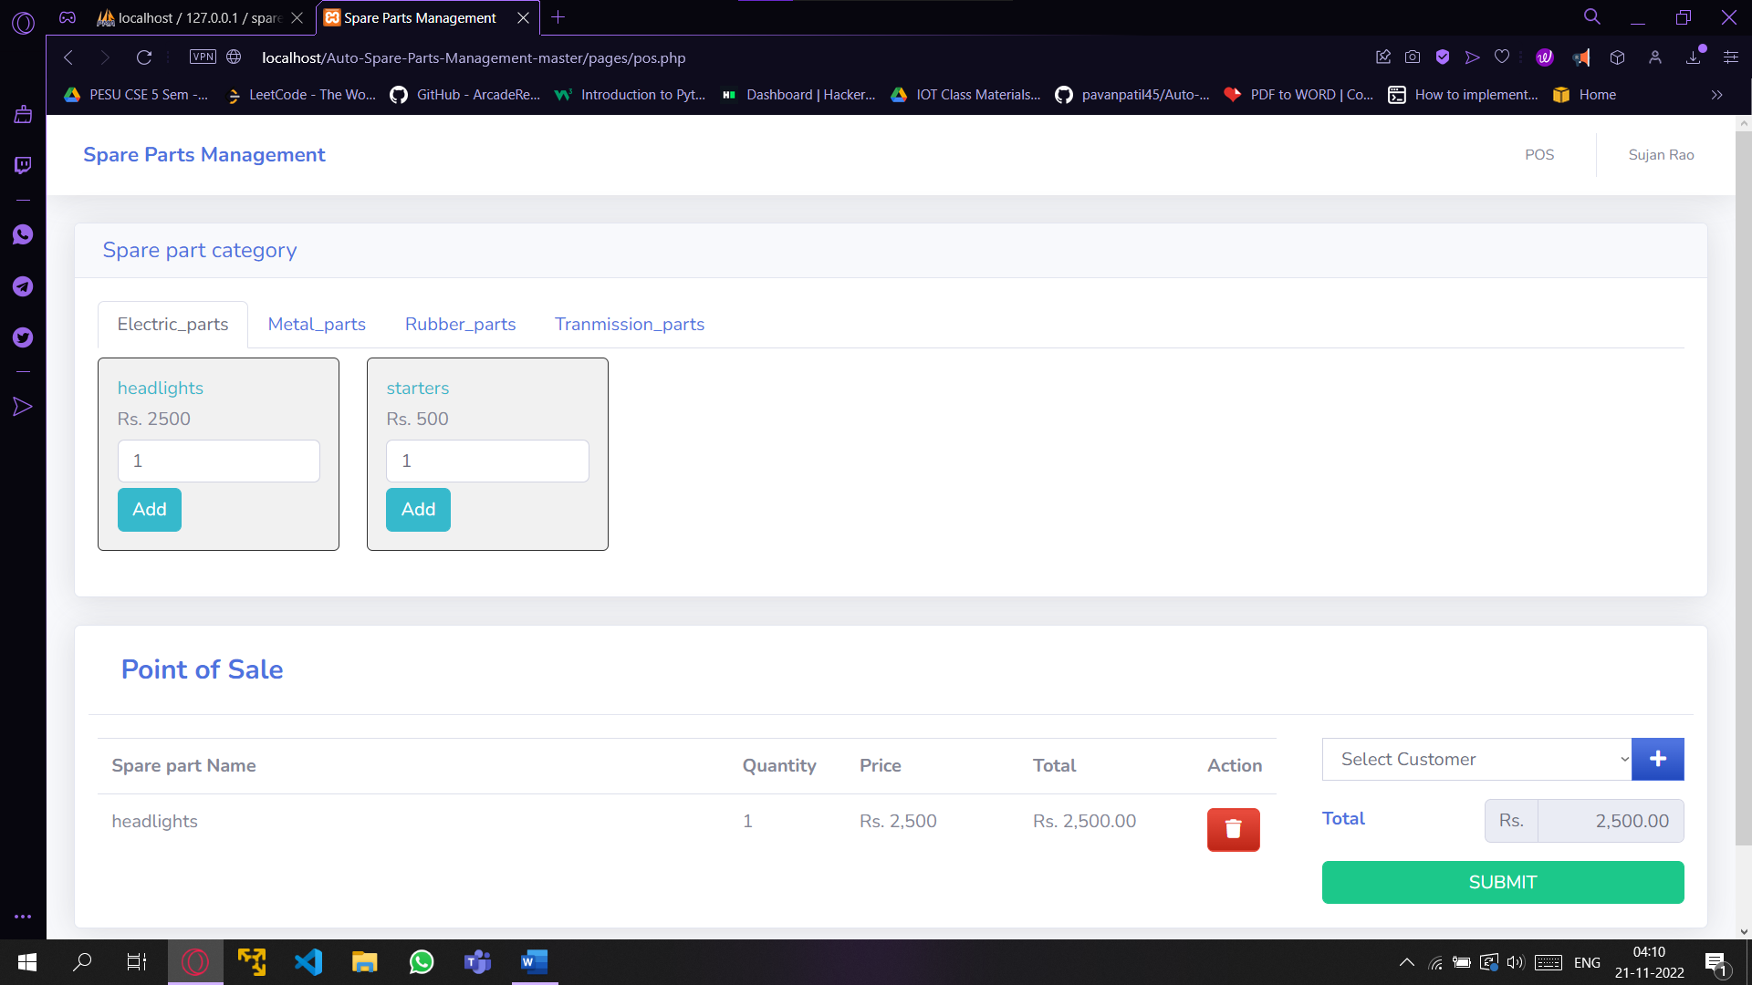

User_login:

