

Flower Shop

Web Application

**TECHNICAL DOCUMENTATION**

**USER GUIDE**

**TYLER LENTZ | ERIC JOHNSON | ARUN PARAMANATHAN**

**KANSAS STATE UNIVERSITY**

**TABLE OF CONTENTS**

**User Guide**

**User signup and login**

When you first open the page, if you are not automatically directed to the login form, please click the “Login” button in the top right corner. You should then see this:

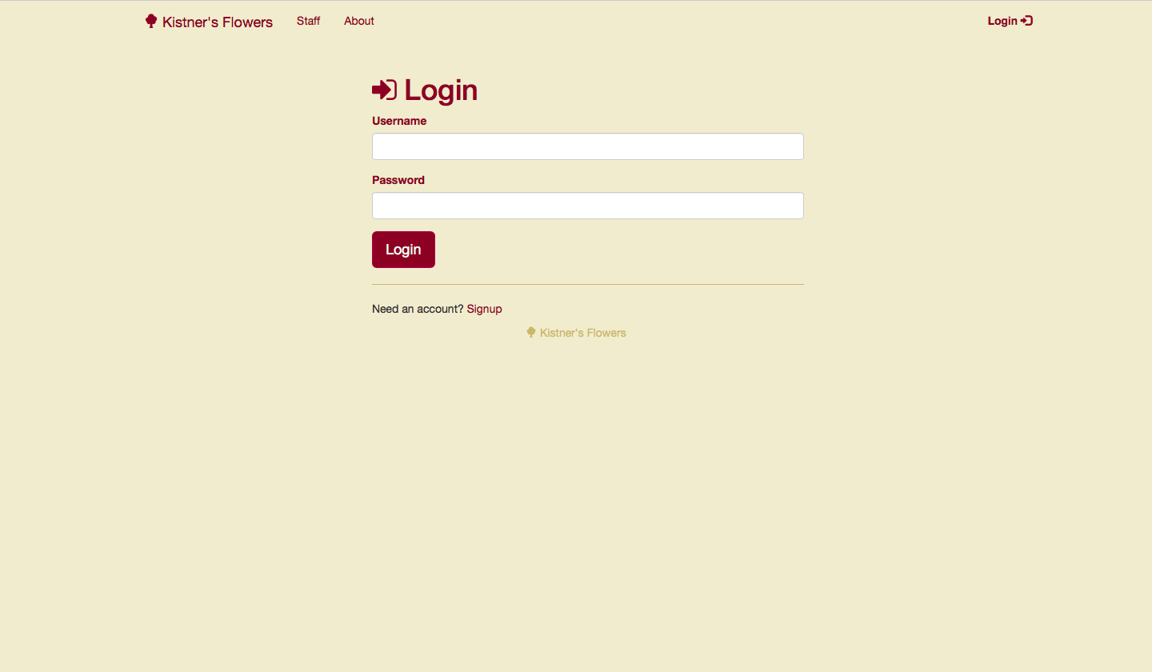

If you need a new account, please click the “Signup” button below the form. You should then see this:

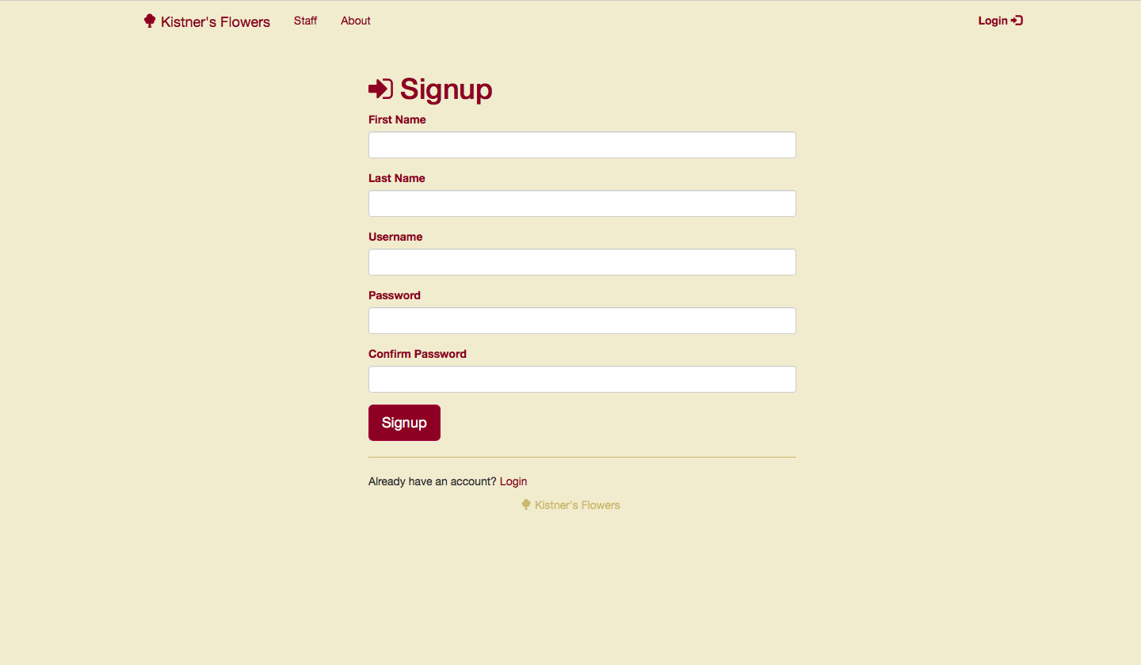

All fields are required. Fill them out and click “Signup” to create your account.

If your account credentials are not recognized, you will see the following error message:

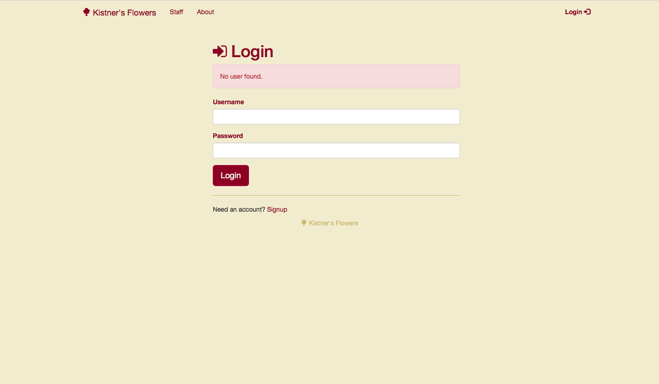

This means your username and/or password were not entered correctly. In this instance, please retry entering your credentials.

**Changing your password**

Click your username in the top right corner, and on the dropdown menu that appears, click “Account Settings”. You should then see this:

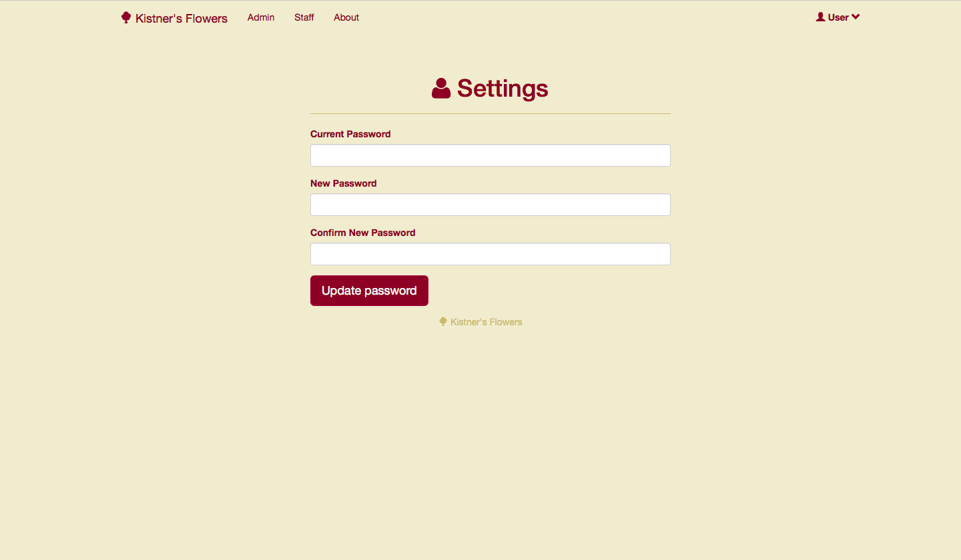

Enter your current password, and then enter the new password you wish to use. You will have to enter it twice to confirm it. Click “Update Password” to finish the process.

**Administrator Page**

The admin user will have access to the following page where they can view and edit users, inventory, and inventory types:

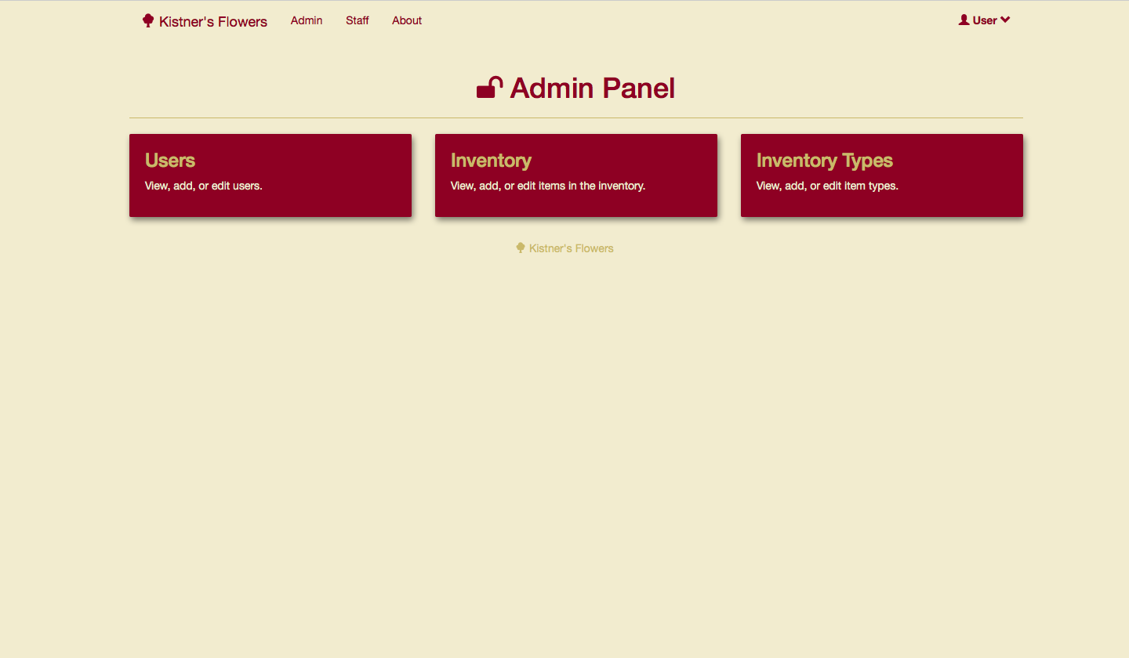

**Staff Page**

The staff page allows you to view users and inventory. This is also where you can begin creating a new event or view all previously created.

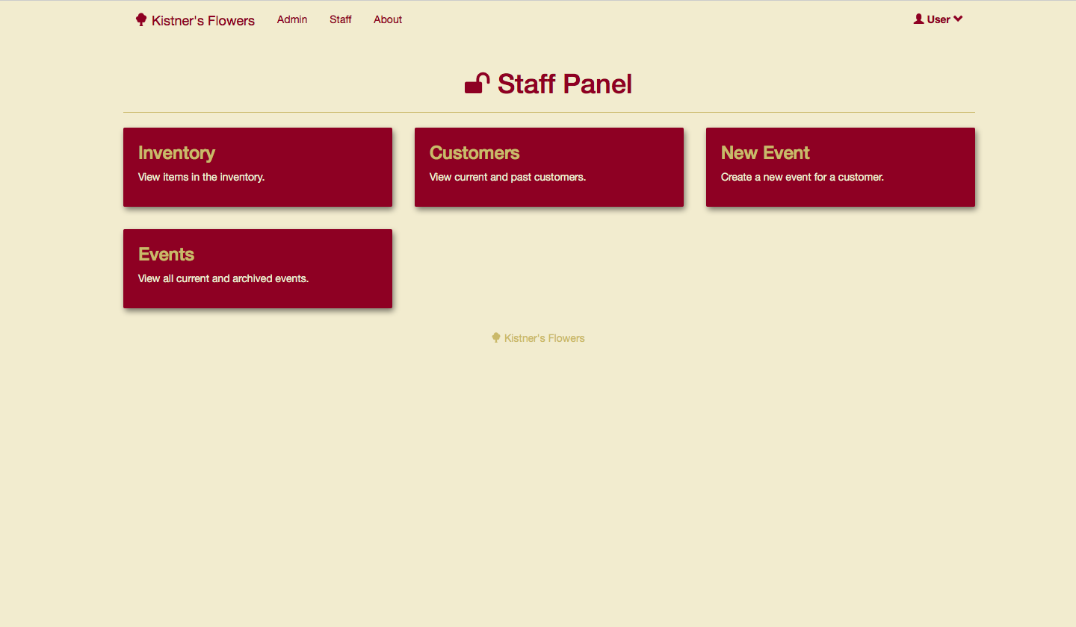

**Editing tables**

Most of the information in the web app is displayed in a table format. The image below shows the “Inventory” page for example. The other tables follow a similar format. You can click the “Add New” button in the top left to add a new entry into the table. Beside each entry, you can click the “Edit” button to edit and update the information for that item. The search bar provides a quick way to find the item you are looking for.

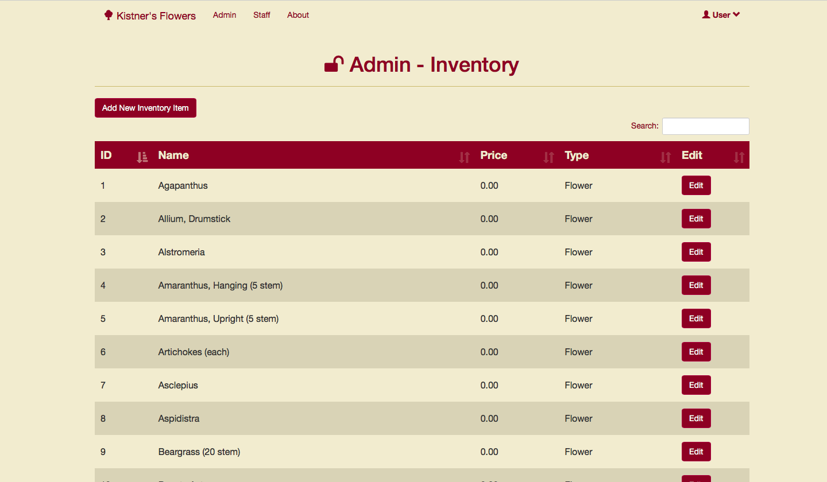

Here is what you will see when adding a new item:

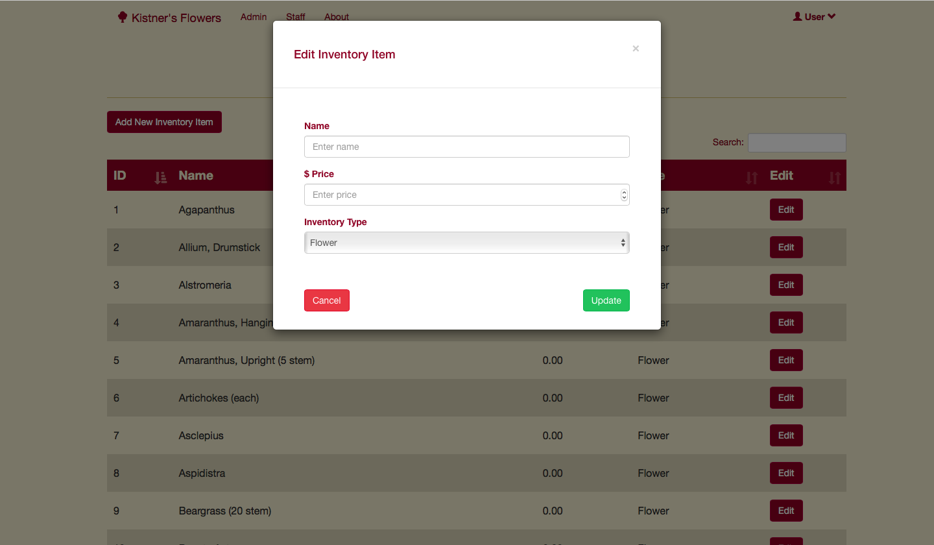

And this is what you see when editing an existing item:

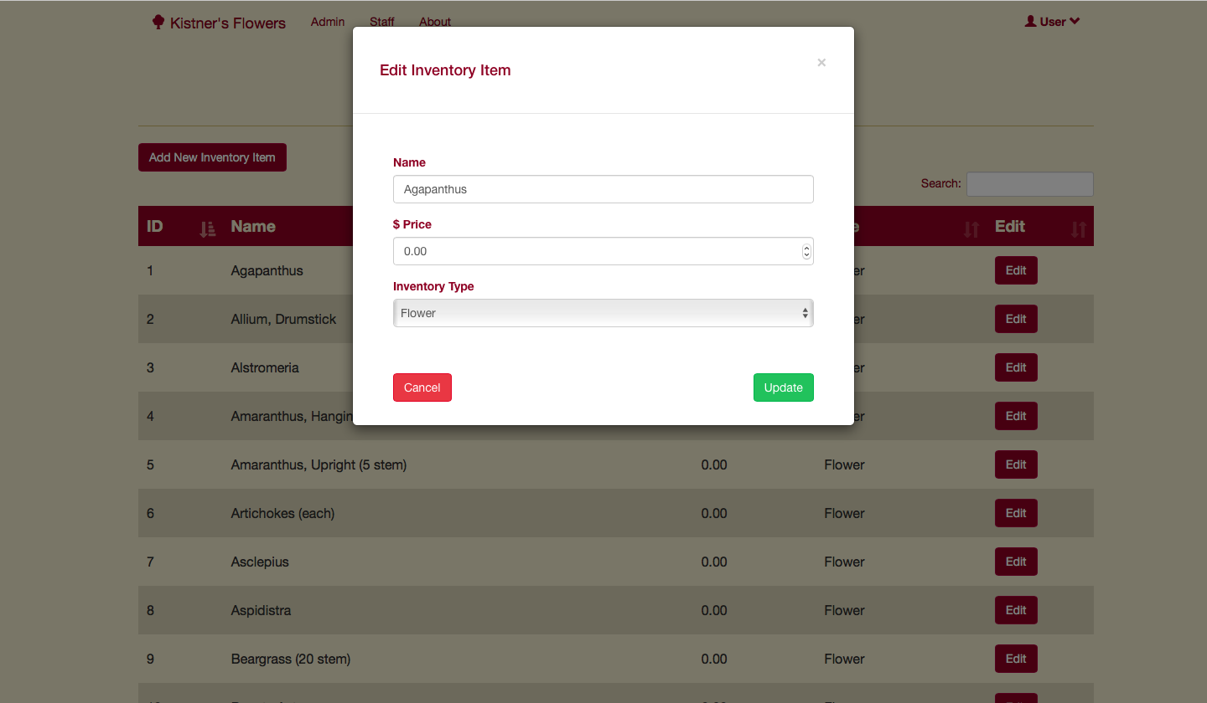

**Creating a new event**

When you click on “New Event”, the event creation form will appear. The sidebar on the left shows the grand total of the order. You can use the quick-links in the sidebar to navigate to different section of the form more quickly. The “Save” button can be pressed at any time to save your progress on the form.

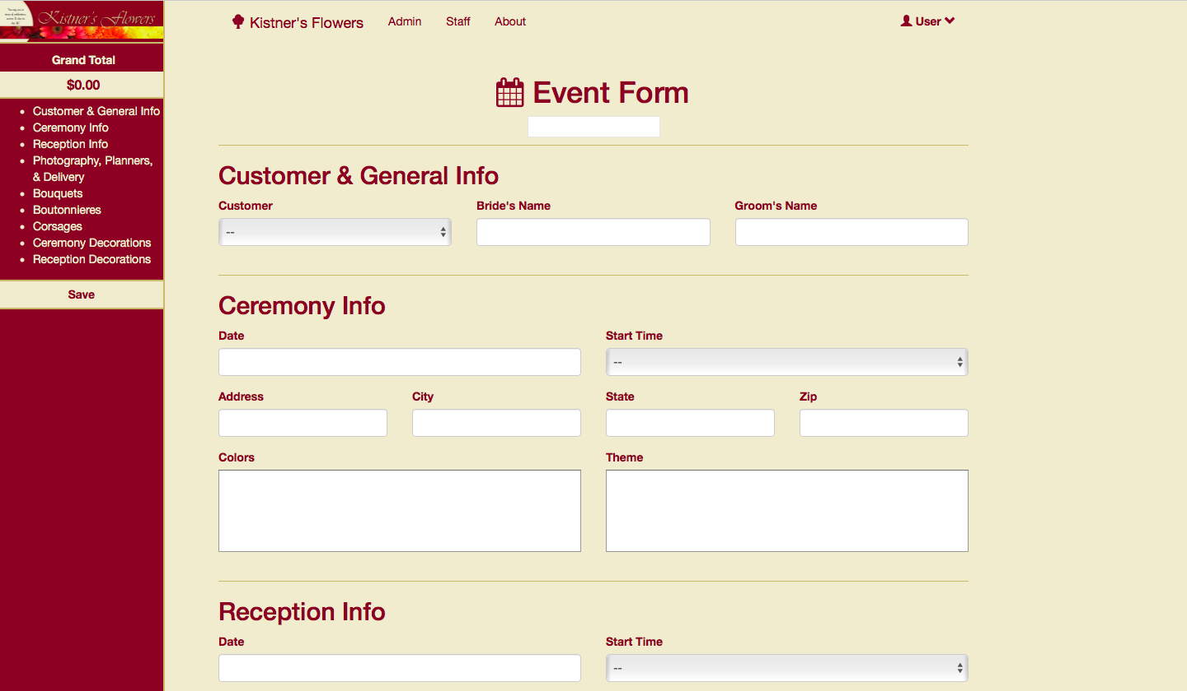

The tables in this form are like the other tables in the web app. Once an item is added, the table’s total and grand total will be updated on the form. The “+” and “-” buttons can be used to increase and decrease the quantity of an item in the table. The “x” button will remove the row entirely. The “Qty” field on the right determines how many of each table will be placed on the order. For example, in the image below, if we need 5 sets of bouquet orders, we can set “Qty” to 5. The grand total price will update accordingly.

