LOAN DEFAULT RISK ANALYSIS DASHBOARD

A Data-Driven Approach to Identify High-Risk Customers

Name: KS VIGNESHWARAN
Institution: IMARTICUS
Course: Postgraduate Program in Data Science and Analytics with GenAI

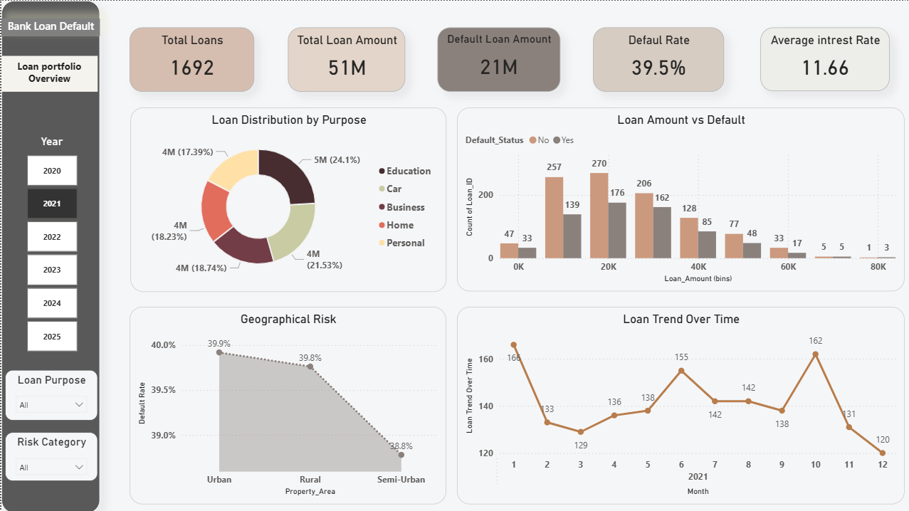

This project analyzes loan data to identify key factors influencing default risk and helps financial institutions make better decisions.

