To solve this I use python program with pandas

import pandas as pd

grocery = pd.read_csv("main.csv")

grocery.head()

**Expected output:-**

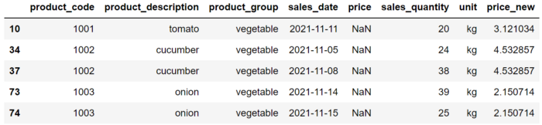

grocery.groupby('product_description')['price'].mean()

grocery["price_new"] = grocery['price'].fillna(

grocery.groupby('product_description')['price'].transform("mean")

)

grocery[grocery["price"].isna()].head()