**Problem Statement:**

We all love to follow to sports but it becomes difficult when at times when you have lot of work on the day of match. We can use our smartphone to get the score updates but the problem is that as soon as we start using the smart phone we stick to it by using social media,watching videos and other sources of entertainment so our important work for that day is NOT going to be completed. So my aim was to get score updates without using a smartphone or a computer.

**Solution:**

I have built a novel method to get live score updates on a simple Nokia screen using a wifi module. So that we can enjoy the match without any other distractions during our work. The device built is very cheap, simple,portable and energy efficient. It uses minimum hardware in a creative way.

**Components Required:**

1. Nokia 5110 GLCD
2. NodeMCU 1.0

**Circuit Diagram:**

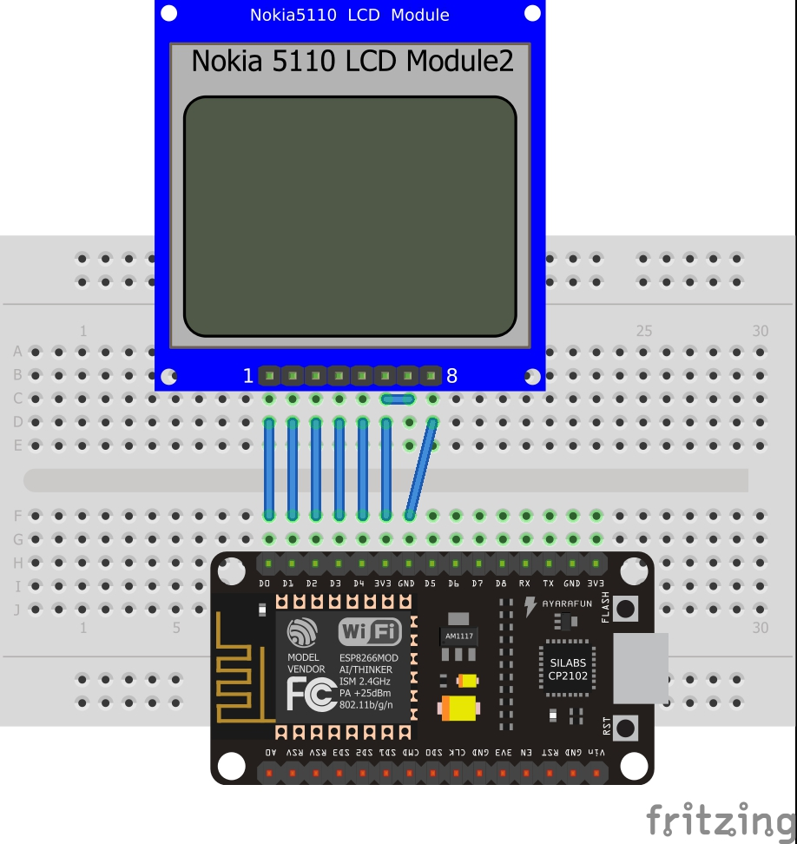

|  |  |
| --- | --- |
| **Nokia 5110 Display** | **Node MCU** |
| **RST** | **D0** |
| **CE** | **D1** |
| **DC** | **D2** |
| **DIN** | **D3** |
| **CLK** | **D4** |
| **VCC** | **3.3 V** |
| **BL** | **3.3 V or 5V** |
| **GND** | **GND** |

**Description:**

The basic principle of my project is to fetch score from the internet and and show it on the Nokia lcd screen. Firstly to fetch data we are using NodeMCU which is simple arduino with a wifi module( to be specific esp8266). It is an low cost device used extensively nowadays in the field of IoT and automation. It connects with the local wifi connection whose SSID and PASSWORD are hardcoded into the module. Now from where can we get the score on internet?

There are many API's available for this purpose. I have used CricScore API which is a free API with unlimited calls. There are many other such API's but some were blocked in my college's wifi. Every API has certain set of rules so builders shoud choose the API at their own risk.

So after going through the documentation of the API we found that it has two basic requests. In one request it sends tha data of the ongoing matches of that day with a unique id of each match. And in the second request if we pass the id of a particular match then it will send the scorecard of that match.

So first we made a POST request from the NodeMCU to the host of the API to get the id of the match we wanted to watch. Then once we got the id of our match now we have to pass the id of our match in the POST request then the API sends the data in JSON format which is received by the NodeMCU. Now we have extract our required information from the response. We can use either JSON parser libraries for arduino or simple string manipulations to extract data. I have used string manipulation as the response was not very complex and had only few data.

Now after getting our required information from the internet we have to display it. I have used Nokia 5110 GLCD for this purpose which a 84*48 pixel display with backlight. You can use any other display of your choice. We have interface this display module with our NodeMCU so I have used Adafruit PCD8544 Nokia5110 LCD Library which makes our things simple. I have also used Adafruit GFX Graphics library to make some graphics on the start of the display. I am going to extend by adding a certain graphics on every boundary in case of a cricket match also I will add few buttons to make it more interactive.

**Other Technical Details:**

Request: ( for match id )

GET /csa HTTP/1.1 Host: cricscore-api.appspot.com

Response:

HTTP/1.1 200 OKContent-Type: application/json[{"id":631136,"t2":"Kenya","t1":"Scotland"},{"id":585683,"t2":"England XI","t1":"Essex"},{"id":593618,"t2":"Worcestershire","t1":"Gloucestershire"},{"id":593617,"t2":"Sussex","t1":"Middlesex"},{"id":593615,"t2":"Durham","t1":"Yorkshire"},{"id":593616,"t2":"Surrey","t1":"Kent"},{"id":597924,"t2":"India","t1":"West Indies"}]

Request: ( for score of match id="xxxxxxxx")

GET /csa?id=xxxxxxxx HTTP/1.1Host: cricscore-api.appspot.com

Response:

HTTP/1.1 200 OK Content-Type: application/json  
[{"de":"WI 25/2 (3.1 ov, J Charles 12*, UT Yadav 2/7)","id":597924,"si":"West Indies 25/1 * v India 229/7"}]

**Prototype :**

