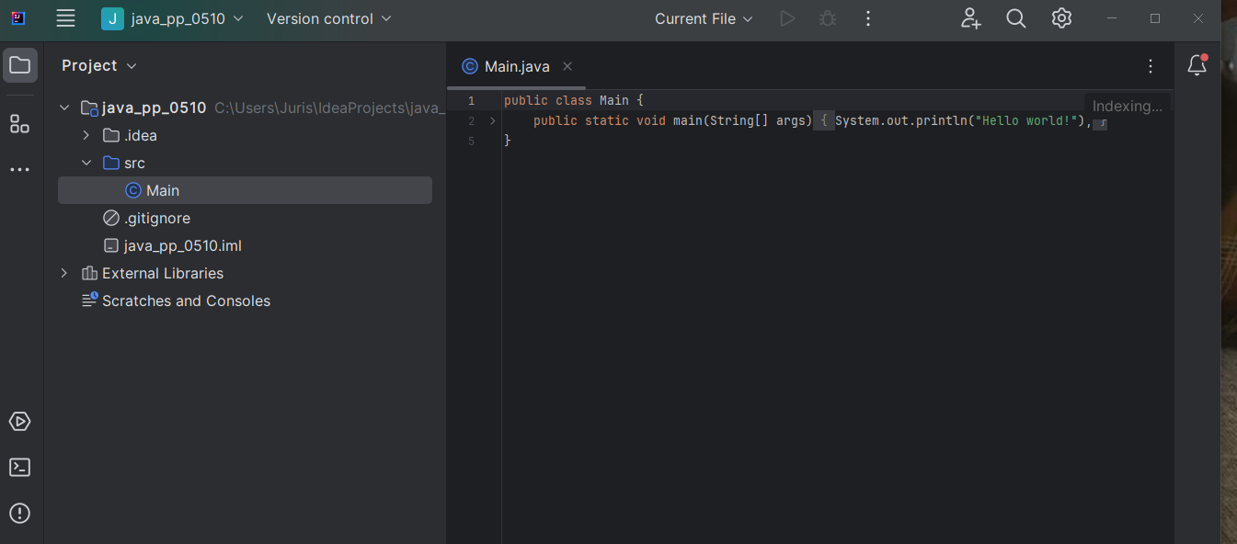

.gitignore- lietas, ko negrib augšuplādēt mākonī.

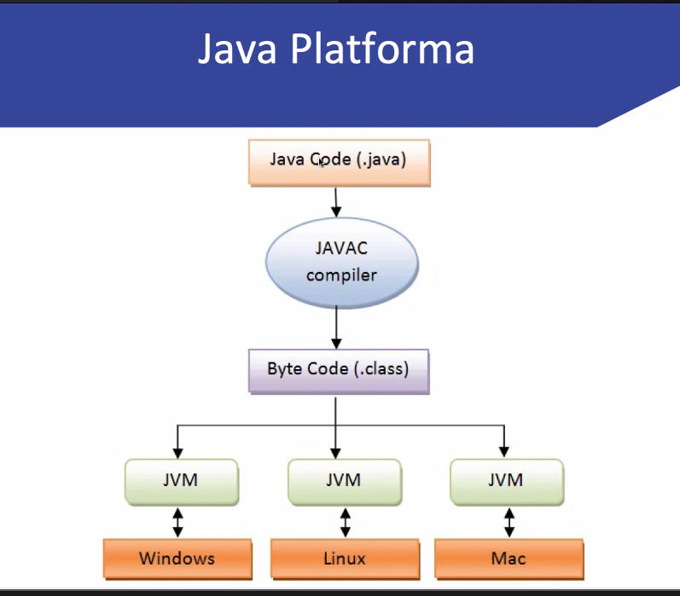

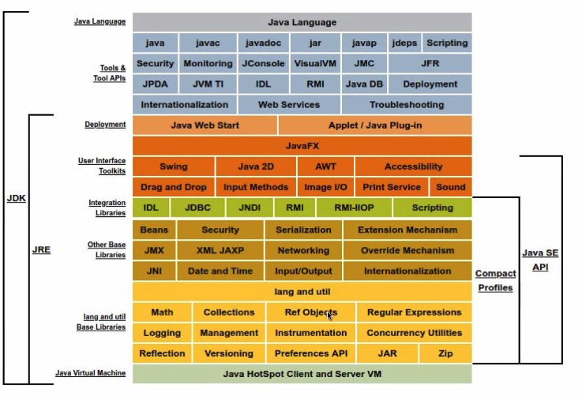



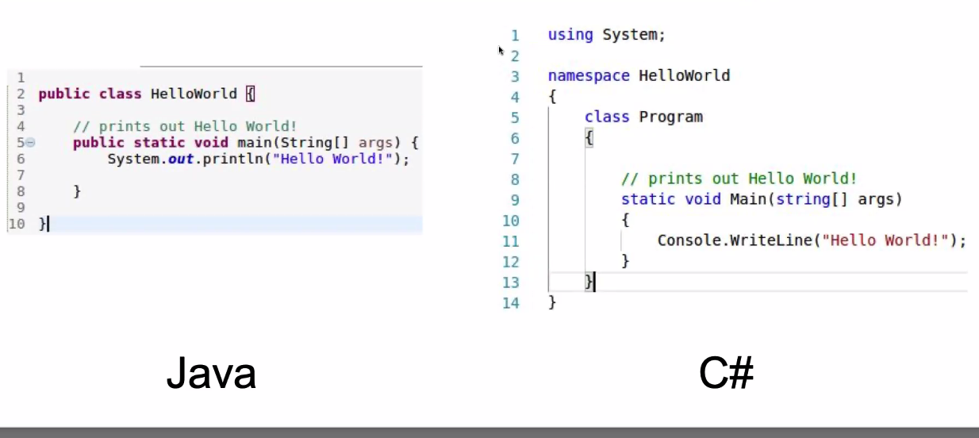

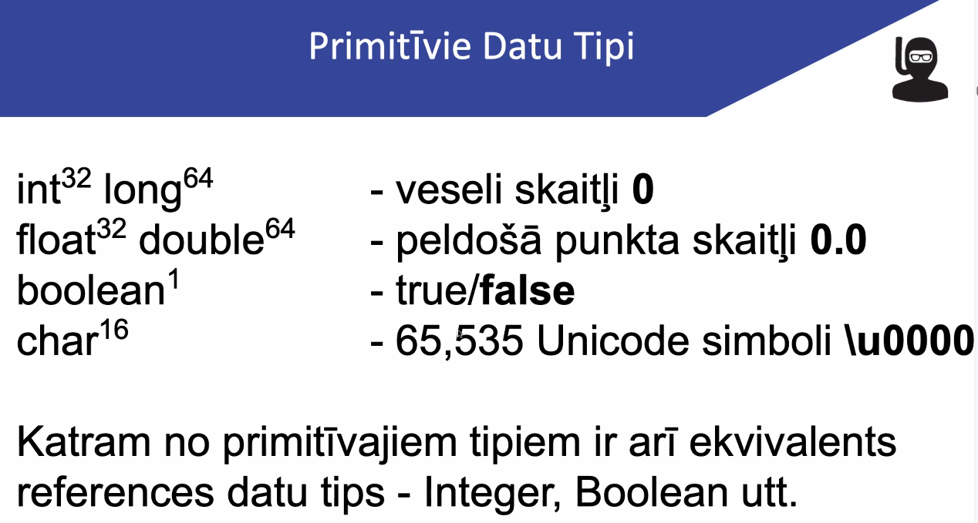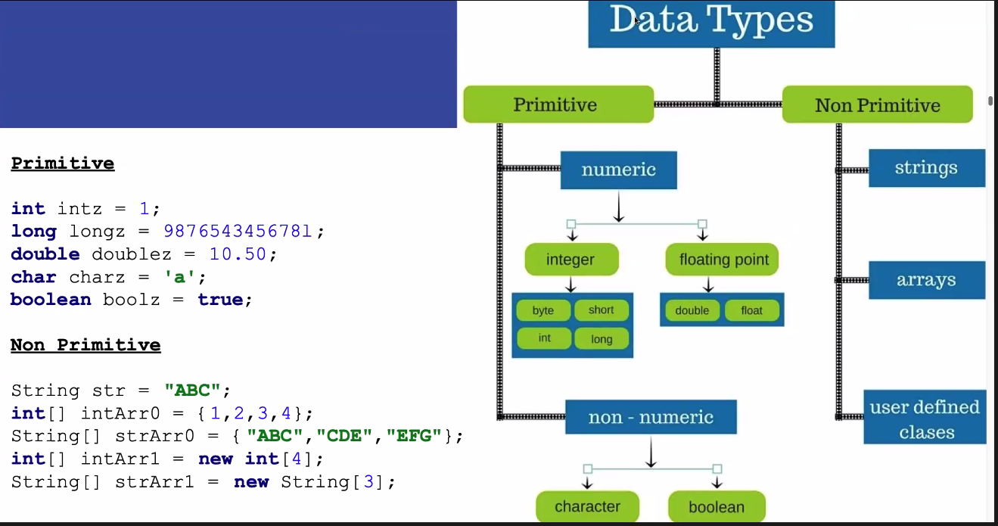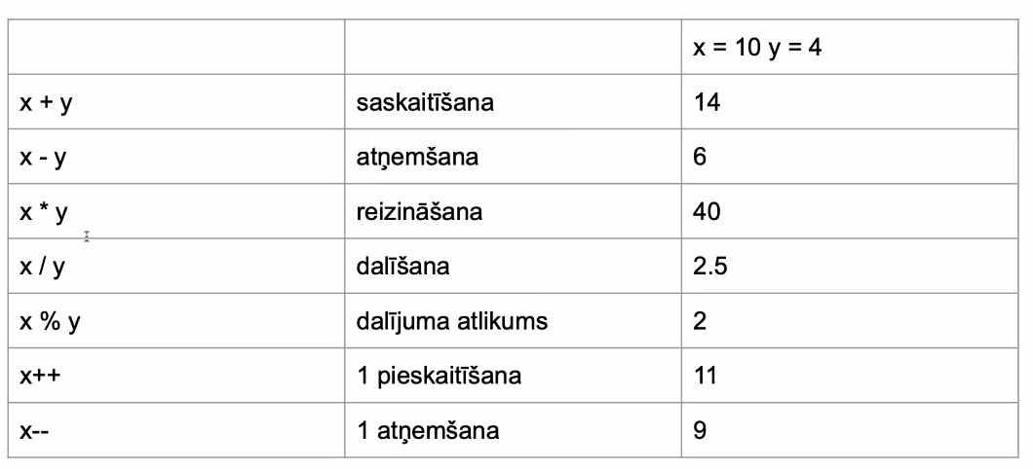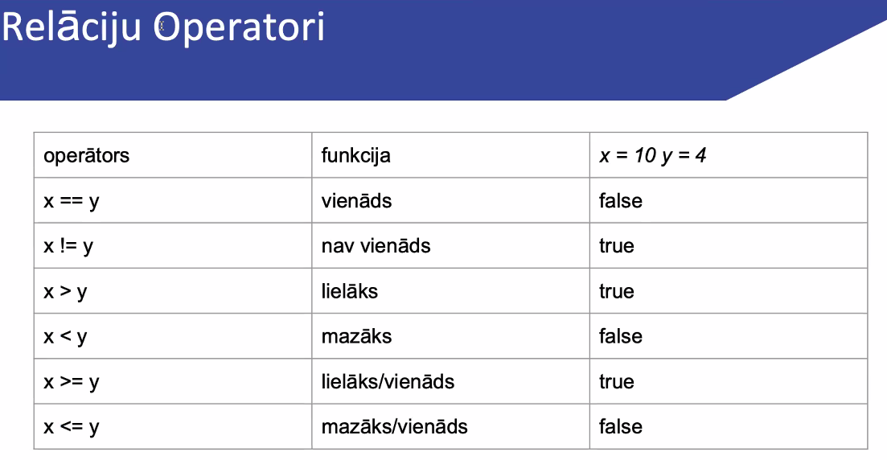

public class Main {  
 public static void main(String[] args) {  
  
 System.*out*.println("Hello world!");  
  
 // byte= 1 byte  
 byte airQualityIndex = 50;  
  
 // short = 2 byte,  
 short sdfsf = 2023;  
  
 //int = 4 byte  
 int age = 45;  
  
 // long = 8 byte  
 long clickCount = 2334555331L;  
  
 //float = 4 byte  
 float currentTemperature = 22.5F;  
  
 // double = 8 byte  
 double currencyExchangeRate = 1.234534D;  
  
 //char = 2 byte  
 char answer_a = "a";  
   
 boolean isTrue = true;  
   
   
 String name = "Madars";  
 }  
}

ublic class Main {  
 public static void main(String[] args) {  
   
 final String name= "Madars";  
  
 System.*out*.println(name);  
  
 int age = 20;  
  
 System.*out*.println(age);  
  
 age = 15;  
  
 System.*out*.println(age);  
  
 String city = "Rīga";  
  
 System.*out*.println("Sveiki " + name + "! Tu dzīvo " + city);  
 }  
}

import java.util.Scanner;  
  
public class Main {  
 public static void main(String[] args) {  
  
 Scanner scan = new Scanner(System.*in*);  
  
 System.*out*.println("Kā Tevi sauc?: ");  
 final String name= scan.nextLine();  
  
 System.*out*.println(name);  
  
 int age = 20;  
  
 System.*out*.println(age);  
  
 age = 15;  
  
 System.*out*.println(age);  
  
 System.*out*.println("Kur Tu dzīvo?: ");  
 String city = "Rīga";  
  
 System.*out*.println("Sveiki " + name + "! Tu dzīvo " + city);  
 }  
}