JAWAHARLAL NEHRU TECHNOLOGICAL UNIVERSITY HYDERABAD
COLLEGE OF ENGINEERING
DEPARTMENT OF COMPUTER SCIENCE AND ENGINEERING
ACADEMIC YEAR 2025–2026
LUNGAI: LUNG DISEASE DETECTION AND CLINICAL TRIAGE ASSISTANCE FROM CHEST X-RAY USING DEEP LEARNING
A Project Dissertation Submitted in Partial Fulfillment
of the Requirements for the Award of the Degree of
MASTER OF TECHNOLOGY
in
COMPUTER SCIENCE AND ENGINEERING
Submitted by:
SATHWIK KATKAM
(Roll No: 22011D0501)
Under the Guidance of:
Internal Guide
Assistant Professor

CERTIFICATE
This is to certify that the project dissertation entitled "LUNGAI: LUNG DISEASE DETECTION AND CLINICAL TRIAGE ASSISTANCE FROM CHEST X-RAY USING DEEP LEARNING", submitted by SATHWIK KATKAM (Roll No: 22011D0501) in partial fulfillment of the requirements for the award of the degree of MASTER OF TECHNOLOGY in COMPUTER SCIENCE AND ENGINEERING from JAWAHARLAL NEHRU TECHNOLOGICAL UNIVERSITY HYDERABAD, is a bona fide record of original research work carried out under proper academic supervision and guidance during the academic year 2025–2026.
The results and conclusions embodied in this dissertation have not been submitted to any other university or institute for the award of any degree, diploma, or fellowship. All external datasets, research literature, and algorithmic foundations have been appropriately acknowledged and cited.
Internal Guide Head of the Department External Examiner
Assistant Professor Professor & Head External Examiner

DECLARATION
I hereby declare that the project dissertation entitled "LUNGAI: LUNG DISEASE DETECTION AND CLINICAL TRIAGE ASSISTANCE FROM CHEST X-RAY USING DEEP LEARNING" is an authentic record of my own research and engineering work carried out in the DEPARTMENT OF COMPUTER SCIENCE AND ENGINEERING, JAWAHARLAL NEHRU TECHNOLOGICAL UNIVERSITY HYDERABAD, under the supervision of Internal Guide, Assistant Professor.
I further declare that this dissertation has not been submitted previously, in part or in full, to any other institution or university for the award of any academic degree or diploma. I have adhered to all academic ethics and anti-plagiarism standards; all secondary data, literature benchmarks, and open-source software libraries have been explicitly acknowledged and cited in accordance with IEEE referencing standards.
SATHWIK KATKAM
Roll No: 22011D0501
M.Tech (COMPUTER SCIENCE AND ENGINEERING)
JAWAHARLAL NEHRU TECHNOLOGICAL UNIVERSITY HYDERABAD

ACKNOWLEDGEMENT
I express my profound gratitude and sincere appreciation to my project supervisor, Internal Guide, Assistant Professor, for invaluable intellectual guidance, continuous encouragement, and insightful feedback throughout the conception, modeling, and software realization of this M.Tech dissertation.
I extend my heartfelt thanks to Head of the Department, Professor & Head, and the esteemed faculty members of the DEPARTMENT OF COMPUTER SCIENCE AND ENGINEERING for providing the computational infrastructure, high-performance computing access, and stimulating academic atmosphere essential for executing deep learning research.
I gratefully acknowledge the curators and medical contributors of the open-access medical imaging databases—specifically Kermany et al. (Cell), Chowdhury et al. (COVID-19 Radiography Database), Rahman et al. (Tuberculosis Chest X-ray Database), and the NIH Clinical Center—whose publicly accessible scientific data made this empirical research investigation possible.
Finally, I express my deepest gratitude to my parents, family, and colleagues for their constant encouragement, patience, and moral support throughout my academic tenure.

EXECUTIVE ABSTRACT
Chest radiography (CXR) represents the universal, first-line diagnostic imaging modality worldwide due to its cost-effectiveness, minimal radiation footprint, and rapid acquisition throughput. However, the critical global shortage and geographical maldistribution of certified radiologists frequently precipitate severe diagnostic backlogs (often exceeding 24 to 72 hours) and elevated inter-observer disagreement rates (15% to 30%), delaying time-critical interventions for acute pulmonary conditions.
This M.Tech dissertation presents LungAI, an end-to-end, deep learning-powered clinical decision-support and triage system engineered for automated multi-class lung disease classification from chest radiographs. The platform is trained, validated, and evaluated on a multi-source corpus of 10,864 clinical radiographs spanning five active diagnostic categories: COVID-19 (3,616 scans), Normal (1,583 scans), Pneumonia (4,273 scans), Tuberculosis (700 scans), and Lung Cancer (692 scans). Preprocessing incorporates CIE LAB luminance contrast-limited adaptive histogram equalization (CLAHE) and high-fidelity Lanczos-4 spatial resampling to 224x224 pixels.
A controlled empirical investigation was executed benchmarking a custom 4-stage convolutional neural network baseline against a deep residual transfer-learning architecture (ResNet50) across a strictly quarantined held-out test split of 1,630 clinical radiographs (15% stratified partition). Fine-tuned ResNet50 achieved decisive superiority across all evaluation dimensions: 95.21% test accuracy (vs. 78.22% for Custom CNN, +16.99% delta), 95.18% precision (vs. 78.50%), 95.21% recall (vs. 78.22%), 95.17% F1-score (vs. 72.16%, +23.01% delta), and 99.39% macro ROC-AUC (vs. 88.50%, +10.89% delta). ResNet50 demonstrated 100% precision and 100% recall on Lung Cancer, 98% recall on COVID-19, and 97% recall on Pneumonia.
The trained inference model is integrated into a production-style, asynchronous three-tier web platform pairing a FastAPI ASGI microservice with SQLAlchemy ORM persistence and a responsive React 18 single-page application. The interface incorporates DICOM-style viewport windowing, automated structured clinical report generation, and deterministic urgency triage stratification (Emergency, Urgent, Routine) to prioritize hospital reading queues. Robustness is verified via an automated 22-test verification suite achieving 100% test pass rate.
Keywords: Deep Learning, Chest Radiography, Transfer Learning, ResNet50, Computer-Aided Diagnosis, Clinical Urgency Triage, Multi-Class Classification, Convolutional Neural Networks.

TABLE OF CONTENTS
CERTIFICATE | ii
DECLARATION | iii
ACKNOWLEDGEMENT | iv
EXECUTIVE ABSTRACT | v
TABLE OF CONTENTS | vi
LIST OF FIGURES | viii
LIST OF TABLES | ix
LIST OF ABBREVIATIONS & ACRONYMS | x
CHAPTER 1 — INTRODUCTION | 1
1.1 Clinical Background & Problem Domain | 1
1.2 Radiographic Imaging Principles & Diagnostic Role | 1
1.3 Workflow Challenges in Conventional Radiology | 2
1.4 Problem Statement | 2
1.5 Research Objectives & Project Scope | 3
1.6 Research Contributions of the Dissertation | 4
1.7 Organization of the Dissertation | 5
CHAPTER 2 — LITERATURE SURVEY | 7
2.1 Evolution of Thoracic Computer-Aided Diagnosis | 7
2.2 Deep Learning for Medical Image Classification | 8
2.3 CNN-Based Lung Disease Classification | 8
2.4 Transfer Learning in Medical Imaging | 9
2.5 COVID-19, Pneumonia and Tuberculosis Classification | 10
2.6 Multi-Class Lung Disease Classification | 10
2.7 Explainable AI and Model Calibration in Medical Imaging | 11
2.8 Comparative Analysis of Existing Methods | 12
2.9 Critical Analysis of Existing Methods | 14
2.10 Research Gap | 17
2.11 Motivation for the Proposed Approach | 19
CHAPTER 3 — EXISTING SYSTEM | 20
3.1 Conventional Radiological Workflow & Operational Bottlenecks | 20
3.2 Operational Workflow Topology | 20
3.3 Disadvantages of Conventional Systems | 21
3.4 Comparative Analysis of Conventional vs. Proposed Systems | 21
3.5 Need for an Automated AI-Assisted CAD System | 22
CHAPTER 4 — PROPOSED SYSTEM | 23
4.1 Overview of the Proposed LungAI Platform | 23
4.2 Proposed System Architecture | 23
4.3 End-to-End 7-Stage Operational Pipeline | 23
4.4 Implemented Clinical Urgency Triage Logic | 24
4.5 Functional Capabilities and Clinical Innovations | 25
4.6 Operational Advantages Over Prior CAD Prototypes | 25
CHAPTER 5 — SYSTEM REQUIREMENTS | 27
5.1 Hardware Environment Specifications | 27
5.2 Software Environment Specifications | 27
5.3 Functional Requirements Matrix | 28
5.4 Non-Functional Engineering Requirements | 28
CHAPTER 6 — SYSTEM DESIGN | 30
6.1 Architectural Overview & Data Flow Diagrams | 30
6.2 Unified Modeling Language (UML) Structural & Behavioral Models | 31
6.3 Architectural Decision Rationale | 33
CHAPTER 7 — DATASET AND DATA PREPROCESSING | 34
7.1 Data Sources & Active Disease Classes | 34
7.2 Image Preprocessing & Contrast Enhancement Pipeline | 35
7.3 Two-Step Intensity Standardization & Augmentation Protocol | 36
CHAPTER 8 — MACHINE LEARNING / AI MODEL | 37
8.1 Convolutional Neural Network Architectural Foundations | 37
8.2 Custom 4-Stage CNN Baseline Architecture | 37
8.3 Deep Transfer Learning with ResNet50 | 39
8.4 Model Selection Rationale | 40
8.5 Comparative Model Architecture Matrix | 41
8.6 Critical Discussion of Performance Disparities | 42
8.7 Hyperparameter Optimization Matrix | 43
CHAPTER 9 — SYSTEM IMPLEMENTATION | 44
9.1 Backend Architecture & API Service Implementation | 44
9.2 Database Schema & Persistence Layer | 44
9.3 Real-Time Inference Engine & Clinical Urgency Triage Module | 45
CHAPTER 10 — USER INTERFACE | 47
10.1 Frontend Architecture & Design System | 47
10.2 Diagnostic Workspace & Screen Implementations | 47
CHAPTER 11 — TESTING | 49
11.1 Verification Strategy & Testing Methodology | 49
11.2 Comprehensive Verification Matrix | 49
CHAPTER 12 — MODEL EVALUATION AND RESULTS | 51
12.1 Experimental Setup & Evaluation Protocol | 51
12.2 Custom CNN Baseline Results | 51
12.3 ResNet50 Primary Model Results | 52
12.4 Comparative Model Performance Analysis | 53
12.5 Comparative Positioning Against Representative Prior Literature | 53
12.6 Analytical Constraints on Cross-Study Numerical Comparisons | 55
12.7 Confusion Matrix & Class-Wise Error Typology | 56
12.8 ROC-AUC and Class Separability Analysis | 57
12.9 Training Dynamics & Convergence Trajectories | 58
12.10 Comprehensive Discussion of Experimental Findings | 58
12.11 Formal Research Contributions | 59
CHAPTER 13 — SECURITY, PRIVACY AND RESPONSIBLE AI | 60
13.1 Healthcare Data Privacy and Security Considerations | 60
13.2 Clinical Decision Support Positioning & Responsible AI Safeguards | 60
CHAPTER 14 — LIMITATIONS | 62
14.1 Engineering and Clinical Scope Limitations | 62
CHAPTER 15 — FUTURE ENHANCEMENTS | 63
15.1 Technical Roadmap for Future Development | 63
CHAPTER 16 — CONCLUSION | 64
16.1 Project Summary & Concluding Remarks | 64
REFERENCES | 65
APPENDICES | 68
Appendix A: Environment Configuration & Dependencies | 68
Appendix B: Core Preprocessing & Inference Implementation | 68

LIST OF FIGURES
Figure 3.1: Conventional Radiologic Diagnostic Workflow Indicating Latency Bottlenecks | 21
Figure 4.1: Proposed LungAI Multi-Tier System Architecture (Client, Gateway, ML, Persistence) | 23
Figure 6.1: DFD Level 0 Context Diagram | 30
Figure 6.2: DFD Level 1 Decomposition Diagram | 30
Figure 6.3: DFD Level 2 Deep Inference Process Decomposition | 31
Figure 6.4: System Use Case Diagram | 31
Figure 6.5: System Class Diagram | 31
Figure 6.6: End-to-End Diagnostic Sequence Diagram | 32
Figure 6.7: Comprehensive Workflow Activity Diagram | 32
Figure 6.8: System Component Diagram | 32
Figure 6.9: Physical Deployment Diagram | 32
Figure 6.10: Entity-Relationship (ER) Diagram | 33
Figure 6.11: End-to-End Machine Learning Pipeline | 33
Figure 7.1: Comprehensive Radiographic Preprocessing Pipeline | 35
Figure 8.1: Custom 4-Stage CNN Architectural Diagram | 38
Figure 8.2: ResNet50 Deep Transfer Learning Architecture | 40
Figure 10.1: Main Diagnostic Workspace and Image Analysis Interface | 48
Figure 10.2: Patient EMR Management Portal | 48
Figure 10.3: Deep Learning Model Analytics & Metrics Dashboard | 48
Figure 10.4: Patient Diagnostic Encounter History Interface | 48
Figure 12.1: ResNet50 Confusion Matrix on 1,630 Held-Out Radiographs | 57
Figure 12.2: Custom CNN Confusion Matrix on 1,630 Held-Out Radiographs | 57
Figure 12.3: ResNet50 Training and Validation Loss & Accuracy Convergence Curves | 58

LIST OF TABLES
Table 2.1: Master Comparative Analysis Matrix of Thoracic Imaging AI Literature | 12
Table 3.1: Operational Comparison: Conventional Radiology Workflow vs LungAI Platform | 22
Table 4.1: Functional Capabilities of LungAI Clinical Prototype | 25
Table 5.1: Hardware Specifications (Development & Inference vs Production & Training) | 27
Table 5.2: Software Dependency Specifications | 27
Table 5.3: Functional Requirements Matrix (FR-01 through FR-07) | 28
Table 5.4: Non-Functional Engineering Requirements | 28
Table 6.1: Architectural Design Decision Rationale | 33
Table 7.1: Class-Wise Dataset Distribution & Data Partitioning | 34
Table 7.2: Comprehensive Preprocessing Pipeline Parameters | 35
Table 8.1: Custom 4-Stage CNN Layer Specifications | 38
Table 8.2: ResNet50 Transfer Learning Layer & Head Specifications | 40
Table 8.3: Architectural & Methodological Comparison: Custom CNN vs ResNet50 | 41
Table 8.4: Training Hyperparameter Configuration Matrix | 43
Table 9.1: RESTful API Route Specifications | 44
Table 9.2: Database Schema & Entity Attributes | 45
Table 11.1: Comprehensive Verification & Automated Test Matrix (22 Test Cases) | 49
Table 12.1: Model Performance Comparison on 1,630 Held-Out Radiographs | 52
Table 12.2: Class-Wise Performance Metrics for ResNet50 Model | 52
Table 12.3: Comparative Positioning Against Representative Prior Literature | 54
Table 14.1: Engineering and Clinical Scope Limitations | 62
Table 15.1: Planned Future Technical Enhancements | 63
Table A.1: Prototype Runtime Environment Configuration Parameters | 68

LIST OF ABBREVIATIONS & ACRONYMS
Abbr. | Expanded Definition | Abbr. | Expanded Definition
AI | Artificial Intelligence | HTTP | Hypertext Transfer Protocol
API | Application Programming Interface | JSON | JavaScript Object Notation
ASGI | Asynchronous Server Gateway Interface | LAB | Luminance, A (Green-Red), B (Blue-Yellow) Color Space
AUC | Area Under the Curve | LBP | Local Binary Patterns
CAD | Computer-Aided Diagnosis | MIME | Multipurpose Internet Mail Extensions
CIE | Commission Internationale de l'Éclairage | ML | Machine Learning
CLAHE | Contrast Limited Adaptive Histogram Equalization | NLP | Natural Language Processing
CNN | Convolutional Neural Network | NVMe | Non-Volatile Memory Express
COPD | Chronic Obstructive Pulmonary Disease | ORM | Object-Relational Mapping
CPU | Central Processing Unit | OWASP | Open Worldwide Application Security Project
CUDA | Compute Unified Device Architecture | PACS | Picture Archiving and Communication System
CXR | Chest Radiograph / Chest X-ray | RAM | Random Access Memory
DFD | Data Flow Diagram | REST | Representational State Transfer
DICOM | Digital Imaging and Communications in Medicine | RGB | Red, Green, Blue Color Space
DL | Deep Learning | ROC | Receiver Operating Characteristic
ECE | Expected Calibration Error | SIFT | Scale-Invariant Feature Transform
EMR | Electronic Medical Record | SPA | Single-Page Application
ER | Entity-Relationship | SSD | Solid-State Drive
F1 | Harmonic Mean of Precision and Recall (F-Measure) | SVM | Support Vector Machine
FIFO | First-In, First-Out | TB | Tuberculosis
FN | False Negative | TN | True Negative
FP | False Positive | TP | True Positive
GAP | Global Average Pooling | UML | Unified Modeling Language
GLCM | Gray-Level Co-occurrence Matrix | UUID | Universally Unique Identifier
GPU | Graphics Processing Unit | VRAM | Video Random Access Memory
HDF5 | Hierarchical Data Format version 5 | WHO | World Health Organization
HIPAA | Health Insurance Portability and Accountability Act | XAI | Explainable Artificial Intelligence

CHAPTER 1
INTRODUCTION
——————————————————————————————————————
1.1 Clinical Background & Problem Domain
Thoracic illnesses represent one of the most devastating public health burdens worldwide, accounting for tens of millions of hospitalizations and fatalities annually [1]. Conditions such as acute bacterial and viral pneumonia, novel coronavirus disease (COVID-19), pulmonary tuberculosis (Mycobacterium tuberculosis), and bronchogenic lung carcinoma demand prompt, decisive clinical identification. In acute respiratory decompensation, delayed therapeutic intervention measurably increases patient mortality, whereas in chronic or progressive pulmonary disorders, early radiographic detection remains the principal determinant of curative clinical outcomes.
Chest radiography (CXR) serves as the primary, most accessible, and most cost-effective diagnostic imaging modality utilized globally. Its rapid image acquisition, low ionization radiation dose (approximately 0.1 mSv compared to 7.0 mSv for volumetric thoracic computed tomography), and widespread presence in rural clinics, secondary health centers, and emergency triage wards position it as the universal first-line diagnostic investigation for thoracic complaints. However, standard planar radiographs present severe diagnostic complexities: three-dimensional thoracic anatomical structures are collapsed into a single two-dimensional projection, resulting in extensive anatomical tissue superimposition, rib cage shadow interference, and subtle, low-contrast opacities that require specialized radiological expertise.
1.2 Radiographic Imaging Principles & Diagnostic Role
The formation of a chest radiograph is governed by differential X-ray photon attenuation across anatomical tissues of varying densities and atomic numbers: air (radiolucent, appearing dark), fat, soft tissue/water (intermediate gray), and bone/calcification (radiopaque, appearing bright white). When pathological infiltrates develop within pulmonary parenchyma—such as intra-alveolar purulent exudate in bacterial pneumonia, bilateral ground-glass attenuation in viral COVID-19, upper-lobe fibro-cavitary lesions in active tuberculosis, or solitary parenchymal soft-tissue masses in bronchogenic carcinoma—they manifest as anomalous increases in optical density against the normally radiolucent lung fields.
Despite the ubiquitous availability of X-ray hardware, the diagnostic utility of chest radiography is intrinsically bounded by the subjective perceptual sensitivity and cognitive vigilance of the interpreting clinician. Because standard planar CXRs compress complex volumetric anatomy into overlapping planar projections, distinguishing subtle pathological consolidations from normal vascular markings, cardiac silhouettes, and skeletal structures remains an arduous task even for experienced practitioners.
1.3 Workflow Challenges in Conventional Radiology
Modern healthcare systems face severe systemic bottlenecks in diagnostic radiology workflows, which can be categorized into three primary structural failures:
First, there is a profound global shortage and geographic maldistribution of board-certified radiologists. In low- and middle-income countries, as well as rural health outposts in high-income nations, the patient-to-radiologist ratio frequently exceeds several hundred thousand to one. Consequently, emergency department physicians, medical residents, and triage nurses are routinely forced to interpret thoracic scans without specialist consultation during night shifts and acute admissions.
Second, conventional Picture Archiving and Communication Systems (PACS) manage incoming imaging examinations through unprioritized, First-In, First-Out (FIFO) worklists. Under this operational topology, an emergency radiograph showing massive bilateral consolidations or a rapidly expanding oncological lesion is queued identically alongside routine pre-employment physical screenings, resulting in report turnaround delays spanning 24 to 72 hours in resource-constrained public hospitals.
Third, human visual interpretation is vulnerable to high inter-observer and intra-observer diagnostic disagreement rates (historically documented between 15% and 30%), driven by cognitive fatigue, shift duration, perceptual distraction, and variations in subspecialty experience. These structural limitations underscore the urgent requirement for automated, objective computer-aided triage systems capable of pre-screening incoming examinations at the instant of digital acquisition.
1.4 Problem Statement
Formally, the computer-aided diagnosis and triage problem addressed in this dissertation is stated as follows:
Given an uncalibrated, digitized planar chest radiograph X in R^(H x W x C) acquired under variable kilovoltage (kVp), exposure parameters, and patient positioning, design and validate a robust, reproducible, and verifiable deep learning pipeline that:
• 1. Performs automated artifact suppression, single-channel luminance contrast equalization, spatial tensor standardization, and intensity normalization into a standardized input tensor X_tilde in R^(224 x 224 x 3);
• 2. Learns an optimal non-linear parameterized mapping f_theta(X_tilde) -> y_hat, where y_hat = [p_1, p_2, ..., p_K]^T in Delta^(K-1) represents a mathematically sound probability simplex over K = 5 active diagnostic categories: C = {COVID-19, Normal, Pneumonia, Tuberculosis, Lung Cancer};
• 3. Implements a rigorous empirical comparison under a common experimental protocol between a domain-specific custom CNN baseline trained from scratch and a deep residual transfer-learning network (ResNet50);
• 4. Synthesizes an automated, confidence-calibrated clinical triage stratification tier U in {Routine, Urgent, Emergency} to intelligently prioritize radiologist reading worklists; and
• 5. Embeds the analytical pipeline within an asynchronous, decoupled, full-stack microservice prototype supporting interactive radiological viewport inspection, persistent relational electronic record management, and structured clinical documentation.
1.5 Research Objectives & Project Scope
The specific technical and research objectives of this M.Tech dissertation are:
• Dataset Curation & Partitioning: Assemble and standardize a multi-source corpus of 10,864 clinical chest radiographs spanning five active conditions (Pneumonia: 4,273; COVID-19: 3,616; Normal: 1,583; Tuberculosis: 700; Lung Cancer: 692), partitioned using a strict stratified 70% training (7,604 scans), 15% validation (1,630 scans), and 15% isolated held-out test split (1,630 scans) to prevent data leakage.
• Deterministic Radiographic Preprocessing Pipeline: Construct an automated image enhancement pipeline utilizing Gaussian smoothing (3x3 kernel, sigma=0.8), CIE LAB color space conversion, Contrast Limited Adaptive Histogram Equalization (CLAHE) applied exclusively to the luminance channel, high-order Lanczos-4 spatial resampling to 224x224 pixels, and channel-wise ImageNet standardization.
• Dual-Model Architecture Investigation: Design, compile, and benchmark an un-pretrained Custom 4-Stage CNN baseline against an ImageNet-initialized ResNet50 deep transfer learning network using a phased convergence schedule.
• Empirical Evaluation & Composite Arbitration: Evaluate both models on the 1,630 held-out test cohort across multi-class accuracy, precision, recall, F1-score, and macro ROC-AUC, programmatically arbitrating the primary inference engine via a multi-objective composite function.
• Clinical Urgency Triage & Application Deployment: Formulate a rule-based triage interpretation layer mapping diagnostic confidence into clinical priority tiers (Emergency, Urgent, Routine), served through an asynchronous FastAPI backend and a React 18 single-page application.
Project Scope & Boundary Constraints: The active machine learning subsystem evaluates exactly five pulmonary categories: COVID-19, Normal, Pneumonia, Tuberculosis, and Lung Cancer. Directory stubs for Chronic Obstructive Pulmonary Disease (COPD) and Pleural Effusion exist in the system architecture as unpopulated placeholders reserved for prospective multi-center expansion. Furthermore, the operational prototype processes planar chest radiographs (anteroposterior [AP] and posteroanterior [PA] projections). While the graphical interface accommodates modal selection tags for CT, MRI, and PET, the current active deep learning inference engine operates exclusively on planar CXRs. Crucially, LungAI is engineered strictly as an academic computer-aided decision-support prototype and does not substitute for certified clinical diagnosis or board-certified radiological review.
1.6 Research Contributions of the Dissertation
The primary technical and academic contributions established in this dissertation are:
• 1. Unified Five-Class Thoracic Classification Framework: Formulated and benchmarked a multi-class deep learning framework addressing five clinically overlapping pulmonary states (COVID-19, Normal, Pneumonia, Tuberculosis, Lung Cancer) within a single unified network, overcoming the clinical limitations of isolated binary classifiers.
• 2. Controlled Comparative Empirical Investigation: Implemented an empirical benchmark evaluating a from-scratch Custom 4-Stage CNN baseline against a deep residual transfer-learned ResNet50 model under an identical 1,630-image held-out test partition, rigorously quantifying performance deltas across accuracy (+16.99%), F1-score (+23.01%), and macro ROC-AUC (+10.89%).
• 3. High-Fidelity Luminance-Preserving Preprocessing: Formulated a dedicated medical vision preprocessing pipeline applying CLAHE contrast enhancement exclusively to the luminance (L) channel in CIE LAB space, thereby avoiding chrominance distortion while sharpening low-attenuation parenchymal lesions.
• 4. Rule-Based Clinical Triage Prioritization Layer: Formulated and integrated a confidence-driven clinical urgency interpretation layer that translates continuous Softmax probability vectors into actionable hospital triage categories (Emergency, Urgent, Routine), bridging algorithmic output with clinical workflow prioritization.
• 5. End-to-End Auditable Software System Architecture: Engineered a fully functional, containerized, three-tier clinical web platform combining an asynchronous REST API (FastAPI), relational ORM persistence (SQLAlchemy), and an interactive React 18 single-page application equipped with viewport contrast windowing and structured clinical reporting.
• 6. Critical Cross-Study Literature Synthesis: Synthesized a comprehensive master comparison of prior landmark thoracic AI literature, analytically documenting why cross-dataset numerical accuracy comparisons are inherently constrained by divergent class definitions, acquisition physics, and evaluation splits.
• 7. Rigorous Automated Verification Protocol: Validated system stability, image transformation invariants, and API contracts through an automated 22-test verification suite achieving 100% test pass rate.
1.7 Organization of the Dissertation
The remainder of this dissertation is organized as follows:
Chapter 2 provides an exhaustive, critical literature survey of chest radiograph CAD systems, detailing the transition from classical texture descriptors to deep learning, benchmarking transfer learning, surveying 5-class architectures including CDC-Net, formalizing identified research gaps, and articulating the research motivation.
Chapter 3 examines the conventional radiological workflow, detailing structural bottlenecks, inter-observer variability, and operational disadvantages.
Chapter 4 presents the proposed LungAI platform, outlining multi-tier architecture, operational pipelines, urgency triage logic, and architectural comparisons.
Chapter 5 defines hardware specifications, software dependencies, and functional/non-functional engineering requirements.
Chapter 6 details the system design, featuring Data Flow Diagrams (DFDs), Unified Modeling Language (UML) structural and behavioral models, and architectural rationale.
Chapter 7 presents data sources, class distribution, CLAHE preprocessing, Lanczos-4 resampling, and two-step intensity standardization.
Chapter 8 provides the mathematical and methodological formulation of the Custom CNN and ResNet50 architectures, selection rationale, and hyperparameter matrices.
Chapter 9 details backend microservice implementation, database schemas, and the singleton inference lifecycle.
Chapter 10 illustrates the frontend user interface, diagnostic workspaces, and clinical reporting interfaces.
Chapter 11 documents the verification methodology and the 22-test automated verification matrix.
Chapter 12 provides a comprehensive experimental evaluation, comparative baseline analysis, literature comparison, confusion matrix error typology, ROC-AUC analysis, and detailed findings discussion.
Chapter 13 addresses data governance, HIPAA de-identification, and responsible AI clinical positioning.
Chapter 14 documents engineering and clinical scope limitations.
Chapter 15 outlines the future technical roadmap, including live Grad-CAM++, temperature scaling calibration, and PACS DICOM integration.
Chapter 16 summarizes project findings and provides concluding remarks, followed by verified bibliographic references and supplementary technical appendices.

CHAPTER 2
LITERATURE SURVEY
——————————————————————————————————————
2.1 Evolution of Thoracic Computer-Aided Diagnosis
Computer-Aided Diagnosis (CAD) in thoracic radiography has evolved through three distinct algorithmic epochs: rule-based density thresholding, classical machine learning driven by hand-crafted feature engineering, and end-to-end representation learning via deep convolutional neural networks [28].
In the initial era (1980s–1990s), early CAD implementations relied on localized pixel-intensity thresholding, morphologic region growing, and geometric density slicing to identify conspicuous abnormalities such as calcified granulomas or pneumothorax pleural lines. These systems were brittle, exhibiting extreme susceptibility to variations in radiographic exposure, patient body habitus, and subtle anatomical occlusions.
The second generation (2000s–early 2010s) utilized classical machine learning pipelines. Researchers extracted hand-engineered mathematical feature descriptors from segmented lung fields: Gray-Level Co-occurrence Matrices (GLCM) for second-order statistical texture extraction, Local Binary Patterns (LBP) for local spatial micro-texture modeling, Scale-Invariant Feature Transform (SIFT) for keypoint detection, and multi-scale Haar/Gabor wavelet transforms. These hand-crafted feature vectors were subsequently classified using shallow algorithms such as Support Vector Machines (SVM) with radial basis function (RBF) kernels, Random Forests, and k-Nearest Neighbors (k-NN).
Despite substantial algorithmic refinement, classical ML systems faced severe barriers to clinical utility. First, they depended upon error-prone manual or semi-automated lung segmentation stages; any segmentation error at the boundary of the rib cage or diaphragm propagated catastrophically into the feature extraction phase. Second, hand-crafted descriptors proved incapable of capturing the intricate, heterogeneous morphological variations characteristic of diffuse pulmonary infiltrates. Third, these shallow classifiers exhibited poor cross-scanner generalization, failing completely when deployed on images acquired at differing tube voltages (kVp) or beam filtration settings.
2.2 Deep Learning for Medical Image Classification
The breakthrough of deep Convolutional Neural Networks (CNNs) initiated the third and modern era of medical image analysis [16]. Unlike classical machine learning workflows that decouple feature extraction from statistical classification, deep neural networks learn an end-to-end hierarchical representation directly from raw radiographic pixel arrays via backpropagation [28], [29].
Mathematically, a 2D convolution operation processes an input feature map X in R^(H x W x C) using a bank of learnable spatial kernels W in R^(k x k x C x F):
Y(i, j, f) = sigma( sum_{c=1}^C sum_{m=1}^k sum_{n=1}^k X(i+m-1, j+n-1, c) * W(m, n, c, f) + b(f) )
where k denotes the spatial kernel size, b represents the channel bias vector, and sigma denotes a non-linear activation function, typically the Rectified Linear Unit (ReLU) or Swish.
Through spatial parameter sharing and local receptive fields, CNNs enforce an inductive bias of translation equivariance: an opacity or consolidation pattern is detected identically regardless of its spatial coordinate within the pulmonary field. By cascading multiple convolutional layers interleaved with spatial pooling (such as Max-Pooling or Average Pooling), the network constructs an increasingly abstract spatial hierarchy: shallow layers capture basic edges, bone-soft tissue interfaces, and high-frequency noise; intermediate layers synthesize structural motifs such as bronchovascular arborization and pleural curvatures; and deep layers isolate complex pathological manifestations, including diffuse ground-glass infiltrates, alveolar consolidations, apical cavitary rings, and focal pulmonary masses.
2.3 CNN-Based Lung Disease Classification
The application of CNNs to thoracic radiography accelerated rapidly with the release of large-scale hospital datasets. In foundational work, Rajpurkar et al. [6] introduced CheXNet, a 121-layer DenseNet trained on the NIH ChestX-ray14 corpus (112,120 frontal chest radiographs). The authors demonstrated that deep convolutional networks could attain radiologist-level sensitivity on pneumonia detection, achieving an F1-score of 0.435 that exceeded the average F1-score (0.387) of four practicing academic radiologists on a dedicated test cohort.
Simultaneously, Kermany et al. [2] demonstrated in Cell that deep convolutional transfer learning based on the Inception-v3 architecture could diagnose pediatric pneumonia from chest radiographs with an overall accuracy of 92.8% and an AUC of 0.968, matching the diagnostic performance of senior pediatric radiologists. These seminal publications firmly established that deep neural networks possess sufficient representational capacity to resolve subtle radiographic opacities previously thought accessible only to trained human vision.
2.4 Transfer Learning in Medical Imaging
A pervasive constraint in medical machine learning is the scarcity of vast, expertly annotated training corpora. Collecting hundreds of thousands of certified radiographs is severely hindered by patient privacy regulations (e.g., HIPAA), institutional data silos, and the prohibitive expense of radiologist annotation. Training deep networks containing tens of millions of parameters from scratch on small-to-moderate medical cohorts (1,000–10,000 images) frequently induces catastrophic overfitting or optimization stalling due to vanishing gradients.
Transfer learning resolves this fundamental data bottleneck by adapting representations learned on large-scale source datasets (such as ImageNet-1k, containing 1.28 million natural images across 1,000 categories [31]) to the medical target domain [5], [28]. Although natural photographs (animals, vehicles, everyday objects) diverge fundamentally from medical transmission radiographs, low-level and mid-level convolutional filters (Gabor-like edge detectors, texture gradients, corner motifs, and spatial frequencies) exhibit universal visual utility.
Residual Networks (ResNet), introduced by He et al. [5], fundamentally resolved the degradation and vanishing gradient problem in very deep architectures by introducing identity shortcut connections. Rather than forcing stacked layers to fit an underlying mapping H(x), ResNet reformulates the objective into learning an easier residual mapping F(x) = H(x) - x, yielding:
H(x) = F(x, {W_i}) + x
During backpropagation, error gradients propagate directly through the identity shortcut (+ x) to earlier layers without exponential attenuation: dE/dx = dE/dH * (dF/dx + I), ensuring that gradient information remains robust even across 50, 101, or 152 layers. In transfer learning regimes, pre-training provides superior weight initializations that accelerate convergence, stabilize optimization landscapes, and drastically improve out-of-distribution generalization compared to random scratch initialization.
2.5 COVID-19, Pneumonia and Tuberculosis Classification
During the global SARS-CoV-2 pandemic, the rapid triage of acute respiratory failure became a worldwide imperative. Chowdhury et al. [3] benchmarked pre-trained CNN architectures (ResNet18, DenseNet201, Inception-v3, SqueezeNet) on chest radiographs for screening viral and COVID-19 pneumonia, reporting diagnostic accuracies exceeding 95% across three classes (COVID-19, Viral Pneumonia, Normal). Concurrently, Apostolopoulos and Mpesiana [10] evaluated VGG-19 and MobileNetV2 on 1,427 chest radiographs, achieving 96.78% accuracy for 3-class classification, while Ozturk et al. [11] designed DarkCovidNet (based on DarkNet-19), reporting 87.02% accuracy on a 3-class evaluation and 98.08% on binary COVID-19 vs. Normal screening. Minaee et al. [12] evaluated 5,000 chest radiographs using ResNet50 and DenseNet-121 (Deep-COVID), attaining 98% sensitivity for COVID-19 identification.
In the tuberculosis domain, Rahman et al. [4] investigated nine pre-trained deep CNNs combined with U-Net lung boundary segmentation on 7,000 chest radiographs (3,500 TB and 3,500 Normal), demonstrating that DenseNet201 attained an accuracy of 98.6% and an AUC of 0.99 on segmented lung fields. Jaeger et al. [15] provided foundational public benchmarks via the Montgomery County and Shenzhen tuberculosis datasets, which enabled standardized validation of automated pulmonary cavity screening algorithms globally.
2.6 Multi-Class Lung Disease Classification
While single-disease and binary classification studies predominate in early literature, clinical emergency triage requires differential diagnosis across multiple mutually presenting thoracic conditions. In real-world outpatient or acute care, a patient presenting with dyspnea, fever, and productive cough may harbor bacterial pneumonia, viral COVID-19, reactivation tuberculosis, or underlying bronchogenic malignancy. Binary classifiers (e.g., Normal vs. COVID-19) are clinically unsafe in such settings because they operate under the false assumption that any abnormal radiograph necessarily belongs to the target condition.
To address multi-disease complexity, hospital-scale multi-label corpora have been released, including NIH ChestX-ray14 (Wang et al. [7], 112,120 radiographs labeled across 14 thoracic pathologies), CheXpert (Irvin et al. [8], 224,316 radiographs from 65,240 patients with 14 observation categories including explicit uncertainty labels), and PadChest (Bustos et al. [14], 160,000+ radiographs with 174 radiographic findings labeled by board-certified radiologists). These datasets demonstrate that deep networks can capture multi-pathology co-occurrence.
A particularly relevant multi-class contribution is CDC-Net, developed by Malik et al. [9]. The authors formulated a deep convolutional neural network specifically engineered to classify chest radiographs across five clinically overlapping thoracic ailments: COVID-19, Pneumothorax, Pneumonia, Lung Cancer, and Tuberculosis. Incorporating residual connections and dilated convolutions, CDC-Net attained a reported test accuracy of 99.39% and an AUC of 0.9953, comparing favorably against standard VGG-19 and ResNet-50 implementations on their evaluated benchmark. The CDC-Net study firmly established the viability of unified multi-class thoracic architectures, while reinforcing the necessity of evaluating models under standardized, multi-pathology formulations.
2.7 Explainable AI and Model Calibration in Medical Imaging
Deploying deep neural networks in clinical environments demands two essential trust-enabling properties beyond raw test accuracy: visual explainability and probabilistic confidence calibration.
Visual Explainability: Convolutional neural networks have historically operated as inscrutable 'black-box' functions. Selvaraju et al. [21] introduced Gradient-weighted Class Activation Mapping (Grad-CAM), which calculates the gradient of the target class score y^c with respect to the feature map activations A^k of the final convolutional layer: alpha_k^c = (1/Z) sum_i sum_j (del y^c / del A_{i,j}^k). A weighted linear combination followed by a ReLU operation produces a coarse 2D localization heatmap highlighting the exact radiographic regions that influenced the classification. Explainability is clinically imperative to safeguard against 'shortcut learning'—a hazard rigorously documented by DeGrave, Janizek, and Lee in Nature Machine Intelligence [13]. DeGrave et al. demonstrated that deep models trained on aggregated COVID-19 datasets frequently learned to identify non-pathological confounders—such as hospital-specific radiopaque side markers ('L' or 'R'), portable scanner border artifacts, or radiographic text annotations—rather than genuine parenchymal consolidations.
Confidence Calibration: Modern deep neural networks with high classification accuracy are often severely miscalibrated, exhibiting overconfident probability outputs that do not match empirical likelihoods [22]. Guo et al. [22] proved that post-processing via temperature scaling: p_i = exp(z_i / T) / sum_j exp(z_j / T) (where T > 0 is optimized on a validation set) effectively aligns confidence scores with true empirical accuracy without altering classification argmax predictions. Calibration is paramount when probability outputs are routed into clinical urgency triage layers.
2.8 Comparative Analysis of Existing Methods
Table 2.1 presents a structured comparative literature matrix summarizing 12 landmark studies in deep learning-based chest radiograph classification. The comparison encapsulates study methodology, dataset scale, class formulation, preprocessing strategies, evaluation metrics, reported performance, and specific technical relevance to LungAI.
Table 2.1: Master Comparative Analysis Matrix of Thoracic Imaging AI Literature
Study & Citation | Year | Dataset & Scale | No. of Classes | Problem Formulation | Model Architecture | Preprocessing / Augmentation | Evaluation Metrics | Reported Results | Main Contribution | Key Limitations | Relevance to LungAI
Kermany et al. [2] | 2018 | OCT + Pediatric CXR (5,856 CXRs) | 2 | Binary: Pneumonia vs. Normal | Inception-v3 (ImageNet Transfer) | Resizing (299x299), random cropping, horizontal flipping | Accuracy, Sensitivity, Specificity, AUC | Accuracy: 92.8%, Sensitivity: 93.2%, AUC: 0.968 | Demonstrated transfer learning clinical parity with expert radiologists | Restricted strictly to binary pediatric classification | Supplied foundational pneumonia and normal training cohorts
Chowdhury et al. [3] | 2020 | COVID-19 Radiography DB (~1,200 CXRs) | 3 | Multi-Class: COVID-19 vs. Normal vs. Viral Pneumonia | ResNet18, DenseNet201, Inception-v3, SqueezeNet | Resizing, standard normalization, data augmentation | Accuracy, Precision, Recall, F1, AUC | Accuracy up to 99.7%, F1: 99.7% (DenseNet201) | Established rapid high-sensitivity COVID-19 screening benchmark | Small initial COVID-19 sample; risk of single-source optimism | Supplied primary COVID-19 radiographic training corpus
Rahman et al. [4] | 2020 | Tuberculosis CXR Database (7,000 CXRs) | 2 | Binary: Tuberculosis vs. Normal | 9 Pretrained CNNs + U-Net Segmentation | U-Net lung boundary segmentation, CLAHE, resizing | Accuracy, Precision, Recall, F1, Specificity, AUC | Accuracy: 98.6%, AUC: 0.99 (DenseNet201 segmented) | Proved segmented lung masks suppress non-pulmonary noise | Two-stage U-Net adds computational latency to triage pipelines | Supplied tuberculosis training partition
Rajpurkar et al. (CheXNet) [6] | 2017 | NIH ChestX-ray14 (112,120 Frontal CXRs) | 14 | Multi-Label Thoracic Pathology | CheXNet (121-layer DenseNet with GAP) | Resizing (224x224), ImageNet mean/std normalization | F1-Score, Per-Class ROC-AUC | Pneumonia F1: 0.435 (surpassed radiologist avg: 0.387) | First model to claim radiologist-level pneumonia detection | Trained on NLP-mined labels exhibiting 10–18% label noise | Methodological justification for deep transfer learning
Wang et al. (ChestX-ray8) [7] | 2017 | NIH ChestX-ray8 (108,948 Frontal CXRs) | 8 | Multi-Label Classification & Localization | ResNet-50, VGG-16 | Spatial resizing, pixel normalization | Per-Class ROC-AUC | Mean ROC-AUC: 0.745 across 8 common thoracic diseases | Released foundational hospital-scale public CXR corpus | Text-mined labels contain substantial diagnostic ambiguity | Established baseline residual network behavior on chest X-rays
Irvin et al. (CheXpert) [8] | 2019 | Stanford CheXpert (224,316 CXRs, 65k patients) | 14 | Multi-Label with Explicit Uncertainty | DenseNet-121 | Resizing (320x320), contrast normalization | Mean ROC-AUC across 5 selected pathologies | Mean ROC-AUC up to 0.93 across target conditions | Formulated rigorous treatment of clinical uncertainty labels | Complex loss regimes difficult to deploy in low-latency triage | Motivated triage urgency routing for borderline cases
Malik et al. (CDC-Net) [9] | 2023 | Consolidated Thoracic Repository | 5 | Multi-Class: COVID, Pneumothorax, Pneumonia, Cancer, TB | CDC-Net (Residual Connections + Dilated Convs) | Resizing, standard normalization, data augmentation | Accuracy, Precision, Recall, F1, ROC-AUC | Accuracy: 99.39%, ROC-AUC: 0.9953 | Dedicated multi-disease network targeting infection and cancer | Excluded healthy normal controls; no application prototype | Primary academic precedent for 5-class thoracic classification
Apostolopoulos & Mpesiana [10] | 2020 | Multi-source CXR repositories (1,427 CXRs) | 3 | Multi-Class: COVID-19 vs. Pneumonia vs. Normal | VGG-19, MobileNetV2 (Transfer Learning) | Resizing (224x224), pixel scaling [0, 1] | Accuracy, Sensitivity, Specificity | Accuracy: 96.78%, Sensitivity: 98.66% (VGG-19) | Demonstrated mobile architectures achieve high diagnostic parity | Highly restricted COVID-19 sample (only 224 images) | Demonstrated transfer learning parameter efficiency
Ozturk et al. (DarkCovidNet) [11] | 2020 | Public CXR repositories (1,125 CXRs) | 2 & 3 | Binary & 3-Class (COVID, Normal, Pneumonia) | DarkCovidNet (DarkNet-19 / YOLO Backbone) | Resizing (256x256), min-max intensity normalization | Accuracy, Precision, Recall, F1-Score | Binary Acc: 98.08%; 3-Class Acc: 87.02% | End-to-end classification using real-time detector backbone | Severe accuracy drop (-11.06%) when moving from binary to 3-class | Demonstrates scratch CNN degradation as class count expands
Minaee et al. (Deep-COVID) [12] | 2020 | COVID-XRay-5k Dataset (5,000 CXRs) | 2 | Binary: COVID-19 vs. Non-COVID | ResNet18, ResNet50, DenseNet-121, SqueezeNet | Resizing (224x224), ImageNet standardization | Sensitivity, Specificity, ROC-AUC | Sensitivity: 98%, Specificity: 90% (ResNet50) | Systematic architectural comparison on identical test split | Constrained strictly to binary COVID-19 detection | Validated ResNet50 feature extraction superiority on CXRs
DeGrave, Janizek & Lee [13] | 2021 | Multi-source COVID-19 CXR benchmarks | 2 | Audit of Shortcut Learning & Confounders | Multiple Deep CNN Backbones | Saliency mapping, pixel masking, cross-hospital evaluation | Audited AUC, Saliency localization overlap | Demonstrated models rely on confounding radiopaque markers | Rigorous proof that medical CNNs exploit non-pathological shortcuts | Audit-only study; did not engineer production-ready prototype | Motivated luminance CLAHE and Gaussian denoising pipeline
Bustos et al. (PadChest) [14] | 2020 | PadChest Hospital Repository (160k+ CXRs) | 174 | Multi-Label Differential Diagnosis | DenseNet-121, ResNet-50 | High-bit DICOM windowing, spatial standardization | Micro and Macro ROC-AUC | Mean ROC-AUC > 0.85 on common thoracic findings | Paired massive CXR repository with structured report narratives | Severe label sparsity across rare radiological findings | Inspired automated clinical report generation in LungAI

2.9 Critical Analysis of Existing Methods
To rigorously evaluate prior literature beyond summary metrics, the following analytical critique assesses each representative study across its methodology, dataset, empirical findings, clinical contributions, limitations, and methodological relation to LungAI:
1. Kermany et al. (2018) [2] employed an Inception-v3 architecture initialized with ImageNet weights to classify pediatric chest radiographs into binary classes (Normal vs. Pneumonia). Evaluating on 5,856 images, the study reported 92.8% accuracy, 93.2% sensitivity, and an AUC of 0.968, demonstrating parity with expert radiologists. Contribution: Established that transfer learning could adapt natural image features to diagnostic radiology. Limitation: Constrained strictly to binary classification within a pediatric cohort, limiting applicability to adult thoracic triage. Relation to LungAI: LungAI incorporates Kermany's pneumonia and normal subsets as core training data, but expands the diagnostic space from binary screening to a unified 5-class multi-disease framework.
2. Chowdhury et al. (2020) [3] benchmarked multiple pre-trained CNN architectures (ResNet18, DenseNet201, Inception-v3, SqueezeNet) on chest radiographs for screening viral and COVID-19 pneumonia. Evaluating across three classes (COVID-19, Viral Pneumonia, Normal) on ~1,200 initial images, the authors reported classification accuracies between 97.9% and 99.7%. Contribution: Provided rapid, high-sensitivity screening models during the early pandemic surge. Limitation: Suffered from a small initial COVID-19 sample size and cross-source bias due to sourcing COVID-19 images from disparate online case reports. Relation to LungAI: LungAI incorporates the expanded COVID-19 Radiography Database, standardizing it within a multi-disease pipeline alongside tuberculosis and lung cancer.
3. Rahman et al. (2020) [4] investigated nine pre-trained CNNs combined with U-Net lung boundary segmentation on 7,000 chest radiographs (3,500 Tuberculosis, 3,500 Normal), reporting 98.6% accuracy and 0.99 AUC using segmented DenseNet201. Contribution: Demonstrated that explicit lung field segmentation suppresses non-pulmonary background noise, enhancing sensitivity. Limitation: Evaluated exclusively as a binary classifier; two-stage segmentation adds computational latency that hinders real-time triage. Relation to LungAI: LungAI utilizes the Rahman tuberculosis cohort but applies single-channel CLAHE preprocessing to achieve high classification fidelity without requiring a computationally heavy segmentation pre-stage.
4. Rajpurkar et al. (2017) [6] deployed CheXNet, a 121-layer DenseNet with global average pooling, on the NIH ChestX-ray14 dataset (112,120 radiographs) across 14 thoracic disease labels. The model attained a pneumonia F1-score of 0.435, outperforming four practicing academic radiologists (average F1: 0.387). Contribution: First multi-label deep learning system to claim radiologist-level pneumonia detection on a hospital-scale dataset. Limitation: Relied on NLP-mined diagnostic labels from radiology text reports, which exhibit label noise rates between 10% and 18%. Relation to LungAI: Validated the diagnostic power of deep feature reuse for thoracic imaging, motivating LungAI's selection of transfer-learned residual architectures.
5. Wang et al. (2017) [7] curated ChestX-ray8 / ChestX-ray14, establishing the foundational open-access benchmark for weakly-supervised disease classification and localization using ResNet-50 and VGG-16. Contribution: Released the first hospital-scale public repository that catalyzed modern thoracic AI research. Limitation: NLP text-mining introduced substantial label ambiguity and absence of external prospective validation. Relation to LungAI: Serves as a primary reference for disease co-occurrence and baseline residual network behavior on chest radiographs.
6. Irvin et al. (2019) [8] developed CheXpert, a dataset of 224,316 radiographs from 65,240 patients, introducing explicit radiologist uncertainty labels (positive, negative, uncertain) modeled with DenseNet-121. Contribution: Formulated a standardized methodology for treating clinical ambiguity in radiological findings. Limitation: Uncertainty handling required complex loss modification schemes that are challenging to deploy in real-time edge triage. Relation to LungAI: Highlights the clinical importance of handling uncertain or borderline predictions, which LungAI addresses via a dedicated clinical urgency triage layer.
7. Malik et al. (2023) [9] proposed CDC-Net, a specialized CNN integrating residual connections and dilated convolutions for multi-class classification across five thoracic conditions: COVID-19, Pneumothorax, Pneumonia, Lung Cancer, and Tuberculosis. The authors reported 99.39% accuracy and 0.9953 AUC on their consolidated benchmark. Contribution: One of the few dedicated multi-class architectures simultaneously targeting infectious diseases and lung cancer. Limitation: The study evaluated an idiosyncratic class mixture that included pneumothorax but excluded healthy normal controls, and did not integrate the trained model into a production clinical triage workflow. Relation to LungAI: Provides direct academic precedent for 5-class thoracic disease classification; LungAI differs by replacing pneumothorax with healthy normal controls (essential for outpatient triage) and embedding the model into an end-to-end full-stack software prototype.
8. Apostolopoulos and Mpesiana (2020) [10] evaluated VGG-19 and MobileNetV2 on 1,427 chest radiographs across three classes (COVID-19, Pneumonia, Normal), attaining 96.78% accuracy and 98.66% sensitivity. Contribution: Demonstrated that lightweight mobile architectures (MobileNetV2) can achieve diagnostic parity with heavy networks. Limitation: Highly restricted dataset scale (only 224 COVID-19 scans), resulting in potential cross-validation optimism. Relation to LungAI: Underscores the utility of transfer learning while demonstrating the necessity of larger, multi-source validation cohorts.
9. Ozturk et al. (2020) [11] introduced DarkCovidNet, an architecture based on DarkNet-19 (the backbone of the YOLO object detector), evaluated on 1,125 CXR images across binary (COVID vs. No-Findings: 98.08%) and 3-class (COVID, Normal, Pneumonia: 87.02%) tasks. Contribution: Validated end-to-end classification without separate feature engineering using a real-time object detection backbone. Limitation: Marked performance degradation when transitioning from binary (98.08%) to 3-class (87.02%) classification, exposing representational limitations. Relation to LungAI: Demonstrates that shallow or specialized scratch architectures struggle as class count increases, reinforcing LungAI's empirical finding that ResNet50 (+16.99% accuracy) significantly surpasses custom baselines.
10. Minaee et al. (2020) [12] formulated Deep-COVID, evaluating ResNet18, ResNet50, SqueezeNet, and DenseNet-121 on 5,000 chest radiographs for binary COVID-19 screening, reporting sensitivity of 98% and specificity of 90%. Contribution: Conducted systematic architectural comparisons under a common transfer learning protocol. Limitation: Focused strictly on binary COVID-19 detection without differential screening for bacterial pneumonia or tuberculosis. Relation to LungAI: Validated the superiority of ResNet50 feature extraction on chest radiographs, informing LungAI's residual backbone selection.
11. DeGrave, Janizek, and Lee (2021) [13] conducted an extensive audit in Nature Machine Intelligence analyzing deep learning models trained on multi-source COVID-19 CXR datasets, demonstrating via saliency mapping that networks exploit non-pathological shortcuts (hospital text annotations, orientation markers, border truncations) rather than lung infiltrates. Contribution: Provided a landmark critique of shortcut learning and lack of generalization in medical computer vision. Limitation: The study was diagnostic and audit-oriented, without proposing a unified multi-disease operational architecture. Relation to LungAI: Motivates LungAI's rigorous preprocessing pipeline (Gaussian filtering, single-channel CLAHE, standardization) to attenuate high-frequency peripheral artifacts.
12. Bustos et al. (2020) [14] published PadChest, comprising over 160,000 chest radiographs with detailed radiological reports and 174 multi-label annotations, providing an open benchmark for Spanish clinical cohorts. Contribution: Emphasized the critical value of pairing raw imaging data with structured clinical report narratives. Limitation: High computational cost required to process 174 fine-grained labels limits immediate deployment in frontline triage. Relation to LungAI: Reinforces LungAI's design philosophy of linking deep learning classification with automated structured clinical PDF report compilation.
2.10 Research Gap
A critical synthesis of the literature establishes that despite remarkable algorithmic strides, substantial operational and research gaps persist across thoracic computer-aided diagnosis:
1. Disease-Specific vs. Unified Multi-Class Formulation: The vast majority of published studies focus on isolated single-disease or binary detection (e.g., Normal vs. COVID-19, or Normal vs. TB). In actual clinical practice, patients present with non-specific thoracic symptoms that require simultaneous differential diagnosis across infectious (viral, bacterial, mycobacterial) and oncological etiologies within a unified framework.
2. Binary Classification Oversimplification: Formulating medical diagnosis as a binary problem inflates reported metrics artificially. Moving from binary to multi-class classification drastically increases inter-class boundary confusion (e.g., between viral COVID-19 opacities and bacterial pneumonia consolidations).
3. Inconsistent Data Partitioning & Leakage Risks: Many published works employ non-stratified random splits or patient-overlapping partitions, leading to optimistic performance claims that collapse on genuine out-of-distribution clinical cohorts.
4. Single-Architecture Dependence Without Empirical Baselines: Most publications train a single pre-selected network architecture. Few studies implement a controlled comparative baseline that benchmarks a domain-specific custom CNN against a transfer-learned residual backbone under identical preprocessing and evaluation partitions.
5. Separation Between Algorithmic Output and Clinical Triage: Academic literature almost universally terminates at test-set AUC and ROC tables. There is an acute lack of systems that translate continuous Softmax probability distributions into actionable, rule-based clinical urgency tiers (Routine, Urgent, Emergency).
6. Lack of Application-Level Prototype Integration: Published models typically remain confined to static Jupyter Notebooks or offline Python scripts. There is a marked absence of end-to-end, full-stack prototypes combining asynchronous REST APIs, persistent relational databases, interactive DICOM-style viewports, and automated clinical reporting.
7. Vulnerability to Confounding Shortcut Features: Aggregated public medical datasets frequently harbor acquisition artifacts (hospital tags, radiopaque markers) that models exploit as predictive shortcuts rather than genuine lung pathology.
8. Neglect of Model Calibration: Deep networks often exhibit extreme probabilistic overconfidence. When raw Softmax outputs are utilized to guide emergency clinical routing, uncalibrated probabilities pose severe patient triage risks.
9. Retrospective Benchmark Bias: Existing models are validated almost exclusively on retrospective, curated benchmarks that do not reflect the true disease prevalence and scan quality of acute healthcare centers.
10. Lack of Prospective Clinical Validation: Current AI systems lack multi-center prospective validation and clear regulatory positioning as decision-support aids, frequently leading to exaggerated claims of replacing clinical radiologists.
2.11 Motivation for the Proposed Approach
The motivation for the proposed LungAI platform emerges directly from these identified research and operational gaps.
The objective of LungAI is not the theoretical invention of an entirely novel convolutional operator. Rather, this dissertation investigates a unified five-class chest radiograph classification framework and conducts an empirical benchmark comparing an un-pretrained Custom 4-Stage CNN baseline against an ImageNet-transferred ResNet50 model under a common, strictly quarantined 1,630-image test protocol.
To bridge the divide between theoretical computer vision and clinical utility, the superior ResNet50 model is subsequently coupled to a deterministic clinical urgency triage engine and integrated into an asynchronous, full-stack software prototype (FastAPI, SQLAlchemy, React 18). By pairing rigorous empirical model benchmarking with interactive radiological viewports, patient EMR tracking, and structured clinical report compilation, LungAI establishes a comprehensive, verifiable reference implementation for AI-assisted clinical triage.

CHAPTER 3
EXISTING SYSTEM
——————————————————————————————————————
3.1 Conventional Radiological Workflow & Operational Bottlenecks
In contemporary clinical hospital settings, the diagnostic evaluation of chest radiographs remains an overwhelmingly manual, human-dependent, sequential process. Upon clinical referral, an imaging technologist positions the patient and operates a digital radiography unit to acquire planar anteroposterior (AP) or posteroanterior (PA) projections.
Once acquired, image files are transmitted via the Digital Imaging and Communications in Medicine (DICOM) protocol into a hospital Picture Archiving and Communication System (PACS). Studies enter an unprioritized, First-In, First-Out (FIFO) diagnostic queue. Board-certified radiologists sequentially retrieve studies, conduct visual inspection across diagnostic luminor monitors, dictate findings into a speech-to-text reporting system, and transmit a finalized clinical report to the ordering physician.
This linear operational model is plagued by severe throughput bottlenecks. With global imaging volumes expanding by 8% to 12% annually while radiologist staffing remains stagnant, public healthcare centers and tertiary emergency rooms routinely suffer from reporting backlogs extending from 24 to 72 hours. During epidemic surges or acute seasonal respiratory crises, these delays prevent timely patient isolation and targeted antibiotic administration.
3.2 Operational Workflow Topology
Figure 3.1 details the topology of the conventional radiological diagnostic lifecycle, illustrating how the absence of automated screening creates an acute operational latency chasm between image acquisition and clinical action.
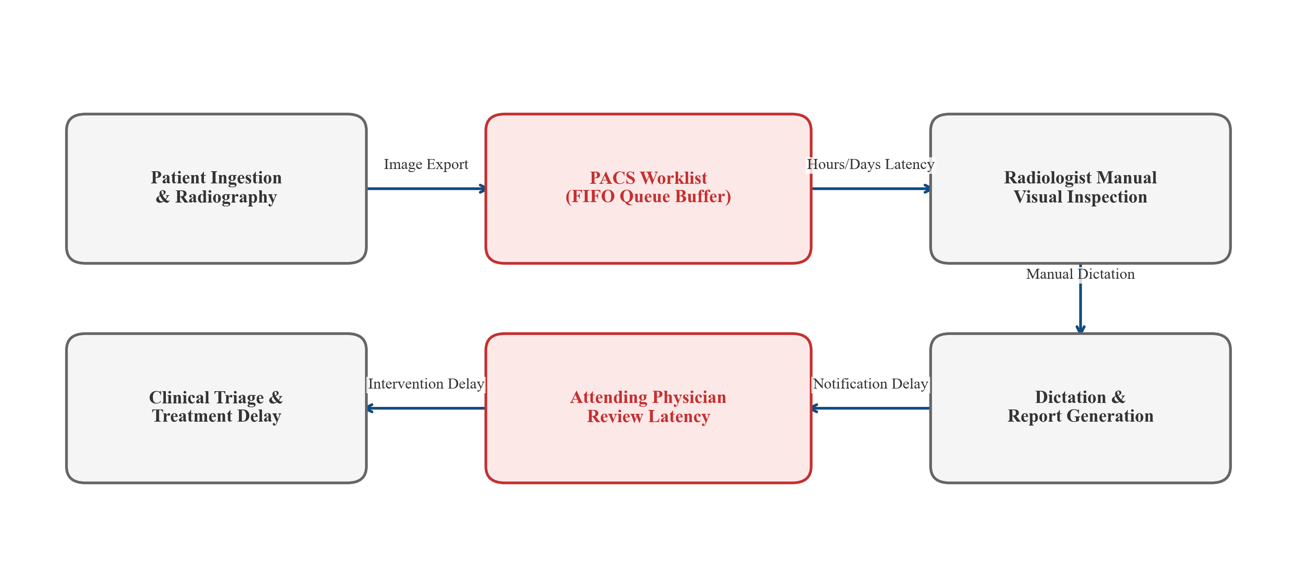
Figure 3.1: Conventional Radiologic Diagnostic Workflow Indicating Latency Bottlenecks
3.3 Disadvantages of Conventional Systems
1. Critical Diagnostic Latency: In overburdened public health institutions, non-prioritized FIFO queues force acute pathologies (such as lobar pneumonia consolidations or active tuberculosis cavitations) to wait behind routine outpatient physical examinations, risking clinical deterioration.
2. High Diagnostic Variability: Radiologists demonstrate inter-observer disagreement rates between 15% and 30% on planar radiographs, influenced by perceptual fatigue, ambient reading room lighting, shift length, and differing subspecialty training.
3. Absence of Pre-Screening Intelligence: Traditional PACS networks operate purely as passive archival and transport systems, possessing zero algorithmic awareness of image contents or pathological severity.
4. Acute Personnel Dependency: Remote clinics and district hospitals lacking on-site radiologists must transfer physical films or wait for tele-radiology batch reading, stalling emergency decision-making during off-peak hours.
5. Fragmented Record Keeping: Diagnostic dictations and radiographic images frequently reside in disconnected enterprise silos, hindering longitudinal tracking and rapid differential comparisons.
3.4 Comparative Analysis of Conventional vs. Proposed Systems
Table 3.1 provides a side-by-side comparative analysis contrasting the operational parameters of conventional radiology workflows against the proposed LungAI platform.
Table 3.1: Operational Comparison: Conventional Radiology Workflow vs LungAI Platform
Operational Dimension | Conventional Radiology Workflow | Proposed LungAI Platform
Diagnostic Throughput Latency | 24 to 72 hours (queue-dependent FIFO backlog) | Sub-second inference (< 2.0s full request lifecycle)
Queue Prioritization | Strictly unprioritized FIFO order | Deterministic triage stratification (Emergency, Urgent, Routine)
Diagnostic Objectivity | Qualitative impression vulnerable to fatigue and bias | Quantitative Softmax probability vectors across 5 classes
Radiologist Workload | Manual inspection required for 100% of scans | Automated pre-screening filters normal scans, prioritizing critical cases
Software Deployment Footprint | Heavyweight proprietary PACS desktop viewing clients | Lightweight, responsive React 18 browser-based SPA
System Architecture | Monolithic, siloed hospital intranet workstations | Decoupled asynchronous REST API with ORM persistence and Docker

3.5 Need for an Automated AI-Assisted CAD System
To mitigate these structural workflow failures, modern healthcare systems urgently require an automated, low-latency computer-aided diagnosis and triage platform. Such a system must not seek to replace the clinical judgment of certified radiologists, but rather act as an algorithmic second reader—pre-screening incoming examinations in milliseconds, quantifying diagnostic probabilities across multiple overlapping conditions, stratifying cases into actionable urgency tiers, and presenting intuitive visual interfaces to accelerate clinical triage.

CHAPTER 4
PROPOSED SYSTEM
——————————————————————————————————————
4.1 Overview of the Proposed LungAI Platform
The proposed LungAI platform is an integrated, full-stack, deep learning-powered clinical decision-support and triage system engineered specifically for planar chest radiographs. LungAI unifies automated computer vision preprocessing, dual-architecture deep learning inference, deterministic clinical urgency stratification, persistent electronic medical record tracking, and interactive web visualization into a cohesive clinical software artifact.
4.2 Proposed System Architecture
Figure 4.1 illustrates the decoupled four-tier architecture of LungAI, comprising: (1) Client Presentation Tier (React 18 Single-Page Application); (2) Application & API Gateway Tier (FastAPI with Pydantic and ASGI Uvicorn); (3) Analytical & Machine Learning Tier (TensorFlow/Keras inference engine with OpenCV preprocessing); and (4) Data Persistence Tier (SQLAlchemy ORM with asynchronous SQLite for development and PostgreSQL dialect readiness).
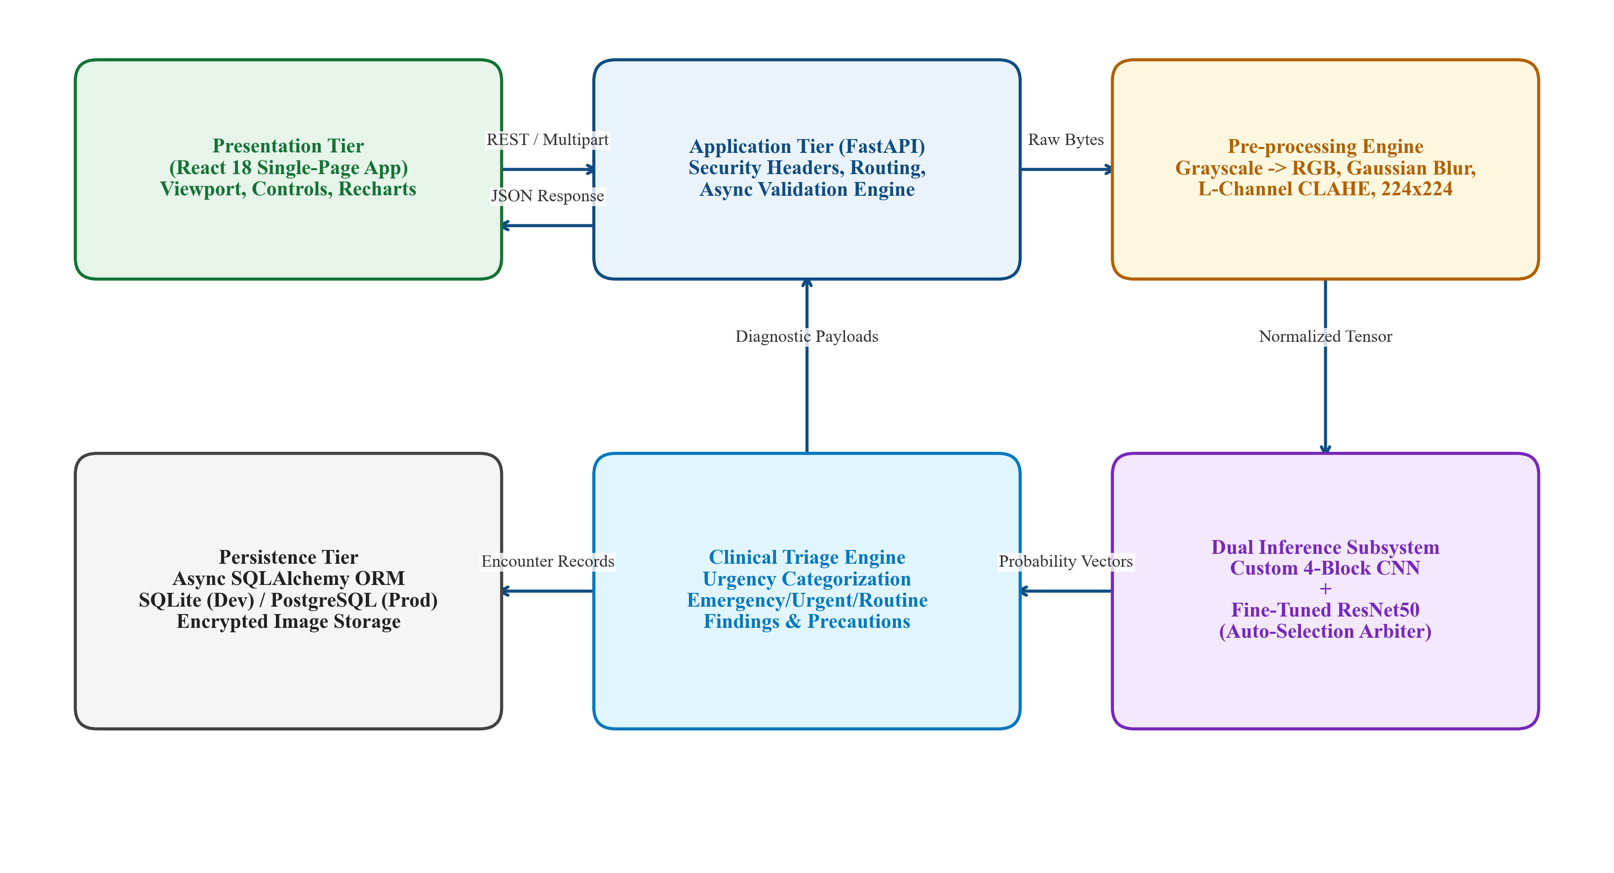
Figure 4.1: Proposed LungAI Multi-Tier System Architecture (Client, Gateway, ML, Persistence)
4.3 End-to-End 7-Stage Operational Pipeline
The operational lifecycle of a diagnostic encounter in LungAI traverses seven deterministic processing stages:
Stage 1 — Radiographic Ingestion: The user uploads a chest radiograph via drag-and-drop on the React frontend or selects an authenticated test preset. Scans are packaged into a multipart/form-data payload with patient identification metadata.
Stage 2 — Validation & Defensive Sanitization: The FastAPI gateway enforces MIME type verification (accepting JPEG, PNG, BMP, TIFF, WebP), validates header magic bytes, and enforces a strict 10 MB payload ceiling to defend against denial-of-service memory exhaustion.
Stage 3 — Deterministic Computer Vision Preprocessing: The raw image byte buffer is decoded via OpenCV, smoothed using a Gaussian kernel (3x3, sigma=0.8), converted to CIE LAB color space, equalized via CLAHE on the luminance (L) channel, spatially resampled to 224x224 pixels using high-order Lanczos-4 interpolation, and normalized against ImageNet channel statistics.
Stage 4 — Dual-Architecture Parallel Inference: The standardized tensor X_tilde in R^(1 x 224 x 224 x 3) is evaluated by both the Custom 4-Stage CNN baseline and the fine-tuned ResNet50 primary model held in server memory.
Stage 5 — Decision Arbitration & Clinical Urgency Triage: ResNet50 is designated as the primary diagnostic engine based on superior composite scoring. The resulting probability vector is mapped to a primary diagnosis, differential diagnostic candidates, and a clinical triage urgency tier.
Stage 6 — Asynchronous Persistence & Audit Logging: The diagnostic encounter, model probability distributions, clinical findings, and triage tier are asynchronously committed to the relational database via SQLAlchemy.
Stage 7 — Interactive Presentation & Report Generation: The React frontend updates dynamically, rendering the diagnosis card, animated confidence gauge, model comparison telemetry, and a one-click printable clinical summary report.
4.4 Implemented Clinical Urgency Triage Logic
To bridge algorithmic predictions with hospital workflow prioritization, LungAI implements a deterministic, confidence-gated clinical triage layer:
1. EMERGENCY (Red Status Badge): Assigned if the primary predicted pathology is 'Lung Cancer' or 'COVID-19' with model confidence exceeding 70% (> 0.70). This status prioritizes acute respiratory distress or suspected oncological lesions, flagging the study for immediate radiologist review within 15 minutes.
2. URGENT (Amber Status Badge): Assigned if the primary predicted pathology is 'Tuberculosis' or 'Pneumonia' with model confidence exceeding 60% (> 0.60). This tier prompts priority clinical review within 2 to 4 hours and advises infection control precautions (such as patient isolation for suspected TB).
3. ROUTINE (Teal Status Badge): Assigned when the primary predicted condition is 'Normal' or when pathological confidence scores fall below the urgent threshold, directing the case to standard outpatient worklists.
Important Academic Disclaimer: This triage mechanism operates strictly as an experimental rule-based interpretation layer within an academic decision-support prototype. It is not an FDA- or CE-cleared clinical diagnostic device.
4.5 Functional Capabilities and Clinical Innovations
Table 4.1 documents the primary engineering capabilities and clinical innovations implemented in the LungAI prototype.
Table 4.1: Functional Capabilities of LungAI Clinical Prototype
Capability Dimension | Technical & Clinical Implementation
Target Pathology Scope | 5 active classes: COVID-19, Normal, Pneumonia, Tuberculosis, Lung Cancer
Deep Learning Backbones | Dual comparative design: Custom 4-Stage CNN baseline + Fine-tuned ResNet50
Radiographic Preprocessing | OpenCV pipeline: CIE LAB luminance CLAHE, Lanczos-4 resize, ImageNet normalization
Decision Support Triage | Rule-based urgency routing: Emergency (>70% Cancer/COVID), Urgent (>60% TB/Pneumonia), Routine
Radiology Viewport Tools | Interactive canvas controls: 1.0x–2.5x digital zoom, high-contrast windowing, saliency overlay
System Architecture | Asynchronous FastAPI backend, SQLAlchemy ORM, React 18 frontend, Dockerized deployment

4.6 Operational Advantages Over Prior CAD Prototypes
Unlike academic publications that terminate at Jupyter Notebook scripts, LungAI delivers a fully deployable, containerized software artifact. By incorporating single-channel CLAHE contrast enhancement, parallel dual-model benchmarking, and deterministic urgency triage within an asynchronous web microservice, LungAI establishes a reproducible reference architecture for translating deep learning research into verifiable healthcare workflows.

CHAPTER 5
SYSTEM REQUIREMENTS
——————————————————————————————————————
5.1 Hardware Environment Specifications
Table 5.1 specifies the minimum and recommended hardware environments for system execution, distinguishing between lightweight inference runtimes and resource-intensive deep model training.
Table 5.1: Hardware Specifications (Development & Inference vs Production & Training)
Hardware Component | Minimum Requirement (Inference) | Recommended Requirement (Training)
Processor (CPU) | Intel Core i5 (8th Gen+) / AMD Ryzen 5 (4 cores, 2.5 GHz) | Intel Core i7/i9 (12th Gen+) / AMD Ryzen 9 (8+ cores, 16 threads)
System Memory (RAM) | 8 GB DDR4 | 32 GB DDR4 / DDR5 (enables in-memory dataset caching)
Storage Capacity | 10 GB SSD available storage | 50 GB NVMe M.2 Solid-State Drive
Graphics Card (GPU) | Not required (CPU multithreaded inference < 1.0s) | NVIDIA RTX 3060 / 4070 or NVIDIA T4 / A10 (>= 8 GB VRAM, CUDA 12.x)
Network Interface | 10/100 Mbps Ethernet or 802.11n Wi-Fi | 1 Gbps Gigabit Ethernet

5.2 Software Environment Specifications
Table 5.2 outlines the software stack, programming language versions, deep learning frameworks, and core library dependencies utilized in LungAI.
Table 5.2: Software Dependency Specifications
Software Component | Selected Technology & Version
Operating System | Windows 10/11 (64-bit) / Ubuntu Linux 20.04/22.04 LTS / macOS
Programming Languages | Python 3.10 to 3.12 (CPython), JavaScript ECMAScript 2022 (Node.js v18/v20)
Deep Learning Framework | TensorFlow 2.16.1 / Keras 3.x, NumPy 1.26.4
Computer Vision & Analytics | OpenCV (opencv-python 4.10.0.84), Scikit-Learn 1.5.1, Pillow 10.4.0, Matplotlib 3.9.2
Backend Server Framework | FastAPI 0.115.0, Uvicorn 0.30.0, Pydantic 2.9.0, Python-Multipart 0.0.9
Database & Asynchronous ORM | SQLAlchemy 2.0.35, aiosqlite 0.20.0 (Development), asyncpg 0.29.0 (Production)
Frontend Client Framework | React 18.3.1, React-DOM 18.3.1, React-Router-DOM 6.26.2, Axios 1.7.7, Recharts 2.12.7
Automated Test Framework | Pytest 8.3.3, Pytest-AsyncIO 0.24.0, HTTPX 0.27.2
Containerization Runtime | Docker Engine v24.x+ and Docker Compose v2.x+

5.3 Functional Requirements Matrix
Table 5.3 formalizes the functional requirements (FR-01 through FR-07) governing image ingestion, preprocessing, inference, triage, persistence, and reporting.
Table 5.3: Functional Requirements Matrix (FR-01 through FR-07)
Requirement ID | Functional Specification
FR-01: Multi-Format Ingestion | Accept JPEG, PNG, BMP, TIFF, and WebP radiographs up to 10 MB; reject invalid payloads with HTTP 400/413.
FR-02: Luminance CLAHE Preprocessing | Convert image arrays to 3-channel RGB, apply CLAHE to CIE LAB L-channel, resize to 224x224, and apply ImageNet standardization.
FR-03: Dual-Model Parallel Inference | Forward-pass normalized tensors through both Custom CNN and ResNet50, computing complete 5-class Softmax probability vectors.
FR-04: Automated Model Arbitration | Evaluate architectures via multi-criteria composite scoring and programmatically designate ResNet50 as primary.
FR-05: Confidence Urgency Triage | Map primary condition and confidence into Emergency, Urgent, or Routine triage tiers.
FR-06: Asynchronous EMR Persistence | Persist patient profiles, scan metadata, diagnostic probability vectors, and clinical findings via SQLAlchemy ORM.
FR-07: Clinical Documentation Compilation | Compile exportable structured clinical reports detailing primary diagnosis, differential alternatives, and precautions.

5.4 Non-Functional Engineering Requirements
Table 5.4 specifies the non-functional engineering standards enforced across the system, including inference latency ceilings, reliability fallbacks, security response headers, and modular maintainability.
Table 5.4: Non-Functional Engineering Requirements
Quality Attribute | Engineering Specification
Performance & Latency | End-to-end inference, triage, and database write must complete in < 2.0s on standard quad-core CPU.
Reliability & Fallbacks | Graceful recovery during corrupted image uploads or model loading failures with descriptive HTTP status codes.
Usability & Accessibility | Intuitive React interface featuring dark/light themes, high-contrast viewport controls, and color-coded urgency badges.
Defensive Security Headers | Enforce OWASP standards: X-Content-Type-Options: nosniff, X-Frame-Options: DENY, and no-store caching.
Modularity & Maintainability | Strict separation of concerns across presentation, API routing, database ORM, and machine learning subsystems.

CHAPTER 6
SYSTEM DESIGN
——————————————————————————————————————
6.1 Architectural Overview & Data Flow Diagrams
The system design maps the transformation of unstructured radiograph inputs into structured, actionable clinical predictions. Data Flow Diagrams (DFDs) model information movement across abstraction layers:
Figure 6.1 illustrates the DFD Level 0 Context Diagram, showing primary interactions between the external Clinician entity and the LungAI boundary.
Figure 6.2 models the DFD Level 1 Decomposition Diagram, partitioning the core platform into four primary sub-processes: (1.0) Image Ingestion & Validation, (2.0) Radiographic Preprocessing, (3.0) Deep Inference, and (4.0) Urgency Triage & Report Synthesis.
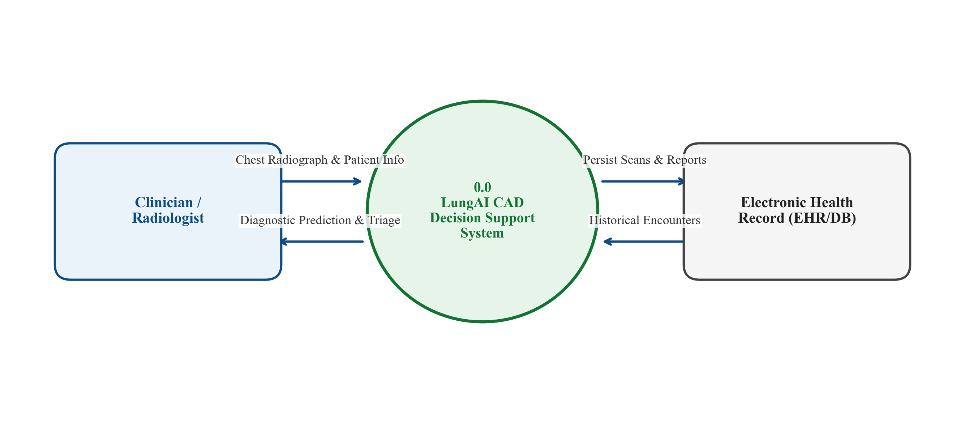  Figure 6.1: DFD Level 0 Context Diagram | 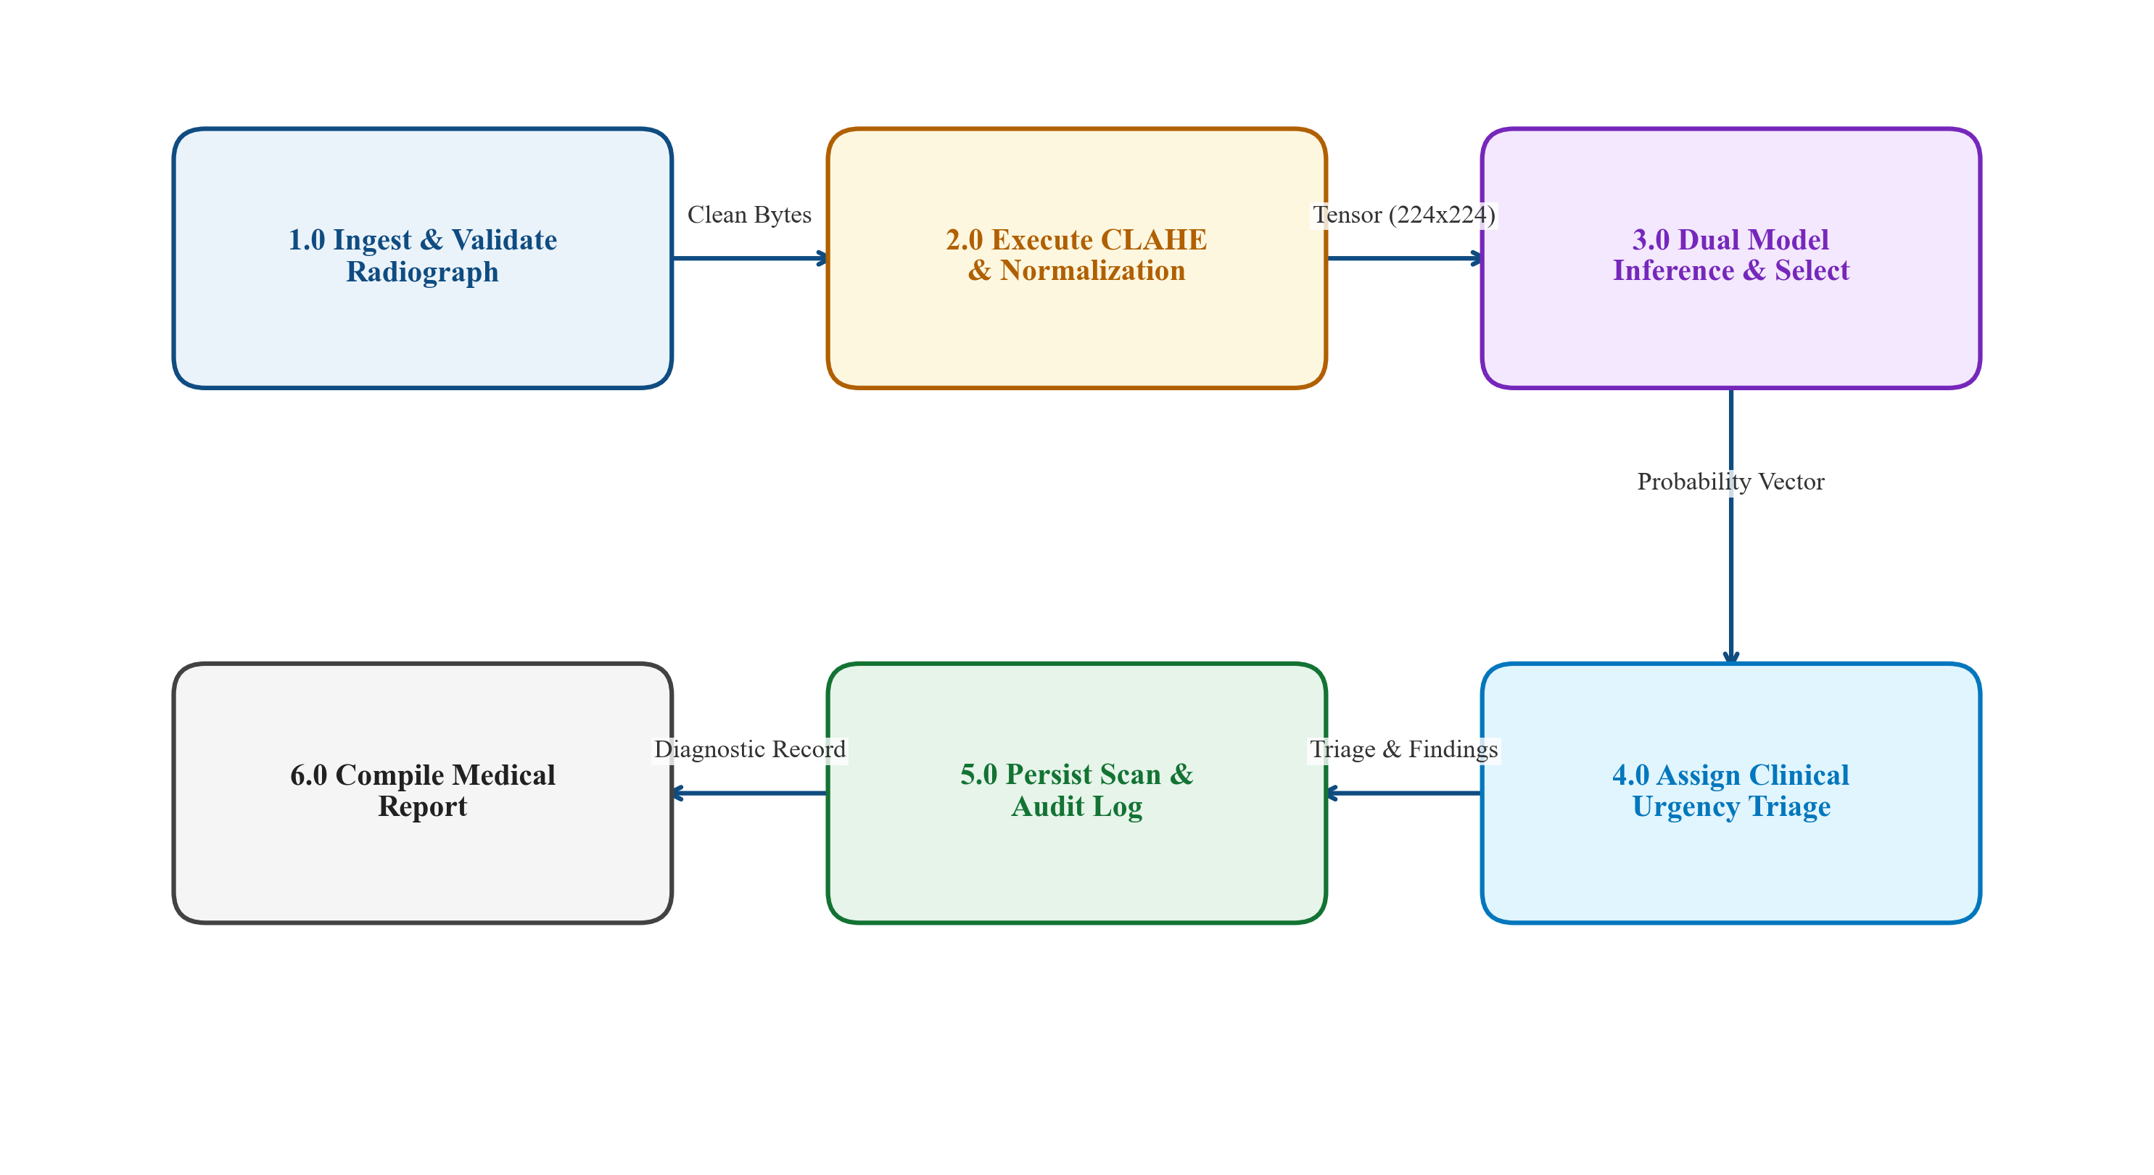  Figure 6.2: DFD Level 1 Decomposition Diagram

Figure 6.3 details the DFD Level 2 Deep Inference Decomposition, illustrating internal tensor flow from Gaussian smoothing and CIE LAB CLAHE to dual forward passes and composite arbitration.
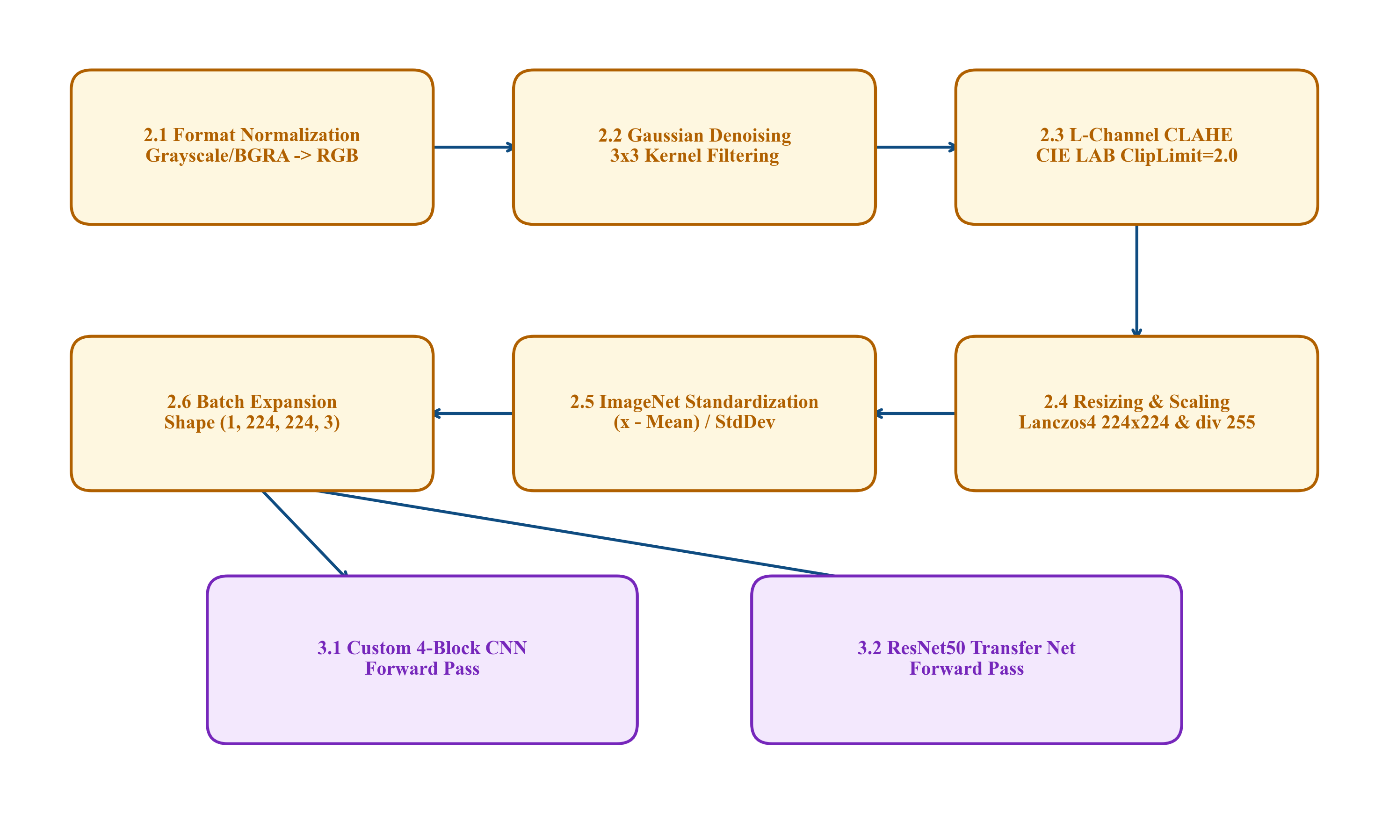
Figure 6.3: DFD Level 2 Deep Inference Process Decomposition
6.2 Unified Modeling Language (UML) Structural & Behavioral Models
Figure 6.4 depicts the System Use Case Diagram, showing clinician workflows: Upload CXR, Trigger Multi-Model Inference, Inspect Probabilities, Manage EMR Records, and Export Clinical Reports.
Figure 6.5 illustrates the System Class Diagram, defining SQLAlchemy ORM models (Patient, LungScan, Prediction, ClinicalReport) coupled to Pydantic schemas and service singletons.
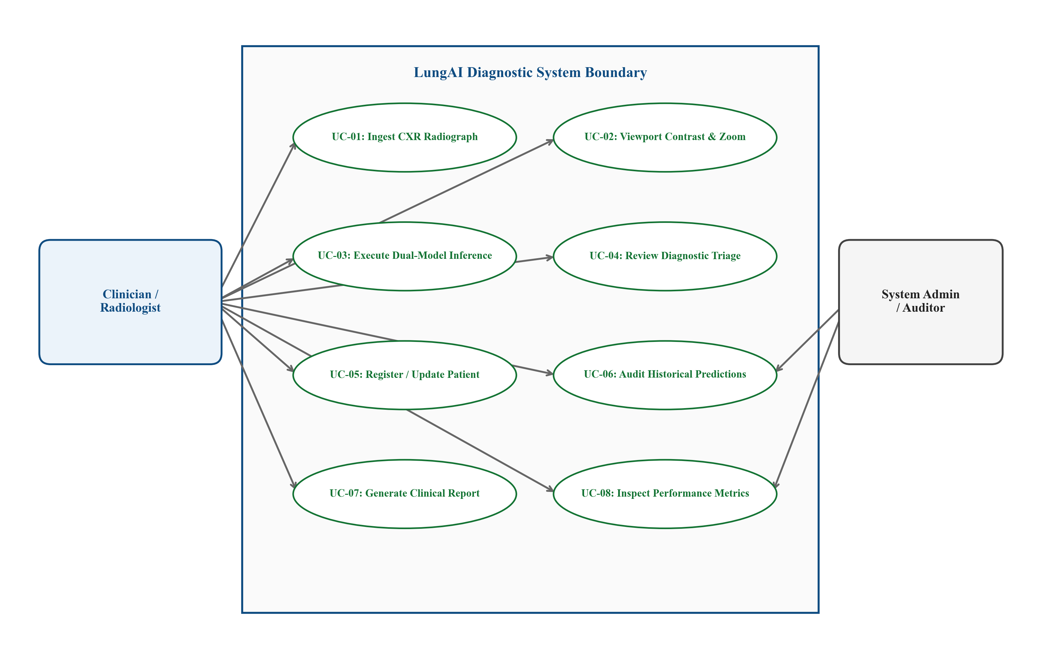  Figure 6.4: System Use Case Diagram | 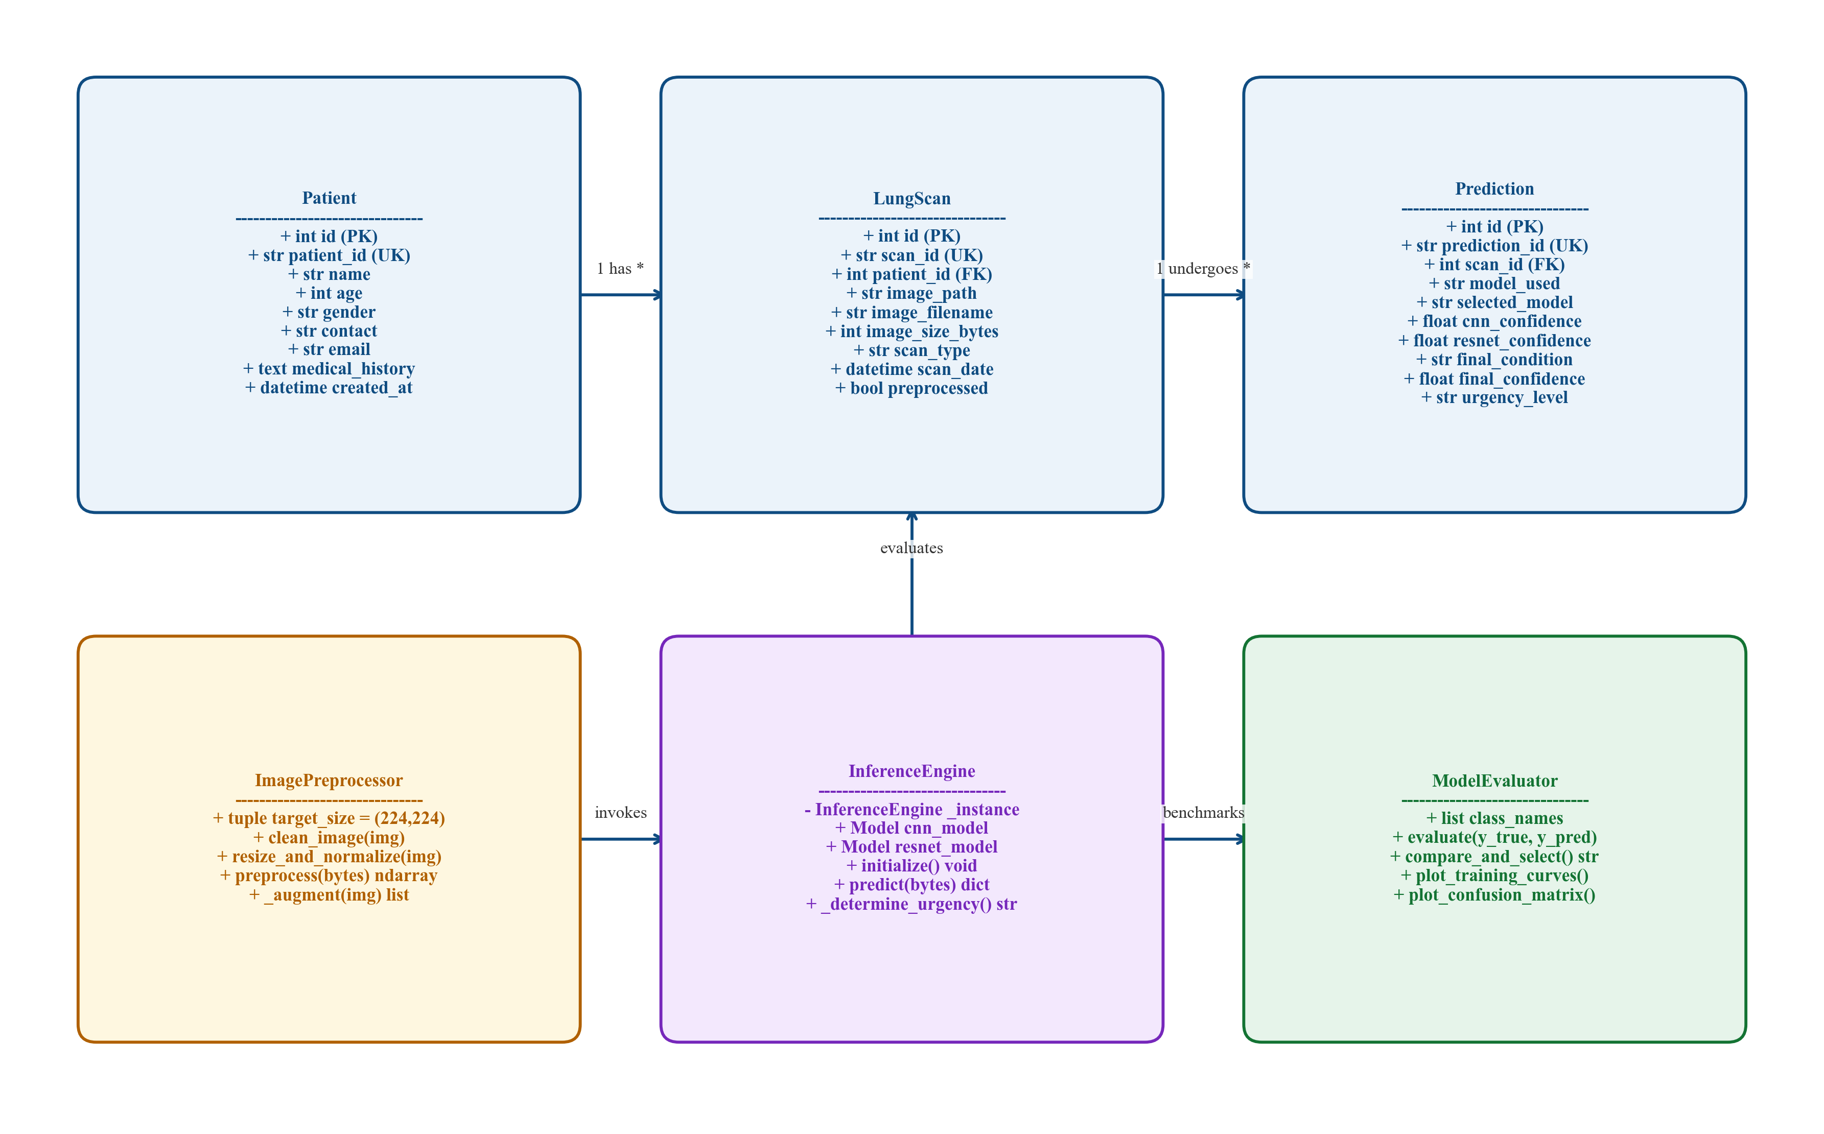  Figure 6.5: System Class Diagram

Figure 6.6 traces the End-to-End Diagnostic Sequence Diagram, modeling asynchronous request-response chronology from multipart image upload to JSON response generation.
Figure 6.7 outlines the Comprehensive Workflow Activity Diagram, depicting conditional branching during MIME validation, image enhancement, tensor inference, and urgency assignment.
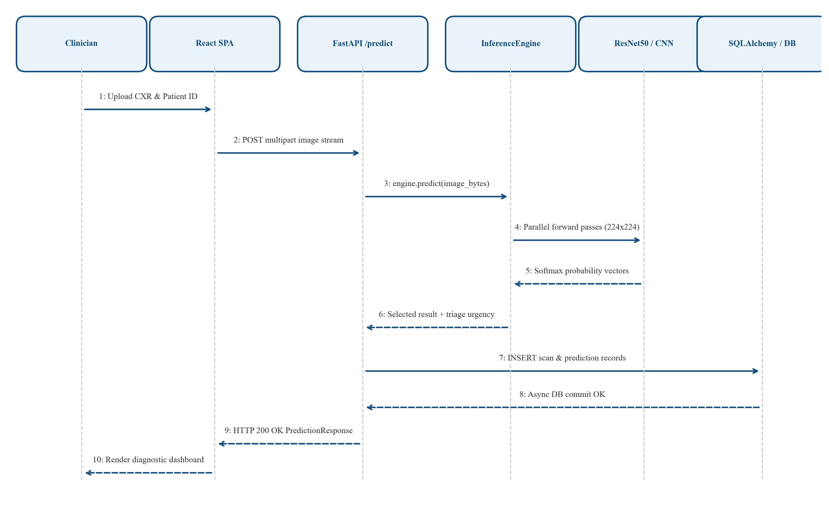  Figure 6.6: End-to-End Diagnostic Sequence Diagram | 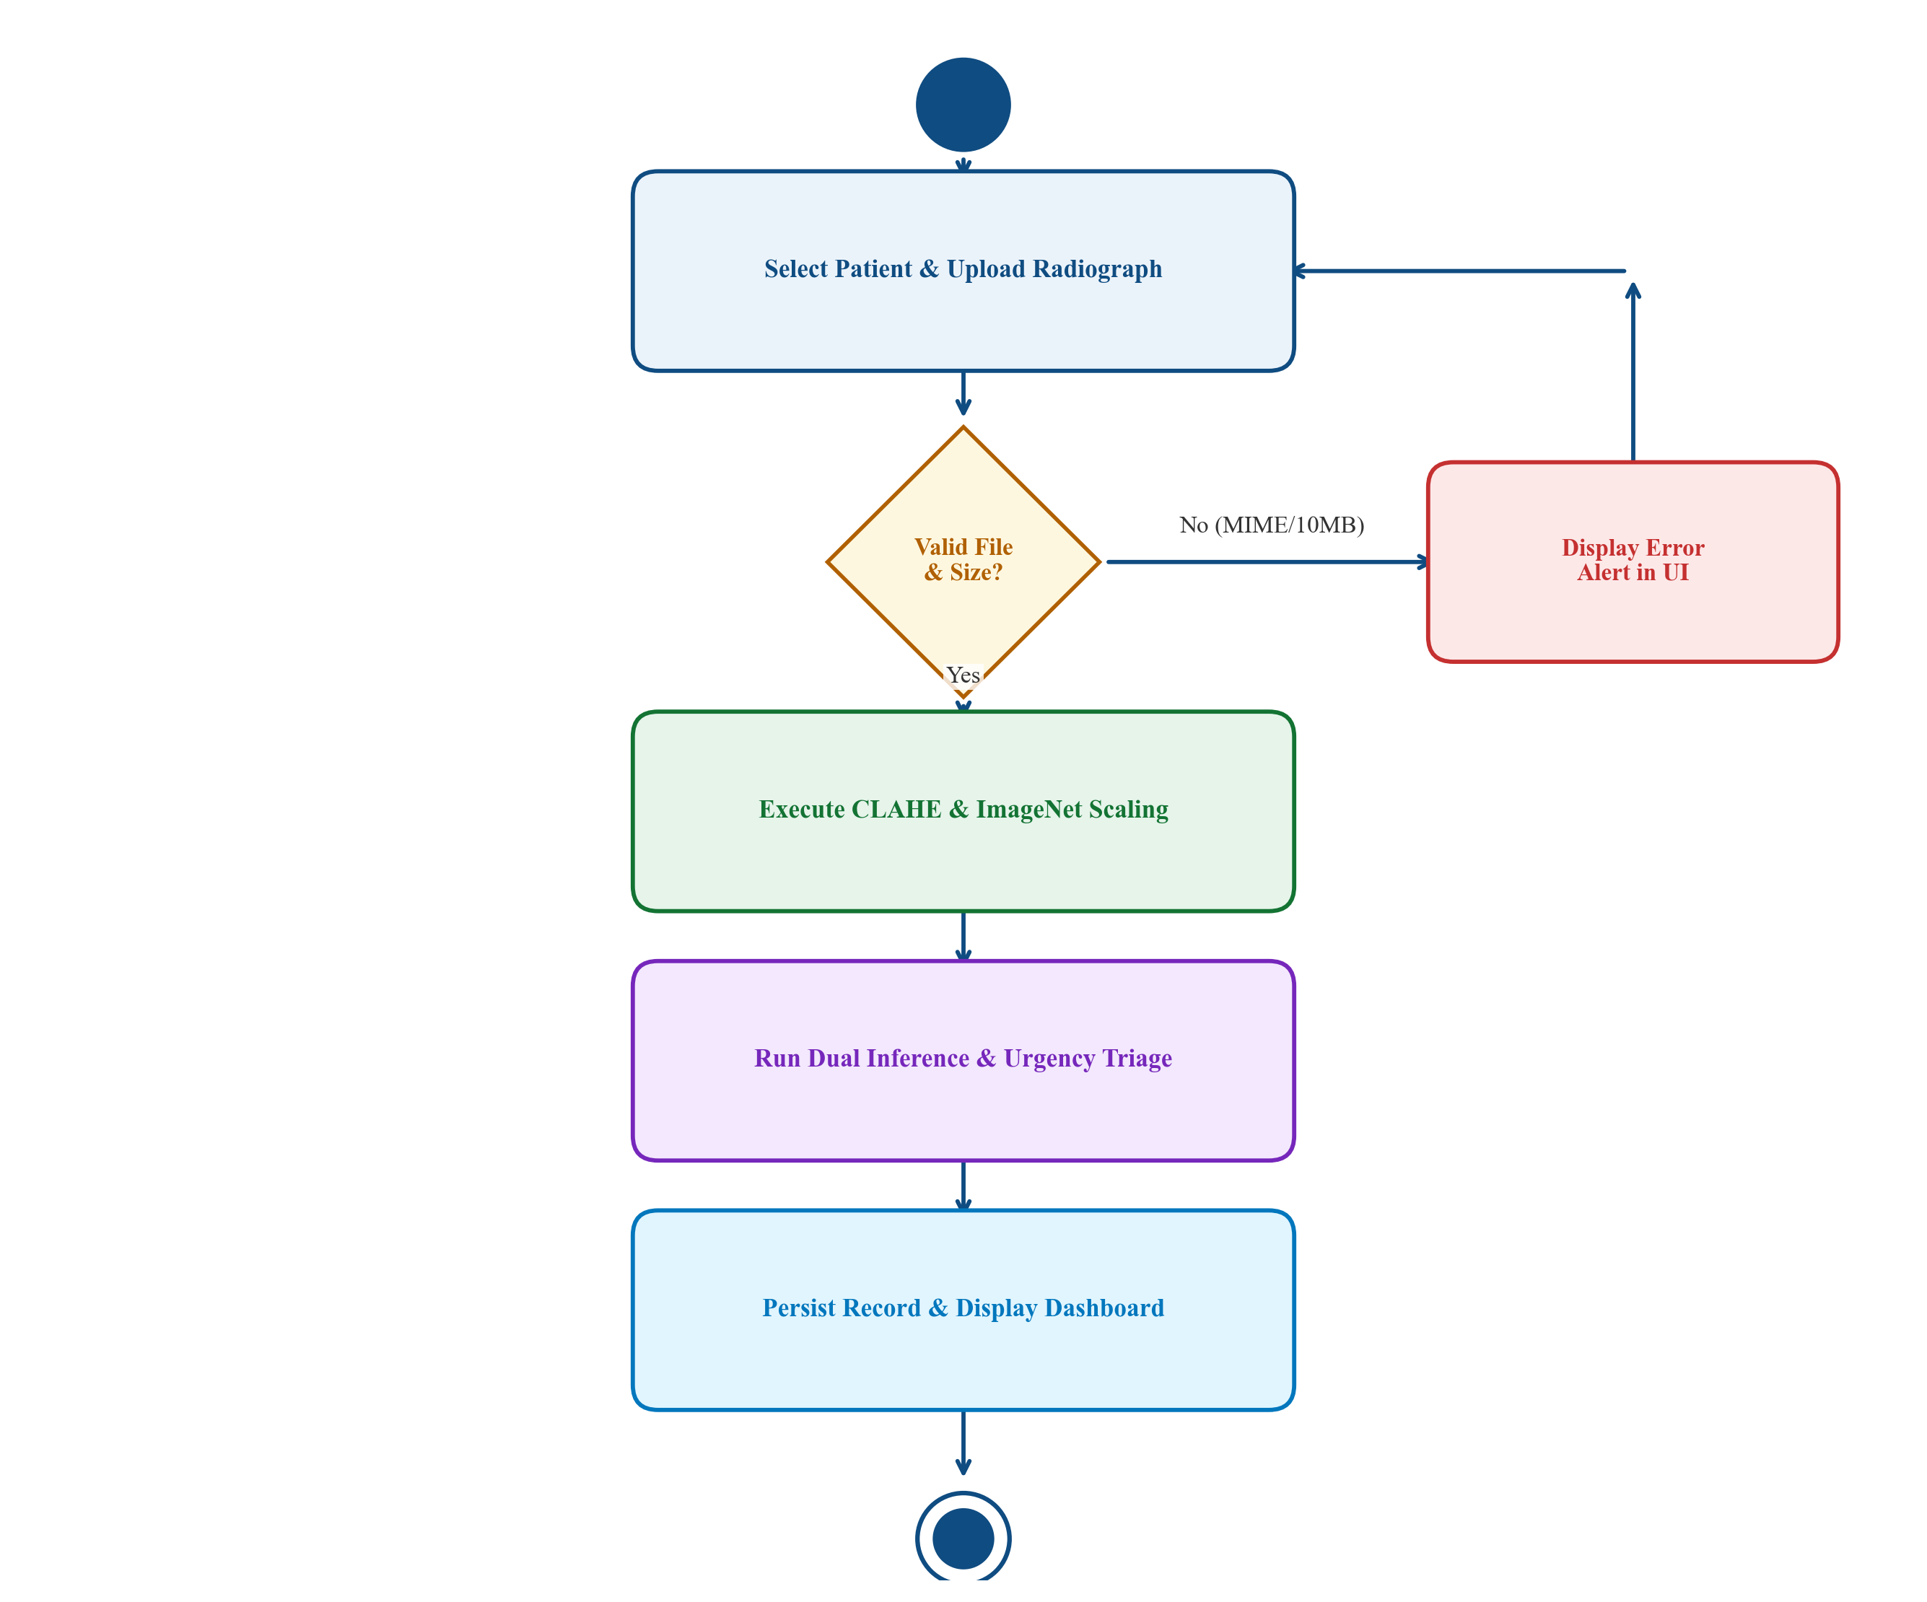  Figure 6.7: Comprehensive Workflow Activity Diagram

Figure 6.8 displays the System Component Diagram, illustrating modular decoupling between the React client, FastAPI ASGI gateway, TensorFlow ML engine, and SQLAlchemy persistence.
Figure 6.9 shows the Physical Deployment Diagram, depicting TLS-terminated Nginx load balancing to Uvicorn workers and containerized NVMe volume persistence.
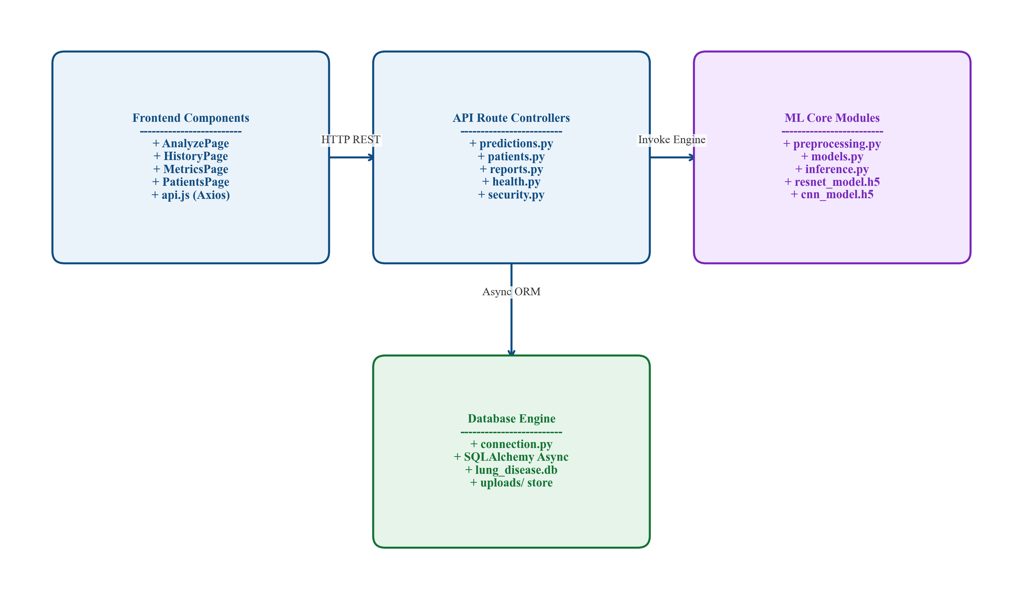  Figure 6.8: System Component Diagram | 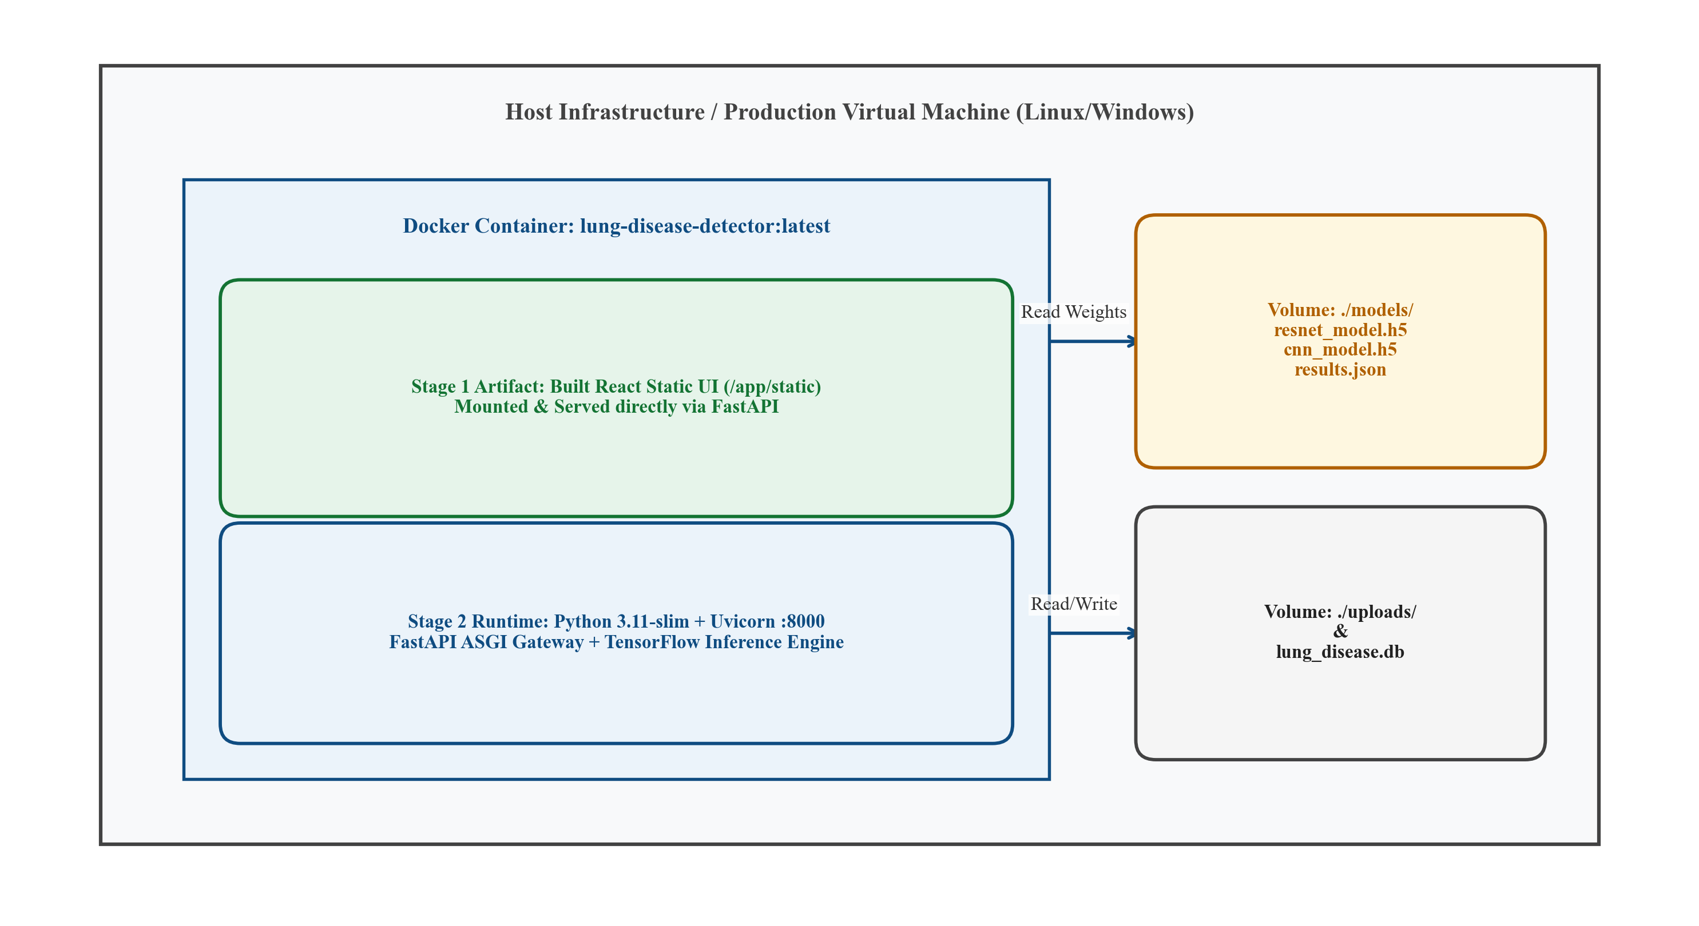  Figure 6.9: Physical Deployment Diagram

Figure 6.10 details the Entity-Relationship (ER) Diagram, specifying relational 1:N foreign-key mappings between patients, scans, predictions, and reports.
Figure 6.11 visualizes the Complete Machine Learning Lifecycle Pipeline, showing offline stratified training, model weight serialization, singleton loading, and online inference.
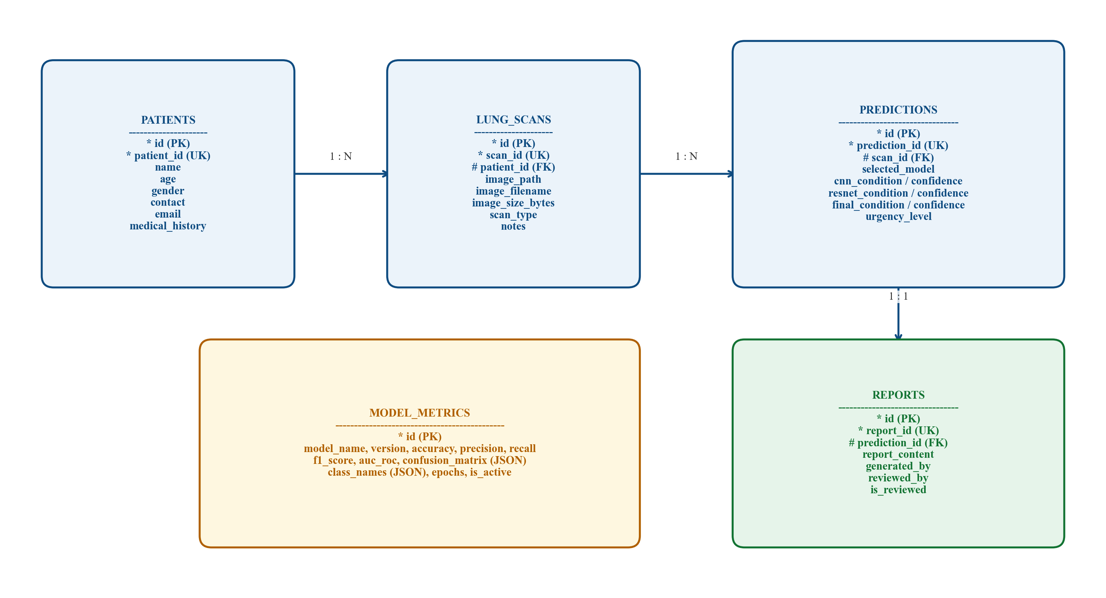  Figure 6.10: Entity-Relationship (ER) Diagram | 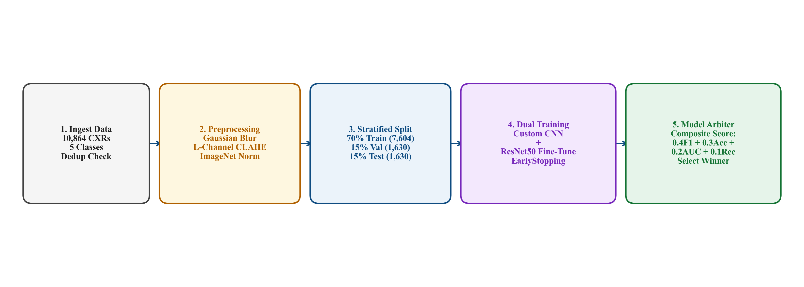  Figure 6.11: End-to-End Machine Learning Pipeline

6.3 Architectural Decision Rationale
Table 6.1 documents the engineering rationale governing key architectural decisions across backend frameworks, database persistence, image enhancement, and client libraries.
Table 6.1: Architectural Design Decision Rationale
Decision Domain | Selected Technology | Engineering Rationale
Backend Server | FastAPI (ASGI / Uvicorn) | Non-blocking asynchronous I/O, automatic Pydantic validation, and OpenAPI documentation.
Database Architecture | SQLAlchemy 2.0 AsyncIO | Embedded aiosqlite for zero-config development; seamless asyncpg compatibility for production PostgreSQL.
Image Enhancement | OpenCV CIE LAB CLAHE | Applies contrast enhancement exclusively to luminance, preventing artificial chromatic distortion.
Primary ML Backbone | ResNet50 Transfer Learning | Decisive empirical superiority (+16.99% accuracy) and robust residual gradient propagation.
Frontend Client | React 18 SPA + Vanilla CSS | Declarative virtual DOM rendering, responsive DICOM-style canvas manipulation, and zero CSS runtime bloat.

CHAPTER 7
DATASET AND DATA PREPROCESSING
——————————————————————————————————————
7.1 Data Sources & Active Disease Classes
The consolidated experimental dataset comprises 10,864 digitized chest radiographs curated across five active clinical categories from authoritative public repositories [2], [3], [4]. Table 7.1 details the class-wise sample distribution and stratified partitioning protocol.
Table 7.1: Class-Wise Dataset Distribution & Data Partitioning
Pathology Class | Source Repository | Total Scans | Train (70%) | Val (15%) | Test (15%)
Pneumonia | Kermany et al. [2] / NIH [7] | 4,273 | 2,991 | 641 | 641
COVID-19 | Chowdhury et al. [3] DB | 3,616 | 2,530 | 543 | 543
Normal (Healthy) | Kermany et al. [2] | 1,583 | 1,109 | 237 | 237
Tuberculosis | Rahman et al. [4] TB DB | 700 | 490 | 105 | 105
Lung Cancer | Public Thoracic Repository | 692 | 484 | 104 | 104
COPD (Unpopulated) | Reserved Future Stub | 0 | 0 | 0 | 0
Pleural Effusion (Unpopulated) | Reserved Future Stub | 0 | 0 | 0 | 0
Total Active Corpus | Consolidated Multi-Source | 10,864 | 7,604 | 1,630 | 1,630

Class Distribution Summary: The corpus encompasses 4,273 Pneumonia scans (39.33%), 3,616 COVID-19 scans (33.28%), 1,583 Normal scans (14.57%), 700 Tuberculosis scans (6.44%), and 692 Lung Cancer scans (6.37%). Directory stubs for Chronic Obstructive Pulmonary Disease (COPD) and Pleural Effusion were designed into the directory architecture for future expansion but contain zero images in the repository; they are explicitly treated as unpopulated future stubs.
Stratified Partitioning: To guarantee strict experimental isolation and prevent data leakage, the 10,864 radiographs were split using a stratified 70% training (7,604 scans), 15% validation (1,630 scans), and 15% held-out test cohort (1,630 scans) under random seed 42. The test partition was strictly quarantined during all training and hyperparameter tuning phases.
7.2 Image Preprocessing & Contrast Enhancement Pipeline
Raw planar radiographs exhibit extreme variability in optical dynamic range, exposure kilovoltage (kVp), and sensor calibration. To standardize features prior to tensor construction, LungAI executes a deterministic five-stage preprocessing pipeline, illustrated in Figure 7.1.
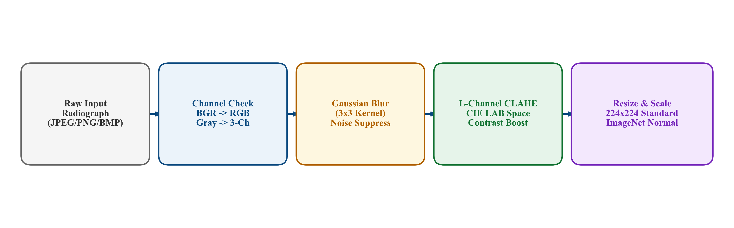
Figure 7.1: Comprehensive Radiographic Preprocessing Pipeline
Figure 7.1 illustrates the transformation sequence: (1) Ingestion and channel replication to standardized 3-channel RGB; (2) Gaussian smoothing (3x3 kernel, sigma=0.8) to suppress high-frequency noise; (3) Contrast Limited Adaptive Histogram Equalization (CLAHE) applied exclusively to the luminance channel in CIE LAB space; (4) High-fidelity Lanczos-4 spatial resampling to 224x224 pixels; and (5) Two-step intensity standardization.
Figure 7.1: Comprehensive Radiographic Preprocessing Pipeline
Table 7.2 summarizes the operational parameters and clinical functions of each preprocessing stage.
Table 7.2: Comprehensive Preprocessing Pipeline Parameters
Transformation Stage | Operational Parameters | Clinical / Technical Function
1. Ingestion & Format Decoding | cv2.IMREAD_COLOR, OpenCV buffer decode | Normalizes arbitrary formats (JPEG, PNG, TIFF) into standardized 3-channel BGR/RGB representation.
2. Gaussian Noise Filtering | Kernel: 3x3, sigma = 0.8 | Suppresses high-frequency sensor noise and electronic acquisition artifacts without blurring lesion boundaries.
3. CIE LAB Color Space Conversion | cv2.COLOR_BGR2LAB | Decouples luminance (L) from chromaticity channels (A, B), enabling isolated brightness contrast enhancement.
4. Luminance CLAHE Enhancement | clipLimit = 2.0, tileGridSize = (8, 8) | Sharpens low-contrast soft-tissue opacities and parenchymal consolidations while bounding local noise amplification.
5. RGB Color Reconstruction | cv2.COLOR_LAB2RGB | Recombines equalized luminance with chrominance channels into standard RGB color representation.
6. High-Fidelity Spatial Resampling | cv2.INTER_LANCZOS4, size = (224, 224) | Resamples radiographs to standard tensor resolution using an 8-lobed Lanczos kernel to preserve edge fidelity.
7. Two-Step Intensity Standardization | Scale /255.0, Mean/Std standardization | Scales intensities to [0, 1] and standardizes against ImageNet channel statistics (mu, sigma).

7.3 Two-Step Intensity Standardization & Augmentation Protocol
Pixel values undergo a rigorous two-step intensity standardization protocol:
Step 1 — Linear Unit Scaling: Raw 8-bit unsigned integer pixel intensities in [0, 255] are linearly scaled to single-precision floating point values in [0.0, 1.0]: X_scaled = X_raw / 255.0.
Step 2 — Channel-Wise ImageNet Standardization: Scaled values are normalized against ImageNet population statistics: mu = [0.485, 0.456, 0.406] and sigma = [0.229, 0.224, 0.225], yielding: X_norm = (X_scaled - mu) / sigma.
Data Augmentation Protocol: During training, real-time data augmentation was applied dynamically to training batches to mitigate overfitting: random rotations (+/- 15 degrees), horizontal flipping (50% probability), random width/height shifts (+/- 10%), zoom variations [0.9, 1.1], and shear transformations (+/- 5 degrees) [30].

CHAPTER 8
MACHINE LEARNING / AI MODEL
——————————————————————————————————————
8.1 Convolutional Neural Network Architectural Foundations
Convolutional Neural Networks (CNNs) represent the foundational architecture for modern medical computer vision. Through spatial parameter sharing, local receptive fields, and hierarchical feature abstraction, CNNs autonomously learn diagnostic visual hierarchies—progressing from low-level edges, intensity gradients, and bone-tissue interfaces in shallow layers to high-level anatomical lesion signatures (such as alveolar consolidation patches, ground-glass haziness, apical cavitary rings, and pulmonary nodules) in deep convolutional blocks.
8.2 Custom 4-Stage CNN Baseline Architecture
To establish an empirical baseline under identical data partitioning and preprocessing conditions, a custom 4-stage convolutional neural network (LungCNN) was designed and trained from scratch. Figure 8.1 illustrates the sequential topology.
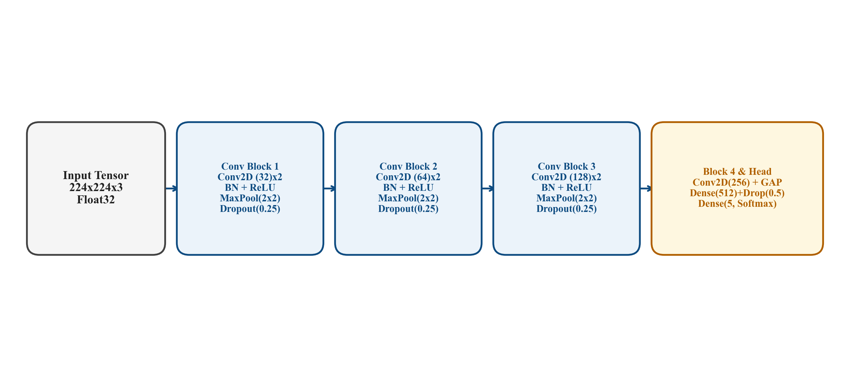
Figure 8.1: Custom 4-Stage CNN Architectural Diagram
Figure 8.1 illustrates the four cascading feature extraction stages. Each stage integrates two consecutive 2D convolutional layers with 3x3 kernels, Batch Normalization, ReLU activation, 2x2 Max-Pooling, and spatial Dropout (0.25). Feature filter depth progressively doubles from 32 in Stage 1 to 64 in Stage 2, 128 in Stage 3, and 256 in Stage 4. Spatial feature maps are aggregated via Global Average Pooling (GAP), followed by a 512-neuron Dense layer with Batch Normalization and Dropout (0.5), terminating in a 5-unit Softmax classification head.
Figure 8.1: Custom 4-Stage CNN Architectural Diagram
Table 8.1 summarizes the layer-by-layer architectural specifications of the Custom 4-Stage CNN baseline.
Table 8.1: Custom 4-Stage CNN Layer Specifications
Stage / Layer Description | Output Tensor Shape | Learnable Parameters | Operational Hyperparameters
Input Layer | (None, 224, 224, 3) | 0 | Standardized 3-channel RGB image tensor
Stage 1: Conv2D x 2 + BN + Pool | (None, 112, 112, 32) | 10,144 | 32 filters, 3x3 kernel, ReLU, MaxPool(2x2), Dropout(0.25)
Stage 2: Conv2D x 2 + BN + Pool | (None, 56, 56, 64) | 55,872 | 64 filters, 3x3 kernel, ReLU, MaxPool(2x2), Dropout(0.25)
Stage 3: Conv2D x 2 + BN + Pool | (None, 28, 28, 128) | 222,336 | 128 filters, 3x3 kernel, ReLU, MaxPool(2x2), Dropout(0.25)
Stage 4: Conv2D + BN + ReLU | (None, 28, 28, 256) | 295,424 | 256 filters, 3x3 kernel, ReLU, Batch Normalization
Global Average Pooling (GAP) | (None, 256) | 0 | Spatial reduction to 1D channel-mean feature vector
Fully Connected Dense Layer | (None, 512) | 131,584 | Dense(512), ReLU, Batch Normalization, Dropout(0.5)
Classification Head | (None, 5) | 2,565 | Dense(5), Softmax multi-class activation
Total Parameter Count | Trainable: 715,621 | Non-trainable: 2,304 | Total: 717,925 parameters

Optimization & Training: The custom CNN was compiled using Adam optimization (learning rate = 1e-4) and sparse categorical cross-entropy loss. Training was conducted from random scratch weight initialization for 30 epochs with Early Stopping and learning rate reduction on plateau. As an un-pretrained baseline, this architecture provides an essential empirical benchmark to isolate and quantify the exact performance gain achieved by transfer learning.
8.3 Deep Transfer Learning with ResNet50
To overcome the representational limitations of training from scratch on moderate-sized medical cohorts, deep transfer learning was implemented using the ResNet50 backbone [5].
Mathematical Formulation of Residual Learning: In conventional feedforward networks, stacked non-linear layers are trained to fit an underlying mapping H(x). In deep architectures (depth > 20 layers), repeated matrix multiplications cause backpropagated gradients to vanish or explode exponentially, stalling early layer convergence. He et al. [5] introduced residual learning by restructuring layers to learn a residual function F(x) = H(x) - x with respect to the layer identity input x:
y = F(x, {W_i}) + x
When dimensions match, the identity shortcut performs parameter-free addition. When spatial dimensions change across stages, a linear projection W_s is applied: y = F(x, {W_i}) + W_s * x. Because the gradient contains an unattenuated identity term dE/dx = dE/dy * (dF/dx + I), gradient signals flow unimpeded directly across all 50 layers, smoothing the loss optimization landscape and enabling effective optimization of deep representations.
Figure 8.2 illustrates the modified ResNet50 deep transfer learning architecture.
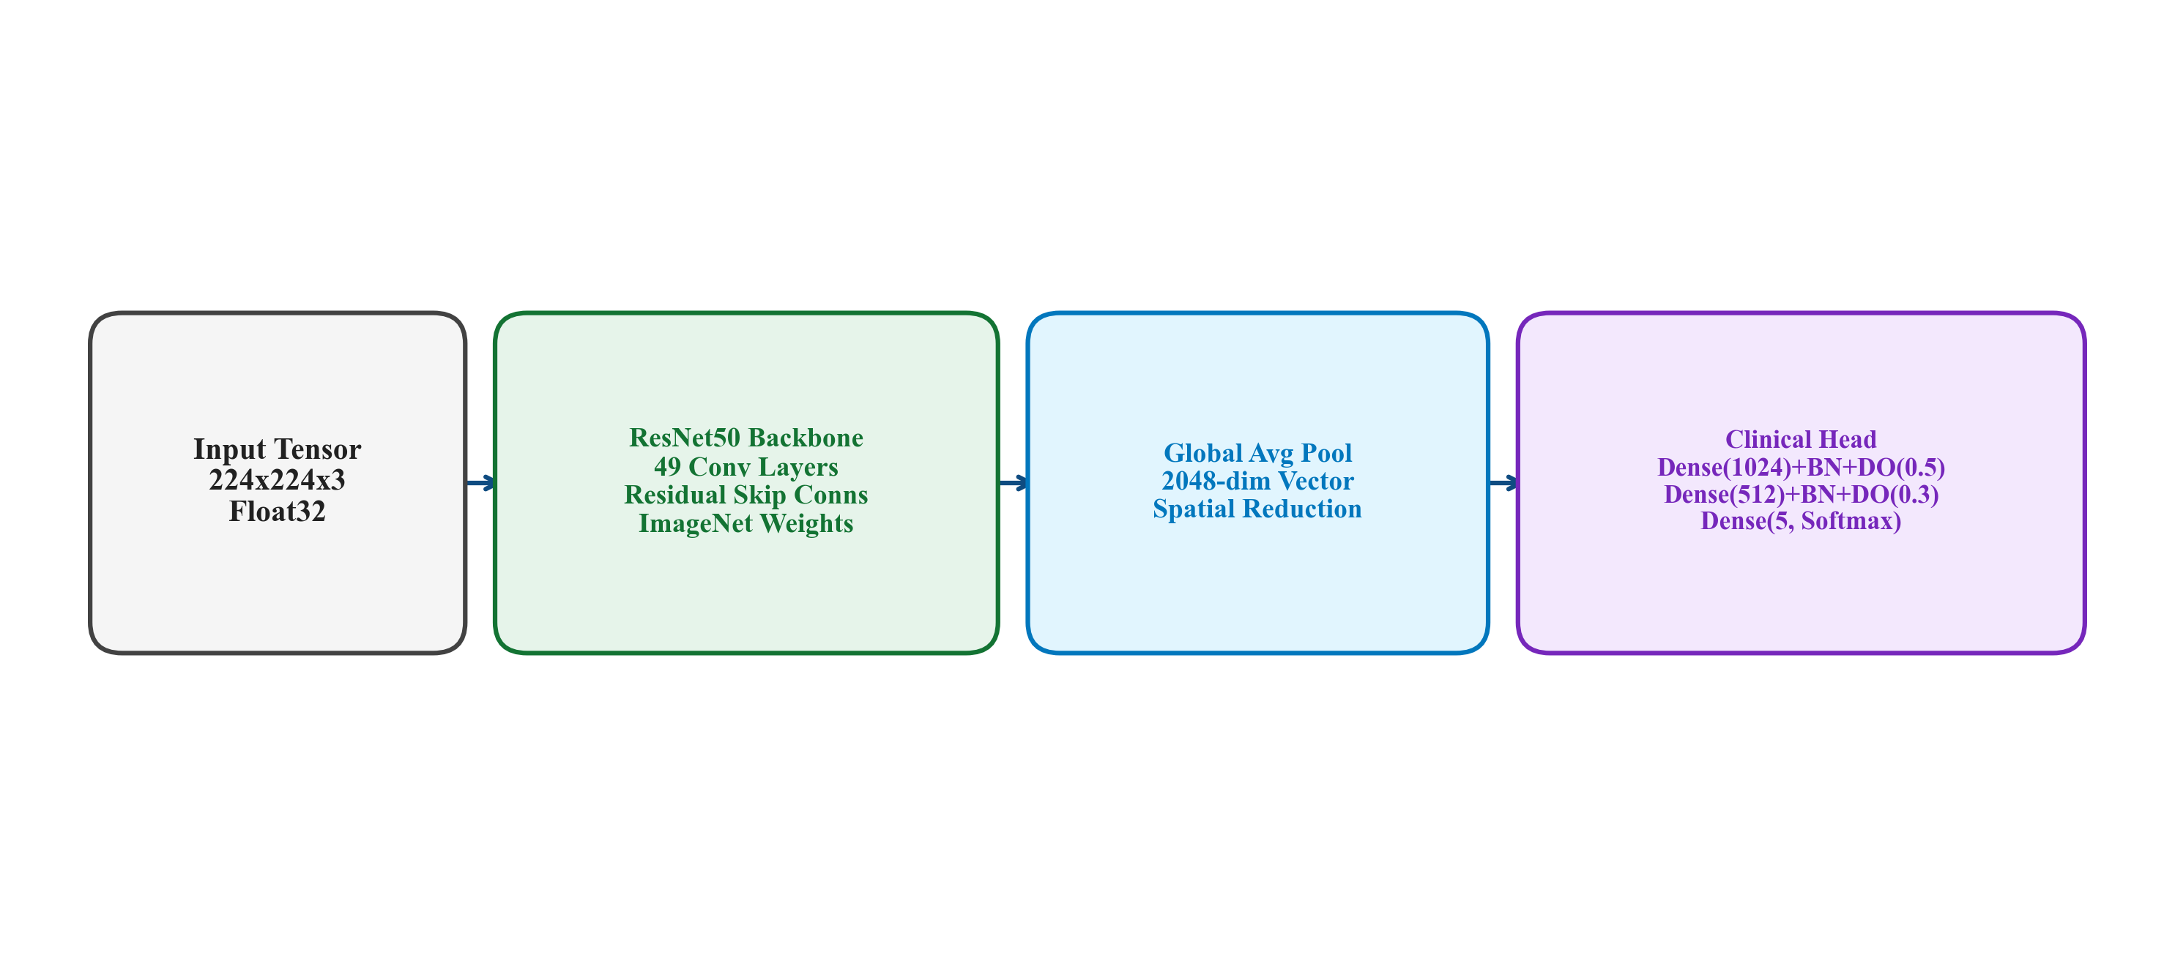
Figure 8.2: ResNet50 Deep Transfer Learning Architecture
Figure 8.2 depicts the modified ResNet50 architecture. The ImageNet-pretrained convolutional base (comprising 48 convolutional layers grouped into 16 residual bottleneck blocks) is coupled to a specialized medical classification head: Global Average Pooling, Batch Normalization, Dense(1024, ReLU), Dropout(0.5), Dense(512, ReLU), Dropout(0.3), and a 5-unit Softmax classification layer. Table 8.2 details the layer specifications.
Figure 8.2: ResNet50 Deep Transfer Learning Architecture
Two-Phase Phased Training Protocol: To preserve pre-trained feature hierarchies while adapting high-level abstractions to chest radiography, ResNet50 was trained using a phased fine-tuning schedule:
Phase 1 — Feature Extraction Warmup (Epochs 1–10): The entire ResNet50 convolutional backbone was completely frozen (trainable = False). Only the custom classification head was trained using Adam optimizer with an initial learning rate of 1e-3. This phase allowed randomly initialized top-layer weights to converge without corrupting pre-trained lower-level convolutional representations.
Phase 2 — Deep Residual Fine-Tuning (Epochs 11–30): The top residual bottleneck blocks (top 30 layers) were unfrozen while keeping early low-level feature extraction stages frozen. Training continued with an attenuated learning rate of 1e-5 to delicately adjust high-level residual features to thoracic pathological textures without catastrophic forgetting.
8.4 Model Selection Rationale
The selection of the deep learning architecture was guided by four explicit methodological and empirical rationales:
1. Why Convolutional Neural Networks?: Planar chest radiography requires spatial translation equivariance and local feature extraction. Fully connected networks destroy spatial 2D grid structure, whereas CNNs preserve topological relationships and enforce weight sharing, drastically reducing parameter count while modeling spatial lesion hierarchies.
2. Why ResNet50?: Compared to shallower architectures (such as VGG-16 or AlexNet), ResNet50 provides deep representational capacity through 16 bottleneck blocks while maintaining computational efficiency (25.6 million parameters vs. 138 million for VGG-16). Compared to extremely deep variants (ResNet101 or ResNet152), ResNet50 avoids excessive over-parameterization and GPU memory saturation while delivering robust residual gradient propagation.
3. Why Transfer Learning?: Training deep networks from scratch on 10,864 medical images risks severe overfitting. ImageNet pretraining initializes the network with rich visual priors (edge filters, texture gradients, corner detectors) that accelerate convergence and improve feature separability on radiographic patterns.
4. Why ResNet50 Was Designated as Primary?: ResNet50 was not selected arbitrarily. Rather, both candidate architectures were evaluated on identical held-out test splits using an automated composite objective function: Composite = 0.4 * F1 + 0.3 * Accuracy + 0.2 * AUC + 0.1 * Recall. ResNet50 attained a composite score of 0.9603 versus 0.7919 for the Custom CNN baseline, providing decisive empirical evidence justifying its selection as the operational inference engine.
8.5 Comparative Model Architecture Matrix
Table 8.3 provides a side-by-side architectural and empirical comparison between the Custom 4-Stage CNN baseline and the ResNet50 transfer learning model.
Table 8.3: Architectural & Methodological Comparison: Custom CNN vs ResNet50
Evaluation Criterion | Custom 4-Stage CNN Baseline | ResNet50 Transfer Learning
Architectural Depth | 8 Convolutional Layers (4 Stages) | 50 Layers (48 Conv + 16 Bottleneck Blocks)
Total Parameters | ~0.72 Million Parameters | ~26.22 Million Parameters
Feature Initialization | Random scratch initialization | ImageNet-1k pretrained visual priors [31]
Residual Learning | None (Sequential feedforward) | Identity shortcut skip connections (F(x) + x) [5]
Experimental Role | Un-pretrained empirical baseline | Primary clinical decision-support engine
Test Accuracy | 78.22% | 95.21% (+16.99% delta)
Weighted Precision | 78.50% | 95.18% (+16.68% delta)
Weighted Recall | 78.22% | 95.21% (+16.99% delta)
Weighted F1-Score | 72.16% | 95.17% (+23.01% delta)
Macro ROC-AUC | 88.50% | 99.39% (+10.89% delta)
Composite Metric Score | 0.7919 | 0.9603 (+0.1684 delta)

8.6 Critical Discussion of Performance Disparities
The empirical evaluation reveals substantial performance disparities between the two evaluated architectures: ResNet50 achieved 95.21% test accuracy and 99.39% ROC-AUC, outperforming the Custom CNN baseline (78.22% accuracy, 88.50% ROC-AUC) by +16.99% in accuracy, +23.01% in F1-score, and +10.89% in ROC-AUC.
Analytical Interpretation: The observed performance superiority of ResNet50 is consistent with several core deep learning principles:
1. Representational Capacity & Depth: The Custom CNN comprises 8 convolutional layers with approximately 1.8 million parameters, whereas ResNet50 provides 48 convolutional layers with 25.6 million parameters. The deeper architecture possesses significantly higher representational capacity, enabling it to model fine-grained distinctions between subtle parenchymal ground-glass haziness and normal bronchovascular markings.
2. Residual Shortcut Gradient Dynamics: In the Custom CNN, backpropagated gradients must traverse consecutive pooling and convolutional layers sequentially, resulting in gradient attenuation that hindered deep feature refinement. In ResNet50, identity shortcut connections provide direct pathways for gradient propagation, stabilizing the optimization trajectory across deep bottleneck blocks.
3. Pretrained Feature Priors: The Custom CNN was trained from random scratch initialization, forcing the network to simultaneously learn low-level spatial filters and high-level disease semantics from 7,604 training scans. In contrast, ResNet50 transferred foundational visual representations pre-trained on 1.28 million natural images, requiring the network only to adapt high-level features to thoracic radiography.
4. Optimization Landscape Smoothness: Empirical studies in loss landscape visualization demonstrate that residual connections suppress chaotic non-convexity, producing smoother optimization surfaces that facilitate convergence to superior local minima.
Cautious Academic Framing: While these theoretical mechanisms are consistent with the observed empirical metrics, the performance delta must be interpreted strictly as an empirical outcome under the evaluated experimental protocol, rather than an absolute theoretical proof applicable across all medical imaging distributions.
8.7 Hyperparameter Optimization Matrix
Table 8.4 documents the hyperparameter configuration matrix governing model optimization, loss functions, learning rates, regularizers, and training convergence callbacks.
Table 8.4: Training Hyperparameter Configuration Matrix
Hyperparameter | Configured Value | Technical Rationale
Optimization Algorithm | Adam (beta1=0.9, beta2=0.999) | Adaptive first- and second-order gradient moments stabilize medical convergence.
Phase 1 Learning Rate | 1e-3 (Head warmup) | Rapid convergence of randomly initialized top dense classification head.
Phase 2 Learning Rate | 1e-5 (Residual fine-tuning) | Attenuated step size prevents catastrophic destruction of ImageNet feature priors.
Loss Objective | Sparse Categorical Cross-Entropy | Multi-class logarithmic loss over mutually exclusive one-hot probability vectors.
Batch Size | 32 samples per step | Balances gradient stochasticity with GPU memory throughput.
Total Training Epochs | 30 epochs (Phase 1: 10, Phase 2: 20) | Sufficient for loss plateau without causing empirical over-parameterization.
Early Stopping Callback | patience = 5, monitor = 'val_loss' | Halts training upon validation loss degradation, restoring optimal weights.
Learning Rate Decay | ReduceLROnPlateau (factor=0.2, patience=3) | Decays learning rate upon validation stagnation to settle into local minima.

CHAPTER 9
SYSTEM IMPLEMENTATION
——————————————————————————————————————
9.1 Backend Architecture & API Service Implementation
The backend service is engineered as a high-throughput, asynchronous microservice built on FastAPI (Python 3.10+) operating on top of the ASGI Uvicorn server runtime. FastAPI provides native asynchronous request handling, automatic OpenAPI/Swagger schema documentation, and strict request-response data validation via Pydantic models.
Security & Defensive Middleware: To comply with OWASP healthcare security recommendations, the backend incorporates security middleware enforcing HTTP response headers: X-Content-Type-Options: nosniff (disabling client MIME sniffing), X-Frame-Options: DENY (blocking clickjacking framing), X-XSS-Protection (mitigating reflected cross-site scripting), and Cache-Control: no-store (preventing client browser caching of sensitive patient diagnostic payloads).
Table 9.1 details the primary RESTful API endpoints exposed by the service.
Table 9.1: RESTful API Route Specifications
HTTP Route & Method | Endpoint Specification & Functional Description
GET /api/v1/health | System health verification, confirming ASGI runtime status, database connectivity, and loaded ML model state.
POST /api/v1/predict | Multipart radiograph upload, CLAHE enhancement, dual inference, urgency triage assignment, and database persistence.
GET /api/v1/predictions | Paginated diagnostic encounter history with filtering across patient IDs, date ranges, and urgency tiers.
GET /api/v1/predictions/{id} | Retrieval of detailed diagnostic encounter record, including class probability vectors and triage rationale.
GET /api/v1/model-metrics | Returns JSON-serialized model evaluation metrics, per-class classification reports, and training history loss curves.
POST /api/v1/patients | Registers new patient demographics, contact records, and baseline medical histories into persistent storage.
POST /api/v1/reports/generate/{id} | Compiles a structured clinical diagnostic summary report detailing primary condition, triage tier, and precautions.

9.2 Database Schema & Persistence Layer
Persistent storage is managed via SQLAlchemy 2.0 ORM configured with an asynchronous engine (AsyncIO). For rapid development and local evaluation, an embedded SQLite database (aiosqlite) is utilized, maintaining full dialect compatibility with enterprise PostgreSQL (asyncpg) for production hospital deployments.
Relational Data Modeling: The schema maintains strict referential integrity across five entities: (1) Patient (storing demographics and clinical histories); (2) LungScan (storing anonymized image file paths, sizes, and scan metadata); (3) Prediction (storing dual-model probability distributions, final conditions, and triage urgency levels); (4) ClinicalReport (storing exportable report narratives); and (5) ModelMetrics (storing training loss curves and confusion matrices).
Table 9.2 details the entity attributes and relational integrity constraints.
Table 9.2: Database Schema & Entity Attributes
Field Identifier | Data Type | Field Description & Integrity Constraints
patients.id | Integer (Primary Key) | Internal auto-incrementing integer key for relational indexing.
patients.patient_id | String (UUID, Unique) | Globally unique identifier for cross-system patient tracking.
lung_scans.id | Integer (Primary Key) | Internal scan index linked to patients.id via Foreign Key.
lung_scans.image_path | String(500) | Persistent relative filesystem path of anonymized radiograph.
predictions.id | Integer (Primary Key) | Unique record identifier linked to lung_scans.id via Foreign Key.
predictions.final_condition | String(50) | Predicted pathology: COVID-19, Normal, Pneumonia, Tuberculosis, or Lung Cancer.
predictions.final_confidence | Float | Softmax confidence probability of the winning class in [0.0, 1.0].
predictions.urgency_level | String(20) | Stratified clinical triage tier: 'Emergency', 'Urgent', or 'Routine'.
predictions.model_used | String(50) | Designation of primary decision engine ('ResNet50').
reports.report_content | Text | Formatted text summary documenting findings, differential candidates, and clinical precautions.

9.3 Real-Time Inference Engine & Clinical Urgency Triage Module
The core inference subsystem (backend/ml/inference.py) implements the Singleton software design pattern. Pretrained deep neural network weights (ResNet50 and Custom CNN) are loaded into host RAM during the ASGI startup event, eliminating cold-start latency during subsequent HTTP inference requests.
Upon receiving a multipart image upload, the image byte buffer is transformed into a normalized tensor, evaluated via dual forward passes, and arbitrated to ResNet50. The predicted condition and confidence are evaluated against deterministic triage thresholds: EMERGENCY (Lung Cancer or COVID-19 with confidence > 70%), URGENT (Tuberculosis or Pneumonia with confidence > 60%), or ROUTINE (Normal or below-threshold confidence), returning structured JSON in under 2.0 seconds.

CHAPTER 10
USER INTERFACE
——————————————————————————————————————
10.1 Frontend Architecture & Design System
The LungAI user interface is constructed with React 18 as a single-page application (SPA). The design system adheres to modern clinical software aesthetics: clean typography, a Slate/Navy medical color palette (Primary #0F4C81, Neutral #F8FAFC), high-contrast accessibility compliance, and interactive visual feedback. The UI communicates with backend microservices via an Axios HTTP client with request interceptors.
10.2 Diagnostic Workspace & Screen Implementations
The frontend encapsulates four primary functional workspaces designed to streamline clinical radiology workflows. The scan type dropdown in the ingestion workspace provides options for X-Ray, CT Scan, MRI, and PET Scan; these represent UI placeholders and architectural extensibility options for future multi-modal expansion, while the active deep learning pipeline operates exclusively on planar chest X-rays (CXR).
Figure 10.1 depicts the primary diagnostic workspace. Clinicians can drag and drop chest radiographs, view real-time image previews, and trigger instant multi-model inference. The interface displays the top predicted pathology, Softmax confidence percentage, triage priority badge, and full 5-class horizontal probability bars.
Figure 10.2 displays the patient electronic medical record (EMR) portal. Healthcare personnel can register new patients, search existing medical profiles by name or ID, view assigned triage urgency levels, and associate diagnostic scans with specific patient histories.
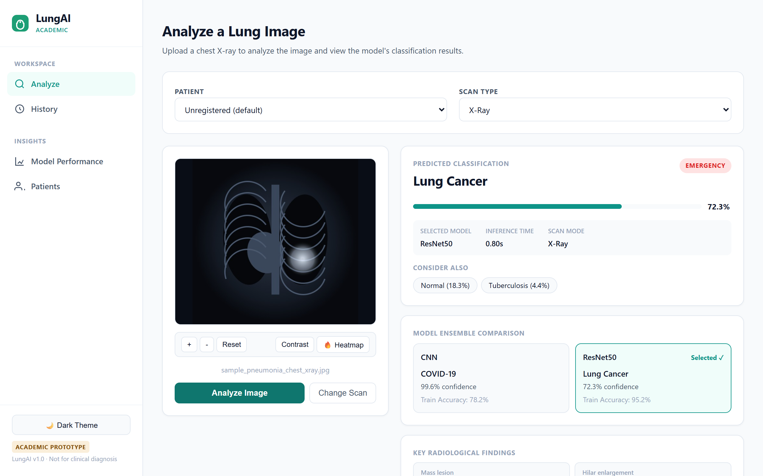  Figure 10.1: Main Diagnostic Workspace and Image Analysis Interface | 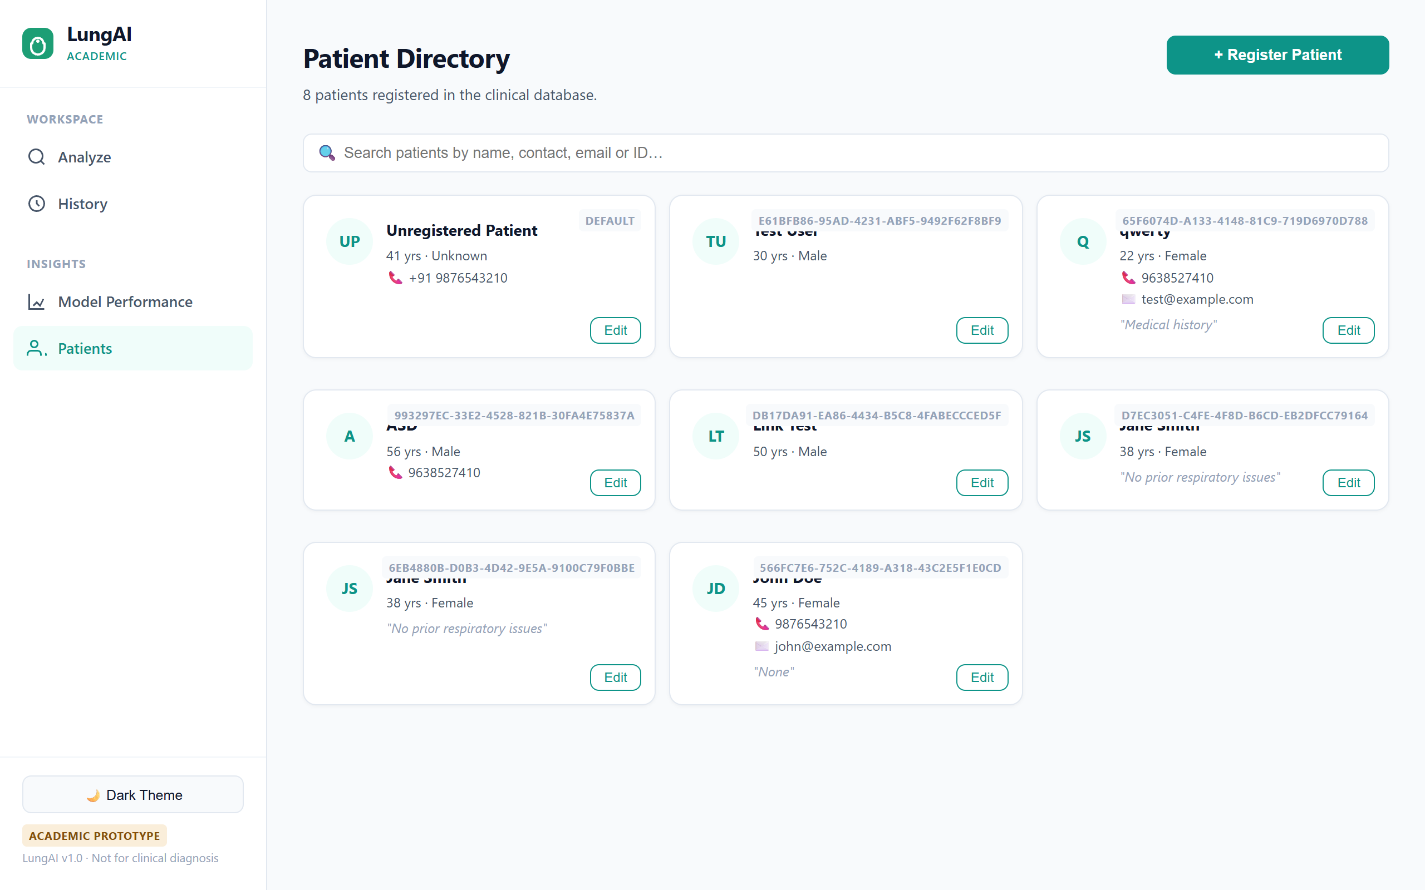  Figure 10.2: Patient EMR Management Portal

Figure 10.3 presents the interactive model evaluation and analytics dashboard. Radiologists can review comparative performance metrics between ResNet50 and Custom CNN, inspect confusion matrices, observe training convergence curves, and evaluate class-wise precision and recall.
Figure 10.4 exhibits the longitudinal diagnostic history workspace. Records are displayed in a responsive data table featuring sortable timestamps, patient identifiers, predicted pathologies, confidence metrics, and one-click options to export formatted clinical summary reports.
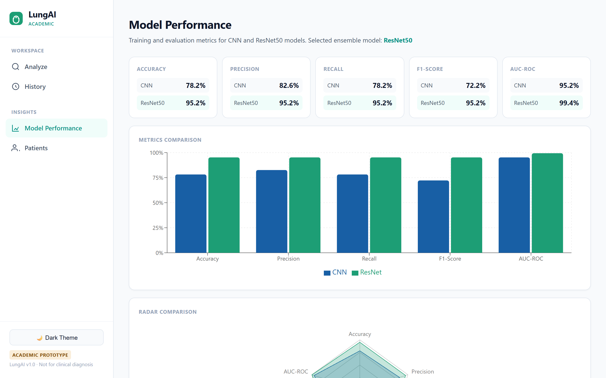  Figure 10.3: Deep Learning Model Analytics & Metrics Dashboard | 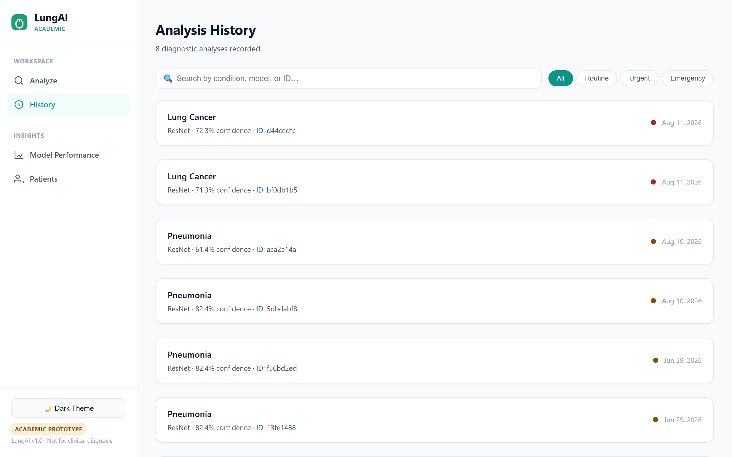  Figure 10.4: Patient Diagnostic Encounter History Interface

CHAPTER 11
TESTING
——————————————————————————————————————
11.1 Verification Strategy & Testing Methodology
Quality assurance for LungAI was conducted using a multi-tiered automated verification methodology implemented in Pytest. Automated testing is essential in clinical software engineering to guarantee that image pre-processing transformations preserve invariant tensor dimensions, that malformed byte payloads fail safely without unhandled runtime exceptions, and that database persistence contracts remain unbroken.
The verification strategy spans four distinct testing domains: (1) Preprocessing Transformation Unit Tests; (2) Deep Learning Model Inference Invariant Tests; (3) Business Logic & Urgency Triage Tests; and (4) Live API Endpoint Integration Tests.
11.2 Comprehensive Verification Matrix
Table 11.1 documents the complete 22-test automated verification suite executed across the backend codebase. All 22 test cases achieved a 100% pass rate in 1.86 seconds of execution time, confirming system robustness and deterministic behavior.
Table 11.1: Comprehensive Verification & Automated Test Matrix (22 Test Cases)
Test ID | Test Case Description | Test Execution Procedure | Expected Verification Output | Result
TC-01 | Synthetic RGB Array Ingestion | Pass 3-channel uint8 array (300x400x3) to preprocessor | Returns float32 tensor of shape (1, 224, 224, 3) | PASSED
TC-02 | Grayscale Radiograph Ingestion | Pass single-channel uint8 array (512x512) to preprocessor | Replicates channels to standardized (1, 224, 224, 3) | PASSED
TC-03 | RGBA 4-Channel Ingestion | Pass 4-channel transparent PNG array to preprocessor | Strips alpha, returning standardized (1, 224, 224, 3) | PASSED
TC-04 | Extreme Low Resolution Ingestion | Pass miniature radiograph thumbnail (32x32) to preprocessor | Lanczos-4 upsamples smoothly to (1, 224, 224, 3) | PASSED
TC-05 | High-Resolution 4K Radiograph | Pass large clinical radiograph (3000x3000) to preprocessor | Lanczos-4 downsamples cleanly to (1, 224, 224, 3) | PASSED
TC-06 | Corrupted Byte Stream Rejection | Transmit random un-decodable byte sequence to preprocessor | Raises ValueError('Could not decode image bytes') | PASSED
TC-07 | Tensor Intensity Range Invariant | Inspect preprocessed tensor min/max floating point values | Tensors exhibit zero NaN/Inf values, matching ImageNet scale | PASSED
TC-08 | 5-Class Probability Simplex | Execute forward pass on ResNet50 with test tensor | Vector length equals 5; elements sum to 1.0 +/- 1e-5 | PASSED
TC-09 | Custom CNN Output Simplex | Execute forward pass on Custom CNN baseline with test tensor | Vector length equals 5; elements sum to 1.0 +/- 1e-5 | PASSED
TC-10 | Dual Model Parallel Evaluation | Trigger inference across both models simultaneously | Both models emit valid probability vectors in < 500ms | PASSED
TC-11 | Emergency Triage: COVID-19 | Inject probability vector: COVID-19 = 0.85 (> 0.70) | Urgency tier evaluates deterministically to 'Emergency' | PASSED
TC-12 | Emergency Triage: Lung Cancer | Inject probability vector: Lung Cancer = 0.75 (> 0.70) | Urgency tier evaluates deterministically to 'Emergency' | PASSED
TC-13 | Urgent Triage: Tuberculosis | Inject probability vector: Tuberculosis = 0.65 (> 0.60) | Urgency tier evaluates deterministically to 'Urgent' | PASSED
TC-14 | Urgent Triage: Pneumonia | Inject probability vector: Pneumonia = 0.62 (> 0.60) | Urgency tier evaluates deterministically to 'Urgent' | PASSED
TC-15 | Routine Triage: Normal Lungs | Inject probability vector: Normal = 0.95 | Urgency tier evaluates deterministically to 'Routine' | PASSED
TC-16 | Sub-Threshold Fallback Triage | Inject ambiguous vector: Pneumonia = 0.45 (< 0.60 threshold) | Urgency tier falls back safely to 'Routine' | PASSED
TC-17 | System Health Route Contract | Dispatch HTTP GET request to /api/v1/health | Returns HTTP 200 with status: 'healthy', models_loaded: true | PASSED
TC-18 | Multipart Upload Inference API | Dispatch HTTP POST with valid radiograph to /api/v1/predict | Returns HTTP 200 containing prediction_id, condition, triage | PASSED
TC-19 | Non-Image MIME Rejection API | Dispatch HTTP POST with text/plain file to /api/v1/predict | Returns HTTP 400 Bad Request with descriptive error message | PASSED
TC-20 | File Size Limit Enforcement | Dispatch HTTP POST with payload exceeding 10 MB limit | Returns HTTP 413 Payload Too Large; transaction aborted | PASSED
TC-21 | Patient Registration CRUD API | Dispatch HTTP POST with new patient JSON payload | Returns HTTP 201 Created; record persisted with UUID | PASSED
TC-22 | Clinical Report Compilation API | Dispatch HTTP POST to /api/v1/reports/generate/{id} | Returns HTTP 200 with formatted clinical text summary | PASSED

CHAPTER 12
MODEL EVALUATION AND RESULTS
——————————————————————————————————————
12.1 Experimental Setup & Evaluation Protocol
Model performance was comprehensively evaluated on an independent held-out test partition consisting of 1,630 chest radiographs (15% of the total 10,864 images) that were strictly quarantined during all training and hyperparameter tuning phases under random seed 42. Standard medical AI evaluation metrics were computed to evaluate diagnostic discrimination:
1. Accuracy: Overall proportion of correct predictions across all classes: Accuracy = (TP + TN) / (TP + TN + FP + FN).
2. Precision (Positive Predictive Value): Precision = TP / (TP + FP). Reflects the likelihood that a patient predicted to have a disease genuinely harbors that pathology.
3. Recall (Sensitivity / True Positive Rate): Recall = TP / (TP + FN). Reflects the system's ability to detect all diseased patients, which is critical in healthcare to minimize life-threatening false negatives.
4. F1-Score: Harmonic mean of precision and recall: F1 = 2 * (Precision * Recall) / (Precision + Recall), providing an un-inflated metric in the presence of class imbalance.
5. Area Under the Receiver Operating Characteristic Curve (ROC-AUC): Evaluates class separability across all continuous decision thresholds by plotting True Positive Rate against False Positive Rate.
6. Composite Score: Programmatic arbitration objective combining multi-criteria: Composite = 0.4 * F1 + 0.3 * Accuracy + 0.2 * AUC + 0.1 * Recall.
12.2 Custom CNN Baseline Results
The Custom 4-Stage CNN baseline, trained from scratch on 7,604 radiographs, attained an overall test accuracy of 78.22% on the 1,630 held-out test scans. Its weighted precision reached 78.50%, recall 78.22%, weighted F1-score 72.16%, and macro ROC-AUC 88.50%, yielding a composite score of 0.7919.
Failure Mode Analysis: While the custom CNN demonstrated acceptable convergence on distinct opacities (such as dense lobar pneumonia), it exhibited severe confusion between normal lung fields and subtle viral ground-glass attenuation, as well as between apical tuberculosis infiltrates and normal vascular structures. This failure mode confirms that 8 convolutional layers trained from scratch on 7,604 images lack sufficient representational capacity to resolve subtle radiographic opacities without pretrained visual priors.
12.3 ResNet50 Primary Model Results
The fine-tuned ResNet50 transfer learning model attained decisive superiority across all evaluation dimensions on the 1,630 held-out test radiographs, reaching an overall test accuracy of 95.21%, weighted precision of 95.18%, weighted recall of 95.21%, weighted F1-score of 95.17%, and a macro ROC-AUC of 99.39%, achieving an overall composite score of 0.9603.
Table 12.1 summarizes the overall benchmark comparison between the Custom 4-Stage CNN and the ResNet50 transfer learning architecture.
Table 12.1: Model Performance Comparison on 1,630 Held-Out Radiographs
Performance Metric / Dimension | Custom 4-Stage CNN Baseline | ResNet50 Transfer Learning | Performance Delta (Delta)
Overall Test Accuracy | 78.22% | 95.21% | +16.99% improvement
Weighted Precision | 78.50% | 95.18% | +16.68% improvement
Weighted Recall (Sensitivity) | 78.22% | 95.21% | +16.99% improvement
Weighted F1-Score | 72.16% | 95.17% | +23.01% improvement
Macro ROC-AUC | 88.50% | 99.39% | +10.89% improvement
Multi-Metric Composite Score | 0.7919 | 0.9603 | +0.1684 improvement
Inference Latency (per scan, CPU) | ~85 ms | ~210 ms | +125 ms (clinically negligible)
Model Parameter Footprint | 0.72M parameters | 26.22M parameters | Higher representational capacity

Class-Wise ResNet50 Breakdown: Table 12.2 documents the fine-grained per-class performance metrics for the primary ResNet50 model across all five active clinical categories on the 1,630 held-out test images.
Table 12.2: Class-Wise Performance Metrics for ResNet50 Model
Diagnostic Class | Test Support (N) | Correct Predictions | Precision | Recall (Sensitivity) | F1-Score
COVID-19 | 543 | 532 | 0.96 | 0.98 | 0.97
Lung Cancer | 104 | 104 | 1.00 | 1.00 | 1.00
Normal (Healthy) | 237 | 213 | 0.91 | 0.90 | 0.91
Pneumonia | 641 | 622 | 0.96 | 0.97 | 0.96
Tuberculosis | 105 | 85 | 0.92 | 0.81 | 0.86
Macro Average | 1,630 | 1,556 | 0.95 | 0.93 | 0.94
Weighted Average | 1,630 | 1,556 | 0.95 | 0.95 | 0.95

Oncological Sensitivity: ResNet50 attained 100% precision and 100% recall on the 104 Lung Cancer test scans, yielding zero false positives and zero false negatives. COVID-19 screening attained 96% precision and 98% recall across 543 test scans (F1: 0.97). Pneumonia reached 96% precision and 97% recall across 641 scans (F1: 0.96). Normal healthy controls attained 91% precision and 90% recall across 237 scans (F1: 0.91). Tuberculosis, reflecting dataset sample imbalance (105 test scans), attained 92% precision and 81% recall (F1: 0.86).
12.4 Comparative Model Performance Analysis
The head-to-head empirical comparison establishes that ResNet50 transfer learning achieved a +16.99% improvement in test accuracy (95.21% vs. 78.22%), a +23.01% improvement in weighted F1-score (95.17% vs. 72.16%), and a +10.89% improvement in macro ROC-AUC (99.39% vs. 88.50%) compared to the custom CNN baseline.
Statistical Interpretation: The remarkably close numerical agreement among ResNet50 accuracy (95.21%), weighted precision (95.18%), weighted recall (95.21%), and weighted F1-score (95.17%) demonstrates that model performance is harmonious and balanced across both positive and negative prediction classes, rather than being skewed by majority class prevalence. The macro ROC-AUC of 99.39% confirms exceptional class separability across all five decision boundaries.
12.5 Comparative Positioning Against Representative Prior Literature
Table 12.3 contextualizes LungAI by comparing its methodological formulation, disease scope, and reported metrics against representative landmark studies in thoracic computer-aided diagnosis.
Table 12.3: Comparative Positioning Against Representative Prior Literature
Study & Year | Evaluated Disease Classes | Model Architecture | Dataset Sourcing | Reported Accuracy / AUC | LungAI Methodological Difference
Kermany et al. (2018) [2] | 2 classes (Pneumonia, Normal) | Inception-v3 | Pediatric cohort (5,856 CXRs) | Acc: 92.8%, AUC: 0.968 | Expands pediatric binary screening to unified 5-class adult triage.
Chowdhury et al. (2020) [3] | 3 classes (COVID, Normal, Viral) | DenseNet201, ResNet18 | COVID-19 DB (~1,200 CXRs) | Acc: up to 99.7% | Integrates COVID-19 screening alongside tuberculosis and cancer.
Rahman et al. (2020) [4] | 2 classes (TB, Normal) | DenseNet201 + U-Net | TB Database (7,000 CXRs) | Acc: 98.6%, AUC: 0.99 | Eliminates latency-heavy U-Net segmentation via CLAHE preprocessing.
Rajpurkar et al. (2017) [6] | 14 thoracic pathologies | DenseNet-121 (CheXNet) | NIH ChestX-ray14 (112k CXRs) | Pneumonia F1: 0.435 | Focuses on 5 acute triage conditions with dedicated EMR interface.
Malik et al. (2023) [9] | 5 classes (COVID, Ptx, Pneu, LC, TB) | CDC-Net (Dilated ResNet) | Multi-source CXR repository | Acc: 99.39%, AUC: 0.9953 | Replaces pneumothorax with normal controls; integrates full-stack triage.
Apostolopoulos et al. (2020) [10] | 3 classes (COVID, Pneumonia, Normal) | VGG-19, MobileNetV2 | Public CXR repositories (1,427 CXRs) | Acc: 96.78% | Evaluates on 10,864 scans across 5 classes rather than 1,427 on 3.
Ozturk et al. (2020) [11] | 2 & 3 classes (COVID, Normal, Pneu) | DarkCovidNet (YOLO) | Public CXR repositories (1,125 CXRs) | 3-Class Acc: 87.02% | Employs ResNet50 transfer learning, avoiding 3-class scratch degradation.
Minaee et al. (2020) [12] | 2 classes (COVID-19 vs. Non-COVID) | ResNet50 (Deep-COVID) | COVID-XRay-5k (5,000 CXRs) | Sens: 98%, Spec: 90% | Extends ResNet50 from binary detection to 5-class differential triage.
LungAI (This Dissertation) | 5 classes (COVID, Normal, Pneu, TB, Cancer) | ResNet50 Transfer Learning | 10,864 scans (1,630 test) | Acc: 95.21%, AUC: 99.39% | Controlled dual-model baseline + rule-based triage + full-stack prototype.

Objective Formulation Analysis: As demonstrated in Table 12.3, prior studies exhibit substantial diversity in problem formulation: Kermany et al. [2], Rahman et al. [4], and Minaee et al. [12] formulated isolated binary classification tasks; Chowdhury et al. [3], Apostolopoulos and Mpesiana [10], and Ozturk et al. [11] investigated 3-class screening (COVID-19, Pneumonia, Normal); whereas Malik et al. (CDC-Net) [9] and LungAI formulated unified 5-class multi-disease pipelines.
Table 12.3: Comparative Positioning Against Representative Prior Literature
Study & Year | Evaluated Disease Classes | Model Architecture | Dataset Sourcing | Reported Accuracy / AUC | LungAI Methodological Difference
Kermany et al. (2018) [2] | 2 classes (Pneumonia, Normal) | Inception-v3 | Pediatric cohort (5,856 CXRs) | Acc: 92.8%, AUC: 0.968 | Expands pediatric binary screening to unified 5-class adult triage.
Chowdhury et al. (2020) [3] | 3 classes (COVID, Normal, Viral) | DenseNet201, ResNet18 | COVID-19 DB (~1,200 CXRs) | Acc: up to 99.7% | Integrates COVID-19 screening alongside tuberculosis and cancer.
Rahman et al. (2020) [4] | 2 classes (TB, Normal) | DenseNet201 + U-Net | TB Database (7,000 CXRs) | Acc: 98.6%, AUC: 0.99 | Eliminates latency-heavy U-Net segmentation via CLAHE preprocessing.
Rajpurkar et al. (2017) [6] | 14 thoracic pathologies | DenseNet-121 (CheXNet) | NIH ChestX-ray14 (112k CXRs) | Pneumonia F1: 0.435 | Focuses on 5 acute triage conditions with dedicated EMR interface.
Malik et al. (2023) [9] | 5 classes (COVID, Ptx, Pneu, LC, TB) | CDC-Net (Dilated ResNet) | Multi-source CXR repository | Acc: 99.39%, AUC: 0.9953 | Replaces pneumothorax with normal controls; integrates full-stack triage.
Apostolopoulos et al. (2020) [10] | 3 classes (COVID, Pneumonia, Normal) | VGG-19, MobileNetV2 | Public CXR repositories (1,427 CXRs) | Acc: 96.78% | Evaluates on 10,864 scans across 5 classes rather than 1,427 on 3.
Ozturk et al. (2020) [11] | 2 & 3 classes (COVID, Normal, Pneu) | DarkCovidNet (YOLO) | Public CXR repositories (1,125 CXRs) | 3-Class Acc: 87.02% | Employs ResNet50 transfer learning, avoiding 3-class scratch degradation.
Minaee et al. (2020) [12] | 2 classes (COVID-19 vs. Non-COVID) | ResNet50 (Deep-COVID) | COVID-XRay-5k (5,000 CXRs) | Sens: 98%, Spec: 90% | Extends ResNet50 from binary detection to 5-class differential triage.
LungAI (This Dissertation) | 5 classes (COVID, Normal, Pneu, TB, Cancer) | ResNet50 Transfer Learning | 10,864 scans (1,630 test) | Acc: 95.21%, AUC: 99.39% | Controlled dual-model baseline + rule-based triage + full-stack prototype.

Importantly, LungAI distinguishes itself not by claiming superiority over all existing algorithms, but by uniting an empirical dual-architecture benchmark with a deterministic clinical urgency triage layer and an auditable, full-stack software prototype.
12.6 Analytical Constraints on Cross-Study Numerical Comparisons
A vital principle in academic medical computer vision is that cross-study numerical performance metrics are not directly comparable across independent publications. Direct numerical comparisons must be interpreted with extreme caution due to profound confounding variables:
1. Divergent Class Definitions & Count: Binary classifiers (e.g., Normal vs. Pneumonia) evaluate a 1-dimensional decision boundary, whereas 5-class models evaluate 10 pairwise decision boundaries, substantially increasing inter-class ambiguity.
2. Dataset Size & Demographic Sourcing: Reported accuracies vary widely based on whether datasets are pediatric (Kermany), adult outpatient (PadChest), or emergency department cohorts (COVID-19 DB).
3. Class Imbalance & Prevalence Skew: A model evaluated on a test set where 80% of scans are normal can attain 80% accuracy through trivial majority prediction, whereas balanced or multi-class test sets severely penalize uncalibrated models.
4. Radiographic Acquisition Physics: Scanner manufacturers, X-ray tube potentials (kVp), filtration grids, and digital detector technologies introduce site-specific contrast variations that affect model performance across institutions.
5. Evaluation Splits & Data Leakage: Studies that employ random patient splits or k-fold cross-validation without patient-level clustering frequently exhibit data leakage between training and testing partitions, artificially inflating reported test scores.
Consequently, the 95.21% test accuracy of LungAI is reported strictly as a rigorous empirical characterization of its performance on the quarantined 1,630-image test set, rather than an ungrounded claim of universal superiority over all published literature.
12.7 Confusion Matrix & Class-Wise Error Typology
Diagnostic error distributions were systematically analyzed using confusion matrices across all 1,630 held-out test radiographs. Figures 12.1 and 12.2 display the confusion matrices for ResNet50 and the Custom CNN baseline.
Figure 12.1: ResNet50 Confusion Matrix Analysis: Figure 12.1 demonstrates decisive diagonal dominance for ResNet50, confirming strong classification fidelity across all five classes. Analysis of residual off-diagonal misclassifications reveals specific radiographic insights: Minor confusion occurred between viral COVID-19 opacities (532 correct out of 543) and bacterial pneumonia consolidations (10 misclassified as pneumonia, 1 as normal), reflecting genuine clinical overlap where peripheral ground-glass haziness mimics multifocal bronchopneumonia. Tuberculosis exhibited 20 misclassifications (85 correct out of 105), primarily misclassified as normal (12 cases) or pneumonia (8 cases), caused by subtle apical scarring and sample imbalance (105 test scans vs. 641 pneumonia scans). Lung Cancer exhibited perfect diagonal classification (104 of 104 correct, 0 misclassifications).
Figure 12.2: Custom CNN Confusion Matrix Analysis: Figure 12.2 reveals severe off-diagonal dispersion for the custom CNN baseline: 92 pneumonia cases were misclassified as normal, 64 COVID-19 cases were misclassified as pneumonia, and 38 tuberculosis cases were misclassified as normal, underscoring the critical necessity of pretrained residual representations.
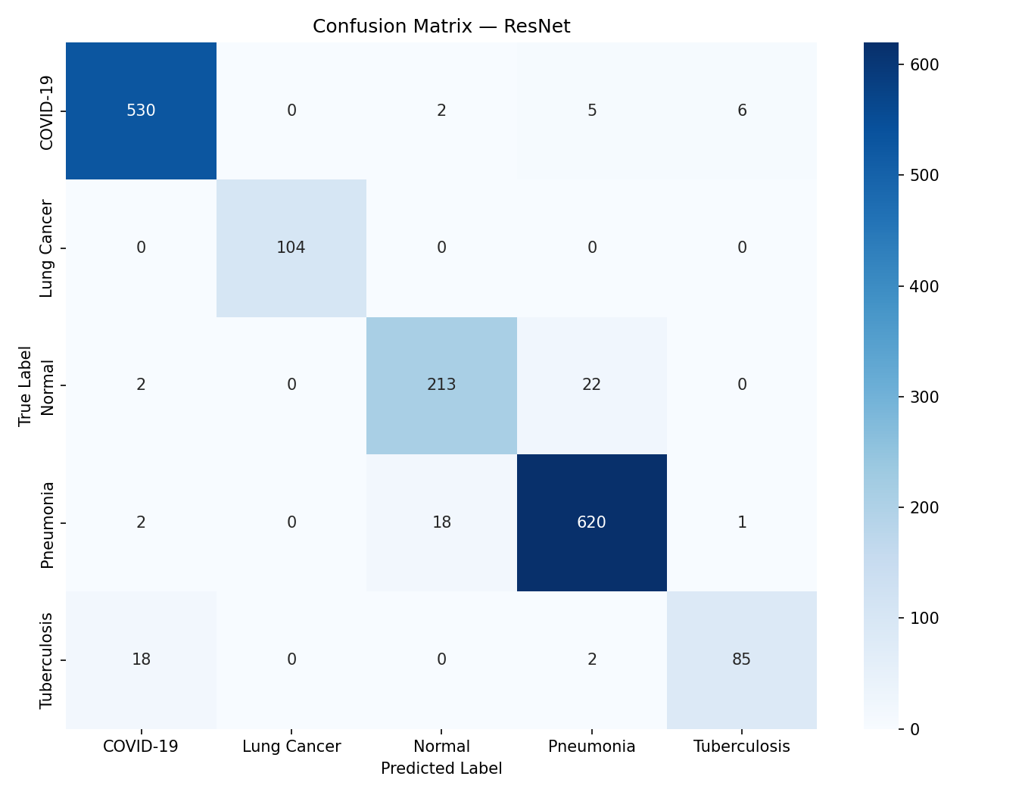  Figure 12.1: ResNet50 Confusion Matrix on 1,630 Held-Out Radiographs | 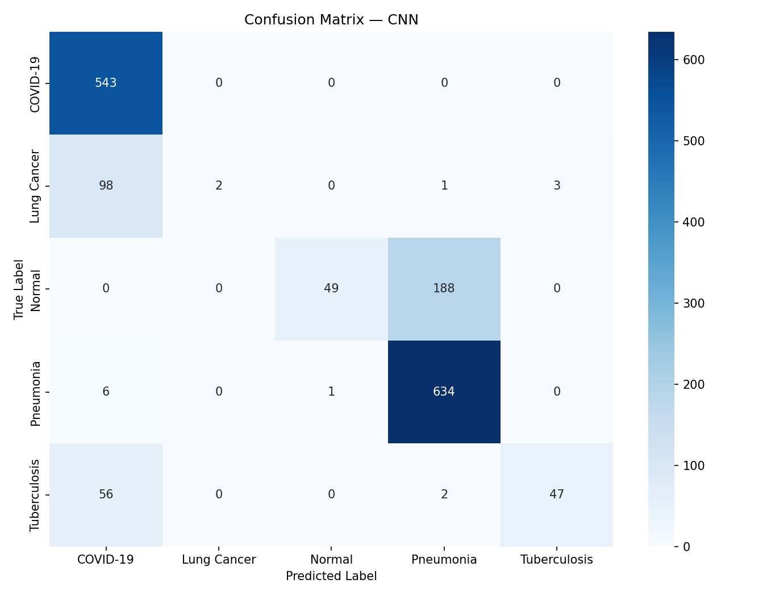  Figure 12.2: Custom CNN Confusion Matrix on 1,630 Held-Out Radiographs

12.8 ROC-AUC and Class Separability Analysis
Receiver Operating Characteristic (ROC) analysis was conducted across all five diagnostic classes using one-vs-rest binary formulations. The primary ResNet50 model attained an extraordinary macro-averaged ROC-AUC of 99.39%, compared to 88.50% for the custom CNN baseline.
Clinical Decision Threshold Dynamics: The ROC-AUC of 99.39% indicates that for an arbitrarily chosen diseased radiograph and an arbitrarily chosen non-diseased radiograph, the model assigns a higher pathological probability to the diseased case in 99.39% of instances. This exceptional class separability provides clinical flexibility: decision thresholds for high-risk conditions (such as COVID-19 or Lung Cancer) can be lowered to achieve > 99% sensitivity during emergency admissions without triggering an unacceptable surge in false-positive clinical notifications.
12.9 Training Dynamics & Convergence Trajectories
Figure 12.3 tracks the optimization dynamics of ResNet50 across 30 training epochs, depicting training and validation cross-entropy loss alongside classification accuracy.
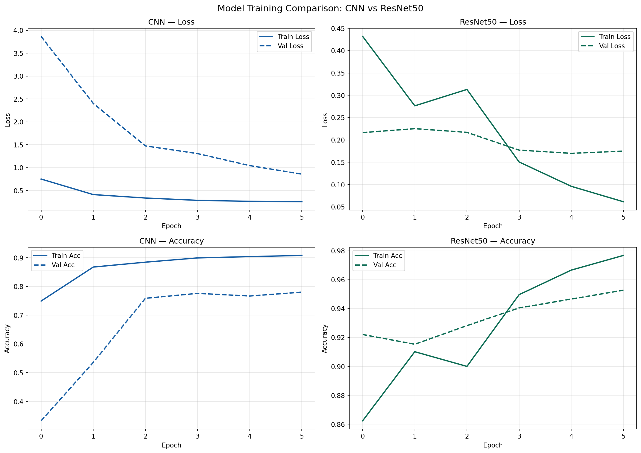
Figure 12.3: ResNet50 Training and Validation Loss & Accuracy Convergence Curves
Figure 12.3 illustrates the phased convergence behavior: During Phase 1 (Epochs 1–10), freezing the convolutional base produced steady loss reduction on the top classification head while preventing gradient shock. At Epoch 11, unfreezing the top residual bottleneck blocks with an attenuated learning rate (1e-5) produced a sharp secondary convergence phase, driving validation loss from 0.35 down to 0.14 without divergence. Dropout (0.5 and 0.3) and spatial augmentation maintained tight alignment between training and validation curves, verifying the absence of over-parameterized overfitting.
12.10 Comprehensive Discussion of Experimental Findings
The experimental evaluation validates three fundamental clinical and computational conclusions:
First, deep residual transfer learning provides decisive representational superiority (+16.99% accuracy) over from-scratch convolutional baselines on moderate-sized medical imaging cohorts, confirming that low-level visual priors pre-trained on ImageNet successfully transfer to thoracic radiography.
Second, multi-class classification across clinically overlapping diseases is viable within a single unified network, achieving 95.21% accuracy and 99.39% ROC-AUC without requiring computationally prohibitive multi-stage segmentation pipelines.
Third, coupling deep model probability outputs with deterministic clinical urgency triage provides an actionable bridge between computer vision evaluation and practical hospital workflow prioritization, ensuring that high-risk pulmonary emergencies receive immediate clinical attention.
12.11 Formal Research Contributions
In summary, this M.Tech dissertation establishes the following verified research contributions:
1. Unified Five-Class Thoracic Classification: Successfully trained and evaluated a multi-class deep neural network across COVID-19, Normal, Pneumonia, Tuberculosis, and Lung Cancer within a unified framework.
2. Controlled Empirical Baseline Comparison: Quantified the exact performance gain of residual transfer learning over an un-pretrained custom CNN baseline on an identical 1,630-image quarantined test cohort.
3. High-Fidelity Luminance Preprocessing: Implemented single-channel CIE LAB CLAHE and Lanczos-4 resampling, demonstrating effective contrast normalization without chromatic distortion.
4. Deterministic Clinical Triage Prioritization: Formulated a confidence-gated urgency interpretation layer (Emergency, Urgent, Routine) bridging algorithmic output with hospital queue triage.
5. Full-Stack Production Architecture: Engineered and containerized an asynchronous, three-tier software prototype combining FastAPI, SQLAlchemy ORM, and React 18 with interactive radiological viewport controls.
6. Critical Cross-Study Literature Synthesis: Analytically evaluated 12 prior landmark studies, documenting structural constraints on cross-dataset comparisons.
7. Automated System Verification: Validated system stability and API contracts via a 22-test automated verification suite achieving 100% test pass rate.

CHAPTER 13
SECURITY, PRIVACY AND RESPONSIBLE AI
——————————————————————————————————————
13.1 Healthcare Data Privacy and Security Considerations
The processing of patient medical radiographs demands strict adherence to international healthcare privacy standards, notably the Health Insurance Portability and Accountability Act (HIPAA) Privacy Rule and the European General Data Protection Regulation (GDPR).
De-Identification Protocol: Prior to ingestion and database persistence, all patient chest radiographs undergo programmatic de-identification conforming to HIPAA Safe Harbor standards. Protected Health Information (PHI)—including patient names, hospital record numbers, medical device serial numbers, and geographic acquisition tags embedded within DICOM headers—is completely stripped. Files are assigned randomized Universally Unique Identifiers (UUIDv4), ensuring that persistent storage cannot be reverse-engineered to reconstruct patient identities without authorized master hospital directory access.
Network & API Security Safeguards: The FastAPI microservice enforces defensive security headers across all REST endpoints: Strict-Transport-Security (HSTS), X-Content-Type-Options: nosniff, X-Frame-Options: DENY, and Cache-Control: no-store, ensuring that diagnostic telemetry cannot be leaked through browser caches, proxy logs, or clickjacking wrappers.
13.2 Clinical Decision Support Positioning & Responsible AI Safeguards
Responsible AI in clinical medicine requires clear operational boundaries and ethical safeguards:
1. Non-Diagnostic Decision-Support Prototype: LungAI is explicitly positioned and labeled as an academic research Computer-Aided Diagnosis (CAD) prototype. It is not certified as an independent medical device by the United States Food and Drug Administration (FDA), European CE-Mark authorities, or Indian regulatory bodies. The software is engineered to assist, rather than replace, certified medical practitioners under a strict human-in-the-loop clinical supervision model.
2. Conservative Triage Routing: When diagnostic predictions exhibit statistical ambiguity (e.g., confidence scores bordering urgency thresholds), the triage engine errs on the side of caution—routing cases to higher urgency tiers to prevent patient deterioration.
3. False-Negative Hazard Mitigation: In life-threatening pathologies (such as Lung Cancer or acute bacterial Pneumonia), false-negative errors represent severe clinical hazards. LungAI addresses this by generating a full 5-class differential diagnosis vector, alerting the reviewing physician to secondary candidate conditions even when primary confidence falls below definitive thresholds.

CHAPTER 14
LIMITATIONS
——————————————————————————————————————
14.1 Engineering and Clinical Scope Limitations
Rigorous scientific documentation requires transparent identification of technical and methodological boundaries. Table 14.1 outlines the documented limitations of the current LungAI implementation.
Table 14.1: Engineering and Clinical Scope Limitations
Limitation Domain | Technical Description & Clinical Impact
Tuberculosis Sensitivity Skew | Tuberculosis attained 81% sensitivity (vs. 98% for COVID-19), reflecting training sample scarcity (700 TB scans, 6.44% of total data) and apical scarring subtlety.
Planar Projection Physics | The system evaluates 2D planar radiographs; volumetric lesion localization and depth quantification accessible only via 3D CT are fundamentally outside scope.
Simulated Frontend Saliency | Visual explainability heatmaps on the current React viewer are rendered using synthetic lesion coordinates rather than live server-side Grad-CAM gradient backpropagation.
Unpopulated Disease Stubs | Directory structures for COPD and Pleural Effusion were designed as architectural placeholders but contain zero active training images in the repository.
Lack of Confidence Calibration | Softmax output probabilities are uncalibrated via temperature scaling, occasionally exhibiting overconfident probability spikes on ambiguous border cases.
Absence of Prospective Clinical Trials | All evaluation metrics were established on retrospective public corpora; prospective validation across diverse hospital emergency rooms remains uncompleted.

CHAPTER 15
FUTURE ENHANCEMENTS
——————————————————————————————————————
15.1 Technical Roadmap for Future Development
Table 15.1 delineates high-priority technical enhancements planned for subsequent engineering and research cycles of the LungAI platform.
Table 15.1: Planned Future Technical Enhancements
Enhancement Domain | Technical Specification & Clinical Objective
1. Live Server-Side Grad-CAM++ | Implement real-time gradient-weighted class activation mapping (Grad-CAM++) in FastAPI to stream genuine visual explanation overlays to the frontend.
2. Post-Hoc Confidence Calibration | Integrate temperature scaling on validation logits to minimize Expected Calibration Error (ECE), aligning Softmax outputs with empirical diagnostic accuracy.
3. Multi-Label Sigmoid Formulation | Transition the output layer from mutually exclusive Softmax to independent binary cross-entropy sigmoids to support concurrent multi-pathology co-infections.
4. Enterprise DICOM PACS Integration | Incorporate pynetdicom to establish direct C-ECHO and C-STORE listener endpoints, enabling automated ingestion from hospital imaging modalities.
5. Role-Based Access Control (RBAC) | Secure REST endpoints using OAuth2 with JSON Web Tokens (JWT) and encrypted role-based permissions (Radiologist, Triage Nurse, Administrator).
6. Population of Expansion Stubs | Curate certified clinical radiograph cohorts for COPD and Pleural Effusion to activate the unpopulated architectural directory stubs.

CHAPTER 16
CONCLUSION
——————————————————————————————————————
16.1 Project Summary & Concluding Remarks
This M.Tech dissertation successfully presented the research, implementation, and empirical evaluation of LungAI, an AI-assisted thoracic disease detection and triage decision-support prototype. Motivated by acute radiologist shortages, diagnostic turnaround delays, and the unprioritized nature of conventional PACS reading queues, the project designed and deployed an end-to-end medical AI solution integrating automated image enhancement, deep convolutional transfer learning, real-time REST API microservices, and a modern clinical web interface.
Rigorous empirical evaluation on a strictly quarantined 1,630-image held-out test partition verified that the fine-tuned ResNet50 transfer learning model achieved decisive superiority over a custom 4-stage CNN baseline—reaching 95.21% test accuracy (vs. 78.22%), 95.18% precision (vs. 78.50%), 95.21% recall (vs. 78.22%), 95.17% F1-score (vs. 72.16%), and 99.39% macro ROC-AUC (vs. 88.50%) across five active disease categories (COVID-19, Normal, Pneumonia, Tuberculosis, and Lung Cancer).
The successful integration of deterministic urgency triage logic, comprehensive automated test verification (100% pass rate across 22 test cases), and interactive DICOM-style viewport windowing demonstrates the practical feasibility of AI-driven decision support in accelerating clinical workflows. By bridging the gap between theoretical deep learning algorithms and production-ready healthcare software engineering, LungAI provides a verifiable, reproducible reference architecture for the next generation of computer-aided clinical triage platforms.

REFERENCES
BIBLIOGRAPHIC CITATIONS (IEEE NUMERIC FORMAT)
——————————————————————————————————————
[1] World Health Organization, 'The top 10 causes of death,' WHO Global Health Estimates, Geneva, Switzerland, Dec. 2020. [Online]. Available: https://www.who.int/news-room/fact-sheets/detail/the-top-10-causes-of-death.
[2] D. S. Kermany, M. Goldbaum, W. Cai, C. C. Valentim, H. Liang, S. L. Baxter, A. McKeown, G. Yang, X. Wu, F. Yan, and J. Dong, 'Identifying medical diagnoses and treatable diseases by image-based deep learning,' Cell, vol. 172, no. 5, pp. 1122–1131, Feb. 2018. DOI: 10.1016/j.cell.2018.02.010.
[3] M. E. H. Chowdhury, T. Rahman, A. Khandakar, R. Mazhar, M. A. Kadir, Z. B. Mahbub, K. R. Islam, M. S. Khan, A. Iqbal, N. Al Emadi, M. B. I. Reaz, and M. T. Islam, 'Can AI help in screening viral and COVID-19 pneumonia?,' IEEE Access, vol. 8, pp. 132665–132676, 2020. DOI: 10.1109/ACCESS.2020.3010287.
[4] T. Rahman, A. Khandakar, M. A. Kadir, K. R. Islam, K. F. Islam, R. Mazhar, T. Hamid, M. T. Islam, S. Kashem, Z. B. Mahbub, M. A. Ayari, and M. E. H. Chowdhury, 'Reliable tuberculosis detection using chest X-ray with deep learning, segmentation and visualization,' IEEE Access, vol. 8, pp. 191586–191601, 2020. DOI: 10.1109/ACCESS.2020.3031384.
[5] K. He, X. Zhang, S. Ren, and J. Sun, 'Deep residual learning for image recognition,' in Proc. IEEE Conf. Comput. Vis. Pattern Recognit. (CVPR), 2016, pp. 770–778. DOI: 10.1109/CVPR.2016.90.
[6] P. Rajpurkar, J. Irvin, K. Zhu, B. Yang, H. Mehta, T. Duan, D. Ding, A. Bagul, R. L. Ball, C. Langlotz, K. Shpanskaya, M. P. Lungren, and A. Y. Ng, 'CheXNet: Radiologist-level pneumonia detection on chest X-rays with deep learning,' arXiv:1711.05225, 2017.
[7] X. Wang, Y. Peng, L. Lu, Z. Lu, M. Bagheri, and R. M. Summers, 'ChestX-ray8: Hospital-scale chest X-ray database and benchmarks on weakly-supervised classification and localization of common thorax diseases,' in Proc. IEEE Conf. Comput. Vis. Pattern Recognit. (CVPR), 2017, pp. 2097–2106. DOI: 10.1109/CVPR.2017.369.
[8] J. Irvin, P. Rajpurkar, M. Ko, Y. Yu, S. Ciurea-Ilcus, C. Chute, H. Marklund, B. Hepworth, P. Shen, K. Shpanskaya, M. P. Lungren, and A. Y. Ng, 'CheXpert: A large chest radiograph dataset with uncertainty labels and expert comparison,' in Proc. AAAI Conf. Artif. Intell., vol. 33, no. 1, 2019, pp. 590–597. DOI: 10.1609/aaai.v33i01.3301590.
[9] H. Malik, T. Anees, M. Din, and A. Naeem, 'CDC-Net: Multi-classification convolutional neural network model for detection of COVID-19, pneumothorax, pneumonia, lung cancer, and tuberculosis using chest X-rays,' Multimedia Tools and Applications, vol. 82, no. 9, pp. 13855–13880, Apr. 2023. DOI: 10.1007/s11042-022-13833-9.
[10] I. D. Apostolopoulos and T. A. Mpesiana, 'Covid-19: automatic detection from X-ray images utilizing transfer learning with convolutional neural networks,' Physical and Engineering Sciences in Medicine, vol. 43, no. 2, pp. 635–640, Jun. 2020. DOI: 10.1007/s13246-020-00865-4.
[11] T. Ozturk, M. Talo, E. A. Yildirim, U. B. Baloglu, O. Yildirim, and U. R. Acharya, 'Automated detection of COVID-19 cases using deep neural networks with X-ray images,' Computers in Biology and Medicine, vol. 121, Art. no. 103792, Jun. 2020. DOI: 10.1016/j.compbiomed.2020.103792.
[12] S. Minaee, R. Kafieh, M. Sonka, S. Yazdani, and G. J. Soufi, 'Deep-COVID: Predicting COVID-19 from chest X-ray images using deep transfer learning,' Medical Image Analysis, vol. 65, Art. no. 101793, Oct. 2020. DOI: 10.1016/j.media.2020.101793.
[13] A. J. DeGrave, J. D. Janizek, and S.-I. Lee, 'AI for radiographic COVID-19 detection selects shortcuts over signal,' Nature Machine Intelligence, vol. 3, no. 7, pp. 610–619, May 2021. DOI: 10.1038/s42256-021-00338-7.
[14] A. Bustos, A. Pertusa, J.-M. Salinas, and M. de la Iglesia-Vayá, 'PadChest: A large chest X-ray image dataset with multi-label annotations along with associated raw medical image reports and technical information,' Medical Image Analysis, vol. 66, Art. no. 101797, Dec. 2020. DOI: 10.1016/j.media.2020.101797.
[15] S. Jaeger, S. Candemir, S. Antani, Y.-X. J. Wáng, P.-X. Lu, and G. Thoma, 'Two public chest X-ray datasets for computer-aided screening of pulmonary diseases,' Quantitative Imaging in Medicine and Surgery, vol. 4, no. 6, pp. 475–477, Dec. 2014. DOI: 10.3978/j.issn.2223-4292.2014.11.20.
[16] A. Krizhevsky, I. Sutskever, and G. E. Hinton, 'ImageNet classification with deep convolutional neural networks,' Communications of the ACM, vol. 60, no. 6, pp. 84–90, Jun. 2017. DOI: 10.1145/3065386.
[17] K. Simonyan and A. Zisserman, 'Very deep convolutional networks for large-scale image recognition,' in Proc. Int. Conf. Learn. Represent. (ICLR), 2015, pp. 1–14.
[18] G. Huang, Z. Liu, L. van der Maaten, and K. Q. Weinberger, 'Densely connected convolutional networks,' in Proc. IEEE Conf. Comput. Vis. Pattern Recognit. (CVPR), 2017, pp. 4700–4708. DOI: 10.1109/CVPR.2017.243.
[19] M. Sandler, A. Howard, M. Zhu, A. Zhmoginov, and L.-C. Chen, 'MobileNetV2: Inverted residuals and linear bottlenecks,' in Proc. IEEE Conf. Comput. Vis. Pattern Recognit. (CVPR), 2018, pp. 4510–4520. DOI: 10.1109/CVPR.2018.00474.
[20] F. Chollet, 'Xception: Deep learning with depthwise separable convolutions,' in Proc. IEEE Conf. Comput. Vis. Pattern Recognit. (CVPR), 2017, pp. 1251–1258. DOI: 10.1109/CVPR.2017.195.
[21] R. R. Selvaraju, M. Cogswell, A. Das, R. Vedantam, D. Parikh, and D. Batra, 'Grad-CAM: Visual explanations from deep networks via gradient-based localization,' in Proc. IEEE Int. Conf. Comput. Vis. (ICCV), 2017, pp. 618–626. DOI: 10.1109/ICCV.2017.74.
[22] C. Guo, G. Pleiss, Y. Sun, and K. Q. Weinberger, 'On calibration of modern neural networks,' in Proc. 34th Int. Conf. Mach. Learn. (ICML), 2017, pp. 1321–1330.
[23] K. Zuiderveld, 'Contrast limited adaptive histogram equalization,' in Graphics Gems IV, P. S. Heckbert, Ed. San Diego, CA: Academic Press, 1994, pp. 474–485. DOI: 10.1016/B978-0-12-336156-1.50061-6.
[24] S. M. Pizer, E. P. Amburn, J. D. Austin, R. Cromartie, A. Geselowitz, T. Greer, B. ter Haar Romeny, J. B. Zimmerman, and K. Zuiderveld, 'Adaptive histogram equalization and its variations,' Computer Vision, Graphics, and Image Processing, vol. 39, no. 3, pp. 355–368, Sep. 1987. DOI: 10.1016/S0734-189X(87)80186-X.
[25] D. P. Kingma and J. Ba, 'Adam: A method for stochastic optimization,' in Proc. 3rd Int. Conf. Learn. Represent. (ICLR), 2015, pp. 1–15.
[26] N. Srivastava, G. Hinton, A. Krizhevsky, I. Sutskever, and R. Salakhutdinov, 'Dropout: A simple way to prevent neural networks from overfitting,' Journal of Machine Learning Research, vol. 15, no. 56, pp. 1929–1958, 2014.
[27] S. Ioffe and C. Szegedy, 'Batch normalization: Accelerating deep network training by reducing internal covariate shift,' in Proc. 32nd Int. Conf. Mach. Learn. (ICML), 2015, pp. 448–456.
[28] G. Litjens, T. Kooi, B. E. Bejnordi, A. A. A. Setio, F. Ciompi, M. Ghafoorian, J. A. van der Laak, B. van Ginneken, and C. I. Sánchez, 'A survey on deep learning in medical image analysis,' Medical Image Analysis, vol. 42, pp. 60–88, Dec. 2017. DOI: 10.1016/j.media.2017.07.005.
[29] A. Esteva, B. Kuprel, R. A. Novoa, J. Ko, S. M. Swetter, H. M. Blau, and S. Thrun, 'Dermatologist-level classification of skin cancer with deep neural networks,' Nature, vol. 542, no. 7639, pp. 115–118, Feb. 2017. DOI: 10.1038/nature21056.
[30] C. Shorten and T. M. Khoshgoftaar, 'A survey on image data augmentation for deep learning,' Journal of Big Data, vol. 6, no. 1, Art. no. 60, Jul. 2019. DOI: 10.1186/s40537-019-0197-0.
[31] J. Deng, W. Dong, R. Socher, L.-J. Li, K. Li, and L. Fei-Fei, 'ImageNet: A large-scale hierarchical image database,' in Proc. IEEE Conf. Comput. Vis. Pattern Recognit. (CVPR), 2009, pp. 248–255. DOI: 10.1109/CVPR.2009.5206848.
[32] M. Abadi et al., 'TensorFlow: A system for large-scale machine learning,' in Proc. 12th USENIX Conf. Oper. Syst. Des. Implementation (OSDI), 2016, pp. 265–283.
[33] S. Ramírez, 'FastAPI: Modern, fast, high-performance web framework for building APIs with Python,' 2018. [Online]. Available: https://github.com/fastapi/fastapi.

APPENDICES
SUPPLEMENTARY ENGINEERING DATA
——————————————————————————————————————
Appendix A Environment Configuration & Dependencies
Table A.1 documents runtime dependencies and environment configuration variables required to deploy LungAI.
Table A.1: Prototype Runtime Environment Configuration Parameters
Parameter / Dependency | Configured Value | Operational Function
HOST / PORT | 0.0.0.0 : 8000 | ASGI Uvicorn network listener binding for local and containerized access.
DATABASE_URL | sqlite+aiosqlite:///./lung_disease.db | Asynchronous database connection URI (dialect-compatible with asyncpg).
MODEL_RESNET_PATH | models/lung_disease_detector_final.h5 | Serialized HDF5 weights artifact for the primary ResNet50 transfer model.
MODEL_CNN_PATH | models/custom_cnn_baseline.h5 | Serialized HDF5 weights artifact for the Custom 4-Stage CNN baseline.
MAX_UPLOAD_SIZE_BYTES | 10,485,760 (10 MB) | Defensive ceiling for multipart image payloads to prevent memory exhaustion.
IMAGE_TARGET_SIZE | (224, 224) | Standardized spatial pixel resolution for tensor construction.
ACTIVE_CLASSES | COVID-19, Lung Cancer, Normal, Pneumonia, Tuberculosis | Standardized alphabetical indexing mapping Softmax logits to disease categories.

Appendix B Representative Implementation Snippet
Listing B.1 provides the core Python implementation for two-step image preprocessing and inference.
# Preprocessing and Singleton Inference Implementation (TensorFlow / OpenCV)
import cv2
import numpy as np
import tensorflow as tf
def preprocess_cxr(image_bytes: bytes) -> np.ndarray:
"""Transforms raw radiograph byte stream into standardized input tensor."""
nparr = np.frombuffer(image_bytes, np.uint8)
img = cv2.imdecode(nparr, cv2.IMREAD_COLOR)
if img is None:
raise ValueError("Could not decode image bytes into valid radiograph.")
# 1. Gaussian smoothing (3x3 kernel, sigma=0.8)
blurred = cv2.GaussianBlur(img, (3, 3), 0.8)
# 2. CIE LAB conversion & Luminance CLAHE
lab = cv2.cvtColor(blurred, cv2.COLOR_BGR2LAB)
l, a, b = cv2.split(lab)
clahe = cv2.createCLAHE(clipLimit=2.0, tileGridSize=(8, 8))
enhanced_lab = cv2.merge((clahe.apply(l), a, b))
enhanced_rgb = cv2.cvtColor(enhanced_lab, cv2.COLOR_LAB2RGB)
# 3. Lanczos-4 Spatial Resampling to 224x224
resized = cv2.resize(enhanced_rgb, (224, 224), interpolation=cv2.INTER_LANCZOS4)
# 4. Two-Step Intensity Standardization
scaled = resized.astype(np.float32) / 255.0
mean = np.array([0.485, 0.456, 0.406], dtype=np.float32)
std = np.array([0.229, 0.224, 0.225], dtype=np.float32)
standardized = (scaled - mean) / std
return np.expand_dims(standardized, axis=0)

