KAKATIYA UNIVERSITY
Warangal, Telangana, India

LUNGAI: A LEAKAGE-CONTROLLED DENSENET-121 SYSTEM FOR SIX-CLASS CHEST X-RAY CLASSIFICATION WITH GRAD-CAM EXPLANATIONS

A Project Report submitted in partial fulfilment of the requirements for the award of the degree of
MASTER OF TECHNOLOGY
in
COMPUTER SCIENCE AND ENGINEERING

Submitted by
KATKAM SATHWIK
Roll No. 24567T7604

Under the guidance of
Prof. Nagavelli Ramana
Principal and Head of the Department (CSE & IT)

Department of Computer Science and Engineering
Kakatiya University College of Engineering and Technology (KUCE&T)
Kakatiya University, Warangal, Telangana, India
2026

KAKATIYA UNIVERSITY COLLEGE OF ENGINEERING AND TECHNOLOGY (KUCE&T)
Department of Computer Science and Engineering
Kakatiya University, Warangal, Telangana, India

LUNGAI: A LEAKAGE-CONTROLLED DENSENET-121 SYSTEM FOR SIX-CLASS CHEST X-RAY CLASSIFICATION WITH GRAD-CAM EXPLANATIONS

Project Report (M.Tech, Computer Science and Engineering)
Academic year 2026

Student
Katkam Sathwik
Roll No. 24567T7604
Email: [TO BE PROVIDED] Mobile: [TO BE PROVIDED]

Supervisor
Prof. Nagavelli Ramana
Principal and Head of the Department (CSE & IT), KUCE&T, Kakatiya University
Email: [TO BE PROVIDED] Mobile: [TO BE PROVIDED]

This report is a research prototype write-up. It makes no claim of clinical validity.

BONAFIDE CERTIFICATE
Department of Computer Science and Engineering
Kakatiya University College of Engineering and Technology (KUCE&T), Kakatiya University, Warangal
This is to certify that the project report entitled "LungAI: A Leakage-Controlled DenseNet-121 System for Six-Class Chest X-Ray Classification with Grad-CAM Explanations" is the bonafide record of project work carried out by Katkam Sathwik (Roll No. 24567T7604) in the Department of Computer Science and Engineering, Kakatiya University College of Engineering and Technology, Kakatiya University, Warangal, in partial fulfilment of the requirements for the award of the degree of Master of Technology in Computer Science and Engineering during the academic year 2026.
This certificate is a template. It becomes valid only when it is signed and sealed by the persons named below. Nothing in this document records that it has been signed, approved or submitted.
__________________________________
Supervisor: Prof. Nagavelli Ramana, Principal and Head of the Department (CSE & IT), KUCE&T. Date: ______________
__________________________________
Head of the Department: ______________________ (name to be filled by the department). Date: ______________ Seal:
__________________________________
External Examiner: ______________________ (name and affiliation to be filled at the viva-voce). Date: ______________
Viva-voce examination held on: ______________

STUDENT DECLARATION
I, Katkam Sathwik (Roll No. 24567T7604), a student of the Master of Technology programme in Computer Science and Engineering at Kakatiya University College of Engineering and Technology (KUCE&T), Kakatiya University, Warangal, declare that the project report entitled "LungAI: A Leakage-Controlled DenseNet-121 System for Six-Class Chest X-Ray Classification with Grad-CAM Explanations" is my own work, carried out under the guidance of Prof. Nagavelli Ramana.
All public datasets, software libraries and published work that I used are acknowledged and cited in the text and in the list of references. The datasets were downloaded from their official distribution points and are used under their published terms; no patient-identifying information was handled beyond what those datasets publish. The work reports a research prototype and makes no claim of clinical validity.
Generative AI tools were used as an assistance in drafting parts of the software and of this report. I have reviewed the content, I take responsibility for it, and every reported number is read from files produced by the evaluation code. [STUDENT TO PERSONALISE: confirm or amend this statement according to the university's policy on AI assistance.]
This declaration has not been signed. It becomes a declaration only when signed by the student.
__________________________________
Signature of the student: Katkam Sathwik (Roll No. 24567T7604)
__________________________________
Date and place: ______________________

SUPERVISOR AND SUPPORTING FACULTY
Contact details are not recorded in this draft. Each is left as the literal placeholder [TO BE PROVIDED] until the person concerned supplies it.
Role | Name and designation | Affiliation | Email | Mobile
Student | Katkam Sathwik, M.Tech (CSE), Roll No. 24567T7604 | Department of Computer Science and Engineering, KUCE&T, Kakatiya University, Warangal | [TO BE PROVIDED] | [TO BE PROVIDED]
Supervisor | Prof. Nagavelli Ramana, Principal and Head of the Department (CSE & IT) | KUCE&T, Kakatiya University | [TO BE PROVIDED] | [TO BE PROVIDED]
Supporting faculty | Dr. P. Tirupathi, Assistant Professor, Department of CSE | JNTUH University College of Engineering, Manthani | [TO BE PROVIDED] | [TO BE PROVIDED]
Supporting faculty | Dr. K. Srinivas, Assistant Professor, CSE | Swathi Reddy Institute of Technology for Women, Warangal | [TO BE PROVIDED] | [TO BE PROVIDED]

The supervisor and the supporting faculty are the intended co-authors of the manuscripts derived from this work. The author order for those manuscripts is: 1. Katkam Sathwik (first author), 2. Prof. Nagavelli Ramana (supervisor), 3. Dr. P. Tirupathi, 4. Dr. K. Srinivas. The corresponding author is [TO BE CONFIRMED]. Contributions must be verified and all authors must approve each manuscript before submission [AUTHORS TO CONFIRM].

ACKNOWLEDGEMENT
[STUDENT TO PERSONALISE: this acknowledgement is generic. Replace or extend it with your own words before submission.]
I thank my supervisor, Prof. Nagavelli Ramana, Principal and Head of the Department (CSE & IT), Kakatiya University College of Engineering and Technology, for guidance, for the freedom to rebuild the data pipeline from first principles when an audit showed that the earlier results could not be trusted, and for insisting that every claim in this report be traceable to a file.
I thank Dr. P. Tirupathi (JNTUH University College of Engineering, Manthani) and Dr. K. Srinivas (Swathi Reddy Institute of Technology for Women, Warangal) for their advice and support during the work.
I thank the faculty and staff of the Department of Computer Science and Engineering, KUCE&T, for the academic environment in which this project was carried out.
I am grateful to the groups who created and publicly released the chest radiograph collections used here, and to the authors of the open-source libraries on which the system is built. This project would not have been possible without their work.
Finally, I thank my family and friends for their patience and encouragement.
Katkam Sathwik

ABSTRACT
Chest radiography is the most common first-line imaging test for lung disease, but reading it is slow where radiologists are scarce. Deep learning models can classify chest X-rays, yet many published systems report accuracy on test sets that share patients, sources or labelling shortcuts with the training data, so their reported performance does not describe how they behave on a new hospital's images. This project builds LungAI, a six-class chest X-ray classifier (COVID-19, Normal, Pleural Effusion, Pneumonia, Pulmonary Nodule / Mass, Tuberculosis) and, more importantly, an auditable and leakage-controlled pipeline around it.
An earlier version of the system (V5) recorded 82.93% internal accuracy. An audit found that 154 of its 1,570 test images (9.8%) shared a patient with the training set, that half of its Pneumonia class consisted of proxy labels, and that on an external hospital cohort it labelled none of 80 normal scans as normal (specificity 0/80). Its checkpoint is lost, and its numbers are reported here only as history. The present work (V6) rebuilds the dataset from the official distribution points of NIH ChestX-ray14, Kermany, Shenzhen, Montgomery, the Cohen COVID-19 collection, TBX11K and the COVID-19 Radiography Database, with label rules fixed before training, per-source caps, content hashes for every image, and a split by patient group in which exact and near-duplicate images are merged into one group. Leakage checks (groups spanning splits, identical files spanning splits, external images in development data) all evaluate to zero. The Montgomery County set is kept as an external cohort that is never used for training or model selection.
The classifier is a DenseNet-121 initialised with ImageNet weights, with a global-average-pooling head, a 256-unit layer and a six-way softmax. Images are processed by a fixed chain of Gaussian blur, CLAHE on the luminance channel, a Gaussian low-pass filter and resizing to 224 × 224. Training is a two-phase schedule (frozen backbone, then fine-tuning of the last 30 layers) with class-balanced weights, a single seed (42), on a laptop CPU within a wall-clock budget. The model is served by a FastAPI backend with a heuristic chest X-ray input gate, Grad-CAM overlays and an SQLite store, and by a React frontend that shows the scores, the explanation and the evaluation metrics of the exact checkpoint in use.
The final model is v6.1 (dataset build v6_build_002, checkpoint 7992b8da10ff), trained on 10,957 images and evaluated once on a patient-grouped internal test set of 2,350 images and on the external cohort of 138 images. Internal test accuracy is 77.4% (95% confidence interval 75.7% to 79.0%), with macro F1 of 78.8% and macro ROC-AUC of 0.955. On the external cohort, 55 of 58 tuberculosis scans were flagged as abnormal while 19 of 80 normal scans were called Normal, and 0 of 58 tuberculosis scans were named Tuberculosis. The internal result therefore overstates behaviour on an unseen hospital: the model flags almost all tuberculosis scans as abnormal but calls only 23.8% of normal scans Normal, and it does not name any tuberculosis scan correctly. Internally the weakest classes are Pulmonary Nodule / Mass (F1 60.1%) and Normal (F1 70.8%), whose labels in the NIH collection are mined from reports. A source-identifiability probe shows that the source of an image can be predicted from the model's features with a balanced accuracy of 93.8% (chance 16.7%), and the Grad-CAM examples for COVID-19 and Normal fall outside the lung fields; together with the external behaviour this is indirect evidence that source cues are available to the classifier, not proof that it uses them. The final model was chosen over the first V6 run by a rule fixed before the second run's results were seen, and much of its advantage lies on sources that only it was trained on. Seed variability and a preprocessing ablation are still being run [PENDING: seed runs] [PENDING: ablation].
The main contributions are an auditable rebuild of a multi-source six-class benchmark from official sources; a reproducible pipeline from acquisition through patient-grouped splitting, training and once-only test and external evaluation to the metrics served by the application; evidence that internal metrics overstate generalisation; and an audit documenting how the earlier pipeline's leakage inflated its results. The system is a research prototype and is not clinically validated. Each result comes from one training run per model, so differences of a few points should not be read as evidence that one model is better.
Keywords: chest X-ray, DenseNet-121, transfer learning, Grad-CAM, patient-grouped split, data leakage, external validation, FastAPI.
TABLE OF CONTENTS
Note: right-click in this list and choose Update field (or press F9) to refresh entries and page numbers.
BONAFIDE CERTIFICATE
STUDENT DECLARATION
SUPERVISOR AND SUPPORTING FACULTY
ACKNOWLEDGEMENT
ABSTRACT
LIST OF ABBREVIATIONS
CHAPTER 1 INTRODUCTION
1.1 Background and motivation
1.2 The problem with reported accuracy
1.3 Where this project started
1.4 The proposed system
1.5 Objectives of the project
1.6 Contributions
1.7 Scope and limits
1.8 Organisation of the report
CHAPTER 2 LITERATURE REVIEW
2.1 Public chest radiograph datasets
2.1.1 Large multi-label collections
2.1.2 Tuberculosis collections
2.1.3 Pneumonia and COVID-19 collections
2.2 Deep learning for chest radiograph classification
2.3 Image preprocessing
2.4 Shortcut learning and generalisation failures
2.5 Data leakage
2.6 Explainability and calibration
2.7 Statistical reporting
2.8 External validation, leakage taxonomy and saliency
2.9 Multi-class classifiers on public data
2.10 Research gap and positioning
CHAPTER 3 PROBLEM DEFINITION AND OBJECTIVES
3.1 Problem statement
3.2 Single-label formulation and its consequences
3.3 Defects of the earlier pipeline that must be removed
3.4 Objectives
3.5 Success criteria
3.6 Research questions
3.7 Constraints
CHAPTER 4 PROPOSED METHODOLOGY AND SYSTEM ARCHITECTURE
4.1 Overview of the methodology
4.2 Design principles
4.3 Model architecture
4.4 Two-phase transfer learning
4.5 System architecture
4.5.1 Request path
4.5.2 Endpoints and persistence
4.6 Evaluation methodology
4.7 Technology stack
CHAPTER 5 DATASET COLLECTION AND PREPROCESSING
5.1 Sources and acquisition
5.1.1 Sources
5.1.2 Acquisition with provenance
5.1.3 Licences and access
5.2 Label rules
5.3 Caps
5.4 Content hashes and duplicate detection
5.5 Patient grouping and the split
5.5.1 Leakage checks
5.6 Composition of the builds
5.7 External cohort
5.8 Image preprocessing
5.9 Augmentation
5.10 Data limitations
5.11 Composition of the final build
CHAPTER 6 MODEL DEVELOPMENT AND IMPLEMENTATION
6.1 Code organisation
6.2 Model construction and checkpoint integrity
6.3 Training protocol
6.3.1 The CPU and memory problem
6.3.2 Two runs
6.4 Backend implementation
6.5 Frontend implementation
6.6 The chest X-ray input gate
6.6.1 Purpose and design
6.6.2 The original threshold rejected most real radiographs
6.6.3 Recalibration on validation radiographs
6.6.4 Re-measurement on unseen radiographs
6.6.5 What the gate does not establish
6.7 Testing
CHAPTER 7 EXPERIMENTAL SETUP AND RESULTS
7.1 Experimental setup
7.1.1 Hardware and software
7.1.2 Data
7.1.3 Training configuration
7.1.4 Evaluation protocol
7.1.5 What is not done
7.2 Training behaviour
7.3 Internal results
7.3.1 Overall performance
7.3.2 Per-class performance
7.3.3 Confusion matrix and ROC curves
7.3.4 Results by source
7.3.5 Calibration
7.4 External results
7.5 Source-identifiability probe
7.6 Grad-CAM examples
7.7 Comparison of the two V6 runs
7.8 Seed variability
7.9 Preprocessing ablation
7.10 Interpretation
7.10.1 Internal results
7.10.2 External results
7.10.3 Evidence on source shortcuts
7.10.4 Failure analysis
CHAPTER 8 VALIDATION, DISCUSSION AND LIMITATIONS
8.1 Validation protocol
8.1.1 The V5 audit as a validation case
8.2 Discussion
8.2.1 Findings that do not depend on the final model
8.3 Threats to validity
8.4 Limitations
8.4.1 Model and training
8.4.2 Data
8.4.3 Application
8.5 Ethical and clinical considerations
CHAPTER 9 CONCLUSION AND FUTURE SCOPE
9.1 Summary of the work
9.2 Conclusions
9.3 Contributions revisited
9.4 Future scope
APPENDIX A API ENDPOINTS
APPENDIX B CONFIGURATION
APPENDIX C REPRODUCIBILITY COMMANDS
APPENDIX D TEST SUMMARY
APPENDIX E HISTORY OF THE V5 AUDIT
APPENDIX F REPORTING CHECKLIST MAPPING
LIST OF FIGURES
Note: right-click in this list and choose Update field to refresh page numbers.
Figure 1.1. End-to-end pipeline of the LungAI project, from source acquisition through the patient-grouped build, training, once-only evaluation and served metrics to the web application.
Figure 4.1. DenseNet-121 backbone with the classification head and the two-phase training schedule.
Figure 4.2. Architecture of the LungAI application: frontend, FastAPI backend with input gate, inference engine, Grad-CAM and database, model store and metrics file.
Figure 4.3. Data flow of one prediction request from upload to display.
Figure 5.1. Number of images per class and source in the training, validation and test splits.
Figure 5.2. One chest radiograph at each step of the preprocessing chain: original, Gaussian blur, CLAHE, low-pass filter and resize to 224 × 224.
Figure 7.1. Training loss and validation accuracy, macro-F1 and macro ROC-AUC per epoch.
Figure 7.2. Precision, recall and F1 per class on the internal test split, with Wilson 95% intervals for recall.
Figure 7.3. Confusion matrix on the internal test split. Rows are true classes and columns are predicted classes.
Figure 7.4. One-versus-rest ROC curves per class on the internal test split.
Figure 7.5. Accuracy on the internal test split by source.
Figure 7.6. Reliability diagram of the top-class score on the internal test split.
Figure 7.7. Predicted class for the normal and the tuberculosis scans of the Montgomery County cohort.
Figure 7.8. Grad-CAM overlays on a few images of the internal test split, for the predicted class.
LIST OF TABLES
Note: right-click in this list and choose Update field to refresh page numbers.
Table 2.1. Public sources used or considered for the six-class benchmark. Counts are those stated by the cited publications; the numbers used in this project are in Chapter 5.
Table 3.1. Defects found in the V5 pipeline and the V6 countermeasure.
Table 4.1. Software stack of the project.
Table 5.1. Access route and licence status of the sources, as recorded in the project's source inventory.
Table 5.2. Label rules of the V6 dataset.
Table 5.3. Per-cell caps that were reached in the builds.
Table 5.4. Leakage checks and patient-identity status of the two V6 builds, read from the build reports.
Table 5.5. Images per class and split in the two V6 builds.
Table 5.6. Images per source and split. External is the Montgomery cohort.
Table 5.7. Exclusion reasons recorded by the builder (number of images).
Table 6.1. Main modules of the implementation.
Table 6.2. Behaviour of the inference engine for the states of the checkpoint.
Table 6.3. Fraction of validation radiographs (build 002) passing the gate at selected thresholds.
Table 6.4. Gate pass rate by source on the validation split at the adopted threshold.
Table 7.1. Training configuration of the evaluated model.
Table 7.2. Overall performance of the final model on the validation and the internal test split.
Table 7.3. Per-class results on the internal test split (percentages except ROC-AUC).
Table 7.4. External results on the Montgomery County cohort, evaluated once.
Table 7.5. Balanced accuracy (%) of a linear probe that predicts the source of a test image. Chance is the accuracy of a random guess among the sources considered.
Table 7.6. Run 1 and run 2 on the common validation set, overall and restricted to the images from the four sources both runs trained on.
Table 7.7. External behaviour of run 1 (not selected; historical values) and run 2 (final) on the Montgomery scans, none of which show COVID-19.
Table 8.1. Recorded results of the earlier V5 model and what the audit found. These numbers describe a superseded model whose checkpoint is lost; they are history and are not comparable with the V6 results.
Table A.1. Endpoints of the backend.
Table A.2. Error bodies of the prediction endpoint.
Table B.1. Main groups of the model configuration.
Table D.1. Test results recorded on the project branch.
Table D.2. What the test suites cover.
Table F.1. Mapping of the report to items of the CLAIM checklist [@mongan2020claim] and the TRIPOD+AI statement [@collins2024tripodai]. This is a self-assessment by the author of the report and has not been reviewed by others.

LIST OF ABBREVIATIONS
Abbreviation | Meaning
AI | Artificial intelligence
AP / PA | Anteroposterior / posteroanterior (radiograph projection)
API | Application programming interface
AUC | Area under the curve
CAM | Class activation mapping
CI | Confidence interval
CLAHE | Contrast-limited adaptive histogram equalisation
CNN | Convolutional neural network
COVID-19 | Coronavirus disease 2019
CPU / GPU | Central / graphics processing unit
CSV | Comma-separated values
CT | Computed tomography
CXR | Chest X-ray (chest radiograph)
DCT | Discrete cosine transform
ECE | Expected calibration error
ERM | Empirical risk minimisation
F1 | Harmonic mean of precision and recall
Grad-CAM | Gradient-weighted class activation mapping
HTTP | Hypertext transfer protocol
IEEE | Institute of Electrical and Electronics Engineers
JSON | JavaScript object notation
JSRT | Japanese Society of Radiological Technology database
LAB | CIE Lab colour space
ML | Machine learning
NIH | National Institutes of Health
NLM | National Library of Medicine
NLP | Natural language processing
OvR | One-versus-rest
PR-AUC | Area under the precision-recall curve
REST | Representational state transfer
ROC | Receiver operating characteristic
SHA-256 | Secure hash algorithm, 256-bit
SPA | Single-page application
SQL | Structured query language
TB | Tuberculosis
TBX11K | Tuberculosis chest X-ray dataset with 11,200 images
UI | User interface
V5 / V6 | Earlier (audited) and current dataset and model versions
WHO | World Health Organization

CHAPTER 1
INTRODUCTION

1.1 Background and motivation
Chest radiography is the most frequently performed diagnostic imaging examination in the world. It is cheap, fast and widely available, and it is usually the first test ordered when a patient presents with cough, breathlessness, fever or chest pain. A single frontal radiograph can show a pleural effusion, a lung nodule or mass, consolidation caused by pneumonia, or the characteristic upper-lobe changes of tuberculosis. Reading it well, however, takes training. In many regions the number of radiologists is small compared with the number of examinations, and the delay between acquisition and report can be long.
This is the setting in which computer-aided interpretation is attractive. Convolutional neural networks (CNNs) trained on large collections of labelled radiographs can assign a finding to an image in a fraction of a second [1], [2]. A dense network such as DenseNet-121 [3], pre-trained on natural images [4] and fine-tuned on radiographs, is a standard and efficient starting point. A tool that ranks or flags studies could help a clinician decide which images to read first, and a tool that highlights the image regions behind its output, for example with Grad-CAM [5], gives the reader something to check.
Tuberculosis (TB) is a particularly important target. It remains a leading infectious cause of death worldwide, and chest radiography is a recommended screening step in high-burden settings. Pneumonia, pleural effusion and lung nodules are common reasons for imaging in every health system, and since 2020 COVID-19 has added a further class that dominated the literature for several years.

1.2 The problem with reported accuracy
The literature on automatic chest X-ray classification reports very high figures, but a large part of them cannot be taken at face value. A model evaluated on a test set that contains other images of the same patients as the training set is partly tested on what it has memorised. A model trained on a class that comes from a single web collection can learn the collection's image style instead of the disease. A model whose labels were extracted from radiology reports by text mining inherits the errors of that process [6]. Systematic reviews of COVID-19 models found that almost none of the published systems was free of high risk of bias [7], [8], and controlled experiments showed that networks can classify COVID-19 radiographs from regions that contain no lung at all [9] or from shortcuts that disappear at a new hospital [10], [11]. A model that does well on images from the hospitals it was trained on can lose much of its performance at a new one [12].
For a student project the lesson is practical. A high internal accuracy is easy to obtain and says little. What is worth building is a pipeline in which each of these failure modes is closed off or at least measured, so that the number reported at the end means what it appears to mean.

1.3 Where this project started
This project did not start from a blank page. An earlier version of the system, called V5 in this report, was a DenseNet-121 trained on 10,547 images pooled from eight public sources. It recorded 82.93% accuracy on its internal test split (1,570 images) and was wrapped in a working web application. When the training and evaluation code was re-implemented from the data up and the dataset was audited, the number turned out not to be trustworthy:
- 154 of the 1,570 test images (9.8%) belonged to patients who also had images in the training set, because the paediatric Kermany images had been split by image rather than by patient;
- for most sources the manifest held synthetic, one-per-image patient identifiers, so patient separation could not be checked at all;
- almost half of the Pneumonia class (1,395 images) consisted of TBX11K images labelled "sick but not TB", which are not evidence of pneumonia, and 124 Tuberculosis labels were latent TB;
- on an external cohort from a different hospital (the Montgomery County TB screening set), the model called none of the 80 normal scans Normal (specificity 0/80), although it flagged all 58 TB scans as abnormal.
Sensitivity quoted without specificity is not a result, and the V5 checkpoint was later lost. The V5 numbers are therefore reported in this report only as history, in Chapter 8 and in Appendix E, and are never compared with the new results as if they were measured on the same data.

1.4 The proposed system
This report describes V6, a rebuild of the data pipeline and of the model around it. The system, called LungAI in this report, is the DenseNet-121 Six-Class Chest X-Ray Classifier. It has four parts.
1. A data pipeline that downloads each source from its official distribution point with logged provenance, applies label rules that were fixed before any training, caps each (source, class) cell, hashes every image, merges duplicate images into patient groups and splits whole groups 70/15/15 into training, validation and test sets. A separate external cohort is excluded from every development decision.
2. A model and training protocol: DenseNet-121 with a small classification head, a two-phase schedule, class-balanced loss, checkpoint selection on validation macro-F1 only, and a single seed, trained on a laptop CPU within a time budget.
3. An evaluation protocol in which the test split and the external cohort are each evaluated exactly once, with confidence intervals, per-class and per-source breakdowns, calibration, and external sensitivity reported only together with specificity.
4. A web application: a FastAPI backend that serves the model, a heuristic input gate that rejects images that are not chest radiographs, Grad-CAM overlays and an SQLite store, and a React frontend that shows the scores and the metrics of the checkpoint actually loaded.
Figure 1.1 shows how these parts fit together.
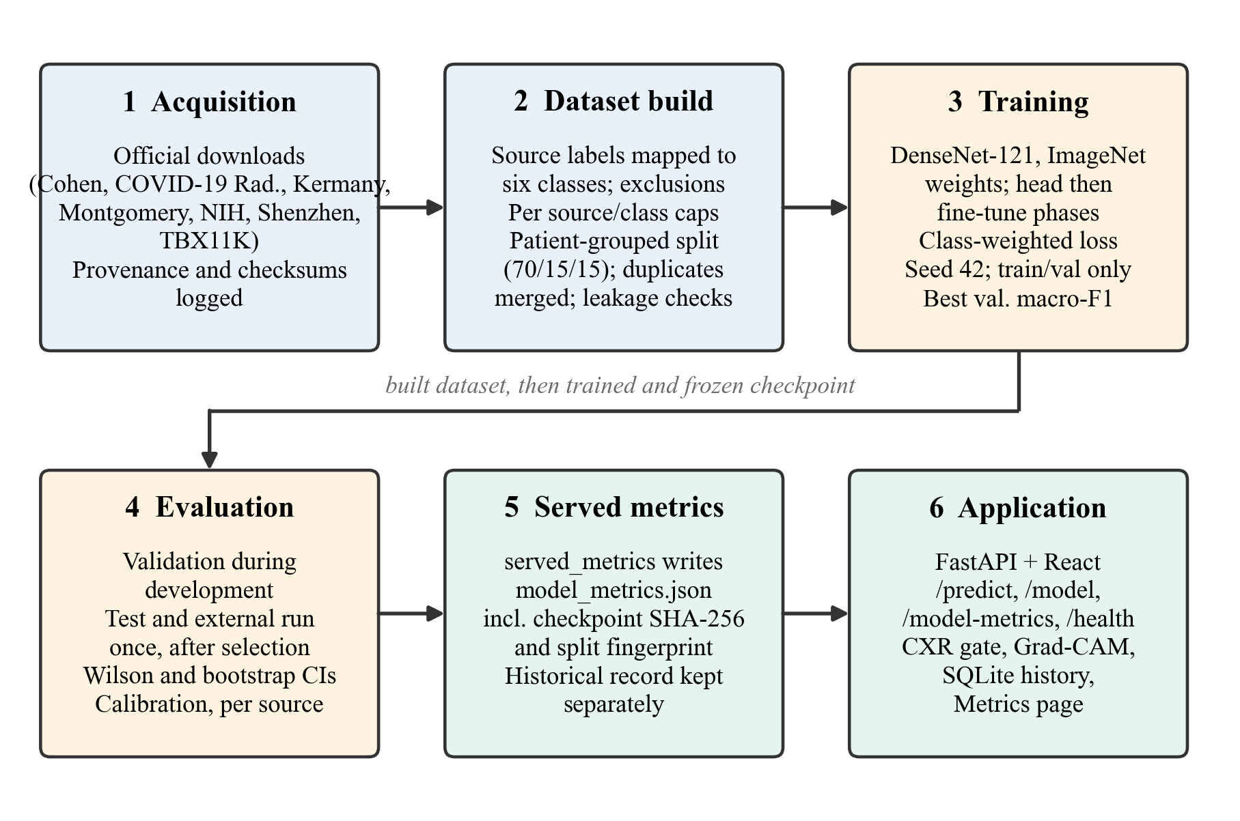
Figure 1.1. End-to-end pipeline of the LungAI project, from source acquisition through the patient-grouped build, training, once-only evaluation and served metrics to the web application.

1.5 Objectives of the project
The objectives are stated precisely in Chapter 3. In brief, the project aims to (i) obtain a defensible multi-source six-class benchmark from official sources, (ii) train and serve a DenseNet-121 classifier on it, (iii) measure internal and external behaviour honestly, and (iv) document everything needed to reproduce the result or to find its faults.

1.6 Contributions
The contributions that this report can defend are the following.
1. An auditable, leakage-controlled rebuild of a multi-source six-class chest X-ray benchmark from official sources, with label rules, caps, exclusions and checks recorded in machine-readable build reports.
2. A reproducible end-to-end pipeline: acquisition, patient-grouped splitting, training, once-only test and external evaluation, and serving of the resulting metrics by the same application that serves predictions.
3. Evidence that internal metrics overstate generalisation, from an external cohort and from a per-source analysis that exposes source shortcuts.
4. An audit that documents how the leakage and proxy labels of the earlier pipeline inflated its results.
The report does not claim a new network architecture, a new state-of-the-art accuracy, or any clinical validity.

1.7 Scope and limits
The classifier solves a single-label problem over six mutually exclusive classes. It sees one frontal image at a time and no clinical information. It was trained once with one seed on a laptop CPU, so run-to-run variation is unknown. Two data sources that would have strengthened the Pleural Effusion and Nodule / Mass classes (VinDr-CXR and JSRT) require credentialing or registration and were not available. The application is a research prototype. These limits are discussed in Chapter 8.

1.8 Organisation of the report
Chapter 2 reviews the datasets, models and evaluation pitfalls relevant to chest X-ray classification. Chapter 3 defines the problem and objectives and lists the defects of the earlier pipeline that the new one must remove. Chapter 4 presents the methodology and the system architecture. Chapter 5 describes data collection, label rules, the split and preprocessing. Chapter 6 covers model development, training, the backend, the frontend, the input gate and testing. Chapter 7 gives the experimental setup and results. Chapter 8 covers validation, discussion and limitations. Chapter 9 concludes and lists future work. The appendices contain the API reference, the configuration, the reproduction commands, the test summary and the history of the V5 audit.

CHAPTER 2
LITERATURE REVIEW
Statements about cited works rest on their abstracts or titles as recorded in the project's literature notes; works verified by title only are cited only for what the title says. No number from a cited paper is compared with the numbers of this project.
This chapter reviews the work that the project builds on. It is organised around the questions that decide whether a chest X-ray classifier can be trusted: which datasets exist and how their labels were made, what models have been used, how classifiers have been explained, and which evaluation mistakes have been documented in earlier studies. It ends with the gap that this project addresses.

2.1 Public chest radiograph datasets

2.1.1 Large multi-label collections
The NIH ChestX-ray14 collection, introduced as ChestX-ray8 and later extended [13], contains 112,120 frontal radiographs from 30,805 patients. Its image labels were mined from the radiology reports with natural language processing rather than read from the images. Independent re-reading has shown that the label quality varies by finding, which matters for any project that uses these labels as ground truth [6]. Even so, ChestX-ray14 is one of the few public sources with genuine patient identifiers, which makes patient-grouped splitting possible.
CheXpert [2] provides 224,316 radiographs from Stanford Hospital with labels extracted from reports and with uncertainty labels, and MIMIC-CXR [14] provides a large collection from a Boston hospital with free-text reports. Both are valuable for pre-training and for multi-label research, but access is controlled by data use agreements and credentialing. VinDr-CXR [15] is notable because its labels were produced by radiologists reading the images, with several readers per training image and bounding-box annotations, but it is distributed through PhysioNet under credentialed access. The JSRT database [16] contains 247 radiographs with CT-confirmed nodule status and is available on registration. These last two sources were identified as useful for the Pleural Effusion and Nodule / Mass classes of this project, but were not accessible and were therefore not used.

2.1.2 Tuberculosis collections
Two small tuberculosis sets were released by the US National Library of Medicine: the Montgomery County set (138 radiographs, 58 with TB and 80 normal) and the Shenzhen set (662 radiographs) [17]. Lung segmentation masks for the Montgomery images were described by Candemir et al. [18]. TBX11K [19] is a larger collection of 11,200 images with image-level categories (healthy, sick but not TB, active TB, latent TB) and bounding boxes for TB lesions. A widely circulated Kaggle archive aggregates several TB sources [20]; because it merges images from different hospitals under new file names, it is unsuitable as a source when an independent external cohort is needed.

2.1.3 Pneumonia and COVID-19 collections
Kermany et al. [21] released paediatric chest radiographs labelled normal or pneumonia (bacterial or viral) from a children's hospital in Guangzhou. The images come from children aged one to five years, which makes them very different from adult radiographs. The COVID-19 image data collection of Cohen et al. [22] assembles radiographs and CT images from publications and websites, with metadata including patient identifiers assigned by the collection. The COVID-19 Radiography Database [23], [24] aggregates COVID-19, viral pneumonia and normal images from several upstream sources. Both COVID-19 collections are convenient and widely used, but their images were gathered from heterogeneous places, and COVID-19 images frequently come from a different set of sources than the non-COVID images they are compared with. This is the root of the shortcut problem discussed in Section 2.4.
Table 2.1 summarises the sources used or considered in this project. The licence and access conditions are described in Chapter 5.
Table 2.1. Public sources used or considered for the six-class benchmark. Counts are those stated by the cited publications; the numbers used in this project are in Chapter 5.
Source | Population and content | Label origin | Patient identity | Role here
NIH ChestX-ray14 [13] | Adults, 14 findings | Mined from reports | Genuine | Development
Kermany [21] | Children 1–5 years, normal / pneumonia | Expert-reviewed | Derived from file names | Development
Shenzhen [17] | Adults, normal / TB | Clinical reading | One image per subject (per documentation) | Development
TBX11K [19] | Adults, healthy / sick / TB | Expert annotation | Not available | Development (run 2)
Cohen COVID-19 collection [22] | Mixed, from publications | Source papers | Assigned by collection | Development
COVID-19 Radiography Database [23] | Aggregated COVID-19 images | Upstream sources | Not available | Development (run 2)
Montgomery [17] | Adults, normal / TB | Clinical reading | Not needed (external) | External cohort only
VinDr-CXR [15] | Adults, radiologist labels | Radiologist consensus | Not available | Not accessed
JSRT [16] | Adults, nodule / non-nodule | CT-confirmed | Not available | Not accessed

2.2 Deep learning for chest radiograph classification
Transfer learning from ImageNet [4] is the dominant strategy, because radiograph collections are small compared with natural image sets. DenseNet [3] connects each layer to all later layers within a block, which encourages feature reuse and keeps the parameter count low. CheXNet [1] fine-tuned a DenseNet-121 on ChestX-ray14 and reported radiologist-level pneumonia detection on its own test split; it popularised DenseNet-121 as the baseline for chest X-ray work. COVID-Net [25] proposed a purpose-built architecture for COVID-19 detection, and Apostolopoulos and Mpesiana [26] applied transfer learning to the same task with small collections. Rahman et al. studied image enhancement for COVID-19 detection [24] and deep networks for TB detection [20].
Many of these studies report very high accuracy, often above 95%. The numbers are valid only for the test set on which they were measured. Whether they transfer to another hospital depends on how the data were collected and split, which is the subject of the following sections. This report does not compare its figures with those of other papers, because the test sets differ.

2.3 Image preprocessing
Radiographs vary in contrast, exposure and scanner characteristics. Histogram equalisation redistributes grey levels to increase contrast [27]. Contrast-limited adaptive histogram equalisation (CLAHE) applies the idea to small tiles and limits the amplification of noise by clipping the histogram [28]. CLAHE applied to the luminance channel, with a mild Gaussian filter before and after, is a common recipe for chest X-ray enhancement. The chain used here follows that recipe and is described in Chapter 5. Preprocessing is not a cure for domain shift: a fixed enhancement cannot remove the differences between hospitals, and this is examined in the external evaluation.

2.4 Shortcut learning and generalisation failures
A recurring finding is that classifiers learn to recognise where an image comes from rather than what it shows. Zech et al. [12] trained pneumonia classifiers on data from several hospitals and showed that performance dropped on images from a hospital not seen in training, and that the networks could identify the source hospital from the image. Geirhos et al. [11] described shortcut learning in general: a network adopts whatever simple cue separates the classes in the training distribution, and fails when the cue is absent.
For COVID-19 the evidence is particularly strong. DeGrave et al. [10] showed that models for radiographic COVID-19 detection relied on shortcuts and generalised poorly to external data. Maguolo and Nanni [9] obtained good classification of COVID-19 images from radiographs in which the lungs had been removed, which cannot reflect disease. Two systematic reviews concluded that nearly all published COVID-19 imaging models were at high or unclear risk of bias and none was ready for clinical use [7], [8]. Seyyed-Kalantari et al. found that chest X-ray classifiers can under-diagnose patients in under-served groups [29], a reminder that aggregate accuracy hides disparities that this project cannot measure because the datasets lack demographic data.

2.5 Data leakage
The most basic protection is to keep every image of a patient on one side of the split. Several public collections contain multiple images per patient, and some distribute images with new file names and without patient identifiers. Splitting such data at the image level places near-identical images of the same patient in training and test sets, which inflates accuracy. Exact and near-duplicate images across collections have the same effect. Oakden-Rayner [6] documents label and duplication problems in large public sets. Good practice, followed here, is to split by patient group, to merge groups that share duplicate images, to record which rows have no patient identity, and to state that separation is proven only where identity is known.

2.6 Explainability and calibration
Grad-CAM [5] uses the gradient of a class score with respect to the last convolutional feature maps to produce a coarse heat map of the regions that influenced the score. It is easy to attach to a CNN, and it can reveal when a model attends to text markers, borders or devices in the image. It does not show radiological reasoning, and it can look plausible when the model is wrong.
Modern networks tend to be over-confident [30]. Calibration can be summarised by the expected calibration error, which compares confidence with accuracy over bins of the top-class score [31], and reliability diagrams plot the same comparison. A softmax output should not be read as a probability of disease unless calibration has been checked and fitted on appropriate data.

2.7 Statistical reporting
For proportions such as accuracy, recall and specificity, the Wilson score interval [32] has better coverage than the normal approximation for small samples and at extreme values; it also gives a sensible interval when the observed count is 0 or all. Percentile bootstrap intervals [33] are used for statistics without a simple closed form. Optimisers such as Adam [34] are the usual choice for fine-tuning. Reporting guidelines for medical imaging AI, the CLAIM checklist [35] and the TRIPOD+AI statement [36], ask authors to state the data sources, the split, the handling of duplicates, the performance measures with intervals and the limitations. Appendix F maps this report to those items.

2.8 External validation, leakage taxonomy and saliency
A systematic review of radiology deep-learning studies with external validation found that most reported at least some drop in performance on external data [37]. Tartaglione et al. showed how dataset bias and transfer-learning bias can enter small-data COVID-19 radiograph classifiers, and validated on a new hospital's data [38]. Bassi and Attux, who classified COVID-19, normal and pneumonia radiographs with a DenseNet201 behind a lung-segmentation stage, reported lower accuracy on an external dataset than internally [39]. Hidden stratification describes how an aggregate metric can conceal poor performance on clinically distinct subsets [40]. Kapoor and Narayanan surveyed data leakage across scientific fields that use machine learning and proposed a taxonomy of leakage types [41]; patient overlap and duplicates between splits belong to it. Other work on domain shift in radiograph classification exists [42], [43], and the title-only entries are cited for what their titles say.
The evidence for saliency maps is weaker than their popularity suggests. Arun et al. found that the saliency methods they tested on chest radiograph data failed at least one localisation or sanity criterion [44], and Ghassemi et al. argued that current explainable-AI methods do not give reliable assurance for individual decisions in health care [45]. This project therefore presents Grad-CAM as an illustrative aid and not as localisation evidence.

2.9 Multi-class classifiers on public data
Several studies classify COVID-19 alongside other conditions on public data, among them DarkCovidNet [46], CNN ensembles [47], and ensemble or comparison studies published in Biomedical Signal Processing and Control [48]–[51]. The latter group is cited by title only. Six-class settings that include pleural effusion and nodules or masses are less common, and no verified six-class comparison on a common protocol was found, so none is claimed.

2.10 Research gap and positioning
The studies above establish three points. Convenient public chest X-ray collections are heterogeneous. Models trained on them learn source cues unless the data are arranged to prevent it. And reported accuracies are usually not comparable because the test sets differ in construction. What is rarely published is a complete and checkable account of how a particular multi-source benchmark was assembled, split and audited, together with an evaluation that includes an untouched external cohort and an honest breakdown by source.
This project contributes such an account on a modest scale. It does not propose a new network. It adopts a standard DenseNet-121 and concentrates on the parts that earlier work often left unchecked: label rules fixed in advance, official sources with logged provenance, a patient-grouped split with duplicate merging and recorded checks, a once-only test and external evaluation, and an application that reports the metrics of the model it serves. It also documents, as a case study, how an earlier version of the same system obtained a misleading result.

CHAPTER 3
PROBLEM DEFINITION AND OBJECTIVES

3.1 Problem statement
Given one frontal chest radiograph, assign it to exactly one of six classes: COVID-19, Normal, Pleural Effusion, Pneumonia, Pulmonary Nodule / Mass or Tuberculosis. The class order is fixed in the configuration file and is used by the trainer, the evaluator, the backend and the frontend. Alongside the class, the system must return the six class scores, a Grad-CAM overlay for the predicted class, and the evaluation metrics of the model that produced them.
The scientific problem is the second half of the task: the numbers reported for such a classifier must describe how it will behave on images it has not seen, from sources it has not seen. That requires a dataset whose splits are free of patient and duplicate leakage, whose labels are defined by explicit rules, and whose evaluation includes a cohort that played no part in development.

3.2 Single-label formulation and its consequences
Real radiographs often show more than one finding. The classifier treats the six classes as mutually exclusive, so a multi-finding image has to be forced into one class or excluded. The project excludes multi-finding images from the NIH collection (only images with exactly one of the target findings, or with "No Finding", are used). The consequence is that the test set contains clear single-label cases, and the reported metrics do not describe performance on the full clinical mixture. This is a modelling assumption, not a clinical statement, and it is repeated among the limitations.

3.3 Defects of the earlier pipeline that must be removed
Table 3.1 lists the defects found by auditing the V5 pipeline and the rule adopted in V6 against each. The audit is documented in Appendix E.
Table 3.1. Defects found in the V5 pipeline and the V6 countermeasure.
Defect in V5 | Evidence | V6 countermeasure
Patient leakage between training and test | 154 of 1,570 test images (9.8%) share a patient with training images; 289 patient groups span splits | Whole patient groups are assigned to one split; groups that share an exact or near-duplicate image are merged
No usable patient identity | 8,478 rows had synthetic one-per-image identifiers | Identity status is recorded per row (genuine, derived from file name, or unknown); identity is never generated
Proxy labels | 1,395 TBX11K "sick but not TB" images labelled Pneumonia (49.7% of the class); 124 latent-TB images labelled Tuberculosis | "Sick but not TB" and latent TB are excluded; each class label comes from the source's own label for that condition
Multi-finding images | 1,440 of 1,467 VinDr images carried two or more findings | Only images with a single target finding are used; conflicting findings are excluded
Unclear provenance | Aggregated archives with renamed files | Each source is downloaded from its official point with URL, size and SHA-256 logged; aggregated archives are not used
Possible contamination of the external cohort | An aggregated TB archive is reported to contain Montgomery images | The archive is not used; every development image is checked by content hash and near-duplicate test against the external cohort
Optimistic, unverifiable evaluation | External specificity 0/80; checkpoint lost; no per-image predictions | Per-image predictions are saved; test and external sets are evaluated once; external sensitivity is reported only with specificity

3.4 Objectives
The project has the following objectives.
1. Data. Acquire the public chest X-ray sources that can be obtained without special credentials from their official distribution points, record provenance, and construct a six-class dataset under label rules that are written down before training.
2. Leakage control. Split the dataset by patient group with duplicate merging, run leakage checks that stop the build on failure, and record which rows lack patient identity so that the strength of the separation can be stated honestly.
3. Model. Train a DenseNet-121 transfer-learning classifier with a protocol that uses only training and validation data for every decision, on commodity hardware (a laptop CPU).
4. Evaluation. Evaluate on the internal test split and on the external cohort exactly once each, report confidence intervals, per-class, per-source and calibration results, and report external sensitivity only together with specificity.
5. Application. Provide a FastAPI and React application that serves predictions with Grad-CAM, rejects inputs that are not chest radiographs, stores results, and shows the metrics of the checkpoint that is loaded.
6. Reproducibility. Make every step scriptable, record hashes and fingerprints, test the code, and document how to reproduce each result and what cannot be reproduced without the images.
7. Transparency about the past. Document the audit of the earlier version so that the reasons for the rebuild are on record.

3.5 Success criteria
The project is judged on process rather than on a headline accuracy. The criteria are:
- the build report shows zero patient groups, zero identical files and zero external-cohort files spanning development splits;
- the training run reads only the training and validation splits, and its metadata records the build and split fingerprints;
- the test split and the external cohort are evaluated once, after the checkpoint is chosen;
- the application shows the same numbers as the evaluation reports, from a generated file;
- every claim in the report can be traced to a generated artifact, and every limitation that the artifacts reveal is stated.

3.6 Research questions
The work is organised around three questions.
1. How different are internal and external results when the internal split is free of patient and duplicate leakage?
2. Do per-source and external breakdowns show that any class is recognised by its source rather than by disease?
3. Can a leakage-controlled six-class pipeline be built, trained and served on a laptop CPU, and what does it cost in time and memory?
The answers to the first two questions depend on the final model and are given in Chapters 7 and 8. In brief: for the final model the internal test accuracy is 77.4% while the external specificity is 19 / 80 and no tuberculosis scan is named Tuberculosis (0 / 58), so the gap is large even with a leakage-controlled split (question 1); the per-source, probe, external and Grad-CAM evidence is consistent with source cues being available to the classifier, but does not prove that they are used (question 2). The third is answered in Chapter 6.

3.7 Constraints
The project runs under the following constraints, which shape the design.
- Compute. The training machine is an 8 GB laptop without a GPU supported by the TensorFlow version used. A training epoch takes roughly 13 to 14 minutes, so a run is limited to about ten epochs.
- Data access. Sources behind credentialing (VinDr-CXR, via PhysioNet) or registration (JSRT) were not available.
- Time. The overnight build, training and evaluation run had to complete within a fixed time box.
- Single seed. Repeating the training with several seeds was not possible in the time available.
- No clinical partner. There is no clinician-reviewed ground truth beyond that of the source datasets, so no clinical claim can be made.

CHAPTER 4
PROPOSED METHODOLOGY AND SYSTEM ARCHITECTURE

4.1 Overview of the methodology
The methodology has seven stages, each of which produces a file that the next stage reads. Keeping the stages separate, and recording a hash or fingerprint at each boundary, is what makes the final numbers auditable.
1. Acquisition. Each source is downloaded from its official distribution point by one script. The script resumes interrupted transfers, compares the final size with the server's stated length, rejects HTML error pages saved as data, and logs URL, time, size and SHA-256 for every file.
2. Build. A builder applies the label rules, the exclusions and the per-cell caps, decodes and hashes every image, merges duplicates into groups, assigns whole groups to training, validation and test sets, runs the leakage checks, preprocesses each image once and caches the result. It writes a manifest and a build report.
3. Training. The trainer reads the manifest and the cached images, uses only the training and validation splits, and records metadata including the build and split fingerprints and the checkpoint hash.
4. Selection. The checkpoint is the epoch with the best validation macro-F1. When more than one run exists, the final model is chosen on a validation set that both runs treat as unseen. The rule is in the run selection protocol and was fixed before the results of run 2 were seen. Run 2 (build v6_build_002) was selected: on the 2,018 common validation images its macro-F1 was 79.6% against 59.4% for run 1, and the difference exceeds the margin of the rule. This comparison is reported in Chapters 6 and 7 with a caveat about the sources the two runs share.
5. Evaluation. The selected checkpoint is evaluated on the test split and the external cohort once each, with the flag that marks the evaluation as final. Per-image predictions are saved.
6. Serving of metrics. A script copies the three evaluation reports and the run metadata into one file, refusing to combine reports of different checkpoints. The application's metrics endpoint serves that file, and the documentation is generated from it.
7. Application. The backend loads the checkpoint only if its SHA-256 matches the configuration, and the frontend shows what the backend returns.
The stages correspond to the boxes of Figure 1.1 in Chapter 1.

4.2 Design principles
Five principles were applied throughout.
- One source of truth for the model definition. The class names and order, the preprocessing parameters, the training hyper-parameters, the checkpoint file name and its SHA-256, the confidence floor and the input gate parameters are all in one JSON configuration. The trainer, the evaluator and the backend read it, and a test fails if any of them declares its own class list.
- One implementation of preprocessing. The builder, the trainer, the evaluator and the backend call the same functions. A test compares them with a frozen copy of the original preprocessing on several image sizes and channel layouts.
- Rules before data. The label rules, the caps and the split fractions are written in a proposal file that is hashed into the build report, and that was fixed before the first training run.
- No silent fallbacks. A missing or mismatching checkpoint produces a 503 error and nothing is stored. There is no fallback model, no mock output and no random output. A malformed model output produces a 500 error.
- Test data are touched once. The test split and the external cohort are evaluated by an explicit final flag, once, after selection. They are never used for thresholds, tuning or model choice.

4.3 Model architecture
The classifier is a DenseNet-121 [3] followed by a small head (see Figure 4.1). The backbone is the Keras Applications implementation without its top layer, initialised with ImageNet weights. It runs in inference mode, so its batch-normalisation statistics stay frozen even while the last layers are trained. The head consists of global average pooling, batch normalisation, a dense layer with 256 units and ReLU activation, dropout with rate 0.3, and a dense layer with six units and softmax activation. The input is a 224 × 224 × 3 image normalised with the ImageNet mean and standard deviation. The output is a vector of six non-negative numbers that sum to one.
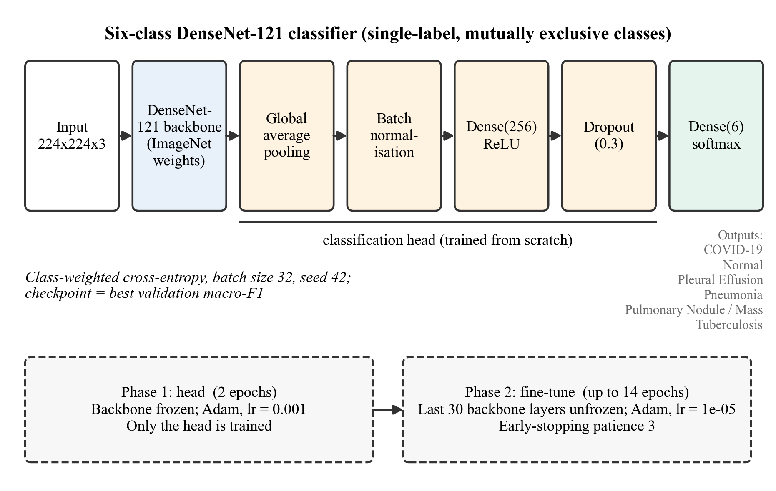
Figure 4.1. DenseNet-121 backbone with the classification head and the two-phase training schedule.
The layer names of the head (gap, bn, dense_features, dropout, class_predictions) are fixed in the configuration, because the checkpoint format and the Grad-CAM code depend on them.

4.4 Two-phase transfer learning
In phase 1 the backbone is frozen and only the head is trained, for two epochs with Adam [34] at learning rate 10⁻³. This lets the randomly initialised head adapt to the pre-trained features without distorting them. In phase 2 the last 30 layers of the backbone are unfrozen and the network is trained with Adam at learning rate 10⁻⁵ until early stopping (three epochs without improvement of validation macro-F1), the epoch limit or the wall-clock budget. The small learning rate protects the pre-trained weights.
The loss is sparse categorical cross-entropy with per-sample weights equal to n / (k · n_c), where n is the number of training images, k = 6 the number of classes and n_c the number of training images of the class. This compensates for class imbalance without resampling.

4.5 System architecture
The application has three tiers (see Figure 4.2). The browser runs a React single-page application. It calls a REST API under the path /api/v1, with an API key header when a key is configured. The FastAPI backend validates uploads, applies the input gate, runs the inference engine, builds the Grad-CAM overlay and writes the result to an SQLite database. The model store holds the checkpoint and the metrics file.
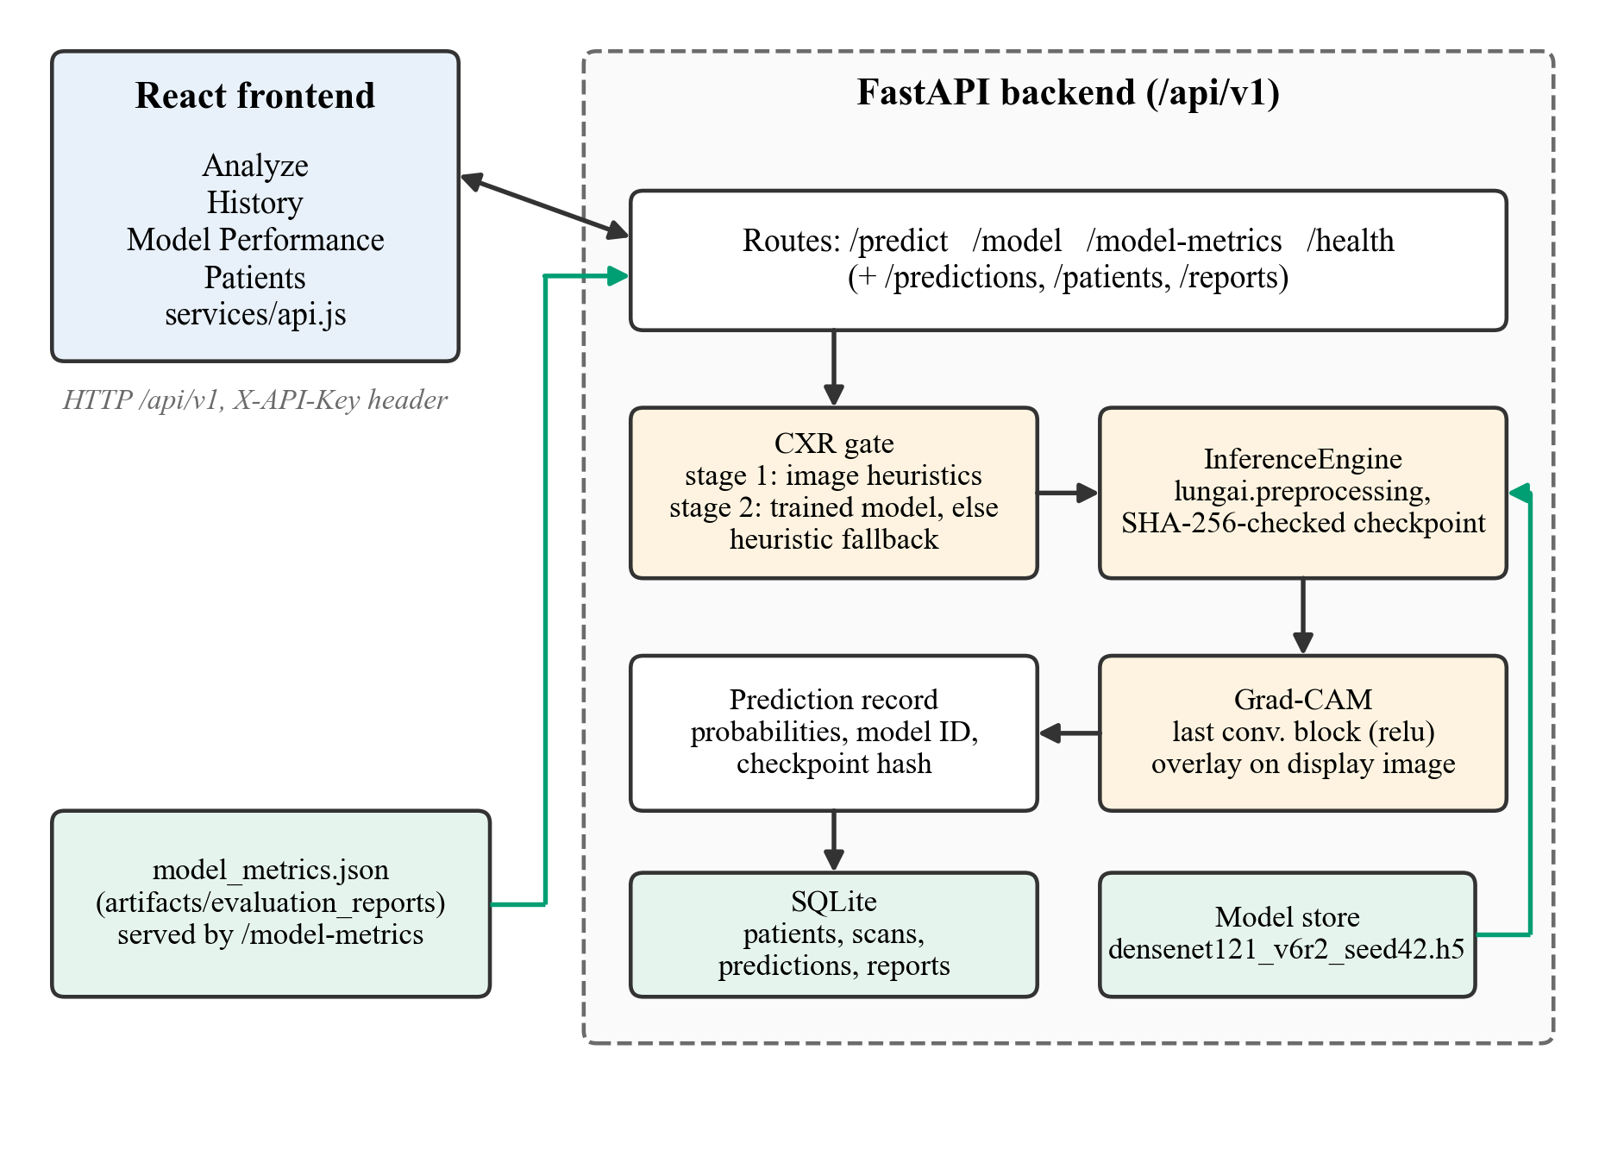
Figure 4.2. Architecture of the LungAI application: frontend, FastAPI backend with input gate, inference engine, Grad-CAM and database, model store and metrics file.
The code is organised in two packages with a one-way dependency. The package lungai holds everything that defines and evaluates the model: configuration, preprocessing, the dataset builder logic, the model definition, the trainer, the evaluator and the metric implementations. The backend package imports lungai, and lungai never imports the backend. This keeps the scientific code independent of the web framework and lets the evaluation scripts run without a server.

4.5.1 Request path
Figure 4.3 shows what happens to one prediction request. The upload is checked for type (JPEG, PNG, BMP, TIFF or WebP), size (at most 10 MB) and emptiness. The stored file name is generated by the server. The input gate then decides whether the image looks like a chest radiograph. Accepted images are preprocessed with the canonical chain, passed through the network, and the output is validated for shape, finiteness and sum. Grad-CAM is computed for the predicted class. The probabilities, the model identity and the checkpoint hash are stored with the prediction, and the response is returned to the browser, which draws the six scores and the overlay.
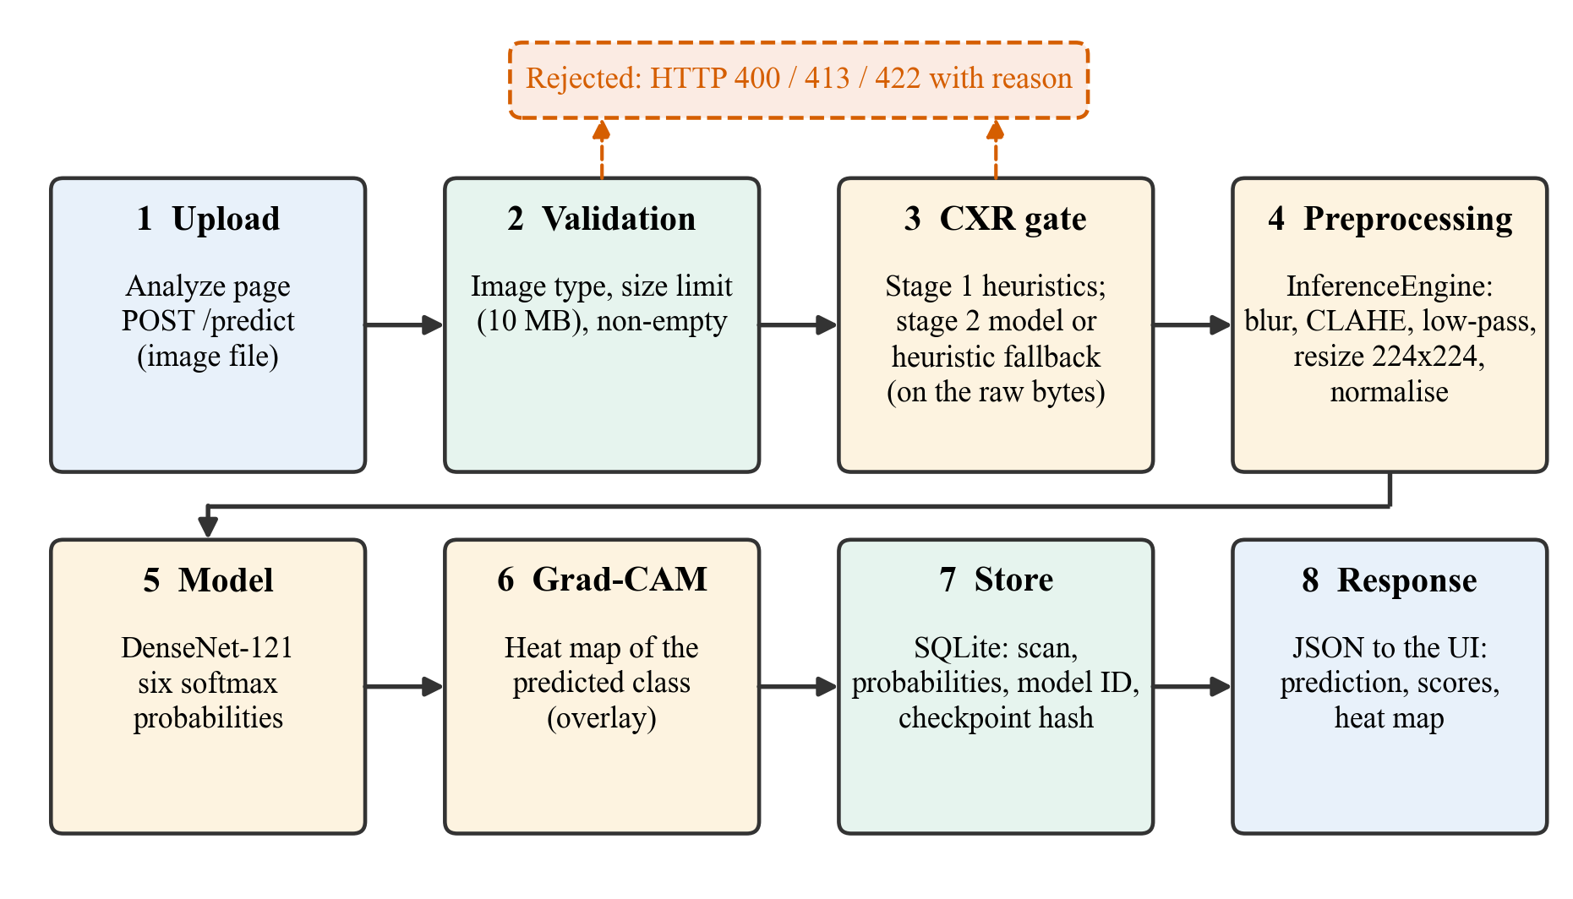
Figure 4.3. Data flow of one prediction request from upload to display.

4.5.2 Endpoints and persistence
The backend exposes endpoints for health, model identity, model metrics, prediction, stored predictions, report generation and patient records. They are listed in Appendix A. The database has four tables (patients, lung scans, predictions and reports), created and migrated by the backend at start-up. Predictions store the six probabilities, the model identifier and version, and the checkpoint SHA-256, so any stored result can be traced to the exact weights that produced it.

4.6 Evaluation methodology
Evaluation follows the definitions below.
- Internal test, six classes. Accuracy with a Wilson 95% interval [32] and a percentile bootstrap interval with 2,000 resamples [33]; per-class precision, recall (with Wilson interval), specificity and F1; macro and support-weighted averages; one-versus-rest ROC-AUC and PR-AUC with macro averaging; the confusion matrix.
- Calibration. Expected calibration error with 15 equal-width bins on the top-class score [30], [31] and a reliability diagram. No calibration is fitted.
- Per source. Accuracy and per-class recall within each source, because overall accuracy depends on the source mix and because a class with a single source can be recognised by that source.
- External cohort, binary. The Montgomery County set contains only normal and TB scans. A scan is called positive if the predicted class is anything other than Normal. Sensitivity and specificity are reported together with Wilson intervals, with the ROC-AUC of P(abnormal) = 1 − P(Normal) and the exact Tuberculosis recall. The prediction breakdown shows which classes the model assigned to each external scan.
The evaluator validates its inputs before computing anything: columns, a single split and checkpoint, unique image identifiers, agreement of the stored class index with the arg-max of the stored probabilities, agreement of the identifier set with the manifest, true labels that agree with the manifest, and well-formed probabilities. It never skips an image silently. The metric code is tested against hand-computed values and against scikit-learn.

4.7 Technology stack
Table 4.1 lists the tools used.
Table 4.1. Software stack of the project.
Component | Technology
Language and runtime | Python 3.12 (3.11 or 3.12 required), Node 18
Deep learning | TensorFlow 2.16.1 with Keras; DenseNet-121 from Keras Applications
Image processing | OpenCV 4.10, NumPy 1.26
Metrics | scikit-learn, own implementations of Wilson and bootstrap intervals and ECE
Backend | FastAPI, SQLAlchemy, SQLite, Uvicorn
Frontend | React 18 (Create React App), Jest for service tests
Quality | pytest (backend and package), Jest, production build with warnings as errors
Reproducibility | Pinned requirements, SHA-256 fingerprints, run metadata, build reports
Hardware | Laptop CPU with 8 GB RAM (no GPU support in the native-Windows TensorFlow build used)

CHAPTER 5
DATASET COLLECTION AND PREPROCESSING
This chapter describes how the V6 dataset was assembled and how each image is prepared for the network. Every rule in it was fixed in a proposal file before the first training run, and every count in the tables is read from the build reports that the builder wrote.

5.1 Sources and acquisition

5.1.1 Sources
Seven sources were used. Six provide development data and one (Montgomery) is reserved as an external cohort.
- NIH ChestX-ray14 [13] supplies Normal, Pleural Effusion, Pneumonia and Pulmonary Nodule / Mass images. It is the only source with genuine patient identifiers and the largest source by far.
- Kermany [21] supplies paediatric Normal and Pneumonia images.
- Shenzhen [17] supplies adult Normal and Tuberculosis images.
- TBX11K [19] supplies Normal and Tuberculosis images (run 2 only).
- Cohen COVID-19 collection [22] supplies COVID-19 images and a few images of other classes.
- COVID-19 Radiography Database [23], [24] supplies additional COVID-19 images (run 2 only).
- Montgomery County set [17] is the external cohort: 138 images, of which 80 are normal and 58 show TB.
Two further sources named in the plan, VinDr-CXR [15] and JSRT [16], were not obtained because they require credentialing or registration. An aggregated Kaggle tuberculosis archive was downloaded for inspection but is excluded as a whole, because it merges images from several hospitals, including Montgomery, under renamed files without patient identity.

5.1.2 Acquisition with provenance
A single script downloads every source from its official location (the registry of sources and URLs is a JSON file in the repository). For each file it records the URL, the download time, the size and the SHA-256, in a provenance folder. The script resumes interrupted downloads, compares the final size with the length announced by the server, and rejects responses that are HTML pages rather than data. This matters because a large archive that is silently truncated or replaced by a login page would otherwise enter the build unnoticed. The downloaded images are not part of the repository, because the licences do not allow redistribution; the repository holds the rules, the builder and the provenance records.

5.1.3 Licences and access
Table 5.1 records the access route and what is known about the terms. The status is taken from the project's source inventory. Where the inventory marks a term as unresolved, it was not confirmed from the publisher's page and must be checked before any redistribution or publication that depends on it.
Table 5.1. Access route and licence status of the sources, as recorded in the project's source inventory.
Source | Host and access | Terms recorded | Status
NIH ChestX-ray14 | NIH Clinical Center download, open | Stated as without restrictions, with citation and acknowledgement requested | Secondary; confirm in the dataset README
Kermany | Mendeley Data (v2), open | CC BY 4.0 | Secondary; confirm on the publisher page
Shenzhen and Montgomery | NLM / LHNCBC public listing, open | Terms in the NLM read-me files | Unresolved
TBX11K | Project page of the authors | CC BY 4.0 according to third-party listings | Secondary
Cohen COVID-19 collection | GitHub repository, open | Per-image terms in the metadata | [CHECK: confirm terms per image before redistribution]
COVID-19 Radiography Database | Kaggle, account needed | Upstream sources carry their own terms | Unresolved
VinDr-CXR | PhysioNet, credentialed | Credentialed health data licence | Not obtained
JSRT | JSRT website, registration | Not confirmed | Not obtained

5.2 Label rules
Labels come from each source's own labels. Each included image records the identifier of the rule that labelled it, and each excluded image records the reason. Table 5.2 gives the rules.
Table 5.2. Label rules of the V6 dataset.
Source | Included as | Excluded
NIH ChestX-ray14 | Exactly one finding: Effusion → Pleural Effusion; Nodule and/or Mass → Pulmonary Nodule / Mass; Pneumonia → Pneumonia. "No Finding" → Normal, at most one image per patient | Any other or additional finding
Kermany | Folder NORMAL → Normal; PNEUMONIA (bacterial or viral) → Pneumonia | Undecodable or too small images
Shenzhen | File name suffix _0 → Normal; _1 → Tuberculosis | None
TBX11K | Healthy → Normal; active TB only → Tuberculosis | Sick but non-TB (cause unspecified, not evidence of pneumonia); any latent-TB annotation; images of the official test split whose labels are withheld
Cohen collection | Frontal X-ray with COVID-19 → COVID-19; other pneumonia → Pneumonia; TB → Tuberculosis; "No Finding" → Normal | Lateral views, CT, findings outside the six classes
COVID-19 Radiography Database | COVID-19 folder → COVID-19 | All other folders of the archive
Montgomery | Role external; never in development | Any development image that matches it

Tuberculosis is labelled only from a source label of TB: active TB in TBX11K or a TB manifestation in Shenzhen. An image is never labelled TB because it comes from a TB-related dataset.
The NIH rule deserves a comment. It uses only images whose label set is exactly one of the target findings, and for "No Finding" it takes at most one image per patient so that healthy patients with many follow-up studies do not dominate the Normal class. It therefore discards most of the collection. The consequence is a cleaner but less representative sample, since many real patients have several findings.

5.3 Caps
To bound CPU training time and to stop one source from dominating a class, the number of images per (source, class) cell is capped. Images are drawn by whole patient group with a fixed seed. Table 5.3 lists the caps that were reached in the builds.
Table 5.3. Per-cell caps that were reached in the builds.
Source and class | Cap
NIH, Normal | 1,200
NIH, Pleural Effusion | 3,000
NIH, Pulmonary Nodule / Mass | 3,000
Kermany, Normal | 1,000
Kermany, Pneumonia | 2,200
TBX11K, Normal | 1,000
COVID-19 Radiography Database, COVID-19 | 2,500

The caps shape the class balance. They make Pleural Effusion and Nodule / Mass larger than the Tuberculosis and COVID-19 classes in run 1, and the class-balanced loss compensates for the remaining imbalance.

5.4 Content hashes and duplicate detection
For every image the builder computes the MD5 and SHA-256 of the file and a 64-bit perceptual hash based on the discrete cosine transform of a reduced greyscale copy. Two images are treated as near-duplicates when their perceptual hashes differ in at most 6 bits and their 64 × 64 thumbnails correlate with a coefficient of at least 0.97. Both tests are required, because a hash alone produces false matches between radiographs, which are visually similar, and a correlation alone is expensive to run over all pairs.
Duplicate detection runs across all sources, including the external cohort. A development image that matches an external image by MD5 or as a near-duplicate is excluded from the dataset, not merely kept out of the test set.

5.5 Patient grouping and the split
The unit of splitting is the patient group, not the image. The base group is the patient identifier where one is known: genuine (NIH, Cohen) or derived from the file name (Kermany, where the file names contain a patient token). Where identity is unknown (TBX11K and the COVID-19 Radiography Database) every image is its own group. Groups are then merged with a union-find structure whenever they share an exact or near-duplicate image, so a duplicate can never fall on both sides of a split.
Whole groups are assigned to training, validation and test sets in the proportions 70/15/15. The assignment is stratified by each group's majority (class, source) pair, uses the fixed seed 20261102, and fills greedily towards the target image counts. A fingerprint, the SHA-256 of the sorted lines of image identifier and split, is written to the build report and to every training and evaluation record, so any later result can be tied to an identical split.

5.5.1 Leakage checks
The build stops if any of the following is non-zero: patient groups spanning splits, identical files (by MD5) spanning splits, and external-cohort files present in development data. Table 5.4 reports these checks and the identity status of the development rows for the two builds. All three checks evaluate to zero.
Table 5.4. Leakage checks and patient-identity status of the two V6 builds, read from the build reports.
Check or statistic | Run 1 | Run 2
Patient groups spanning splits | 0 | 0
Identical files (MD5) spanning splits | 0 | 0
External-cohort files (MD5) present in development data | 0 | 0
Near-duplicate pairs merged into one split group | 39 | 545
Development rows with genuine patient identity | 8,844 | 8,882
Development rows with identity derived from file name | 2,665 | 2,643
Development rows with unknown identity (grouped per image) | 0 | 4,130
Split fingerprint (first 12 characters of SHA-256) | 872abd3b3a7e | 5973233fb9ea
Manifest SHA-256 (first 12 characters) | 06b6af8a79a3 | 3e2d465300f1

The zero in the first row proves separation only for the rows whose identity is known. Rows with unknown identity are grouped per image and merged with their exact and near-duplicates, so leakage there is reduced but not eliminated. This is stated again among the limitations.

5.6 Composition of the builds
Two builds were made. Run 1 (build 001) uses four development sources and the external cohort. Run 2 (build 002) adds TBX11K and the COVID-19 Radiography Database, which enlarges the Tuberculosis and COVID-19 classes. The final model is chosen between the runs on a common validation set The final model, v6.1, was trained on build v6_build_002 (run 2); build 001 (run 1) is the superseded first build and its model is kept only as a documented earlier experiment. Table 5.5 shows the class composition, Table 5.6 the source composition and Table 5.7 the reasons images were left out. Figure 5.1 shows the same composition graphically.
Table 5.5. Images per class and split in the two V6 builds.
Class | Run 1 train | Run 1 val | Run 1 test | Run 2 train | Run 2 val | Run 2 test
COVID-19 | 334 | 73 | 71 | 2,083 | 444 | 451
Normal | 1,477 | 308 | 314 | 2,152 | 464 | 467
Pleural Effusion | 2,112 | 448 | 440 | 2,099 | 457 | 444
Pneumonia | 1,804 | 390 | 391 | 1,829 | 394 | 394
Pulmonary Nodule / Mass | 2,085 | 458 | 457 | 2,110 | 441 | 449
Tuberculosis | 242 | 54 | 51 | 684 | 148 | 145
Total | 8,054 | 1,731 | 1,724 | 10,957 | 2,348 | 2,350

Table 5.6. Images per source and split. External is the Montgomery cohort.
Source | Run 1 train / val / test | Run 2 train / val / test | External | Excluded (run 2)
nih_cxr14 | 5,240 / 1,123 / 1,121 | 5,270 / 1,128 / 1,124 | 0 | 104,598
kermany | 1,863 / 402 / 400 | 1,848 / 397 / 398 | 0 | 4,732
shenzhen | 463 / 100 / 99 | 463 / 100 / 99 | 0 | 0
cohen_covid | 488 / 106 / 104 | 493 / 94 / 111 | 0 | 252
covid_radiography | not used | 1,742 / 384 / 374 | 0 | 1,116
tbx11k | not used | 1,141 / 245 / 244 | 0 | 6,770
montgomery | not used | n/a | 138 | 0

Table 5.7. Exclusion reasons recorded by the builder (number of images).
Reason recorded in the build report | Run 1 | Run 2
nih: other or multiple findings | 34,976 | 42,242
nih normal: one image per patient | 31,062 | 35,454
not sampled: cap 1200 for nih cxr14/Normal | 19,747 | 23,707
tbx sick non tb: cause unspecified, not used as Pneumonia | 0 | 3,800
not sampled: cap 1000 for tbx11k/Normal | 0 | 2,800
not sampled: cap 2200 for kermany/Pneumonia | 2,243 | 2,243
not sampled: cap 3000 for nih cxr14/Pulmonary Nodule / Mass | 1,370 | 2,240
not sampled: cap 1000 for kermany/Normal | 1,932 | 1,932
not sampled: cap 2500 for covid radiography/COVID-19 | 0 | 1,116
not sampled: cap 3000 for nih cxr14/Pleural Effusion | 360 | 955
undecodable or too small image | 535 | 557
tbx latent: latent (ObsoletePulmonaryTuberculosis) or unknown TB annotation | 0 | 169
cohen: not a frontal X-ray | 168 | 168
cohen: finding outside the six classes | 84 | 84
tbx: TB image without box annotation | 0 | 1

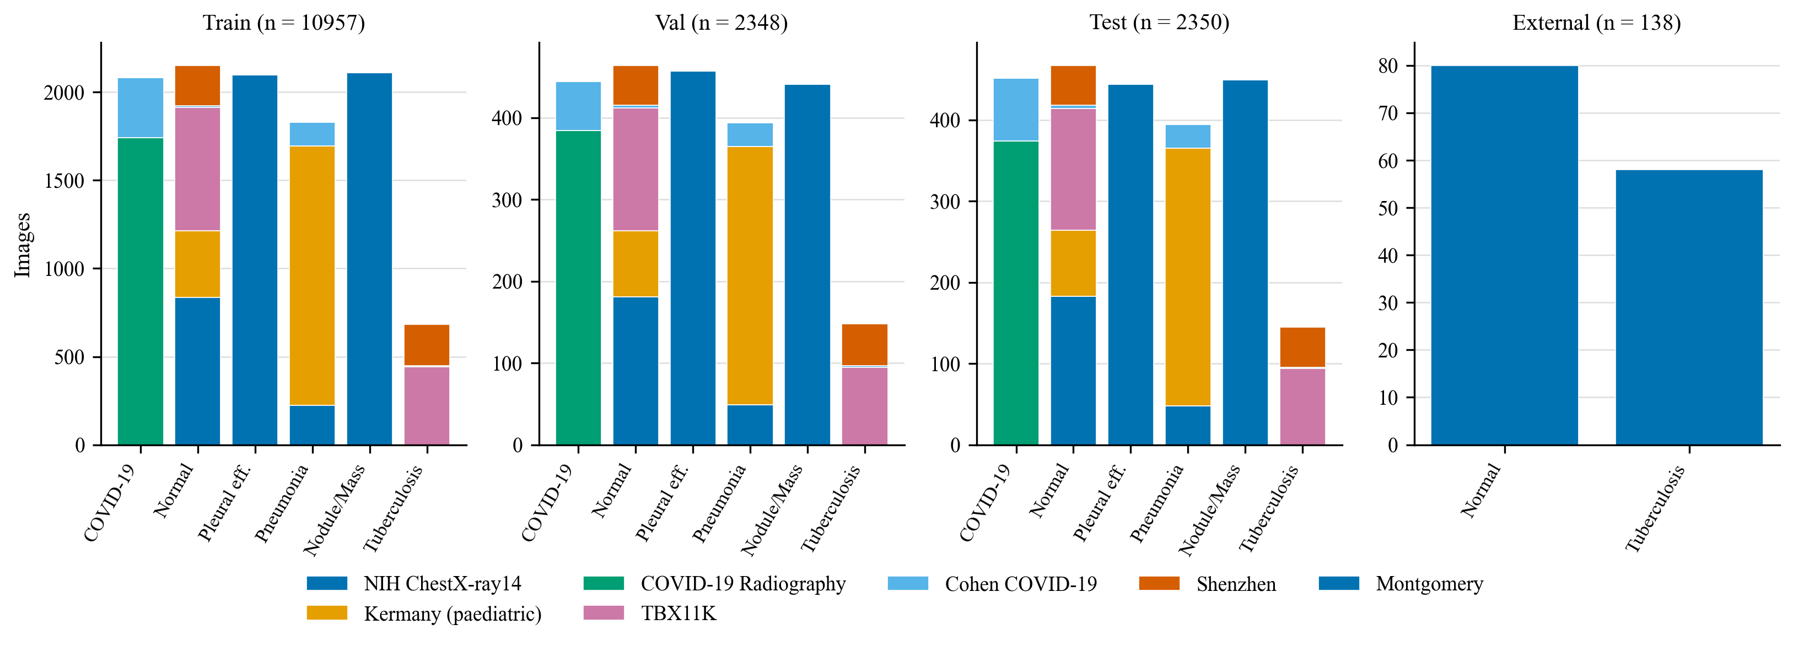
Figure 5.1. Number of images per class and source in the training, validation and test splits.
The tables show a point that influences the interpretation of every result: in run 1 every COVID-19 image comes from the Cohen collection, which gathers figures from publications and websites; in run 2 a second COVID-19 source is added, but both are web-collected sets. The Tuberculosis class is similarly dominated by Shenzhen in run 1 and by Shenzhen and TBX11K in run 2. Classes that have a single kind of source can be recognised by their image style. This is examined in Chapters 7 and 8.

5.7 External cohort
The Montgomery County set is used only to evaluate the selected checkpoint, once. It contains 138 frontal radiographs from a tuberculosis screening programme: 80 normal and 58 with TB. It does not contain any COVID-19, effusion, pneumonia or nodule cases, so it can test only whether the model separates abnormal from normal scans at a hospital it has not seen. It cannot test six-class accuracy. The builder checks every development image against it by content, and the build report records zero matches.

5.8 Image preprocessing
All images, whether for training, evaluation or serving, go through the same chain, implemented once in the package and called by every component. Figure 5.2 shows one radiograph at each step.
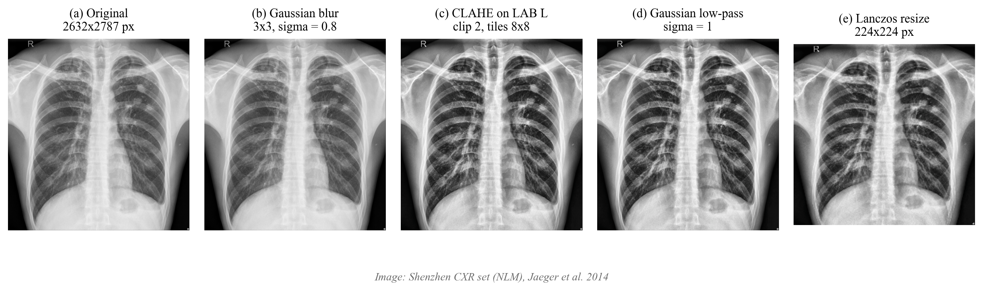
Figure 5.2. One chest radiograph at each step of the preprocessing chain: original, Gaussian blur, CLAHE, low-pass filter and resize to 224 × 224.
1. Decode. The file is decoded to a 3-channel 8-bit image. Grayscale is replicated to three channels, an alpha channel is dropped, and the channel order is converted to RGB. Files that cannot be decoded or are too small are rejected.
2. Gaussian blur. A 3 × 3 kernel with σ = 0.8 suppresses pixel noise before contrast enhancement.
3. CLAHE. Contrast-limited adaptive histogram equalisation [27], [28] is applied to the L channel of the CIE Lab colour space, with a clip limit of 2.0 and 8 × 8 tiles. Working on the luminance channel changes contrast without shifting colour.
4. Low-pass filter. A Gaussian filter with σ = 1.0 and a 7 × 7 kernel smooths the result. The choice σ = 1.0 was made in the V5 work by evaluating an unfiltered baseline under ten candidate filters on a validation set and picking the one with the best validation macro-F1. Gaussian filters with σ of 1, 2 and 3, ideal and Butterworth low-pass filters at three cut-offs, and no filter were compared.
5. Resize. Lanczos-4 interpolation to 224 × 224.
6. Normalise. Pixel values are divided by 255 and standardised with the ImageNet mean (0.485, 0.456, 0.406) and standard deviation (0.229, 0.224, 0.225).
The builder applies steps 1 to 5 once and caches the 224 × 224 result, so training does not repeat the expensive filtering at each epoch. The backend applies the same functions to uploaded images, so the pixels the network sees at serving time are produced exactly as in training. A test compares the implementation with a frozen copy of the original code on five image sizes and channel layouts, and checks that the bytes path used by the backend equals the file path used by the trainer.
One limitation is inherited from the original design. Steps 2 to 4 run at native resolution, before the resize, so their effective strength depends on the size of the input image. The order was kept so that training and serving match the checkpoints trained with it. A redesign that resizes to a canonical size first was considered and left as future work.

5.9 Augmentation
Augmentation is applied only to the training split: a horizontal flip with probability 0.5 and a rotation of up to ±10° with reflected borders. Evaluation never augments, and a test confirms that the evaluation loader accepts no random generator. The horizontal flip reverses cardiac laterality and is therefore questionable for chest radiographs; it is kept because it was part of the protocol of the original model, and its removal is listed among the future work.

5.10 Data limitations
Several properties of the data limit what the results can show.
- The Kermany images are paediatric (one to five years), and all other sources are adult. No demographic data are available for the rest.
- The NIH labels are mined from reports and not read from the images.
- Patient identity is unknown for TBX11K and the COVID-19 Radiography Database.
- Pleural Effusion and Nodule / Mass come from NIH alone, because VinDr-CXR and JSRT were not accessible.
- The single-label rule discards multi-finding images.

5.11 Composition of the final build
The final build is v6_build_002, the Run 2 columns of Table 5.5 and Table 5.6. It has 10,957 training, 2,348 validation and 2,350 internal test images and the 138-image external cohort. Seven sources contribute: six to the development splits and Montgomery as the external cohort. The Tuberculosis class is the smallest, which is why balanced class weights are used in training. Build 001 is kept only as the first, superseded build: it was used to train run 1, which was not selected. Patient identity is unknown for the TBX11K and COVID-19 Radiography rows of the final build, so the separation of patients is proven only for the other sources (see Table 5.4).

CHAPTER 6
MODEL DEVELOPMENT AND IMPLEMENTATION

6.1 Code organisation
The repository separates the scientific code from the application. Table 6.1 lists the main modules.
Table 6.1. Main modules of the implementation.
Module | Responsibility
lungai/configs/lungai_densenet121.json | Model identity, class order, preprocessing, training, evaluation and gate parameters, checkpoint name and SHA-256
lungai/preprocessing.py | The single preprocessing chain used by builder, trainer, evaluator and backend
lungai/data/v6.py | Patient grouping, duplicate merging, split assignment and leakage checks
scripts/data/acquire.py | Downloads with resume, size check, HTML rejection and provenance log
scripts/data/build_v6_manifest.py | Applies label rules, caps and exclusions, hashes and caches images, writes the manifest and build report
lungai/models/densenet.py | Builds the model; loads a checkpoint only if its SHA-256 matches
lungai/training/train_v6.py | Two-phase trainer with per-epoch validation, checkpointing, resume and run metadata
lungai/evaluation/ | Metric implementations, evaluator, served-metrics writer and documentation renderer
backend/ | FastAPI application: routes, inference engine, input gate, database
frontend/ | React application: Analyze, History, Model Performance and Patients pages
scripts/pipeline/run_overnight.py | Chains download wait, extraction, build, training and evaluation, with stage state for restart

6.2 Model construction and checkpoint integrity
The model is built from the configuration in one function. Keras Applications supplies DenseNet-121 with ImageNet weights, which Keras downloads on first use. The head layers are given the fixed names listed in the configuration. A checkpoint is loaded only if its SHA-256 equals the value in the configuration. A mismatch produces a 503 response from the backend with both hashes (shortened) in the message, unless an explicit environment switch allows an unverified checkpoint, in which case every response states that the checkpoint is not verified and the frontend shows a warning. A checkpoint whose input is not 224 × 224 × 3 or whose output is not six-way is refused.

6.3 Training protocol
The trainer implements the protocol of Chapter 4. Its steps are:
1. read the manifest and the cached 224 × 224 images made by the builder; stop if any cached image is missing;
2. compute balanced class weights from the training split;
3. phase 1: two epochs with the backbone frozen, Adam at 10⁻³;
4. phase 2: the last 30 backbone layers trainable, Adam at 10⁻⁵, batch size 32, until early stopping with patience three, the epoch limit or the wall-clock budget;
5. after every epoch, a validation pass; the model is saved if validation macro-F1 is the best so far (ties broken by validation macro ROC-AUC); the last weights and a state file are always saved;
6. write run metadata at the end.
The run metadata records the code commit, the build and manifest hashes, the split fingerprint, library versions, the per-epoch history, the selected epoch, the class weights and the checkpoint SHA-256. The trainer never reads the test split or the external cohort. Re-running the same command resumes after the last completed epoch; the weights are restored but the optimiser moments restart, and this is recorded in the metadata.
Python, NumPy and TensorFlow are seeded with 42. Augmentation draws come from one seeded generator and are made sequentially. Floating-point accumulation across threads is not deterministic, so a repeated run is expected to differ slightly.

6.3.1 The CPU and memory problem
The training machine has 8 GB of memory and no GPU supported by the native-Windows TensorFlow 2.16 build. The first two overnight attempts stalled at the first validation pass. Calling the model eagerly on the CPU took minutes per batch and exhausted memory, because each call re-traced and re-allocated the full DenseNet graph. The fix was to run inference in the trainer and in the evaluator as one compiled TensorFlow graph with a fixed batch shape. With that change an epoch on 8,054 training images takes about 13 to 14 minutes including validation, so a ten-epoch run fits within one night. The compiled graph does not change the computed values, and the evaluation reports are computed from the saved per-image outputs of the same graph. The measured time per epoch is the practical limit on this project: it is the reason for the single seed, for the cap on epochs, and for the time-boxed stop.

6.3.2 Two runs
Two runs were trained with the same protocol on two builds. Run 1 used build 001. Run 2 used build 002, which adds TBX11K and the COVID-19 Radiography Database. Both used seed 42. The final model was chosen after run 2 on a common validation set that neither run used for selection. Run 2 was selected by the rule fixed before its results were seen. On the 2,018 validation images that neither build used for training or testing, run 2 reached macro-F1 79.6% against 59.4% for run 1, accuracy 77.0% against 63.5% and macro ROC-AUC 0.957 against 0.880. Restricted to the 1,392 of those images from the four sources both runs trained on, accuracy is almost equal (67.8% against 67.6%) and the macro-F1 gap is smaller (68.5% against 62.2%), so much of the advantage of run 2 is on TBX11K and COVID-19 Radiography images, which are in-distribution for run 2 only. Run 2 was started after the external results of run 1 were known; only the selection rule was fixed before run 2's results. The full comparison is in Chapter 7. Because each run is a single seed, a small difference between runs is not evidence that one is better.

6.4 Backend implementation
The backend is a FastAPI application with a start-up routine that loads the model, the input gate and the database. Its main behaviours are as follows.
- Authentication. If an API key is configured, every route except health requires the header X-API-Key. If no key is configured only loopback clients are served. There are no user accounts.
- Upload handling. The content type must be JPEG, PNG, BMP, TIFF or WebP, the size at most 10 MB (read with a cap), and the file non-empty. The stored name is generated by the server, which blocks path traversal.
- Inference engine. One model instance per process, held by a singleton. The loading rules are summarised in Table 6.2. After the network runs, the output is checked for shape (6), finiteness, non-negativity and a sum of one within a tolerance; otherwise the response is a 500 and nothing is stored.
- Confidence floor. If the top score is below 0.5 the result is marked inconclusive. The threshold is a display rule that has not been validated clinically, because the softmax scores are not calibrated.
- Grad-CAM. The engine builds a sub-model from the final convolutional feature map of the backbone to the backbone output, computes the gradient of the predicted class score with respect to that map, pools it over the spatial dimensions, weights the maps, applies ReLU, normalises and overlays the heat map on the original image [5]. Its caption states that it shows influence on the score and not radiological reasoning.
- Persistence. The probabilities, model identity and checkpoint hash are stored with each prediction in SQLite.
- Metrics endpoint. The model-metrics endpoint serves the generated metrics file and flags a mismatch if the file belongs to a different checkpoint. The limitation notice returned with every prediction is built at start-up from the same file.
Table 6.2. Behaviour of the inference engine for the states of the checkpoint.
Situation | Engine state | Health status | Predict endpoint
File missing | Not ready | Degraded, "not found" | 503, nothing stored
SHA-256 differs | Not ready | Degraded, both hashes named | 503
SHA-256 differs and override set | Ready, checkpoint_verified false | Healthy | 200 with an unverified flag
Corrupt or incompatible file | Not ready | Degraded | 503
Canonical file | Ready, checkpoint_verified true | Healthy | 200

6.5 Frontend implementation
The frontend is a React 18 application with four pages. The Analyze page uploads an image and shows the predicted class (or "Inconclusive"), the top score, six score bars and the Grad-CAM overlay, and a warning when the checkpoint is not verified. The History page lists stored predictions with their six scores, the model and the checkpoint hash. The Model Performance page shows the generated metrics with the evidence level, the selection epoch and per-class ROC-AUC; external sensitivity is always shown with specificity, and the V5 record is shown separately as history. The Patients page manages patient records.
The code enforces several rules. Class names and order come from the API response, so the frontend has no class list of its own. A malformed response (a missing or out-of-range score, or a predicted class that is not in the order) raises an error that is displayed as such, and a missing value is never drawn as zero. Scores are labelled "uncalibrated softmax" and not as probability of disease. Errors are never replaced with mock results, and the errors module maps the 401, 413, 422, 503 and network failures to specific messages.

6.6 The chest X-ray input gate

6.6.1 Purpose and design
A classifier that always returns one of six diseases will happily classify a photograph of a car. The input gate tries to reject images that are not chest radiographs before inference. It has two stages. Stage 1 applies simple heuristics on image size, aspect ratio, contrast, colour content and brightness. Stage 2 scores the anatomical plausibility of the image from its intensity profile. A trained gate model was planned but is absent, so stage 2 runs in a heuristic fallback mode, reported by the health endpoint as heuristic_fallback, and an image passes if its score reaches the heuristic threshold. A rejected upload receives HTTP 422 with the error code INVALID_CXR and no prediction. The reported model metrics are computed without the gate.

6.6.2 The original threshold rejected most real radiographs
The threshold was initially 0.83. It was measured on the radiographs of the V6 test split of build 001 and on the Montgomery set, with the script that applies the gate to each image. At 0.83 the gate rejected 1,096 of 1,724 test radiographs (63.6%) and 83 of 138 Montgomery radiographs (60.1%). The rejection rate by test source ranged from 33.3% for Shenzhen to 81.7% for the Cohen collection. In practice the Analyze page would have refused most genuine X-rays.

6.6.3 Recalibration on validation radiographs
The threshold was recalibrated on validation radiographs only, using the validation split of build 002 (2,348 images), so no test image influenced it. The rule is: take the larger of (a) the quantile of the score distribution that passes 98% of validation radiographs and (b) the highest score among the available non-radiograph images that pass stage 1, plus 0.01. The first value is 0.504. The non-radiograph images are seven synthetic images (a colour and a grayscale car image, a dog, a selfie, a landscape, a screenshot and a CT slice); the highest stage-1-passing negative, the CT slice, scored 0.6922. The second value therefore dominates and sets the threshold to 0.703. Stage 1 rejected 9 of the validation radiographs. Table 6.3 shows how the validation pass rate falls with the threshold, and Table 6.4 shows the pass rate by source at the new threshold.
Table 6.3. Fraction of validation radiographs (build 002) passing the gate at selected thresholds.
Threshold | Validation pass rate (%)
0.50 | 97.7
0.60 | 96.4
0.70 | 91.2
0.703 (adopted) | 91.0
0.78 | 70.1
0.80 | 58.4
0.83 (original) | 38.7

Table 6.4. Gate pass rate by source on the validation split at the adopted threshold.
Source | Validation images | Pass rate (%)
Cohen COVID-19 collection | 94 | 89.4
COVID-19 Radiography Database | 384 | 82.0
Kermany | 397 | 96.7
NIH ChestX-ray14 | 1128 | 91.7
Shenzhen | 100 | 99.0
TBX11K | 245 | 90.2

All 7 of the 7 synthetic non-radiographs are rejected at the adopted threshold. The validation pass rate rises from 38.7% at 0.83 to 91.0% at 0.703.

6.6.4 Re-measurement on unseen radiographs
After the change the gate was applied again to the test radiographs of build 002 and to the Montgomery set. It rejects 218 of 2,350 real test radiographs (9.3%) and 18 of 138 Montgomery radiographs (13.0%), compared with 63.6% and 60.1% before. Because the test and external images were not used to set the threshold, these figures are an honest measure of how often the gate refuses a genuine radiograph.

6.6.5 What the gate does not establish
The negatives used for calibration are synthetic and few, so the rejection of real non-radiographs, such as photographs of films, other body regions or CT scans in the wild, is not established. A gate trained or calibrated on both radiographs and a real set of non-radiographs is future work. The gate is also a convenience for the demonstration. It is not a safety control, and the model metrics do not depend on it.

6.7 Testing
Testing is described in Appendix D. In summary, the backend and package suites cover configuration, preprocessing equivalence, model construction and checkpoint refusal, metric definitions, the evaluator's input validation, the data splitting rules, consistency of the documentation with the generated evidence, every API behaviour listed above, and the integration of the backend with a random-weight network of the canonical architecture. The frontend service modules have Jest tests, and the production build compiles with warnings treated as errors. A manual browser check with the production build served from the backend confirmed that the scores on the page equal the API response and that the missing-checkpoint, unverified-checkpoint and inconclusive states are shown correctly. Tests that use stubs or random weights check mechanics only and are not evidence that the trained model is accurate.

CHAPTER 7
EXPERIMENTAL SETUP AND RESULTS

7.1 Experimental setup

7.1.1 Hardware and software
All training and evaluation were run on one laptop with an 8 GB memory and a CPU only, under Windows 11, with Python 3.12, TensorFlow 2.16.1, Keras 3.15.1, NumPy 1.26.4 and OpenCV 4.10. TensorFlow 2.16 has no GPU support on native Windows, so no accelerator was used. Library versions, the code commit and the checkpoint hash are recorded in the metadata of each run.

7.1.2 Data
The model evaluated in this chapter is v6.1, trained on dataset build v6_build_002 with the split described in Chapter 5. The training set has 10,957 images, the validation set 2,348 and the internal test set 2,350. The external cohort has 138 images (58 TB and 80 normal scans from Montgomery County). The checkpoint has the short hash 7992b8da10ff. All numbers in this chapter refer to this final model, which was selected over the first V6 run by the rule described in Chapter 6; results of the first run appear only where they are labelled as run 1.

7.1.3 Training configuration
Table 7.1 lists the training configuration.
Table 7.1. Training configuration of the evaluated model.
Item | Value
Backbone | DenseNet-121, ImageNet initialisation
Head | GAP, batch normalisation, Dense 256 (ReLU), Dropout 0.3, Dense 6 (softmax)
Input | 224 × 224 × 3, ImageNet mean and standard deviation
Loss | Sparse categorical cross-entropy with balanced class weights
Phase 1 | 2 epochs, backbone frozen, Adam, learning rate 10⁻³
Phase 2 | Last 30 backbone layers trainable, Adam, learning rate 10⁻⁵
Batch size | 32
Augmentation | Horizontal flip (p = 0.5), rotation ±10° with reflected borders
Early stopping | Three fine-tuning epochs without validation macro-F1 gain
Checkpoint rule | Best validation macro-F1 (tie: validation macro ROC-AUC)
Seed | 42 (one run)
Epochs trained | 16; selected epoch 16

7.1.4 Evaluation protocol
The validation split is evaluated after every epoch and is used to choose the checkpoint. The test split and the external cohort are evaluated once, with the final flag, after the checkpoint is chosen. Confidence intervals for accuracy and recall are Wilson intervals; the bootstrap interval for accuracy uses 2,000 resamples with seed 42. Calibration uses 15 bins. The definitions are in Chapter 4.

7.1.5 What is not done
No hyper-parameter search was run. Run-to-run variation is measured only by the follow-up seed runs reported in the section on seed variability [PENDING: seed runs]. No threshold was tuned on the test split or the external cohort. No calibration method was fitted. No comparison with other published systems is made.

7.2 Training behaviour
Figure 7.1 shows the training loss and the validation accuracy, macro-F1 and macro ROC-AUC per epoch. The checkpoint was selected at epoch 16 out of 16.
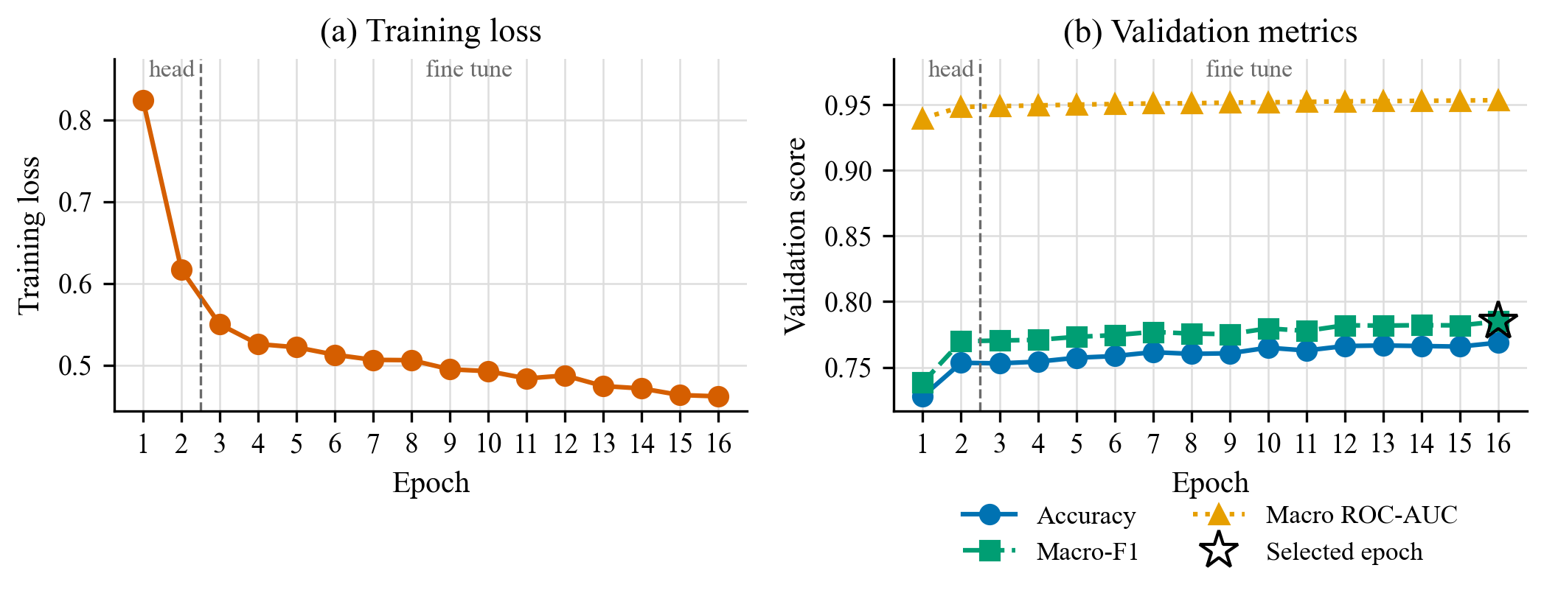
Figure 7.1. Training loss and validation accuracy, macro-F1 and macro ROC-AUC per epoch.
The run completed its full schedule of 16 epochs (the head epochs followed by fine-tuning) and was not stopped early. Validation macro-F1 rose slowly during fine-tuning and was highest at the last epoch (16), where it was 78.5%. The validation curve was therefore still rising slightly when training ended, and a longer schedule might change the result; this was not tested

7.3 Internal results

7.3.1 Overall performance
Table 7.2 gives the overall metrics on the validation and test splits.
Table 7.2. Overall performance of the final model on the validation and the internal test split.
Split | N | Accuracy (%) | Macro F1 (%) | Macro ROC-AUC
Validation | 2,348 | 76.9 | 78.5 | 0.953
Test | 2,350 | 77.4 (95% CI 75.7 to 79.0) | 78.8 | 0.955

On the test split the weighted F1 is 77.7%, the macro recall 78.1%, the macro precision 79.9%, the macro PR-AUC 0.849 and the expected calibration error 0.020.

7.3.2 Per-class performance
Table 7.3 gives the per-class results on the test split and Figure 7.2 shows precision, recall and F1 with the recall intervals.
Table 7.3. Per-class results on the internal test split (percentages except ROC-AUC).
Class | Support | Precision | Recall | Specificity | F1 | ROC-AUC
COVID-19 | 451 | 96.6 | 93.8 | 99.2 | 95.2 | 0.994
Normal | 467 | 75.5 | 66.6 | 94.6 | 70.8 | 0.937
Pleural Effusion | 444 | 70.1 | 82.0 | 91.9 | 75.6 | 0.954
Pneumonia | 394 | 91.3 | 80.2 | 98.5 | 85.4 | 0.949
Pulmonary Nodule / Mass | 449 | 57.0 | 63.5 | 88.7 | 60.1 | 0.904
Tuberculosis | 145 | 88.9 | 82.8 | 99.3 | 85.7 | 0.994

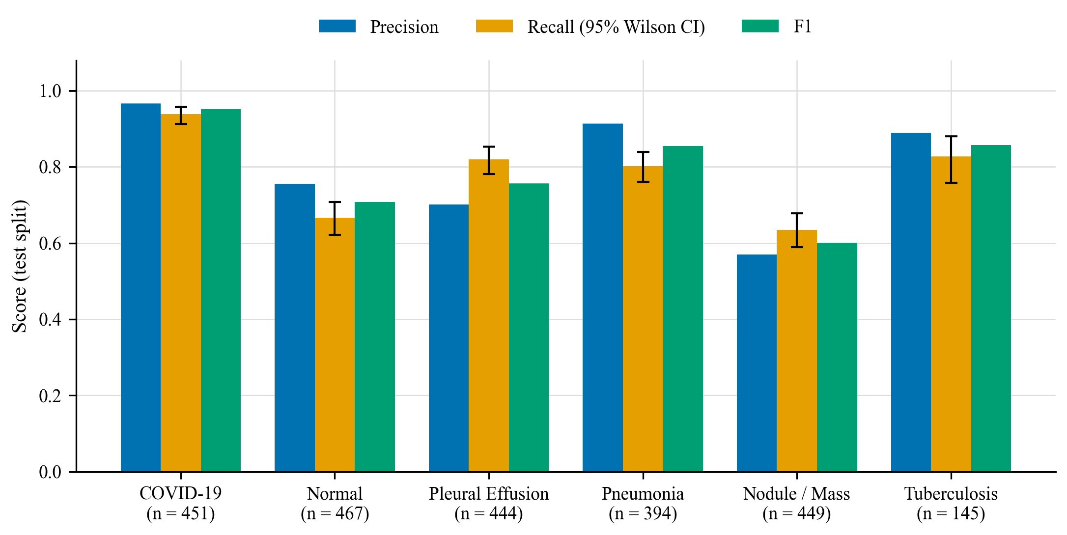
Figure 7.2. Precision, recall and F1 per class on the internal test split, with Wilson 95% intervals for recall.

7.3.3 Confusion matrix and ROC curves
Figure 7.3 shows the confusion matrix of the test split, as counts and as row-normalised proportions, and Figure 7.4 the one-versus-rest ROC curves.
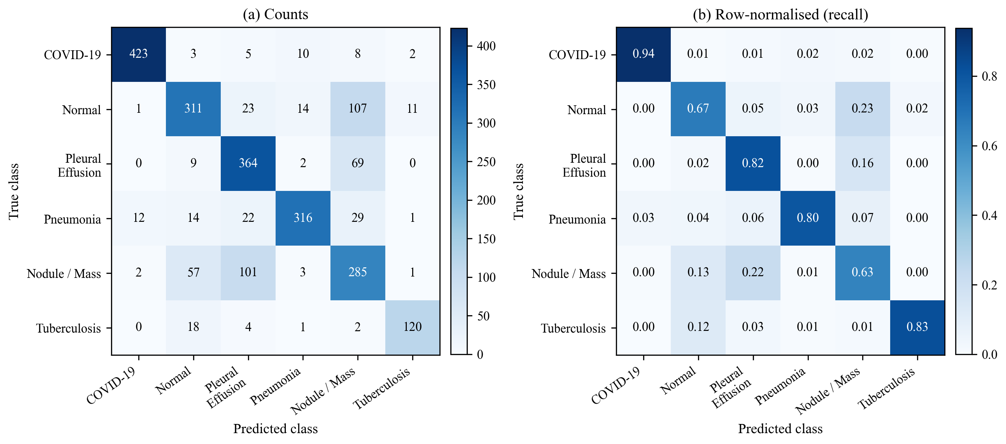
Figure 7.3. Confusion matrix on the internal test split. Rows are true classes and columns are predicted classes.
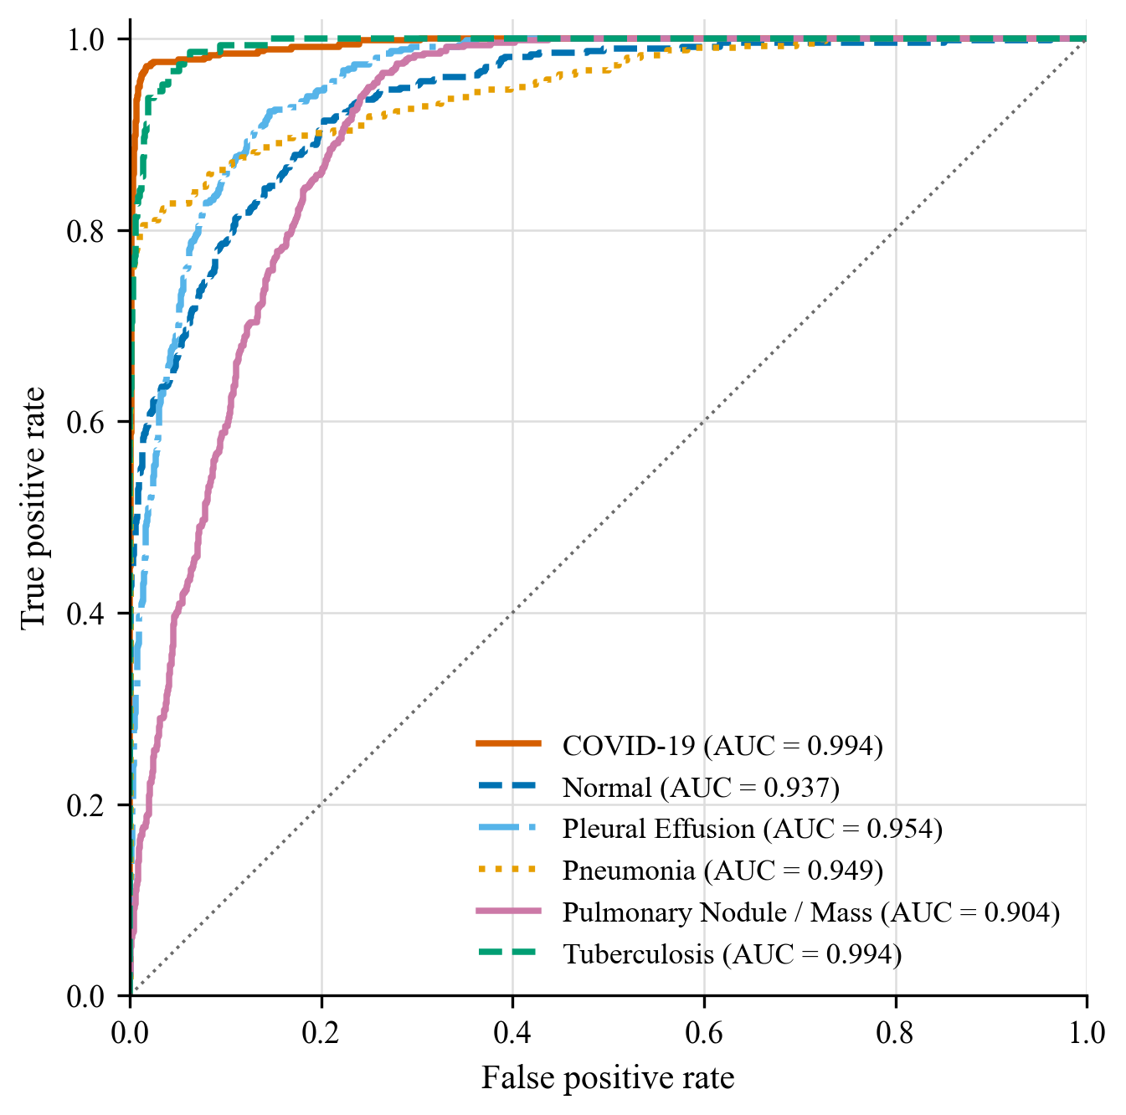
Figure 7.4. One-versus-rest ROC curves per class on the internal test split.

7.3.4 Results by source
The internal test split mixes sources whose difficulty differs greatly, so overall accuracy depends on the source mix. Figure 7.5 shows accuracy by source.
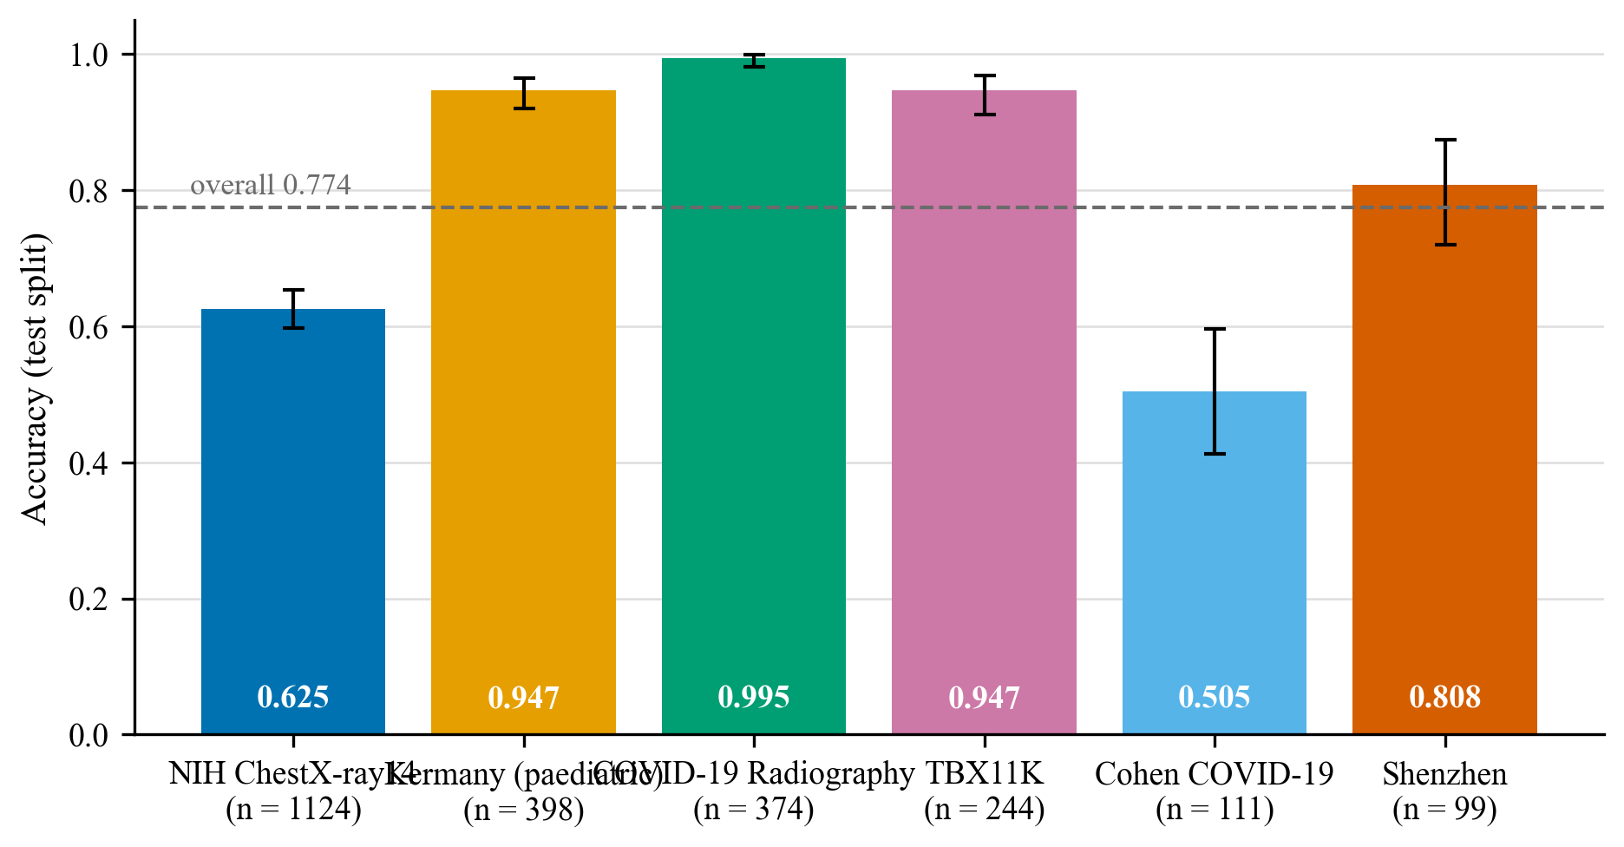
Figure 7.5. Accuracy on the internal test split by source.

7.3.5 Calibration
Figure 7.6 is the reliability diagram on the test split. The expected calibration error is 0.020. No calibration was fitted, so the scores shown by the application are uncalibrated softmax outputs.
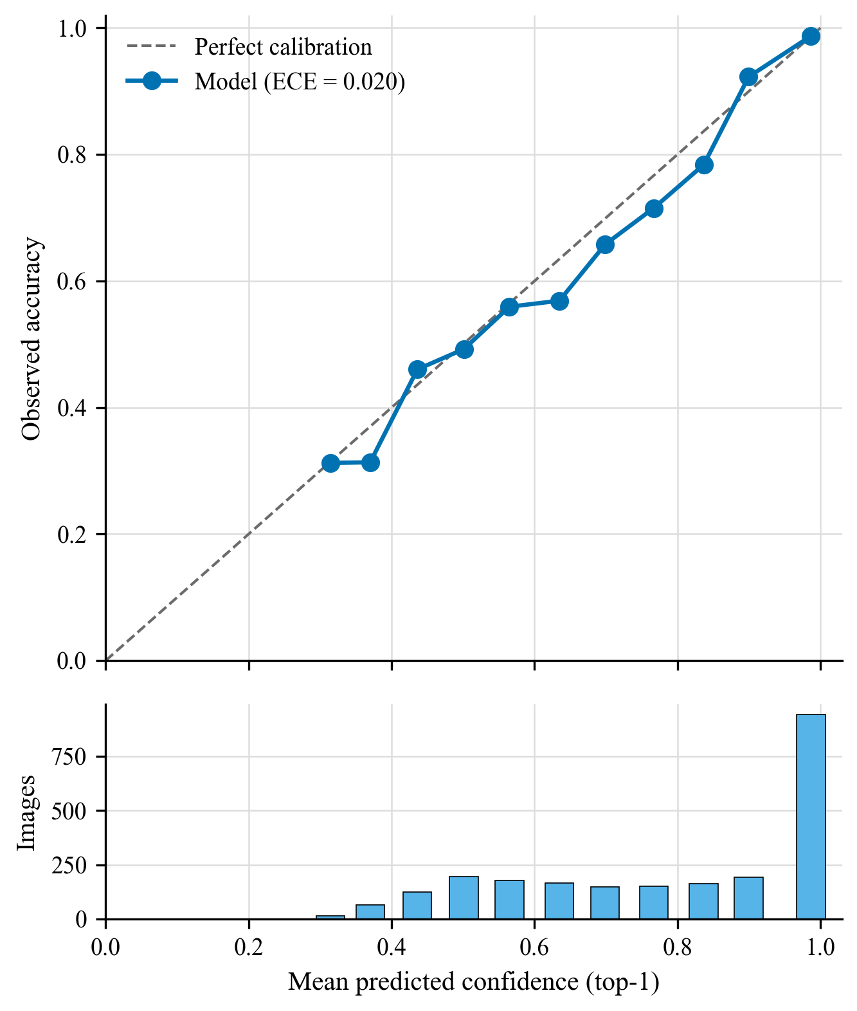
Figure 7.6. Reliability diagram of the top-class score on the internal test split.

7.4 External results
On the Montgomery County cohort the task is binary. Table 7.4 reports the results. Sensitivity is reported only together with specificity.
Table 7.4. External results on the Montgomery County cohort, evaluated once.
Quantity | Result
TB scans flagged abnormal (sensitivity) | 55 / 58 (94.8%; 95% CI 85.9 to 98.2)
Normal scans called Normal (specificity) | 19 / 80 (23.8%; 95% CI 15.8 to 34.1)
TB scans called Tuberculosis (exact recall) | 0 / 58 (0.0%)
ROC-AUC of P(abnormal) | 0.809
Scans assigned to COVID-19 | 3

Figure 7.7 shows the class assigned to the normal and TB scans. Montgomery contains no COVID-19 cases, so any scan assigned to COVID-19 is a wrong class.
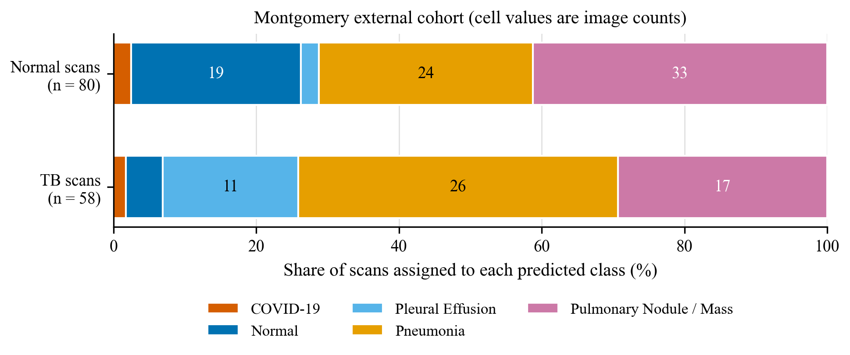
Figure 7.7. Predicted class for the normal and the tuberculosis scans of the Montgomery County cohort.

7.5 Source-identifiability probe
Because class and source are confounded in the benchmark, a control was run on the final build. A linear classifier was fitted on frozen features of 1,952 training images and evaluated on 1,033 test images to predict the source of an image rather than its class. Table 7.5 gives the balanced accuracy.
Table 7.5. Balanced accuracy (%) of a linear probe that predicts the source of a test image. Chance is the accuracy of a random guess among the sources considered.
Features | All sources (6; chance 16.7) | Within Normal (5 sources; chance 20.0) | Within Tuberculosis (3; chance 33.3) | Within Pneumonia (3; chance 33.3) | Within COVID-19 (2; chance 50.0)
ImageNet features | 93.8 | 97.2 | 98.9 | 89.1 | 89.0
Backbone of the trained model | 93.8 | 97.4 | 98.9 | 88.4 | 89.2

The source is predicted far above chance, and also within a single class, where the label is the same and only the source differs. Fine-tuning changed only the last 17 weighted layers of the backbone (verified by comparing weights), so the features of the trained model stay close to those of ImageNet, which is why the two rows are similar. The probe shows that source information is linearly available in the features the classifier uses. It does not show that the classifier uses it.

7.6 Grad-CAM examples
Figure 7.8 shows Grad-CAM overlays for a few test images. They illustrate the output of the application and are not evidence of localisation. The images were chosen by a rule fixed before the heatmaps were viewed: one correctly classified test image per class, at the median confidence of that class. In these examples the COVID-19 and Normal heatmaps concentrate on the neck and trachea, the shoulders and the image borders, the Nodule / Mass and Tuberculosis heatmaps fall inside the lung fields, and the Pneumonia heatmap, on a paediatric Kermany image, is diffuse. With one image per class this is qualitative and illustrative only.
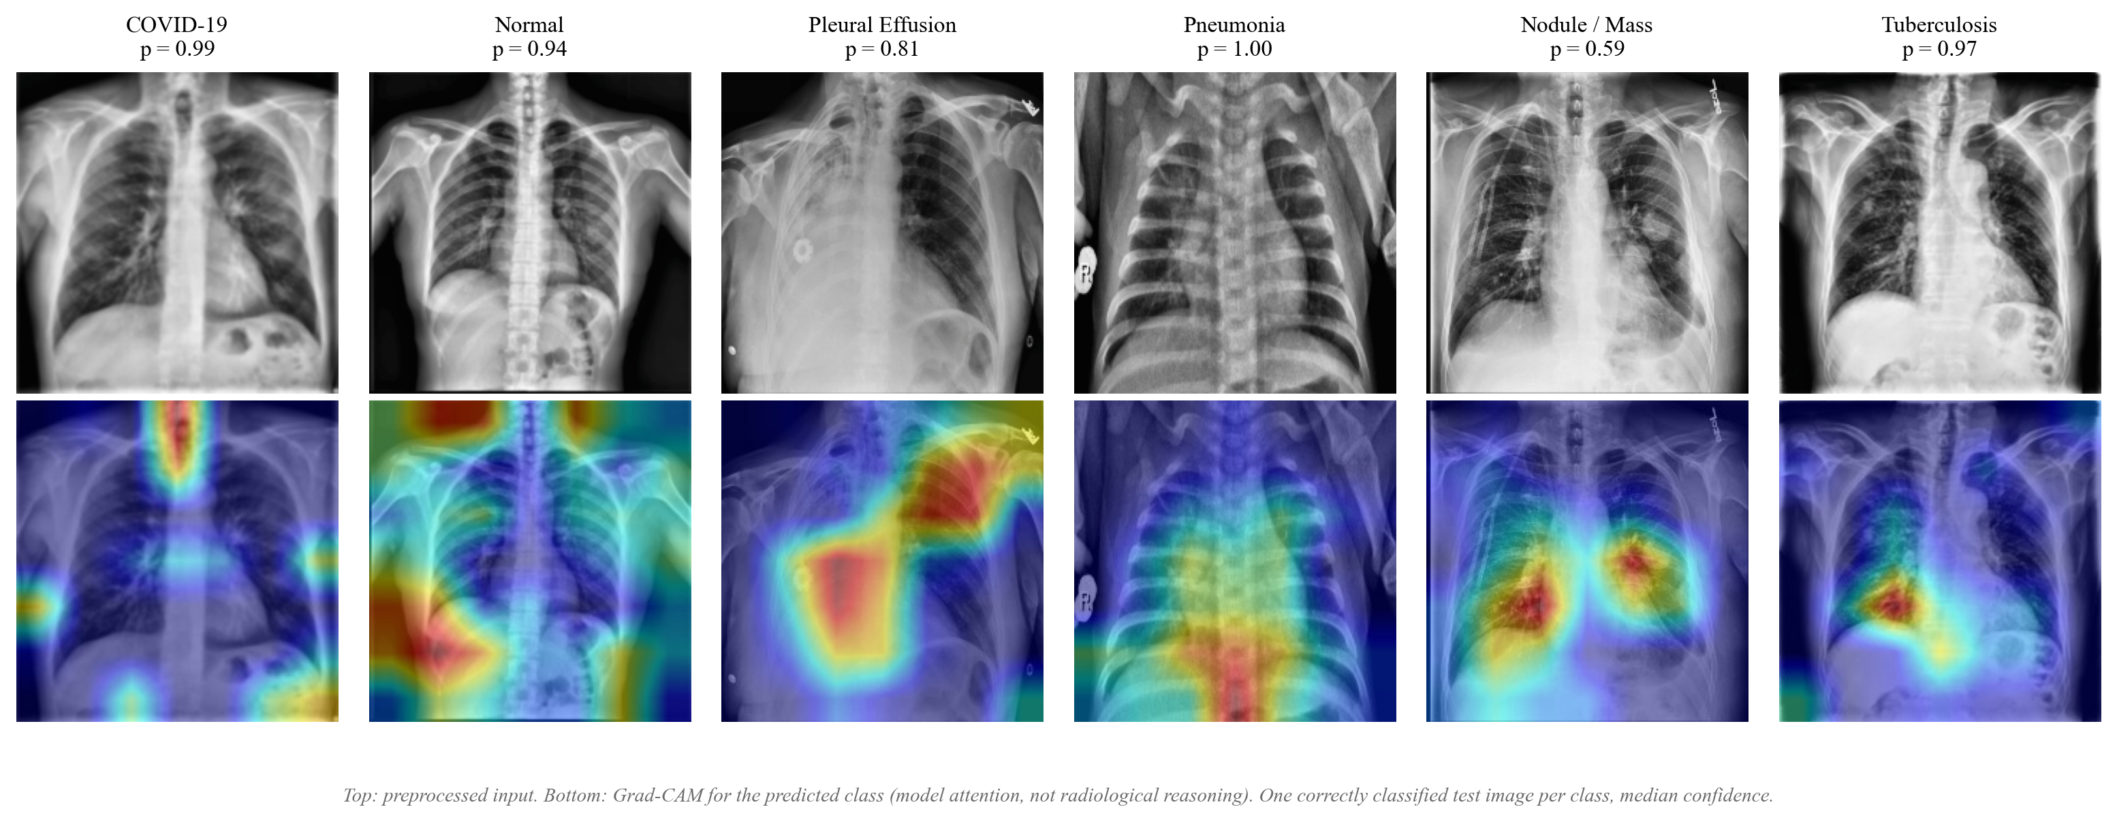
Figure 7.8. Grad-CAM overlays on a few images of the internal test split, for the predicted class.

7.7 Comparison of the two V6 runs
The two runs were compared on the 2,018 validation images that neither build used for training or testing, by the rule fixed in advance (Chapter 6). Table 7.6 gives the result.
Table 7.6. Run 1 and run 2 on the common validation set, overall and restricted to the images from the four sources both runs trained on.
Set | Run | N | Accuracy (%) | Macro F1 (%) | Macro ROC-AUC
Common set | Run 1 | 2,018 | 63.5 | 59.4 | 0.880
Common set | Run 2 (final) | 2,018 | 77.0 | 79.6 | 0.957
Shared sources only | Run 1 | 1,392 | 67.6 | 62.2 | 0.929
Shared sources only | Run 2 (final) | 1,392 | 67.8 | 68.5 | 0.929

Run 2 has the higher macro-F1 and was selected. On the paired images, run 1 was right and run 2 wrong for 132 images and the reverse held for 404 (exact McNemar p = 4.57e-33; descriptive only). The caveat is the shared-sources rows: on the images from the four sources both runs trained on, accuracy is almost equal and the macro-F1 gap is smaller, so much of the advantage of run 2 lies on TBX11K and COVID-19 Radiography images, which only run 2 saw in training. Each run is a single seed, so the comparison does not show that the recipe of run 2 is better in general. Run 2 was started after the external results of run 1 were known; only the selection rule was fixed before run 2's results.
Table 7.7 puts the external behaviour of the two runs side by side. The run 1 values are historical and come from the external evaluation file of run 1 (artifacts/evaluation_reports/v6_external/metrics_external.json); each run was evaluated on Montgomery once.
Table 7.7. External behaviour of run 1 (not selected; historical values) and run 2 (final) on the Montgomery scans, none of which show COVID-19.
Quantity | Run 1 | Run 2 (final)
Scans assigned to COVID-19 | 71 of 138 | 3 of 138
Normal scans called Normal | 43 / 80 | 19 / 80
TB scans called Tuberculosis | 1 / 58 | 0 / 58
ROC-AUC of P(abnormal) | 0.730 | 0.809

7.8 Seed variability
[PENDING: seed runs] Two further seeds of the selected recipe are being trained. The mean, sample standard deviation, minimum and maximum of the main metrics over the three seeds will be reported here.

7.9 Preprocessing ablation
[PENDING: ablation] One run on images without the Gaussian blur, CLAHE and low-pass filter, with the same manifest, split and seed, will be compared here with the final model. Until it is complete, this report makes no claim that the preprocessing helps.

7.10 Interpretation

7.10.1 Internal results
The internal test accuracy of 77.4% hides large differences between classes. COVID-19 (F1 95.2%), Tuberculosis (85.7%) and Pneumonia (85.4%) are the strongest classes. Pulmonary Nodule / Mass (F1 60.1%) is the weakest, followed by Normal (70.8%). The confusion matrix shows that the main confusions involve Nodule / Mass, Normal and Pleural Effusion with one another. Nodule / Mass and Pleural Effusion both come from NIH only and have labels mined from reports, so part of the error may be label noise and not model error; this was not tested. Accuracy varies a great deal between sources (Figure 7.5), from 50.5% for the Cohen collection and 62.5% for NIH to 99.5% for the COVID-19 Radiography Database. The sources differ in the classes they contain and in their image style, so these numbers must not be read as a ranking of data quality. The expected calibration error of 0.020 is small, so on the internal test split the top-class score is close to the observed frequency of being right; this does not make it a probability of disease, and it was not checked at another hospital.

7.10.2 External results
On the unseen hospital the picture is different. The model flags 55 of 58 tuberculosis scans as abnormal, but it calls only 19 of 80 normal scans Normal, so most healthy patients of this cohort would be flagged. The exact Tuberculosis recall is 0 of 58: the abnormal sensitivity does not mean that tuberculosis is recognised. Most scans, normal and tuberculosis alike, were assigned to Pneumonia or Pulmonary Nodule / Mass (Figure 7.7), and only 3 scans were called COVID-19. The internal Tuberculosis F1 of 85.7% therefore does not transfer to this cohort.
Run 1 called 71 of 138 Montgomery scans COVID-19. Adding a second large COVID-19 source in run 2 removed that behaviour, but the external errors moved to the other abnormal classes: the internal gains did not translate into better external specificity or into any recognition of Tuberculosis. Adding sources changed which error appears; it did not close the external gap.

7.10.3 Evidence on source shortcuts
Three observations point the same way. The source of an image is predictable from the features, also within a single class (the probe). The external behaviour shows low specificity and no Tuberculosis recognition. The Grad-CAM examples for COVID-19 and Normal fall outside the lung fields. Each piece of evidence is indirect: the probe shows availability, the external result shows failure to generalise, and the heatmaps are qualitative and few. Together they are consistent with a source shortcut, but this report does not state as proven that the model uses source cues.

7.10.4 Failure analysis
The failures of the final model fall into four groups. First, confusions among Nodule / Mass, Normal and Pleural Effusion on the internal test split, in classes whose labels are mined from reports. Second, low accuracy for some sources inside the test split, for example the Cohen collection. Third, on the external cohort, normal scans assigned to disease classes, which is the failure that matters most for use. Fourth, no tuberculosis scan of the external cohort assigned to Tuberculosis. No failure case was reviewed by a radiologist.

CHAPTER 8
VALIDATION, DISCUSSION AND LIMITATIONS

8.1 Validation protocol
Validation here means the checks that make the reported numbers trustworthy, not only the metrics themselves. They fall into five groups.
Data validation. The build stops when patient groups, identical files or external-cohort files span splits. Every image has recorded hashes, and the split has a fingerprint. These checks are evaluated for both builds in Table 5.4. Separation is proven only for rows with known patient identity; the build report states how many rows have unknown identity.
Process validation. The trainer reads only the training and validation splits, and a run records the build and split fingerprints. The evaluator refuses to compute metrics if its input is inconsistent with the manifest, if a split or checkpoint is mixed, or if stored class indices disagree with the stored probabilities. The test split and the external cohort require an explicit final flag. A script that publishes the metrics to the application refuses to combine reports of different checkpoints.
Code validation. The test suites check the metric implementations against hand-computed values and scikit-learn, the preprocessing against a frozen copy, the evaluator against tampered inputs, and the splitting rules against the known leakage of V5 (the test that pins the 154 leaked images keeps the defect detectable). Appendix D summarises the results.
Result validation. Per-image predictions are saved, so every reported number can be recomputed. The documentation is generated from the served metrics file, and a test fails if a number in the documentation differs from it. This report reads its numbers from a generated JSON file at build time.
Application validation. The scores displayed by the frontend were compared with the API response in a manual browser check, and the application states the metrics of the checkpoint it loaded.

8.1.1 The V5 audit as a validation case
The audit of the earlier pipeline is itself a validation result. Table 8.1 compares what V5 recorded with what the audit found. The comparison shows how the same architecture can produce an attractive internal accuracy and a useless external behaviour when the data are not controlled.
Table 8.1. Recorded results of the earlier V5 model and what the audit found. These numbers describe a superseded model whose checkpoint is lost; they are history and are not comparable with the V6 results.
Aspect | V5 as recorded | Audit finding
Internal test accuracy | 82.9% on 1,570 images | 154 test images (9.8%) share a patient with training images
External specificity | 0 / 80 | The model called no normal scan Normal
External sensitivity | 58 / 58 | Quoted without specificity, it looked perfect
Pneumonia class | 2,805 images | 1,395 were TBX11K "sick but not TB" images
Tuberculosis class | 1,348 images | 124 were latent TB
Checkpoint | Recorded SHA-256 | The file is lost; no per-image predictions exist

8.2 Discussion
The main findings of the final model, v6.1, are discussed in five points.
Internal and external performance. The internal test accuracy is 77.4% on a split that is free of known patient and duplicate leakage, and the macro ROC-AUC is 0.955. On the external cohort the same model calls 19 of 80 normal scans Normal and none of the 58 tuberculosis scans Tuberculosis. Removing leakage therefore does not remove the gap: a clean internal split measures performance on the same sources, not on a new hospital.
Weak classes. Pulmonary Nodule / Mass (F1 60.1%) and Normal (70.8%) are the weakest. Nodule / Mass and Pleural Effusion come from NIH alone, with labels mined from reports, and are confused with Normal and with each other. Label noise is a plausible contributor but was not measured.
Source shortcuts. For COVID-19, the first run's external behaviour (71 of 138 Montgomery scans assigned COVID-19) suggested a shortcut tied to its single source. The second run removed that behaviour after a second COVID-19 source was added, but the errors moved to other abnormal classes. For Tuberculosis, the good internal result does not appear on Montgomery. The probe shows that the source is predictable from the features, also within a class, and the COVID-19 and Normal heatmaps fall outside the lung fields. This evidence is indirect and consistent with, but does not prove, the use of source cues.
Comparison of the two runs. Run 2 was better on the common validation set (79.6% against 59.4% macro-F1), but on the images from sources both runs trained on, the accuracy is almost equal (67.8% against 67.6%). Much of the gain is on sources only run 2 saw. Each is a single seed, and seed variability is still to be measured [PENDING: seed runs].
Calibration. The expected calibration error is 0.020 on the internal test split, so the displayed scores are reasonably calibrated there. This was not checked externally, no calibration was fitted, and a score is not a probability of disease.

8.2.1 Findings that do not depend on the final model
Three observations hold whichever model is selected.
First, the dominant cost of a trustworthy result was not the network but the data. Most of the work went into acquisition, label rules, duplicate handling and checks. The training itself is a standard transfer-learning recipe.
Second, the external cohort contains only normal and TB scans. It can say whether the model separates abnormal from normal at a hospital it has not seen, and whether it can name TB, but it cannot assess the other four classes. Any statement about those four classes outside the internal test set would be unsupported.
Third, sources define classes in this benchmark. A class with a single type of source (COVID-19 from web-collected sets, TB mostly from two screening sets) is exposed to the risk of being recognised by image style. Per-source reporting is therefore not an extra; it is required for an honest reading of the overall accuracy. The reasoning is supported by the literature on shortcut learning [10]–[12], although the extent in this project is a result of the final model and is given in the discussion above.

8.3 Threats to validity
- Internal validity. One run per model, one seed. The ranking of two runs that differ by a few points is not reliable. A learning curve that is still rising at the time limit means that the model is not converged.
- Label validity. NIH labels are mined from reports and not read from the images [6]. The Kermany and Cohen labels come from their sources. No re-reading by a radiologist was done.
- Construct validity. The single-label rule means that the test set contains clear single-finding cases. It overstates performance on the real mixture of findings.
- External validity. One external cohort, from one programme and with two classes. Population effects, scanners and prevalence are not controlled. No demographic data are available, so subgroup performance [29] cannot be assessed.
- Statistical validity. Wilson intervals describe sampling error of the test set only. They do not include training variance, and several sources contribute few images to the test split.

8.4 Limitations
The following limitations come from the project's limitation record. Those that depend on the final model's behaviour are listed at the end of the first group.

8.4.1 Model and training
- One run, CPU, time-boxed. Run-to-run variation is measured only by the follow-up seed runs [PENDING: seed runs], and the effect of the preprocessing is untested until the ablation is complete [PENDING: ablation]. Differences of a few points are not evidence of a better model.
- The six classes are treated as mutually exclusive.
- Preprocessing steps run at native resolution, before the resize, so the same anatomy scanned at another resolution receives a different effective filter. Training and serving use the same code and therefore agree with each other.
- Grad-CAM shows which regions influenced the score. It does not show radiological reasoning, and saliency maps have been found to be unreliable as localisation evidence [44], [45].
- The softmax output is not a probability of disease. The 0.5 inconclusive threshold is not validated. The expected calibration error is reported but no calibration was fitted [30].
- External behaviour: on Montgomery the model flags most normal scans as abnormal (specificity 19 of 80), so it would flag most healthy patients of that hospital. The abnormal sensitivity (55 of 58) is not tuberculosis detection, because no tuberculosis scan is named Tuberculosis (0 of 58). Tuberculosis therefore does not transfer.
- Source shortcut: the first run assigned COVID-19 to many Montgomery scans; the final run does not, but its errors moved to other classes, and source information is predictable from its features. The Grad-CAM examples for COVID-19 and Normal fall outside the lung fields. The evidence is indirect.
- Weak classes: Pulmonary Nodule / Mass and Normal have the lowest F1, and their labels, like those of Pleural Effusion, come from report mining.
- Per-source differences: accuracy differs between sources in the test split, so overall accuracy depends on the source mix.
- Much of the gain of the final run over the first is on sources only the final run trained on.
- Run 2 was started after run 1's external results were known; only the selection rule was fixed beforehand

8.4.2 Data
- Patient identity is unknown for TBX11K and the COVID-19 Radiography Database. Their images are grouped one per image plus exact and near-duplicates, so the same patient could still appear in two splits. For NIH, Kermany, Shenzhen and Cohen the grouping uses real or file-name-derived identifiers.
- Images with more than one finding are excluded, so the test set contains only clear single-label cases.
- The Kermany images are paediatric (one to five years); all other sources are adult. No demographic data are available.
- VinDr-CXR and JSRT were not available, so Pleural Effusion and Nodule / Mass come from NIH alone.
- The images are not redistributed. The repository holds the rules, the builder and the download provenance.
- A contamination risk recorded for the earlier pipeline (an aggregated TB archive reported to contain Montgomery images) could not be ruled out by content matching. V6 does not use that archive, and every development image is checked against the external cohort by content.

8.4.3 Application
- The input gate is heuristic. After recalibration it rejects 9.3% of the real test radiographs of build 002 and 13.0% of Montgomery radiographs, down from 63.6% and 60.1% at the original threshold. Its rejection of real non-radiographs is not established, because only seven synthetic negatives were available.
- The "typical features" and "precautions" texts are generic per class, not findings read from the image.
- Authentication is a single shared key or loopback-only access. There are no user accounts, no audit log, and uploads are kept indefinitely.
- The Docker image could not be built on the development laptop, and continuous integration has not run because the branch was not pushed.

8.5 Ethical and clinical considerations
The system is not a medical device and was not clinically validated. It must not be used to decide a diagnosis or treatment. The application carries a notice with every prediction. The datasets were used under their published terms, and no identifiable patient data were handled beyond what the datasets publish. Reporting of sensitivity without specificity, which is the failure that hid the V5 problem, is prevented in the code of the application. Any future clinical study would need ethics approval, representative local data and prospective evaluation.

CHAPTER 9
CONCLUSION AND FUTURE SCOPE

9.1 Summary of the work
This project rebuilt a six-class chest X-ray classification system around a leakage-controlled dataset. It started from an earlier model whose recorded 82.93% internal accuracy did not survive an audit, found the causes (patient leakage, proxy labels, unverifiable identity and an external specificity of zero), and replaced the data pipeline with one that downloads from official sources with logged provenance, applies label rules fixed in advance, hashes every image, splits by patient group with duplicates merged, and stops on any leakage check. A DenseNet-121 was trained with a two-phase transfer-learning schedule on a laptop CPU, after a memory problem was solved by running inference as a compiled graph. The model, its Grad-CAM explanations, a heuristic input gate whose threshold was recalibrated on validation radiographs, and the metrics of the loaded checkpoint are served by a FastAPI and React application that is tested at the unit, integration and browser level.

9.2 Conclusions
For the final model, v6.1, the answers to the three research questions of Chapter 3 are as follows.
1. Internal versus external. With a patient-grouped, leakage-controlled split the internal test accuracy is 77.4% (macro-F1 78.8%), but on the external hospital the model calls only 19 of 80 normal scans Normal and none of 58 tuberculosis scans Tuberculosis. The gap is large and a clean internal split does not close it.
2. Source shortcuts. The source of an image is predictable from the features (balanced accuracy 93.8% against a chance of 16.7%), also within a class. The first run's COVID-19 assignments on Montgomery were removed in the final run by adding a second source, but the external errors moved to other classes. The evidence is consistent with source shortcuts and is indirect; it does not prove them.
3. Cost. The pipeline, from acquisition to served metrics, runs on a laptop CPU; training the final model took several hours, and each run is a single time-boxed seed.
Seed variability and the preprocessing ablation will be added when those runs finish: [PENDING: seed runs] [PENDING: ablation].
Conclusions that do not depend on the final model are the following.
1. A pipeline in which every step is scripted, hashed and checked can be built and run on commodity hardware within a night, and the checks (zero groups, files and external images spanning splits) can be made part of the build.
2. Audit findings of the earlier system show that a high internal accuracy is not evidence of generalisation, and that external sensitivity without specificity is not a result.
3. The honest evaluation of a multi-source benchmark requires per-source reporting and an external cohort, because the class label is partly a label of the source.
4. A research prototype can be built so that it cannot show a number that it did not compute: the application serves the generated metrics of the checkpoint it loaded and refuses to run with an unverified one.

9.3 Contributions revisited
The four contributions stated in Chapter 1 stand as pipeline and audit contributions: the auditable rebuild, the reproducible end-to-end pipeline, the evidence about internal versus external behaviour internal metrics of 77.4% accuracy against an external specificity of 19 of 80, and the audit of the earlier pipeline. The project does not claim a new architecture or a clinically useful classifier.

9.4 Future scope
The most valuable extensions follow from the limitations.
- More seeds. Train at least five seeds per configuration (about five hours of CPU time each) and report mean and spread, so that differences between configurations can be judged.
- Better data for the weak classes. Obtain VinDr-CXR and JSRT through credentialing and registration, to give Pleural Effusion and Nodule / Mass radiologist-read labels and a second source. Add a source with real patient identifiers for COVID-19 and TB.
- Source-shortcut controls. A source-prediction probe on frozen features was run in this work. Report leave-one-source-out results for multi-source classes, and test whether performance holds when the border and annotation regions of the image are masked.
- Preprocessing redesign. Resize to a canonical size before blur, CLAHE and low-pass filtering, remove the dependence on image resolution, and choose between the variants on validation. Reconsider the horizontal flip, which reverses cardiac laterality.
- Calibration. Fit temperature scaling on the validation split and validate the inconclusive threshold.
- Multi-label formulation. Replace the single-label assumption by a multi-label output that can represent co-existing findings.
- Input gate. Train or calibrate a gate on real radiographs and a real set of non-radiographs, and report its false-reject and false-accept rates.
- Explanations. Compare Grad-CAM with other attribution methods and test their localisation against bounding boxes (available in VinDr-CXR and TBX11K), given the doubts about saliency maps.
- Fairness. Evaluate performance by age, sex and site where such data exist.
- Deployment. Build and test the Docker image, run continuous integration, add user accounts and an audit log, and retention rules for uploads.
- Prospective clinical evaluation. Any claim of clinical utility needs ethics approval, representative local data, comparison with radiologists and prospective evaluation, following reporting guidelines such as CLAIM and TRIPOD+AI [35], [36].

REFERENCES
[1] P. Rajpurkar et al., “CheXNet: Radiologist-Level Pneumonia Detection on Chest X-Rays with Deep Learning,” arXiv preprint arXiv:1711.05225, 2017. [Online]. Available: https://arxiv.org/abs/1711.05225.
[2] J. Irvin et al., “CheXpert: A Large Chest Radiograph Dataset with Uncertainty Labels and Expert Comparison,” in Proceedings of the AAAI Conference on Artificial Intelligence, 2019, pp. 590–597, doi: 10.1609/aaai.v33i01.3301590.
[3] G. Huang, Z. Liu, L. van der Maaten, and K. Q. Weinberger, “Densely Connected Convolutional Networks,” in 2017 IEEE Conference on Computer Vision and Pattern Recognition (CVPR), 2017, pp. 2261–2269, doi: 10.1109/CVPR.2017.243.
[4] J. Deng, W. Dong, R. Socher, L.-J. Li, K. Li, and L. Fei-Fei, “ImageNet: A large-scale hierarchical image database,” in 2009 IEEE Conference on Computer Vision and Pattern Recognition, 2009, pp. 248–255, doi: 10.1109/CVPR.2009.5206848.
[5] R. R. Selvaraju, M. Cogswell, A. Das, R. Vedantam, D. Parikh, and D. Batra, “Grad-CAM: Visual Explanations from Deep Networks via Gradient-Based Localization,” in 2017 IEEE International Conference on Computer Vision (ICCV), 2017, pp. 618–626, doi: 10.1109/ICCV.2017.74.
[6] L. Oakden-Rayner, “Exploring Large-scale Public Medical Image Datasets,” Academic Radiology, vol. 27, no. 1, pp. 106–112, 2020, doi: 10.1016/j.acra.2019.10.006.
[7] L. Wynants et al., “Prediction models for diagnosis and prognosis of covid-19: systematic review and critical appraisal,” BMJ, p. m1328, 2020, doi: 10.1136/bmj.m1328.
[8] M. Roberts et al., “Common pitfalls and recommendations for using machine learning to detect and prognosticate for COVID-19 using chest radiographs and CT scans,” Nature Machine Intelligence, vol. 3, no. 3, pp. 199–217, 2021, doi: 10.1038/s42256-021-00307-0.
[9] G. Maguolo and L. Nanni, “A critic evaluation of methods for COVID-19 automatic detection from X-ray images,” Information Fusion, vol. 76, pp. 1–7, 2021, doi: 10.1016/j.inffus.2021.04.008.
[10] A. J. DeGrave, J. D. Janizek, and S.-I. Lee, “AI for radiographic COVID-19 detection selects shortcuts over signal,” Nature Machine Intelligence, vol. 3, no. 7, pp. 610–619, 2021, doi: 10.1038/s42256-021-00338-7.
[11] R. Geirhos et al., “Shortcut learning in deep neural networks,” Nature Machine Intelligence, vol. 2, no. 11, pp. 665–673, 2020, doi: 10.1038/s42256-020-00257-z.
[12] J. R. Zech, M. A. Badgeley, M. Liu, A. B. Costa, J. J. Titano, and E. K. Oermann, “Variable generalization performance of a deep learning model to detect pneumonia in chest radiographs: A cross-sectional study,” PLOS Medicine, vol. 15, no. 11, p. e1002683, 2018, doi: 10.1371/journal.pmed.1002683.
[13] X. Wang, Y. Peng, L. Lu, Z. Lu, M. Bagheri, and R. M. Summers, “ChestX-Ray8: Hospital-Scale Chest X-Ray Database and Benchmarks on Weakly-Supervised Classification and Localization of Common Thorax Diseases,” in 2017 IEEE Conference on Computer Vision and Pattern Recognition (CVPR), 2017, pp. 3462–3471, doi: 10.1109/CVPR.2017.369.
[14] A. E. W. Johnson et al., “MIMIC-CXR, a de-identified publicly available database of chest radiographs with free-text reports,” Scientific Data, vol. 6, no. 1, 2019, doi: 10.1038/s41597-019-0322-0.
[15] H. Q. Nguyen et al., “VinDr-CXR: An open dataset of chest X-rays with radiologist's annotations,” Scientific Data, vol. 9, no. 1, 2022, doi: 10.1038/s41597-022-01498-w.
[16] J. Shiraishi et al., “Development of a Digital Image Database for Chest Radiographs With and Without a Lung Nodule: Receiver Operating Characteristic Analysis of Radiologists' Detection of Pulmonary Nodules,” American Journal of Roentgenology, vol. 174, no. 1, pp. 71–74, 2000, doi: 10.2214/ajr.174.1.1740071.
[17] S. Jaeger, S. Candemir, S. Antani, Y.-X. J. Wáng, P.-X. Lu, and G. Thoma, “Two public chest X-ray datasets for computer-aided screening of pulmonary diseases,” Quantitative Imaging in Medicine and Surgery, vol. 4, no. 6, pp. 475–477, 2014, doi: 10.3978/j.issn.2223-4292.2014.11.20.
[18] S. Candemir et al., “Lung Segmentation in Chest Radiographs Using Anatomical Atlases With Nonrigid Registration,” IEEE Transactions on Medical Imaging, vol. 33, no. 2, pp. 577–590, 2014, doi: 10.1109/TMI.2013.2290491.
[19] Y. Liu, Y.-H. Wu, Y. Ban, H. Wang, and M.-M. Cheng, “Rethinking Computer-Aided Tuberculosis Diagnosis,” in 2020 IEEE/CVF Conference on Computer Vision and Pattern Recognition (CVPR), 2020, pp. 2643–2652, doi: 10.1109/CVPR42600.2020.00272.
[20] T. Rahman et al., “Reliable Tuberculosis Detection Using Chest X-Ray With Deep Learning, Segmentation and Visualization,” IEEE Access, vol. 8, pp. 191586–191601, 2020, doi: 10.1109/ACCESS.2020.3031384.
[21] D. S. Kermany et al., “Identifying Medical Diagnoses and Treatable Diseases by Image-Based Deep Learning,” Cell, vol. 172, no. 5, pp. 1122–1131.e9, 2018, doi: 10.1016/j.cell.2018.02.010.
[22] J. P. Cohen, P. Morrison, L. Dao, K. Roth, T. Q. Duong, and M. Ghassemi, “COVID-19 Image Data Collection: Prospective Predictions Are the Future,” Machine Learning for Biomedical Imaging, pp. 1–38, 2020, doi: 10.59275/j.melba.2020-48g7.
[23] M. E. H. Chowdhury et al., “Can AI Help in Screening Viral and COVID-19 Pneumonia?,” IEEE Access, vol. 8, pp. 132665–132676, 2020, doi: 10.1109/ACCESS.2020.3010287.
[24] T. Rahman et al., “Exploring the effect of image enhancement techniques on COVID-19 detection using chest X-ray images,” Computers in Biology and Medicine, vol. 132, p. 104319, 2021, doi: 10.1016/j.compbiomed.2021.104319.
[25] L. Wang, Z. Q. Lin, and A. Wong, “COVID-Net: a tailored deep convolutional neural network design for detection of COVID-19 cases from chest X-ray images,” Scientific Reports, vol. 10, no. 1, 2020, doi: 10.1038/s41598-020-76550-z.
[26] I. D. Apostolopoulos and T. A. Mpesiana, “Covid-19: automatic detection from X-ray images utilizing transfer learning with convolutional neural networks,” Physical and Engineering Sciences in Medicine, vol. 43, no. 2, pp. 635–640, 2020, doi: 10.1007/s13246-020-00865-4.
[27] S. M. Pizer et al., “Adaptive histogram equalization and its variations,” Computer Vision, Graphics, and Image Processing, vol. 39, no. 3, pp. 355–368, 1987, doi: 10.1016/S0734-189X(87)80186-X.
[28] K. Zuiderveld, “Contrast Limited Adaptive Histogram Equalization,” in Graphics Gems, Elsevier, 1994, pp. 474–485, doi: 10.1016/B978-0-12-336156-1.50061-6.
[29] L. Seyyed-Kalantari, H. Zhang, M. B. A. McDermott, I. Y. Chen, and M. Ghassemi, “Underdiagnosis bias of artificial intelligence algorithms applied to chest radiographs in under-served patient populations,” Nature Medicine, vol. 27, no. 12, pp. 2176–2182, 2021, doi: 10.1038/s41591-021-01595-0.
[30] C. Guo, G. Pleiss, Y. Sun, and K. Q. Weinberger, “On Calibration of Modern Neural Networks,” in Proceedings of the 34th International Conference on Machine Learning (ICML), 2017, pp. 1321–1330. [Online]. Available: https://proceedings.mlr.press/v70/guo17a.html.
[31] M. Pakdaman Naeini, G. Cooper, and M. Hauskrecht, “Obtaining Well Calibrated Probabilities Using Bayesian Binning,” in Proceedings of the AAAI Conference on Artificial Intelligence, 2015, doi: 10.1609/aaai.v29i1.9602.
[32] E. B. Wilson, “Probable Inference, the Law of Succession, and Statistical Inference,” Journal of the American Statistical Association, vol. 22, no. 158, pp. 209–212, 1927, doi: 10.1080/01621459.1927.10502953.
[33] B. Efron and R. J. Tibshirani, An Introduction to the Bootstrap. Chapman and Hall/CRC, 1994, doi: 10.1201/9780429246593.
[34] D. P. Kingma and J. Ba, “Adam: A Method for Stochastic Optimization,” in 3rd International Conference on Learning Representations (ICLR), 2015. [Online]. Available: https://arxiv.org/abs/1412.6980.
[35] J. Mongan, L. Moy, and C. E. Kahn, “Checklist for Artificial Intelligence in Medical Imaging (CLAIM): A Guide for Authors and Reviewers,” Radiology: Artificial Intelligence, vol. 2, no. 2, p. e200029, 2020, doi: 10.1148/ryai.2020200029.
[36] G. S. Collins et al., “TRIPOD+AI statement: updated guidance for reporting clinical prediction models that use regression or machine learning methods,” BMJ, vol. 385, p. e078378, 2024, doi: 10.1136/bmj-2023-078378.
[37] A. C. Yu, B. Mohajer, and J. Eng, “External Validation of Deep Learning Algorithms for Radiologic Diagnosis: A Systematic Review,” Radiology: Artificial Intelligence, vol. 4, no. 3, 2022, doi: 10.1148/ryai.210064.
[38] E. Tartaglione, C. A. Barbano, C. Berzovini, M. Calandri, and M. Grangetto, “Unveiling COVID-19 from Chest X-Ray with Deep Learning: A Hurdles Race with Small Data,” International Journal of Environmental Research and Public Health, vol. 17, no. 18, p. 6933, 2020, doi: 10.3390/ijerph17186933.
[39] P. R. A. S. Bassi and R. Attux, “Covid-19 detection using chest X-rays: is lung segmentation important for generalization?,” Research on Biomedical Engineering, vol. 38, no. 4, pp. 1121–1139, 2022, doi: 10.1007/s42600-022-00242-y.
[40] L. Oakden-Rayner, J. Dunnmon, G. Carneiro, and C. Ré, “Hidden stratification causes clinically meaningful failures in machine learning for medical imaging,” in Proceedings of the ACM Conference on Health, Inference, and Learning (CHIL '20), 2020, pp. 151–159, doi: 10.1145/3368555.3384468.
[41] S. Kapoor and A. Narayanan, “Leakage and the reproducibility crisis in machine-learning-based science,” Patterns, vol. 4, no. 9, p. 100804, 2023, doi: 10.1016/j.patter.2023.100804.
[42] E. H. P. Pooch, P. Ballester, and R. C. Barros, “Can We Trust Deep Learning Based Diagnosis? The Impact of Domain Shift in Chest Radiograph Classification,” in Thoracic Image Analysis, Springer International Publishing, 2020, pp. 74–83, doi: 10.1007/978-3-030-62469-9_7.
[43] J. P. Cohen, M. Hashir, R. Brooks, and H. Bertrand, “On the limits of cross-domain generalization in automated X-ray prediction,” in Proceedings of Medical Imaging with Deep Learning (MIDL), 2020, pp. 136–155. [Online]. Available: https://proceedings.mlr.press/v121/cohen20a.html.
[44] N. Arun et al., “Assessing the Trustworthiness of Saliency Maps for Localizing Abnormalities in Medical Imaging,” Radiology: Artificial Intelligence, vol. 3, no. 6, 2021, doi: 10.1148/ryai.2021200267.
[45] M. Ghassemi, L. Oakden-Rayner, and A. L. Beam, “The false hope of current approaches to explainable artificial intelligence in health care,” The Lancet Digital Health, vol. 3, no. 11, pp. e745–e750, 2021, doi: 10.1016/S2589-7500(21)00208-9.
[46] T. Ozturk, M. Talo, E. A. Yildirim, U. B. Baloglu, O. Yildirim, and U. Rajendra Acharya, “Automated detection of COVID-19 cases using deep neural networks with X-ray images,” Computers in Biology and Medicine, vol. 121, p. 103792, 2020, doi: 10.1016/j.compbiomed.2020.103792.
[47] S. Rajaraman, J. Siegelman, P. O. Alderson, L. S. Folio, L. R. Folio, and S. K. Antani, “Iteratively Pruned Deep Learning Ensembles for COVID-19 Detection in Chest X-Rays,” IEEE Access, vol. 8, pp. 115041–115050, 2020, doi: 10.1109/ACCESS.2020.3003810.
[48] S. U. Amin, S. Taj, A. Hussain, and S. Seo, “An automated chest X-ray analysis for COVID-19, tuberculosis, and pneumonia employing ensemble learning approach,” Biomedical Signal Processing and Control, vol. 87, p. 105408, 2024, doi: 10.1016/j.bspc.2023.105408.
[49] S. R. Nayak, D. R. Nayak, U. Sinha, V. Arora, and R. B. Pachori, “Application of deep learning techniques for detection of COVID-19 cases using chest X-ray images: A comprehensive study,” Biomedical Signal Processing and Control, vol. 64, p. 102365, 2021, doi: 10.1016/j.bspc.2020.102365.
[50] A. Iqbal, M. Usman, and Z. Ahmed, “Tuberculosis chest X-ray detection using CNN-based hybrid segmentation and classification approach,” Biomedical Signal Processing and Control, vol. 84, p. 104667, 2023, doi: 10.1016/j.bspc.2023.104667.
[51] J. D. Arias-Londoño and J. I. Godino-Llorente, “Analysis of the Clever Hans effect in COVID-19 detection using Chest X-Ray images and Bayesian Deep Learning,” Biomedical Signal Processing and Control, vol. 90, p. 105831, 2024, doi: 10.1016/j.bspc.2023.105831.

APPENDIX A
API ENDPOINTS
The base path is /api/v1. Interactive documentation is served at /docs when the backend runs. If the environment variable LUNGAI_API_KEY is set, every route except the health route requires the header X-API-Key; otherwise only loopback clients are served. Failures return 401.
Table A.1. Endpoints of the backend.
Method | Path | Purpose | Status codes
GET | /health | Service status, model readiness, gate mode | 200
GET | /model | Model identity, class mapping, expected checkpoint SHA-256, load status | 200, 401
GET | /model-metrics | Generated evaluation results of the configured checkpoint, with evidence level and a flag for a mismatch | 200, 401
POST | /predict | Multipart file with optional patient_id, scan_type, notes; returns the prediction | 200, 400, 401, 404, 413, 422, 500, 503
GET | /predictions | List stored predictions (skip, limit) | 200, 401
GET | /predictions/{prediction_id} | One stored prediction with its six probabilities | 200, 401, 404
POST | /reports/generate/{prediction_id} | Text report for a stored prediction | 200, 401, 404
GET | /reports | List reports | 200, 401
GET, POST, PUT | /patients | Patient records | 200, 201, 401, 404, 409, 422

The response of a successful prediction contains: the prediction and scan identifiers; the model identifier, version, display name and checkpoint SHA-256 with the verification flag; the class order; the predicted class and index; the confidence (top score) and the inconclusive flag; the six probabilities keyed by class name; the Grad-CAM overlay, original image, target class and disclaimer; a summary block with urgency, alternative conditions, key findings and precautions; the external-generalisation limitation notice; and the creation time.
Table A.2. Error bodies of the prediction endpoint.
Status | Body
422, gate | detail with error INVALID_CXR, a message, a reason and the score
503 | detail with error MODEL_NOT_LOADED, a message and a path-free reason
400, 404, 413, 500 | detail with a message string

APPENDIX B
CONFIGURATION
The single configuration file lungai/configs/lungai_densenet121.json defines the model. Table B.1 lists its main groups.
Table B.1. Main groups of the model configuration.
Group | Content
Identity | Model identifier, display name, version, architecture description
Classes | Six class identifiers and names in the fixed order, indices 0 to 5
Layer names | gap, bn, dense_features, dropout, class_predictions and the Grad-CAM convolution name
Preprocessing | Blur kernel and sigma, CLAHE clip limit and tiles, low-pass sigma and kernel, interpolation, target size, ImageNet statistics
Training | Batch size, learning rates, number of unfrozen layers, phases, seed, checkpoint selection rule
Augmentation | Flip probability, rotation range, border mode
Checkpoint | File name and expected SHA-256
Inference | Confidence floor 0.5, input gate parameters (model threshold 0.83, heuristic threshold 0.703)
Dataset | Description of the V6 build, split fingerprint; the V5 description is kept under a historical key

The dataset rules are in lungai/configs/dataset_v6_proposal.json: the seed 20261102, the split fractions 0.70, 0.15 and 0.15, the stratification keys, the near-duplicate thresholds (at most 6 bits of perceptual hash difference and thumbnail correlation of at least 0.97), the per-source label rules and the sampling caps.
Environment variables that change behaviour: LUNGAI_API_KEY (authentication), LUNGAI_ALLOW_UNVERIFIED_CHECKPOINT (permits a checkpoint whose hash differs, flagged in every response) and MODELS_DIR (location of the checkpoint).

APPENDIX C
REPRODUCIBILITY COMMANDS
The images are not distributed, so the data steps need a download. The commands below are those used by the project; replace the angle-bracket placeholders.
# 1. Acquire a source (provenance is logged under data/raw/_provenance)
python scripts/data/acquire.py <source> --execute

# 2. Build the dataset (rules, caps, patient-grouped split, leakage checks)
python scripts/data/build_v6_manifest.py --raw-root data/raw --out data/derived/<build> --sources <ids...>

# 3. Train (train and validation only)
python -m lungai.training.train_v6 --build data/derived/<build> --run-name <run> --max-hours <H>

# 4. Evaluate: validation, then test and external once with --final
B=data/derived/<build>; C=runs/<run>/model.h5; R=artifacts/evaluation_reports
python -m lungai.evaluation.evaluate_v6 --build $B --checkpoint $C --split val --out $R/<prefix>_val
python -m lungai.evaluation.evaluate_v6 --build $B --checkpoint $C --split test --final --out $R/<prefix>_test
python -m lungai.evaluation.evaluate_v6 --build $B --checkpoint $C --split external --final --out $R/<prefix>_external

# 5. Publish metrics to the application and regenerate the documentation
python -m lungai.evaluation.served_metrics --eval-prefix <prefix> --run runs/<run>
python -m lungai.evaluation.render_docs

# 6. Install the checkpoint (only if its SHA-256 matches the configuration)
python scripts/install_checkpoint.py --from runs/<run>/model.h5

# 7. Tests
python -m pytest
cd frontend && CI=true npx react-scripts test --watchAll=false
cd frontend && CI=true npm run build

# 8. This report
python docs/thesis/build_report.py

A rebuild from the same sources, rules and seed reproduces the split; its fingerprint is compared with the one in the build report. Training uses one seed and is not bit-deterministic, so small differences between repeated runs are expected. Steps that need the images or the checkpoint cannot be reproduced from the repository alone. Re-running steps 5 and 8 from saved reports is possible.

APPENDIX D
TEST SUMMARY
The tests run on Windows 11 with Python 3.12.4, TensorFlow 2.16.1 and Node 18. The Python suite was re-run after the final model (v6.1) was integrated; the frontend figures below were recorded on 2 November 2026.
Table D.1. Test results recorded on the project branch.
Suite | Result
Python tests (package and backend) | Python suite: all tests pass except one skip that applies only when no checkpoint is installed
Browser end-to-end check of v6.1 (2026-11-03, backend serving the production build on 127.0.0.1:8001) | Passed: Model Performance page equals /api/v1/model-metrics in every displayed value; a test-split Tuberculosis radiograph was accepted by the CXR gate and predicted Tuberculosis, the six displayed scores equal the API probabilities, version v6.1 and the verified checkpoint hash were returned, the Grad-CAM overlay rendered, and the limitation notice quoted the generated v6.1 metrics; the stored record holds version and hash. The version label on the History page was added after this check and is covered by an API test, not re-checked in the browser
Frontend Jest tests (errors, prediction, metrics modules) | 18 passed
Frontend production build, warnings as errors | Compiled successfully
V5 manifest validation | Runs; overall FAIL, which is the expected result because it detects the known V5 patient leakage
Recorded V5 results check | 5 of 5 runs consistent, 0 mismatches

The remaining skip applies only when no checkpoint is installed. Image-level checks, training and evaluation on the real data are not automated tests because they need the images.
Table D.2. What the test suites cover.
Area | Covers
Configuration | Fixed class order; consistency with recorded mappings; invalid configurations rejected
Preprocessing | Equality with a frozen copy on five sizes and channel layouts; bytes path equals file path; missing, corrupt and tiny inputs raise; evaluation never augments
Model | Six-way softmax; layer names; save and load round trip; SHA-256 refusal
Metrics | Hand-computed confusion values; agreement with scikit-learn; Wilson intervals; ECE; invalid inputs rejected
Evaluation | Recompute from a predictions file; tampering and mixed checkpoints detected; external binary task; final flag required
Data | Schema; split counts; known V5 leakage pinned; duplicates; external isolation; deterministic grouped split with no group spanning partitions
Consistency | No competing model names or re-declared class lists; documentation numbers match the generated files
Backend API | Persistence, 503, 400, 413, 422, 500 behaviours, path traversal, inconclusive state, authentication, gate, metrics and health content, database migration
Backend and model | Hash refusal, bad checkpoints, API probabilities equal the raw softmax, Grad-CAM wiring, determinism

APPENDIX E
HISTORY OF THE V5 AUDIT
This appendix records what the audit of the earlier model found, for the record. The V5 numbers describe a superseded model whose checkpoint is lost, and must not be compared with V6 results.
Dataset. V5 unified eight public sources into 10,547 images (7,398 training, 1,579 validation, 1,570 test; Montgomery as a 138-image external cohort). It was built in stages over several versions, each keeping the split of the patient identifiers it inherited. For most sources the patient identifiers were synthetic and one per image, so the split was effectively by image.
Findings.
1. Patient leakage: 289 derived patient groups spanned splits; 154 test images (Kermany Pneumonia 110, Normal 44) and 191 validation images shared a patient with training images.
2. Unknown identity: 8,478 rows had synthetic identifiers.
3. Proxy labels: 1,395 TBX11K "sick but not TB" images were labelled Pneumonia (49.7% of the class); 124 latent-TB images were labelled Tuberculosis; 1,440 of 1,467 VinDr images carried two or more findings.
4. A near-duplicate pair crossed validation and test with conflicting labels; the stored perceptual hash was not informative for near-duplicate detection.
5. Confounding: COVID-19 came from a single source and Pleural Effusion was 88% VinDr.
6. External failure: on Montgomery, 0 of 80 normal scans were called Normal while all 58 TB scans were flagged abnormal.
7. Possible contamination of the external cohort by an aggregated TB archive, which could not be resolved by content matching.
8. The checkpoint (SHA-256 recorded) is lost, and no per-image predictions were saved, so ROC-AUC, PR-AUC and calibration could not be verified.
Variants. Five variants (filter, empirical risk minimisation, Deep CORAL, domain-adversarial training, and filter with CORAL) were each trained once for four epochs; the kept checkpoint was the final epoch. The recorded results of the five runs were found internally consistent (29 checks per run), but their data were leaked.
Consequence. V6 was built to remove these defects: see Table 3.1.

APPENDIX F
REPORTING CHECKLIST MAPPING
Table F.1. Mapping of the report to items of the CLAIM checklist [35] and the TRIPOD+AI statement [36]. This is a self-assessment by the author of the report and has not been reviewed by others.
Item | Where addressed
Study design and objectives | Chapters 1 and 3
Data sources and access | Chapter 5, Table 5.1
Inclusion and exclusion criteria | Chapter 5, Table 5.2 and Table 5.7
Reference standard and labelling | Chapter 5; limitations on label origin in Chapter 8
Data partitions and leakage control | Chapter 5, Table 5.4
Preprocessing | Chapter 5
Model, training and selection | Chapters 4 and 6
Evaluation metrics and uncertainty | Chapters 4 and 7
External validation | Chapter 7, Table 7.4
Failure analysis | Chapter 7, subsection on failure analysis; Chapter 8
Explainability | Chapters 6 and 7
Limitations and bias | Chapter 8
Code and data availability | Appendix C
Ethics | Chapter 8

