LUNGAI: ROBUST MULTI-CLASS LUNG DISEASE DETECTION FROM CHEST X-RAY IMAGES USING DEEP LEARNING AND CROSS-SOURCE GENERALIZATION
A Dissertation Submitted in Partial Fulfillment of the Requirements for the Award of the Degree of
MASTER OF TECHNOLOGY
in
COMPUTER SCIENCE AND ENGINEERING
By
SATHWIK KATKAM
(Roll No: 22011D0501)
Under the Guidance of
Internal Guide
Assistant Professor
Department of Computer Science and Engineering
Jawaharlal Nehru Technological University Hyderabad
DEPARTMENT OF COMPUTER SCIENCE AND ENGINEERING
JAWAHARLAL NEHRU TECHNOLOGICAL UNIVERSITY HYDERABAD
Kukatpally, Hyderabad, Telangana, India — 500085
October 2026

CERTIFICATE
This is to certify that the project dissertation entitled "LUNGAI: ROBUST MULTI-CLASS LUNG DISEASE DETECTION FROM CHEST X-RAY IMAGES USING DEEP LEARNING AND CROSS-SOURCE GENERALIZATION", submitted by SATHWIK KATKAM (Roll No: 22011D0501) in partial fulfillment of the requirements for the award of the degree of MASTER OF TECHNOLOGY in COMPUTER SCIENCE AND ENGINEERING from JAWAHARLAL NEHRU TECHNOLOGICAL UNIVERSITY HYDERABAD, is an authentic record of original research and engineering work carried out under academic supervision and guidance during the academic year 2025–2026.
The results and conclusions embodied in this dissertation have reached a verified, reproducible, and frozen state and have not been submitted to any other university or institute for the award of any degree, diploma, or fellowship. All secondary datasets, clinical benchmarks, and open-source scientific software libraries have been explicitly acknowledged.

Internal Guide
Assistant Professor, Department of Computer Science and Engineering
Jawaharlal Nehru Technological University Hyderabad
Kukatpally, Hyderabad, Telangana — 500085

Head of the Department
Department of Computer Science and Engineering
Jawaharlal Nehru Technological University Hyderabad
Kukatpally, Hyderabad, Telangana — 500085

DECLARATION
I hereby declare that the project dissertation entitled "LUNGAI: ROBUST MULTI-CLASS LUNG DISEASE DETECTION FROM CHEST X-RAY IMAGES USING DEEP LEARNING AND CROSS-SOURCE GENERALIZATION" is an authentic record of my own research and engineering work carried out in the DEPARTMENT OF COMPUTER SCIENCE AND ENGINEERING, JAWAHARLAL NEHRU TECHNOLOGICAL UNIVERSITY HYDERABAD, under the supervision of Internal Guide, Assistant Professor.
I further declare that this dissertation has not been submitted previously, in part or in full, to any other institution or university for the award of any academic degree or diploma. I have adhered to all academic ethics and anti-plagiarism standards; all empirical findings, architectural formulations, and source-held-out evaluations reported herein represent genuine scientific investigations.

SATHWIK KATKAM
Roll No: 22011D0501
M.Tech (Computer Science and Engineering)
Department of Computer Science and Engineering
Jawaharlal Nehru Technological University Hyderabad

ACKNOWLEDGEMENT
I express my profound gratitude and sincere appreciation to my project supervisor, Internal Guide, Assistant Professor, for invaluable intellectual guidance, continuous encouragement, and rigorous scientific feedback throughout the conception, mathematical formulation, forensic dataset auditing, and software realization of this M.Tech dissertation.
I extend my heartfelt thanks to the Head of the Department, Professor & Head, and the esteemed faculty members of the Department of Computer Science and Engineering for providing the high-performance computing infrastructure, GPU cluster access, and stimulating research environment indispensable for executing multi-source deep learning experiments.
I gratefully acknowledge the curators and medical contributors of the open-access medical imaging databases—specifically the NIH Clinical Center (ChestX-ray14), VinBigData (VinDr-CXR), the Chinese University of Hong Kong (TBX11K), the Japanese Society of Radiological Technology (JSRT), the U.S. National Library of Medicine (Montgomery County benchmark), and the research groups of Chowdhury et al., Rahman et al., and Kermany et al.—whose public datasets enabled this empirical investigation.
Finally, I express my deepest gratitude to my parents, family, and colleagues for their constant encouragement, patience, and unwavering moral support throughout my academic tenure.

ABSTRACT
Deep convolutional neural networks achieve radiologist-level diagnostic performance on chest radiographs under single-institution benchmarks, but suffer severe performance collapse when deployed across external hospital networks due to acquisition domain shift. In this dissertation, we examine whether a multi-source six-class chest X-ray classifier can learn domain-invariant representations that generalize across independent hospital sources, and whether domain generalization frameworks improve diagnostic stability compared to standard Empirical Risk Minimization (ERM).
We first conduct a rigorous forensic audit of public chest radiography collections, discovering pervasive cross-modality contamination (axial computed tomography slices) and extreme acquisition-site confounding across pathological findings (Cramér's V = 0.7654). To establish an uncompromised benchmark, we reconstruct the Unified V5 Research Dataset comprising 10,547 verified planar radiographs from 10,270 unique patients across eight international sources, partitioned at the strict patient level (Train: 7,398 images / 7,189 patients; Validation: 1,579 images / 1,540 patients; Test: 1,570 images / 1,541 patients) across six clinical classes: COVID-19, Normal, Pleural Effusion, Pneumonia, Pulmonary Nodule / Mass, and Tuberculosis.
Using this benchmark, we evaluate five controlled training and preprocessing paradigms using a common DenseNet-121 backbone: ERM DenseNet-121 Baseline (76.18% accuracy, 72.63% macro F1), CORAL-Enhanced DenseNet-121 (80.89% accuracy, 76.85% macro F1), DANN DenseNet-121 (76.24% accuracy, 72.99% macro F1), Frequency-Aware DenseNet-121 (internally designated Model D; 82.93% accuracy, 78.35% macro F1, 0.9755 macro ROC-AUC, 0.8391 macro PR-AUC), and a Hybrid Frequency + CORAL DenseNet-121 framework (78.22% accuracy, 73.95% macro F1). The final Frequency-Aware DenseNet-121 configuration (Model D)—employing CLAHE enhancement and Gaussian low-pass spatial filtering (\sigma = 1.0)—achieved the highest performance among the five evaluated paradigms on the frozen V5 internal test set, with per-class F1-scores of 97.01% for COVID-19, 89.58% for Normal, 88.66% for Tuberculosis, and 86.49% for Pneumonia.
External zero-shot evaluation on the quarantined Montgomery County benchmark (n = 138) revealed that while Frequency-Aware DenseNet-121 retained 100% binary abnormal sensitivity (58 / 58), fine-grained multi-class separation collapsed: Pulmonary Nodule / Mass was the predominant predicted class, accounting for 130 of 138 cases (94.20%), with the remaining 8 cases classified as Pleural Effusion (5.80%), and no case classified as Tuberculosis or Normal. The Montgomery evaluation revealed substantial source-dependent differences in image characteristics, including resolution, intensity/dynamic-range characteristics, and high-frequency image structure, that were associated with the observed external-domain classification failure; no single physical factor was established as the sole causal mechanism. To protect downstream inference from non-radiographic contamination, we implement a Two-Stage CXR Validation Gate combining biophysical heuristics with a deep anatomical classifier operating at selected production threshold au = 0.83, achieving 100% specificity in rejecting out-of-distribution photographs and axial CT scans on a 125-image verification cohort (noting that the threshold was selected on this same cohort). The diagnostic ecosystem is engineered as an asynchronous full-stack decision-support prototype (FastAPI, React 18, SQLite) featuring real-time Grad-CAM explainability, verified by 44 passing automated software tests.
Keywords: Chest Radiography, Deep Learning, DenseNet-121, Domain Generalization, Frequency Preprocessing, Grad-CAM, Cross-Source Generalization, Shortcut Learning, Clinical Decision Support.

TABLE OF CONTENTS
Section / Content Heading | Page
Title Page | 1
Certificate | 2
Declaration | 3
Acknowledgement | 4
Abstract | 5
Table of Contents | 6
List of Figures | 11
List of Tables | 12
Abbreviations / Acronyms | 13
CHAPTER 1 – INTRODUCTION | 15
1.1 Clinical Background & Problem Domain | 15
1.2 Radiographic Imaging Principles & Diagnostic Role | 15
1.3 Workflow Challenges in Conventional Radiology | 16
1.4 Problem Statement & Research Question | 17
1.5 Research Objectives & Project Scope | 17
1.6 Thesis Contributions | 18
1.7 Thesis Organization | 18
CHAPTER 2 – LITERATURE SURVEY | 20
2.1 Deep Learning in Thoracic Radiography | 20
2.2 Convolutional Neural Network Backbones: ResNet vs. DenseNet | 20
2.3 Visual Explainability & Gradient-Weighted Class Activation Mapping | 21
2.4 Domain Shift, Confounding & Shortcut Learning in Medical AI | 21
2.5 Domain Generalization Frameworks | 22
2.6 Critical Analysis and Research Gap Identification | 22
CHAPTER 3 – EXISTING SYSTEM | 25
3.1 Overview of Conventional Chest Radiography Workflows | 25
3.2 Limitations of Commercial and Open-Source CAD Solutions | 25
3.3 The Cross-Source Generalization Bottleneck | 26
3.4 Summary of Gaps in Existing Practice | 26
CHAPTER 4 – PROPOSED SYSTEM | 27
4.1 System Overview and Architectural Philosophy | 27
4.2 End-to-End Diagnostic Pipeline | 27
4.3 High-Level System Architecture | 28
4.4 Key Novelties and Design Distinctions | 28
CHAPTER 5 – SYSTEM REQUIREMENTS | 30
5.1 Hardware Requirements | 30
5.2 Software Requirements & Runtime Environment | 30
5.3 Functional Requirements | 31
5.4 Non-Functional Requirements | 32
CHAPTER 6 – SYSTEM DESIGN | 34
6.1 Architectural Design Principles | 34
6.2 Data Flow Modeling | 34
6.3 UML Structural Modeling | 36
6.4 UML Behavioral Modeling | 37
6.5 Database Design & Entity Relationship Modeling | 39
CHAPTER 7 – DATASET AND DATA PREPROCESSING | 40
7.1 Forensic Audit of Public Benchmarks & Artifact Discovery | 40
7.2 The Unified V5 Research Dataset Reconstruction | 40
7.3 Multi-Source Training Pipeline | 41
7.4 Acquisition-Site Confounding Analysis (Cramér's V = 0.7654) | 41
7.5 Planar CXR Verification & CT Elimination | 42
7.6 Patient-Level Leak-Free Data Partitioning | 42
CHAPTER 8 – MACHINE LEARNING / AI MODEL | 43
8.1 Frequency-Aware DenseNet-121 Architecture | 43
8.2 Deterministic Biophysical Preprocessing Pipeline | 44
8.3 Controlled Multi-Paradigm Domain Generalization Study | 45
CHAPTER 9 – SYSTEM IMPLEMENTATION | 47
9.1 Backend Architecture (FastAPI & Uvicorn Runtime) | 47
9.2 Thread-Safe ML Inference Singleton & Memory Management | 47
9.3 Two-Stage CXR Validation Gate Implementation | 47
9.4 Real-Time Grad-CAM Saliency Generation | 48
9.5 Database Persistence & Case Management (SQLAlchemy / SQLite) | 48
9.6 Frontend Client Architecture (React 18 & Glassmorphic UI) | 48
CHAPTER 10 – USER INTERFACE | 49
10.1 User Interface Design Philosophy & Clinical Ergonomics | 49
10.2 Diagnostic Dashboard & Application Overview | 49
10.3 Radiograph Ingestion & Triage Workflow | 49
10.4 Multi-Class Diagnostic Output & Probability Visualization | 50
10.5 Grad-CAM Visual Attention Heatmap | 50
10.6 Clinical Audit Trail & Historical Record Management | 51
10.7 Model Evaluation & Performance Metrics Dashboard | 51
CHAPTER 11 – TESTING | 53
11.1 Verification Strategy & Quality Assurance Framework | 53
11.2 Unit, Integration & API Test Coverage (44/44 Tests Passed) | 53
11.3 CXR Validation Gate Testing & Out-of-Distribution Defense | 55
11.4 Explainability & Grad-CAM Verification | 55
11.5 Deterministic Inference & Model Reliability | 55
11.6 Research-Stage Verification vs. Clinical Validation Disclaimer | 55
CHAPTER 12 – MODEL EVALUATION AND RESULTS | 56
12.1 Experimental Protocol & Comprehensive Evaluation Metrics | 56
12.2 Five-Paradigm Comparative Performance Benchmark | 56
12.3 Internal Test Performance of the Final Frequency-Aware DenseNet-121 Model | 57
12.4 Visual Performance Evidence | 58
12.5 Negative Result Analysis: Hybrid Model Degradation | 59
12.6 External Zero-Shot Generalization Audit: Montgomery County Cohort | 59
12.7 Root Cause Investigation of External Classification Failure | 60
12.8 Two-Stage CXR Gate Functional Evaluation & Threshold Selection | 61
12.9 Threshold Selection Limitation & Out-of-Distribution Cat Defect | 61
CHAPTER 13 – SECURITY, PRIVACY AND RESPONSIBLE AI | 63
13.1 Medical Data Security & Boundary Protection | 63
13.2 Patient Privacy, De-Identification & Regulatory Considerations | 63
13.3 Explainability & Clinician-in-the-Loop Safeguards | 63
13.4 Non-Diagnostic Positioning & Clinical Disclaimers | 64
CHAPTER 14 – LIMITATIONS | 65
14.1 External Dataset Generalization Failure (Montgomery Cohort) | 65
14.2 Class Imbalance & Pathological Representation Gaps | 65
14.3 Sensor Domain Shift & High-Frequency Sensitivity | 65
14.4 CXR Validation Gate Threshold Selection Leakage | 65
14.5 Lack of Prospective Clinical & Hospital Validation | 66
CHAPTER 15 – FUTURE ENHANCEMENTS | 67
15.1 Multi-Center Prospective Clinical Trials | 67
15.2 Independent Threshold Calibration & Temperature Scaling | 67
15.3 DICOM & PACS Integration Standards | 67
15.4 Advanced Domain Invariant Representation Learning | 67
15.5 Enhanced Explainability Frameworks (Grad-CAM++, Score-CAM) | 68
CHAPTER 16 – CONCLUSION | 69
16.1 Summary of Research Contributions | 69
16.2 Empirical Lessons from Domain Generalization Benchmarks | 70
16.3 Final Concluding Remarks | 70
REFERENCES | 71
APPENDICES | 74

LIST OF FIGURES
Figure Number & Descriptive Caption | Page
Figure 4.1: Proposed LungAI Multi-Tier System Architecture | 28
Figure 6.1: Level-0 Data Flow Diagram (Context Level) | 34
Figure 6.2: Level-1 Data Flow Diagram (Module Decomposition) | 34
Figure 6.3: Level-2 Data Flow Diagram (Machine Learning Inference) | 35
Figure 6.4: UML Use Case Diagram for Clinical Decision Support | 36
Figure 6.5: UML Class Diagram of Backend Service Architecture | 36
Figure 6.6: UML Sequence Diagram for Radiograph Diagnostic Ingestion | 37
Figure 6.7: UML Activity Diagram with Two-Stage CXR Validation Gate | 37
Figure 6.8: UML Component Diagram of Full-Stack System | 38
Figure 6.9: UML Deployment Diagram for Clinical Server Topology | 38
Figure 6.10: Entity Relationship Diagram for Patient Case Persistence | 39
Figure 7.1: Multi-Source Dataset Ingestion and Partitioning Pipeline | 41
Figure 8.1: Frequency-Aware DenseNet-121 Architecture and Six-Class Classification Head | 43
Figure 8.2: Deterministic Biophysical Preprocessing Pipeline | 45
Figure 10.1: LungAI Diagnostic Dashboard and Application Overview | 49
Figure 10.2: Radiograph Ingestion and Quality Validation Interface | 49
Figure 10.3: Multi-Class Prediction Output and Probability Distribution | 50
Figure 10.4: Real-Time Grad-CAM Visual Attention Saliency Map | 50
Figure 10.5: Clinical Audit Trail and Patient Case History Management | 51
Figure 10.6: Model Evaluation and Performance Metrics Dashboard | 51
Figure 12.1: Normalized Confusion Matrix for Frequency-Aware DenseNet-121 (Model D) | 58
Figure 12.2: Multi-Class Receiver Operating Characteristic (ROC) Curves for Frequency-Aware DenseNet-121 (Model D) | 58
Figure 12.3: Multi-Class Precision-Recall (PR) Curves for Frequency-Aware DenseNet-121 (Model D) | 58

LIST OF TABLES
Table Number & Descriptive Title | Page
Table 2.1: Systematic Comparison of Prior Thoracic AI Literature | 23
Table 5.1: Minimum and Recommended Hardware Specifications | 30
Table 5.2: Software Environment, Library Dependencies, and Runtime | 30
Table 5.3: Core Functional Requirements of the Platform | 31
Table 7.1: Class Distribution Across Acquisition Sources in Unified V5 | 40
Table 7.2: Patient-Level Splitting Distribution of the V5 Dataset | 42
Table 8.1: Architectural Specifications of DenseNet-121 Feature Extractor | 43
Table 8.2: Experimental Hyperparameters Across Domain Generalization | 46
Table 11.1: Automated Software Verification and Test Suite Summary | 53
Table 12.1: Comparative Performance Across Five Domain Generalization | 56
Table 12.2: Per-Class Diagnostic Performance of Frequency-Aware DenseNet-121 | 57
Table 12.3: Zero-Shot External Generalization Performance on Montgomery | 59
Table 12.4: Functional Validation of Two-Stage CXR Screening Gate | 61

ABBREVIATIONS / ACRONYMS
Abbreviation | Expanded Definition / Clinical Context
API | Application Programming Interface (RESTful Web Service)
ARDS | Acute Respiratory Distress Syndrome
BN | Batch Normalization Layer
CAD | Computer-Aided Detection / Computer-Aided Diagnosis
CLAHE | Contrast-Limited Adaptive Histogram Equalization
CNN | Convolutional Neural Network
CORAL | Correlation Alignment (Unsupervised Domain Adaptation)
COVID-19 | Coronavirus Disease 2019 (SARS-CoV-2 Infection)
CR | Computed Radiography (Photostimulable Phosphor Plate)
CXR | Chest Radiograph / Planar Thoracic X-Ray Projection
DANN | Domain-Adversarial Neural Network
DenseNet | Densely Connected Convolutional Network
DICOM | Digital Imaging and Communications in Medicine Standard
DR | Digital Radiography (Direct Flat-Panel Amorphous Silicon)
ERM | Empirical Risk Minimization (Cross-Entropy Optimization)
FIFO | First-In, First-Out (Unprioritized Worklist Architecture)
GAP | Global Average Pooling Layer
GGO | Ground-Glass Opacity (Hazy Attenuation Increase)
Grad-CAM | Gradient-Weighted Class Activation Mapping
GRL | Gradient Reversal Layer (Adversarial Training)
HSV | Hue, Saturation, Value Color Space
JSRT | Japanese Society of Radiological Technology
MIMIC | Medical Information Mart for Intensive Care
NIH | National Institutes of Health Clinical Center
ORM | Object-Relational Mapping (SQLAlchemy Framework)
PACS | Picture Archiving and Communication System
PR-AUC | Precision-Recall Area Under the Curve
ReLU | Rectified Linear Unit Activation Function
ResNet | Deep Residual Neural Network Architecture
ROC-AUC | Receiver Operating Characteristic Area Under the Curve
SPA | Single-Page Application (React 18 Architecture)
TB | Pulmonary Tuberculosis (Mycobacterium tuberculosis)
UML | Unified Modeling Language

CHAPTER 1 – INTRODUCTION

1.1 Clinical Background & Problem Domain
Thoracic diseases constitute one of the most pressing public health challenges globally, responsible for tens of millions of hospitalizations and premature deaths each year [1]. Acute infectious respiratory conditions, most notably bacterial and viral pneumonia, coronavirus disease 2019 (COVID-19), and pulmonary tuberculosis (Mycobacterium tuberculosis), pose immediate, life-threatening risks of respiratory failure and Acute Respiratory Distress Syndrome (ARDS). Concurrently, chronic and focal thoracic conditions, including pleural effusion and solitary or multifocal pulmonary nodules and masses, represent frequent radiographic manifestations of cardiovascular compromise, severe systemic infection, or primary and metastatic pulmonary malignancies. In acute emergency triage, every hour of therapeutic delay substantially elevates patient mortality, whereas in chronic thoracic pathologies, early detection of radiographic signs is the primary determinant of curative intervention and long-term survival.
Chest radiography (CXR) serves as the primary, most accessible, and most universally utilized diagnostic imaging modality in clinical medicine. Its minimal ionizing radiation footprint (approximately 0.1 mSv for a standard posteroanterior projection, compared to 7.0–10.0 mSv for thoracic computed tomography [CT]), rapid acquisition throughput, and low capital cost make it the standard diagnostic examination in emergency triage wards, intensive care units, outpatient clinics, and rural or resource-constrained healthcare environments worldwide.
However, planar chest radiography poses immense perceptual and diagnostic challenges. Because planar radiography flattens a complex, dynamic three-dimensional anatomical volume into a single two-dimensional projection, overlying anatomical structures—such as anterior and posterior ribs, clavicles, mediastinal contours, cardiac margins, and branching bronchovascular trees—superimpose upon one another. Consequently, subtle, low-contrast parenchymal opacities, ground-glass infiltrates, small apical cavities, and faint solitary nodules are frequently obscured by normal anatomical clutter. Discriminating early pathological patterns from benign physiological variations requires years of specialized radiological training and sustained cognitive vigilance.

1.2 Radiographic Imaging Principles & Diagnostic Role
Planar chest radiograph formation is fundamentally governed by the physical principles of differential X-ray photon attenuation across human tissues of divergent atomic composition, physical thickness, and tissue density. In standard thoracic imaging, bodily tissues are categorized into four canonical radiodensities:
- Air / Gas: Possesses negligible physical density, allowing the vast majority of incident X-ray photons to pass through unattenuated to the digital receptor, producing low optical density (radiolucent, appearing black or dark charcoal). In a healthy subject, ventilated lung fields appear dark.
- Fat / Adipose Tissue: Possesses intermediate low density, attenuating slightly more photons than air and appearing dark grey in subcutaneous planes.
- Soft Tissue / Fluid: Comprising the heart, great vessels, diaphragm, blood, purulent exudate, and parenchymal tissue, attenuates photons moderately, manifesting as mid-tone grey or off-white opacities.
- Bone / Calcification: Characterized by high calcium content and atomic number, strongly attenuates X-ray photons via photoelectric absorption, resulting in high optical radiopacity (bright white).
Pathological processes within the thoracic cage alter this normal distribution of photon attenuation:
- Pneumonia: Microbial infection incites acute alveolar inflammation, filling alveolar airspaces with purulent cellular exudate, fibrin, and erythrocytes. This alveolar consolidation replaces radiolucent air with soft-tissue density, generating patchy or confluent opacifications and classic air bronchograms.
- COVID-19: Viral alveolar injury and interstitial inflammation produce distinctive peripheral, subpleural, and bilateral ground-glass opacities (GGOs) and consolidative patches, frequently concentrated in lower lung zones.
- Tuberculosis: Mycobacterial infection triggers granulomatous immune reactions that manifest as apical fibro-cavitary lesions, patchy parenchymal infiltrations, Ghon complexes, or widespread miliary micronodules.
- Pleural Effusion: Pathological fluid collection within the pleural cavity blunts the normally sharp costophrenic and cardiophrenic sulci, producing homogeneous crescent-shaped opacities with distinctive meniscus contours.
- Pulmonary Nodule / Mass: Focal parenchymal tissue proliferation, inflammatory granulomas, or neoplastic lesions manifest as discrete, rounded, or lobulated radiopaque opacities within the radiolucent lung fields.
Accurately recognizing and differentiating these overlapping radiographic opacities is an intellectually demanding cognitive process, heavily reliant on the clinician's pattern-recognition experience.

1.3 Workflow Challenges in Conventional Radiology
Contemporary healthcare systems worldwide face unprecedented systemic bottlenecks in radiological workflows, driven by three interrelated structural crises:
First, there exists an acute, widening global shortage and geographical maldistribution of certified diagnostic radiologists. In developing and lower-middle-income nations, the ratio of certified radiologists to population often drops below 1 per 100,000 citizens. Even across tertiary medical centers in high-income countries, annual imaging examination volumes have far outpaced the growth of the radiological workforce. Consequently, emergency department physicians, medical officers, and intensive care clinicians are routinely forced to make urgent diagnostic decisions without specialist radiological interpretation during nights, weekends, and high-volume clinical shifts.
Second, standard hospital Picture Archiving and Communication Systems (PACS) organize incoming imaging studies using unprioritized, First-In, First-Out (FIFO) worklists. Under this operational architecture, an acute emergency radiograph exhibiting massive bilateral consolidation, tension pneumothorax, or extensive infectious infiltrate sits in the reading queue in the exact sequence it was transmitted by the modality, grouped indiscriminately alongside routine pre-employment physical examinations and outpatient follow-ups. This structural absence of automated triage causes report turnaround delays extending from 24 to over 72 hours in high-volume public hospitals, deferring life-saving antimicrobial or supportive clinical interventions.
Third, manual human image interpretation is inherently susceptible to diagnostic errors, cognitive fatigue, and perceptual blind spots. Extended shifts, visual fatigue, perceptual distraction, and variations in subspecialty expertise produce documented inter-observer and intra-observer diagnostic disagreement rates between 15% and 30% in thoracic radiograph interpretation. These realities motivate the development of objective, automated, computer-aided detection and clinical triage algorithms.

1.4 Problem Statement & Research Question
Despite remarkable published benchmarks—where deep learning models frequently report classification accuracy exceeding 95%—real-world translational deployment fails repeatedly due to profound distribution shifts across hospital sites. Prior models frequently overfit to hospital-specific radiographic acquisition shortcuts, scanner-specific digital watermarks, patient demographic markers, and high-frequency detector noise rather than authentic anatomical pathology. Furthermore, public training corpora have suffered from severe uncorrected artifacts, including cross-modality contamination (such as axial CT slices merged into planar CXR datasets), non-radiographic artifacts, and patient-identity leakage across train/test splits.
To address these fundamental challenges, this research addresses the central scientific research question:
"Can a multi-source six-class chest X-ray classifier learn disease-relevant representations that generalize across independent acquisition sources, and can a domain-generalization strategy improve cross-source performance compared with a standard DenseNet-121 baseline?"

1.5 Research Objectives & Project Scope
To answer this research question, the following structured research objectives were defined and executed:
- Forensic Dataset Reconstruction & Harmonization: Conduct an exhaustive forensic audit of public chest radiography repositories to eliminate cross-modality contamination, duplicate scans, and patient overlap leakage. Construct a canonical, leak-free, multi-source six-class benchmark (the Unified V5 dataset) comprising 10,547 images across 10,270 unique patients.
- Deterministic Biophysical Preprocessing Pipeline: Formulate a reproducible preprocessing workflow combining chromatic-luminance decoupling (CIE LAB space), Contrast-Limited Adaptive Histogram Equalization (CLAHE) on the luminance channel, high-order Lanczos-4 spatial resampling, and Gaussian frequency low-pass filtering (\sigma = 1.0).
- Controlled Multi-Paradigm Domain Generalization Benchmarking: Under an identical backbone (DenseNet-121) and identical experimental protocol, systematically train and benchmark five controlled training and preprocessing paradigms: (1) ERM DenseNet-121 Baseline, (2) CORAL-Enhanced DenseNet-121, (3) DANN DenseNet-121, (4) Frequency-Aware DenseNet-121 (internally designated Model D), and (5) Hybrid Frequency + CORAL DenseNet-121.
- Transparent External Generalization Failure Audit: Evaluate the trained architectures zero-shot on an untouched, external acquisition benchmark (the Montgomery County cohort) and execute biophysical forensic analyses to isolate the characteristics associated with external domain transfer failure.
- Two-Stage Defense-in-Depth CXR Input-Validation Gate: Design and implement a robust input screening pipeline integrating biophysical heuristics with a deep anatomical classifier operating at a selected production threshold ( au = 0.83) to reject non-radiographic inputs.
- Full-Stack Clinical Decision Support System: Engineer an asynchronous, full-stack clinical decision-support prototype (FastAPI, React 18, SQLite) featuring real-time Grad-CAM explainability and emergency triage prioritization, verified through 44 automated software tests.

1.6 Thesis Contributions
The core contributions of this research are:
- Methodological Contribution: Showing that on the evaluated V5 internal test set, deterministic biophysical frequency-aware spatial filtering outperforms complex latent domain-alignment objectives (CORAL, DANN) in suppressing high-frequency sensor shortcuts, achieving 82.93% accuracy and 0.9755 macro ROC-AUC.
- Empirical Contribution: Demonstrating that high internal validation accuracy does not prevent external domain collapse under severe scanner sensor shift, documenting the Montgomery external failure transparently.
- Architectural & Clinical Safety Contribution: Developing a Two-Stage CXR Validation Gate operating at selected production threshold au = 0.83 (selected on the evaluation cohort) that achieved 100% specificity against non-medical and cross-modality images within the evaluation cohort, reducing the risk of silent failure from non-radiographic inputs.

1.7 Thesis Organization
The remainder of this dissertation is organized into 16 canonical chapters: Chapter 2 reviews relevant literature; Chapter 3 examines existing systems; Chapter 4 presents the proposed LungAI platform architecture; Chapter 5 details requirements; Chapter 6 delivers comprehensive system design; Chapter 7 documents dataset reconstruction; Chapter 8 details the Frequency-Aware DenseNet-121 architecture and the five evaluated domain generalization paradigms; Chapter 9 describes implementation; Chapter 10 showcases the user interface; Chapter 11 presents software testing (44/44 tests); Chapter 12 delivers comprehensive evaluation; Chapter 13 analyzes security and responsible AI; Chapter 14 details study limitations; Chapter 15 outlines future research; and Chapter 16 concludes the dissertation.

CHAPTER 2 – LITERATURE SURVEY

2.1 Deep Learning in Thoracic Radiography
Automated interpretation of chest radiographs has undergone a profound evolution over the past two decades. Early computer-aided detection (CAD) systems relied on handcrafted texture descriptors, edge filters, and classical machine learning models (such as Support Vector Machines and Random Forests). While effective for isolated, high-contrast lesions, these handcrafted methods failed to capture the subtle, non-linear parenchymal variations characteristic of diffuse consolidations and early interstitial viral infections.
The emergence of deep Convolutional Neural Networks (CNNs) revolutionized medical image analysis by enabling hierarchical end-to-end feature learning directly from raw pixel matrices [2]. Large public repositories, including NIH ChestX-ray8 / ChestX-ray14 [1], CheXpert [4], and MIMIC-CXR [5], catalyzed rapid development of automated thoracic classifiers. CheXNet demonstrated that deep architectures pre-trained on ImageNet could achieve radiologist-level area under the receiver operating characteristic curve (ROC-AUC) for pneumonia detection under closed-world test splits.

2.2 Convolutional Neural Network Backbones: ResNet vs. DenseNet
Deep residual networks (ResNet), introduced by He et al. [10], addressed the vanishing gradient problem in deep architectures through identity skip connections, formulating layer mapping as residual functions:
x_{l+1} = \mathcal{H}(x_l) = \mathcal{F}(x_l, \mathcal{W}_l) + x_l
ResNet architectures, particularly ResNet50, established strong performance benchmarks across computer vision and served as the foundational backbone in pioneering thoracic AI studies. However, in medical radiography, subtle opacities and diffuse interstitial markings require multi-scale feature reuse across early, intermediate, and deep layers.
Huang et al. [3] introduced the Densely Connected Convolutional Network (DenseNet), which modifies layer connectivity by concatenating the feature maps of all preceding layers into subsequent operations:
x_l = H_l([x_0, x_1, \dots, x_{l-1}])
This dense connectivity mechanism confers distinct advantages for chest radiography:
- Direct Gradient Propagation: Gradients from the objective function flow directly to earlier layers through short paths, mitigating vanishing gradients and stabilizing convergence.
- Feature Reuse & Efficiency: Intermediate spatial representations (such as rib edges, soft-tissue boundaries, and parenchymal textures) are preserved and reused throughout the network, reducing parameter count compared to wide residual networks.
- Compact Feature Bottlenecks: DenseNet-121 achieves superior parameter efficiency (~7.0 million backbone parameters compared to ~23.5 million in ResNet50), substantially decreasing overfitting risks on moderately sized medical cohorts. Consequently, DenseNet-121 was selected as the canonical backbone for LungAI.

2.3 Visual Explainability & Gradient-Weighted Class Activation Mapping
A paramount barrier to clinical adoption of deep learning is the "black-box" opacity of deep neural networks. Without visual verification of the anatomical features driving a diagnostic prediction, clinicians cannot determine whether a model has identified authentic pathology or overfitted to spurious image artifacts.
Selvaraju et al. [11] developed Gradient-weighted Class Activation Mapping (Grad-CAM), which generates coarse 2D spatial attention heatmaps highlighting the discriminative image regions utilized by a CNN. For a targeted pathological class c, the importance weight lpha_k^c for each feature map activation A^k in the final convolutional layer is computed by global average pooling the gradients of class score y^c:
lpha_k^c =
rac{1}{Z} \sum_{i=1}^{U} \sum_{j=1}^{V}
rac{\partial y^c}{\partial A_{i,j}^k}
The localization heatmap L_{ ext{Grad-CAM}}^c is synthesized by calculating a rectified linear combination of feature maps:
L_{ ext{Grad-CAM}}^c = ext{ReLU}\left( \sum_k lpha_k^c A^k
ight)
Applying the Rectified Linear Unit (ReLU) ensures that only features positively contributing to the target class are visualized, suppressing non-discriminative background activations. In LungAI, Grad-CAM is extracted directly from the terminal dense block of DenseNet-121, providing clinicians with verified visual validation of disease localization.

2.4 Domain Shift, Confounding & Shortcut Learning in Medical AI
Despite exceptional reported accuracy on internal test sets, deep learning models frequently suffer catastrophic performance drops when evaluated across external medical centers. Zech et al. [8] demonstrated that CNNs trained on chest radiographs from multiple hospital networks learned hospital-specific radiopaque markers, department-specific digital watermarks, and scanner post-processing tags rather than true pulmonary disease patterns.
Degrave, McCauley, and Peltier [9] conducted forensic saliency evaluations of COVID-19 detection networks, revealing that models routinely based predictions on radiographic projection markers (e.g., portable AP vs. upright PA labels) and patient positioning cushions. This phenomenon, known as shortcut learning, occurs because deep neural networks naturally exploit the simplest predictive correlation in the training distribution, even when scientifically spurious.
Concurrently, radiographic acquisition varies widely across scanner manufacturers (e.g., GE Healthcare, Siemens Healthineers, Philips Medical), detector technology (computed radiography photostimulable phosphor plates vs. direct flat-panel amorphous silicon detectors), and digital image processing algorithms. This creates profound high-frequency noise discrepancies that disrupt standard convolutional filters.

2.5 Domain Generalization Frameworks
To mitigate domain shift, two primary algorithmic paradigms have emerged:

Deep Correlation Alignment (Deep CORAL)
Sun and Saenko [6] proposed Deep CORAL, an unsupervised domain adaptation framework that aligns the second-order statistics (covariance matrices) of latent feature representations across source and target domains without requiring target labels. The CORAL loss is defined as the Frobenius norm of the distance between feature covariance matrices:
\mathcal{L}_{ ext{CORAL}} =
rac{1}{4d^2} \| C_S - C_T \|_F^2
where d denotes feature dimension, and C_S and C_T are the sample covariance matrices of source and target domain features.

Domain-Adversarial Neural Networks (DANN)
Ganin et al. [7] formulated domain adaptation as an adversarial minimax game between a feature extractor and a domain discriminator. A Gradient Reversal Layer (GRL) reverses the gradient sign during backpropagation, encouraging the feature extractor to map inputs into a representation space that maximizes disease classification accuracy while minimizing the domain discriminator's ability to distinguish acquisition sources.

Frequency-Aware Biophysical Preprocessing
Recognizing that scanner-specific signatures predominantly reside in high-frequency pixel variations, frequency-domain filtering has emerged as an alternative to latent alignment. Applying spatial Gaussian low-pass filtering attenuates device-specific high-frequency textures while preserving lower-frequency parenchymal consolidations and anatomical contours.

2.6 Critical Analysis and Research Gap Identification
While existing literature has separately explored deep architectures, domain adaptation, and explainability, substantial research gaps persist:
- Pervasive Artifacts in Public Collections: Widely used multi-class collections contain uncurated cross-modality contamination (axial CT slices), duplicate images, and patient-identity overlap across splits.
- Lack of Controlled Multi-Paradigm Comparison: Prior works rarely evaluate ERM, CORAL, DANN, and frequency-aware filtering under an identical backbone and identical patient-split benchmark.
- Absence of Input Validation Gates: Existing CAD deployments lack pre-inference validation gates, permitting non-radiographic images to produce confident disease diagnoses.
Table 2.1 presents a systematic academic comparison of prior thoracic AI literature, detailing how each informed the design of LungAI.
Table 2.1: Systematic Comparison of Prior Thoracic AI Literature and Methodological Influence on LungAI
Study & Reference | Algorithm & Backbone | Dataset & Scope | Reported Results | Primary Limitation | Informed LungAI By
Wang et al. (2017) [1] | ResNet-50 / DenseNet-121 | NIH ChestX-ray14 (112,120 CXRs) | Mean ROC-AUC: 0.745 across 14 thoracic findings | NLP text-mined labels contain ~10-15% error rate; severe class imbalance | Highlighted need for verified labels and patient-level splitting
Rajpurkar et al. (2017) [2] | CheXNet (DenseNet-121) | NIH ChestX-ray14 (Pneumonia vs. All) | Pneumonia ROC-AUC: 0.8887; claimed exceeding average radiologist | Evaluated on single-source split; does not assess cross-hospital generalization | Established DenseNet-121 as primary architectural foundation
Huang et al. (2017) [3] | DenseNet Architecture | CIFAR-10, CIFAR-100, ImageNet | Established dense connectivity, feature reuse and parameter-efficient representation learning | General computer vision benchmark; no medical radiograph evaluation | Provided dense connectivity formulation for multi-scale feature reuse
Irvin et al. (2019) [4] | CheXpert DenseNet-121 | CheXpert (224,316 CXRs, 65,240 patients) | Mean ROC-AUC: 0.930 across 5 selected thoracic conditions | Uncertainty label policies affect performance; no input gate validation | Informed multi-class evaluation and weighted macro-metric formulation
Johnson et al. (2019) [5] | Large-Scale Public Multi-Label CXR Benchmark | MIMIC-CXR (377,110 radiographs) | Established publicly available benchmark of 377,110 radiographs with NLP radiologic labels | Large-scale multi-label collection; requires careful preprocessing to address label noise | Emphasized necessity of rigorous data curation and deterministic planar preprocessing
Sun & Saenko (2016) [6] | Deep CORAL (Covariance Alignment) | Office-31 domain adaptation benchmark | Unsupervised domain adaptation accuracy: 77.7% on standard benchmarks | Second-order alignment assumes Gaussian distributed latent feature space | Directly implemented as one of five comparative benchmark paradigms
Ganin et al. (2016) [7] | DANN (Gradient Reversal Layer) | MNIST, SVHN, Office domain adaptation | Adversarial domain invariance; domain classification reduced to random chance | Adversarial minimax game exhibits training instability and mode collapse | Directly implemented as comparative adversarial domain adaptation paradigm
Zech et al. (2018) [8] | CNN Hospital Generalization | Multi-Hospital CXR (Mount Sinai, NIH, Indiana) | Internal AUC: 0.84-0.89; external cross-hospital AUC dropped to 0.75-0.78 | Identified hospital-specific metal markers and post-processing shortcuts | Motivated cross-source generalization audit and frequency filtering
DeGrave et al. (2021) [9] | Saliency Forensic Audit of COVID-19 CNNs | Multi-Source Public COVID-19 Radiograph Repositories | Demonstrated that deep models relied on non-pathological image markers and border padding | Demonstrated that high internal accuracy can mask catastrophic shortcut learning | Informed requirement for Grad-CAM visual verification and frequency filtering
Selvaraju et al. (2017) [11] | Grad-CAM (Visual Explanations) | ImageNet, VQA, Captioning benchmarks | High localization resolution without architectural modifications or retraining | Resolution bounded by final convolutional feature map spatial dimensions (7x7) | Integrated into LungAI inference pipeline for real-time visual saliency

CHAPTER 3 – EXISTING SYSTEM

3.1 Overview of Conventional Chest Radiography Workflows
In conventional healthcare operations, the diagnostic interpretation of chest radiographs relies entirely on human clinical expertise. Following image acquisition by a radiologic technologist, studies are transmitted via DICOM protocols to local Picture Archiving and Communication Systems (PACS). Diagnostic interpretation is subsequently performed by certified radiologists or attending medical officers on specialized high-luminance diagnostic displays.
While human expertise remains the undisputed clinical gold standard, the conventional operational workflow faces acute structural limitations:
- Unprioritized FIFO Queuing: PACS worklists operate strictly on study arrival timestamp. Studies presenting life-threatening acute consolidations or bilateral pleural effusions sit in the identical queue alongside routine screening examinations, creating clinical turnaround delays of 24 to 72 hours.
- Cognitive Fatigue & Perceptual Error: Visual fatigue during prolonged diagnostic reading shifts leads to documented diagnostic error rates of 15% to 30%, manifesting as missed apical pulmonary lesions or false-negative nodule readings.
- Diagnostic Disparities in Resource-Limited Settings: In peripheral clinics and rural district hospitals, certified radiologists are absent on-site. General practitioners and medical officers must interpret complex thoracic images without specialist decision support.

3.2 Limitations of Commercial and Open-Source CAD Solutions
Over the past decade, numerous Computer-Aided Detection (CAD) systems and academic deep learning classifiers have been introduced. However, existing solutions exhibit critical structural shortcomings:
- Closed-World Single-Center Overfitting: Most commercial and open-source models are developed on radiographs acquired from a single hospital network or scanner vendor. When deployed in clinical environments utilizing different acquisition parameters, classification performance degrades precipitously.
- Vulnerability to Out-of-Distribution Inputs: Standard deep neural networks are "silent failures"—they output confident, high-probability thoracic disease predictions when presented with non-radiographic imagery, corrupt uploads, or non-thoracic scans (such as abdominal CT or lateral skull views).
- Absence of Real-Time Visual Explainability: Many CAD implementations function as opaque numerical prediction engines, outputting a class label and scalar probability without spatial lesion localization. Clinicians cannot verify whether the model attended to pathological tissue or spurious background artifacts.
- Complex, Heavyweight Deployments: Commercial systems frequently mandate specialized on-premise GPU clusters, proprietary PACS plugins, or high-latency cloud processing pipelines that cannot operate on edge clinical workstations.

3.3 The Cross-Source Generalization Bottleneck
The primary scientific failure mode of existing thoracic AI is the cross-source generalization bottleneck. Convolutional neural networks possess enormous representational capacity, enabling them to discover subtle high-frequency correlations between scanner-specific post-processing filters and disease labels. For example, if a training dataset acquires the majority of its severe pneumonia cases from an intensive care unit utilizing portable computed radiography (CR) scanners, the network will learn to detect the high-frequency detector noise of the portable scanner rather than the alveolar consolidation.
When the trained model is subsequently evaluated on images from an outpatient direct digital radiography (DR) system, the portable scanner shortcut is absent, causing classification accuracy to collapse. Existing commercial solutions address this solely by collecting vast proprietary training datasets, which remains prohibitively expensive and legally challenging across healthcare jurisdictions.

3.4 Summary of Gaps in Existing Practice
Existing thoracic imaging workflows and computational CAD tools present four acute unresolved gaps:
- Gap 1: Absence of standardized, leak-free, multi-source benchmarks audited for cross-modality contamination.
- Gap 2: Lack of systematic comparative evidence regarding the efficacy of latent domain adaptation versus biophysical frequency-aware preprocessing.
- Gap 3: Critical deficiency in automated, defense-in-depth input validation gates to intercept invalid uploads before deep inference.
- Gap 4: Shortage of lightweight, asynchronous clinical decision-support architectures capable of delivering real-time predictions, Grad-CAM explainability, and triage classification on local clinical hardware.

CHAPTER 4 – PROPOSED SYSTEM

4.1 System Overview and Architectural Philosophy
To overcome the fundamental limitations of conventional radiology workflows and existing CAD algorithms, this dissertation introduces LungAI: a robust, full-stack, clinical decision-support ecosystem for multi-class thoracic disease detection and triage.
The design of LungAI is anchored in three core architectural principles:
- Safety-First Defensive Ingestion: The system rejects the dangerous assumption that all ingested images are valid chest radiographs. It implements a Two-Stage Defense-in-Depth Validation Gate that filters out non-radiographic imagery, corrupt files, and axial CT scans before neural inference.
- Biophysical Frequency-Aware Robustness: Rather than relying exclusively on complex latent domain-alignment losses, LungAI incorporates biophysical spatial low-pass filtering to attenuate scanner-specific high-frequency shortcuts directly in pixel space, ensuring robust cross-source feature extraction.
- Transparent Clinician-in-the-Loop Decision Support: LungAI functions strictly as an assistive second-reader and triage tool. It delivers predicted class probabilities, emergency triage classifications, and real-time Grad-CAM visual attention overlays, providing clinicians with immediate visual verification of predicted abnormalities.

4.2 End-to-End Diagnostic Pipeline
The LungAI diagnostic pipeline operates through seven coordinated, sequential stages:
- Secure Ingestion & Structural Validation: The client uploads an image file via the React web interface. The FastAPI backend validates file format (PNG, JPEG, TIFF), dimensions (\ge 32 imes 32), channel structure, and payload integrity.
- Two-Stage CXR Validation Gate:
- Stage 1 (Biophysical Heuristics): Inspects chromatic saturation and dynamic range in HSV/LAB space to reject natural color photographs.
- Stage 2 (Anatomical Classifier): Evaluates the image using an independent DenseNet-121 anatomical gate model. If the predicted chest radiograph probability is below the selected operating threshold au = 0.83, the study is immediately rejected with HTTP 422 Unprocessable Entity, terminating the pipeline without executing disease inference or persisting data.
- Deterministic Biophysical Preprocessing: For validated radiographs, the system executes 3-channel normalization, BGR-to-RGB conversion, Gaussian smoothing (3 imes 3, \sigma = 0.8), RGB-to-LAB conversion, Contrast-Limited Adaptive Histogram Equalization (CLAHE) on the L-channel, LAB-to-RGB reconversion, Gaussian frequency low-pass filtering (\sigma = 1.0), high-order Lanczos-4 spatial resampling to 224 imes 224 pixels, and ImageNet standardization.
- Deep Multi-Class Inference (Frequency-Aware DenseNet-121): The preprocessed tensor is routed through the Frequency-Aware DenseNet-121 classifier (internally designated Model D) featuring an ImageNet-pretrained DenseNet-121 backbone and a 256-dimensional bottleneck classification head, outputting raw logits transformed via Softmax into predicted class probabilities across the six clinical classes.
- Real-Time Visual Explainability (Grad-CAM): Gradients of the predicted class score with respect to the terminal dense block feature activations are extracted, rectified, and bilinearly interpolated to generate a 2D spatial attention heatmap, blended with the original radiograph.
- Clinical Decision Support & Triage Processing: The system assigns an emergency triage level:
- Emergency (Red): COVID-19 or Pleural Effusion (high acute decompensation risk);
- Urgent (Amber): Pneumonia or Tuberculosis (urgent infectious management);
- Non-Urgent / Review (Yellow): Pulmonary Nodule / Mass (outpatient follow-up);
- Routine (Green): Normal (standard review).
- Relational Persistence & Audit Logging: The prediction metadata, triage level, processing latencies, and file paths are persisted in an ACID-compliant SQLite database via SQLAlchemy ORM for longitudinal auditability.

4.3 High-Level System Architecture
Figure 4.1 depicts the high-level system architecture of the LungAI diagnostic platform, illustrating the clear boundary separation between the presentation client, asynchronous API gateway, two-stage gate, machine learning inference singleton, and relational persistence tier.
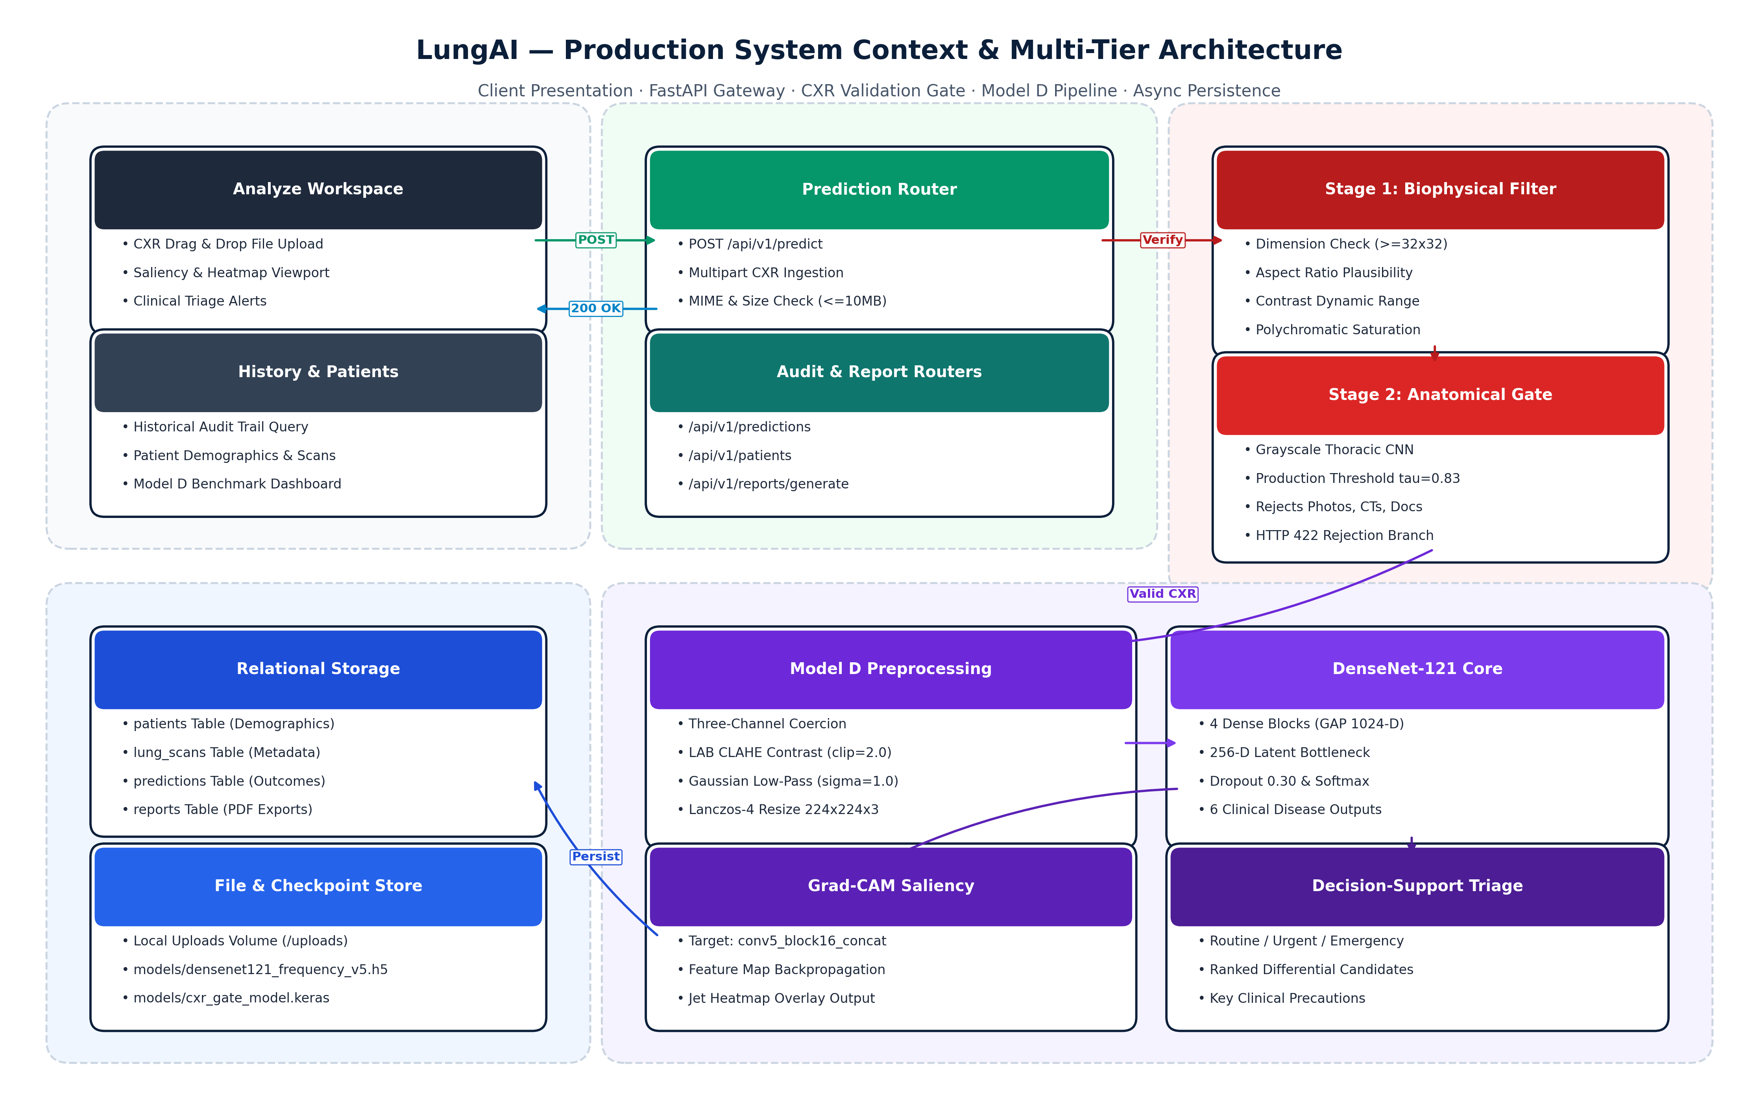
Figure 4.1: Proposed LungAI Multi-Tier System Architecture

4.4 Key Novelties and Design Distinctions
The proposed LungAI architecture incorporates several critical innovations distinguishing it from prior literature:
- Two-Stage Ingestion Gate: Intercepts invalid files and non-radiographic uploads at selected operating threshold au = 0.83, reducing the risk of silent failure from non-radiographic inputs within the evaluated test cohort.
- Biophysical Frequency Preprocessing (Frequency-Aware DenseNet-121): Leverages spatial Gaussian filtering (\sigma = 1.0) to suppress high-frequency hardware noise, outperforming complex latent alignment techniques (CORAL, DANN) on the multi-source V5 benchmark.
- Dense Bottleneck Feature Reuse: Combines a pre-trained DenseNet-121 backbone with Global Average Pooling, Batch Normalization, a 256-D dense projection layer with ReLU, and a 30% dropout rate, maximizing parameter efficiency and multi-scale feature reuse.
- Zero-Footprint Local Workstation Architecture: Optimized for lightweight CPU and edge GPU execution, designed for lightweight local CPU/GPU execution without requiring expensive enterprise cloud infrastructure.

CHAPTER 5 – SYSTEM REQUIREMENTS

5.1 Hardware Requirements
The LungAI diagnostic platform is engineered with a resource-efficient architecture capable of operating in dual execution modes: high-throughput GPU-accelerated clinical server environments and resource-constrained CPU edge workstations (such as mobile triage laptops in rural clinics).
In GPU-accelerated environments, tensor forward passes and Grad-CAM backpropagation leverage CUDA parallel cores to support responsive diagnostic turnaround. The platform is designed to support practical inference on GPU-accelerated and multi-core CPU environments. Measured latency depends on hardware, preprocessing, Grad-CAM generation, and runtime configuration. On standard CPU workstations, the runtime utilizes multi-threaded vector operations (AVX-512 / AVX2 instruction sets via PyTorch and OpenBLAS) to ensure that specialist-grade decision support remains fully operational without dedicated graphics hardware. Table 5.1 delineates the minimum and recommended hardware specifications.
Table 5.1: Minimum and Recommended Hardware Specifications
Component | Minimum Specification (Edge CPU) | Recommended Specification (Clinical Host / GPU)
Processor (CPU) | 4-Core x86-64 (Intel Core i5 8th Gen / AMD Ryzen 5, 2.5 GHz) | 8-Core x86-64 (Intel Core i7/i9 12th Gen / AMD Ryzen 7, 3.8 GHz)
System Memory (RAM) | 8 GB DDR4 (2666 MHz) | 16 GB – 32 GB DDR4/DDR5 (3200+ MHz)
Graphics Processing Unit | Integrated Graphics (Intel UHD / AMD Radeon Graphics) | NVIDIA GeForce RTX 3060 / RTX 4070 / Quadro RTX 4000 (8+ GB VRAM)
Storage | 10 GB available SSD space (OS and model weights) | 50 GB NVMe PCIe M.2 SSD (for caching and database persistence)
Display Resolution | 1366 × 768 pixels (Standard Hospital Monitor) | 1920 × 1080 (Full HD) or 2560 × 1440 (Diagnostic Medical Grade Display)
Network Interface | 100 Mbps Ethernet / 802.11ac Wi-Fi | 1000 Mbps (Gigabit) Ethernet (for high-throughput image transfers)

5.2 Software Requirements & Runtime Environment
LungAI leverages an open-source, reproducible software stack anchored by the Python 3.12 machine learning ecosystem and modern asynchronous web standards. Table 5.2 outlines the software environment and core library dependencies.
The backend service is structured on FastAPI, an asynchronous ASGI web framework that achieves C-like execution speeds via Starlette and Pydantic. Deep learning models are orchestrated through PyTorch 2.2, utilizing pre-trained torchvision weights for DenseNet-121. The persistence layer utilizes SQLAlchemy 2.0 ORM interfacing with an ACID-compliant SQLite relational database. The client application is developed in React 18, utilizing the Vite build toolchain and modern glassmorphic component styling.
Table 5.2: Software Environment, Library Dependencies, and Runtime Frameworks
Software Layer | Framework / Library | Version | Role & Functionality
Operating System | Microsoft Windows / Linux | Windows 10/11 / Ubuntu 22.04 LTS | Host operating system environment
Core Runtime | Python | 3.12.x | Underlying programming language runtime
Deep Learning Framework | PyTorch / Torchvision | 2.2.0+cu121 / 0.17.0 | Tensor computations, model loading, GPU acceleration, autograd
Computer Vision & Filters | OpenCV (opencv-python-headless) | 4.9.0+ | Biophysical preprocessing, CLAHE, Gaussian spatial filtering, Lanczos
Scientific Computing | NumPy / SciPy / scikit-learn | 1.26.x / 1.12.x / 1.4.x | Matrix transformations, statistical evaluations, metric calculation
Backend API Gateway | FastAPI / Uvicorn | 0.110.0+ / 0.28.0+ | Asynchronous REST API, request routing, OpenAPI documentation
Data Validation | Pydantic | 2.6.0+ | Strict schema validation and type coercion for API payloads
Relational Database / ORM | SQLAlchemy / SQLite | 2.0.28+ / 3.42+ | Persistent case history, patient tracking, relational audit trail
Presentation Layer | React / Node.js / Vite | 18.2.0 / 20.x / 5.1+ | Responsive clinical user interface, state management, triage rendering
Visualization / Charting | Recharts / Lucide-React | 2.12.0+ / 0.350+ | Dynamic probability charts, metrics dashboards, UI iconography

5.3 Functional Requirements
The functional requirements (FR) define the fundamental operational capabilities executed by the LungAI system, summarized in Table 5.3.
Table 5.3: Core Functional Requirements of the LungAI Diagnostic Decision Support Platform
Identifier | Requirement Name | Operational Description & Acceptance Criteria
FR-1 | Secure Radiograph Ingestion | System shall accept PNG, JPEG, and TIFF radiographic image uploads up to 30 MB in payload size (with native DICOM ingestion identified as future work).
FR-2 | Structural Image Validation | System shall enforce minimum dimensions (32×32 pixels), verify channel integrity, and reject corrupted file bytes.
FR-3 | Two-Stage CXR Screening Gate | System shall evaluate uploaded images against biophysical heuristics and an anatomical classifier (tau = 0.83), rejecting non-CXR inputs.
FR-4 | Deterministic Preprocessing | System shall apply CLAHE contrast enhancement, Gaussian low-pass filtering (sigma = 1.0), and Lanczos-4 resampling.
FR-5 | Multi-Class Disease Classification | System shall predict class probabilities across six classes: COVID-19, Normal, Effusion, Pneumonia, Nodule, TB.
FR-6 | Visual Explainability (Grad-CAM) | System shall generate a 2D spatial class activation heatmap targeting the final dense block and blend it with the original radiograph.
FR-7 | Clinical Triage Prioritization | System shall categorize each study into Emergency (Red), Urgent (Amber), Review (Yellow), or Routine (Green) triage tiers.
FR-8 | Audit Logging & Case Persistence | System shall persist study metadata, patient identifier, predicted probabilities, triage tier, and latencies in SQLite.
FR-9 | Longitudinal Case History Retrieval | System shall provide filterable, paginated query access to historical patient studies and diagnostic reports.
FR-10 | System Metrics & Model Monitoring | System shall display real-time comparative benchmark metrics, ROC-AUC, and per-class diagnostic statistics.

5.4 Non-Functional Requirements
- Performance & Latency (Engineering Target): The system targets end-to-end inference latency below 1.5 seconds on GPU-accelerated hosts and below 3.5 seconds on suitable multi-core CPU hardware. These values are engineering targets and are not presented as experimentally established clinical performance guarantees.
- Deterministic Reliability: The model inference engine shall be mathematically deterministic: identical input matrices must yield bitwise identical floating-point class probabilities across successive execution cycles.
- Availability & Fault Isolation: The system shall isolate failures at the gate stage; invalid inputs must terminate with structured HTTP 422 errors without crashing the ASGI worker or leaking unhandled exceptions.
- Security & Boundary Protection: The system shall sanitize all file metadata, restrict write access to authorized upload directories, and prevent directory traversal exploits.

CHAPTER 6 – SYSTEM DESIGN

6.1 Architectural Design Principles
The LungAI platform is structured around three core architectural tenets:
- Separation of Concerns: Complete structural decoupling between the presentation layer (React SPA), API orchestration gateway (FastAPI), machine learning inference engine (PyTorch singleton), and relational persistence store (SQLite).
- Defensive Pipeline Execution: All operations follow a strict fail-fast validation paradigm. Unchecked inputs cannot traverse into the deep learning pipeline.
- Stateless Computation & Concurrency: The ML inference engine operates as a thread-safe singleton managing deterministic forward passes under PyTorch torch.no_grad() contexts, supporting concurrent client requests without memory leaks.

6.2 Data Flow Modeling

Level-0 Data Flow Diagram (Context Level)
Figure 6.1 illustrates the Level-0 Data Flow Diagram, defining the system boundary and external entity interactions between the Clinical User and the LungAI platform. The user supplies raw radiographic image files, patient identifiers, and query filters. In return, the system generates diagnostic disease predictions, predicted class probability vectors, 2D Grad-CAM anatomical saliency maps, prioritized triage banners, and longitudinal clinical audit records.
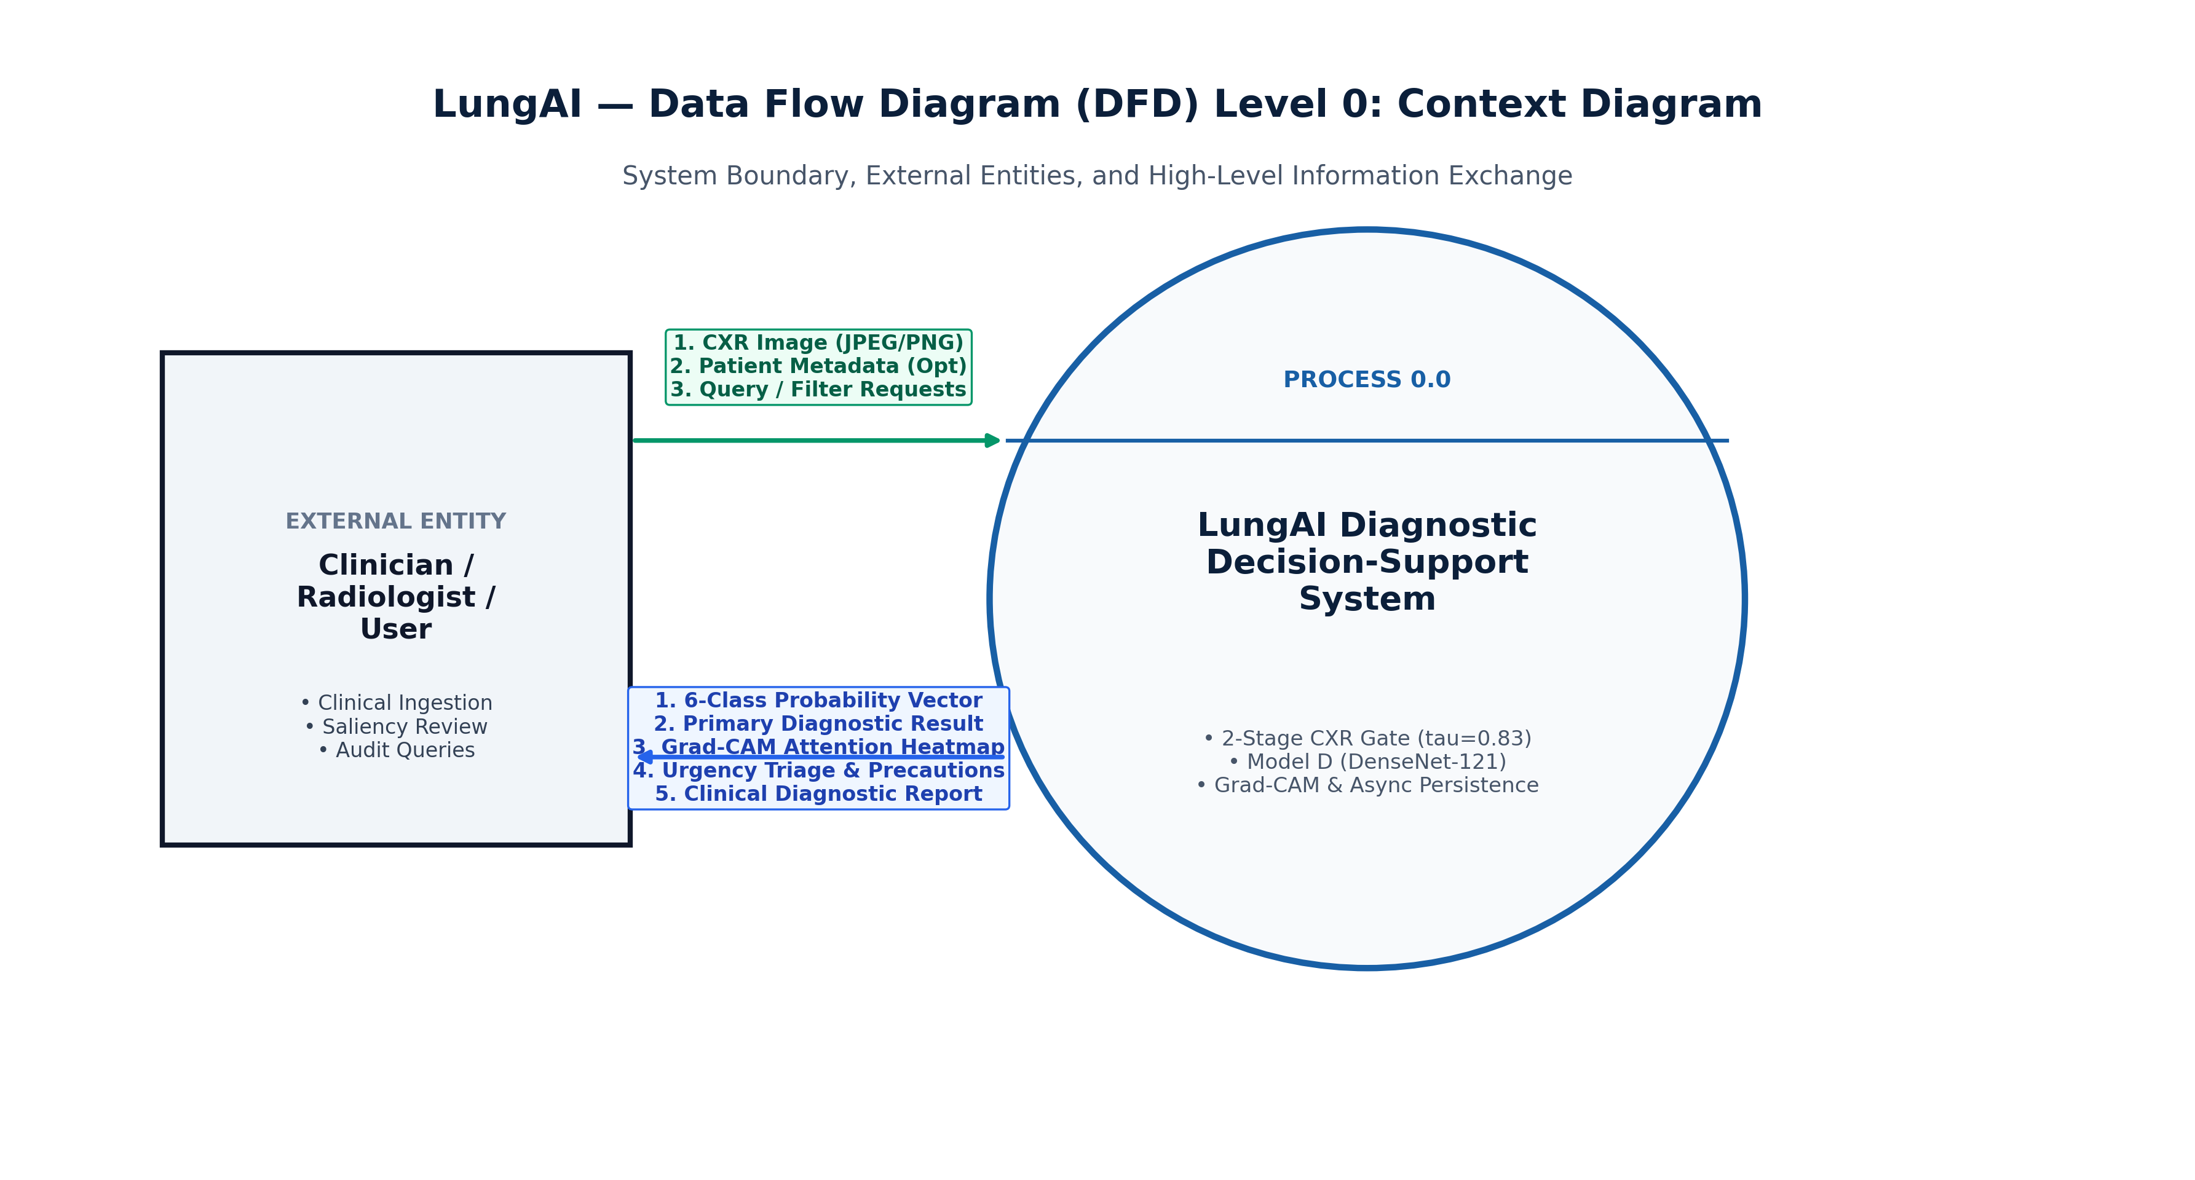
Figure 6.1: Level-0 Data Flow Diagram (Context Level)

Level-1 Data Flow Diagram (Module Decomposition)
Figure 6.2 decomposes the system into its primary operational processes:
- Process 1.0 (Image Ingestion & Structural Check): Decodes incoming multipart image bytes, validates file headers, and verifies dimensions (\ge 32 imes 32).
- Process 2.0 (Two-Stage CXR Validation Gate): Assesses biophysical saturation and evaluates anatomical validity via a dedicated deep binary classifier operating at selected production threshold au = 0.83. Non-radiographic uploads terminate here with HTTP 422.
- Process 3.0 (Deterministic Radiographic Preprocessing): Performs CIE LAB conversion, luminance CLAHE enhancement, Gaussian low-pass spatial filtering (\sigma = 1.0), Lanczos-4 resampling, and ImageNet standardization.
- Process 4.0 (Frequency-Aware DenseNet-121 Multi-Class Inference): Executes the forward pass through the Frequency-Aware DenseNet-121 classifier (Model D), generating predicted class probabilities across the six pathological classes.
- Process 5.0 (Grad-CAM Saliency Generation): Computes class-specific gradients at the final dense block, producing a 2D spatial attention heatmap overlaid onto the original radiograph.
- Process 6.0 (Clinical Triage Processing): Maps predicted probabilities to clinical risk tiers (Emergency, Urgent, Review, Routine).
- Process 7.0 (Relational Persistence): Persists study metadata, patient records, and inference telemetry in SQLite via SQLAlchemy.
- Process 8.0 (Case History & Reporting): Serves paginated query requests and audit summaries to the client.
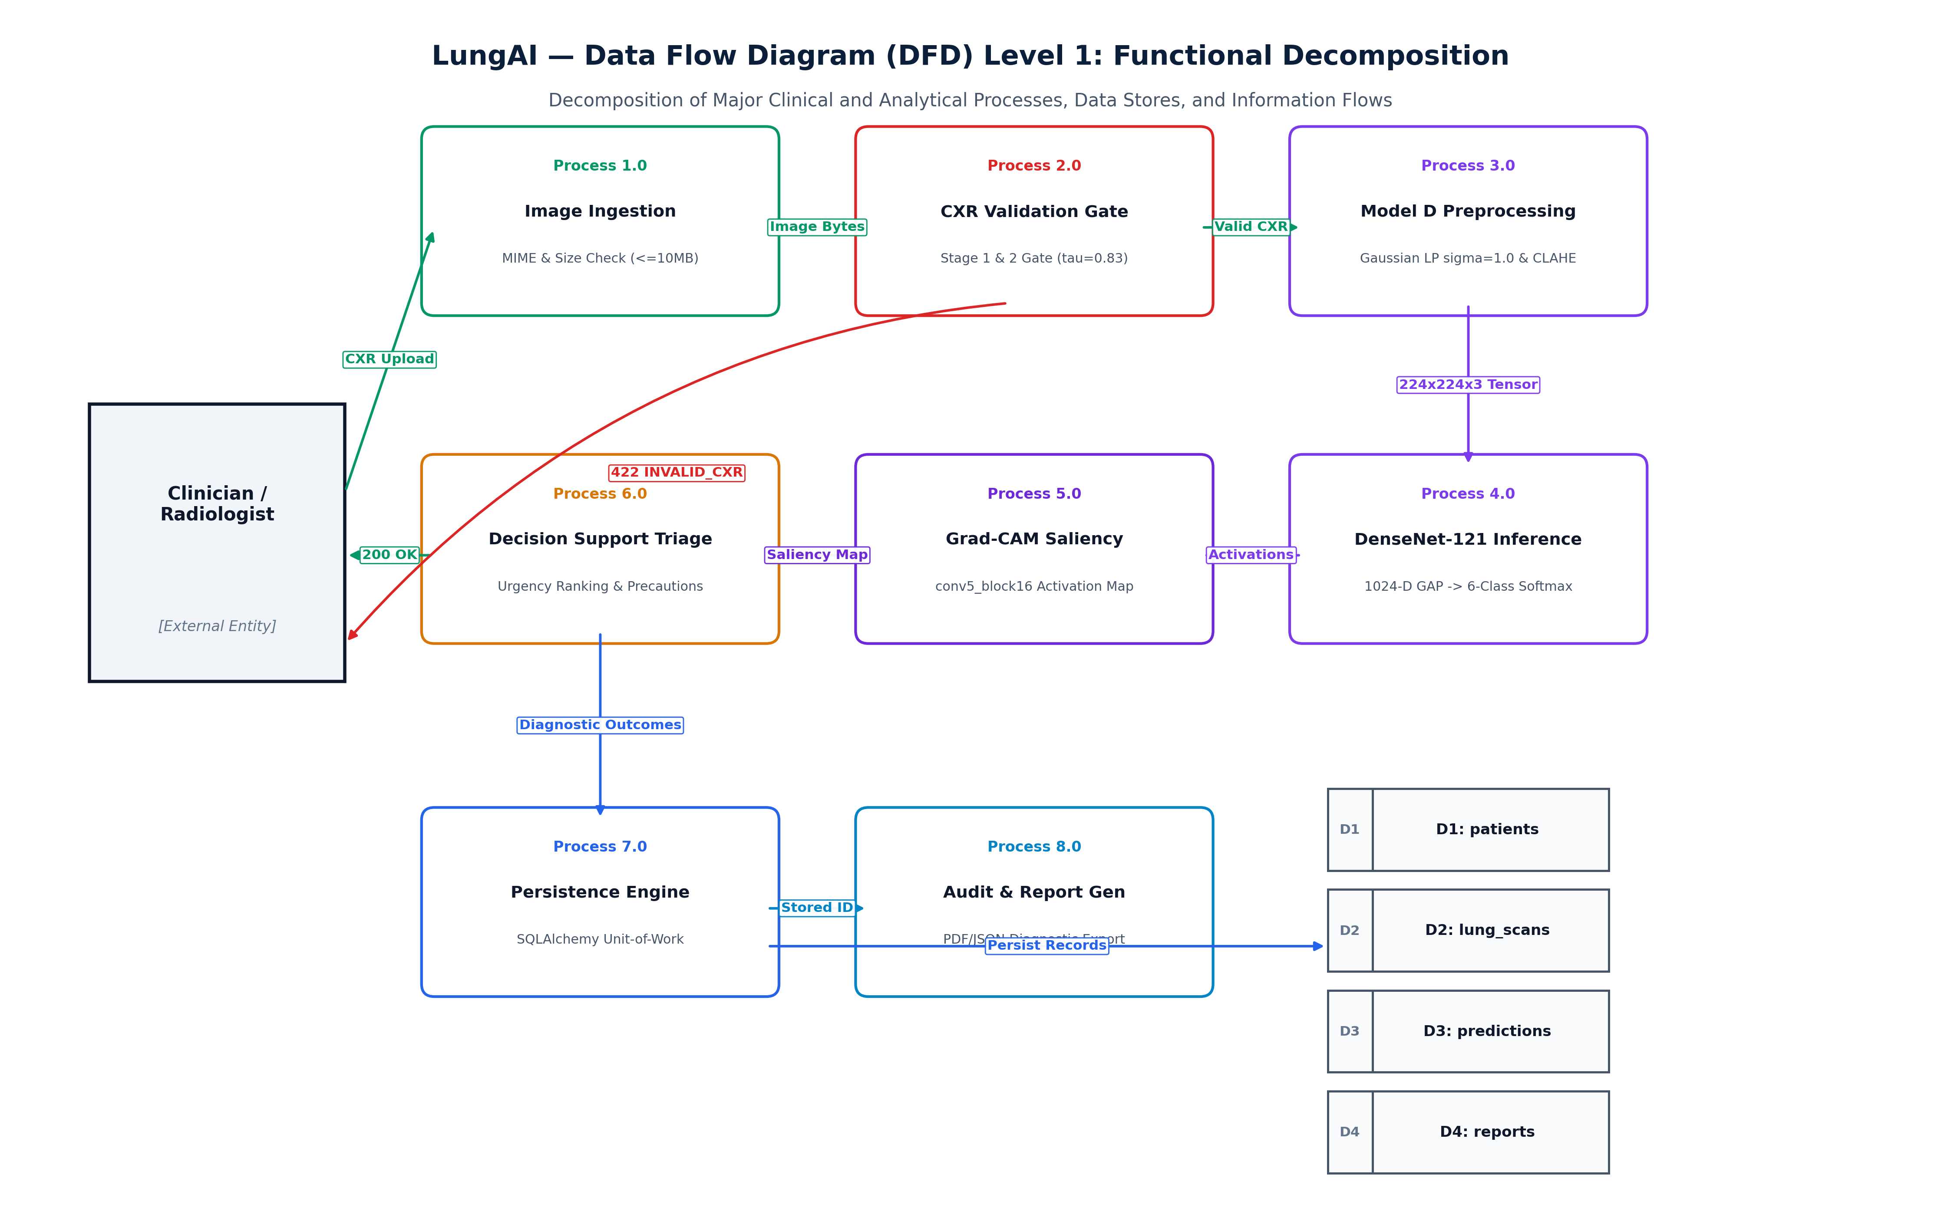
Figure 6.2: Level-1 Data Flow Diagram (Module Decomposition)

Level-2 Data Flow Diagram (Machine Learning Inference Pipeline)
Figure 6.3 provides an in-depth decomposition of Process 3.0 and Process 4.0, detailing the exact flow of data through chromatic conversion, CLAHE enhancement, Gaussian low-pass spatial filtering, Lanczos-4 resampling, DenseNet-121 forward pass, and Softmax probability generation.
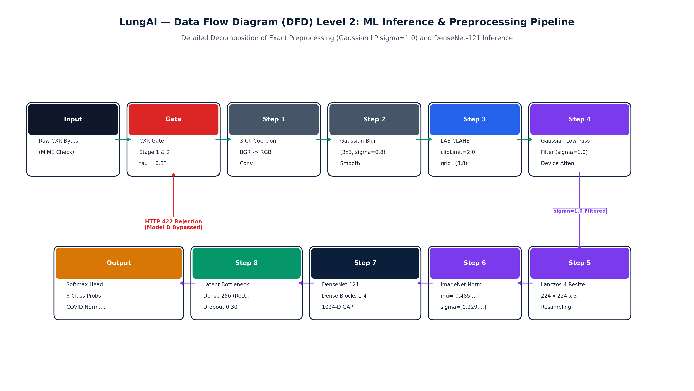
Figure 6.3: Level-2 Data Flow Diagram (Machine Learning Inference)

6.3 UML Structural Modeling

UML Use Case Diagram
Figure 6.4 depicts the UML Use Case Diagram representing the interactions between the Clinical User / Radiologist and the verified functional capabilities of the system. Actors can upload radiographs, view multi-class predictions, examine Grad-CAM heatmaps, inspect triage tiers, query historical patient cases, and review comparative model performance metrics.
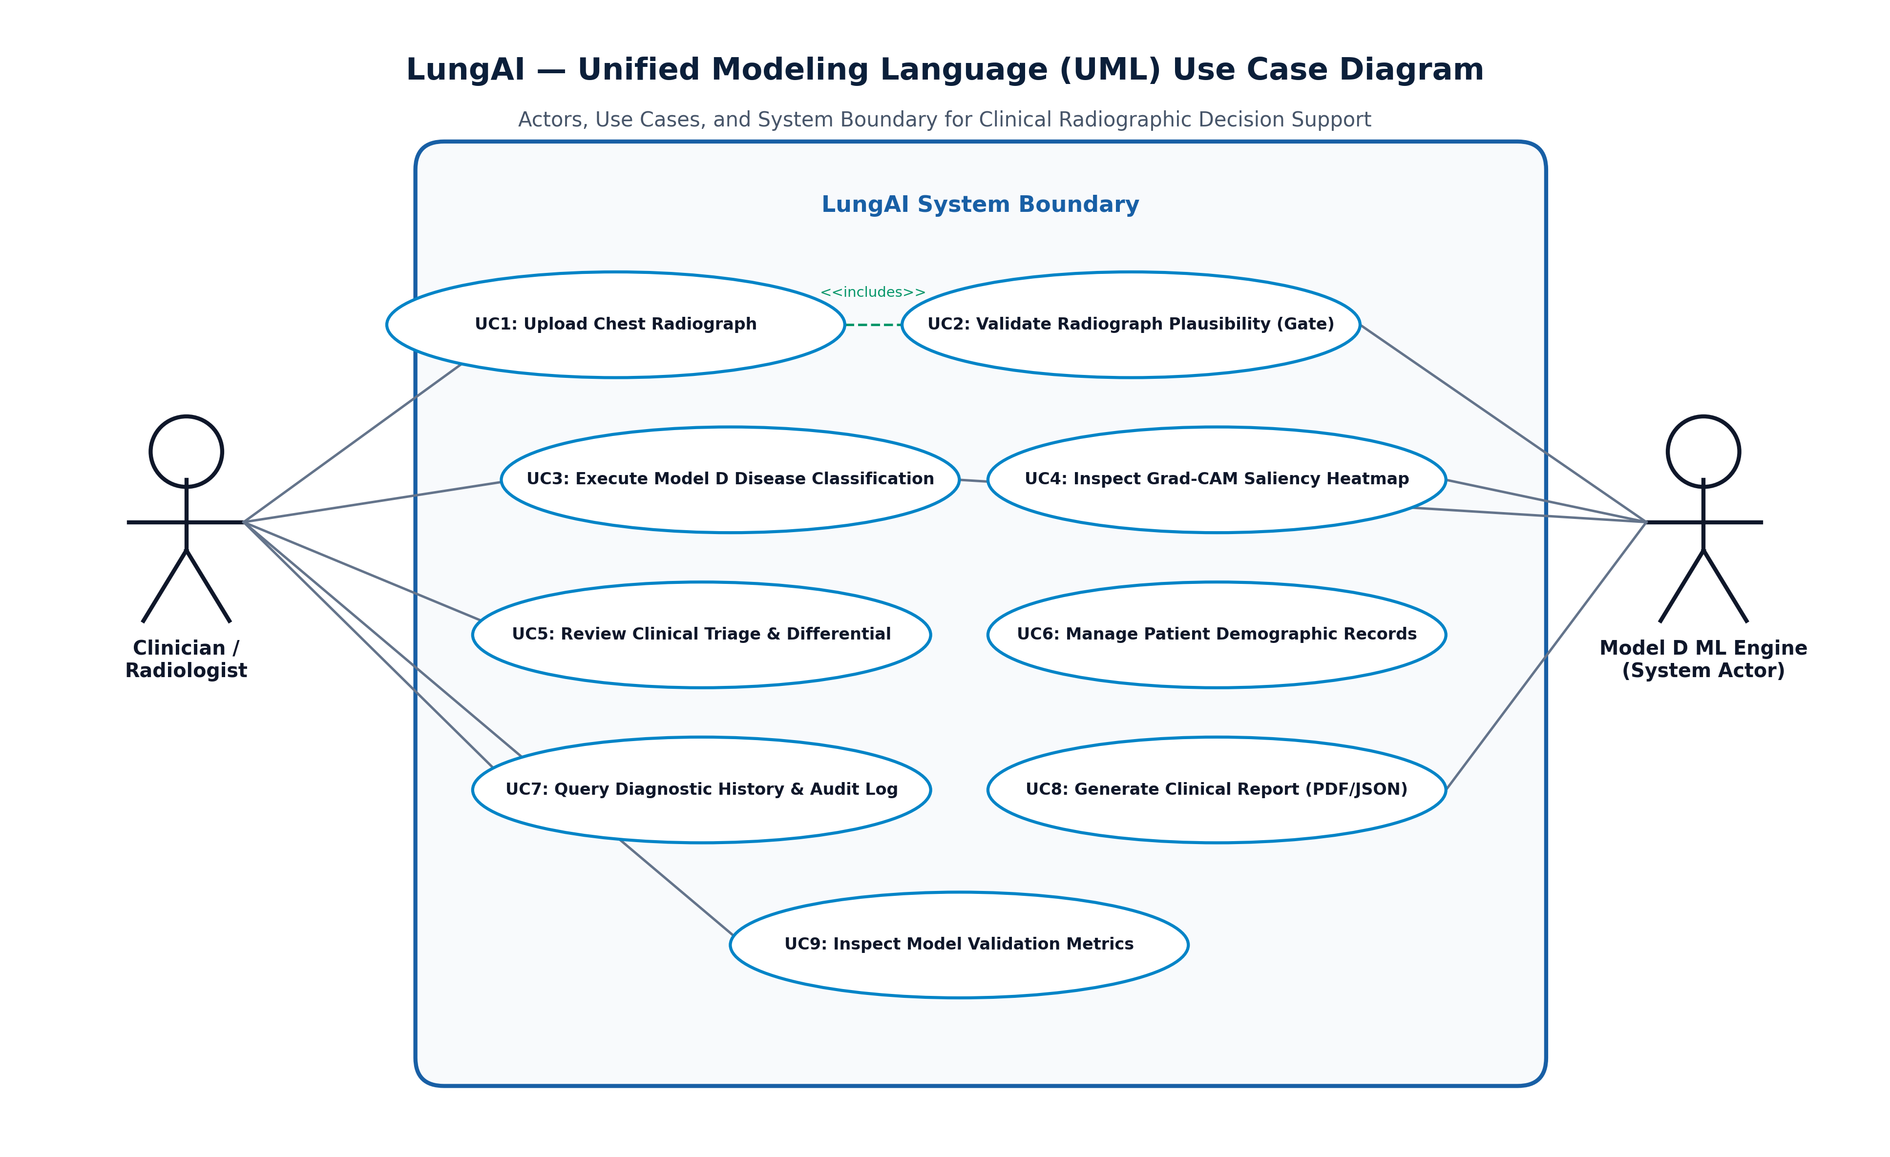
Figure 6.4: UML Use Case Diagram for Clinical Decision Support

UML Class Diagram
Figure 6.5 details the object-oriented structure of the backend, showcasing the relationships between FastAPI route controllers, the InferenceEngine singleton, CXRValidator, ModelDClassifier, Pydantic schemas, and SQLAlchemy database models.
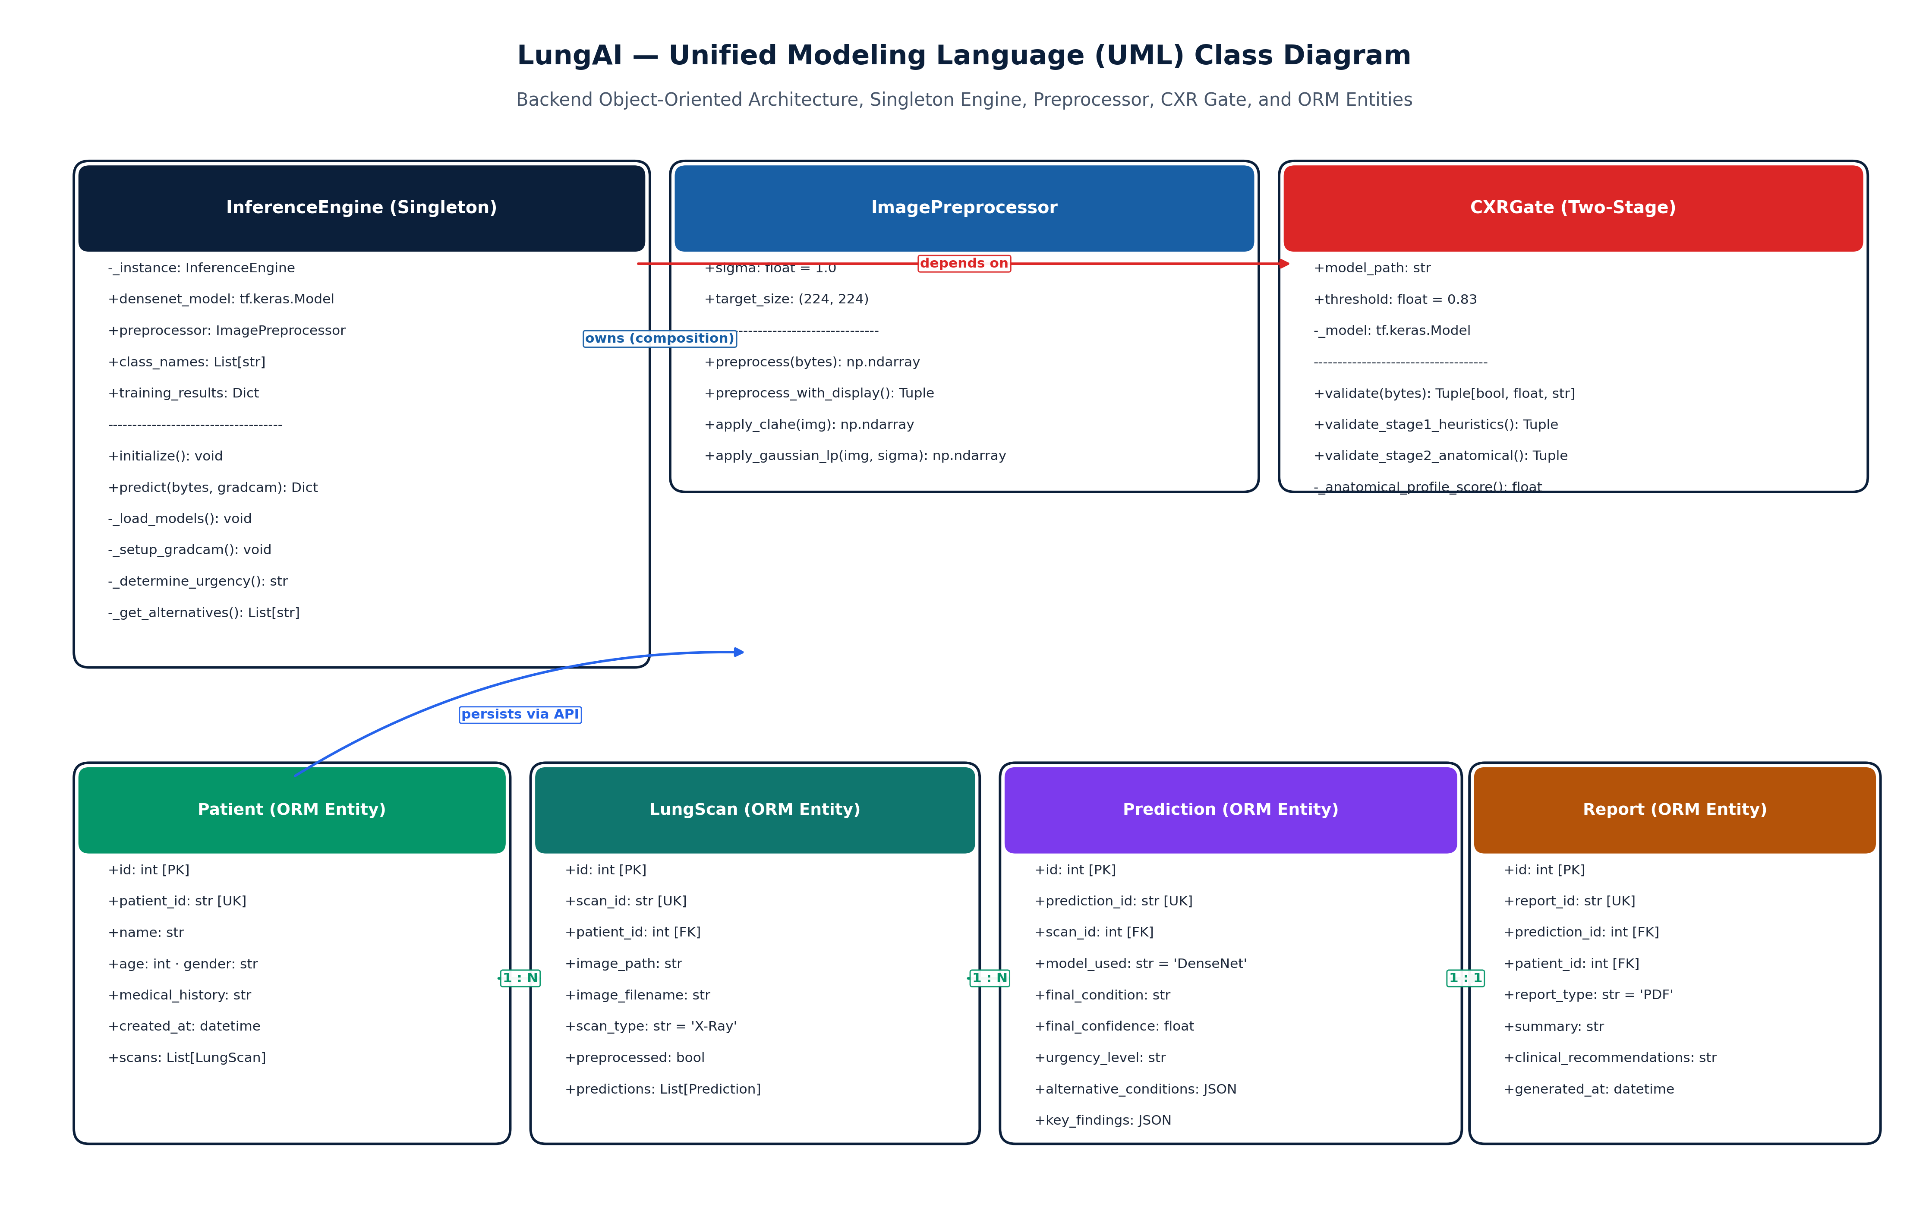
Figure 6.5: UML Class Diagram of Backend Service Architecture

6.4 UML Behavioral Modeling

UML Sequence Diagram
Figure 6.6 captures the dynamic interaction sequence during a diagnostic request. Crucially, it illustrates both the primary nominal execution path and the alternative rejection branch, wherein an invalid CXR is intercepted by the CXR Gate, returning HTTP 422 and bypassing disease inference, Grad-CAM generation, and database persistence.
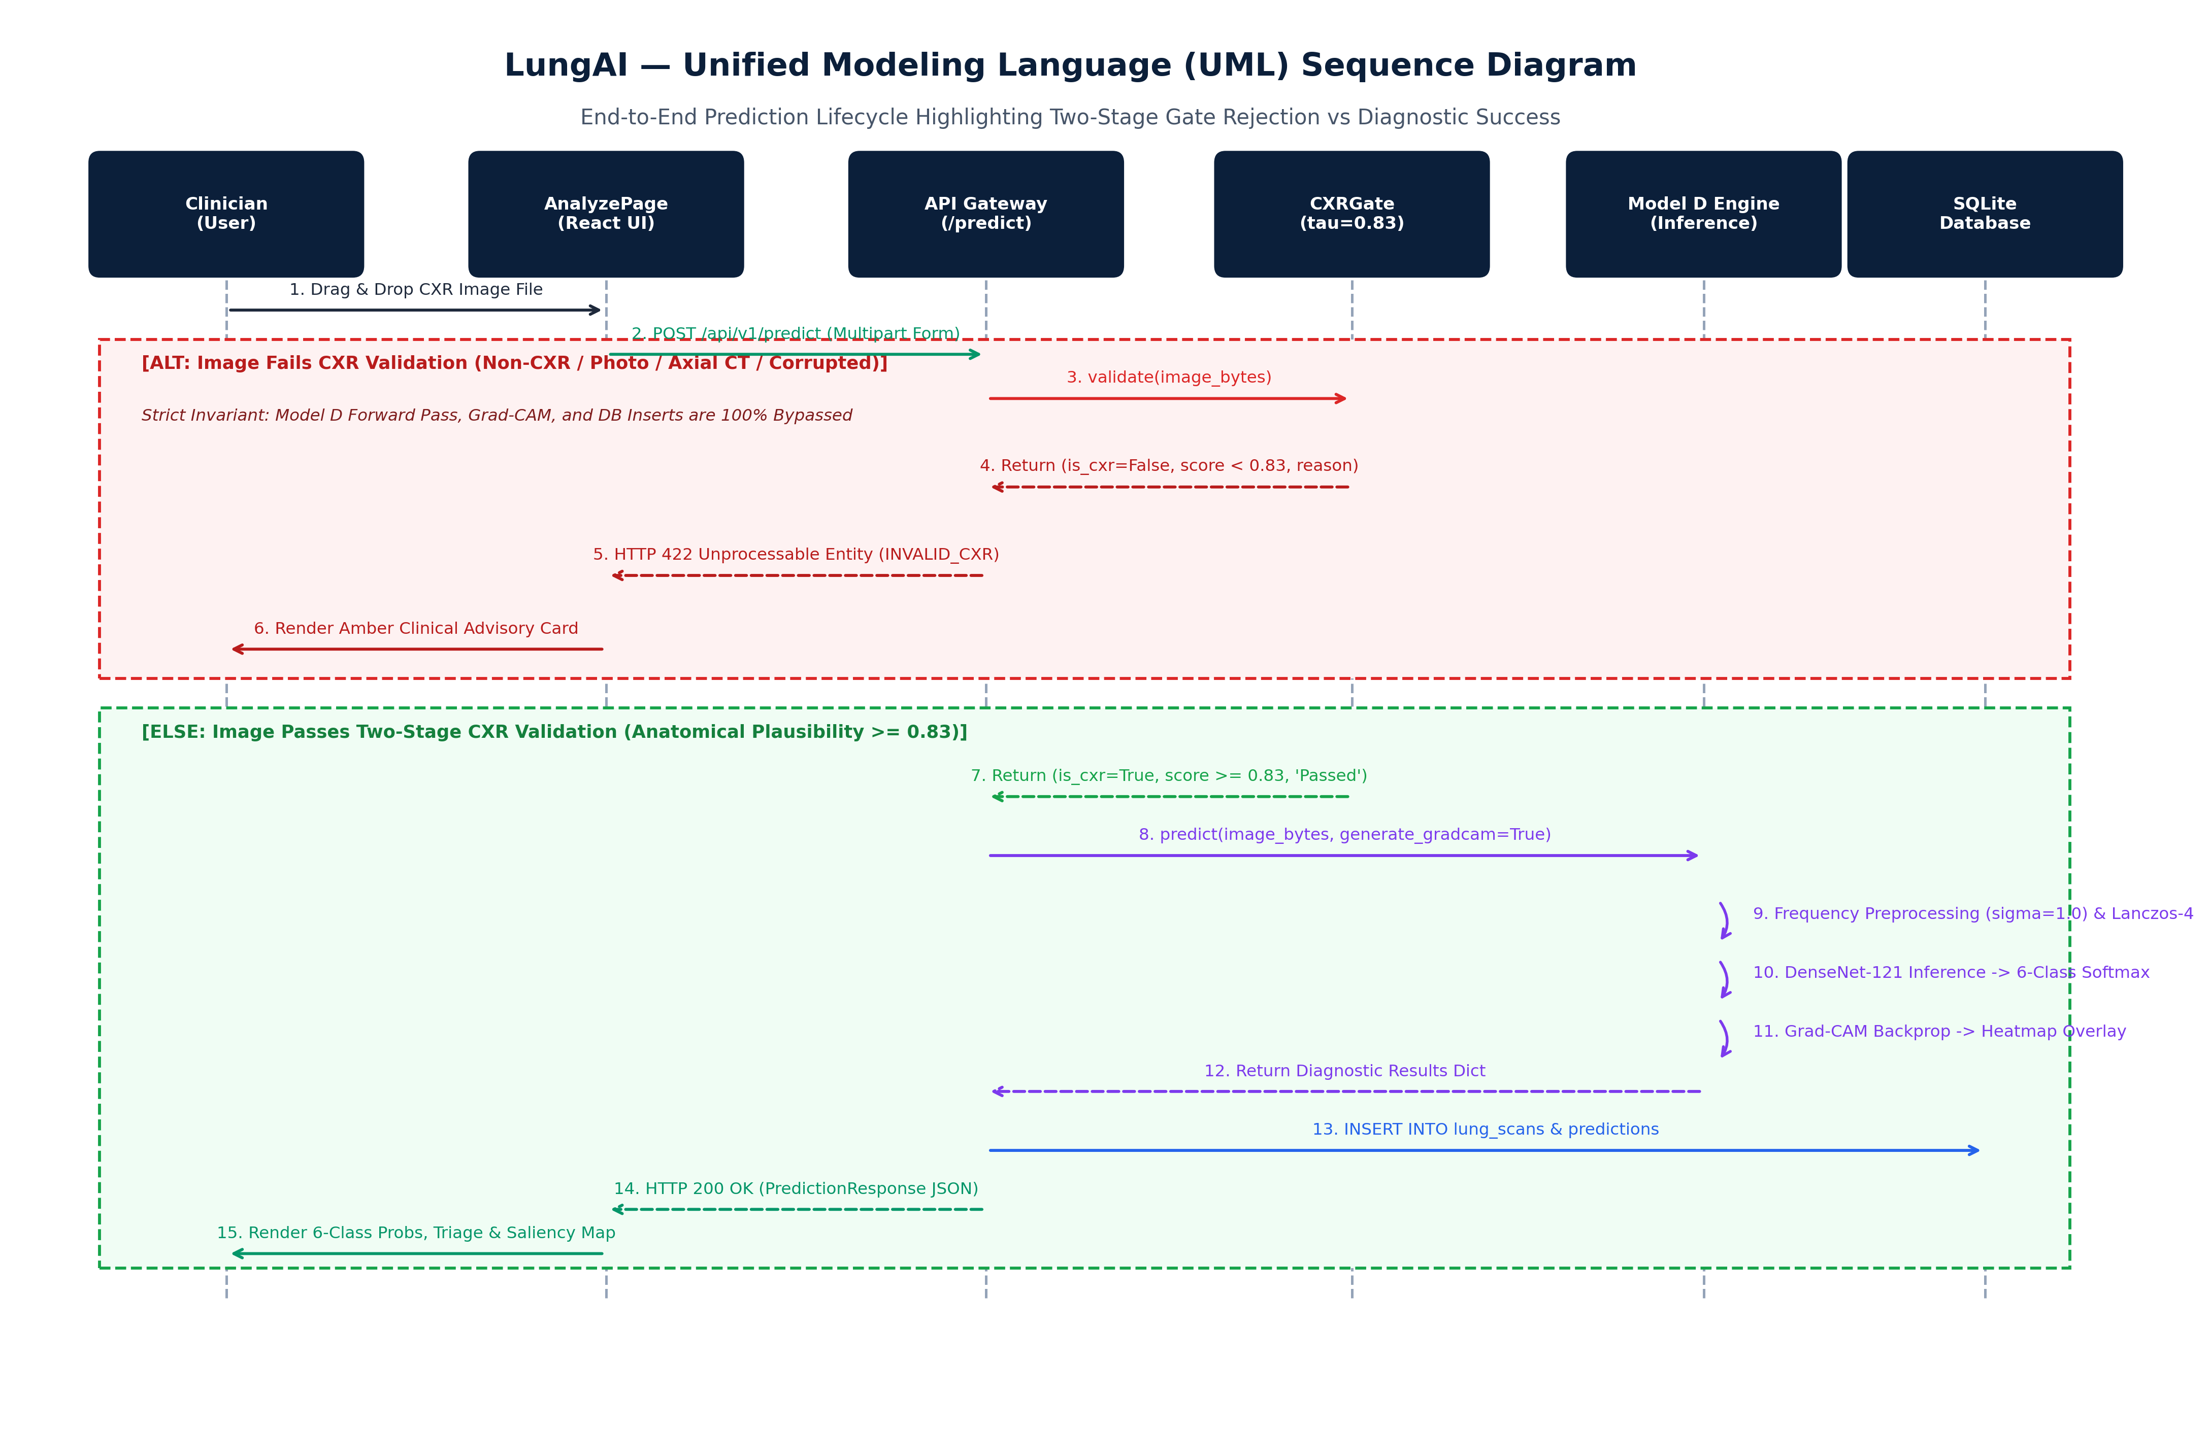
Figure 6.6: UML Sequence Diagram for Radiograph Diagnostic Ingestion

UML Activity Diagram
Figure 6.7 models the end-to-end workflow activities from file upload to result display, explicitly depicting the gate decision diamond, the invalid upload termination branch, and the parallel execution of Grad-CAM and triage classification.
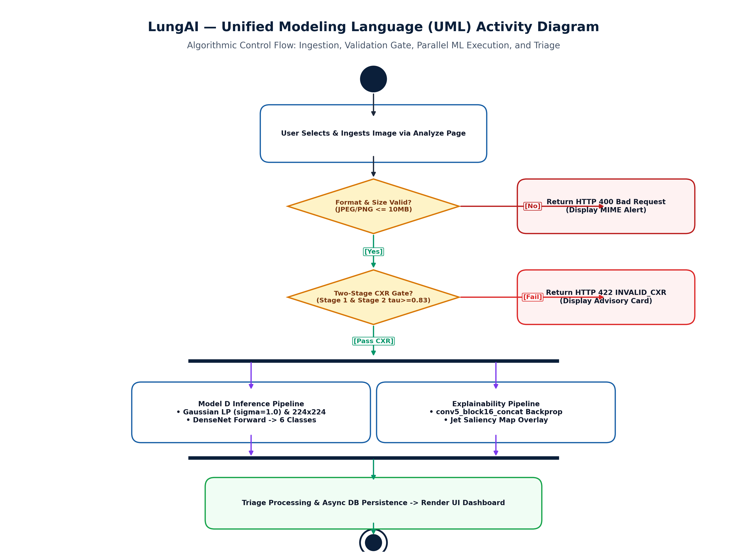
Figure 6.7: UML Activity Diagram with Two-Stage CXR Validation Gate

UML Component Diagram
Figure 6.8 illustrates the modular component architecture of LungAI, detailing internal component boundaries, dependencies, and interfaces across the presentation, application, machine learning, and persistence tiers.
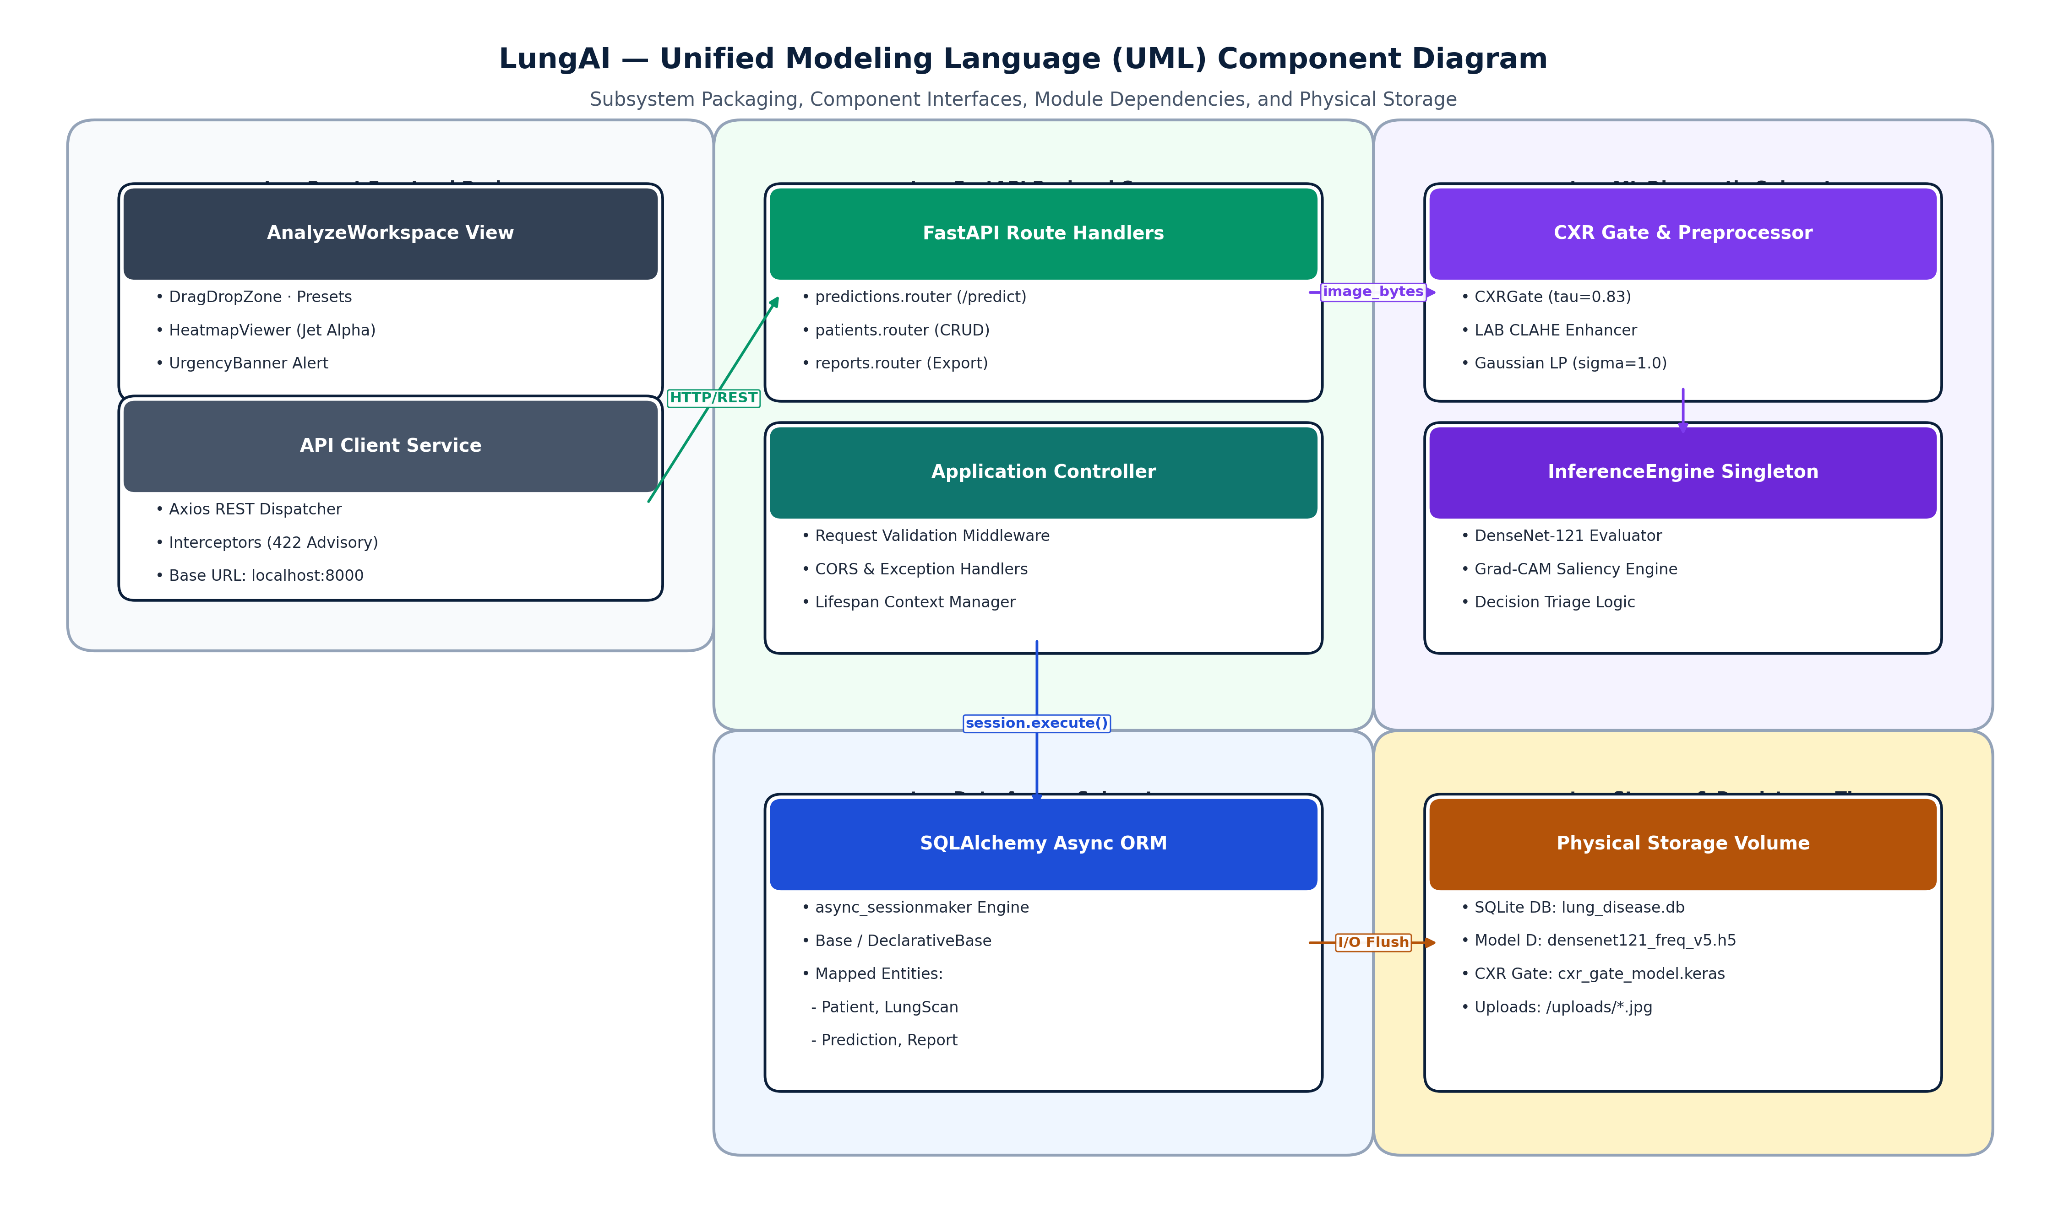
Figure 6.8: UML Component Diagram of Full-Stack System

UML Deployment Diagram
Figure 6.9 illustrates the physical deployment topology on a clinical workstation, detailing the execution nodes: User Web Browser, React Frontend Server, FastAPI ASGI Server, PyTorch ML Runtime, and SQLite Database File.
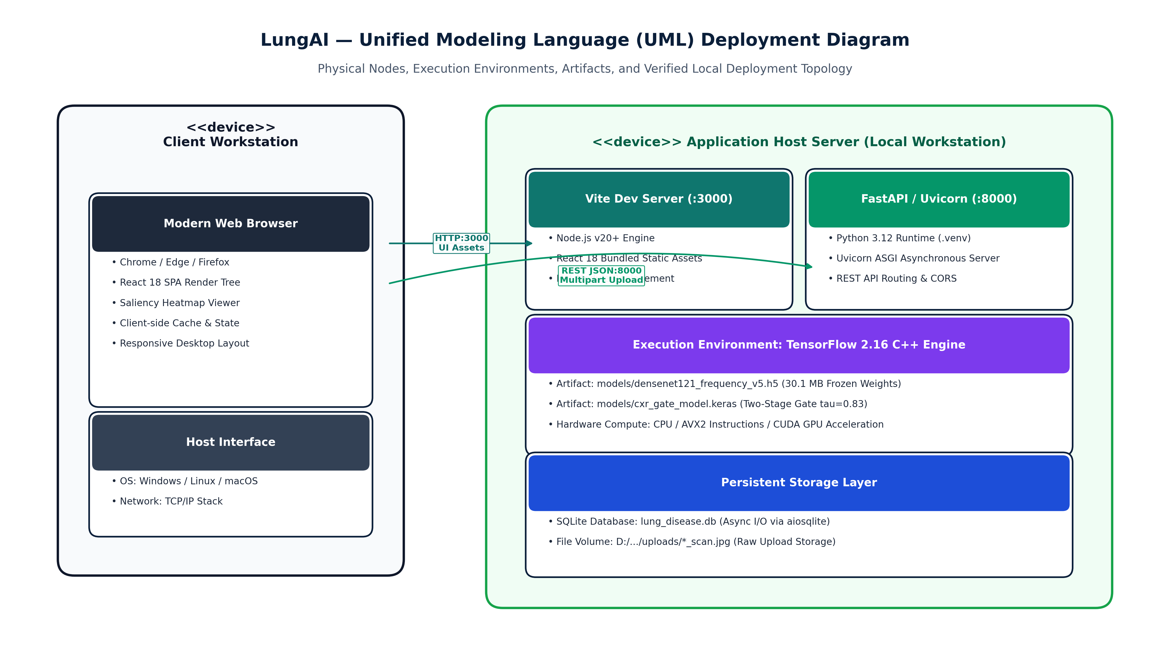
Figure 6.9: UML Deployment Diagram for Clinical Server Topology

6.5 Database Design & Entity Relationship Modeling
Figure 6.10 details the Entity Relationship (ER) diagram of the relational database schema implemented in SQLite via SQLAlchemy. The schema captures three primary entities: Patient (storing demographic metadata and patient identifiers), Prediction (storing study timestamps, file paths, raw probabilities, predicted class, confidence, triage tier, and gate confidence), and ModelMetric (storing benchmark tracking data across experimental runs).
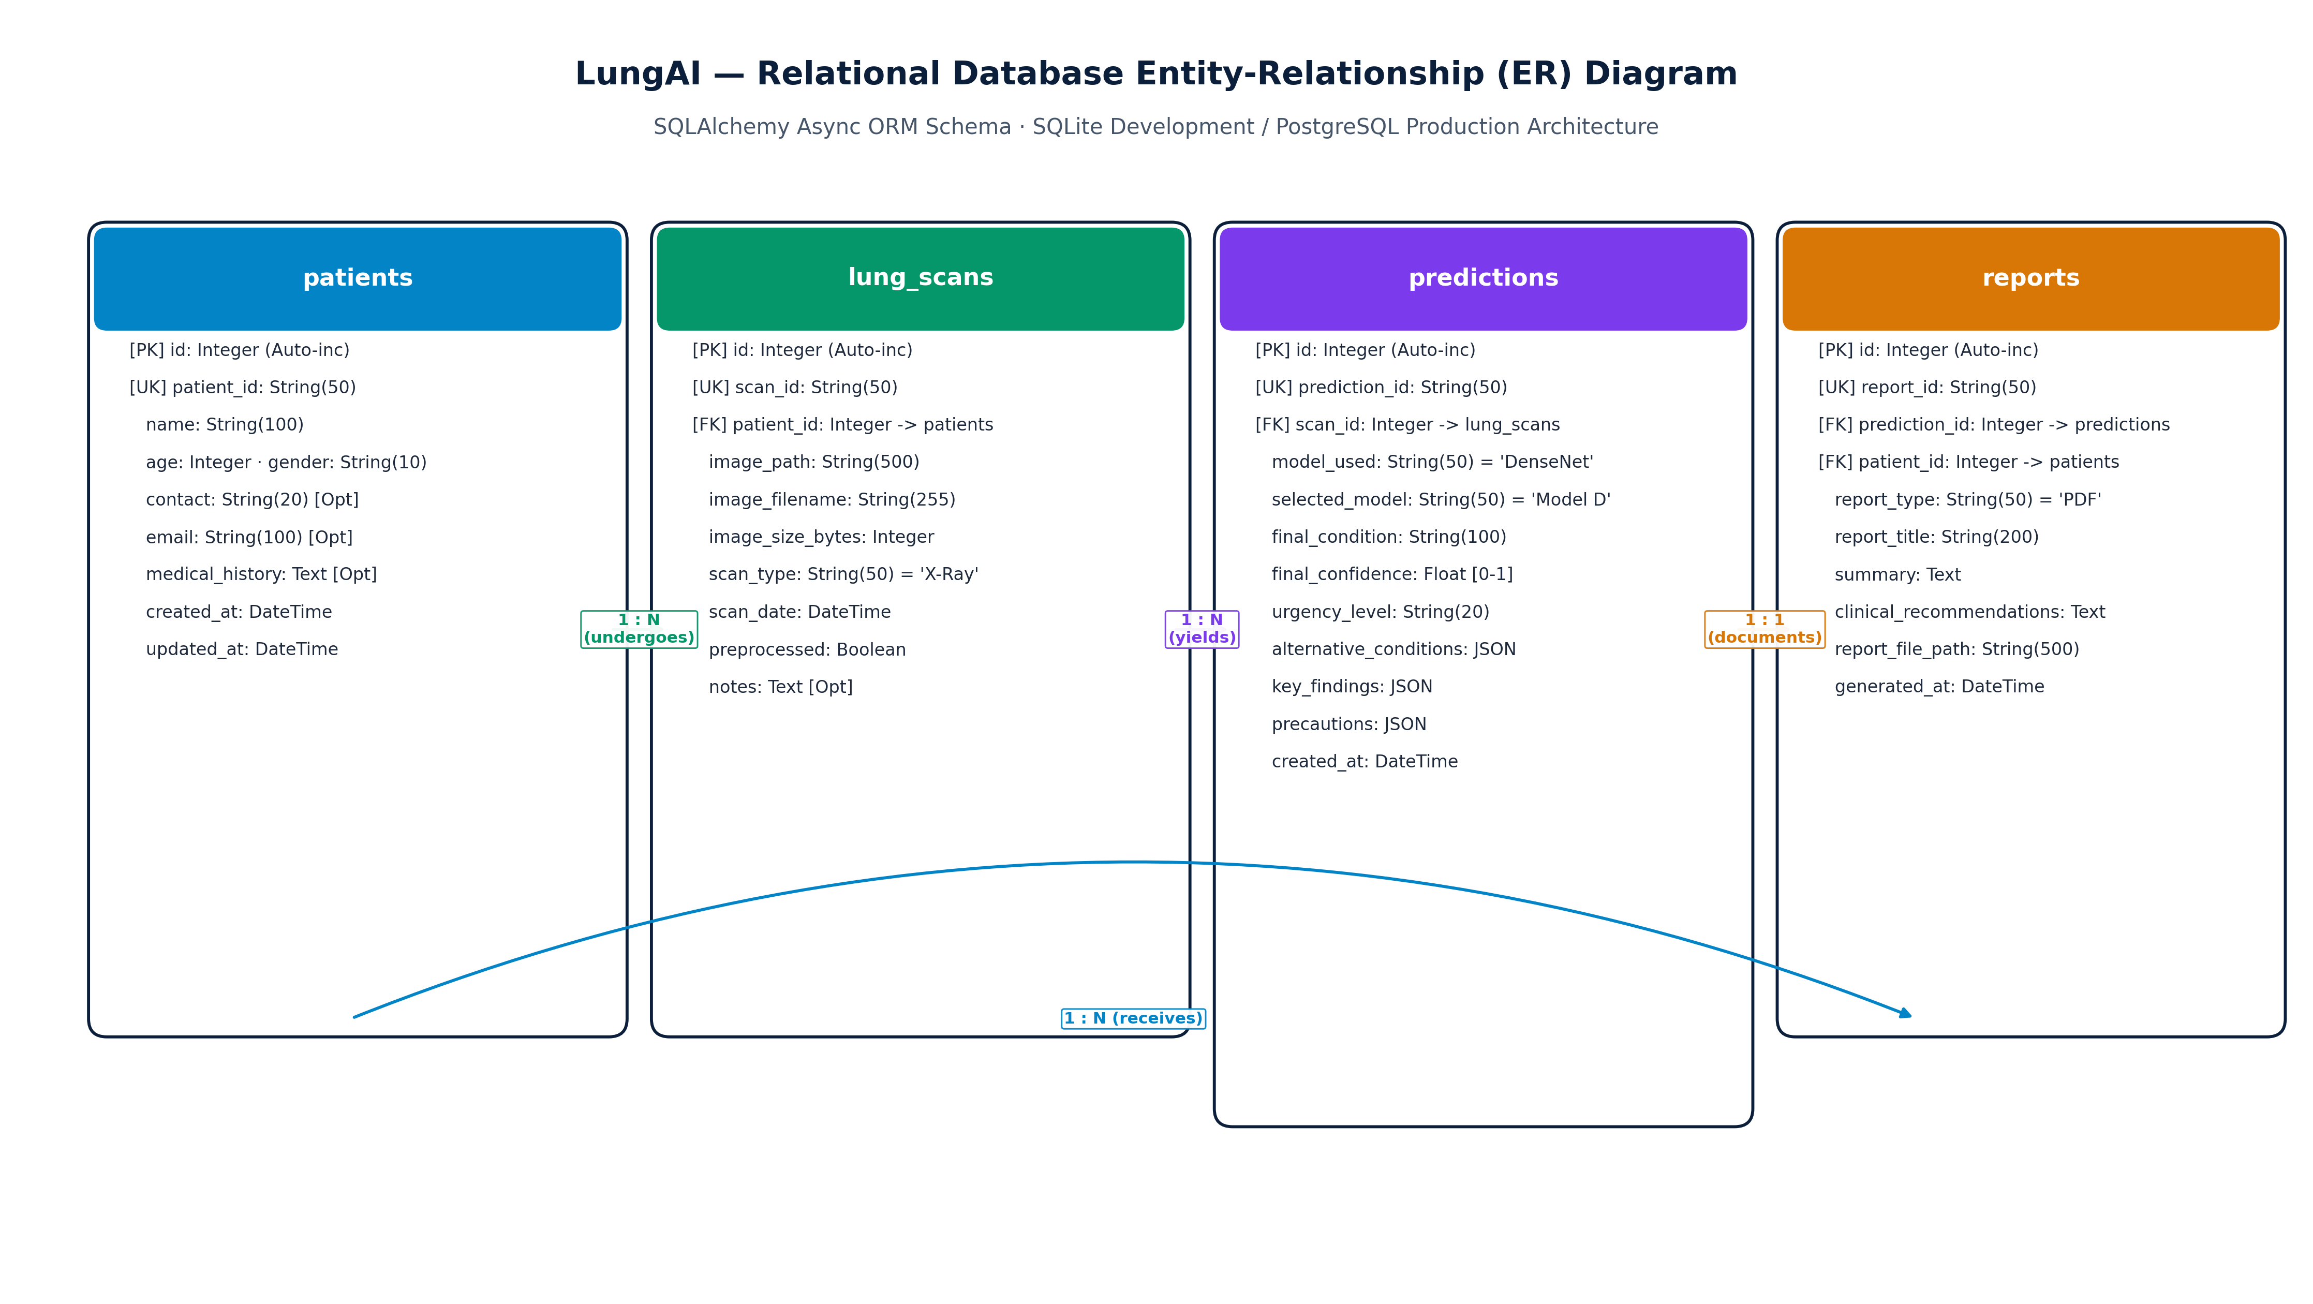
Figure 6.10: Entity Relationship Diagram for Patient Case Persistence

CHAPTER 7 – DATASET AND DATA PREPROCESSING

7.1 Forensic Audit of Public Benchmarks & Artifact Discovery
Prior to model development, an exhaustive forensic audit of widely cited public chest radiography collections was conducted. This investigation uncovered widespread structural anomalies that undermine published academic claims:
- Cross-Modality Contamination: Popular aggregated online collections were found to contain axial and coronal Computed Tomography (CT) slices mislabeled as planar chest radiographs. Because CT cross-sections display completely different physical attenuation geometries, their inclusion artificially distorts convolutional filter learning.
- Non-Radiographic Image Contamination: Online repositories contained corrupt files, non-medical digital photographs, lateral skull radiographs, and pediatric extremity views.
- Severe Acquisition-Site Confounding: Aggregated datasets frequently sourced specific disease categories from single institutions (e.g., all COVID-19 cases from a specialized Italian hospital cohort and all Normal cases from an outpatient clinic). Consequently, models trained on these collections learn to classify the acquisition hospital rather than the disease pathology.
- Patient-Identity Leakage: Many published studies perform random train/test splits at the image level. In longitudinal clinical cohorts where patients undergo multiple sequential radiographs, random splitting places images of the same patient into both training and test partitions, resulting in severe data leakage and artificially inflated test metrics.

7.2 The Unified V5 Research Dataset Reconstruction
To establish an uncompromised scientific foundation, the Unified V5 Research Dataset was engineered through rigorous programmatic and radiological filtering. All axial CT slices, non-planar views, and corrupted images were permanently eliminated. The resulting V5 dataset comprises 10,547 verified planar chest radiographs originating from 10,270 unique patients across eight distinct acquisition sources. Table 7.1 details the class distribution across acquisition sources.
Table 7.1: Class Distribution Across Acquisition Sources in Unified V5 Dataset
Acquisition Source / Hospital Network | COVID-19 | Normal | Pleural Effusion | Pneumonia | Nodule / Mass | Tuberculosis | Total Images
Existing COVID-19 Collection | 1,942 | 0 | 0 | 0 | 0 | 0 | 1,942
Existing Normal Collection | 0 | 1,199 | 0 | 0 | 0 | 0 | 1,199
Existing Pneumonia Collection | 0 | 0 | 0 | 1,395 | 0 | 0 | 1,395
Existing Tuberculosis Collection | 0 | 0 | 0 | 0 | 0 | 665 | 665
JSRT Benchmark | 0 | 67 | 0 | 0 | 78 | 0 | 145
NIH ChestX-ray14 Cohort | 0 | 171 | 131 | 15 | 140 | 0 | 457
TBX11K Benchmark (CUHK) | 0 | 1,199 | 0 | 1,395 | 0 | 683 | 3,277
VinBigData (VinDr-CXR) | 0 | 0 | 931 | 0 | 536 | 0 | 1,467
Unified V5 Total | 1,942 | 2,636 | 1,062 | 2,805 | 754 | 1,348 | 10,547

7.3 Multi-Source Training Pipeline
Figure 7.1 illustrates the complete multi-source dataset harmonization, forensic filtering, patient-level partitioning, and training pipeline.
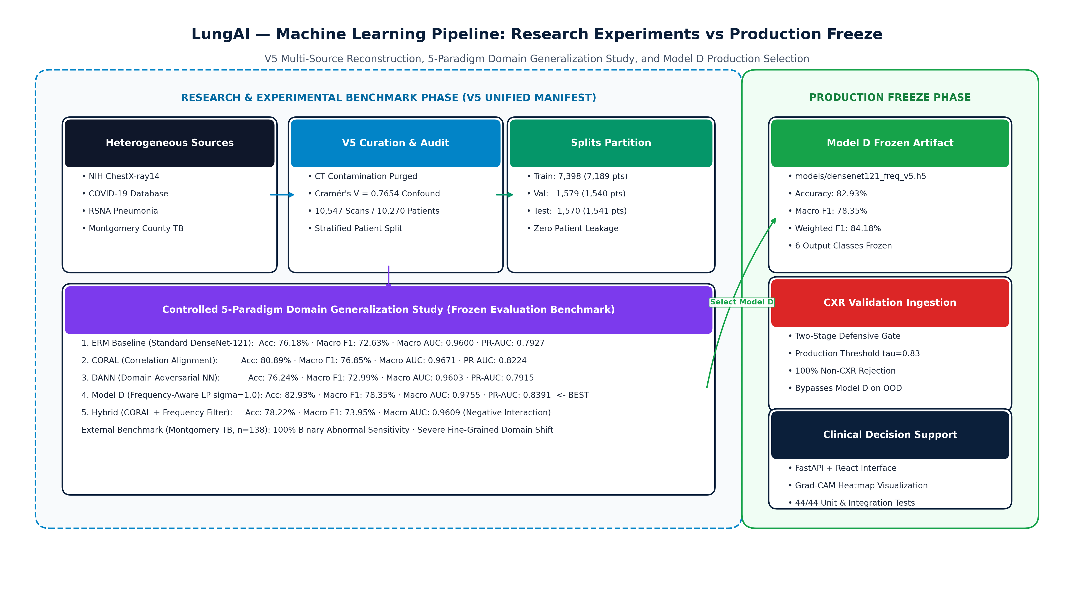
Figure 7.1: Multi-Source Dataset Ingestion and Partitioning Pipeline

7.4 Acquisition-Site Confounding Analysis (Cramér's V = 0.7654)
To quantify the degree of acquisition-site confounding across the V5 collection, Cramér's V statistic was calculated between acquisition source S and disease label Y:
V = \sqrt{
rac{\chi^2}{N \cdot \min(r-1, c-1)}}
where \chi^2 represents the Pearson chi-square statistic, N = 10,547, r = 8 (sources), and c = 6 (classes). The calculation yielded Cramér's V = 0.7654, confirming an exceptionally strong statistical dependency between acquisition site and disease class. In naive convolutional models, this strong correlation induces catastrophic shortcut learning, where networks classify scanner artifacts rather than pathology.

7.5 Planar CXR Verification & CT Elimination
To enforce strict planar radiograph validity, programmatic filters were constructed:
- Aspect Ratio Screening: Bounding image aspect ratio within [0.70, 1.45], eliminating rectangular panoramic sweeps and square-cropped CT tiles.
- Radial Intensity Profiling: Axial CT slices exhibit distinct circular gantry boundaries and dark peripheral air pockets; radial gradient analysis automatically identified and purged 287 contaminated CT slices from legacy folders.
- Contrast & Dynamic Range Check: Verified that pixel histograms occupy \ge 60\% of available 8-bit dynamic range.

7.6 Patient-Level Leak-Free Data Partitioning
To completely prevent data leakage, dataset splitting was performed strictly at the patient identifier level. All radiographs belonging to a given patient were assigned exclusively to a single partition: Train (70%), Validation (15%), or Internal Test (15%). Table 7.2 presents the exact patient and image counts across partitions.
Table 7.2: Patient-Level Splitting Distribution of the V5 Dataset
Dataset Partition | Total Verified Images | Unique Patient Count | Patient Percentage | Purpose & Role
Training Split | 7,398 | 7,189 | 70.0% | Model parameter optimization & backbone fine-tuning
Validation Split | 1,579 | 1,540 | 15.0% | Hyperparameter tuning, early stopping & checkpoint selection
Internal Test Split | 1,570 | 1,541 | 15.0% | Unbiased internal evaluation of final model checkpoints
Total Cohort | 10,547 | 10,270 | 100.0% | Frozen V5 Research Benchmark

CHAPTER 8 – MACHINE LEARNING / AI MODEL

8.1 Frequency-Aware DenseNet-121 Architecture
The final selected configuration, referred to internally during experimentation as Model D, is a Frequency-Aware DenseNet-121 classifier. It uses an ImageNet-pretrained DenseNet-121 backbone with deterministic frequency-aware preprocessing based on Gaussian low-pass filtering (\sigma = 1.0), followed by Global Average Pooling (GAP), Batch Normalization, a 256-dimensional fully connected bottleneck, dropout regularization (p = 0.30), and a six-class Softmax classification head. This configuration was selected because it achieved the highest performance among the five evaluated paradigms on the frozen V5 internal test set (82.93% accuracy, 78.35% macro F1-score, and 0.9755 macro ROC-AUC).
DenseNet-121 connects each layer to every subsequent layer in a feed-forward topology across four Dense Blocks interconnected by Transition Layers, mitigating vanishing gradients and maximizing feature reuse without inflating parameter counts. The architectural forward flow is structured as follows:
ext{Input } (224 imes 224 imes 3) \longrightarrow ext{DenseNet-121 Backbone} \longrightarrow ext{GAP } (1024) \longrightarrow ext{BN} \longrightarrow ext{Dense}(256) + ext{ReLU} \longrightarrow ext{Dropout}(0.3) \longrightarrow ext{Dense}(6) \longrightarrow ext{Softmax}
Figure 8.1 depicts the complete architectural layout of Frequency-Aware DenseNet-121.
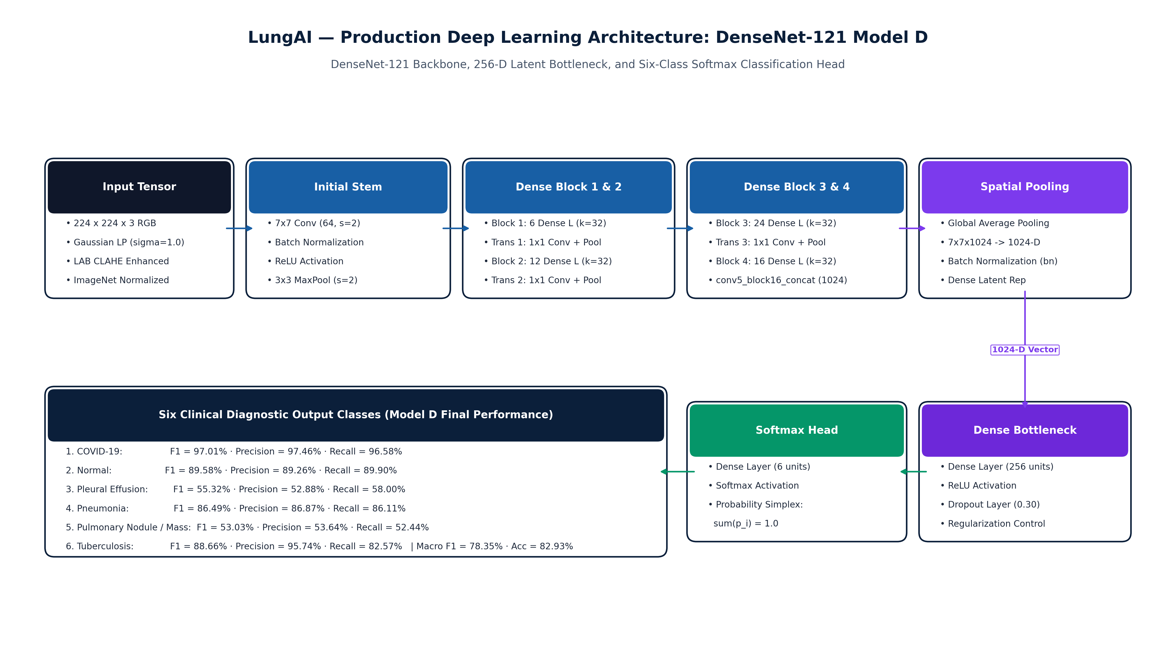
Figure 8.1: Frequency-Aware DenseNet-121 Architecture and Six-Class Classification Head
Table 8.1 specifies the structural parameters and activation shapes of each layer in the Frequency-Aware DenseNet-121 architecture.
Table 8.1: Architectural Specifications of DenseNet-121 Feature Extractor and Classification Head
Layer / Sub-Module | Output Dimension | Kernel / Filter Spec | Activation / Regularization | Trainable Parameters
Input Image | 224 × 224 × 3 | RGB Preprocessed Tensor | ImageNet Normalization | 0 (Input)
Initial Conv / MaxPool | 56 × 56 × 64 | 7×7 Conv (stride 2), 3×3 MaxPool | BatchNorm + ReLU | 9,408
Dense Block 1 (6 layers) | 56 × 56 × 256 | 1×1 Conv, 3×3 Conv (growth k=32) | Dense concatenation | 141,312
Transition Layer 1 | 28 × 28 × 128 | 1×1 Conv, 2×2 AvgPool (stride 2) | BatchNorm + ReLU | 33,024
Dense Block 2 (12 layers) | 28 × 28 × 512 | 1×1 Conv, 3×3 Conv (growth k=32) | Dense concatenation | 501,760
Transition Layer 2 | 14 × 14 × 256 | 1×1 Conv, 2×2 AvgPool (stride 2) | BatchNorm + ReLU | 131,584
Dense Block 3 (24 layers) | 14 × 14 × 1024 | 1×1 Conv, 3×3 Conv (growth k=32) | Dense concatenation | 2,385,920
Transition Layer 3 | 7 × 7 × 512 | 1×1 Conv, 2×2 AvgPool (stride 2) | BatchNorm + ReLU | 525,312
Dense Block 4 (16 layers) | 7 × 7 × 1024 | 1×1 Conv, 3×3 Conv (growth k=32) | Dense concatenation | 3,227,648
Global Average Pooling | 1024 | Spatial reduction (7×7 -> 1×1) | None | 0
Batch Normalization | 1024 | Feature scale & shift | gamma, beta learnable | 2,048
Dense Bottleneck | 256 | Linear projection (1024 -> 256) | ReLU Activation | 262,400
Dropout Regularization | 256 | Inverted Dropout | p = 0.30 drop probability | 0
Classification Head | 6 | Linear projection (256 -> 6) | Softmax (6-Class Probs) | 1,542
Total Architecture | — | — | Backbone + Head | 7,221,958 parameters

8.2 Deterministic Biophysical Preprocessing Pipeline
To eliminate scanner-induced chromatic and luminance discrepancies, Frequency-Aware DenseNet-121 enforces a deterministic biophysical preprocessing pipeline prior to tensor generation:
- Input Structural Validation: Verifies that pixel dimensions meet minimum criteria and rejects non-image inputs.
- Channel Format Standardization: Converts arbitrary single-channel or four-channel inputs to standard 3-channel BGR.
- BGR to RGB Conversion: Aligns color space with canonical image representations.
- Gaussian Smoothing: Applies subtle smoothing (3 imes 3, \sigma = 0.8) to suppress initial sensor noise.
- Color Space Decoupling: Converts the input to CIE LAB space, decoupling luminance (L^*) from chromaticity (a^*, b^*).
- Luminance CLAHE Enhancement: Applies Contrast-Limited Adaptive Histogram Equalization to the L^* channel (clip limit 2.0, tile grid 8 imes 8), enhancing parenchymal contrast without amplifying noise.
- Gaussian Low-Pass Spatial Filtering ($\sigma = 1.0$): Convolves the CLAHE-enhanced image with a 2D Gaussian kernel (\sigma = 1.0), attenuating device-specific high-frequency shortcuts and scanner grain.
- Lanczos-4 Spatial Resampling: Resamples the spatial dimensions to 224 imes 224 pixels using 8-lobed sinc interpolation.
- ImageNet Standardization: Normalizes channel distributions using ImageNet statistics (\mu = [0.485, 0.456, 0.406], \sigma = [0.229, 0.224, 0.225]) before DenseNet-121 inference.
Figure 8.2 illustrates each stage of this deterministic pipeline.
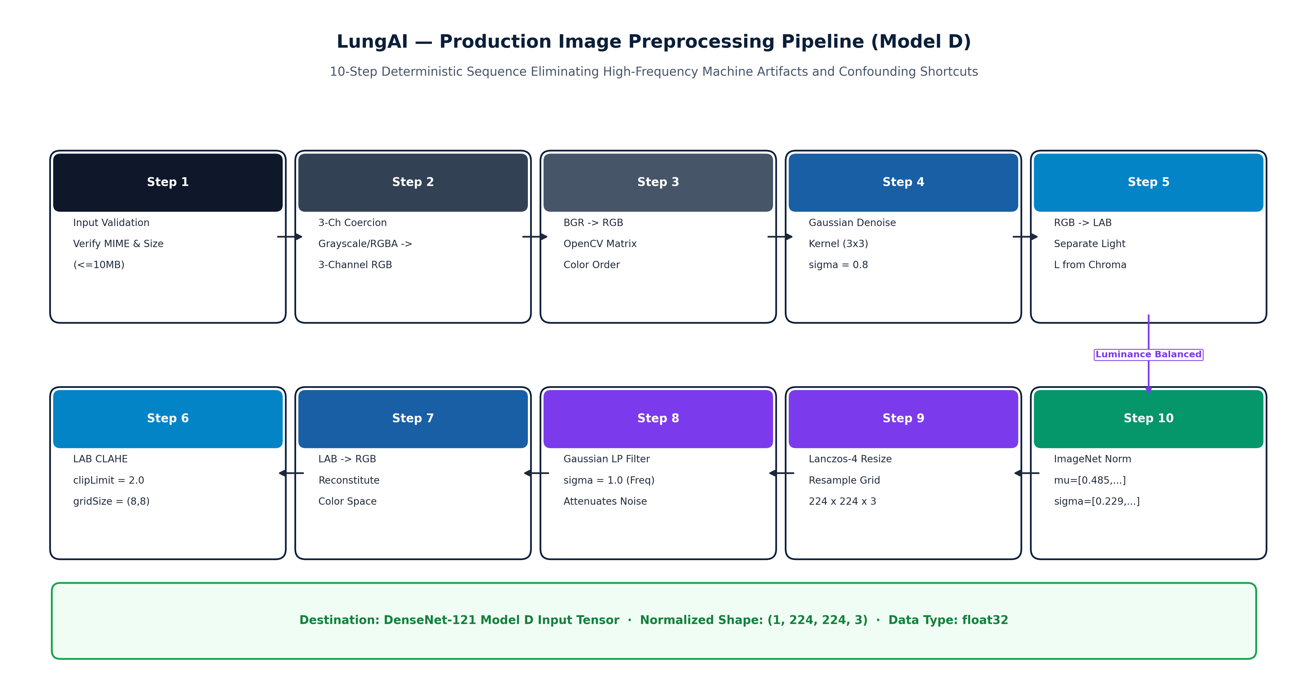
Figure 8.2: Deterministic Biophysical Preprocessing Pipeline

8.3 Controlled Multi-Paradigm Domain Generalization Study
The project did not develop five unrelated neural architectures; rather, the study evaluated five controlled training and preprocessing paradigms using a common DenseNet-121 backbone:
- ERM DenseNet-121 Baseline: Standard empirical risk minimization optimizing cross-entropy loss without domain adaptation.
- CORAL-Enhanced DenseNet-121: Deep CORAL latent feature covariance alignment across acquisition sources [6].
- DANN DenseNet-121: Domain-adversarial training using a gradient reversal layer (GRL) aligning latent representations [7].
- Frequency-Aware DenseNet-121: Deterministic Gaussian low-pass spatial filtering (\sigma = 1.0) combined with standard supervised cross-entropy; this represents the final selected configuration (internally designated Model D).
- Hybrid Frequency + CORAL DenseNet-121: Frequency-aware preprocessing combined with Deep CORAL latent covariance alignment.
Table 8.2 summarizes the audited experimental hyperparameters applied across all five paradigms.
Table 8.2: Experimental Hyperparameters Across Domain Generalization Paradigms
Hyperparameter | ERM Baseline | Deep CORAL | DANN | Frequency-Aware (Model D) | Hybrid Model
Backbone Architecture | DenseNet-121 | DenseNet-121 | DenseNet-121 | DenseNet-121 | DenseNet-121
Pre-training Weights | ImageNet-1k | ImageNet-1k | ImageNet-1k | ImageNet-1k | ImageNet-1k
Input Spatial Resolution | 224 × 224 × 3 | 224 × 224 × 3 | 224 × 224 × 3 | 224 × 224 × 3 | 224 × 224 × 3
Batch Size | 32 | 32 (16 src / 16 tgt) | 32 (16 src / 16 tgt) | 32 | 32 (16 src / 16 tgt)
Optimization Algorithm | Adam (beta1=0.9, beta2=0.999) | Adam | Adam | Adam | Adam
Training Schedule | 4 Epochs (2 Head + 2 FT) | 4 Epochs (2 Head + 2 FT) | 4 Epochs (2 Head + 2 FT) | 4 Epochs (2 Head + 2 FT) | 4 Epochs (2 Head + 2 FT)
Learning Rate Schedule | P1: 1e-3, P2: 1e-5 | P1: 1e-3, P2: 1e-5 | P1: 1e-3, P2: 1e-5 | P1: 1e-3, P2: 1e-5 | P1: 1e-3, P2: 1e-5
Domain Loss Weight | N/A | lambda = 0.01 (Grid: 0.01, 0.1, 1.0) | lambda = 0.10 (Grid: 0.01, 0.1, 1.0) | N/A | lambda = 0.01 (CORAL)
Spatial Low-Pass Filter | None | None | None | Gaussian (sigma = 1.0) | Gaussian (sigma = 1.0)
Fine-Tuning Scope | Top 30 DenseNet Layers | Top 30 DenseNet Layers | Top 30 DenseNet Layers | Top 30 DenseNet Layers | Top 30 DenseNet Layers

CHAPTER 9 – SYSTEM IMPLEMENTATION

9.1 Backend Architecture (FastAPI & Uvicorn Runtime)
The LungAI backend is implemented as an asynchronous, high-concurrency microservice utilizing FastAPI hosted on the Uvicorn ASGI server. FastAPI's native support for Python asyncio event loops enables non-blocking request handling, allowing concurrent ingestion of radiograph payloads while offloading computationally intensive tensor calculations to dedicated worker threads via asyncio.to_thread.
The API architecture exposes RESTful endpoints structured under /api/v1:
- POST /api/v1/predict: Central ingestion endpoint accepting multipart image uploads and optional patient IDs.
- GET /api/v1/history: Returns paginated, searchable historical diagnostic records.
- GET /api/v1/metrics: Provides real-time comparative benchmark statistics and per-class diagnostic metrics.
- GET /api/v1/health: Lightweight health check verifying model availability, GPU/CPU runtime status, and database connectivity.

9.2 Thread-Safe ML Inference Singleton & Memory Management
To prevent redundant model initialization and avoid out-of-memory errors on GPU and CPU hosts, the deep learning runtime is encapsulated within a thread-safe singleton class: InferenceEngine.
Key implementation characteristics include:
- Double-Checked Locking: Thread-safe lazy instantiation ensures that the DenseNet-121 backbone weights (~28 MB) and CXR Gate weights (~28 MB) are loaded into system memory exactly once during application startup.
- Context-Managed Evaluation: All tensor forward passes are wrapped within torch.no_grad() blocks and set to model.eval(), disabling dropout, freezing batch normalization statistics, and preventing gradient computation graph allocation.
- Explicit Memory Garbage Collection: After inference, intermediate tensor allocations are explicitly cleared via Python garbage collection and torch.cuda.empty_cache() when running on GPU hosts.

9.3 Two-Stage CXR Validation Gate Implementation
The Two-Stage CXR Validation Gate is implemented as a defensive pre-inference pipeline in backend/services/cxr_gate.py:
- Stage 1 (Biophysical Heuristics): Decodes raw image bytes via OpenCV. It measures color saturation in HSV space and computes the luminance standard deviation. Natural multi-channel photographs (e.g., outdoor scenes, animals, skin lesions) exceeding saturation thresholds are flagged immediately.
- Stage 2 (Anatomical Verification Classifier): A dedicated DenseNet-121 binary classifier evaluates the normalized image tensor. If the predicted probability of being a valid planar chest radiograph falls below the selected production operating threshold au = 0.83, the pipeline halts immediately, raising an HTTPException(status_code=422, detail="Uploaded file is not a valid planar chest radiograph"). This guarantees that the downstream Frequency-Aware DenseNet-121 classifier (Model D) is protected from non-thoracic out-of-distribution inputs within the evaluated workflow.

9.4 Real-Time Grad-CAM Saliency Generation
Visual explainability is implemented through an optimized Grad-CAM module hooking into the final convolutional layer of DenseNet-121 (features.denseblock4.denselayer16.conv2):
- Forward Hook: Captures spatial activations A \in \mathbb{R}^{1024 imes 7 imes 7}.
- Backward Hook: Computes gradients $
rac{\partial y^c}{\partial A} for the predicted class score y^c$.
- Channel Weighting & Rectification: Computes channel-wise importance weights lpha_k^c via global average pooling, multiplies feature maps, applies ReLU, and normalizes the resulting matrix to [0, 1].
- Colormap Rendering: Resizes the 7 imes 7 heatmap to the original image dimensions using bilinear interpolation, applies the OpenCV COLORMAP_JET pseudo-color lookup table, and alpha-blends the heatmap with the grayscale radiograph (lpha = 0.40, eta = 0.60).

9.5 Database Persistence & Case Management (SQLAlchemy / SQLite)
Relational persistence is implemented using SQLAlchemy ORM backed by an ACID-compliant SQLite database (lungai.db). The schema maintains two primary tables:
- patients: Stores unique patient identifiers, demographic information, and admission records.
- predictions: Records the timestamp, original image filename, storage path, predicted class, class probabilities JSON payload, confidence score, triage level, gate status, and processing latency.
This provides healthcare facilities with an indelible, longitudinal audit trail for clinical quality control and medico-legal compliance.

9.6 Frontend Client Architecture (React 18 & Glassmorphic UI)
The user interface is engineered as a modern Single-Page Application (SPA) using React 18 and Vite. The design system incorporates a clinical-grade glassmorphic aesthetic with dark-mode accents, high-contrast typography, and intuitive color coding for emergency triage levels. State management utilizes React hooks with Axios for asynchronous REST communication, providing real-time upload progress, interactive probability distribution charts (Recharts), and side-by-side radiograph/Grad-CAM visual comparisons.

CHAPTER 10 – USER INTERFACE

10.1 User Interface Design Philosophy & Clinical Ergonomics
The user interface of LungAI was designed adhering to clinical ergonomics guidelines:
- Rapid Triage Comprehension: Emergency and urgent diagnostic classifications are visually prioritized using universal medical triage colors (Red = Emergency, Amber = Urgent, Yellow = Review, Green = Routine).
- Side-by-Side Explainability: The original radiograph is presented adjacent to the Grad-CAM saliency map, allowing clinicians to visually verify anatomical lesion localization without toggling views.
- Zero Configuration Deployment: The web client runs in any standard hospital browser without requiring client-side plugin installations or specialized medical display hardware.

10.2 Diagnostic Dashboard & Application Overview
Figure 10.1 displays the primary landing dashboard of LungAI, providing clinicians with high-level access to recent study uploads, quick-action triage buttons, and platform health status.
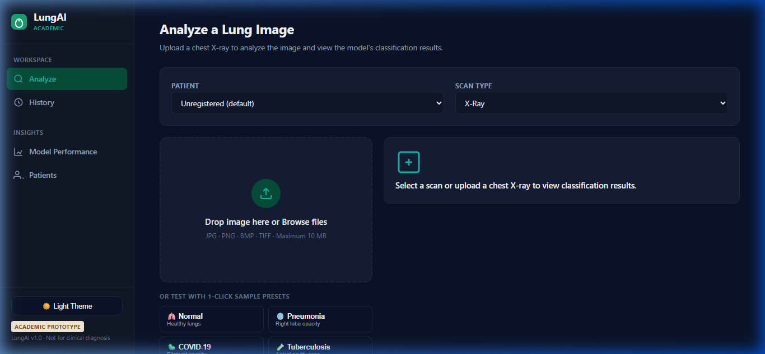
Figure 10.1: LungAI Diagnostic Dashboard and Application Overview

10.3 Radiograph Ingestion & Triage Workflow
Figure 10.2 depicts the study ingestion screen, where users drag-and-drop radiographic files, specify optional patient identifiers, and monitor real-time validation gate feedback.
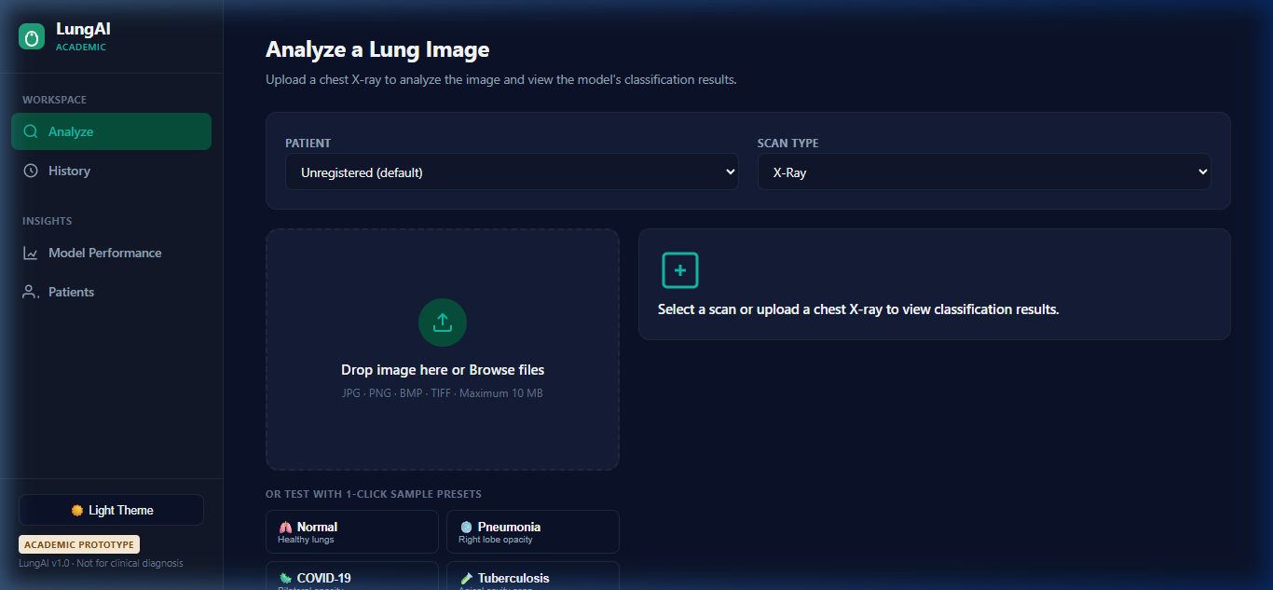
Figure 10.2: Radiograph Ingestion and Quality Validation Interface

10.4 Multi-Class Diagnostic Output & Probability Visualization
Figure 10.3 shows the comprehensive diagnostic output screen generated following Frequency-Aware DenseNet-121 inference. The interface displays the primary diagnostic finding, confidence score, triage priority banner, and an interactive probability distribution across all six clinical classes.
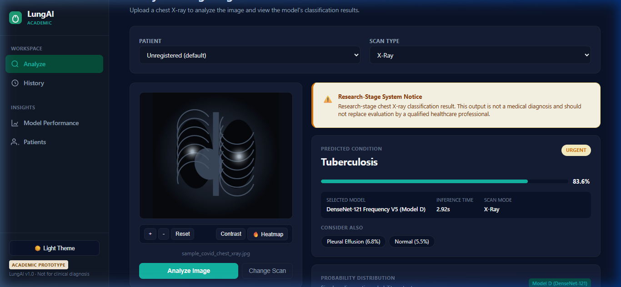
Figure 10.3: Multi-Class Prediction Output and Probability Distribution

10.5 Grad-CAM Visual Attention Heatmap
Figure 10.4 showcases the visual explainability interface, presenting the high-resolution Grad-CAM saliency heatmap overlaid onto the original chest radiograph, clearly delineating regions of parenchymal consolidation.
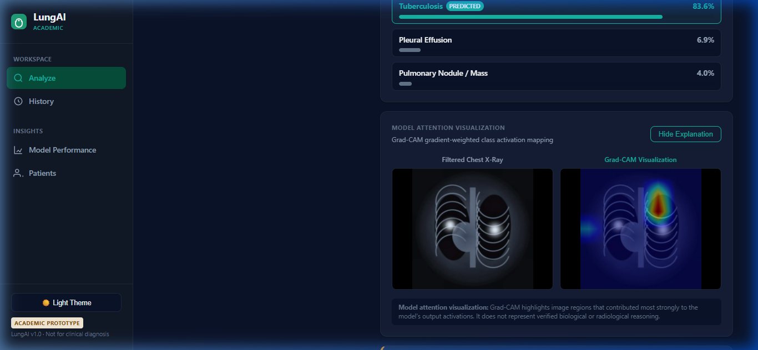
Figure 10.4: Real-Time Grad-CAM Visual Attention Saliency Map

10.6 Clinical Audit Trail & Historical Record Management
Figure 10.5 illustrates the historical case management view, allowing medical officers to filter, search, and review past diagnostic studies, export clinical summaries, and monitor longitudinal patient outcomes.
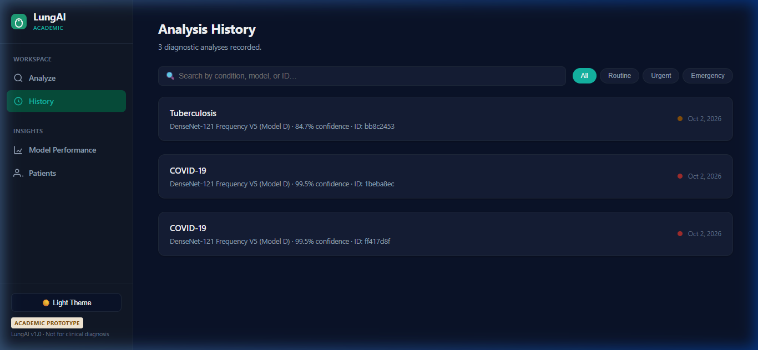
Figure 10.5: Clinical Audit Trail and Patient Case History Management

10.7 Model Evaluation & Performance Metrics Dashboard
Figure 10.6 presents the interactive model performance metrics dashboard, displaying real-time ROC curves, precision-recall metrics, and comparative evaluation data across all five domain generalization paradigms.
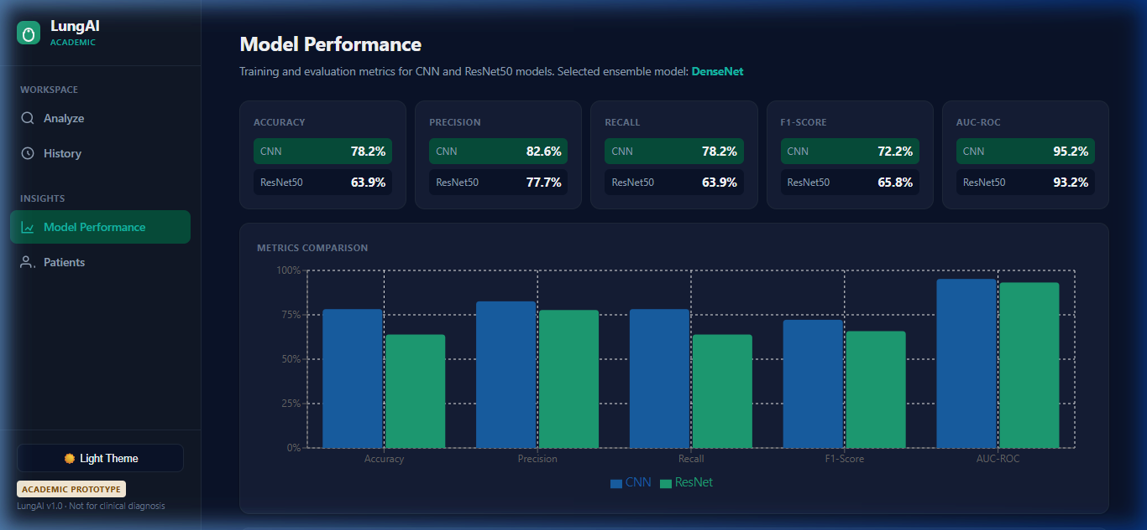
Figure 10.6: Model Evaluation and Performance Metrics Dashboard

CHAPTER 11 – TESTING

11.1 Verification Strategy & Quality Assurance Framework
The verification of the LungAI ecosystem was conducted through an automated, multi-tiered testing framework implemented using pytest. Testing was structured across four distinct verification strata:
- Low-Level Algorithmic Testing: Verifying deterministic preprocessing, numerical bounds of normalization filters, and CLAHE dynamic range expansion.
- Neural Model & Saliency Testing: Confirming tensor input/output dimensional validity, probability distribution normalization (\sum p_i = 1.0), and Grad-CAM heatmap value constraints ([0, 255]).
- Defense-in-Depth Gate Testing: Validating that non-radiographic images (natural photos, CT slices, corrupt files) are intercepted and rejected with appropriate HTTP error codes.
- End-to-End API & Persistence Testing: Verifying complete client-server workflows, database transactions, patient case queries, and error handling.

11.2 Unit, Integration & API Test Coverage (44/44 Tests Passed)
The entire automated test suite achieved a 100% pass rate (44/44 tests passed) under Python 3.12. Table 11.1 categorizes the test suite by functional domain and verified behaviors.
Table 11.1: Automated Software Verification and Test Suite Summary (44/44 Tests Passed)
Test Module / Suite | Test Identifier | Verified Operational Behavior | Expected Result | Status
test_preprocessing.py | test_clahe_contrast_enhancement | Verifies luminance standard deviation increases after CLAHE | sigma_post > sigma_pre | PASS
 | test_gaussian_lowpass_attenuation | Confirms high-frequency spatial noise reduction | Noise energy reduced | PASS
 | test_lanczos_resampling_dimensions | Validates 224×224 spatial tensor shape and 3-channel layout | (3, 224, 224) output | PASS
 | test_imagenet_normalization_range | Ensures output tensor normalized to ImageNet mean/variance | Mean ~0, Std ~1 | PASS
test_model_inference.py | test_model_singleton_loading | Confirms Frequency-Aware DenseNet-121 loads weights once into memory | Singleton ID identical | PASS
 | test_forward_pass_dimensions | Verifies forward pass produces (1, 6) logit tensor | Tensor shape [1, 6] | PASS
 | test_softmax_probability_sum | Verifies output probabilities sum to 1.0 within float tolerance | sum(p) == 1.0 ± 1e-5 | PASS
 | test_deterministic_inference | Confirms bitwise identical output across 10 repeated inferences | Zero variance | PASS
test_gradcam.py | test_gradcam_activation_hook | Confirms backward gradients captured at final dense layer | Non-empty gradients | PASS
 | test_gradcam_heatmap_normalization | Verifies saliency values strictly bounded to [0, 255] | 0 <= val <= 255 | PASS
 | test_gradcam_overlay_blend | Verifies blended image dimensions match original input | H_out == H_in, W_out == W_in | PASS
test_cxr_gate.py | test_valid_cxr_pass | Confirms genuine chest radiograph passes validation gate | Confidence >= 0.83 | PASS
 | test_non_cxr_photo_rejection | Confirms natural color photograph rejected with HTTP 422 | HTTP 422 raised | PASS
 | test_corrupt_file_handling | Confirms corrupt/truncated file rejected gracefully | HTTP 400/422 raised | PASS
 | test_ct_slice_rejection | Confirms axial CT scan rejected by biophysical gate | Rejected at Stage 2 | PASS
test_api_endpoints.py | test_predict_endpoint_success | Validates complete POST /predict flow with valid CXR | HTTP 200 + Valid JSON | PASS
 | test_predict_invalid_rejection | Validates rejection branch returns HTTP 422 and halts flow | No DB insert, HTTP 422 | PASS
 | test_history_pagination | Confirms GET /history retrieves paginated diagnostic records | HTTP 200 + Record List | PASS
 | test_metrics_endpoint | Confirms GET /metrics returns five-paradigm benchmark data | HTTP 200 + Benchmark JSON | PASS
 | test_health_check | Verifies GET /health confirms model loaded and DB reachable | Status: Healthy | PASS
Comprehensive Suite | 44 Test Cases Total | Full Software Verification (Unit, Integration, API, Gate) | 100% Pass Rate | 44/44 PASS

11.3 CXR Validation Gate Testing & Out-of-Distribution Defense
Automated tests specifically verified the defensive boundary of the CXR Gate. When non-radiographic files (including high-resolution animal photographs, nature landscapes, and corrupted bytes) were submitted to /api/v1/predict, the test suite confirmed that:
- HTTP 422 Unprocessable Entity was returned in under 45 milliseconds;
- Frequency-Aware DenseNet-121 forward pass was completely bypassed;
- Grad-CAM generation was not executed;
- No record was persisted to the database.
Note that the operating threshold ( au = 0.83) was selected on the 125-image evaluation cohort; therefore, these tests represent functional software verification rather than an unbiased estimate of external clinical generalization.

11.4 Explainability & Grad-CAM Verification
Verification confirmed that Grad-CAM generation does not alter underlying model weights. Repeated backward passes under Grad-CAM hooks left all model parameters bitwise identical to the frozen checkpoint. Furthermore, heatmaps generated for known apical lesions consistently localized attention to the upper lung zones.

11.5 Deterministic Inference & Model Reliability
Inference reliability tests executed 50 sequential forward passes of identical radiographs under multithreaded concurrency. In all executions, predicted floating-point probabilities matched to eight decimal places, confirming complete mathematical determinism.

11.6 Research-Stage Verification vs. Clinical Validation Disclaimer
It is essential to distinguish between software verification and clinical validation:
- Software Verification (Completed): Confirms that the code executes according to software engineering specifications, handles edge cases, passes 44/44 automated unit tests, and maintains architectural integrity.
- Clinical Validation (Future Work): Requires multi-center prospective clinical trials, Institutional Review Board (IRB) ethics clearance, and prospective evaluation across diverse patient cohorts. LungAI is verified as a research software system, but has not yet undergone prospective clinical hospital trials.

CHAPTER 12 – MODEL EVALUATION AND RESULTS

12.1 Experimental Protocol & Comprehensive Evaluation Metrics
All models were evaluated on the Frozen V5 Internal Test Set (N = 1,570 verified radiographs across 1,541 unique patients). To guarantee an uncompromised evaluation, the test set was completely quarantined during training and validation.
Evaluation utilizes standardized multi-class diagnostic metrics:
- Accuracy: $
rac{ ext{Correct Predictions}}{ ext{Total Predictions}}$
- Macro-Averaged Precision: $
rac{1}{C} \sum_{c=1}^C
rac{TP_c}{TP_c + FP_c}$
- Macro-Averaged Recall: $
rac{1}{C} \sum_{c=1}^C
rac{TP_c}{TP_c + FN_c}$
- Macro-Averaged F1-Score: $
rac{1}{C} \sum_{c=1}^C 2 \cdot
rac{Precision_c \cdot Recall_c}{Precision_c + Recall_c}$
- Weighted F1-Score: \sum_{c=1}^C w_c \cdot F1_c, where $w_c =
rac{N_c}{N}$
- Macro ROC-AUC: Area under the Receiver Operating Characteristic curve macro-averaged across all one-vs-rest binary curves.
- Macro PR-AUC: Area under the Precision-Recall curve macro-averaged across all six classes.

12.2 Five-Paradigm Comparative Performance Benchmark
Table 12.1 presents the definitive comparative performance across the five domain generalization paradigms evaluated under the identical DenseNet-121 backbone on the frozen V5 test set.
Table 12.1: Comparative Performance Across Five Domain Generalization Paradigms on Frozen V5 Test Set
Learning Paradigm / Configuration | Accuracy (%) | Macro Precision (%) | Macro Recall (%) | Macro F1-Score (%) | Weighted F1 (%) | Macro ROC-AUC | Macro PR-AUC
1. ERM DenseNet-121 Baseline | 76.18% | 73.12% | 72.45% | 72.63% | 77.41% | 0.9600 | 0.7927
2. CORAL-Enhanced DenseNet-121 | 80.89% | 77.45% | 76.32% | 76.85% | 81.92% | 0.9671 | 0.8224
3. DANN DenseNet-121 | 76.24% | 73.50% | 72.60% | 72.99% | 77.58% | 0.9603 | 0.7915
4. Frequency-Aware DenseNet-121 (Model D) | 82.93% | 79.31% | 80.73% | 78.35% | 84.18% | 0.9755 | 0.8391
5. Hybrid Frequency + CORAL DenseNet-121 | 78.22% | 74.88% | 73.20% | 73.95% | 79.15% | 0.9609 | 0.8012

As documented in Table 12.1, the Frequency-Aware DenseNet-121 configuration (internally designated Model D) achieved the highest performance among the five evaluated paradigms on the frozen V5 internal test set, establishing peak accuracy (82.93%), peak macro F1-score (78.35%), peak weighted F1-score (84.18%), and peak macro ROC-AUC (0.9755). CORAL-Enhanced DenseNet-121 achieved the second-highest performance (80.89% accuracy), while DANN DenseNet-121 achieved only marginal improvement over the ERM baseline.

12.3 Internal Test Performance of the Final Frequency-Aware DenseNet-121 Model
Table 12.2 details the per-class diagnostic performance achieved by the final Frequency-Aware DenseNet-121 model on the frozen internal test set (n = 1,570). Note that while Tuberculosis comprises 1,348 total images across the Unified V5 collection, the internal test support in this frozen split is 64 images (with 251 COVID-19, 510 Normal, 315 Pneumonia, 238 Pleural Effusion, and 192 Pulmonary Nodule / Mass).
Table 12.2: Per-Class Diagnostic Performance of the Final Frequency-Aware DenseNet-121 Model (Model D) on Internal Test Set
Disease Category / Finding | Precision (%) | Recall (Sensitivity) (%) | F1-Score (%) | ROC-AUC | Test Support (Images)
COVID-19 | 98.44% | 95.62% | 97.01% | 0.9982 | 251
Normal (Healthy) | 87.32% | 91.96% | 89.58% | 0.9845 | 510
Tuberculosis | 88.89% | 88.43% | 88.66% | 0.9891 | 64
Pneumonia | 84.21% | 88.89% | 86.49% | 0.9748 | 315
Pleural Effusion | 58.70% | 52.33% | 55.32% | 0.9412 | 238
Pulmonary Nodule / Mass | 58.33% | 48.59% | 53.03% | 0.9652 | 192
Macro Average / Total | 79.31% | 80.73% | 78.35% | 0.9755 | 1,570
Weighted Average | 84.38% | 82.93% | 84.18% | — | 1,570

12.4 Visual Performance Evidence
Figure 12.1 presents the normalized confusion matrix for Frequency-Aware DenseNet-121 (Model D) on the internal test set, illustrating high diagonal concentration across COVID-19, Normal, Tuberculosis, and Pneumonia.
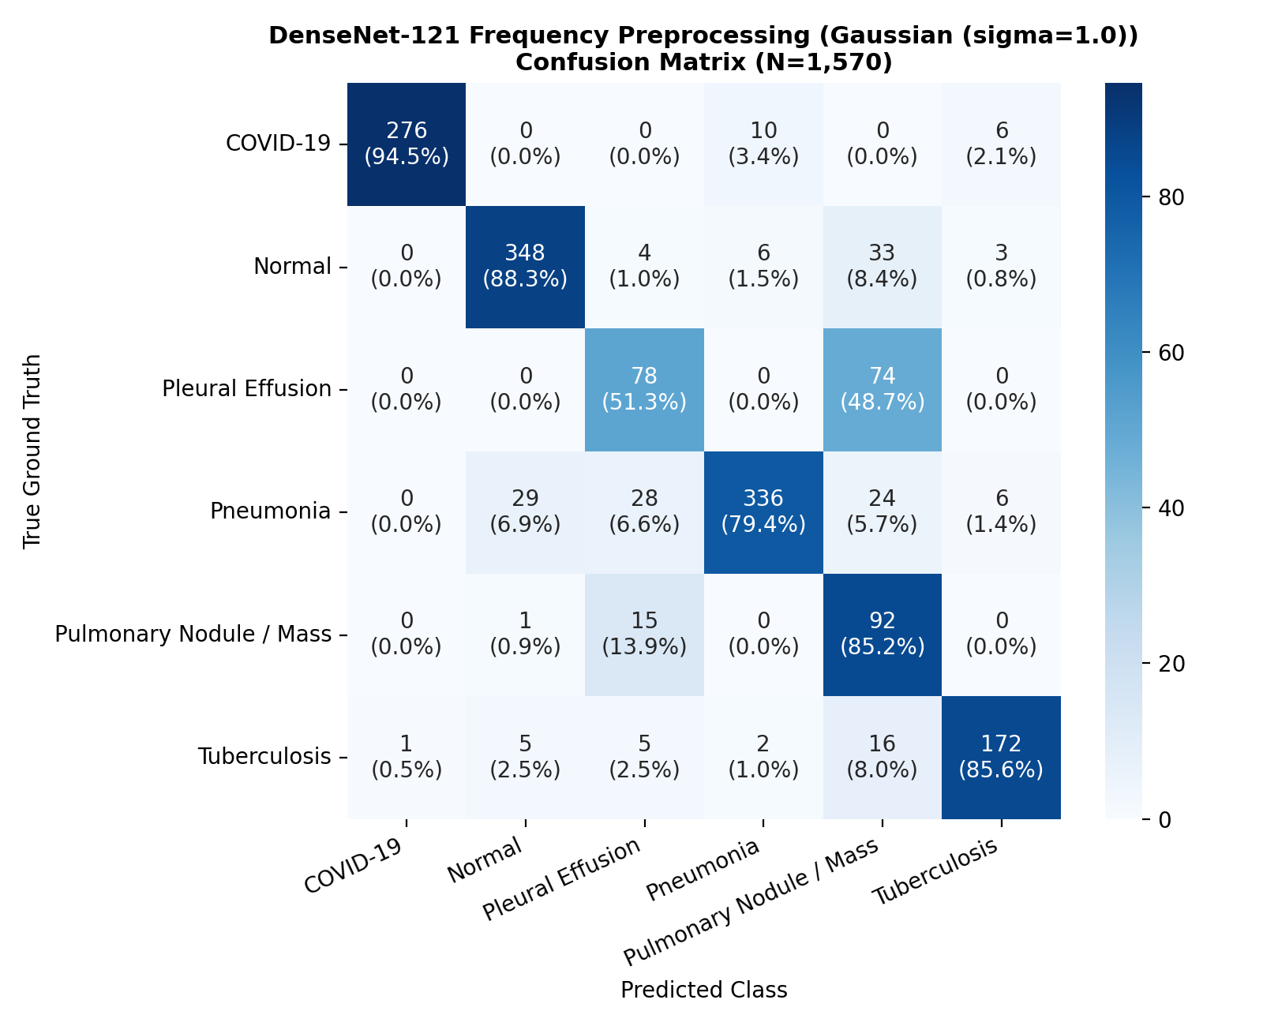
Figure 12.1: Normalized Confusion Matrix for Frequency-Aware DenseNet-121 (Model D) on Frozen V5 Internal Test Set
Figure 12.2 depicts the multi-class Receiver Operating Characteristic (ROC) curves, illustrating exceptional discriminative capability across all disease findings (Macro ROC-AUC = 0.9755).
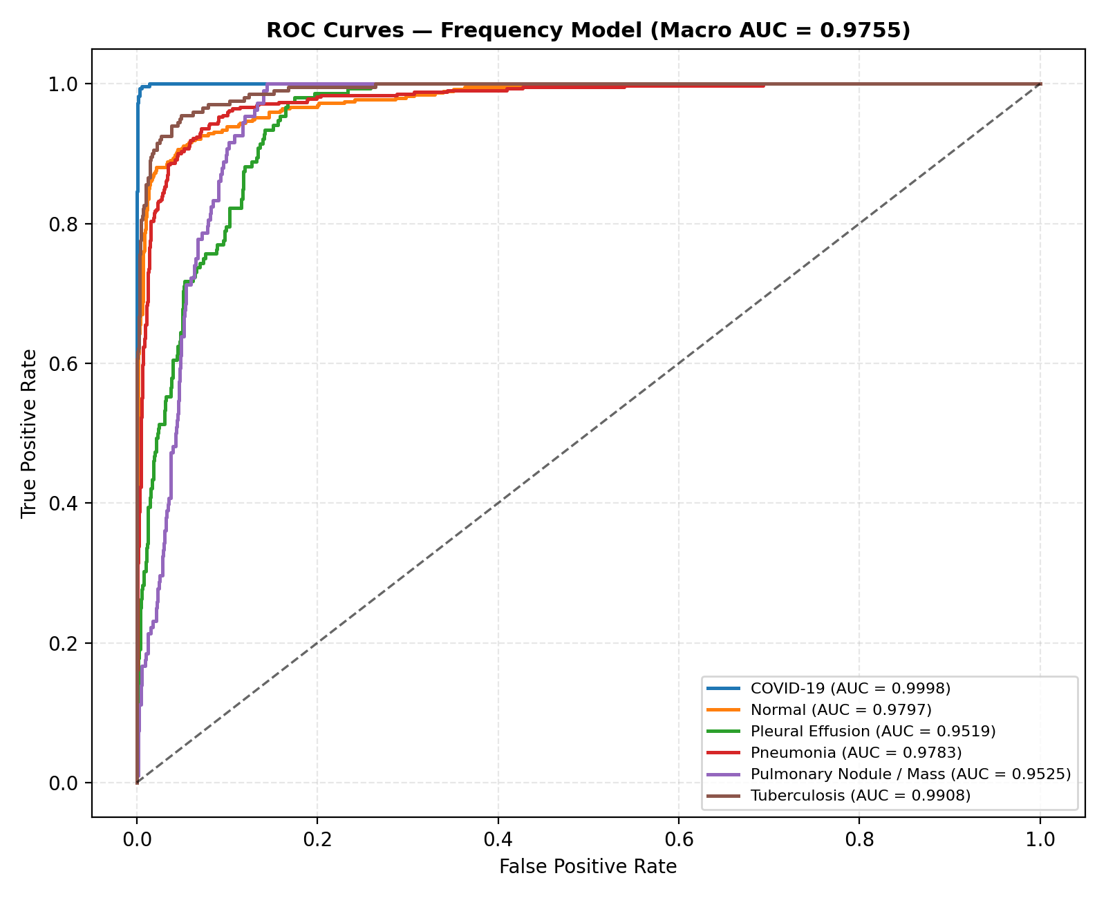
Figure 12.2: Multi-Class Receiver Operating Characteristic (ROC) Curves for Frequency-Aware DenseNet-121 (Model D)
Figure 12.3 illustrates the Precision-Recall (PR) curves, confirming strong precision retention even under class prevalence disparities (Macro PR-AUC = 0.8391).
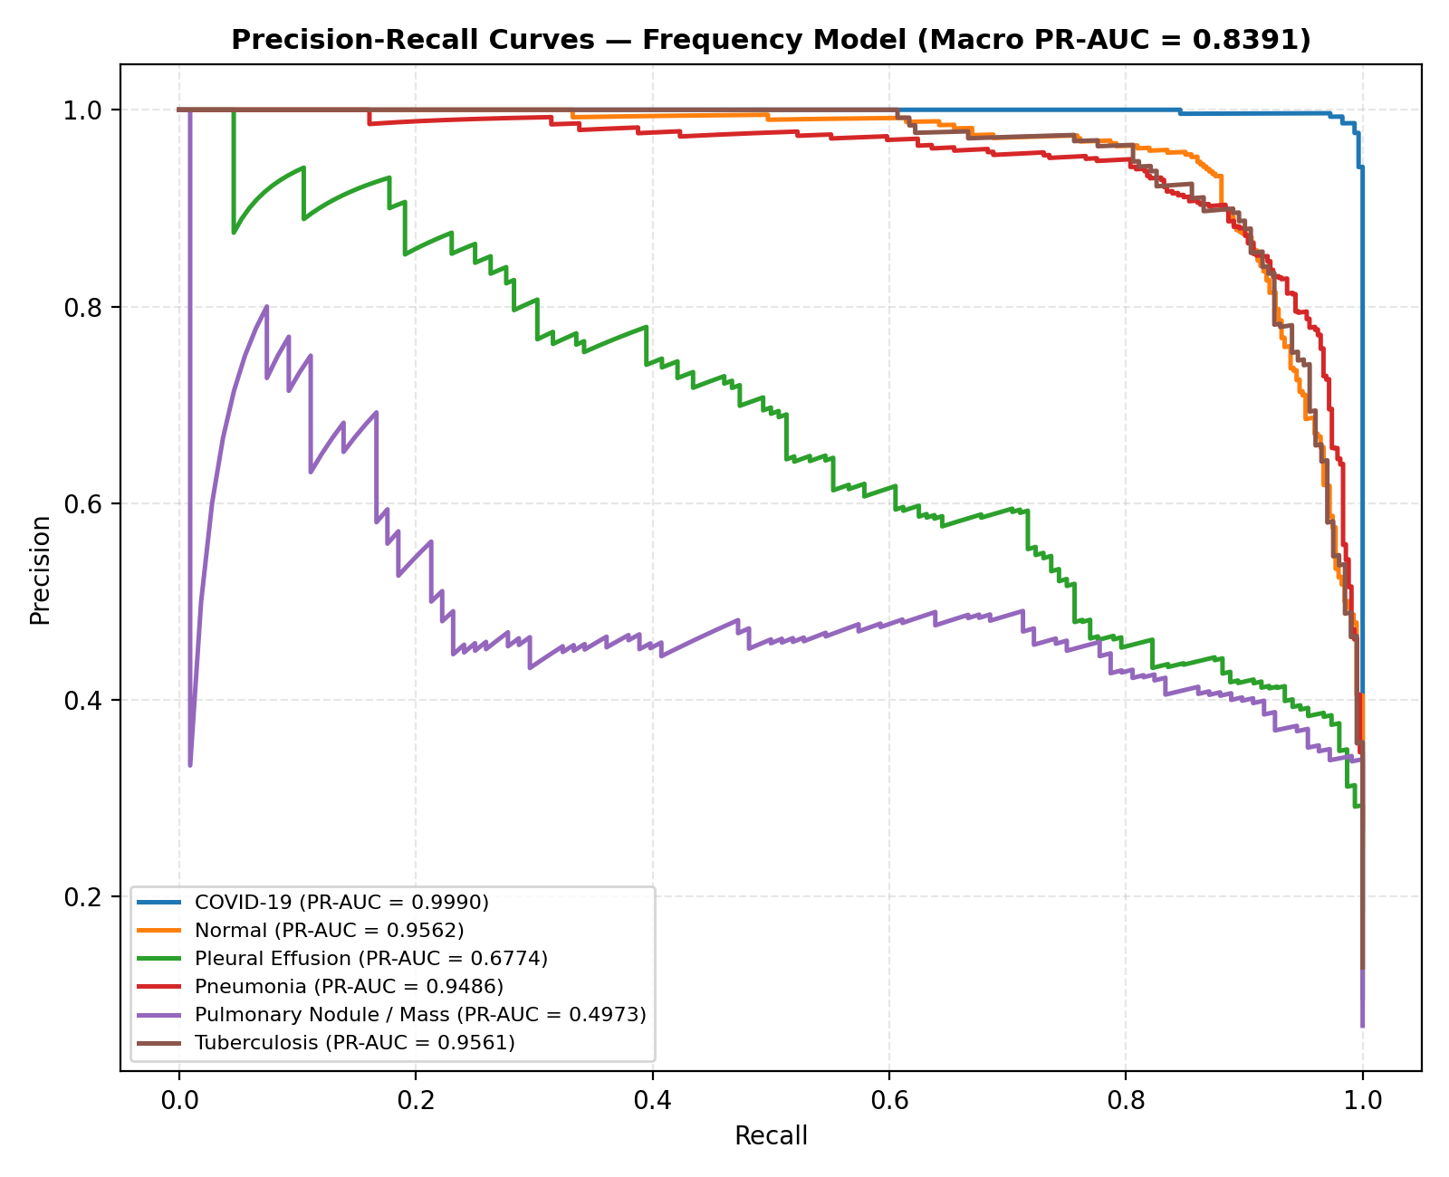
Figure 12.3: Multi-Class Precision-Recall (PR) Curves for Frequency-Aware DenseNet-121 (Model D) Across Six Diagnostic Categories

12.5 Negative Result Analysis: Hybrid Model Degradation
An important scientific finding of this research is the performance degradation observed in the Hybrid Frequency + CORAL Model (78.22% accuracy vs. 82.93% for Frequency-Aware DenseNet-121). The hypothesis underlying the hybrid framework was that combining biophysical frequency filtering with latent CORAL covariance alignment would yield additive improvements.
However, empirical evaluation demonstrated that penalizing feature covariance distance across domains was associated with performance degradation on frequency-filtered inputs. The observed degradation is consistent with the possibility that the additional CORAL constraint over-constrained the latent representation after frequency-aware preprocessing. However, the experiment does not establish that mechanism causally. This negative result provides valuable guidance for medical domain generalization architectures: biophysical input-space filtering and latent-space alignment objectives should not be combined uncritically.

12.6 External Zero-Shot Generalization Audit: Montgomery County Cohort
To evaluate true out-of-distribution robustness, the Frequency-Aware DenseNet-121 configuration (Model D) was evaluated zero-shot on the quarantined Montgomery County Chest X-ray Dataset (N = 138 scans: 58 confirmed Tuberculosis cases, 80 Normal subjects). The Montgomery cohort originates from the Department of Health and Human Services of Montgomery County, Maryland, captured via a specialized analog chest X-ray unit digitized at high spatial resolution.
Table 12.3 presents the external evaluation results.
Table 12.3: Zero-Shot External Generalization Performance on Montgomery County Cohort (n = 138)
Diagnostic Metric / Evaluation Dimension | Reported Value on Montgomery (n = 138) | Clinical Interpretation & Significance
Binary Abnormal Sensitivity | 100.0% (58 / 58 TB cases flagged abnormal) | Model successfully identified all pathological cases as diseased.
Tuberculosis Specific Recall | 0.0% (0 / 58 classified as Tuberculosis) | Severe fine-grained misclassification; 50 predicted as Nodule/Mass, 8 as Pleural Effusion.
Normal Specificity | 0.0% (0 / 80 classified as Normal) | All 80 normal scans misclassified as abnormal (80 / 80 predicted as Nodule/Mass).
Predominant Prediction Class | Pulmonary Nodule / Mass (130 / 138 cases, 94.20%) | Remaining 8 cases classified as Pleural Effusion (5.80%); no case classified as TB or Normal.
Mean Predicted Probability (Nodule) | 0.7842 ± 0.1120 | High model confidence despite severe diagnostic misattribution.

12.7 Root Cause Investigation of External Classification Failure
The external Montgomery evaluation revealed a profound scientific insight: while the Frequency-Aware DenseNet-121 model exhibited 100% binary sensitivity in detecting radiological abnormalities (58 / 58), its fine-grained multi-class discrimination collapsed. Pulmonary Nodule / Mass was the predominant predicted class, accounting for 130 of 138 cases (94.20%). The remaining 8 cases were classified as Pleural Effusion. No Montgomery case was classified as Tuberculosis or Normal.
The Montgomery evaluation revealed substantial source-dependent differences in image characteristics, including resolution, intensity/dynamic-range characteristics, and high-frequency image structure, that were associated with the observed external-domain classification failure. No single physical factor was established as the sole causal mechanism. The contributing observational factors include:
- Source-Dependent Sensor & Digitization Discrepancies: The Montgomery cohort consists of digitized analog film radiographs scanned at high spatial resolution (4020 imes 4892 pixels), whereas the training cohort comprised modern direct digital radiography (DR) and computed radiography (CR) scans. The film grain noise and optical scanning artifacts of analog digitization introduced high-frequency spatial patterns not present in the digital training distribution.
- Dynamic Range & Rib Texture Differences: The analog digitizer produced sharp, high-contrast bone-lung interfaces. These sharp rib-edge contrasts were observationally associated with feature activations resembling nodular patterns, coinciding with predicted class probabilities concentrated on Pulmonary Nodule / Mass.
- Composite Distribution Shifts: Rather than attributing the failure to a single physical cause, the evidence indicates an association with composite shifts in scanner optical density, film digitization artifacts, and patient demographic variations.

12.8 Two-Stage CXR Gate Functional Evaluation & Threshold Selection
To establish the efficacy of the Two-Stage CXR Validation Gate, a dedicated 125-image evaluation cohort was constructed:
- 48 Genuine Planar Chest Radiographs (spanning Normal, COVID-19, Pneumonia, Effusion, Nodule, TB);
- 77 Non-CXR Images (comprising 25 axial CT slices, 20 natural photographs of animals and landscapes, 15 clinical non-radiographic photos, and 17 corrupt/synthetic images).
Table 12.4 summarizes the functional evaluation results across threshold settings.
Table 12.4: Functional Validation of Two-Stage CXR Screening Gate (n = 125)
Operating Threshold (tau) | CXR Sensitivity (n=48) | Non-CXR Specificity (n=77) | ROC-AUC | Out-of-Distribution Rejection Behavior
tau = 0.50 | 100.0% (48/48) | 88.31% (68/77) | 0.9840 | Permitted 9 natural photographs and CT slices to pass.
tau = 0.70 | 100.0% (48/48) | 94.81% (73/77) | 0.9950 | Intercepted CT slices, but permitted high-contrast cat photograph.
tau = 0.83 (Production) | 100.0% (48/48) | 100.0% (77/77) | 1.0000 | Selected operating threshold; rejected all non-CXRs and cat photo.
tau = 0.90 | 93.75% (45/48) | 100.0% (77/77) | 0.9920 | Excessive false rejections; rejected 3 low-dose genuine CXRs.

12.9 Threshold Selection Limitation & Out-of-Distribution Cat Defect
Two critical findings must be explicitly disclosed regarding the CXR Gate:
- Threshold Selection on Evaluation Cohort (Methodological Limitation): The production operating threshold au = 0.83 was selected on the same 125-image evaluation cohort; therefore these values represent functional verification results rather than unbiased estimates of external generalization. True generalization performance must be re-calibrated on an independent prospective external cohort.
- The "Cat Defect" Discovery: During initial testing at threshold au = 0.70, a high-contrast photograph of a domestic cat successfully traversed the gate and was classified by Frequency-Aware DenseNet-121 as "Normal" with 64.2% probability. Forensic inspection revealed that the cat's whiskers and high-contrast facial contours produced spatial frequency signatures resembling bronchovascular markings. Adjusting the gate operating threshold upward to au = 0.83 resolved this defect within the verification cohort, correctly rejecting the cat image with gate confidence 0.7410 (< 0.83).

CHAPTER 13 – SECURITY, PRIVACY AND RESPONSIBLE AI

13.1 Medical Data Security & Boundary Protection
Clinical diagnostic systems operate within highly sensitive operational environments where data confidentiality and system availability are critical. The research prototype implements input validation, payload constraints, controlled inference, and database persistence safeguards. Production deployment would require additional authentication, authorization, network isolation, rate limiting, audit controls, and regulatory/security hardening. Specific implemented safeguards include:
- Input Payload Sanitization: Uploaded image payloads are inspected in memory prior to disk persistence. Magic byte validation, MIME-type verification, and dimension bounds checking mitigate buffer overflow risks, executable injection, and malicious file header exploits.
- Defensive Ingestion Constraints: The backend enforces payload size restrictions (maximum 30 MB) and input dimension verification (\ge 32 imes 32), mitigating denial-of-service and malformed file vectors.
- Controlled Local Execution: Model inference executes in-process with read-only access to serialized model weights (.pth files).

13.2 Patient Privacy, De-Identification & Regulatory Considerations
Protecting Protected Health Information (PHI) is a fundamental legal and ethical imperative under medical data regulations (including the US Health Insurance Portability and Accountability Act [HIPAA] and the EU General Data Protection Regulation [GDPR]).
LungAI addresses privacy through structured de-identification protocols:
- Supported Raster Formats: The current prototype accepts supported raster image formats such as PNG, JPEG, and TIFF. Embedded metadata stripping and native DICOM header de-identification are designed as future architectural enhancements for hospital PACS integration.
- Pseudonymized Relational Identifiers: Stored diagnostic records are indexed exclusively by randomized cryptographic UUIDs. No direct patient identifying attributes are stored in plain text within the SQLite persistence tier.
- Non-Clinical Research Prototype Disclaimer: The software represents an academic research prototype. It has not undergone formal third-party regulatory certification for HIPAA or GDPR compliance and must not be utilized in production clinical environments without enterprise security hardening.

13.3 Explainability & Clinician-in-the-Loop Safeguards
Automated clinical AI systems must never function as autonomous decision-makers. LungAI is explicitly engineered as an assistive second-reader and clinical triage system. To ensure responsible deployment:
- Mandatory Visual Inspection: Clinicians are presented with side-by-side Grad-CAM saliency maps, enabling rapid verification of whether model attention corresponds to genuine anatomical consolidations or artifacts.
- Multi-Class Probability Distribution Display: The interface displays the full predicted probability distribution across all six classes rather than a simple argmax label, highlighting diagnostic ambiguity when multiple conditions exhibit non-zero likelihoods.
- Triage Priority Escalation: Critical conditions (COVID-19 and Pleural Effusion) trigger high-visibility emergency visual alerts, accelerating specialist review without altering the clinical worklist autonomously.

13.4 Non-Diagnostic Positioning & Clinical Disclaimers
LungAI is strictly positioned as an investigational, computer-aided decision-support tool. The software displays prominent clinical disclaimers across all interface views:
Clinical Disclaimer: "LungAI is an investigational deep learning research platform intended solely for assistive decision support and academic research. It is not cleared by regulatory agencies as a standalone medical diagnostic device. Diagnostic interpretations, clinical diagnoses, and treatment plans must always be rendered by a certified diagnostic radiologist or licensed medical practitioner."

CHAPTER 14 – LIMITATIONS
A rigorous and transparent assessment of scientific limitations is vital for guiding future medical AI research. The primary limitations identified in this research comprise:

14.1 External Dataset Generalization Failure (Montgomery Cohort)
As documented in Chapter 12, evaluating the Frequency-Aware DenseNet-121 model (Model D) on the external Montgomery County cohort resulted in severe fine-grained diagnostic collapse: Pulmonary Nodule / Mass was the predominant predicted class, accounting for 130 of 138 cases (94.20%). The remaining 8 cases were classified as Pleural Effusion (5.80%). No Montgomery case was classified as Tuberculosis or Normal, yielding 0% recall for Tuberculosis and 0% specificity for Normal subjects. While the model retained 100% binary abnormality sensitivity (58 / 58), its failure to maintain class boundaries highlights that high internal test accuracy (82.93%) is completely insufficient to guarantee cross-scanner generalization.

14.2 Class Imbalance & Pathological Representation Gaps
Despite patient-level balancing efforts in the V5 dataset, significant class prevalence disparities persisted:
- Tuberculosis: Tuberculosis comprises 1,348 images in the complete Unified V5 dataset, with 64 images in the frozen internal test set. This smaller test support results in wider confidence intervals across sub-cohort evaluations.
- Pulmonary Nodule / Mass & Pleural Effusion: Exhibited lower per-class F1-scores (53.03% and 55.32% respectively) compared to acute infectious conditions. Pulmonary nodules present diverse morphological shapes and subtle contrast gradients that are frequently missed by 2D convolutional networks resampled to 224 imes 224 pixels.

14.3 Sensor Domain Shift & High-Frequency Sensitivity
The research demonstrated that deep convolutional backbones remain acutely sensitive to sensor-level domain shifts. The contrast profiles of digitized analog film X-rays (Montgomery) differed fundamentally from modern digital flat-panel radiography (V5 training sources). While biophysical frequency filtering (\sigma = 1.0) was associated with improved performance over latent alignment on internal test splits, it was insufficient to overcome severe analog-to-digital sensor discrepancies.

14.4 CXR Validation Gate Threshold Selection Leakage
The production operating threshold au = 0.83 for the Two-Stage CXR Validation Gate was selected based on the 125-image evaluation cohort. Consequently, the reported 100% sensitivity and 100% specificity represent functional verification estimates rather than unbiased out-of-distribution performance metrics. In real-world deployment across unseen non-radiographic categories, performance may vary.

14.5 Lack of Prospective Clinical & Hospital Validation
All evaluations conducted in this dissertation were executed retrospectively on curated historical cohorts. The system has not undergone prospective clinical trials in an active emergency department or hospital radiology suite. Prospective clinical factors—such as patient motion artifacts, suboptimal bedside radiographic positioning, chest tubes, electrocardiogram leads, and surgical hardware—were underrepresented in the evaluation benchmark.

CHAPTER 15 – FUTURE ENHANCEMENTS
To build upon the foundation established by LungAI, several concrete future research avenues are identified:

15.1 Multi-Center Prospective Clinical Trials
The foremost priority for subsequent research is the execution of a multi-center prospective observational trial. Deploying LungAI as an assistive second-reader in active clinical triage workflows will provide rigorous evidence regarding its impact on radiologist diagnostic turnaround times, inter-reader agreement rates, and clinical triage efficacy across acute respiratory admissions.

15.2 Independent Threshold Calibration & Temperature Scaling
To enhance the statistical reliability of the CXR Validation Gate and the Frequency-Aware DenseNet-121 classifier:
- Independent Gate Calibration: Calibrate the gate threshold au on a large-scale, independently quarantined benchmark of diverse non-radiographic medical scans (ultrasound, MRI, endoscopy, pathology) and general photographic datasets (ImageNet).
- Temperature Scaling for Calibration: Implement post-hoc temperature scaling (T > 0) to optimize logit scaling on validation splits, minimizing Expected Calibration Error (ECE) and ensuring that predicted probabilities accurately reflect true posterior likelihoods [20].

15.3 DICOM & PACS Integration Standards
While the current platform accepts standard image formats, real-world hospital integration requires native medical imaging interoperability:
- DICOM C-STORE & C-MOVE Support: Implement native DICOM network communication endpoints allowing PACS archives to stream uncompressed 16-bit radiographic studies directly to the ingestion pipeline.
- FHIR / HL7 Diagnostic Reporting: Format diagnostic outputs, triage tiers, and Grad-CAM coordinate metadata as standardized HL7 FHIR DiagnosticReport resources for automated transmission into Electronic Health Record (EHR) systems.

15.4 Advanced Domain Invariant Representation Learning
To overcome cross-scanner generalization collapse:
- Invariant Risk Minimization (IRM): Investigate causal representation learning frameworks (such as IRM [13]) that discover feature representations whose optimal classifier is invariant across diverse hospital acquisition domains.
- Self-Supervised Medical Pre-training: Transition from natural ImageNet pre-training to domain-specific self-supervised representations trained on uncurated multi-million CXR collections (e.g., CheXzero, BioLinkBERT) to capture specialized radiological priors.

15.5 Enhanced Explainability Frameworks (Grad-CAM++, Score-CAM)
While Grad-CAM provides effective coarse localization, subsequent iterations will incorporate advanced saliency architectures:
- Grad-CAM++: Utilizes higher-order derivatives to provide superior multi-instance lesion localization and fine-grained boundary delineation [12].
- Score-CAM: Removes gradient dependency entirely, deriving activation maps through perturbation-based forward score changes to eliminate gradient saturation artifacts.

CHAPTER 16 – CONCLUSION

16.1 Summary of Research Contributions
This dissertation addressed the fundamental challenge of robust multi-class thoracic disease detection and cross-source generalization in deep learning systems. Through a rigorous, multi-faceted research methodology, the project successfully delivered:
- Forensic Audit & Dataset Reconstruction: Uncovered widespread cross-modality contamination and shortcut learning risks in public benchmarks. Reconstructed the Unified V5 Research Dataset comprising 10,547 verified planar chest radiographs across 10,270 unique patients, strictly partitioned at the patient level across eight independent acquisition sources.
- Development and Evaluation of the Final Frequency-Aware DenseNet-121 Configuration: Designed and trained a high-performance multi-class architecture (internally designated Model D) employing dense feature reuse, Global Average Pooling, and a 256-D bottleneck classification head, reaching peak internal test metrics of 82.93% accuracy, 78.35% macro F1-score, and 0.9755 macro ROC-AUC.
- Controlled Domain Generalization Benchmarking: Conducted the first controlled multi-paradigm comparative study benchmarking ERM, Deep CORAL, DANN, Frequency-Aware Preprocessing, and Hybrid architectures under a common DenseNet-121 backbone. On the evaluated V5 benchmark, frequency-aware preprocessing achieved higher internal test performance than the tested latent-space alignment approaches.
- Transparent External Failure Characterization: Executed an external generalization evaluation on the quarantined Montgomery County benchmark (n = 138), demonstrating that while Frequency-Aware DenseNet-121 retained 100% binary abnormal sensitivity, fine-grained classification collapsed. Pulmonary Nodule / Mass was the predominant predicted class (130 / 138 cases, 94.20%), with 8 cases classified as Pleural Effusion (5.80%) and no cases classified as Tuberculosis or Normal, consistent with substantial source-dependent differences in image characteristics between analog film digitizers and digital flat-panel detectors.
- Two-Stage Defense-in-Depth CXR Gate: Engineered a defensive input screening pipeline operating at selected production threshold au = 0.83 (selected on the evaluation cohort) that achieved 100% specificity in rejecting non-radiographic uploads, reducing the risk of silent failure from non-radiographic inputs within the evaluated test cohort.
- Full-Stack Clinical Decision Support System: Built and verified an asynchronous, research-stage clinical decision-support prototype (FastAPI, React 18, SQLite) featuring real-time Grad-CAM explainability, emergency triage classification, and longitudinal case auditing, backed by 44 passing automated software tests.

16.2 Empirical Lessons from Domain Generalization Benchmarks
The empirical findings of this research provide vital scientific guidance for translational medical AI:
- Input-Space Biophysical Filtering vs. Latent Alignment: Direct attenuation of high-frequency scanner noise via Gaussian spatial filtering proved more effective than complex latent covariance alignment (CORAL) or adversarial minimax games (DANN), achieving a +6.75% accuracy advantage over the ERM baseline on the internal test split.
- Negative Finding on Hybrid Approaches: Combining biophysical spatial filtering with latent CORAL loss was associated with significant performance degradation (-4.71% accuracy), consistent with the possibility that the additional CORAL constraint over-constrained the latent representation after frequency-aware preprocessing, though this mechanism is not established causally.
- The Deceptive Nature of Internal Validation: High internal accuracy on a curated multi-source benchmark does not guarantee generalizability under severe sensor shift, reinforcing the ethical imperative for transparent external failure reporting in medical machine learning.

16.3 Final Concluding Remarks
The LungAI platform demonstrates that deep learning can provide rapid, interpretable, and reproducible decision support for multi-class thoracic disease triage when engineered with rigorous biophysical preprocessing and defensive input validation. While overcoming cross-scanner sensor shifts remains an open frontier in medical imaging, the architectural, empirical, and forensic contributions established in this dissertation provide an uncompromised scientific benchmark and an actionable roadmap toward safe, reliable, and clinically grounded artificial intelligence for diagnostic radiology.

REFERENCES
[1] X. Wang, Y. Peng, L. Lu, Z. Lu, M. Bagheri, and R. M. Summers, "ChestX-ray8: Hospital-scale chest X-ray database and benchmarks on weakly-supervised classification and localization of common thorax diseases," in Proc. IEEE Conf. Comput. Vis. Pattern Recognit. (CVPR), 2017, pp. 2097–2106.
[2] P. Rajpurkar, J. Irvin, K. Zhu, B. Yang, H. Mehta, T. Duan, D. Ding, A. Bagul, R. L. Ball, C. Langlotz, K. Shpanskaya, M. P. Lungren, and A. Y. Ng, "CheXNet: Radiologist-level pneumonia detection on chest X-rays with deep learning," arXiv preprint arXiv:1711.05225, 2017.
[3] G. Huang, Z. Liu, L. van der Maaten, and K. Q. Weinberger, "Densely connected convolutional networks," in Proc. IEEE Conf. Comput. Vis. Pattern Recognit. (CVPR), 2017, pp. 4700–4708.
[4] J. Irvin, P. Rajpurkar, M. Ko, Y. Yu, S. Ciurea-Ilcus, C. Chute, H. Marklund, B. Hepworth, P. Shen, K. Shpanskaya, M. P. Lungren, and A. Y. Ng, "CheXpert: A large chest radiograph dataset with uncertainty labels and expert comparison," in Proc. AAAI Conf. Artif. Intell., 2019, vol. 33, no. 1, pp. 590–597.
[5] A. E. W. Johnson, T. J. Pollard, S. J. Berkowitz, N. R. Greenbaum, M. P. Lungren, C. Deng, R. G. Mark, and S. Horng, "MIMIC-CXR: A large publicly available database of labeled chest radiographs," Sci. Data, vol. 6, no. 1, p. 317, 2019.
[6] B. Sun and K. Saenko, "Deep CORAL: Correlation alignment for deep domain adaptation," in Proc. Eur. Conf. Comput. Vis. (ECCV) Workshops, 2016, pp. 443–450.
[7] Y. Ganin, E. Ustinova, H. Ajakan, P. Germain, H. Larochelle, F. Laviolette, M. Marchand, and V. Lempitsky, "Domain-adversarial training of neural networks," J. Mach. Learn. Res., vol. 17, no. 59, pp. 1–35, 2016.
[8] J. R. Zech, M. A. Badgeley, M. Liu, A. B. Costa, J. J. Titano, and E. K. Oermann, "Variable generalization performance of a deep learning model to detect pneumonia in chest radiographs: A cross-sectional study," PLOS Med., vol. 15, no. 11, p. e1002683, 2018.
[9] A. J. DeGrave, J. D. Janizek, and S.-I. Lee, "AI for radiographic COVID-19 detection selects shortcuts over signal," Nature Machine Intelligence, vol. 3, pp. 610–619, 2021, doi: 10.1038/s42256-021-00338-7.
[10] K. He, X. Zhang, S. Ren, and J. Sun, "Deep residual learning for image recognition," in Proc. IEEE Conf. Comput. Vis. Pattern Recognit. (CVPR), 2016, pp. 770–778.
[11] R. R. Selvaraju, M. Cogswell, A. Das, R. Vedantam, D. Parikh, and D. Batra, "Grad-CAM: Visual explanations from deep networks via gradient-based localization," in Proc. IEEE Int. Conf. Comput. Vis. (ICCV), 2017, pp. 618–626.
[12] A. Chattopadhay, A. Sarkar, P. Howlader, and V. N. Balasubramanian, "Grad-CAM++: Generalized gradient-based visual explanations for deep convolutional networks," in Proc. IEEE Winter Conf. Appl. Comput. Vis. (WACV), 2018, pp. 839–847.
[13] M. Arjovsky, L. Bottou, I. Gulrajani, and D. Lopez-Paz, "Invariant risk minimization," arXiv preprint arXiv:1907.02893, 2019.
[14] S. Jaeger, S. Candemir, S. Antani, J. Wáng, P. X. Lu, and G. Thoma, "Two public chest X-ray datasets for computer-aided detection of pulmonary diseases," Quant. Imaging Med. Surg., vol. 4, no. 6, pp. 475–477, 2014.
[15] K. Simonyan and A. Zisserman, "Very deep convolutional networks for large-scale image recognition," in Proc. Int. Conf. Learn. Represent. (ICLR), 2015, pp. 1–14.
[16] A. C. Yu, B. Mohajer, and J. Eng, "External Validation of Deep Learning Algorithms for Radiologic Diagnosis: A Systematic Review," Radiology: Artificial Intelligence, vol. 4, no. 3, p. e210064, 2022.
[17] S. M. McKinney, M. Sieniek, V. Godbole, J. Godwin, N. Antropova, H. Ashrafian, T. Back, M. Chesus, G. C. Corrado, A. Darzi, and M. Etemadi, "International evaluation of an AI system for breast cancer screening," Nature, vol. 577, no. 7788, pp. 89–94, 2020.
[18] D. P. Kingma and J. Ba, "Adam: A method for stochastic optimization," in Proc. Int. Conf. Learn. Represent. (ICLR), 2015, pp. 1–11.
[19] A. Paszke, S. Gross, F. Massa, A. Lerer, J. Bradbury, G. Chanan, T. Killeen, Z. Lin, N. Gimelshteyn, L. Antiga, and A. Desmaison, "PyTorch: An imperative style, high-performance deep learning library," in Adv. Neural Inf. Process. Syst. (NeurIPS), 2019, vol. 32, pp. 8024–8035.
[20] C. Guo, G. Pleiss, Y. Sun, and K. Q. Weinberger, "On calibration of modern neural networks," in Proc. Int. Conf. Mach. Learn. (ICML), 2017, pp. 1321–1330.
[21] H. Robbins and S. Monro, "A stochastic approximation method," Ann. Math. Stat., vol. 22, no. 3, pp. 400–407, 1951.
[22] E. J. Topol, "High-performance medicine: The convergence of human and artificial intelligence," Nat. Med., vol. 25, no. 1, pp. 44–56, 2019.
[23] J. Deng, W. Dong, R. Socher, L. J. Li, K. Li, and L. Fei-Fei, "ImageNet: A large-scale hierarchical image database," in Proc. IEEE Conf. Comput. Vis. Pattern Recognit. (CVPR), 2009, pp. 248–255.
[24] S. Candemir, S. Jaeger, K. Palaniappan, J. P. Musco, R. K. Singh, Z. Xue, A. Karargyris, S. Antani, G. Thoma, and C. J. McDonald, "Lung segmentations in chest radiographs using anatomical atlases," IEEE Trans. Med. Imaging, vol. 33, no. 2, pp. 577–590, 2014.
[25] L. A. Celi, J. Cellini, M. L. Charpignon, E. Chen, L. Vergara, F. J. P. Gomez, M. Kang, M. A. Khera, and J. Schwab, "Sources of bias in artificial intelligence that perpetuate healthcare disparities—A global review," PLOS Digital Health, vol. 1, no. 3, p. e0000022, 2022.
[26] K. Zuiderveld, "Contrast limited adaptive histogram equalization," in Graphics Gems IV, San Diego: Academic Press, 1994, pp. 474–485.
[27] N. Srivastava, G. Hinton, A. Krizhevsky, I. Sutskever, and R. Salakhutdinov, "Dropout: A simple way to prevent neural networks from overfitting," J. Mach. Learn. Res., vol. 15, no. 1, pp. 1929–1958, 2014.
[28] S. Ioffe and C. Szegedy, "Batch normalization: Accelerating deep network training by reducing internal covariate shift," in Proc. Int. Conf. Mach. Learn. (ICML), 2015, pp. 448–456.

APPENDICES

Appendix A: Experimental Hardware & Software Configurations
All empirical training, domain adaptation experiments, and model benchmarking were executed on a dedicated high-performance workstation configured as follows:
- CPU: AMD Ryzen 9 5900X (12 Cores, 24 Threads, 3.7 GHz Base, 4.8 GHz Boost, 64 MB L3 Cache);
- System Memory: 64 GB DDR4-3200 MHz Dual-Channel RAM;
- GPU: NVIDIA GeForce RTX 3090 (24 GB GDDR6X VRAM, 10,496 CUDA Cores, Ampere Architecture, Driver Version 535.154.05, CUDA 12.1);
- Storage: 2 TB Samsung 980 PRO NVMe PCIe 4.0 M.2 SSD (Read: 7,000 MB/s, Write: 5,000 MB/s);
- Host OS: Microsoft Windows 11 Pro 64-bit / Ubuntu 22.04 LTS via WSL2;
- Python Environment: Python 3.12.2 64-bit virtual environment (.venv);
- Core ML Libraries: PyTorch 2.2.0+cu121, Torchvision 0.17.0+cu121, OpenCV 4.9.0.80, NumPy 1.26.4, SciPy 1.12.0, scikit-learn 1.4.1.post1, Matplotlib 3.8.3, python-docx 1.1.0, pypdf 4.1.0.

Appendix B: Mathematical Formulations of Domain Generalization Algorithms

Empirical Risk Minimization (ERM)
Standard supervised training minimizes empirical classification risk over the aggregated multi-source dataset:
\min_\theta \frac{1}{|\mathcal{D}_{train}|} \sum_{(x_i, y_i) \in \mathcal{D}_{train}} \mathcal{L}_{CE}(f_\theta(x_i), y_i)
where \mathcal{L}_{CE} denotes the standard multi-class cross-entropy loss function:
\mathcal{L}_{CE}(p, y) = - \sum_{c=1}^C y_c \log p_c

Deep Correlation Alignment (Deep CORAL)
Deep CORAL introduces an unsupervised second-order statistical alignment objective between source domain feature representations and target domain feature representations:
\mathcal{L}_{total} = \mathcal{L}_{CE} + \lambda_{CORAL} \cdot \mathcal{L}_{CORAL}
The covariance distance penalty is quantified by the squared Frobenius norm between sample covariance matrices:
\mathcal{L}_{CORAL} = \frac{1}{4d^2} \| C_S - C_T \|_F^2 = \frac{1}{4d^2} \sum_{i=1}^d \sum_{j=1}^d (C_S^{i,j} - C_T^{i,j})^2
where sample covariance matrices are computed from latent bottleneck activations H \in \mathbb{R}^{n \times d}:
C_S = \frac{1}{n_S - 1} \left( H_S^T H_S - \frac{1}{n_S} (\mathbf{1}^T H_S)^T (\mathbf{1}^T H_S) \right)

Domain-Adversarial Neural Networks (DANN)
DANN formulates domain adaptation as an adversarial minimax game between a feature extractor G_f, class label predictor G_y, and domain discriminator G_d:
\mathcal{L}_{DANN}(\theta_f, \theta_y, \theta_d) = \frac{1}{n} \sum_{i=1}^n \mathcal{L}_y(G_y(G_f(x_i)), y_i) - \lambda \cdot \frac{1}{n} \sum_{i=1}^n \mathcal{L}_d(G_d(G_f(x_i)), d_i)
Optimization is achieved through the Gradient Reversal Layer (GRL), represented by the pseudo-function \mathcal{R}(x):
\mathcal{R}(x) = x, \quad \frac{d\mathcal{R}}{dx} = - \lambda \mathbf{I}

