Cloud Computing – SWE 2022 [~KShawki]

***Chapter 5. Edge Computing & IoT***

Cloud Computing Challenges:

The traditional centralized Cloud Computing is encountering severe challenges:

* High latency,
* Low spectral efficiency (SE), and
* Non-adaptive machine type of communication

Edge devices of the network solve these challenges

Internet of Thing (IoT):

* IoT refers to the interaction and communication between billions of devices that produce and exchange data related to real-world objects (i.e. things).
* IoT introduces new challenges that cannot be adequately addressed by the centralized Cloud Compute architecture, such as:
  + High latency,
  + Capacity constraints,
  + Resource-constrained devices,
  + Uninterrupted services with discontinuous connectivity
  + Enhanced security
* loT applications generate enormous amounts of data (BigData) by loT sensors which needs to analyze to determine reactions to events or to extract analytics or statistics.
* Sending all data to the Cloud will require high network bandwidth
  + If you use cloud computing, you’ll have challenges like: high latency, low spectral efficiency
  + The solution is Edge Computing

**Edge Computing:**

* the massive data generated by different kinds of loT devices can be processed at the network edge instead of transmitting it to the centralized Cloud to solve **bandwidth** and **energy consumption** concerns, So Services could be provided with **faster response** and **greater quality** comparing to Cloud Computing.
* Three typical Edge computing technologies:
* Cloudlets,
* Mobile Edge Computing
* Fog Computing.
* Edge computing systems should integrate with Cloud environments, to create a hybrid Edge-Cloud infrastructure.
* Applications, data, logs, and the like generated at the Edge should be linked back to the Cloud, whether Private or Public.
  + Likewise, resources that exist primarily in the Cloud should be tied back to the Edge, To ensure production continues even if the Cloud disappears for a time.

**Edge Characteristics:**

* Low Latency, Real Time, Optimized Infrastructure and Rapid Response
* Massive Various Data Storage and Movement, Data Sovereignty
* Enhanced Security and Data Privacy
* Context or Location Awareness, Localization
* Multi-Access Networking across Large-Scale and Small-Size Sites: Unreliable, Limited, High Bandwidth
* Intelligence, Smartness, Autonomy, Zero- Touch, Self-X

**IoT, Edge-Computing**

* Edge computing-based architecture can be considered for the future loT infrastructure
* Software Defined Networking **(SDN)** and the associated concept of Network Function Virtualization **(NFV)** are proposed as emerging solutions for the future network
* **NFV** enables Edge devices to provide computing services and operate network functions by creating multiple Virtual Machines (VMs).
* Ultra-low latency is identified as one of the major requirements of the fifth generation (5G) Radio Access Networks **(RANs)**

**Cloudlets Technology**

* Cloudlet is a mobility-enhanced small-scale cloud data center located at the Edge of the internet.
* A Cloudlet is a trusted, resource-rich computer or cluster of computers that is well-connected to the internet and available for use by nearby mobile devices.
* Cloudlets has proposed to support **low-latency** requirements for:
  + resource-intensive
  + interactive mobile applications
* Cloudlets represent the middle tier of the 3-tier hierarchy architecture:
  + Mobile device layer
  + Cloudlet Layer
  + Cloud layer to achieve crisp response time.

Cloudlet: Treated as "data center in a box" running a virtual machine capable of provisioning resources to end devices and users in real time over a WLAN network. The services are Cloudlets are provided over a one-hop access with high bandwidth, thus offering low latency for applications.

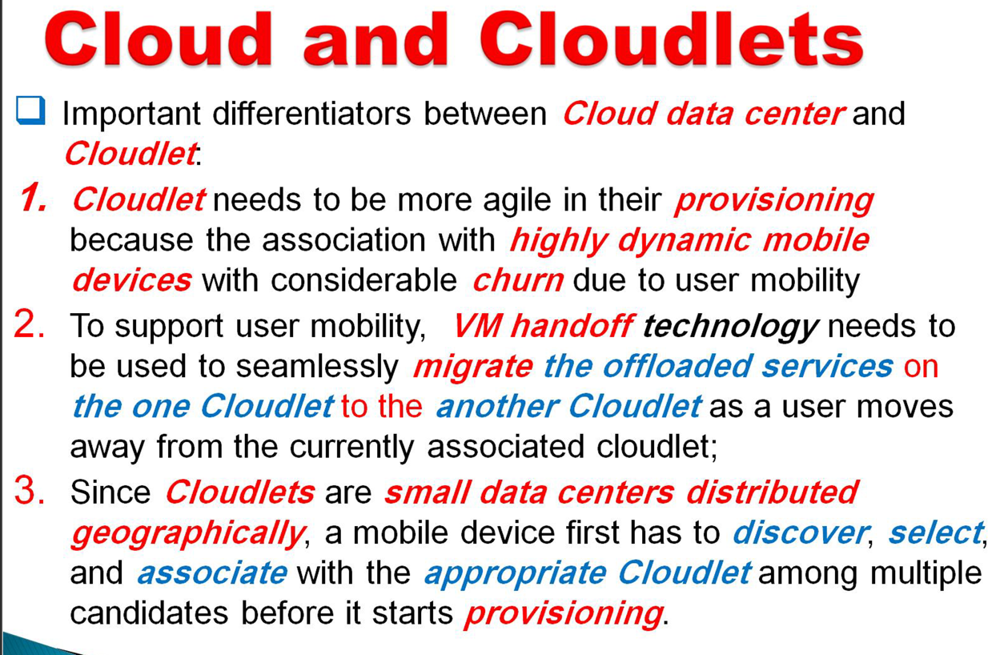

**MOBILE EDGE COMPUTING (MEC)**

Mobile/Multi-access Edge Computing (MEC):

* "To bring computational and storage capacities to the edge of the network within the Radio Access Network to: **Reduce latency and improve context awareness.**
* The MEC nodes or servers are usually co-located with the **Radio Network Controller** or a **macro base-station**.
* The servers run multiple instances of MEC host which has the capabilities to perform computation and storage on a virtualized interface."

**Fog Computing:** placing some processes and resources at the edge of the Cloud, instead of establishing channels for Cloud storage and utilization.