*L.x zo*

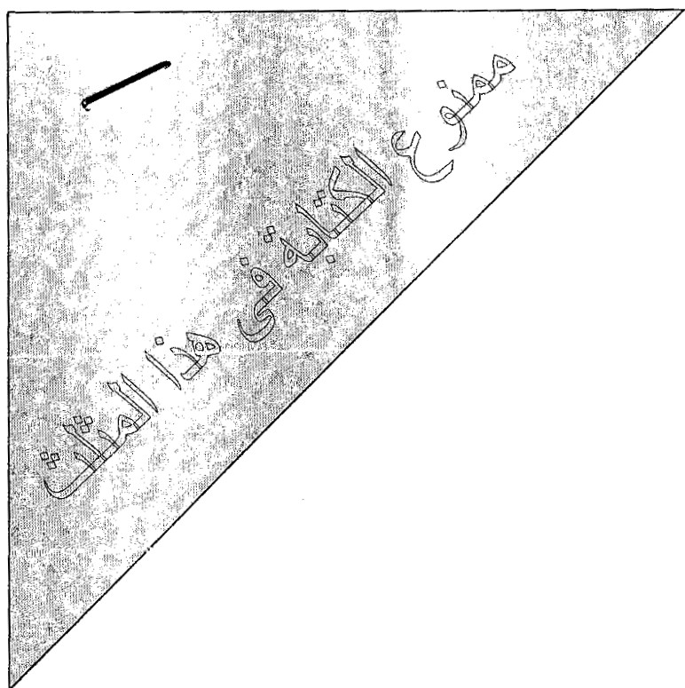

***Question 1{20 marks]***

## Select the correct answer (4 marks)

1- The search strategy which is complete, i.e., always finds a soh:tion if there is one.

a) Breadth -first search b) Depth-first search

1. The search strategy which is optimal, i.e., always finds the best solution.

a) Greedy search b) Uniform search

1. In constraints satisfaction problems, the heuristic which orders the variable to consider is

a) Minimum remainin g value b) Degree heuri stic

***4-*** In game playin g, a function used to evaluate each move "board configuration " to

decide what is the best single move to make next is called

a) Utility function b) heuri stic function

## Compare between the followin (6 rnarks)

|  |  |  |
| --- | --- | --- |
| **Search Strategy** | Informed search strategies | Uninformed search strategies |
| Techniques |  |  |
| Advantage |  | --- |
| Dis-  advantage |  |  |

1. **State True/False (Explain in case of false) [10 marks]**
   1. The class precedence list i s used by the inference mechanism in semantic network
   2. The *primary* purpose of the OPEN list in search is to produce the path from the goa l node found

back to the initial state

* 1. A lgorithm A* =U niform Cost Search + Greedy Search
  2. In semantic network s, nodes are used to represent relationships between the objects
  3. Unlike standard search problem , CSP is consider the state as a "bl ack box"
  4. Informed search requires domain-specific know ledge about the problem
  5. The backtrackin g techniqu e used for solving a CSP apply breadth first with single variable

assignment at each leve l

* 1. In order to improve the efficiency of generated and test algorithms, heuristic is used to select

the variables

* 1. Alpha-Beta is a breath first search algorithm

*10-* Any *knowledge repr esentation language* is d e fined by only syntax and sem atic aspects

**Question 2 [20 marks]**

* 1. Find a proposition with three variables p, q, and r that is true when p and r are true

and q is false, and false otherwise. [**1 marks]**

* 1. Find a proposition with three variables p, q, and r that is never true. **[1 marks]**
  2. Determin e whether p (q r) and p (q A r) are equivalent . **[1 marks)**
  3. Determine whether this proposition is a tautology: ((p _,g) A q) _,p. **[2 marks]**
  4. A student is asked to give the negation of ·'all bananas are ripe". [3 **marks]**
     1. The student respond s "no bananas are ripe". Explain why this is not correct.
     2. Another student says that the negation of the statement is "some bananas are ripe".

Expl ain why this is not correct.

* + 1. Give the correct nega tion.
  1. Consider the following sentences:
* The members of Giza Club are Moham ed, Mona, and Iman .
* Mohamed is married to Mona.
* Am ir is !man 's brother.
* The partner (husband/wife) of every married person in the Club is also in the

Club.

* The last meeting was at Mohamed's house.

1. Translate these (premises) sentences into Predicate Logic using the following predicates: member/ 1. married/2, brother/2, lastmeeting/ 1 **[4 marks]**
2. Convert the premises into conjunctive normal form (CNF). **[4 marks)**
3. Prove the following sentence is true given the premise s using **Proof by Resolution : [4 marks]**

The last meeting of the Club was at Mona's house.

Note that the sentence should be proved to be true. If you cannot reach this conclu sion, then add the necessary sentence to your knowledge base and then construct the proof.

**Question 3 [20 marks]**

* 1. In the search tree below, the G node is a goa l node, List the nodes created by:
     1. Breadth Depth
     2. The iterati ve-deepening algorithm **[4 marks]**

*v*

/

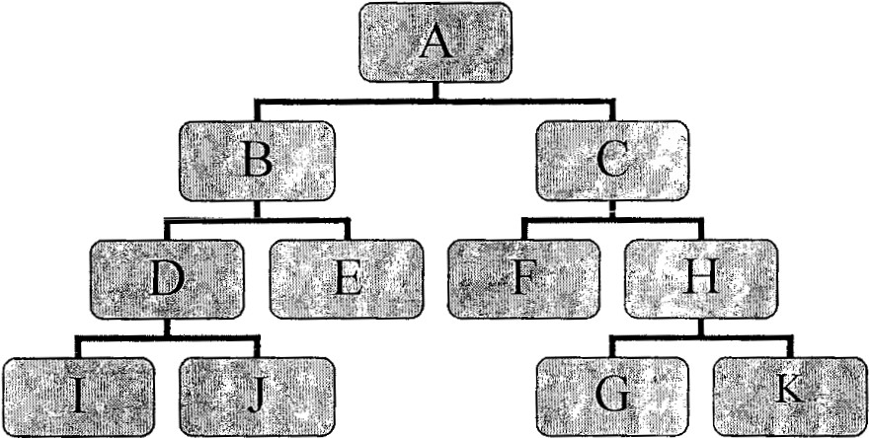

*Bj* Apply the *minimax* algorithm to the partial gam e tree below, where it is the maximum's tum to

pl ay. Write the estimated va lues of the intermediate nod es inside their circles, and indicate the proper move of the maximum by circling one of the root's outgoing arcs. Then, list leaf nodes which could be pruned when using Alpha-Beta. **[4 marks]**

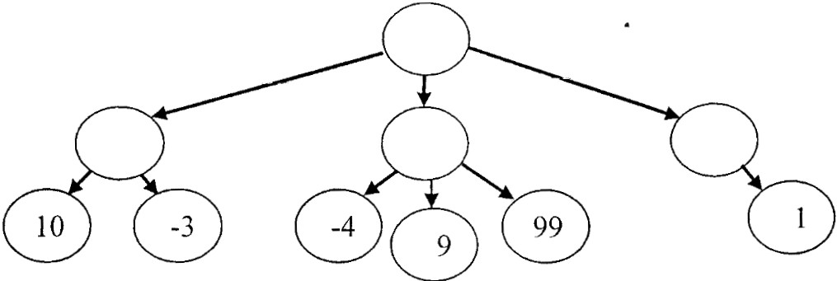

1. Consider the following search space where we want to find a path from the start state

S to the goal state G. The following table shows two different heuristic functions *hi*and *h2.*

[12 **marks]**

# 5

|  |  |  |
| --- | --- | --- |
| NODE | *Hi* | *H2* |
| A | 3 | 5 |
| B | 4 | 2 |
| c | 2 | 5 |
| D | 5 | '>  .) |
| G | 0 | 0 |

*[;\/ (?*'"--

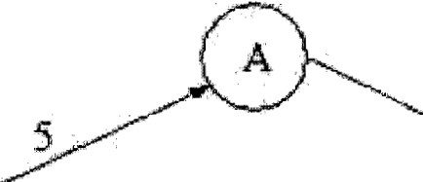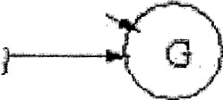

2

v *y* /

&.- (rVs

D l

*J*

Give the solution paths fou nd using each of the heuristic functions, for the following search algorithms:

* 1. Greedy Best-First
  2. Un iform Cost 3- A * algorith m

Greedy Best-First