Q1)

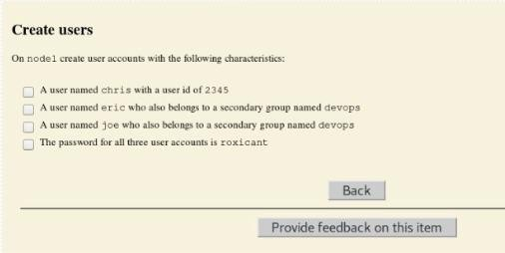

useradd -u 2345 chris

passwd chris --> roxicant

groupadd devops

useradd eric

passwd eric --> roxicant

useradd -G devops eric

useradd joe

passwd eric --> roxicant

useradd -G devops joe

=========================================================

Q2)

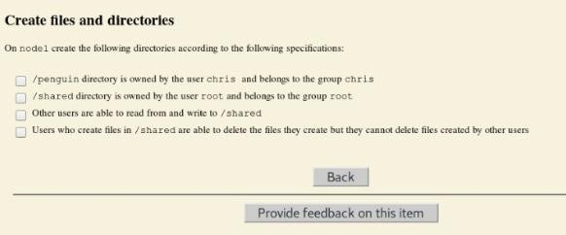

Mkdir /penguin

Chown chris:chris /penguin

Chown root:root /shared

Chmod o+rw /shared

Chmod o+t /shared

=========================================================

Q3)

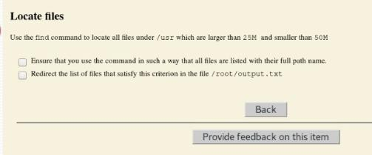

find /usr -size +25M -size 50M > /root/output.txt

Q4)

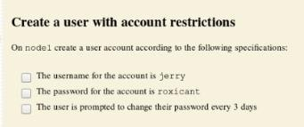

useradd jerry

passwd hosni --> roxicant

chage -M 3 jerry

chage -d 3 jerry

chage -l jerry

=========================================================

Q5)

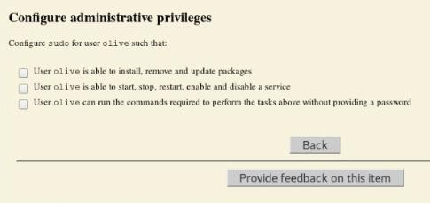

which yum ====> /usr/bin/yum

which systemctl ====> /usr/bin/systemctl

vim /etc/sudoers.d/olive

(

olive ALL=(ALL) /usr/bin/yum install *

olive ALL=(ALL) /usr/bin/yum remove *

olive ALL=(ALL) /usr/bin/yum update *

olive ALL=(ALL) /usr/bin/systemctl start *

olive ALL=(ALL) /usr/bin/systemctl stop *

olive ALL=(ALL) /usr/bin/systemctl enable *

olive ALL=(ALL) /usr/bin/systemctl disable *

olive ALL=(ALL) /usr/bin/systemctl restart *

olive ALL=(ALL) NOPASSWD:ALL

)

=========================================================

Q6)

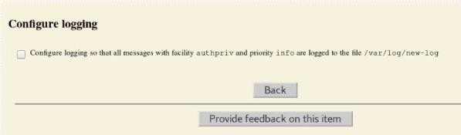

vim /etc/rsyslog.d/authpriv.conf

(

authpriv.info /var/log/new-log

)

systemctl restart rsyslog

logger -p authpriv.info "test"

tail /var/log/new-log

=========================================================

Q7)

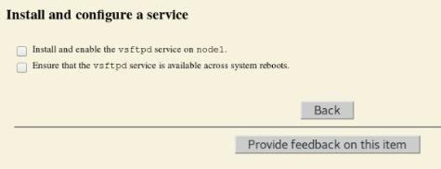

yum install vsftpd

systemctl start vsftpd

systemctl enable vsftpd

systemctl is-active vsftpd

systemctl is-enabled vsftpd

=========================================================

Q8)

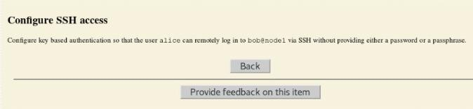

[root@node1 ~] su - alice

[alice @node1 ~] ssh-keygen

[alice @node1 ~] ssh-copy-id bob@node1

[alice @node1 ~] ssh bob@node1

=========================================================

Q9)

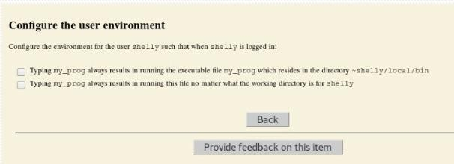

Su - shelly

export PATH=${PATH}:~shelly/local/bin

my_prog

=========================================================

Q10)

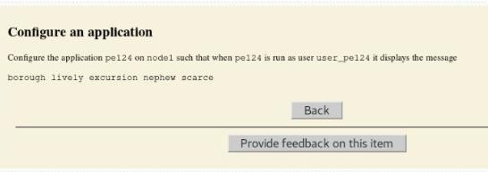

Su – user_pe124

vim .bashrc

under #user specific environment: add your message

echo "hello "`borugh lively excursion nephew scarce`

=========================================================

Q11)

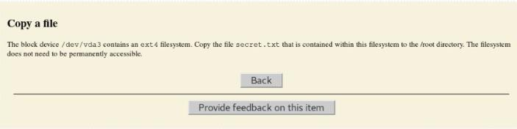

mount /dev/vda3 /mnt

cd /mnt

ls ======> secret.txt

cp secret.txt /root