

Cairo University
جامعة القاهرة
Faculty of Computers and Artificial Intelligence
Final Exam
- Maximum number of nodes in a binary tree with height k, where root is height 0, is
(A) 2^{k} − 1 (B ) 2^{k+1} – 1 (C) 2^{k-1} + 1 (D) 2^{k} – 1
- Quick sort algorithm is an example of
A - Greedy approach B - Improved binary search C - Dynamic Programming D - Divide and conquer
- The minimum number of edges required to create a cyclid graph of n vertices is
A – n B - n - 1 C - n + 1 D - 2n
- Which of the following is example of not in-place algorithm?
A - Bubble Sort B - Merge Sort C - Insertion Sort D - All of the above
- Time required to merge two sorted lists of size m and n, is
A - Ο(m | n) B - Ο(m + n) C - Ο(m log n) D - Ο(n log m)
- Which of the following uses memorization?
A - Greedy approach B - Divide and conquer approach C- Dynamic programming approach D - None
- Heap is an example of
A - complete binary tree B - spanning tree C - sparse tree D - binary search tree
- Access time of a binary search tree may go worse in terms of time complexity upto
A - Ο(n²) B - Ο(n log n) C - Ο(n) D - Ο(1)
- What will be the Huffman code for the letters a,b,c,d,e? if The probability are ½,1/4, 1/8,1/16,,1/32
(a) 0,10,110,1110,1111 (b)10,011,11,001,010 (c)10,01,0001,100,1010 (d)100,110,001,000,010
- From the following sorting algorithms which algorithm needs the minimum number of swaps
A. Bubble Sort B. Quick Sort C. Merge Sort D. Selection Sort
- From the following sorting algorithms which has the lowest worst case complexity?
A. Bubble Sort B. Quick Sort C. Merge Sort D. Selection Sort
- Match the following pairs
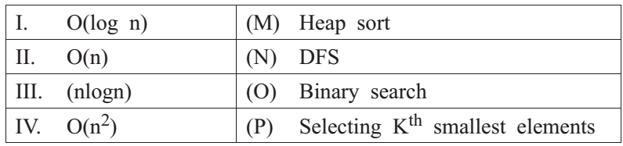
A I-P, II-M, III-N, IV-O B I-O, II-P, III-M, IV-N
C I-O, II-N, III-M, IV-P D I-O, II-N, III-P, IV-M

- What shall be value of x in the following pseudocode?
x = 0; For (t = 1; t< N; t++) For( p = 1; p<= t; p++)
x = x+1; Endfor Endfor
- x=N+1 B- x=N(N-1)/2 C- x=N(N+1)/2 D- x=N^2
- Time complexity of merging three sorted lists of sizes m, n and p is
A Θ(m+n+p) B Θ(min(m,n,p)) C Θ(max(m,n,p)) D Θ (m.n.p)
- Which of the algorithm design approach is used by Mergesort
A-Branch and bound approach B-Dynamic approach
C-Divide and Conquer approach D-Greedy approach
- Which of the following shortest path algorithm cannot detect -presence of negative weight cycle graph?
A-Bellman Ford Algorithm B-Floyd-Warshall Algorithm
C-Dijsktra’s Algorithm D-None of the above

- For the figure below, starting at vertex A, which is a correct order for Prim’s minimum spanning tree algorithm to add edges to the minimum spanning tree?
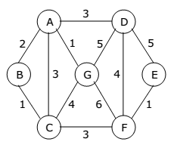
(A,G) then (G,C) then (C,B) then (C,F) then (F,E) then (E,D)
(A,G) then (A,B) then (B,C) then (A,D) then (C,F) then (F,E)
(A,G) then (B,C) then (E,F) then (A,B) then (C,F) then (D,E)
(A,G) then (A,B) then (A,C) then (A,D) then (A,D) then (C,F)
- For the figure below, which is a correct order for Kruskal’s minimum spanning tree algorithm to add edges to the minimum spanning tree?
(A,G) then (G,C) then (C,B) then (C,F) then (F,E) then (E,D)
(A,G) then (A,B) then (B,C) then (A,D) then (C,F) then (F,E)
(A,G) then (B,C) then (E,F) then (A,B) then (C,F) then (D,E)
(A,G) then (A,B) then (A,C) then (A,D) then (A,D) then (C,F)

- If G is an directed graph with 20 vertices, how many boolean values will be needed to represent G using an adjacency matrix?
A-20 B-40 C- 200 D-400
- What is the special property of red-black trees and what root should always be?
a) a color which is either red or black and root should always be black color only
b) height of the tree c) pointer to next node d) a color which is either green or black
- Why do we impose restrictions like . root property is black . every leaf is black . children of red node are black . all leaves have same black
a) to get logarithm time complexity b) to get linear time complexity
c) to get exponential time complexity d) to get constant time complexity
- What are the operations that could be performed in O(logn) time complexity by red-black tree?
a) insertion, deletion, finding predecessor, successor
b) only insertion c) only finding predecessor, successor d) for sorting
- Why Red-black trees are preferred over hash tables though hash tables have constant time complexity?
a) no they are not preferred
b) because of resizing issues of hash table and better ordering in redblack trees
c) because they can be implemented using trees d) because they are balanced
- What is the below pseudo code trying to do, where pt is a node pointer and root pointer?
redblack(Node root, Node pt) :
if (root == NULL) return pt
if (pt.data < root.data)
{
root.left = redblack(root.left, pt);
root.left.parent = root
}
else if (pt.data > root.data)
{
root.right = redblackt(root.right, pt)
root.right.parent = root
} return root
- insert a new node B ) delete a node C) search a node D) count the number of nodes
- Dijkstra’s Algorithm is used to solve _____________ problems.
a) All pair shortest path b) Single source shortest path c) Network flow d) Sorting
- What is the time complexity of Dijikstra’s algorithm?
a) O(N) b) O(N³) c) O(N²) d) O(logN)
- Dijkstra’s Algorithm cannot be applied on ______________
a) Directed and weighted graphs b) Graphs having negative weight function
c) Unweighted graphs d) Undirected and unweighted graphs
- How many priority queue operations are involved in Dijkstra’s Algorithm?
a) 1 b) 3 c) 2 d) 4
- How many times the insert and extract min operations are invoked per vertex?
a) 1 b) 2 c) 3 d) 0
- The maximum number of times the decrease key operation performed in Dijkstra’s algorithm will be equal to ___________
a) Total number of vertices b) Total number of edges c) Number of vertices – 1
d) Number of edges – 1

- What is running time of Dijkstra’s algorithm using Binary min- heap method?
a) O(V) b) O(VlogV) c) O(E) d) O(ElogV)

- Consider the following graph

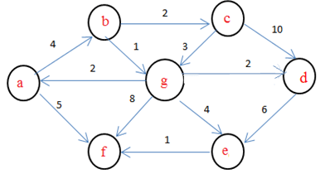

If b is the source vertex, what is the minimum cost to reach f vertex?
a) 8 b) 9 c) 4 d) 6

- In the given graph:
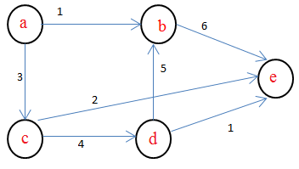

Identify the shortest path having minimum cost to reach vertex E if A is the source vertex
a) a-b-e b) a-c-e c) a-c-d-e d) a-c-d-b-e

- Dijkstra’s Algorithm is the prime example for ___________
a) Greedy algorithm b) Branch and bound c) Back tracking d) Dynamic programming

Good Luck
Dr Basheer Youssef.

