

Cairo University
جامعة القاهرة
Faculty of Computers and Artificial Intelligence
Final Summer Exam

Question (1) [ 26 points one for each] Write T for True or F False.
جامعة القاهرة

# | Item | Tor F
1 | For two algorithm s A and B, if O(A) = n^100 and O(B) = 10^n, then algorithm A is the better choice | T
2 | To perform a binary search the data set must be sorted. | T
3 | There is a significant difference in the running time f(n) = n and the running time g(n) = lg n. | T
4 | The master method can be used to solve all recurrence equations that have the form T(n) = aT(n/b) + f(n). | T Or F two answer accepted
5 | Printing every node in a balanced tree takes θ(lg n) time | F
6 | In a red-black tree, a black node must have only red children | F
7 | Dynamic programming has the potential to transform exponential-time algorithms to polynomial time | T
8 | In Kruskal's algrorithm for building a minimum spanning tree, we proceed node by node, adding the connecting edges to the tree | F
9 | Huffman encoding uses a dynamic programming strategy to compress data | F
10 | minimum spanning tree has |V| -1 edges | T
11 | Both matrix and lists can be used to represent weighted graphs | T
12 | A matrix is a good choice for representing a dense graph. | T
13 | We do not have to make any key comparisons to find the min or max nodes of a binary search tree. | T

Question (2) [13 points one for each ] Chose the correct answer
- Select the correct asymptotic notation for the function f(n) n^3 + 1000 - 100n^2 - 100n.
A. θ(n^3) B. O(n^3) C. O(n lg n) D. Ω(2^n)
- Greedy algorithms make _______________optimal choices leading to _______________ optimal solutions.
A. Globally, locally B. Top-down, bottom-up C. Locally, globally D. Bottom-up, top-down
- The basic restructuring operation for red-black trees is
A. Dynamic programming B. Binary sort C. Depth-first search D. Rotation
- . Bottom-up dynamic programming works by
A. Doubling the recursive calls
B. Transforming recursive calls to a loop
C. Solving the same subproblem multiple times
D. Solving larger subproblems first, followed by smaller subproblems
- What is the name of the technique that stores computed values for future lookup, rather than recomputing them?
A recursion tree B Topological sort C. amortize analysis D.Dynamic Programming
- Which of the following is NOT a property of a minimum spanning tree?
A It may have one or more cycles. B. It has |V| -1 edges.
C. It is not necessarily unique. D. The sum of weights of the edges is minimal.
- Which of the following is true regarding Prim's algorithm for finding a minimum spanning tree?
A. The starting node must be connected to the edge with the least weight.
B. The algorithm grows only a single tree from start to finish.
C. "Marked" nodes indicate nodes that will not be in the final tree.
D. When selecting the next edge, we consider only edges that connect unmarked nodes to the other unmarked nodes.
- What distinguishing feature should cause us to choose dynamic programming rather than a divide-and-conquer approach to a problem?
A. It is an optimization problem. B. The problem can be solved recursively.
C. The problem does not have a brute force solution. D. The subproblems for the solution overlap.
- Which one of the following is a true for a red-black tree?
A. The root is red.
BThe root and leaves are black.
CAll simple paths from a node to the leaves contain the same number of red and black nodes.
D A red node can have only one black child.
- The recurrence equation T(n) = T(n-1) + θ(n) represents the
A. Best case running time for Quicksort B. Worst-case running time for Quicksort
C. Best-case running time for Heapsort D. Worst-case running time for Heapsort
.
- An algorithm that takes constant time is represented by
A. Ω(o) B. W(g(n)) C. θ(n) D. θ(1)
- Given the algorithm for Bubblesort below, what is an accurate description of it's running time? BUBBLESORT(A) for I = 1 to A.length -1 for j = A.length downto I + 1 If A[j] < A[j-1] exchange A[j] with A[j-1]
A. T(n-1) + θ(n) B. θ(n^2) C. 2T(n/2) + θ(1) D. O(n)
- What is the smallest value of n such that an algorithm whose running time is n^2 runs slower than an algorithm whose running time is 3n + 1?
A. 2 B. 25 C. 4 D. 15
Question (3) [5 point ]
k-way-Merge Sort. Suppose you are given k sorted arrays, each with n elements, and you want to combine them into a single array of kn elements. Consider the following approach. Using the merge subroutine taught in lecture, you merge the first 2 arrays, then merge the 3rdgiven array with this merged version of the first two arrays, then merge the 4th given array with the merged version of the first three arrays, and so on until you merge in the final (kth) input array.
- the is the running time taken by this successive merging algorithm, as a function of k and n, is.
A. nk B. n²k C. nk² D. 1

Question (4)[5 points ]
- the amortized analysis for dynamic hash table which start by one size and extend 2 power i I in 0 1 ,2 4 8 ……. By aggregation methods
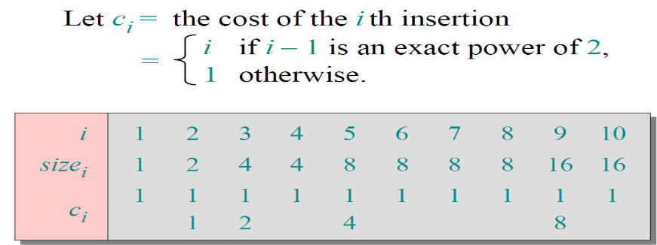
A. n B. C. nlgn D. 1
Question (5) [4 points ]

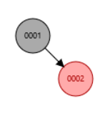
- inserting these numbers in (1,2,3,4 ) in red-blact tree will give the follwing tree
- b B.

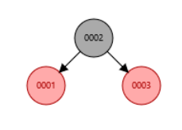
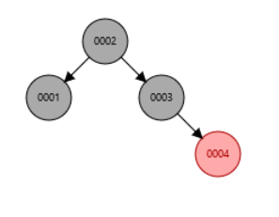
C. D.

Question(7) [27 points ]for
Finding the shortest path for the following graph from node 1 (one) to each nodes using Dijkstra’s algorithm which of the following solution steps are true and which steps are false .
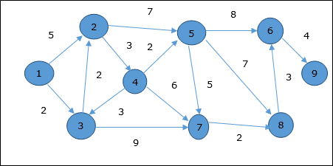
 |  |  | 3 | 1 | 2 | 4 | 8 | 3 | 7 | 6
 | node | 1 | 2 | 3 | 4 | 5 | 6 | 7 | 8 | 9
 |  | 0 | ∞ | ∞ | ∞ | ∞ | ∞ | ∞ | ∞ | ∞
 |  |  | 5 | 2 | ∞ | ∞ | 45 | ∞ | ∞ | ∞
 |  |  | 4 |  | ∞ | 46 | ∞ | 11 | ∞ | ∞
 |  |  |  |  | 7 | 11 | 90 | 11 | ∞ | ∞
 |  |  |  |  |  | 9 | ∞ | 11 | 91 | ∞
 |  |  |  |  |  |  | 17 | 11 | 16 | 96
 |  |  |  |  |  |  | 17 |  | 13 | ∞
 |  |  |  |  |  |  | 16 |  |  | ∞
 |  |  |  |  |  |  |  |  |  | 20

Paths
 | From 1 to 2 | 1-3-2
 | From 1 to 3 | 1-3
 | From 1 to 4 | 1-3-2-4
 | From 1 to 5 | 1-3-2-4-5
 | From 1 to 6 | 1-3-7-8-6
 | From 1 to 7 | 1-3-7
 | From 1 to 8 | 1-3-7-8
 | From 1 to 9 | 1-3-7-8-6-9
Good Luck
Dr Basheer Youssef.

