(20 Marks)
Question1

a- What are different inference mechanisms used in the following general purpose AI knowledge representation scheme: (8 Marks)
- Frames
- Semantic Networks
- First Order Logic
- Rule Based Systems
KR scheme | Inference1 | Inference2 | Inference3
Frames | Multiple Inheritance
Semantic Networks | Intersection search | Inheritance
First Order Logic | Resolutio | Resolution by refutation | Unification
Rule Based Systems

b- Select the best answer (6 marks)

1- The search strategy which is complete, i.e., always finds a solution if there is one.

a) Breadth-first search b) Depth-first search

2- The search strategy which is optimal, i.e., always finds the best solution.

a) Greedy search b) Uniform-cost search

3- A heuristic is

a) A function that represents domain specific knowledge
b) A static evaluation function that always finds the right answer when incorporated into algorithm A
c) A rule that works for almost any problem.

c) Define, discuss, or describe these terms in a sentence or two (6 marks)
- Informed search techniques

- Conflict Resolution
It is the strategy that are used to select Which rule is chosen to fire when there are
many candidate rules for firing. Example: Rule ordering, Recency, Specificity,
Refraction, User-defined priority

- State space
The state-space is the configuration of the possible states and how they connect to each other e.g. the legal moves between states.

Question2

(20 Marks)

a) State True/False (Explain) (6 marks)

(1) Since greedy search minimizes the estimated cost of the path from the current node to the goal, it always finds an optimal solution.

False
estimated cost of the node

(2) Uniform-cost search minimizes the estimated cost of the path from the start through the current node to the goal.
true

(3)Algorithm A = Uniform Cost Search + Greedy Search
true

(4) Alph-Beta is a breath first search algorithm
False
Depth first

b) Consider the following frame system which presents the following: (6 marks)
1- WPI department provides all its employees with free membership to AAA and to American Express (AE).
2- The city of Worcester provides all its residents with free membership to American Express (AE) and to US Airlines Frequently Free program (UFF).
Assume also that Jean works at WPI and lives in Worcester.
1- Give the class precedence list for Jean

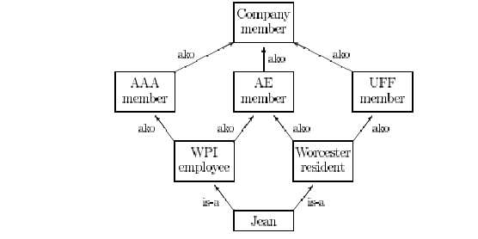

- Jean
- WPI
- AAA
- Woroester
- AE
- UFF
- Company member

2- Suppose that AAA, AE, and UFF provide discounted subscriptions to Science
Magazine for their members with the following percentage:
AAA (40%), AE (30%) and UFF (20%) respectively and assuming that these discounted rates cannot be combined. Which discount will Jean obtain when she subscribes to the magazine? (Based on her class precedence list)

Jean will obtain (40%)

c) In the search tree below, the G node is a goal node, the rest of the nodes are not goal nodes. (8 marks)

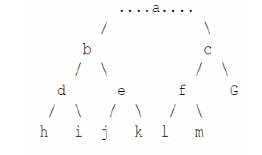

(1) How many nodes would be created by the breadth-first search algorithm?

7

(2) How many nodes would be created by the iterative-deepening search algorithm?

7

(3) List the nodes created by the breadth-first algorithm in their order of creation.

Open list Closed list

{A} {}
A {b c} {a}
B{c d e} {a b}
C {d e f g} {a b c}
D {e f g h I} {a b c d}
E {f g h I j k} {a b c d e}
F {g h I j k l m} {a b c d e f}
G {h I j k l m} {a b c d e f g}

(4) List the nodes created by the iterative-deepening algorithm in their order of creation.

Final {a b d e c f g}

(20 Marks)
Question3

a) Consider the following game tree in which the root corresponds to a MAX node and the values of a static evaluation function are given at the leaves.
(1) What is the minimax value computed at the root node for this tree?
(2) What move should MAX choose?
(3) Which nodes are not examined when Alpha-Beta Pruning is performed? (10 marks)
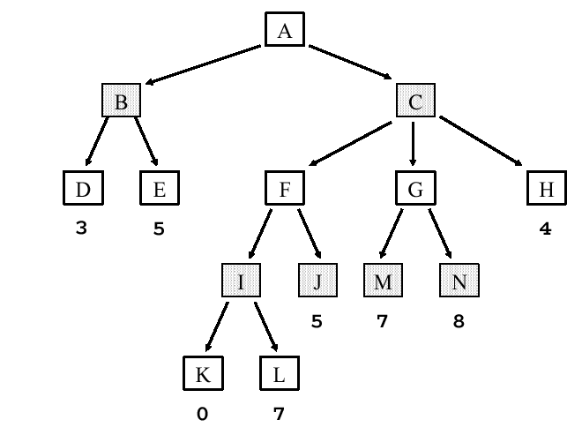
b) Consider the following state space graph where the arcs represent the legal successors of a start node S. The cost of moving to a successor node is given by the number on the arc. The value of a heuristic evaluation function, h, if computed at a state, is shown along side each node. Give the sequence of nodes as they are removed from the NODES list (for expansion or before halting at the goal) for each of the following search methods.
(a) Uniform-Cost search
(b) A* heuristic search
(c) Greedy Best-First (10 marks)

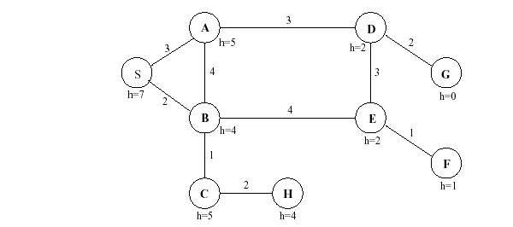

(a) Uniform-Cost search
(b) A* heuristic search
(c) Greedy Best-First

