CAIRO UNIVERSITY
Faculty of Computers and Information

Course: CS361 Artificial Intelligence Midterm Exam Date: 2^{ed} April, 2017
Instructors: Dr. Khaled Wassif & Dr. Cherry Ahmed Allowed Time: 60 minutes

CS | 1
IS | 2
IT | 3
 | 4
 | 5
 | 6
 | 7

Name: ______________________ ID: _________ Group:

Attempt ALL Questions:
Q1) Mark each statement with T or F in the right side: (0.5x10 Marks)
- The set of actions for a problem in a state space is formulated by the transition model.  - Simple reflex agents work only if the environment is fully observable. ( T )  - With problem-solving agents (except contingency problems), a solution is executed without paying attention to percepts.  - Breadth-first search method takes less memory.  - Depth-first search implements queue operation for searching the states.  - Best-first search is complete and optimal when h(n) is consistent.  - Rational agents maximize actual performance, while perfect agents maximize expected performance.  - Greedy search takes the biggest bite possible to reach the goal without worrying about whether this will be best in the long run.  - A problem with fewer restrictions on the actions is called a relaxed problem.  - A local maximum is a peak that is lower than each of its neighboring states but higher than the global maximum. | ( F )  ( T )  ( T )  ( F )  ( F )  ( F )  ( F )  ( T )  ( T )  ( F )
Q2) By Prolog, define a reverse predicate with two lists as arguments: the first is the input list and the other is the reversed list. (3 Marks)
append([ ], L, L).
append([H|T], L1, [H|L2]) :- append(T, L1, L2).
reverse([ ], [ ]).
reverse([H|T], RL) :- reverse(T, RT), append(RT, [H], RL).
Q3) Consider the state space problem shown below: (8 Marks)
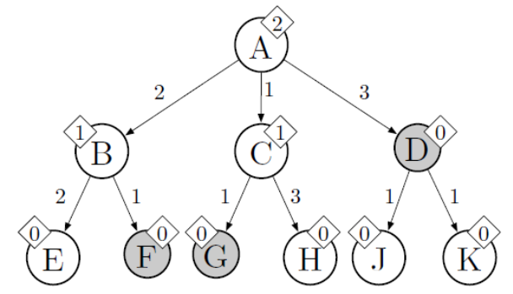

A is the start state and the shaded states (D, F, and G) are goals. Arrows encode possible state transitions, and numbers by the arrows represent action costs. Note that state transitions are directed. Numbers shown in diamonds are heuristic values that estimate the optimal (minimal) cost from that node to a goal.
For each of the following search strategies, give the path that would be returned, or write none if no path will be returned. Also, give all the states that are expanded in the order that they are expanded.
- Depth-first search (ignores costs) (1.5 Marks)
Expanded: A, B, E, F
Path: A, B, F

- Breadth-first search (ignores costs) (1.5 Marks)
Expanded: A, B, C, D
Path: A, D

- Uniform cost search (1.5 Marks)
Expanded: A, C, B, G
Path: A, C, G

- Greedy search (1.5 Marks)
Expanded: A, D
Path: A, D

- A* search (2 Marks)
Expanded: A, C, G
Path: A, C, G

Q4) Describe and evaluate A* search strategy. (4 Marks)
A* evaluates nodes by combining g(n), the cost to reach the node, and h(n), the cost to get from the node to the goal: f(n) = g(n) + h(n). Since g(n) gives the path cost from the start node to node n, and h(n) is the estimated cost of the cheapest path from n to the goal, then f(n) is the estimated cost of the cheapest solution through n.
Thus, if we are trying to find the cheapest solution, a reasonable thing to try first is the node with the lowest value of g(n) and h(n). It turns out that this strategy is more than just reasonable: provided that the heuristic function h(n) satisfies certain conditions. (2 Marks)
Optimal? Yes
  - A∗ is optimally efficient for any given consistent heuristic.
  - No other optimal algorithm is guaranteed to expand fewer nodes than A∗.
Complete? Yes
  - Unless there are infinitely many nodes with f ≤ f(G).
Time complexity? Exponential
Space complexity? Keeps all expanded nodes in memory (2 Marks)

With Our Best Wishes

