# Table of Contents

Contents

Table of Contents 1

1 Individual Reports: 2

1.1 All Students Report: 2

1.2 Active Students Report: 2

1.3 Active Students Report: 3

1.4 Events Report: 3

2 Class Wise Reports: 4

2.1 Class wise students Report: 4

2.2 Class wise active students Report: 4

2.3 Class wise inactive students Report: 4

2.4 Class wise total marks of students Report: 5

2.5 Term wise marks of each class Report: 5

2.6 Class Time Table Report: 5

2.7 Class Attendance Report: 6

2.8 Detailed Class Assessment Report: 6

3 Students Reports: 7

3.1 Student Information Report: 7

3.2 Student Subject Report: 7

3.3 Student Total Marks Report: 8

3.4 Student Term Wise Marking Report: 8

3.5 Student Attendance Report: 8

Following reports are generated in this project:

# Individual Reports:

## All Students Report:

This report contains the data of all the students that are admitted (i.e. active and approved students) in the school in each class.

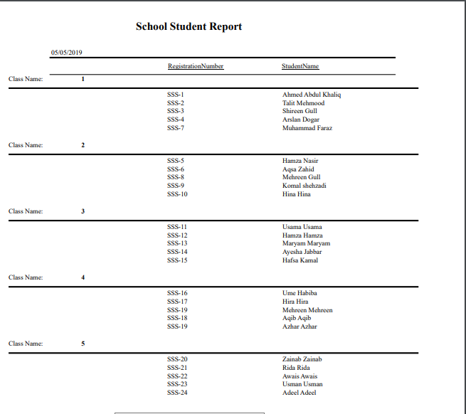

## Active Students Report:

This report shows the detail of all the students that are active (not left or passed out of school, still studying in the school).

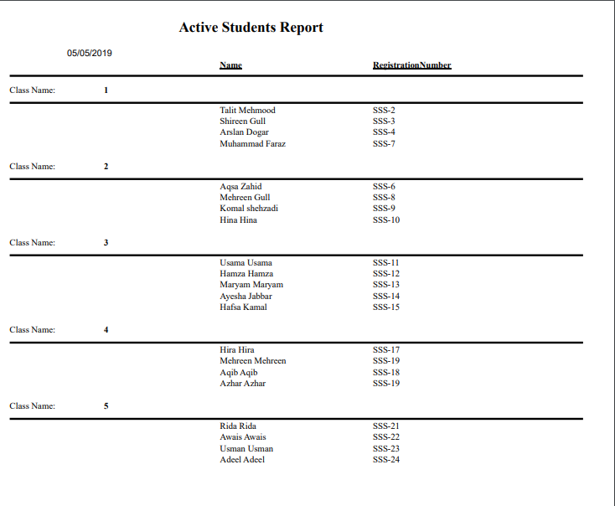

## Active Students Report:

This report shows the information of students that are passed out of the school.

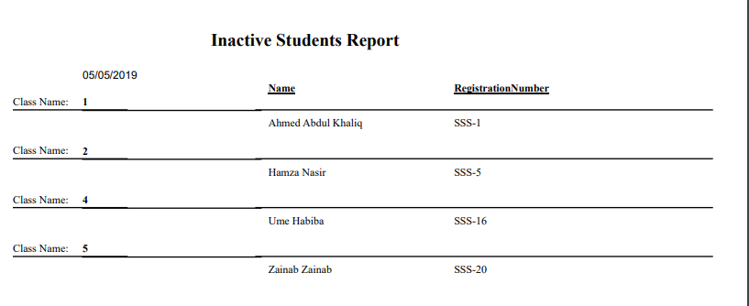

## Events Report:

This report shows all the events that are going to occur in the school added by administrator.

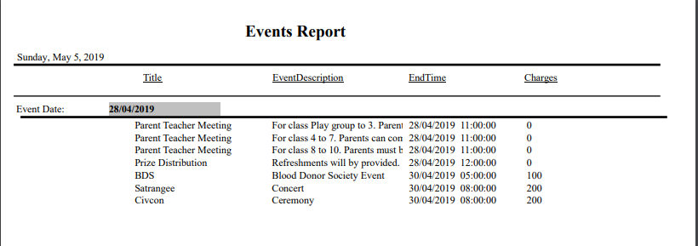

# Class Wise Reports:

## Class wise students Report:

This report shows the student of class that is selected by the user (in this picture report of students of class 1 are shown).

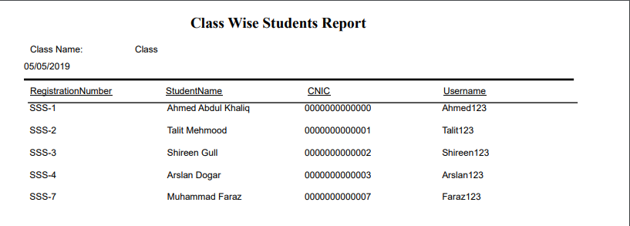

## Class wise active students Report:

This report shows the active students of class that is selected.

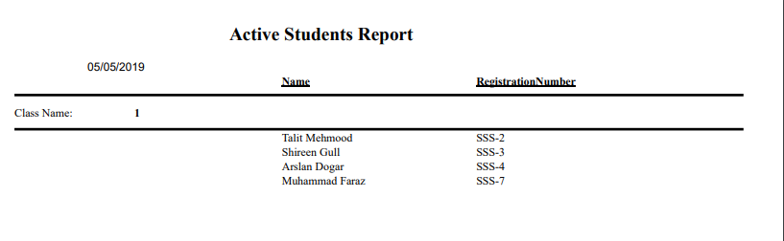

## Class wise inactive students Report:

This report shows the inactive students of class that is selected.

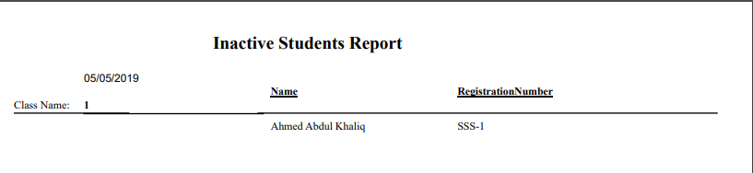

## Class wise total marks of students Report:

This report shows the total marks of all students of class that is selected.

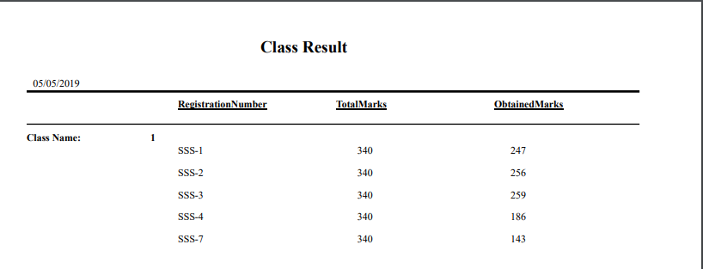

## Term wise marks of each class Report:

This report shows the term wise total marks of students of class that is selected.

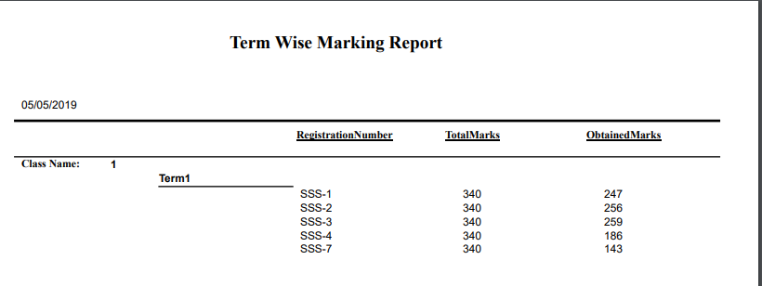

## Class Time Table Report:

This report shows the time table of class that is selected.

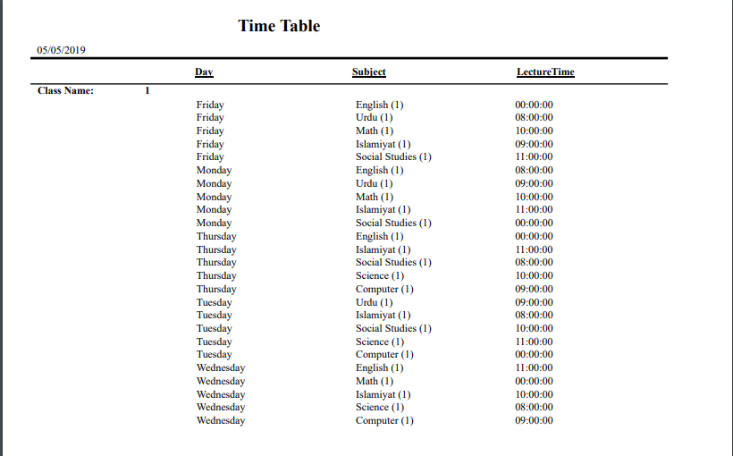

## Class Attendance Report:

This report shows all attendances of class that is selected.

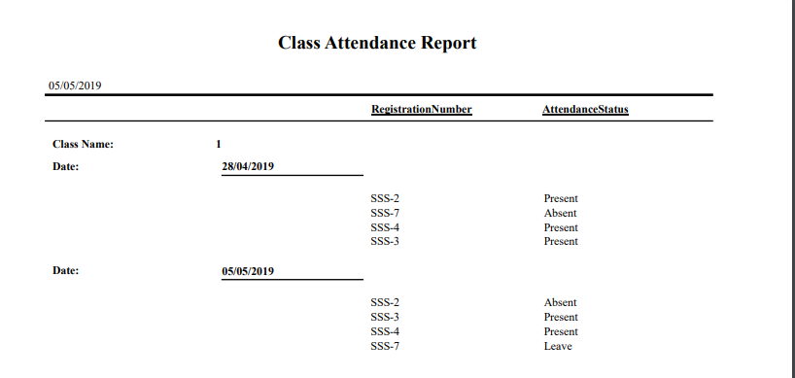

## Detailed Class Assessment Report:

This report shows all assessments of class that is selected in all subjects.

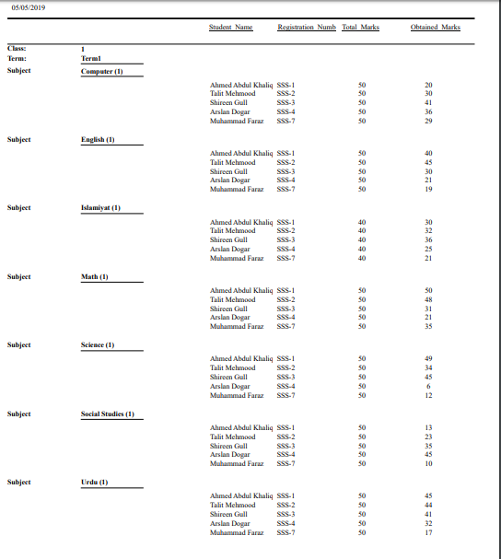

# Students Reports:

## Student Information Report:

This report shows the data of particular student.

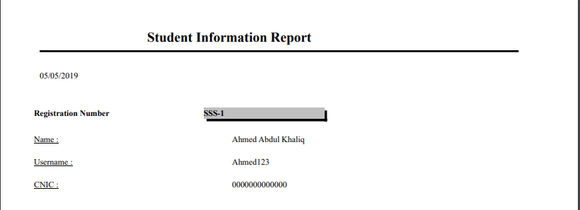

## Student Subject Report:

This report shows the subject of particular student that he/she is studying.

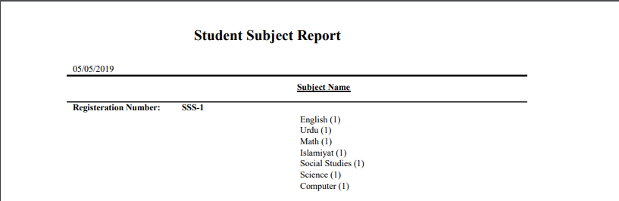

## Student Total Marks Report:

This report shows the total marks of particular student.

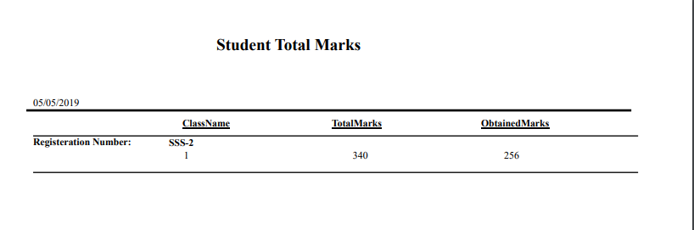

## Student Term Wise Marking Report:

This report shows the term wise marks of particular student.

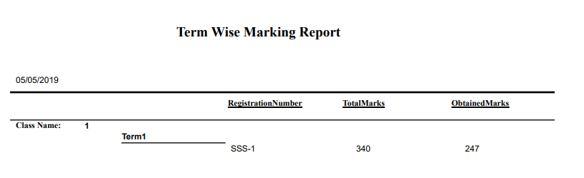

## Student Attendance Report:

This report shows the attendance of student.

