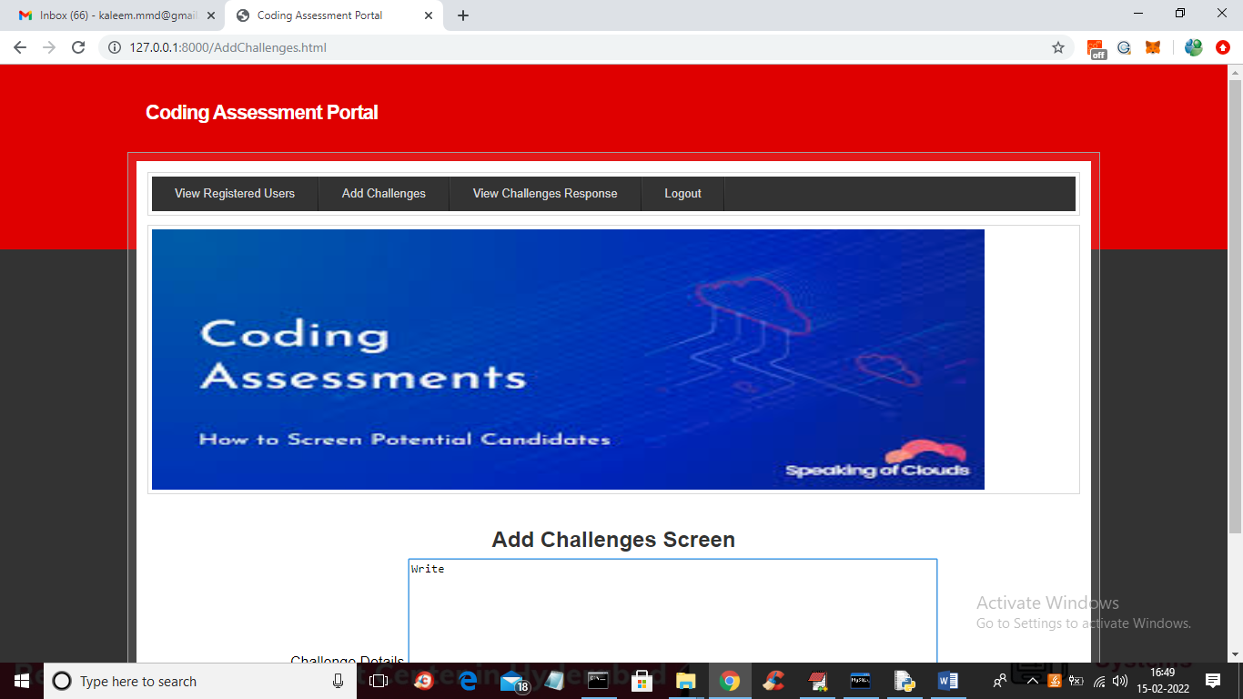

In above screen admin can click on ‘Add Challenges’ screen to add challenges like below screen

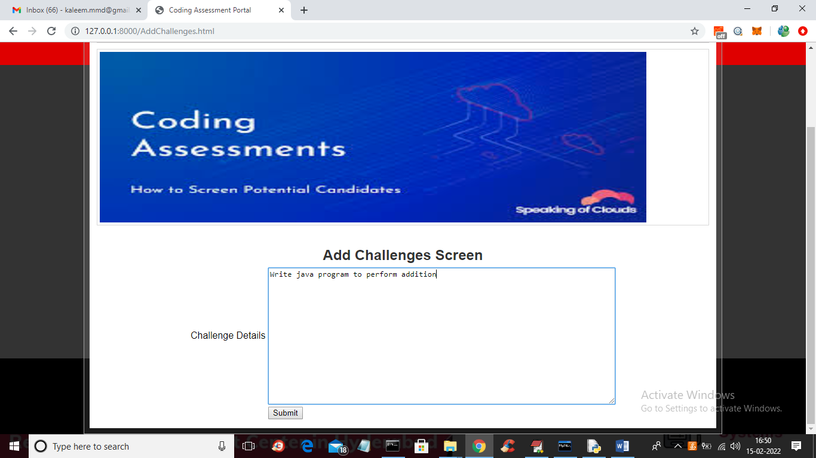

In above screen admin can write challenges as program topic and press submit button to get below output

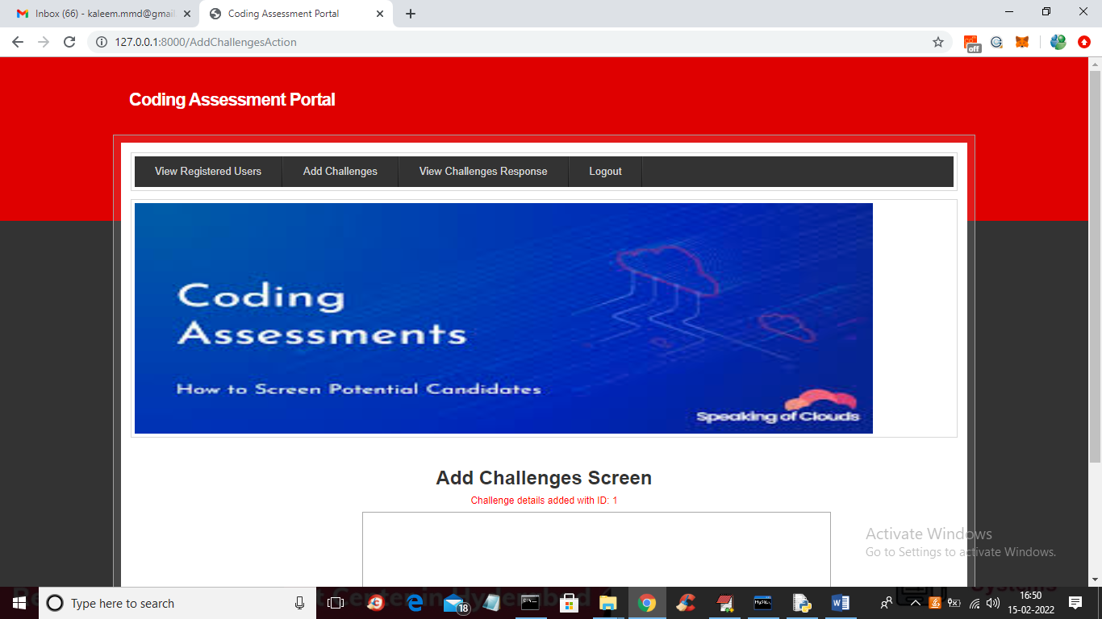

In above screen challenge is added with ID 1 and now logout and login as student to accept that challenge

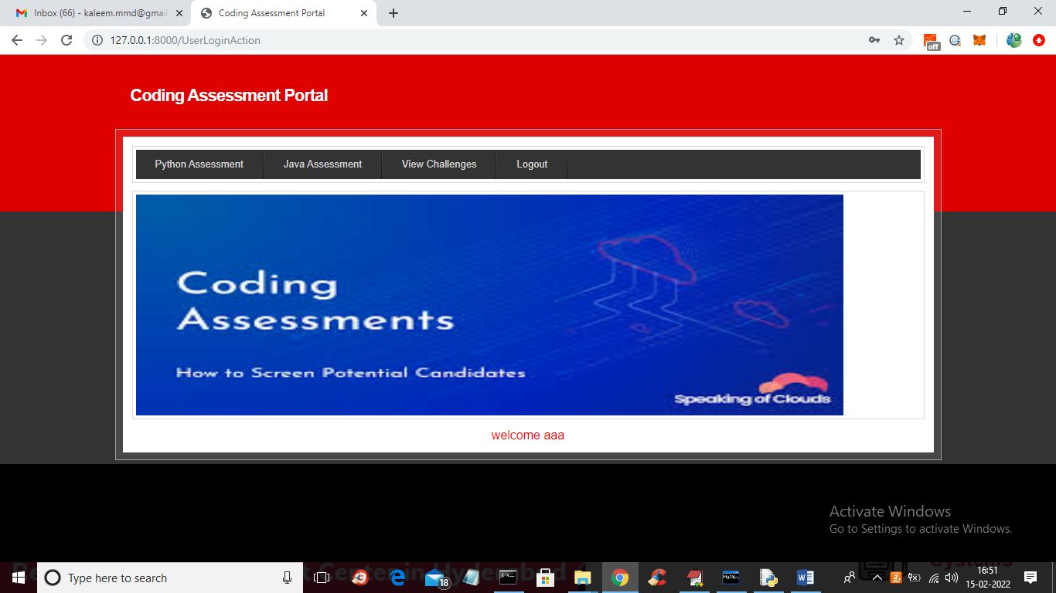

In above screen students can click on ‘View challenges’ link to view all challenges added by admin like below screen

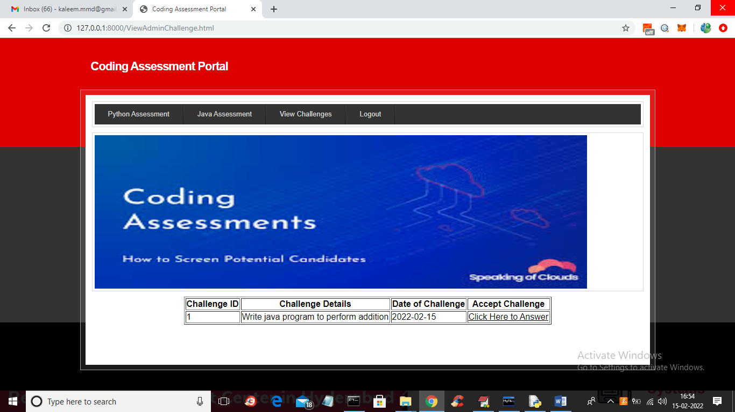

In above screen users can view all challenges and then click on ‘Click Here to Answer’ link to submit answer and to get below screen

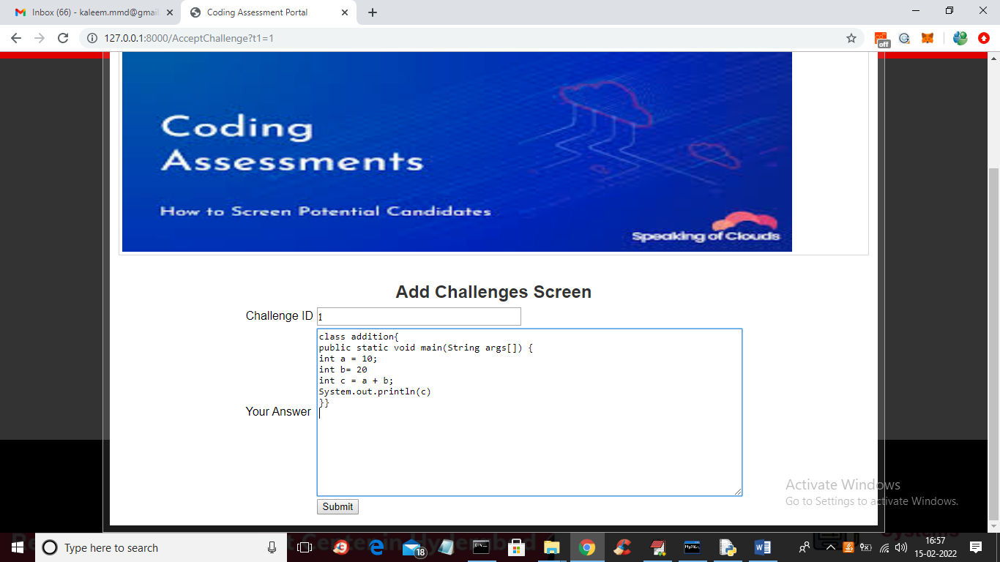

In above screen student will write answer and press submit button to get below output

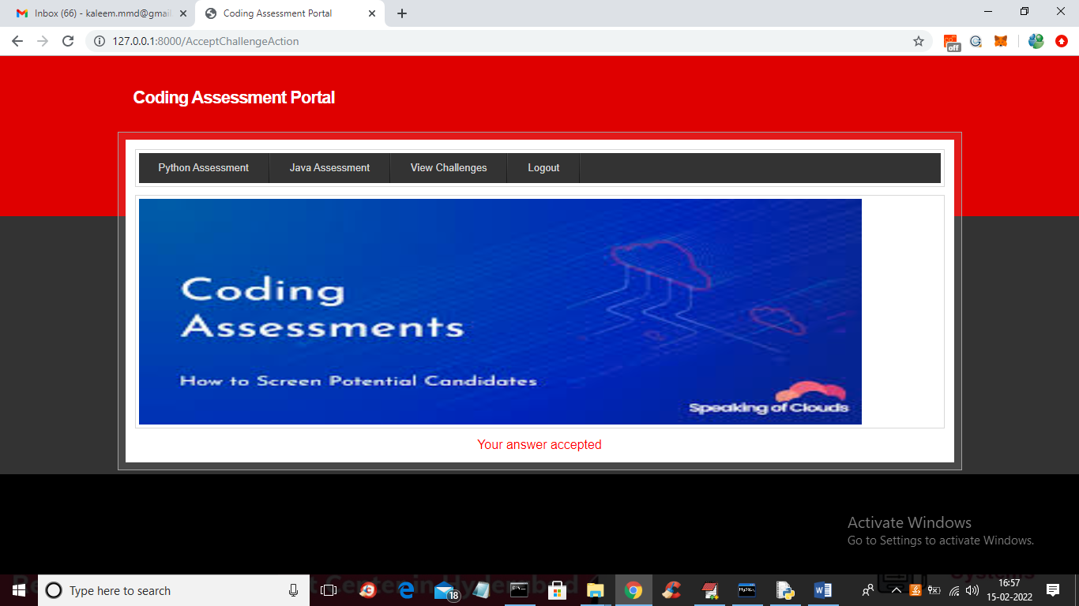

In above screen we can see student answer accepted and now student click on ‘View Challenges’ link to get below output

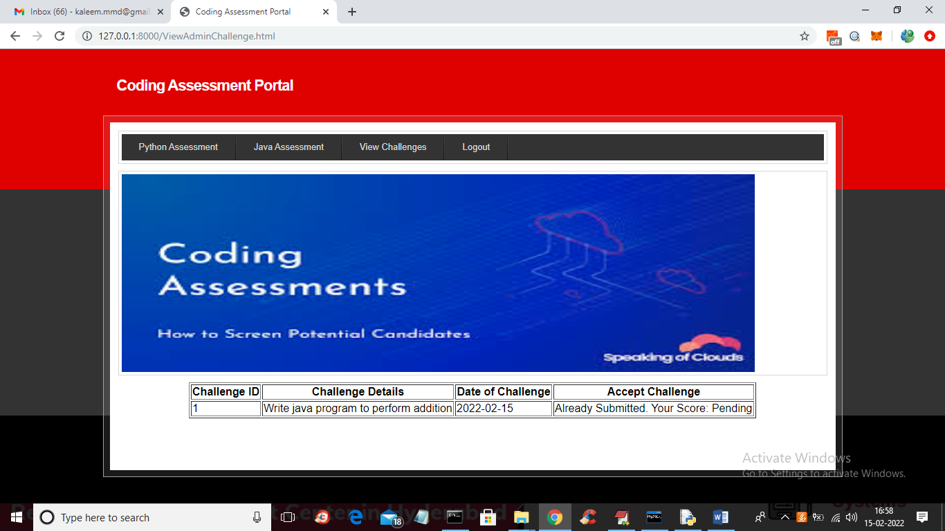

In above screen we got response as ‘answer already submitted and score is pending and once admin give score then user can view that score and now logout and login as admin to give score

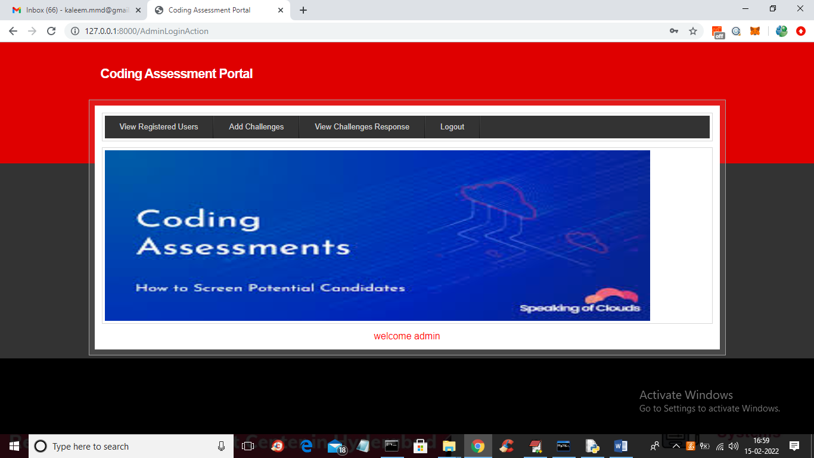

In above screen admin can click on ‘View Challenges Responses’ link to view user answer and give score

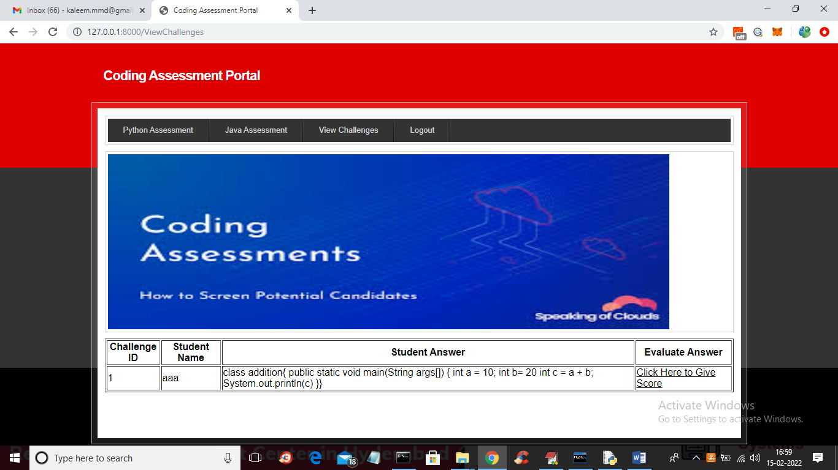

In above screen admin can view all users answers an now click on ‘Click Here to Give Score’ link to give score to that user like below screen

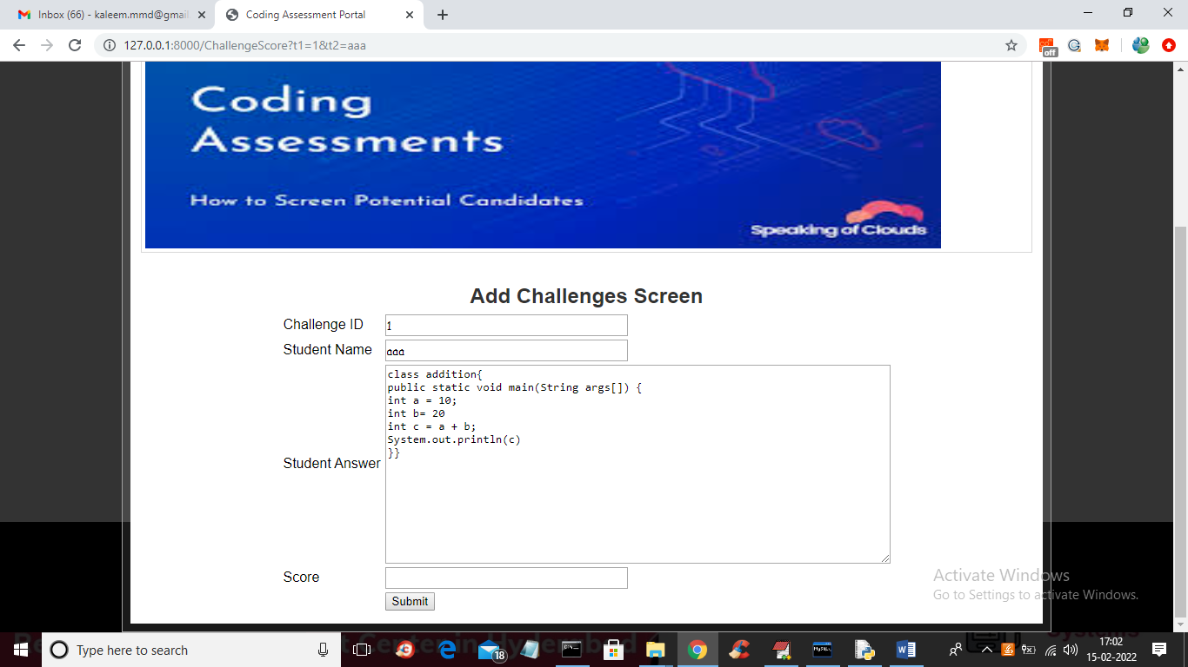

In above screen admin can view all answer and then enter score value and then press submit button to assign score to that student

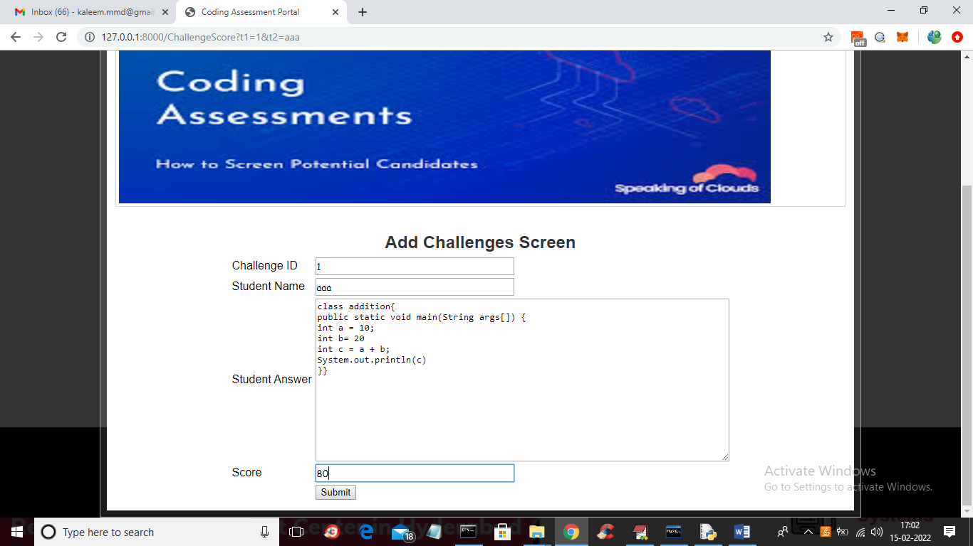

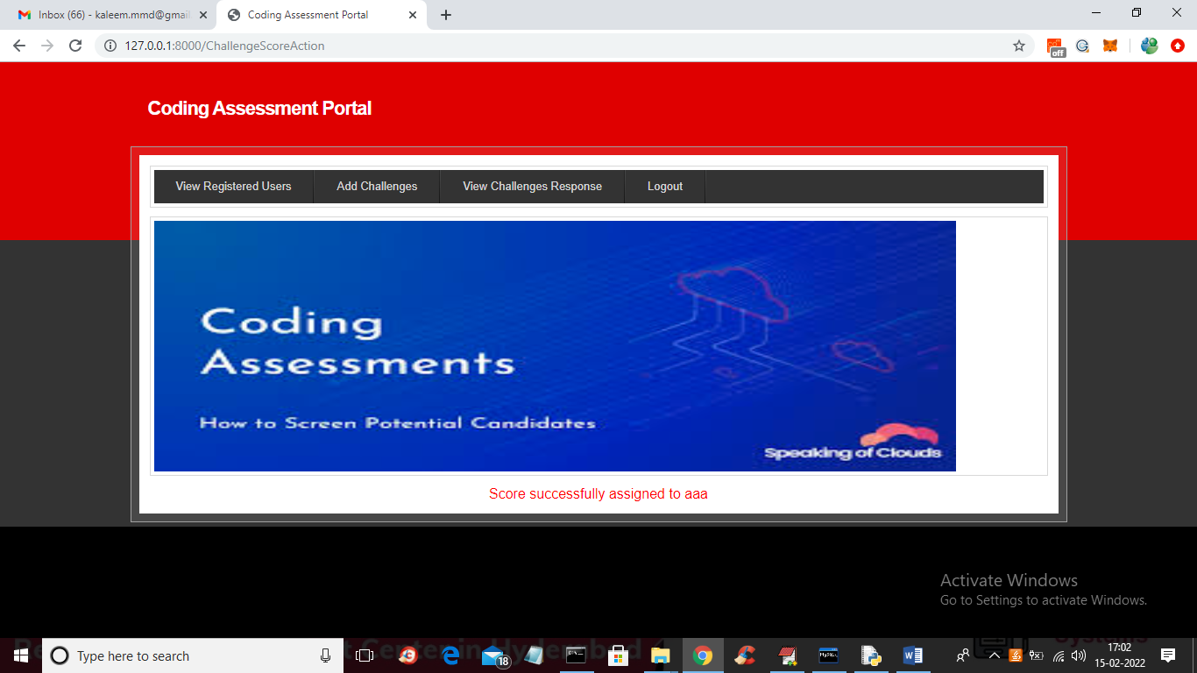

In above screen score 80 is given to student and logout and login as student to view that score

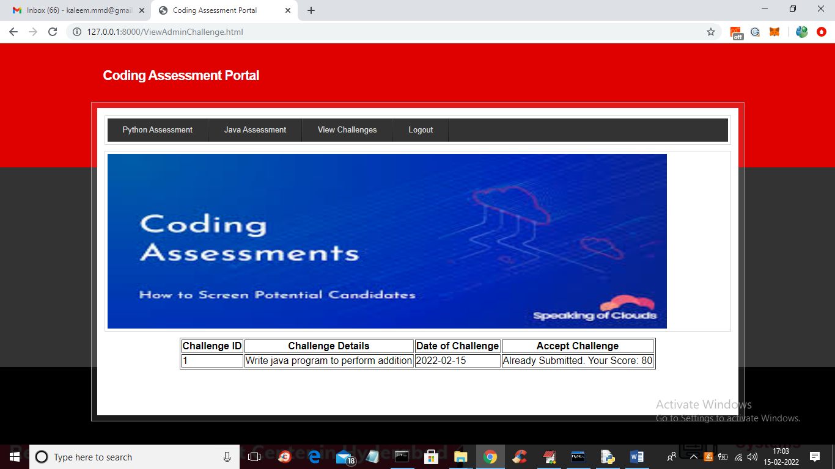

In above screen student can view he got score as 80