Cloudflare Open-Source Ecosystem Intelligence
IBM SkillsBuild Data Analytics with AI Academic Internship
Project Report
Prepared by Sirushti K
Summary:
This project analyzes 1,882 Cloudflare-related GitHub repositories to understand the current structure and health of the surrounding open-source developer ecosystem. The dataset contains 26 source variables and was analyzed using Python, Pandas, NumPy, Matplotlib, and Seaborn.
The analysis focuses on repository popularity, community engagement, technology composition, maintenance activity, ownership, and repository health. Because the source data is a current snapshot rather than a historical panel, the project deliberately avoids making unsupported claims about historical growth.

Problem Statement:
Cloudflare's developer ecosystem includes official repositories and a much larger set of community repositories related to Cloudflare technologies. The challenge is to convert raw repository-level data into useful intelligence: which areas attract attention, which repositories remain active, and where potential ecosystem risks or opportunities can be identified.

Objectives:

- Measure the size and composition of the Cloudflare-related repository ecosystem.
- Identify popular repositories and programming-language patterns.
- Compare official Cloudflare repositories with community-owned repositories.
- Analyse maintenance activity using repository push recency.
- Examine relationships among stars, forks, repository age, issues, and activity.
- Identify potential risks and opportunities using measurable repository signals.
- Develop a transparent descriptive Repository Health Score.
- Translate analytical findings into practical recommendations.

Dataset:
https://www.kaggle.com/datasets/riyagarg0314/cloudflare-github-ecosystem-2026/data

Methodology:
- Data loading and validation
The CSV was loaded with Pandas. Dataset dimensions, data types, descriptive statistics, missing values, and duplicate records were inspected.
- Cleaning
Column names and text fields were standardized, date fields were parsed, and exact duplicate rows were removed. No observations were removed solely because they were unusual.
- Feature engineering
Derived measures include fork-to-star ratio, issues per 1,000 stars, activity status, repository age groups, and a descriptive Repository Health Score.
- Exploratory analysis
The analysis examines ownership, language, popularity, activity, and repository-level engagement. Visualizations are used to communicate patterns rather than to increase chart count.
- Health scoring
The Repository Health Score combines activity, popularity, engagement, maintenance, and recency indicators. It is intended as an analytical prioritization index, not as a validated prediction model.

Executive KPIs

KPIs | Values
Total Repositories | 1,882
Total stars | 770,170
Total forks | 318,380
Total watchers | 770,170
Official Cloudflare repositories | 300
Archived repositories | 153

Programming-Language Analysis
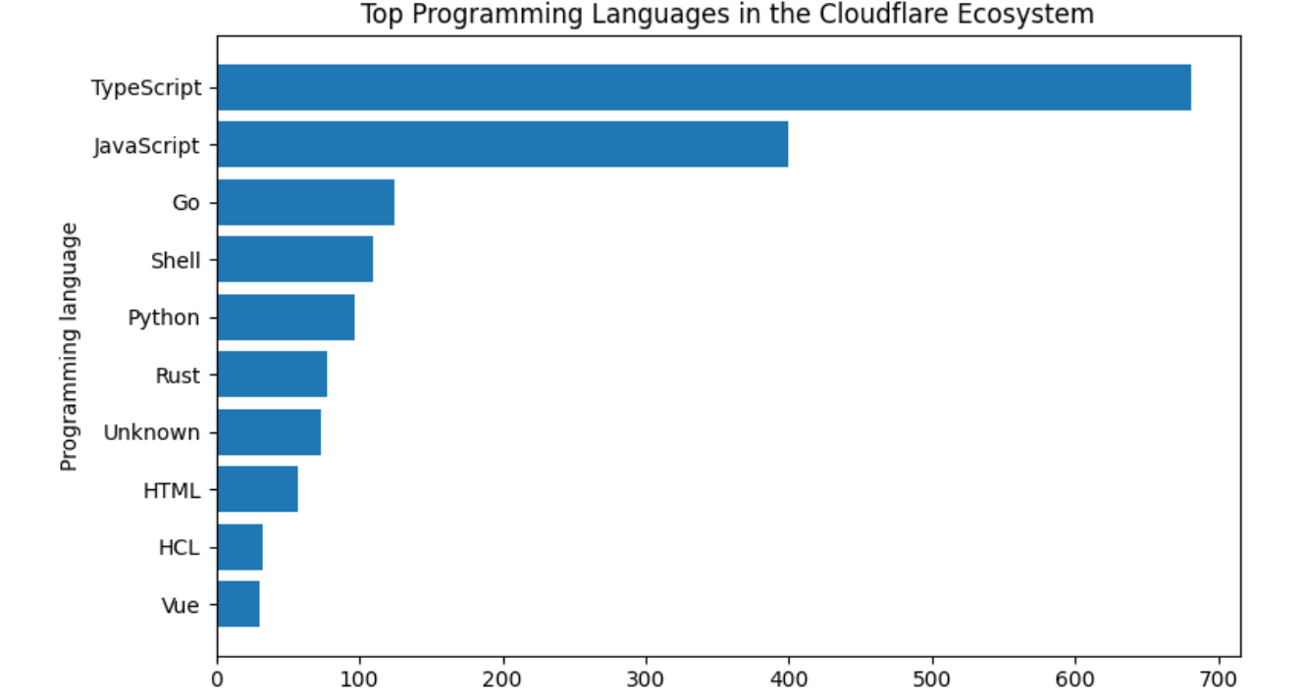

Repository Activity and Maintenance
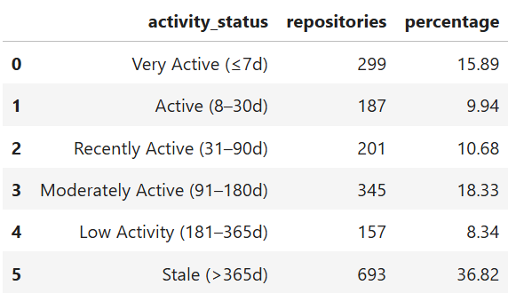

Popularity and Community Engagement

Top repositories by stars in the supplied snapshot:
- honojs/hono — 31,662 stars — TypeScript
- supermemoryai/supermemory — 28,909 stars — TypeScript
- cloudflare/pingora — 27,196 stars — Rust
- kriasoft/react-starter-kit — 23,665 stars — TypeScript
- yonggekkk/Cloudflare-vless-trojan — 15,910 stars — JavaScript
- cloudflare/cloudflared — 15,225 stars — Go
- maillab/cloud-mail — 13,403 stars — JavaScript
- cloudflare/quiche — 11,766 stars — Rust
- dreamhunter2333/cloudflare_temp_email — 11,295 stars — TypeScript
- cloudflare/moltworker — 9,936 stars — TypeScript

Risks and Opportunities
Potential risks
- Repositories with very old push activity may require review if they are still expected to support active users.
- Highly popular repositories with weak recent activity deserve separate investigation rather than being assumed healthy.
- A high number of open issues relative to stars can indicate support or maintenance pressure, although issue counts alone do not prove poor quality.
- Archived repositories should be distinguished from actively maintained projects when evaluating ecosystem health.
Potential opportunities
- Highly active repositories with strong community engagement can indicate areas where developer interest is concentrated.
- Technology segments with both strong activity and community participation may be candidates for additional documentation, tooling, or ecosystem support.
- Community projects can reveal adoption patterns outside the official Cloudflare organization.

Recommendations
- Prioritize ecosystem support around repositories that combine high engagement with recent development activity.
- Investigate popular but stale repositories separately before treating them as declining projects; repository purpose and maintenance expectations matter.
- Use activity and engagement together rather than relying on stars alone when evaluating ecosystem strength.
- Track the same repository metrics periodically in future versions of the project so that actual historical growth and decline can be measured.
- Use the health score as a prioritization aid, not as a substitute for qualitative engineering review.

Limitations
- The dataset is a snapshot, so it cannot establish historical growth rates.
- GitHub stars, forks, watchers, and issues are proxy measures and do not perfectly represent real-world adoption or software quality.
- The Repository Health Score is a custom descriptive index and has not been externally validated.
- The dataset's coverage depends on the repositories and topics captured by the source collection process.
- Correlation between variables should not be interpreted as causation.

Conclusion
The analysis converts 1,882 Cloudflare-related repositories into a structured view of ecosystem composition, popularity, engagement, and maintenance. The strongest use of this dataset is not to claim historical market growth, but to identify current ecosystem patterns and prioritize areas for deeper investigation or support. The resulting notebook provides a reproducible analytical base for the project and its accompanying documentation.

