Work Order System Application

## Introduction

In general, the purpose of the web-based application “Clarkson Work Order System” is to provide an occupant of a building the ability to report facilities-related issues to the management of that building. It also gives the facilities management team the opportunity to manage the reported issues, known as work orders. This document will explain the application in detail from the perspective of each type of user: Requester, Technician, and Manager.[1]

Upon loading the home page of the application, the user will be prompted to login with a Username and Password. If the user has never used the system before, they will first need to choose the “Sign Up” option at the bottom of the login page (as seen in the image below) to create an account.

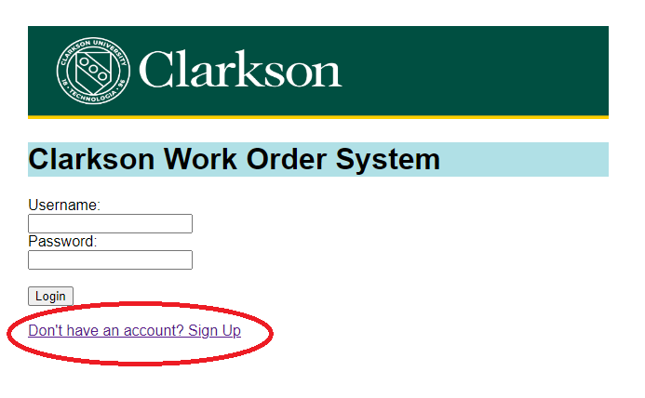

The user will be prompted for their name, email, password, phone number and typical room they occupy within the building. Once they click “Submit”, the information will be saved, and the user will be brought back to the home page in order to log into the system.

It should be noted that the **Location** field is not required, since Technician’s use the same page to sign up for an account, and they don’t always have a typical location in the building.

When an account is created, it is automatically assigned the role of “Requester”. For a user who needs to become a “Technician” or “Manager”, another manager/administrator will have to enter the system and update their “Role”.

## Interface Descriptions

# Requester

When a user who is a Requester logs into the application, they will be greeted with following interface:

The options listed do the following:

* Report a Problem – allows the user to log a work order, i.e. report a problem they have encountered within the building.
* Update Your Account – provides the opportunity for the user to update their information, i.e. phone number, location, password.
* Review Work Orders - this will list all of the work orders that the Requester has entered in the past, no matter their status.

#### Report a Problem

This page is where a Requester can report a problem they are having to the building facilities team. By default, their office location is listed but a dropdown list allows the user to change if necessary.

The “Problem/Issue:” is a required value and must be at least 10 characters in length but can be up to 100. Once the user has entered the desired text, they click on Submit to log the issue.

#### Update Your Account

Using this section of the application allows the Requester to alter their account details. They can change any of the data provided on the page.

#### Review Work Orders

Clicking on this option loads the Work Order List for the current Requester. It provides the Work Order #(Number), the Date the Work Order was entered, a description of the problem and the current status.

Clicking on one of the Work Order #s, will move the user to another page that provides more details associated with that work order.

This page not only gives the user a chance to review the summary of the work order, but from the top choice menu the user can access the Message interface.

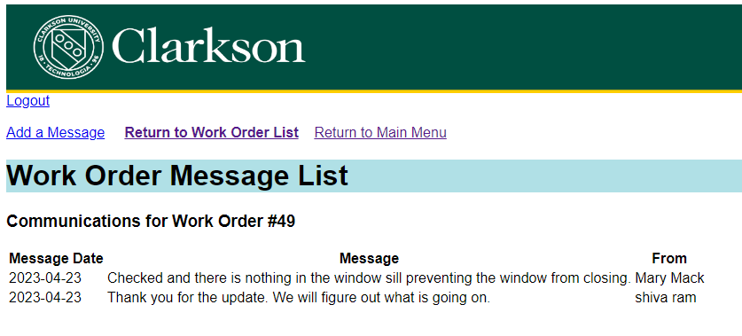

This page provides all communications exchanged within the system between the Requester, the assigned Technician, and the Manager. Clicking on the “Add a Message” from the menu at the top of the page is where the user can add to the conversation.

This page of the application is pretty straightforward and self-explanatory.

# Technician

The main menu page for the Technician looks like the following:

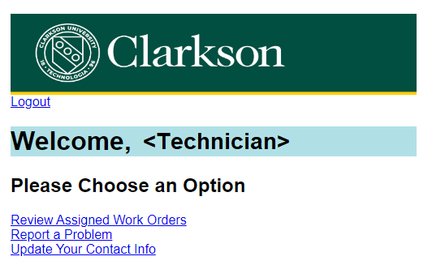

These options allow the Technician to perform the necessary documentation of their work.

* Review Assigned Work Orders – allows to Technician to see all “Open” work orders assigned to them.
* Report a Problem – in the event that the Technician observes an issue within the building or due to the problem at hand, has a subsequent/follow-up issue that needs to be resolved by someone else, this link gives them the opportunity to enter a new work order.
* Update Your Contact Info – if anything changes in the Technician’s account details, they can use this link to make those changes to their record.

#### Review Assigned Work Orders

The Work Order List page provides a quick summary of each of the currently open work orders assigned to the Technician who is logged in.

By clicking on the work order number located on the left of each line, the Technician will be provided with the complete details of the work order or Work Order Summary.

As explained at the top of the page, the Technician can provide updates to the lines where there is a drop-down list or input box. For example, if the asset or location of the problem is incorrect, the Technician can choose the appropriate asset from the available list.

Most importantly, this is the interface in which the Technician closes the work order. To do so, the Technician should change the Status to “Complete”, enter the total number of hours it took to solve the problem, and enter a quick description of how the issue was resolved.

In addition, this page is where a Technician can check on any messages left by the Requester or add any messages/questions to pass along to the Requester. The messaging interface for the Technician is the same as for the Requester so please refer to that section of this document to learn more.

#### Report a Problem

This page is the same as for the Requester, please refer to the above section for details on what it entails.

#### Update Your Contact Info

Once again this link leads to a page that is exactly the same as for the Requester, so for a description please review the Requester’s “Update Your Account” segment of this document.

# Manager (Administrator)

# *Features Not Included*

Below are some features that were not included with this application but would be a good addition:

* A tool to import assets into the Assets table. Currently the only way to add assets into the table is to use the Add option within the Manager’s interface. It would be ideal if a tool was provided to import a list of assets into the database using an repeating INSERT INTO SQL statement.
  + Same with the Problems table. It would be easier to create the problem codes within a separate software, i.e. Excel, and then load it into the application.

1. The initial credentials to log into the system as a Requester, Technician, and Manager are provided at the end of the document.