## Introduction

In general, the purpose of the web-based application “Clarkson Work Order System” is to provide an occupant of a building the ability to report facilities related issues to the management of that building. It also gives the facilities management team the opportunity to manage the reported issues, known as work orders. This document will explain the application in detail from the perspective of each type of user: Requester, Technician, and Manager.

Upon loading the home page of the application, the user will be prompted to login with a Username and Password. If the user has never used the system before, they will first need to choose the “Sign Up” option at the bottom of the login page (as seen in the image below).

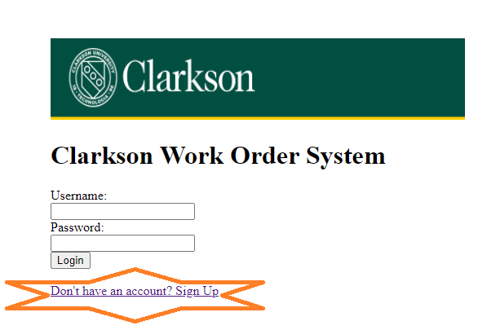

The user will be prompted for their name, email, password, phone number and typical room they occupy within the building. Once they click “Submit”, the information will be saved and the user will be brought to the home page in order to log into the system.

When an account is created, it is automatically assigned the role of “Requester”. For a user who needs to become a “Technician” or “Manager”, another manager/administrator will have to enter into the system and update their “Role”.

## Interface Descriptions

### Requester

### Technician

The main menu page for the Technician allows them to review all of their currently assigned work orders, create a new work order, and update their contact information.

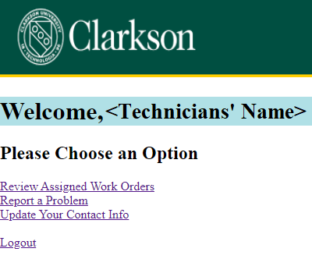

#### Work Order List

The Work Order List page provides a quick summary of each of the currently open work orders assigned to the Technician who is logged in.

By clicking on the work order number located on the left of each line, the Technician will be provided with the complete details of the work order or Work Order Summary.

#### Work Order Summary

As indicated at the top of the page, the Technician can provide updates to the details where there is a drop down list of input box. For example, if the asset or location of the problem is incorrect, the Technician change choose the appropriate asset from the available list.

Most importantly, this is the interface in which the Technician closes the work order. To do so, the Technician should change the Status to “Complete”, enter the hours it took to solve the problem, and enter a quick description of how the issue was resolved.

In addition, this page is where a Technician can check on any messages left by the Requester or add any messages/questions to pass along to the Requester.

### Manager (Administrator)