## SQL Queries for the Work Order System

**Dropdown Menu for the Location field on the Create Account page**

SELECT * FROM Assets WHERE ParentAsset = ‘BHSnell’;

**Create Work Order Page**

Default Location/Asset ID

SELECT Users.LocationID, Assets.AssetID, Assets.AssetTag

FROM Users INNER JOIN Assets ON Users.LocationID=Assets.AssetID;

**Create Work Order Summary Page, (T) Open Work Order Summary Page, Close Work Order Page, & (M) Create Work Order Page**

Various values needed from different fields in different tables

* Wanted to get just the specific fields needed but the system throws an error when attempted so getting all fields from all 3 tables. Will use python to grab just the data needed.

SELECT * FROM WorkOrders as wo

INNER JOIN Users AS u ON wo.RequesterID = u.UserID

INNER JOIN Assets AS a ON wo.AssetID = a.AssetID;

*<Snapshot unavailable since many fields returned>*

**Update User Information Page**

SELECT * FROM USERS WHERE UserID = <pkval>; // <variable/session> information

*~~~~*

**Open Work Order Summary Page**

Listing of all work orders submitted by the Requester

SELECT WorkOrders.WorkOrderID, WorkOrders.RequestDate, WorkOrders.Issue, WorkOrders.Status, WorkOrders.TechnicianID, Users.UserID, Users.UserFirstName, Users.UserLastName FROM WorkOrders INNER JOIN Users ON WorkOrders.TechnicianID = Users.UserID



**Existing Work Order Review Page**

Details of a work order selected from the Work Order List Page

SELECT * FROM WorkOrders as wo

INNER JOIN Users AS u ON wo.TechnicianID = u.UserID

INNER JOIN Assets AS a ON wo.AssetID = a.AssetID

WHERE WorkOrderID = <pkval>; // <variable/session> information

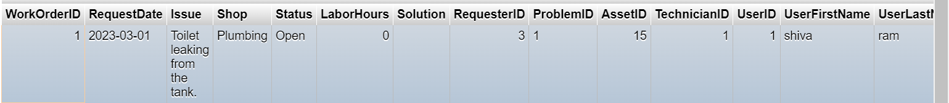

**Existing Work Order Review Page (“See Messages”) & Work Order Message Page**

SELECT WorkOrderComms.CommDate, WorkOrderComms.Message, WorkOrderComms.UserID AS WOCUserID, Users.UserID AS UsersUserID, Users.UserFirstName, Users.UserLastName FROM WorkOrderComms

INNER JOIN Users ON WorkOrderComms.UserID = Users.UserID

WHERE WorkOrderComms.WorkOrderID = <pkval>; // <variable/session> information

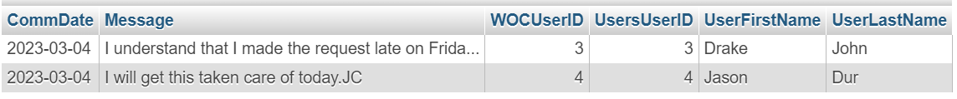

**User List Page**

List of users for manager to select from in order to update their information

SELECT UserFirstName, UserLastName FROM Users WHERE ;

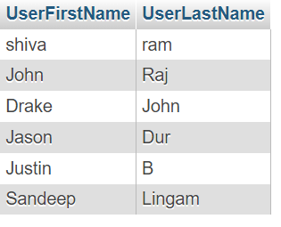

**Update Users Information Page**

List of users for manager to select from in order to update their information

SELECT Users.UserFirstName, Users.UserLastName, Users.Username, Users.PhoneNumber, Users.LocationID, Users.Role, Assets.AssetID, Assets.AssetTag FROM Users LEFT JOIN Assets ON Users.LocationID = Assets.AssetID;

**List All Technicians Page**

List of all users classified as Technicians (Not Requesters)

SELECT UserFirstName, UserLastName, Role FROM Users WHERE Users.Role <> 'Requester';

*Still need to figure out the Total Number of Work Orders for this page. Tried to add a join and a COUNT but isn’t working as expected.*

**List All Assets Page**

List of all assets with total number of work orders

SELECT * FROM Assets;

*Still need to figure out the Total Number of Work Orders for this page.*