It is not a secret that computers have an important role in our lives, a properly assembled, productive computer makes our life easier for us, but unfortunately many of them make mistakes while selecting components for their PC, and many inexperienced users even buy ready-made assemblies in home appliance stores with an inflated price tag, where often we are simply deceived and sold not a "gaming PC", but a mediocre, unbalanced Assembly wrapped in meters of led tape. Such assemblies will not make your life easier, but will simply kill thousands of nerve cells.

Our goal is to avoid such problems and explain to inexperienced users how to choose the right PC and teach them how to build them yourself.

The motherboard of the computer.The computer motherboard is the Foundation on which all the components of the system block are built.

The role of the computer's motherboard cannot be overestimated. After all, it only depends on whether You will be able to expand the functionality of Your PC in the future or not? Increase the amount of RAM, put a more productive video card? Will further expansion ("upgrade" — upgrade) of the entire system allow the presence of additional, initially unused, slots and connectors? This is like the Foundation of a house: you do not make it high quality and, over time, the structure may collapse.

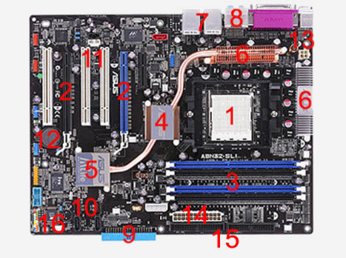

Let's, as usual, go through all the symbols in order and find out what components the computer motherboard consists of.

CPU socket (the socket where the computer processor is installed)

two slots for PCI Express video cards are indicated (in expensive motherboards, you can install two discrete video cards simultaneously)

four slots for DDR2 RAM

North bridge computer motherboard chipset

South bridge motherboard chipset

cooling system radiators for CPU power circuits (power phases)

four USB outputs (output to the back of the computer case)

built-in sound card outputs

interface of floppy disk 3.5 (disk drive) FDC controller

four SATA outputs for connecting hard drives

three PCI slots for connecting additional expansion cards (TV tuner, network or sound card, video capture card, etc.)

battery "BIOS"

four-pin 12-volt CPU power connector

24-pin connector for connecting the power supply and supplying voltage to the motherboard

two connectors for connecting hard disks or CD-DVD-ROM of the old"IDE" model

the "BIOS" chip itself»

(не читать)

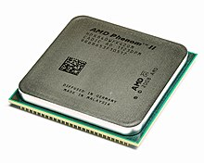

***central processing unit*, *CPU***

***-***an electronic block or integrated circuit that executes machine instructions (program code), the main part of the hardware of a computer or a programmable logic controller. Sometimes referred to as a microprocessor or just a processor.

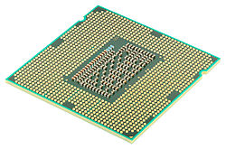

Initially, the term Central processing unit described a specialized class of logical machines designed to run complex computer programs. Due to the fairly accurate correspondence of this assignment to the functions of existing computer processors at that time it was naturally transferred to the computers themselves

The main characteristics of the CPU are: clock speed, performance, power consumption, standards of the lithographic process used in production (for microprocessors), and architecture.

GPU

A device that converts a graphic image stored as the contents of the computer's memory (or the adapter itself) into a form suitable for further display on a monitor screen. The first monitors built on cathode-ray tubes worked on the television principle of scanning the screen with an electron beam, and the display required a video signal generated by a video card.

Usually the video card is made in the form of a printed circuit Board (expansion Board) and inserted into an expansion slot, universal or specialized (AGP, PCI Express).

Specifications of GPU(не читать все. Кратко)

**The width of the memory bus**, measured in bits — the number of bits of information transmitted per clock cycle. An important parameter in the performance of the card.

**the amount of video memory,** measured in megabytes, is the **amount of the video card's own RAM**. More volume doesn't always mean more productivity.

Video cards that are integrated into the system logic set of the motherboard or are part of the CPU usually do not have their own video memory and use part of the computer's RAM (UMA — Unified Memory Access) for their needs.

**core and memory frequencies** are measured in megahertz. the higher the frequency, the faster the video card will process information.

the texture and pixel fill rate, measured in millions of pixels per second, shows the amount of information output per unit of time.

**Important** technical features that characterize the video card include a built-in cooling system, if implemented, and connectors for data transfer interfaces.

**random access memory(RAM)**

an energy-dependent part of a computer memory system that stores machine code (programs) being executed, as well as input, output, and intermediate data processed by the processor while the computer is running.

Data is exchanged between the processor and RAM:

**Computer power supply** unit-designed to generate power supply voltages for computer systems. To some extent, the power supply also performs the functions of stabilization and protection from minor interference of the supply voltage.

**Periphery**

the keyboard and mouse are used for entering data

the computer screen used for image output

the audio card and audio interfaces are used for audio input and output.

Let's start selecting the processor. There are two leading processors on the market: intel and amd. We will not go into the arguments specifically for or against each of the companies, but only consider the key differences between the processors of the "blue" and "red" companies.

**СборкаПК**

The motherboard for a computer is the basis for assembling all its components. Therefore, its choice should be approached with all seriousness.

1) Pay attention to the processor socket. The processor socket is one of the main elements of the motherboard. The processor is installed in the socket, and it is very important that the processor socket that it is aimed at is compatible with the socket on the motherboard.

2) Supported RAM. Motherboards differ in support of frequency and type of operating memory. So some motherboards can support DDR3 1333hz RAM, some do not. It is worth paying attention to the support of RAM by the processor. This information is spelled out in the characteristics of components.

RAM is worth buying two bars of the same frequency and generation, so it will work in multi-channel mode. When you activate the two-channel option, the RAM speed increases by 2 times, compared to 1-channel. It turns out that a pair of 8 GB modules give more performance than a single 16 GB bar.

Power supply.

The power supply must be taken with a reserve of power.

First of all, there is always a risk of underestimating some load parameters. Secondly, the constant operation of the power supply at maximum loads will definitely have a bad effect on its life cycle. For example, the power consumption of the most voracious video cards in peak load can reach as much as 300 watts.

Hard disk or SSD

In my opinion, if the budget allows, it is worth taking an ssd to install the system, this will greatly improve the performance of the system. SSDs also have a high speed of data exchange, they are more reliable than hard drives and much quieter.

What should I pay attention to first?

First, decide on your budget, if you want to build a reliable computer, you will not be able to save on most components, but at the same time you can find good analogues of popular products that are not inferior to them in anything.

Let's start with the price, of course.

Intel holds the position of the market leader, so the stability of their processors is higher than that of competitors, in this regard, AMD's pricing policy looks more profitable.

Let's move on to performance. In short, AMD processors are good for tasks that can load all cores evenly, counting more cores than INTEL. These tasks include web surfing, video encoding and decoding, scientific and engineering calculations, and parallel use of several programs. Also, AMD processors do not restrict users in overclocking.

Intel processors are also strong where powerful cores are required, which is often games and office software.

As you have already understood, it is impossible to accurately determine the leader, because each processor is good in its own way.

When selecting, pay attention to the comparison of processors in synthetic tests, the results of benchmarks and tests in games.

AMD and Intel processors have different chipsets of different generations, so what is a chipset? A chipset is a set of chips designed to work together to perform certain tasks. The second name is a set of system logic.

It's time for the video card.

The video card should be selected based on the processor, do you want to build a balanced system?

You need to choose a video card that will fully reveal your processor.

Here the situation is similar to processors, there are two leaders AMD and NVIDIA.

AMD is famous for its availability, while NVIDIA is famous for its performance and high price.

In addition, AMD has a big problem-these are drivers, you have to wait a long time for a stable driver for the video card.

And here again, you need to look at the test results and separately consider each video card model.