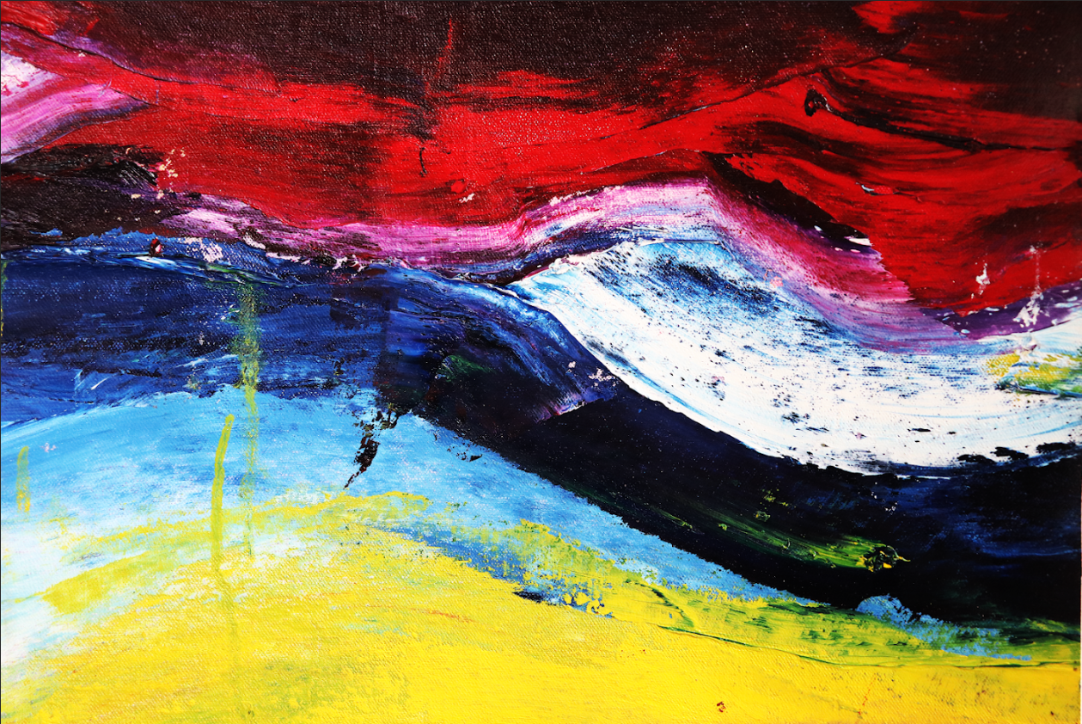

***ULTRASOUND DISTANCE DETECTION***

Testing set up of ultrasound distance detection unit and moveable object to measure

Ultrasound is a useful medium to explore since it is relatively easy to do tests on and be able to view in a lab to study its behaviour. The things learnt about ultrasound can ultimately be applied to higher frequency waves as well, since they share fundamental similarities and so work on ultrasound can be used to understand problems faced at higher frequencies but at ultrasound it is far easier to set up and view. Although distance is measured more often using infra-red which has the bonus of being viewable so it is always known what is being measured and can be more accurate than ultrasound, ultrasound has the advantage that it could measure distance through substances other than air more effectively as its wave is not effected by light intensity which changes in most substances, whereas infra-red is.

This project aimed to explore the medium and limitations of ultrasound by using it to measure distance between a distance detection unit and an object. Distance can be calculated by using the equation: *DISTANCE = SPEED * TIME* and since soundwaves travel at a constant speed so long as the temperature and substance the waves are travelling through remain the same, then all that needs to be measured is the time it takes for an ultrasound pulse from when it is sent from a transmitting ultrasound transducer to bounce off an object and be picked up by a receiving transducer adjacent to the transmitting one. This can then be halved, as the time measured is to the object and back, and then put into the distance equation to measure the distance to the object.

Due to the nature of the ultrasound being a constantly oscillating wave, then knowing exactly when the ultrasound pulse starts is difficult, especially once it has been received having bounced off the object it is measuring. This is because the ultrasound wave loses a lot of its power while travelling between transducers and is received relatively slowly on the transducer (it takes about 100-200us to reach the full amplitude of the pulse signal). Since the channel is very noisy, (before the pulse has been received the receiving transducer still registers small signals from background noise) it is very hard to differentiate between the start of the received pulse and the noise already on the channel. Further, as the distance to the object increases, the amplitude of the received signal only gets smaller and smaller, making it even more difficult to distinguish between signal and noise until it becomes indistinguishable. The signal can only be amplified a certain amount before it is sent as the transducers can take at most 20Vrms applied to them before they break, and after they are received re-amplification of the signal will also amplify the noise. Other problems arise from the fact that ultrasound is quite difficult to direct and spreads from the transmitter, meaning that left totally undirected the ultrasound signal could be bouncing off of anything and also be reflected multiple times before it reaches the receiver without an easy way to tell exactly what it is bouncing off since ultrasound is invisible. There are important challenges, then in directing the ultrasound as well as choosing where to start and end the time measurement in relation to the pulse when trying to measure distance with ultrasound.

Use of housing to direct ultrasound wave

Background art by Emily Dalley

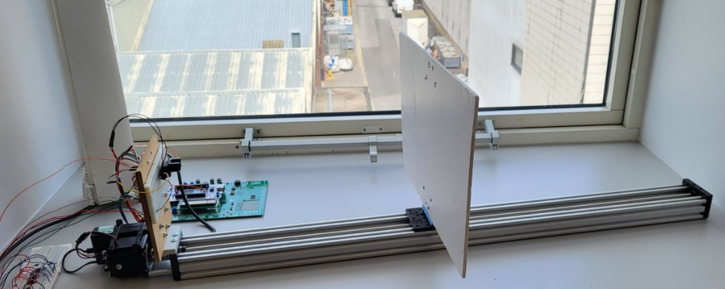

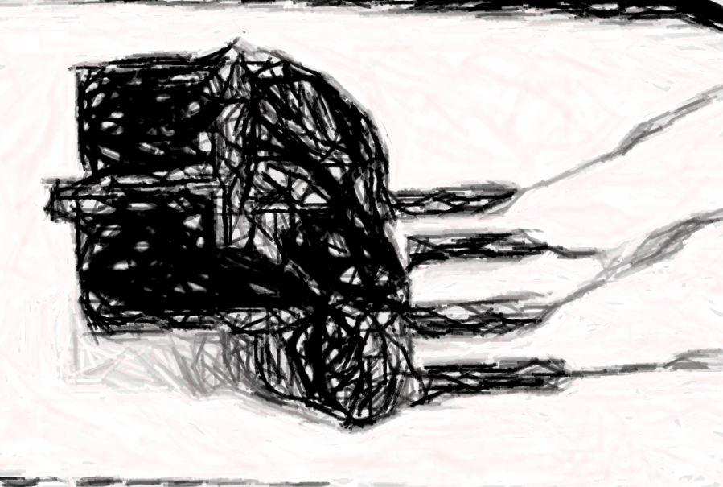

kieran.small@students.plymouth.ac.uk

Beng (Hons) Electrical and Electronic Engineering 2023

Kieran Small