Micro Project Work

http://localhost:8383/WebFormExample/index.html

Title of the Project : Student Enrollment Form

Description : Student Enrollment Form that will store data in STUDENT-TABLE relation of SCHOOL-DB database. Input Fields: {Roll-No, Full-Name, Class, Birth-Date, Address, Enrollment-Date}

Primary key: Roll No.

Benefits of using JsonPowerDB : Simplest way to retrieve data in a JSON format. Schema-free, Simple to use, Nimble and In-Memory database. It is built on top of one of the fastest and real-time data indexing engine - PowerIndeX. It is low level (raw) form of data and is also human readable. It helps developers in faster coding, in-turn reduces development cost. Release History (release of your JsonPowerDB related code on Github)

Additional you can have: JsonPowerDB is a Real-time, High Performance, Lightweight and Simple to Use, Rest API based Multi-mode DBMS. JsonPowerDB has ready to use API for Json document DB, RDBMS, Key-value DB, GeoSpatial DB and Time Series DB functionality. JPDB supports and advocates for true serverless and pluggable API development.

Table of contents: Roll-No Student Full Name Class Birth-Date Address Enrollment-Date SAVE - INSERT CHANGE - UPDATE DELETE RESET

Illustrations:-

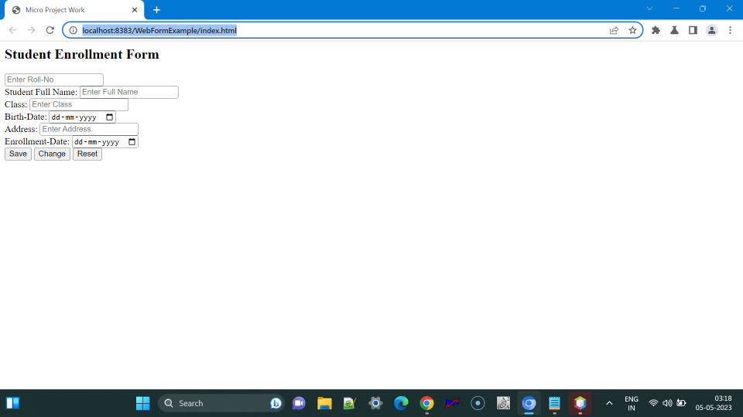

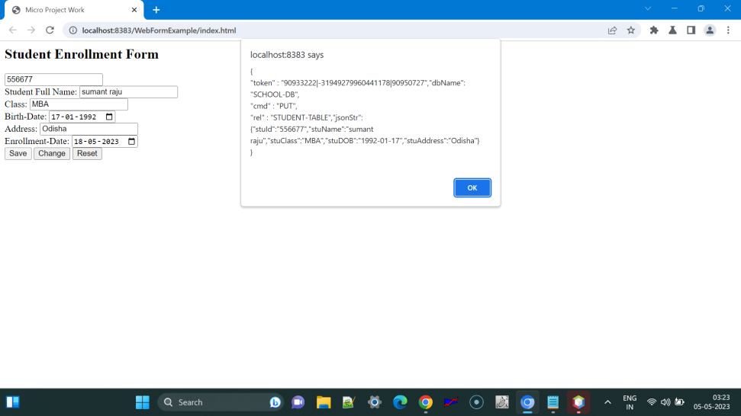
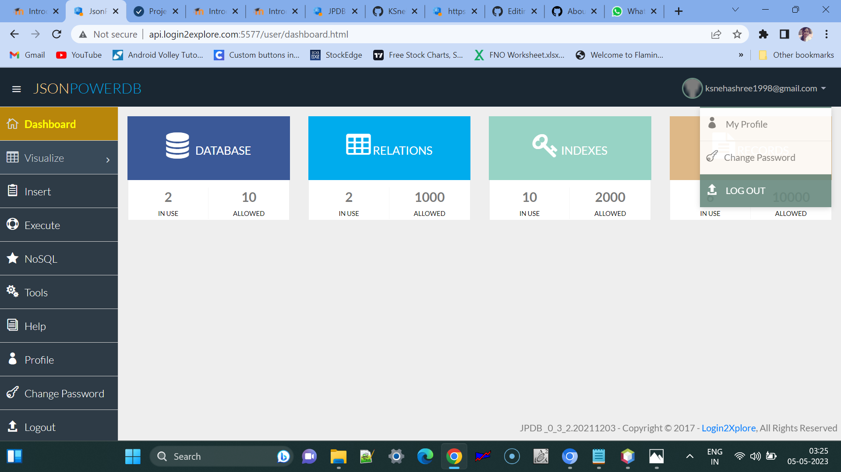
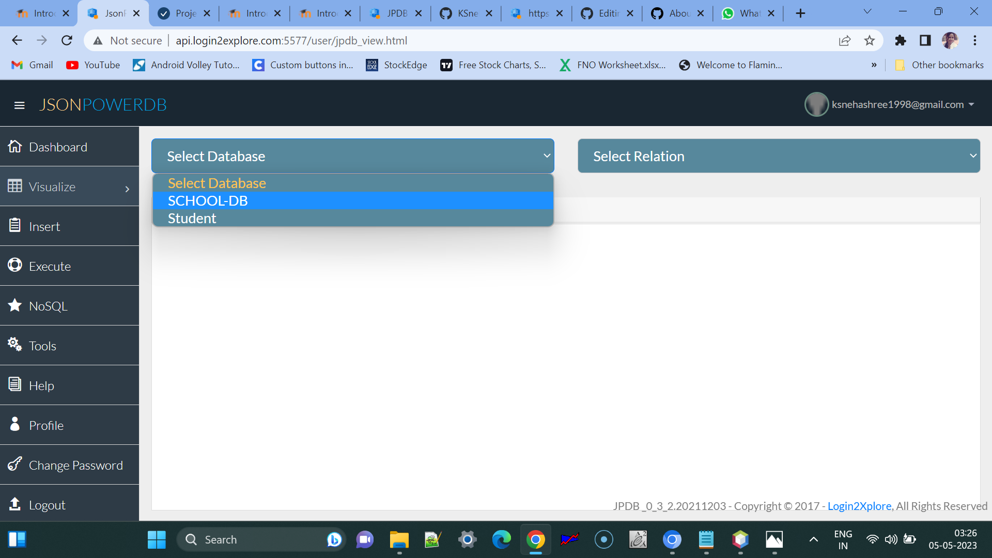

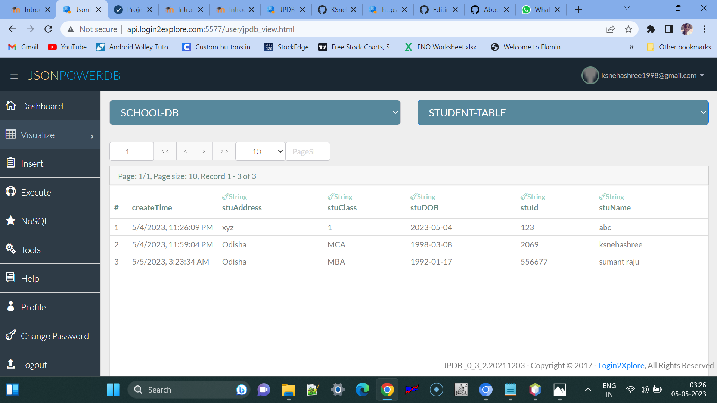

Scope of functionalities :

Examples of use : can be used foe various other platforms like Online Examination Registration , Job Application , profile creation , and many more other uses .

Project status : Done

Sources :Introduction to JsonPowerDB - V2.0
https://careers.login2explore.com/course/view.php?id=14

Other information Sources :
https://login2explore.com/jpdb/docs.html

STEP BY STEP COURSE DOCUMENTATION :

JsonPOwerDB

Introduction to JsonPowerDB - V2.0 Login2Xplore

Creating a Developer Account and Generating Connection Token : -

Visit: http://api.login2explore.com:5577/user/index.html REGISTER After registration check your email-id for password. Login at http://api.login2explore.com:5577/user/index.html using your email and password received. First of all change password - Left Navigation >> Change Password. Login with new password.

Tools > Token > connection token > Generate (Token needed to communicate with Data Base)

"90933222|-31949279960441178|90950727"

Token used to execute the API

Installing Talend API Tester : -

Google > settings > Extensions > Chrome Web store > Talend API Tester - Free Edition > Add to chrome extension

Understanding JsonPowerDB and its Features : -

nimble , schema Free , simple to use , in memory and real time , easy to maintain , serverless support , enables multi mode database , power Index , Web services API Cost efficient , multiple security layers , best performance

JsonPowerDB Use case and Benefits : -
any software app that needs backend db all rdbms use cases all document db use cases all key- value db use cases use cases that needs GeoSpacial/Time series Analytics Best suited to real - time application for data analytics Improving existing application reporting/ analytics performance. Live working HTML, Templates.

PUT Command - Creating (Inserting) Record : - # IML (JPDB Index Manipulation Language) PUT : Insert single record in the database Token - "90933222|-31949279960441178|90950727"

Talend > post Base url : http://api.login2explore.com:5577 End-point url : /api/iml (mentioned in command when different)

BODY : { "token":"90933222|-31949279960441178|90950727", "cmd": "PUT", "dbName": "Employee", "rel": "Emp-Rel", "jsonStr": { "id": "1", "name": "Soniya", "email": "soniya@gmail.com", "mobileno": "9967825671" } }

Send >

{"data":"{"rec_no":[1]}","additionalData":{"processReqType":0,"dbUpdateFlag":true}, "message":"RELATION CREATED, TEMPLATE CREATED FROM JSON, DATA INSERTED, Total 1 rows are inserted, Added 0 columns as New Index Columns.","status":200}

Dashboard > Visualize > Jsondb > select Database and Relation

1 2/24/2023, 8:21:16 PM soniya@gmail.com 1 9967825671 Soniya

New row-
{
"token": "90933222|-31949279960441178|90950727",
"cmd": "PUT",
"dbName": "Student",
"rel": "Student-Rel",
"jsonStr": {
"id": "3",
"name": "Sumant",
"address": "odisha",

}
}

{"data":"{\"rec_no\":[3]}","additionalData":{"processReqType":0,"dbUpdateFlag":true},"message":"DATA INSERTED, Total 1 rows are inserted, Added 1 columns as New Index Columns.","status":200}

Dashboard > Visualize > Jsondb > select Database and Relation

1 2/24/2023, 8:21:16 PM soniya@gmail.com 1 9967825671 Soniya,
3 5/3/2023, 2:27:22 PM odisha 3 7098162348 sumant

GET Command - Retrieving Record : - # IRL (JPDB Index Retrieval Language)

Talend - Add a project

Name - PUT Project - JPDB Service - CRUD save

GET_BY_KEY : Retrieve single record by json data

Talend > Save as > Name : GET >

POST | http://api.login2explore.com:5577/api/irl

"token":"90933222|-31949279960441178|90950727"

{
"token":"90933222|-31949279960441178|90950727",

"cmd": "GET",
"dbName": "Student",
"rel": "Student-Rel",
"jsonStr": {
"name": "Sneha"
}

}

{"data":"{\"name\":\"Sneha\",\"id\":\"2\",\"email\":\"sneha@gmail.com\"}","message":"DATA RETRIEVED FROM PI","status":200}

REMOVE Command - Remove a record : - # IML (JPDB Index Manipulation Language) - To insert, update and delete Json data.

REMOVE : Remove records from the database

POST | http://api.login2explore.com:5577/api/iml

{
"token": "90933222|-31949279960441178|90950727",
"cmd": "REMOVE",
"dbName": "Student",
"rel": "Student-Rel",
"record": 1,
"jsonStr" : {}
}

{"data":"{\"removedRecNos\":[1],\"alreadyRemovedRecNos\":[],\"invalidRecNos\":[]}","additionalData":{"processReqType":0,"dbUpdateFlag":true},"message":"Success","status":200}

Test - Understanding JPDB
Test your knowledge

Attempts allowed: 5

Time limit: 5 mins

Grading method: Highest grade

Summary of your previous attempts
Attempt State Grade / 5.00 Review Feedback
1 Finished
Submitted Wednesday, 3 May 2023, 1:34 PM
5.00
Congratulations!! Excellent Performance! Keep it Up.

Highest grade: 5.00 / 5.00.
Overall feedback
Congratulations!! Excellent Performance! Keep it Up.

Ajax Concepts - A Desktop application feel on web-pages ; -

AJAX - Asynchronous JavaScript And XML.
How to use JsonPowerDB in Web Pages

Creating a Web Project in NetBeans : -

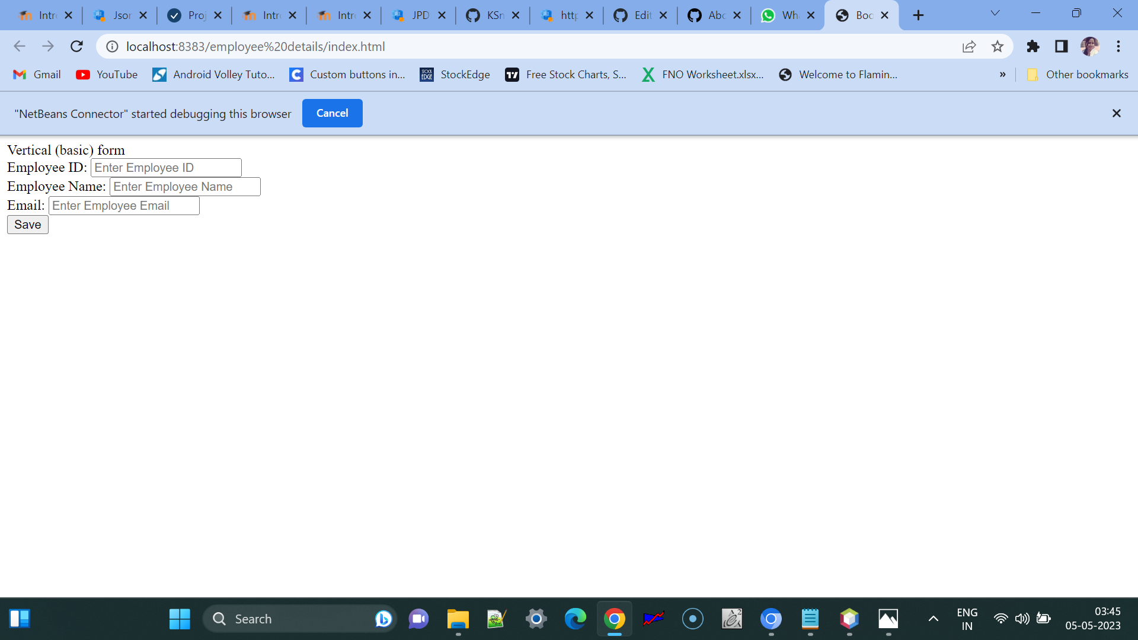

CODE -

<title>Bootstrap Example</title> <script src="https://ajax.googleapis.com/ajax/libs/jquery/3.5.1/jquery.min.js"></script> <script src="https://maxcdn.bootstrapcdn.com/bootstrap/3.4.1/js/bootstrap.min.js"></script>
Vertical (basic) form
Employee ID:
<input
type="text"
class="form-control"
name="empId"
id="empId"
placeholder="Enter Employee ID"
required
/>
</div>
<div class="form-group">
<label for="empName">Employee Name:</label>
<input
type="text"
class="form-control"
id="empName"
placeholder="Enter Employee Name"
name="empName"
/>
</div>
<div class="form-group">
<label for="empEmail">Email:</label>
<input
type="email"
class="form-control"
id="empEmail"
placeholder="Enter Employee Email"
name="empEmail"
/>
</div>
<input
type="button"
class="btn btn-primary"
id="empSave"
value="Save"
onclick="saveEmployee();"
/>
</form>
</div>

<script>
function validateAndGetFormData() {
var empIdVar = $("#empId").val();
if (empIdVar === "") {
alert("Employee ID Required Value");
$("#empId").focus();
return "";
}
var empNameVar = $("#empName").val();
if (empNameVar === "") {
alert("Employee Name is Required Value");
$("#empName").focus();
return "";
}
var empEmailVar = $("#empEmail").val();
if (empEmailVar === "") {
alert("Employee Email is Required Value");
$("#empEmail").focus();
return "";
}
var jsonStrObj = {
empId: empIdVar,
empName: empNameVar,
empEmail: empEmailVar,
};
return JSON.stringify(jsonStrObj);
}

// This method is used to create PUT Json request.
function createPUTRequest(connToken, jsonObj, dbName, relName) {
var putRequest =
"{\n" +
'"token" : "' +
connToken +
'",' +
'"dbName": "' +
dbName +
'",\n' +
'"cmd" : "PUT",\n' +
'"rel" : "' +
relName +
'",' +
'"jsonStr": \n' +
jsonObj +
"\n" +
"}";
return putRequest;
}

function saveEmployee() {
// validate form data

// create JPDB request string - token , dbname , relation name ...

// Execute this request

//Reset the form data

var jsonStr = validateAndGetFormData();
if (jsonStr === "") {
return;
}
var putReqStr = createPUTRequest(
"90933222|-31949279960441178|90950727",

jsonStr,
"SAMPLE",
"EMP-REL"
);

alert(putReqStr);
jQuery.ajaxSetup({ async: false });
/*
var resultObj = executeCommand(
putReqStr,
"http://api.login2explore.com:5577",
"/api/iml"
);

*/

jQuery.ajaxSetup({ async: true });
alert(JSON.stringify(resultObj));
resetForm();
}
</script>

Saving data in JPDB from HTML form :-

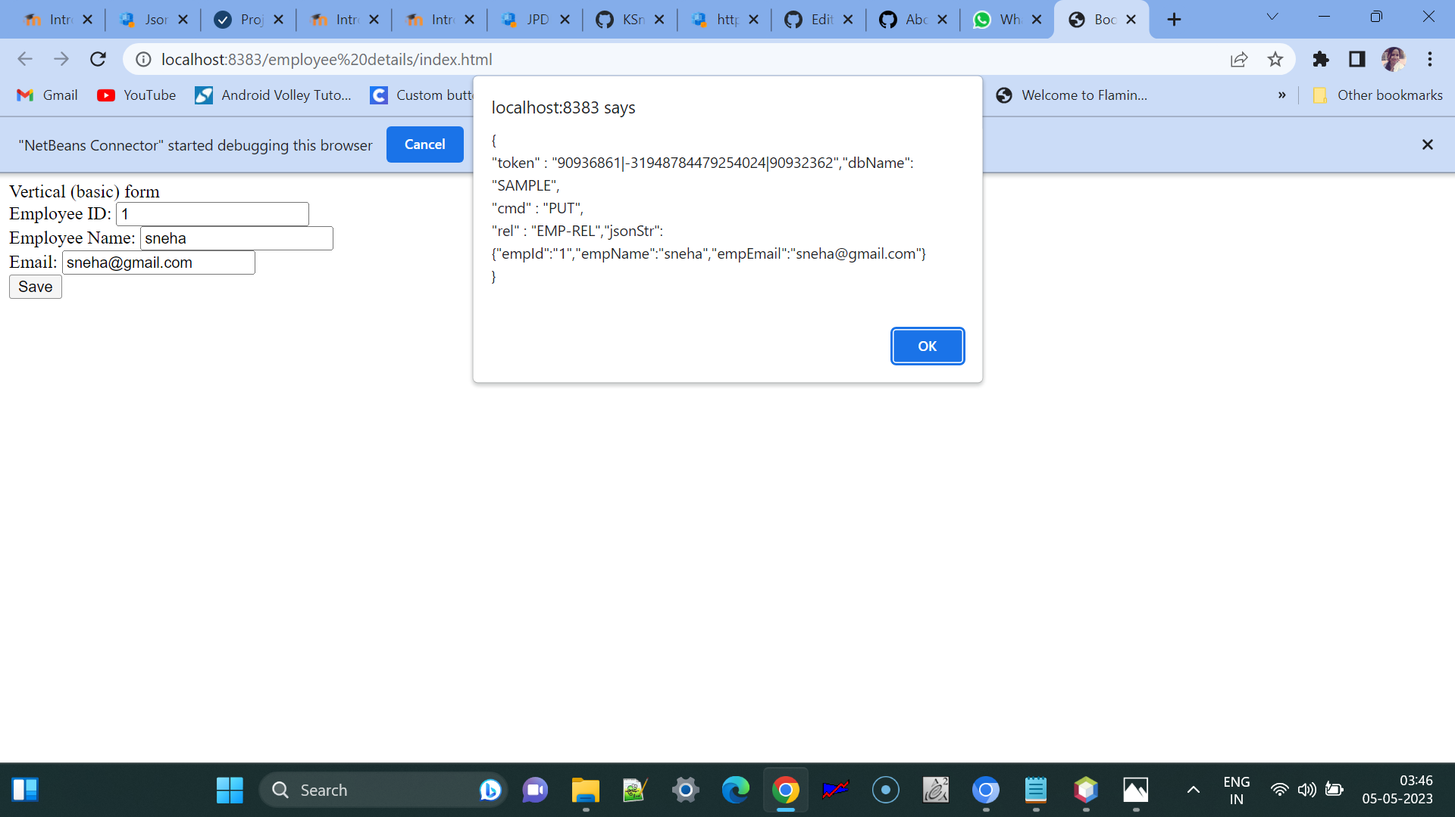

CODE --

<title>Bootstrap Example</title> <script src="https://ajax.googleapis.com/ajax/libs/jquery/3.5.1/jquery.min.js"></script> <script src="https://maxcdn.bootstrapcdn.com/bootstrap/3.4.1/js/bootstrap.min.js"></script>
Vertical (basic) form
Employee ID:
<input
type="text"
class="form-control"
name="empId"
id="empId"
placeholder="Enter Employee ID"
required
/>
</div>
<div class="form-group">
<label for="empName">Employee Name:</label>
<input
type="text"
class="form-control"
id="empName"
placeholder="Enter Employee Name"
name="empName"
/>
</div>
<div class="form-group">
<label for="empEmail">Email:</label>
<input
type="email"
class="form-control"
id="empEmail"
placeholder="Enter Employee Email"
name="empEmail"
/>
</div>
<input
type="button"
class="btn btn-primary"
id="empSave"
value="Save"
onclick="saveEmployee();"
/>
</form>
</div>

<script>
function validateAndGetFormData() {
var empIdVar = $("#empId").val();
if (empIdVar === "") {
alert("Employee ID Required Value");
$("#empId").focus();
return "";
}
var empNameVar = $("#empName").val();
if (empNameVar === "") {
alert("Employee Name is Required Value");
$("#empName").focus();
return "";
}
var empEmailVar = $("#empEmail").val();
if (empEmailVar === "") {
alert("Employee Email is Required Value");
$("#empEmail").focus();
return "";
}
var jsonStrObj = {
empId: empIdVar,
empName: empNameVar,
empEmail: empEmailVar,
};
return JSON.stringify(jsonStrObj);
}

// This method is used to create PUT Json request.
function createPUTRequest(connToken, jsonObj, dbName, relName) {
var putRequest =
"{\n" +
'"token" : "' +
connToken +
'",' +
'"dbName": "' +
dbName +
'",\n' +
'"cmd" : "PUT",\n' +
'"rel" : "' +
relName +
'",' +
'"jsonStr": \n' +
jsonObj +
"\n" +
"}";
return putRequest;
}

function executeCommand(reqString, dbBaseUrl, apiEndPointUrl) {
var url = dbBaseUrl + apiEndPointUrl;
var jsonObj;
$.post(url, reqString, function (result) {
jsonObj = JSON.parse(result);
}).fail(function (result) {
var dataJsonObj = result.responseText;
jsonObj = JSON.parse(dataJsonObj);
});
return jsonObj;
}

function resetForm() {
$("#empId").val("");
$("#empName").val("");
$("#empEmail").val("");
$("#empId").focus();
}

function saveEmployee() {
// validate form data

// create JPDB request string - token , dbname , relation name ...

// Execute this request

//Reset the form data

var jsonStr = validateAndGetFormData();
if (jsonStr === "") {
return;
}
var putReqStr = createPUTRequest(
"90933222|-31949279960441178|90950727",
jsonStr,
"SAMPLE",
"EMP-REL"
);

alert(putReqStr);

jQuery.ajaxSetup({ async: false });
var resultObj = executeCommand(
putReqStr,
"http://api.login2explore.com:5577",
"/api/iml"
);
jQuery.ajaxSetup({ async: true });

alert(JSON.stringify(resultObj));
resetForm();
}
</script>

JPDB using jpdb common js - A Javascript library to make it even easy and fast for developers :-

Code -

<title>Bootstrap Example</title> <script src="https://ajax.googleapis.com/ajax/libs/jquery/3.5.1/jquery.min.js"></script> <script src="https://maxcdn.bootstrapcdn.com/bootstrap/3.4.1/js/bootstrap.min.js"></script> <script src="https://login2explore.com/jpdb/resources/js/0.0.3/jpdb-commons.js"></script>
Vertical (basic) form
Employee ID:
<input
type="text"
class="form-control"
name="empId"
id="empId"
placeholder="Enter Employee ID"
required
/>
</div>
<div class="form-group">
<label for="empName">Employee Name:</label>
<input
type="text"
class="form-control"
id="empName"
placeholder="Enter Employee Name"
name="empName"
/>
</div>
<div class="form-group">
<label for="empEmail">Email:</label>
<input
type="email"
class="form-control"
id="empEmail"
placeholder="Enter Employee Email"
name="empEmail"
/>
</div>
<input
type="button"
class="btn btn-primary"
id="empSave"
value="Save"
onclick="saveEmployee();"
/>
</form>
</div>

<script>
function validateAndGetFormData() {
var empIdVar = $("#empId").val();
if (empIdVar === "") {
alert("Employee ID Required Value");
$("#empId").focus();
return "";
}
var empNameVar = $("#empName").val();
if (empNameVar === "") {
alert("Employee Name is Required Value");
$("#empName").focus();
return "";
}
var empEmailVar = $("#empEmail").val();
if (empEmailVar === "") {
alert("Employee Email is Required Value");
$("#empEmail").focus();
return "";
}
var jsonStrObj = {
empId: empIdVar,
empName: empNameVar,
empEmail: empEmailVar,
};
return JSON.stringify(jsonStrObj);
}

function resetForm() {
$("#empId").val("");
$("#empName").val("");
$("#empEmail").val("");
$("#empId").focus();
}

function saveEmployee() {
// validate form data

// create JPDB request string - token , dbname , relation name ...

// Execute this request

//Reset the form data

var jsonStr = validateAndGetFormData();
if (jsonStr === "") {
return;
}
var putReqStr = createPUTRequest(
"90932512|-31949274757731994|90949158",
jsonStr,
"SAMPLE",
"EMP-REL"
);

alert(putReqStr);

jQuery.ajaxSetup({ async: false });
var resultObj = executeCommandAtGivenBaseUrl(
putReqStr,
"http://api.login2explore.com:5577",
"/api/iml"
);
jQuery.ajaxSetup({ async: true });

alert(JSON.stringify(resultObj));
resetForm();
}
</script>

Test - Interactive JPDB
Test your knowledge

Attempts allowed: 5

Time limit: 5 mins

Grading method: Highest grade

Summary of your previous attempts
Attempt State Grade / 4.00 Review Feedback

Finished
Submitted Friday, 5 May 2023, 4:20 AM
4.00
Congratulations!! Excellent Performance! Keep it Up.

Highest grade: 4.00 / 4.00.
Overall feedback
Congratulations!! Excellent Performance! Keep it Up.

Micro Project Work

Student Enrollment Form

CODE -

<html lang="en">
<head>
<title>Micro Project Work</title>
<script
src=" https://maxcdn.bootstrapcdn.com/bootstrap/3.4.1/css/bootstrap.min.css"></script>
<script
src="https://ajax.googleapis.com/ajax/libs/jquery/3.5.1/jquery.min.js"></script>
<script
src="https://login2explore.com/jpdb/resources/js/0.0.3/jpdb-commons.js"></script>
</head>
<body>
<div class="container">
<h2>Student Enrollment Form</h2>
<input
type="text"
class="form-control"
onchange="getStu()"
name="stuId"
id="stuId"
placeholder="Enter Roll-No"
required
/>
</div>

<div class="form-group">
<label for="stuName">Student Full Name:</label>
<input
type="text"
class="form-control"
id="stuName"
placeholder="Enter Full Name"
name="stuName"
/>
</div>

<div class="form-group">
<label for="stuClass">Class:</label>
<input
type="text"
class="form-control"
id="stuClass"
placeholder="Enter Class"
name="stuClass"
/>
</div>

<div class="form-group">
<label for="stuDOB">Birth-Date:</label>
<input
type="date"
class="form-control"
id="stuDOB"
placeholder="Enter Birth-Date"
name="stuDOB"
/>
</div>

<div class="form-group">
<label for="stuAddress">Address:</label>
<input
type="text"
class="form-control"
id="stuAddress"
placeholder="Enter Address"
name="stuAddress"
/>
</div>

<div class="form-group">
<label for="stuEnrollDate">Enrollment-Date:</label>
<input
type="date"
class="form-control"
id="stuEnrollDate"
placeholder="Enter Enrollment-Date"
name="stuEnrollDate"
/>
</div>

<input
type="button"
class="btn btn-primary"
id="empSave"
value="Save"
onclick="saveData();"
/>
<input
type="button"
class="btn btn-primary"
id="empChange"
value="Change"
onclick="changeData();"
/>
<input
type="button"
class="btn btn-primary"
id="empReset"
value="Reset"
onClick="resetForm()"
/>
<!-- window.location.reload() -->

<script>
function validateAndGetFormData() {
var stuIdVar = $("#stuId").val();
if (stuIdVar === "") {
alert("Student Roll-No Required Value");
$("#stuId").focus();
return "";
}
var stuNameVar = $("#stuName").val();
if (stuNameVar === "") {
alert("Student Name is Required Value");
$("#stuName").focus();
return "";
}
var stuClassVar = $("#stuClass").val();
if (stuClassVar === "") {
alert("Student Class is Required Value");
$("#stuClass").focus();
return "";
}

var stuDOBVar = $("#stuDOB").val();
if (stuDOBVar === "") {
alert("Student Birth-Date is Required Value");
$("stuDOB").focus();
return "";
}

var stuAddressVar = $("#stuAddress").val();
if (stuAddressVar === "") {
alert("Student Address is Required Value");
$("#stuAddress").focus();
return "";
}

var stuEnrollDateVar = $("stuEnrollDate").val();
if (stuEnrollDateVar === "") {
alert("Student Enrollment-Date is Required Value");
$("stuEnrollDate").focus();
return "";
}

var jsonStrObj = {
stuId: stuIdVar,
stuName: stuNameVar,
stuClass: stuClassVar,
stuDOB: stuDOBVar,
stuAddress: stuAddressVar,
stuEnrollDate: stuEnrollDateVar,
};
return JSON.stringify(jsonStrObj);
}

function getstuIdASJsonObj() {
var stuid = $("#stuid").val();
var jsonStr = {
id: stuid,
};
return JSON.stringify(jsonStr);
}

function getStu() {
var stuIdJsonObj = getstuIdASJsonObj();
var getRequest = createGET_BY_KEYRequest(
connToken,
stuDBName,
stuRelationName,
stuIdJsonObj
);
jQuery.ajaxSetup({async: false});
var resJsonObj = executeCommandAtGivenBaseUrl(
getRequest,
jpdbBaseURL,
jpdbURL
);
jQuery.ajaxSetup({async: true});
if (resJsonObj.status === 400) {
$("#save").prop("disabled", flase);
$("#reset").prop("disabled", false);
$("#stuname").focus();
} else if (resJsonObj.status === 200) {
$("#stuid").prop("disabled", true);
fillData(resJsonObj);
$("#change").prop("disabled", false);
$("#reset").prop("disabled", false);
$("#stuname").focus();
}
}

function resetForm() {
$("#stuId").val("");
$("#stuName").val("");
$("#stuClass").val("");
$("#stuDOB").val("");
$("#stuAddress").val("");
$("#stuEnrollDate").val("");
$("#stuId").focus();
}

function changeData() {
$("#change").prop("disabled", true);
jsonChg = validateData();
var updateRequest = createUPDATERecordRequest(
ConnToken,
jsonChg,
stuDBName,
stuRelationName,
localStorage.getItem("recno")
);
jQuery.ajaxSetup({async: falses});
var resJsonObj = executeCommandAtGivenBaseUrl(
updateRequest.jpdBaseURL,
jpdbIML
);
jQuery.ajaxSetup({async: true});
console.log(resJsonObj);
resetForm();
$("#stuID").focus();
}

function saveData() {
// validate form data

// create JPDB request string - token , dbname , relation name ...

// Execute this request

//Reset the form data

var jsonStr = validateAndGetFormData();
if (jsonStr === "") {
return;
}
var putReqStr = createPUTRequest(
"90933222|-31949279960441178|90950727",
jsonStr,
"SCHOOL-DB",
"STUDENT-TABLE"
);

alert(putReqStr);

jQuery.ajaxSetup({async: false});
var resultObj = executeCommandAtGivenBaseUrl(
putReqStr,
"http://api.login2explore.com:5577",
"/api/iml"
);
jQuery.ajaxSetup({async: true});

alert(JSON.stringify(resultObj));
resetForm();
}
</script>

</html>

