DriverPass Business Requirements Document
Keishmar Sobers | CS 255 System Analysis and Design
Southern New Hampshire University | July 30, 2026

System Components and Design

Purpose
• The client is DriverPass, a driver-training company created to help address the high failure rate among people taking state driving tests.
• The purpose of this project is to design a secure, cloud-based system that combines online learning, practice tests, package enrollment, payment, lesson scheduling, progress tracking, and business reporting in one location.
• The system must serve customers, the secretary, driving instructors, the owner, and the IT officer while giving each user only the access needed for that role.

System Background
• DriverPass found that more than 65% of applicants fail the driving test because many prepare only by studying previous tests. The company plans to improve preparation through online classes, practice exams, in-person instruction, and on-the-road training.
• Customers may choose from three training packages. Each driving session lasts two hours, and the packages provide six, eight, or twelve hours of driving instruction with additional classroom or online benefits depending on the package.
• The proposed system needs account and role management, student registration, secure payment processing, package management, reservation scheduling, driver and vehicle assignment, online course and testing features, reporting, activity tracking, customer communication, and a connection for DMV updates.
• DriverPass wants the system hosted on the web, preferably in the cloud, so authorized users can reach it from computers and mobile devices without the company maintaining its own backup and security infrastructure.

Objectives and Goals
• Provide one central system where customers and employees can access current information from a supported web browser.
• Allow customers to register, choose a package, review learning content, take practice tests, and schedule, modify, or cancel driving lessons online.
• Allow the secretary to register customers and manage reservations for customers who call or visit the office.
• Schedule every lesson as a two-hour session and match it with an available customer, instructor, vehicle, date, and time without double-booking a resource.
• Track package hours, test names, time taken, score, completion status, lesson times, and instructor comments so student progress is easy to review.
• Give the owner downloadable business and activity reports, including who created, changed, or canceled each reservation.
• Use role-based access so the IT officer can maintain accounts, reset passwords, and block access while other users receive only the permissions required for their work.
• Keep course content and practice questions current by receiving DMV update notifications and applying approved content changes.

Requirements

Nonfunctional Requirements

Performance Requirements
• The system will operate as a responsive web application hosted in a managed cloud environment and will support normal use from desktop and mobile browsers.
• Common actions such as logging in, viewing progress, checking availability, and saving a reservation should complete without unnecessary delay under expected business usage.
• Reservation updates must be committed immediately while the user is online so another user cannot reserve the same instructor or vehicle for the same time.
• DMV content updates and notifications should be processed promptly after they are received so practice material does not remain outdated.
• The cloud service should provide routine backups, recovery capability, monitoring, and enough capacity to support growing numbers of customers and transactions.

Platform Constraints
• The user-facing system must be web based and preferably cloud hosted; it should not depend on one desktop operating system.
• The interface must work on current computer and mobile browsers without requiring customers to install a separate application.
• A centralized database is required to store accounts, roles, packages, reservations, resource assignments, test results, lesson notes, and audit records.
• Any change to shared system data must occur while online. Offline use is limited to downloaded reports or exported information, such as files opened in Excel.
• The back end must support secure connections to a payment service and to the DMV update source when those interfaces are available.

Accuracy and Precision
• Each customer, employee, reservation, vehicle, instructor, package, transaction, and test attempt will use a unique identifier so records are not confused.
• The system will validate required fields, accepted date and time formats, payment inputs, pickup and drop-off information, and package eligibility before saving a record.
• Passwords will remain case-sensitive, while names and addresses will be stored in a consistent format that does not create duplicate users because of capitalization.
• Before confirming a reservation, the system will verify that the customer, instructor, and vehicle are available for the complete two-hour period.
• The system will record the user, timestamp, and action for reservation creation, modification, and cancellation.
• The IT officer or system administrator will be alerted about failed integrations, repeated security failures, unavailable services, or other errors that could affect data integrity.

Adaptability
• User accounts, roles, permissions, and account status will be stored as configurable data so the IT officer can add, modify, reset, block, or deactivate accounts without changing source code.
• The owner will be able to disable an existing package so new customers cannot purchase it while historical records remain available.
• Course content, practice questions, DMV rules, and policies will be maintained separately from application code so approved updates can be applied efficiently.
• The responsive interface and standards-based web design will allow the system to adapt to supported browser and mobile-platform updates.
• Creating or removing entire package modules is outside the first release and will require a developer or systems analyst, as stated during the interview.

Security
• Every user will authenticate with a unique username and password before accessing protected information.
• Role-based access control will separate customer, secretary, instructor, owner, and IT-administrator permissions.
• All browser-to-server and service-to-service exchanges will use encrypted connections, and sensitive stored data will be encrypted where appropriate.
• Passwords will be stored using a secure one-way password-hashing method rather than as readable text.
• Repeated failed login attempts will trigger rate limits and temporary account protection, with the event recorded for IT review.
• Customers will receive a secure, time-limited password-reset process; the IT officer will also be able to reset or block employee accounts.
• Payment information will be sent to a compliant payment processor. The card security code will be used only to authorize the transaction and will not be retained by DriverPass.
• Audit logs, backups, session timeouts, and least-privilege permissions will help protect customer data and identify unauthorized changes.

Functional Requirements
• The system shall validate user credentials and open the correct role-based dashboard.
• The system shall allow the IT officer to create, modify, reset, block, and deactivate user accounts.
• The system shall allow a customer to reset a forgotten password through a secure automated process.
• The system shall store customer contact information, pickup and drop-off locations, selected package, payment status, and training progress.
• The system shall display the three DriverPass training packages and their included services.
• The system shall allow the owner to disable a package so it is unavailable for new registrations.
• The system shall process customer payments through a secure payment service.
• The system shall allow customers to create, modify, and cancel driving-lesson reservations online.
• The system shall allow the secretary to register customers and create, modify, or cancel reservations for customers who call or visit.
• The system shall schedule driving lessons in two-hour blocks.
• The system shall assign an available instructor and vehicle to each confirmed driving lesson.
• The system shall prevent overlapping reservations for a customer, instructor, or vehicle.
• The system shall track completed and remaining driving hours for each customer package.
• The system shall provide authorized customers with online course content and practice tests included with their package.
• The system shall record each practice test's name, time taken, score, and status as not taken, in progress, failed, or passed.
• The system shall allow authorized instructors to record lesson times and driver comments.
• The system shall provide the owner with downloadable business, progress, and activity reports that can be opened in applications such as Excel.
• The system shall record who created, modified, or canceled each reservation and when the action occurred.
• The system shall receive DMV rules, policies, and sample-question updates and notify authorized staff when new information is available.
• The system shall provide a contact page and a way for authorized staff to contact customers.

User Interface
• The interface will be responsive and browser based so users can work from supported computers, tablets, and mobile phones.
• Customers will have pages for registration, secure login and password reset, package selection, payment, lesson scheduling, course content, practice tests, progress, driver notes, and contacting DriverPass.
• The secretary will have customer and reservation forms that support phone and in-person registration, availability searches, and appointment changes.
• Driving instructors will have a limited interface for viewing assigned lessons and entering lesson times and comments.
• The owner will have dashboards and downloadable reports for reservations, activity history, packages, student progress, instructors, and vehicles.
• The IT officer will have administrative screens for user accounts, roles, access status, system notifications, and update management.
• The student record interface will include a special-needs field, the student's photograph, and the assigned driver's photograph, consistent with Liam's interface sketch.
• Scheduling screens will use a clear calendar or availability view and will show confirmation, conflict, validation, and cancellation messages before changes are finalized.
• The test-progress page will display test name, time taken, score, and status in a readable table, while the driver-notes page will display lesson time and instructor comments.
• Forms will use clear labels, required-field indicators, helpful error messages, consistent navigation, and accessible keyboard and mobile interaction.

Assumptions
• Users will have an internet connection and a supported browser whenever they create or change shared data.
• A managed cloud provider will supply hosting, backup, recovery, monitoring, and baseline infrastructure security.
• The DMV will provide a usable and authorized method for DriverPass to receive rules, policies, or sample-question updates.
• DriverPass will use a third-party payment processor rather than storing complete card credentials in its own database.
• Customers will provide valid contact information and will normally use the same pickup and drop-off location unless an authorized employee corrects the record.
• Instructors will have authenticated accounts for viewing assignments and entering lesson notes, even though the interview focused more directly on customer and office roles.
• DriverPass will define the business rules for passing scores, cancellation windows, refunds, record retention, and notification timing before development is finalized.
• The project dates in the interview represent one continuous implementation schedule, and listed end/start dates may overlap when one task hands work directly to the next.

Limitations
• Shared data cannot be created or updated offline because doing so could produce duplicates and conflicting versions.
• The first release can disable an existing package, but adding or removing complete package modules requires future development work.
• The availability of lessons is limited by DriverPass's ten vehicles, instructor schedules, two-hour lesson blocks, and the services included in each package.
• DMV updates depend on the accuracy, availability, and technical capabilities of an external source that DriverPass does not control.
• System availability and recovery depend partly on the selected cloud and payment providers.
• The interview does not define a final budget, service-level agreement, retention policy, accessibility standard, or detailed legal and compliance requirements; these items must be confirmed before production.
• Future features not identified in the interview are outside the scope of the first release.

Gantt Chart
The schedule below follows the dates, overlaps, and handoffs stated in the DriverPass interview. Tasks without a dependency may run at the same time, while later implementation work begins only after the required design or approval work is complete.
Task | Start | End | Dependency / Rationale
Collect Requirements | Jan 22 | Feb 4 | Project start
Create Use Case Diagrams | Feb 11 | Feb 18 | Requirements
Build Activity Diagrams for Each Use Case | Feb 15 | Mar 9 | Use cases
Research User Interface Designs | Feb 27 | Mar 7 | Independent design research
Build Class Diagram | Mar 1 | Mar 9 | Requirements; staff availability
Get Customer Approval | Mar 10 | Mar 11 | Design models and UI research
Build Interface | Mar 12 | Mar 24 | Customer approval
Link DB to Interface | Mar 24 | Apr 3 | Interface
Build Business Logic | Apr 5 | Apr 27 | Database connection
Test System | Apr 27 | May 7 | Integrated system
Deliver System | May 8 | May 9 | Testing
Sign-off Meeting | May 9 | May 10 | Delivery
Figure note. The full Lucidchart screenshot appears on the following landscape page. The three short milestone bars are labeled in the screenshot for readability.

DriverPass Project Gantt Chart
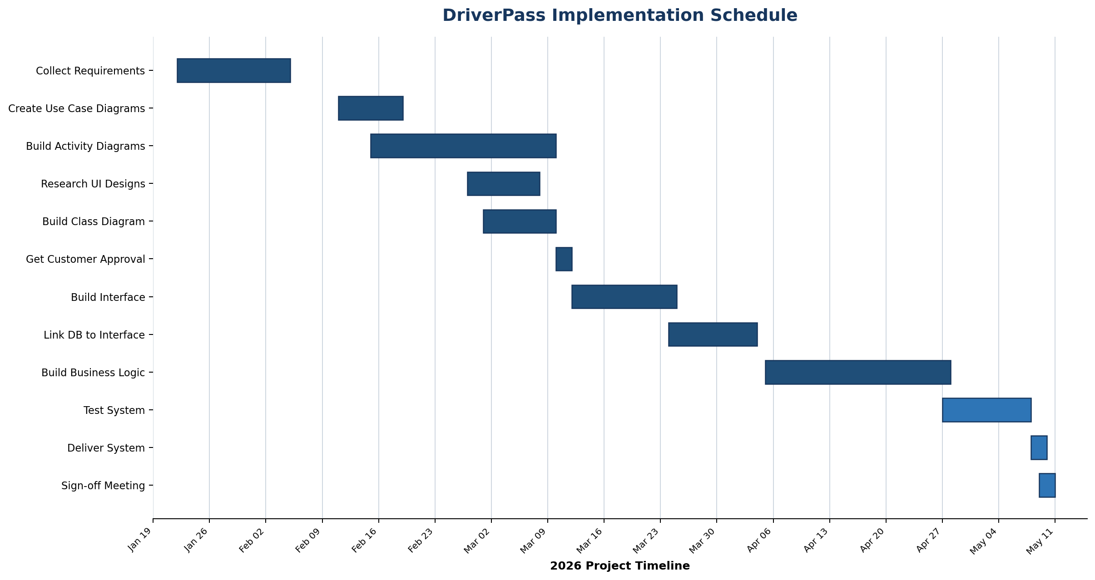
Schedule based on the DriverPass interview: January 22 through May 10. Overlapping tasks indicate work that can proceed concurrently.

