
CS 255 System Design Document
DriverPass Project Two
Student | Keishmar Sobers
Course | CS 255: System Analysis and Design
Instructor | Dr. Eric Aghadiuno
Date | August 13, 2026

Design Overview
DriverPass needs one centralized web system for customer registration, training packages, payments, two-hour driving lessons, online course work, practice tests, progress tracking, instructor notes, reporting, account administration, and DMV content updates. The design supports customers and the four employee roles named in the interview: secretary, instructor, owner, and IT officer.
The model uses a blended approach. Activity and sequence diagrams show how work moves from one step to the next, while the use case and class diagrams show who uses the system and how its business information is organized. Together, the models give developers both the workflow rules and the data structure needed for implementation.

Confirmed Design Assumptions
- Driving lessons use two-hour blocks and consume the customer’s purchased package hours.
- DriverPass begins with three packages containing 6, 8, or 12 hours of behind-the-wheel instruction.
- A lesson cannot be confirmed unless the customer, an instructor, and one of the 10 vehicles are available for the entire block.
- Shared information is changed only while online so every user sees the same current record.
- Payments are authorized through an outside payment service, and the card security code is not retained by DriverPass.
- Authorized employees can download reports in an Excel-compatible format; downloaded copies may be viewed offline.

UML Use Case Diagram
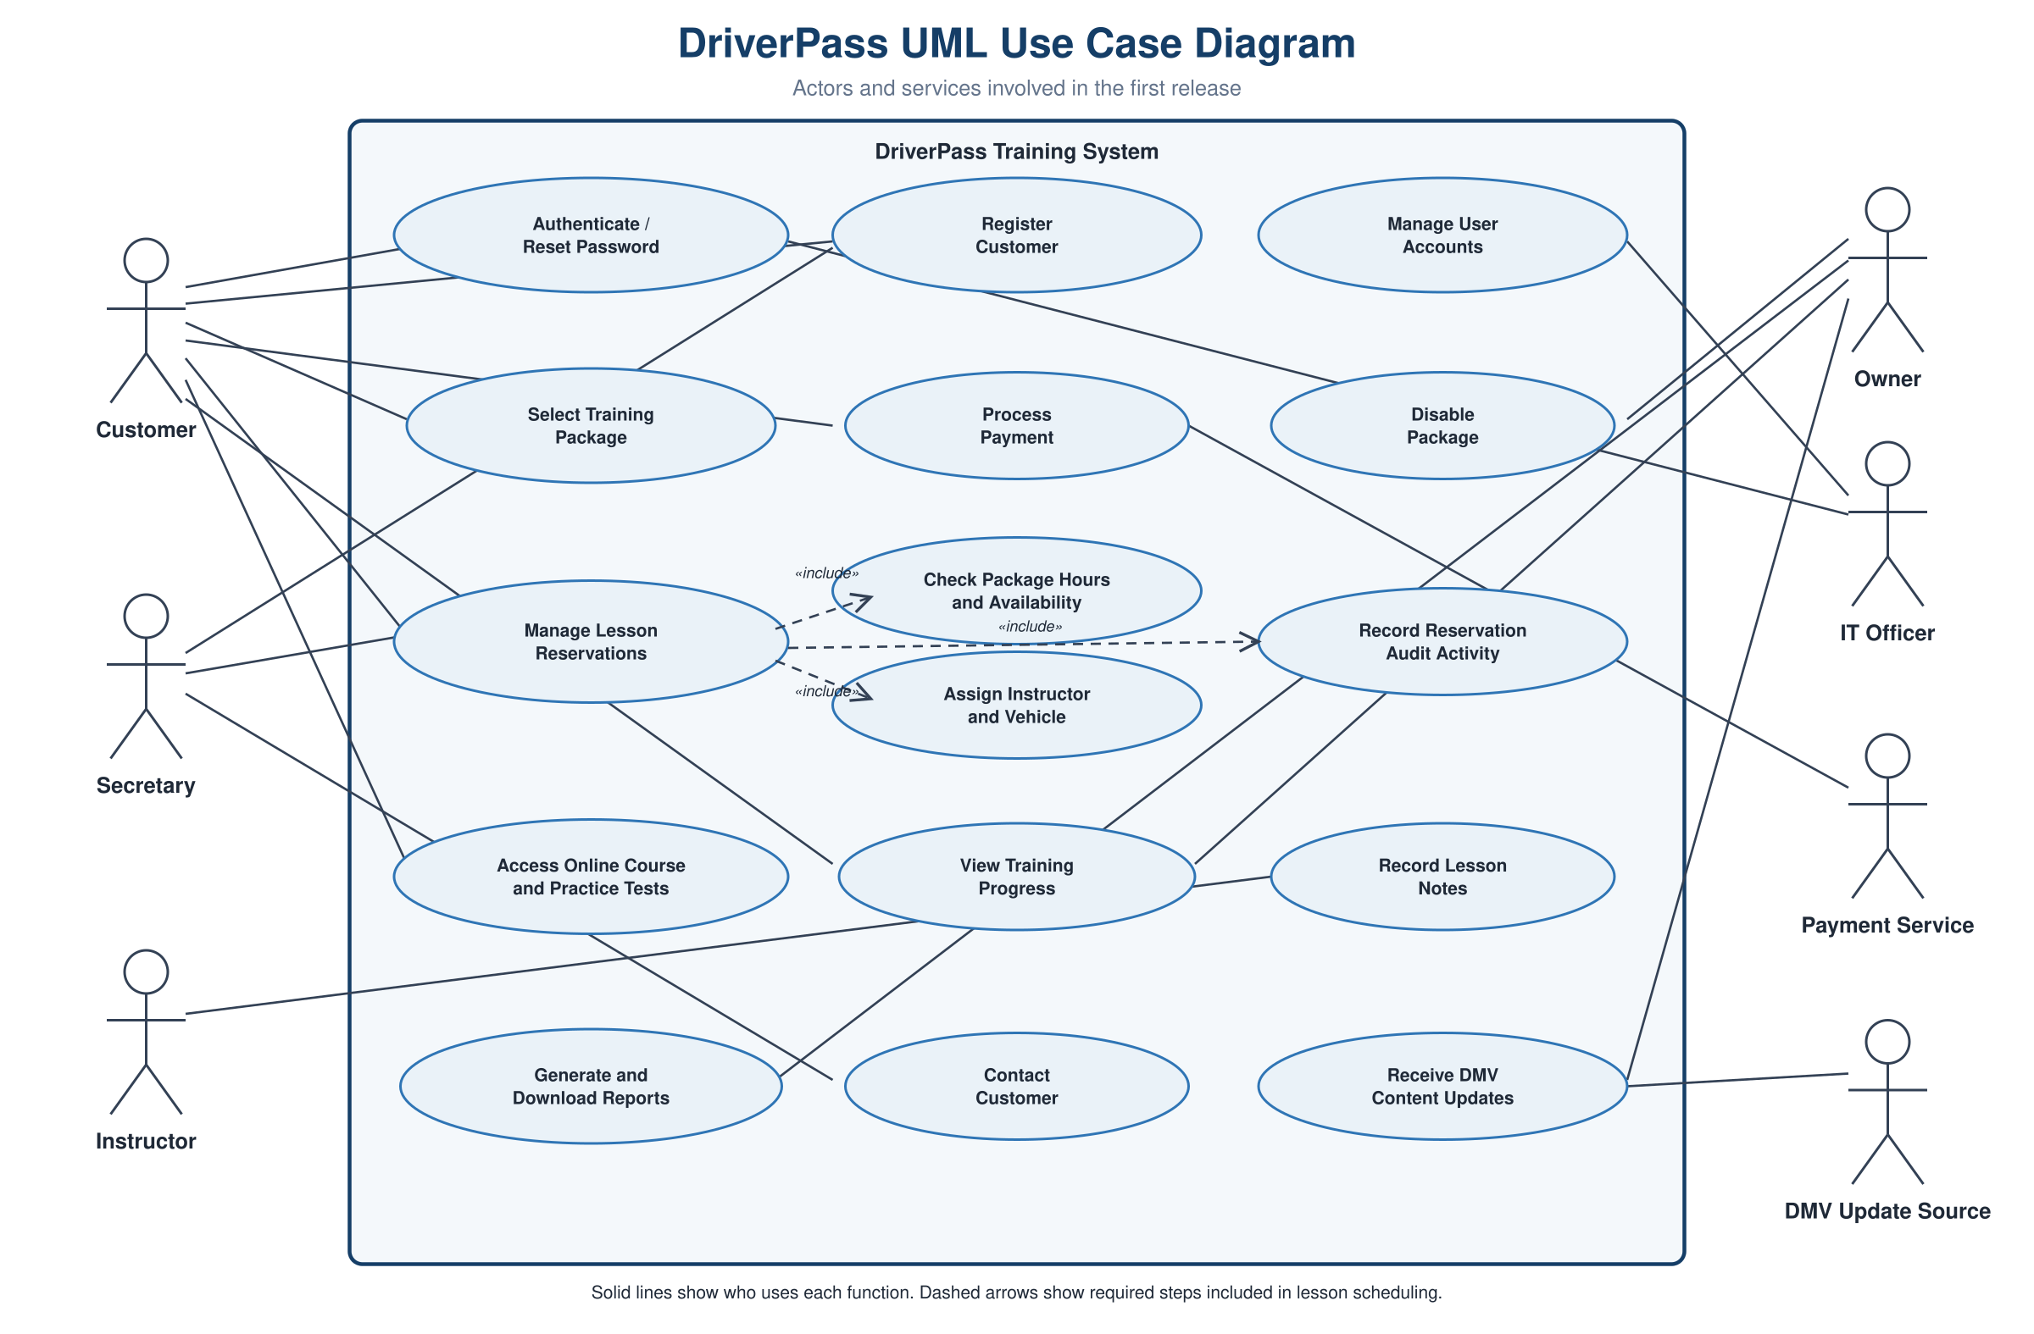
Figure 1. Customers, staff roles, the payment service, and the DMV update source interact with the major system functions. The dashed include relationships show that package-hour checks, resource assignment, and audit recording are required parts of lesson scheduling.

UML Activity Diagram 1: Schedule Driving Lesson
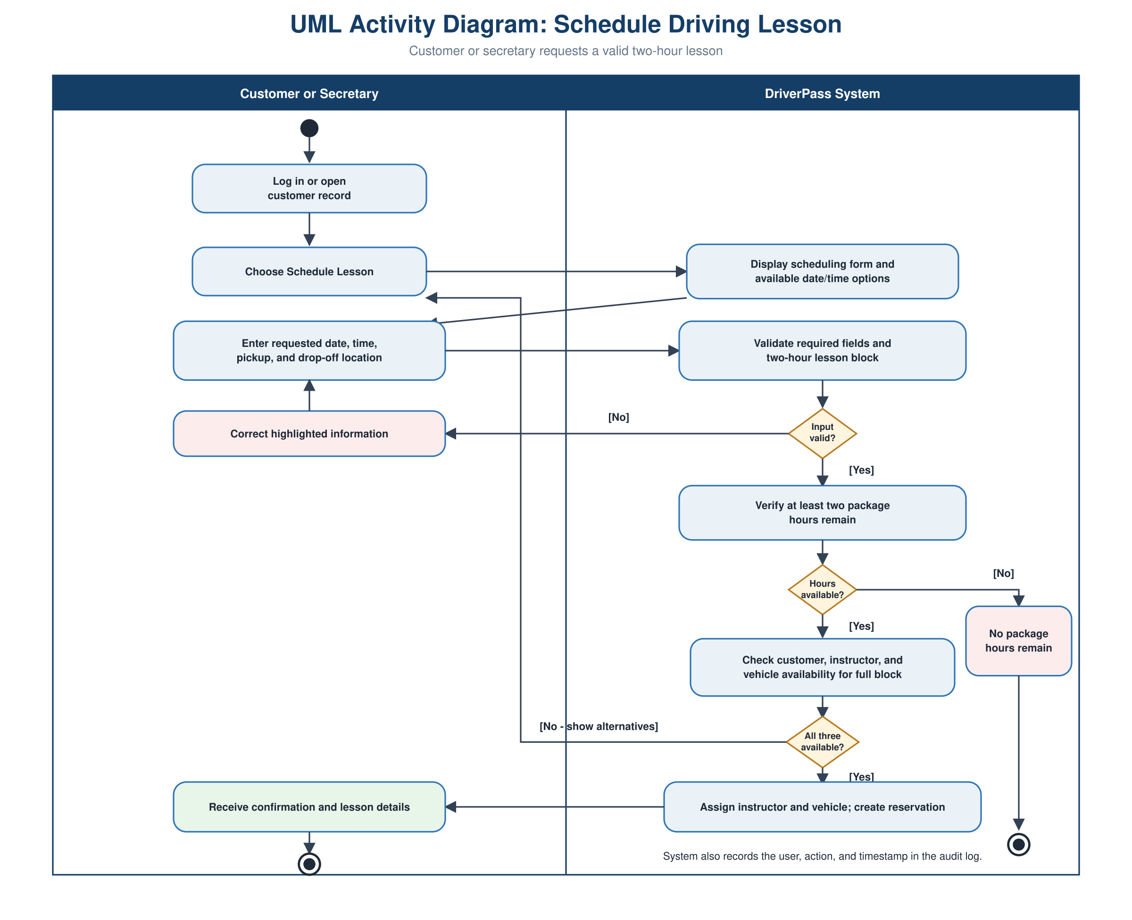
Figure 2. A requester enters lesson details, and the system validates the request, remaining package hours, and availability. Invalid information returns for correction, conflicts return alternatives, and a valid request receives an instructor, vehicle, reservation, confirmation, and audit entry.

UML Activity Diagram 2: Registration and Payment
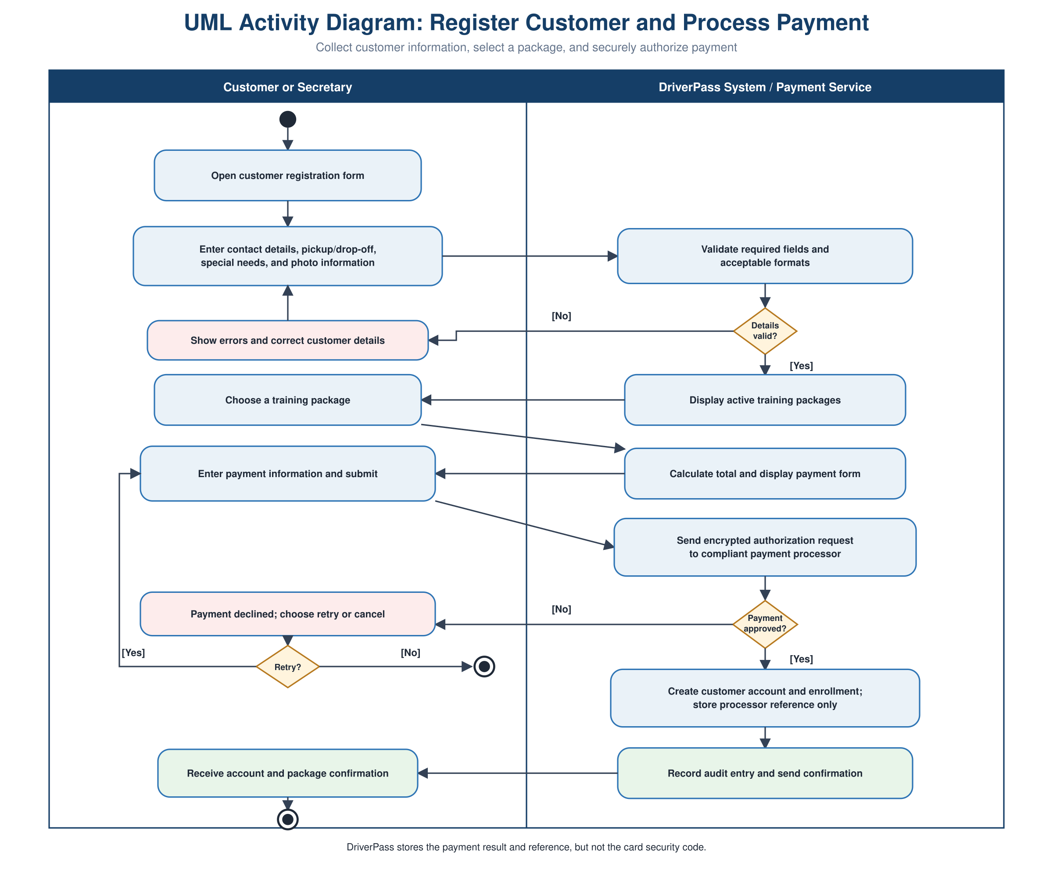
Figure 3. Registration proceeds only after required information is valid and payment is approved. A declined payment may be retried or canceled; approval creates the customer account and enrollment while storing only the processor’s payment reference.

UML Sequence Diagram: Schedule Driving Lesson
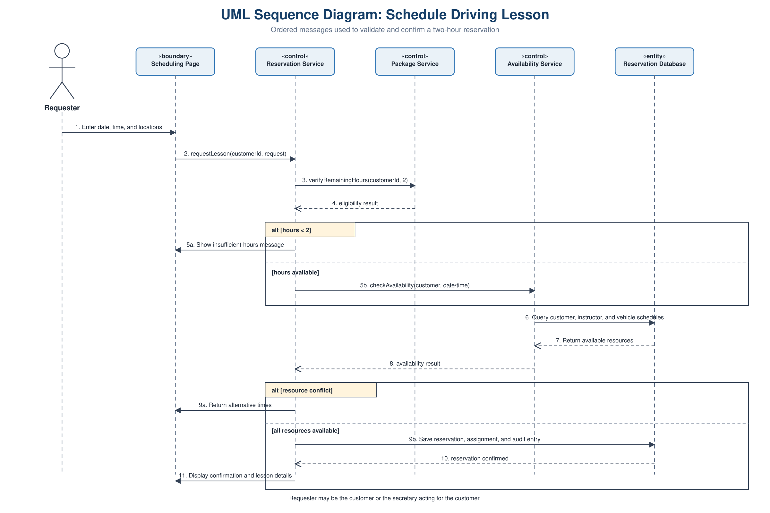
Figure 4. The ordered messages verify remaining hours first, then query customer, instructor, and vehicle schedules. Alternative fragments show the insufficient-hours and resource-conflict outcomes before a reservation, assignment, audit entry, and confirmation are saved.

UML Class Diagram
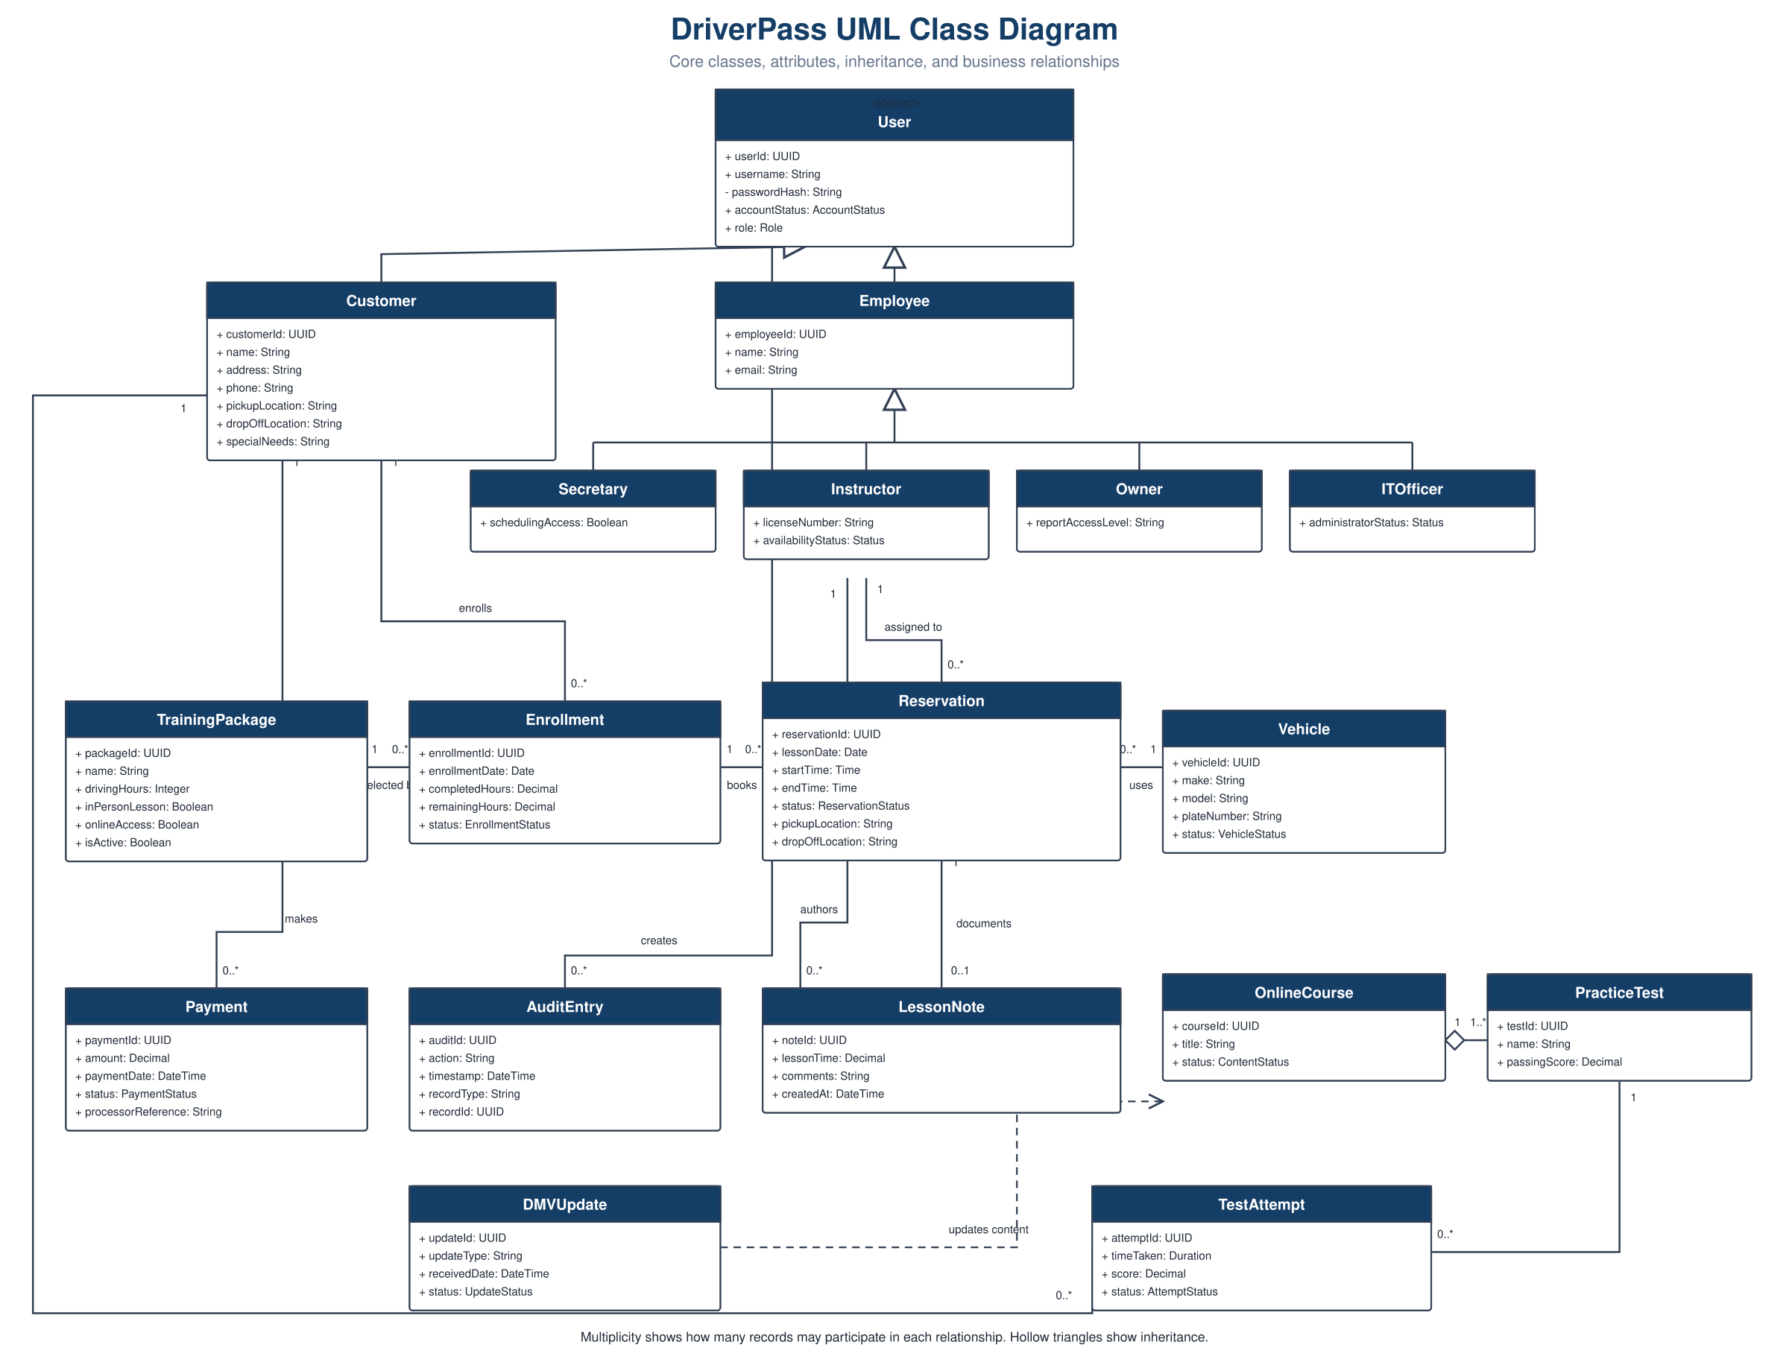
Figure 5. The class model organizes user roles, packages, enrollments, reservations, vehicles, payments, audit records, notes, course content, tests, attempts, and DMV updates. Inheritance reduces duplicate user information, while multiplicities document how many records may participate in each relationship.

Technical Requirements
The proposed solution is a responsive, cloud-hosted web application with one authoritative database. The following requirements translate DriverPass’s requested functions and quality expectations into the hardware, software, tools, and infrastructure needed by the development and operations teams.

Hardware
- Staff and customers need internet-connected desktop, laptop, tablet, or smartphone hardware that can run a current standards-based web browser.
- The DriverPass office needs reliable broadband service, secured wireless networking, and existing printer access for any required paper copies.
- The production environment needs managed cloud compute capacity, relational database storage, approved object storage for profile images and course content, and encrypted backup storage.
- Cloud capacity must be adjustable so increasing traffic, customers, reservations, tests, and reports do not require replacement of office equipment.

Software
- A responsive browser interface must support account access, registration, packages, payments, lessons, courses, tests, progress, notes, reports, and administration on both computers and mobile devices.
- An application and service layer must enforce business rules, including two-hour lessons, remaining package hours, role permissions, active-package status, and complete customer/instructor/vehicle availability.
- A relational database must use stable unique identifiers, status fields, timestamps, referential constraints, and transactions so linked records remain consistent and the same resource cannot be double-booked.
- The reporting component must create downloadable, Excel-compatible files from authorized data without exposing records outside the requesting user’s role.
- Integration components must connect to a compliant payment processor and the selected DMV update source. Payment records retain the result and processor reference, not the card security code.

Development and Design Tools
- A computer-aided diagramming tool must maintain the UML models and export clear images for the design document.
- Source control must preserve reviewed versions of application code, database migrations, test assets, and deployment configuration.
- The team needs an integrated development environment, database client, API-testing tool, automated unit and integration tests, and a browser/device testing service.
- Automated build and deployment tooling should run code-quality, dependency, security, and regression checks before changes move to production.

Infrastructure
- Separate development, test, and production environments must prevent unfinished work or test data from affecting customers.
- All browser and integration traffic must use encrypted connections. Sensitive data must also be encrypted at rest, and passwords must be stored only as strong salted password hashes.
- Role-based access control must apply least privilege to customers, secretaries, instructors, the owner, and the IT officer. Password-reset links must expire and be single use.
- Reservation creation, modification, and cancellation must write the acting user, action, record identifier, and timestamp to a protected audit log.
- Automated backups, point-in-time database recovery, restore testing, uptime monitoring, capacity alerts, error logging, and incident notification are required for dependable operation.
- Failed payment or DMV connections must time out safely, preserve a clear status, avoid duplicate processing, and support controlled retry or IT follow-up.

Security, Quality, and Operating Constraints

Security and Privacy Controls
Authentication, authorization, input validation, encrypted transmission, encrypted storage, secure session handling, and protected audit records must be applied throughout the system rather than added only to individual pages. Administrative actions require stronger privileges than normal customer or staff work. The payment provider should handle card data through hosted or tokenized payment controls so DriverPass reduces the amount of sensitive payment information it stores.

Availability and Performance
Common pages should respond quickly under expected demand, and reservation availability must be recalculated at confirmation time. Database transactions, constraints, and retry-safe requests are required to prevent duplicate accounts, payments, reservations, or audit entries. Monitoring must alert the IT officer to service failures, unusual error rates, capacity pressure, failed backups, and integration problems.

Known Constraints and Open Decisions
- The interview does not select a cloud vendor, programming framework, database product, payment provider, or DMV interface. Those choices should follow a short technical evaluation of cost, support, security, and integration fit.
- DriverPass does not support offline updates. Only previously downloaded reports may be viewed while disconnected.
- Scheduling capacity remains limited by the available instructors, the initial fleet of 10 vehicles, and each customer’s remaining package hours.
- The first release supports the three requested packages. Adding new package modules or rules later will require configuration or development work.
- The owner still needs to approve measurable service targets, data-retention periods, backup recovery objectives, budget limits, and the final external providers before production release.

Requirement-to-Design Alignment
The following controls connect the most important client needs to concrete design decisions. This traceability will help the development team test whether the implementation matches the approved requirements.
Client Need | Technical Response
Prevent double-booking | Validate the customer, instructor, and vehicle for the full two-hour block in one database transaction before saving a reservation.
Track package hours | Store completed and remaining hours in the enrollment record; reject a lesson request when fewer than two hours remain.
Protect role-specific work | Apply least-privilege permissions for customers, secretaries, instructors, the owner, and the IT officer on every protected request.
Keep an audit trail | Record the acting user, action, affected record, and timestamp for reservation creation, modification, and cancellation.
Support current DMV material | Receive, validate, publish, and monitor outside content updates; retain status and error information for follow-up.
Support reports | Generate downloadable, Excel-compatible reports from authorized views of the centralized database.

Validation and Handoff
Before release, the team should verify each major path shown in the UML models, including invalid registration data, declined payment, insufficient package hours, reservation conflicts, cancellation, audit creation, permission denial, report export, backup restoration, and external-service failure. User acceptance testing should include a customer and representatives of the secretary, instructor, owner, and IT officer roles so the final workflow reflects daily operations.
The design is ready to guide detailed interface design, database definition, implementation planning, and test-case creation. The open vendor and service-level decisions should be recorded before the development team commits to production architecture or contracts.

AI Use Acknowledgment
ChatGPT (OpenAI, 2026) was used to help organize the assignment requirements, develop diagram drafts, review UML flow, and revise wording for clarity. I reviewed the final document and verified its content against the DriverPass interview, my Project One business requirements, and the Project Two rubric.

References
OpenAI. (2026). ChatGPT [Large language model]. https://chatgpt.com/
Sobers, K. (2026). DriverPass business requirements [Unpublished course assignment].
Southern New Hampshire University. (n.d.). CS 255 DriverPass interview transcript [Course document].
Southern New Hampshire University. (n.d.). CS 255 Project Two guidelines and rubric [Course document].

