ANA650- Project week 2

Team:

Paul Boley

Jeremy Ireland

Kornkanok Somkul

**ERD for Data Taco Project**

**Logical Model**

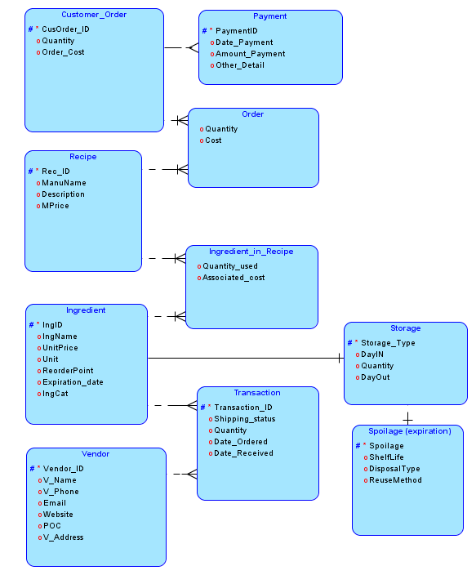

**Rational Model**

