**Hochschule Flensburg Wind Energy Technology Institude**

University of Applied Science Research on wind Energy

**Advance Wind Farm Development, WiSe 2024/25**

Master’s degree in Wind Engineering, Flensburg, Germany

**Submitted by**

Karan Soni (760153)

Mozafary Mostafa (750247)

Patil Rahul (750532)

**Supervising Professors:**

Prof. Dipl.-Met. Eva Maria Nikolai

Prof. Dr. Jörg Winterfeldt

**Exam Date:** 16.01.2025

**Date of submission:**

# Introduction and Motivation

This report presents general information on wind farm planning area. The project was developed as part of the exam “Advance Wind Farm Planning” module within the Wind Energy Engineering Master’s Program at the University of Applied Sciences in Flensburg. Wind farm planning is increasing energy production and energy quality as well as reduce structural load. [1]

The shapefile already provided into exam, which shows the planned wind farm area, including all exclusion zones, so no need to consider distances to roads or boundaries. The tip height is limited to **200 meters**. Lidar measurements were taken at coordinates **548207 E, 6061864 N (UTM ETRS89 Z32).** This report presents wind farm layouts for **Vestas V150-4.5MW** and **Enercon E-147 EP5 E2 5000** turbines, considering maximum hub height limit. The layouts follow a minimum spacing of **5 RD** in the main wind direction and **3.5 RD** perpendicular.

The Objective of this report is to estimate the energy yield for the baseline layout of two turbines, considering losses, without accounting for flicker and noise. The calculations will include the Levelized Cost of Energy (LCOE), Net Present Value (NPV), and Internal Rate of Return (IRR) for each turbine layout. The same calculations will be repeated, this time including flicker, noise, and bat losses. Based on the NPV, the report will identify the best compliant layout. Finally, the **P75** and **P90** Annual Energy Production (AEP) will be calculated for the selected best compliant layout.

Chapter 2 discusses the method used to achieve the objective. Chapter 3 covers our wind farm layout with two types of wind turbines, both with and without requirements. Chapter 4 investigate into the optimization process we followed during the exam time **(4 hours)**. Chapter 5 presents the results of the report. Chapter 6 discusses how the optimization of the wind farm could be improved if more time was available during the exam.

For the achieved of these tasks, we used lecture notes and the WindPro software, which we learned during class.

# Methodology

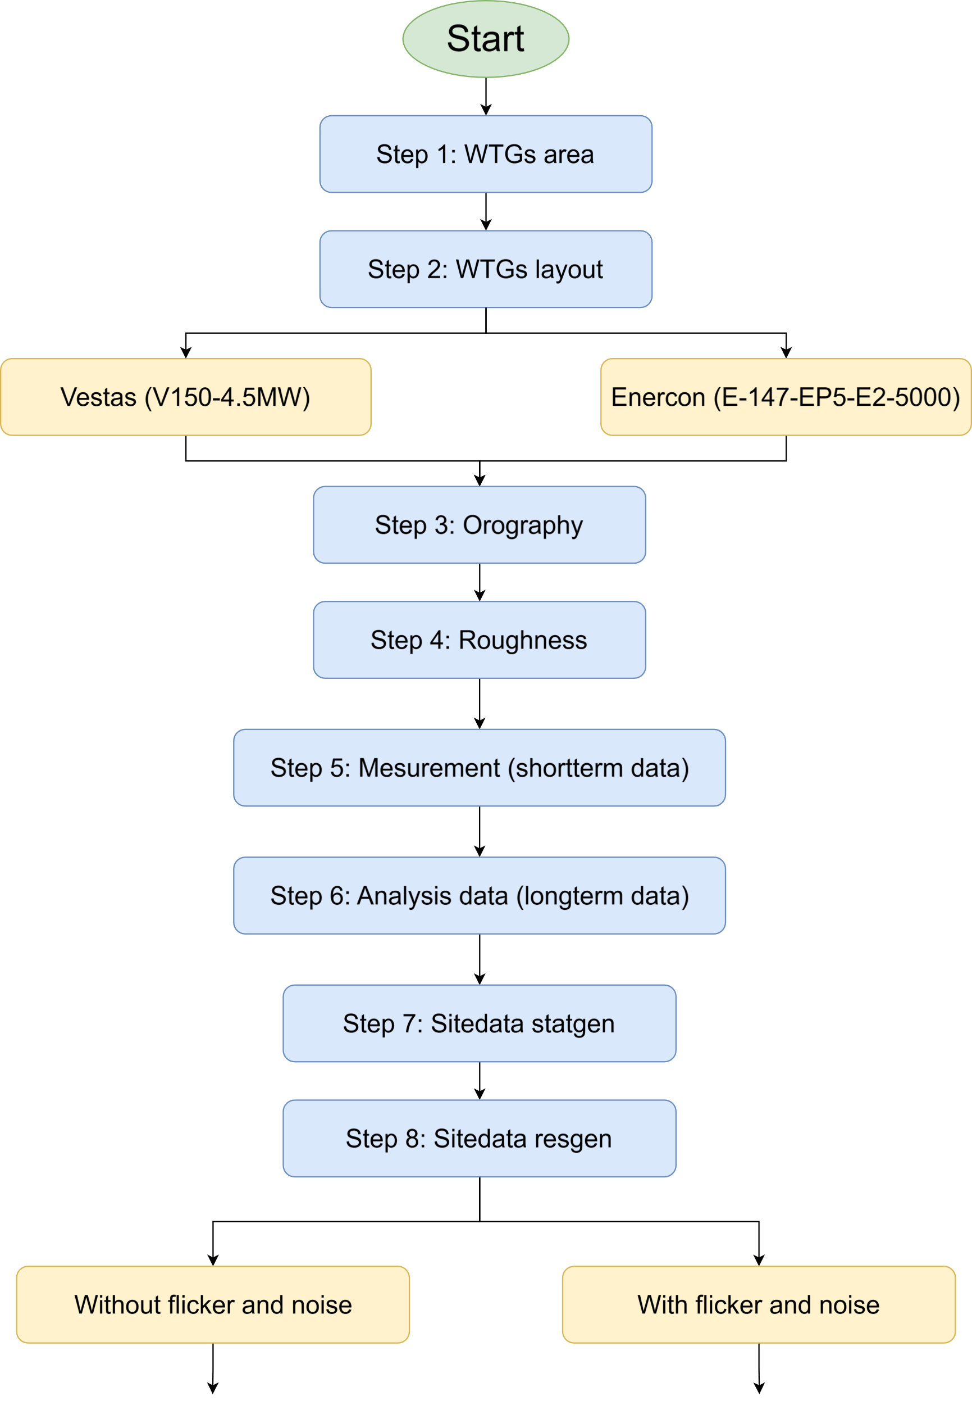

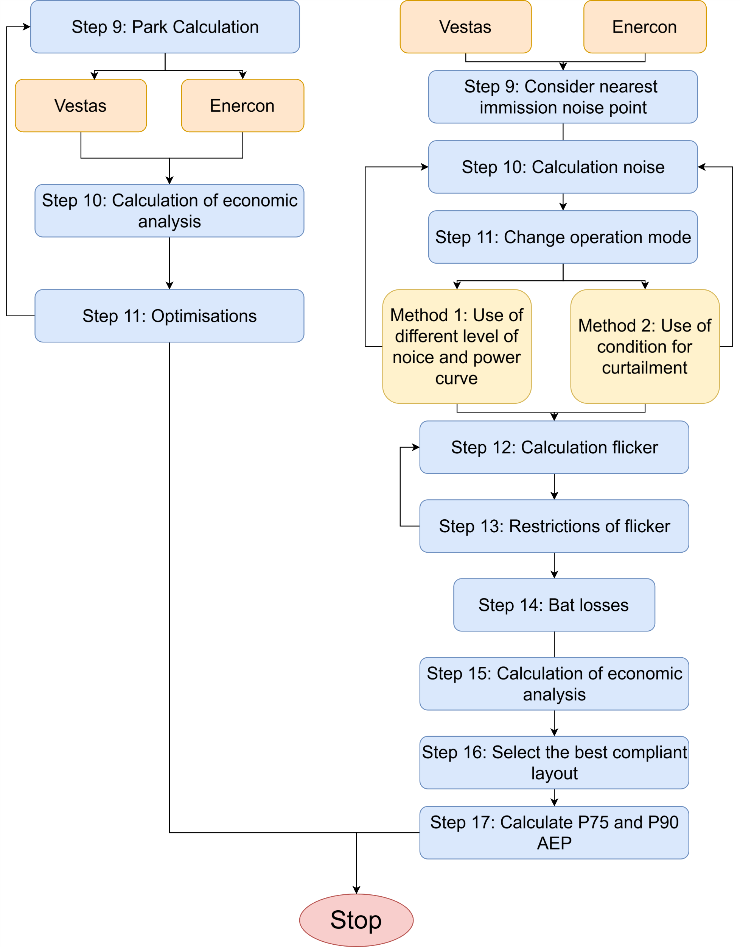

# Wind Farm Development

## Baseline layout without flicker and noise requirements

## Flicker and noise compliant layout

# Optimization

# Results

# Recommendations for Future Work

# Conclusion

# References

# Appendix