# Exercise 1: To visualise wind power potential and aspects that relate to wind energy utilisation in a country of your choice.

Step 1: Open QGIS🡪 Open .Tif file form browser Step 2: Right Click on Layer 🡪 Properties Step 3: Properties 🡪 Histogram

Step 4: Properties 🡪 Symbology Step 5: Properties 🡪 Histrogram Step 6: Symbology Windowmenu

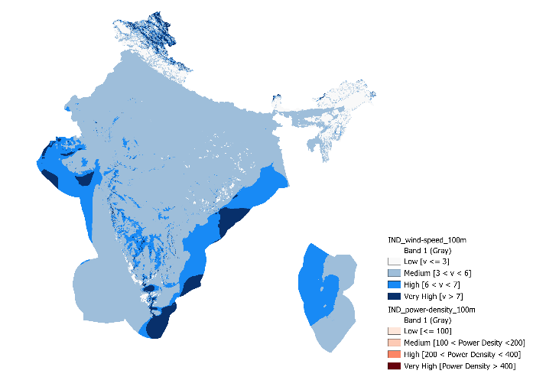

|  |  |
| --- | --- |
| Country | India |
| Download Wind Data | Energy data info |
| Content of Data | Wind Speed and Power Density |

In a Figure 1.1, you can see the approach used to find the solution for average wind speed at a height of 100 meters. Specifically, in Step 3, my first approach involved analysing the data using a histogram and dividing it into four categories: Low, Medium, High, and Very High. The categories are based on wind speed values as follows:

Low: Less than 3 m/s

Medium: Between 3 and 6 m/s

High: Between 6 and 7 m/s

Very High: Greater than 7 m/s

In Step 4, I applied this classification in the Symbology menu, as you can see in the image.

In a Figure 1.2, you can see the approach used to find the solution for average power density at a height of 100 meters. I followed same approach of Figure 1.1, see in step 5 and step 6.

Low: Less than 100 W/

Medium: Between 100 and 200 W/

High: Between 200 and 400 W/

Very High: Greater than 400 W/

(Figure 1.1: Average Wind Speed at a Hight of 100 m)

(Figure 1.2: Average Power Density at a Hight of 100 m)

# Exercise 2: Download and visualise the wind speed and power density map for Denmark.

**Step 1:** Open QGIS 🡪 Open (.Tif) files of Wind speed and Power density map for Denmark, **Step 2**: Project 🡪 Properties [See Fig. 2.1, Change coordinates reference system, Used **ETRS89 / UTM zone 32N**], **Step 3:** Right click on Layer 🡪 Properties 🡪 Histogram [my first approach involved analysing the data using a histogram] 🡪 Symbology [dividing it into categories, names and different colours]. I didn’t include photos of step 2 and 3 because it has already explained in Exercise 1. I added only final look photos, see in Fig 2.2 [Wind speed] and 2.3 [Power density].

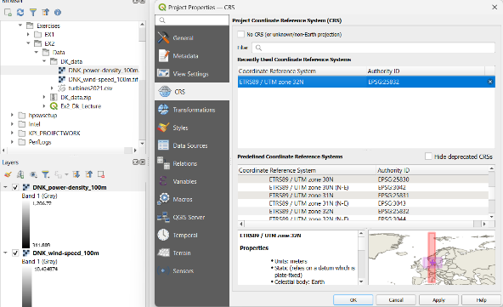 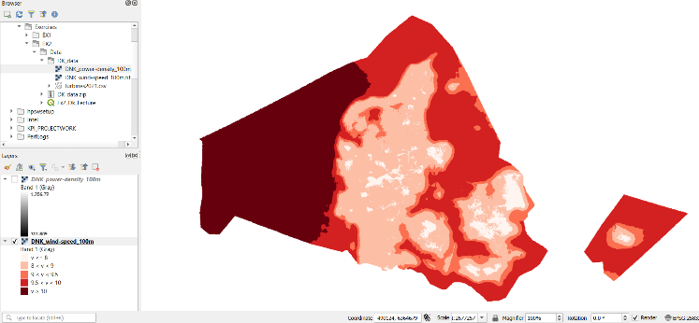

(Figure 2.1) (Figure 2.2)

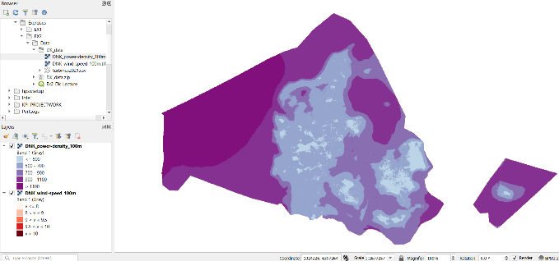 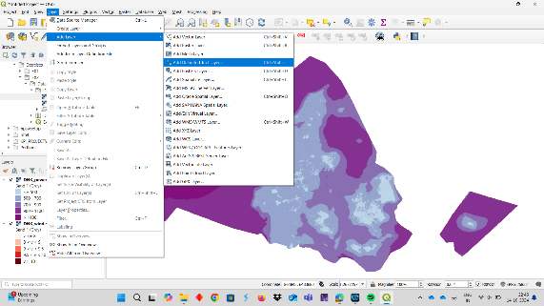

(Figure 2.3) (Figure 2.4)

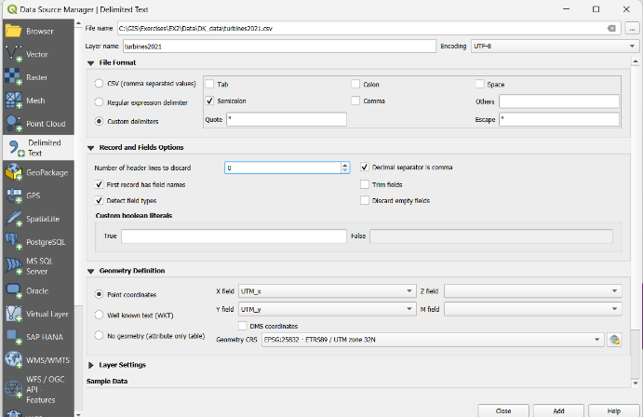

**Step 4**: Layer 🡪 Add Layer 🡪 Add Delimited Test Layer [See fig. 2.4 and 2.5], Here basically added (.csv) file of containing of Wind turbine. Before added in QGIS, Opened in Notepad (App) and understood given data.

(Figure 2.5)

**Step 5**: Right click on Layer 🡪 Properties 🡪 Symbology [See Fig. 2.6], Here, the task is to visualize the installed capacity of the wind turbines. In the selection menu, choose the **Graduated** category and set the value to **Power**. The output is shown in Fig. 2.7. **Step 6:** I followed the same steps to visualize the **manufacturer** of the wind turbines, but I changed the category type. I selected specific companies and removed other companies for visualization [See Fig. 2.8]. The result is shown in Fig. 2.9. **Step 7:** Go toView 🡪 Decorations, I added a Grid, a North arrow using this option [See Fig. 2.10]**.**

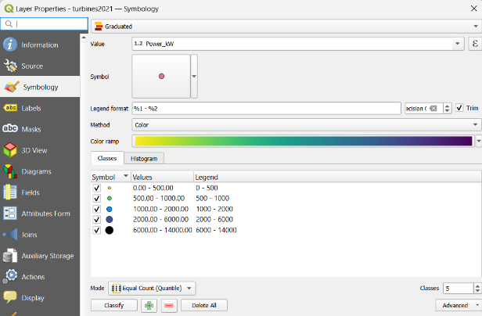 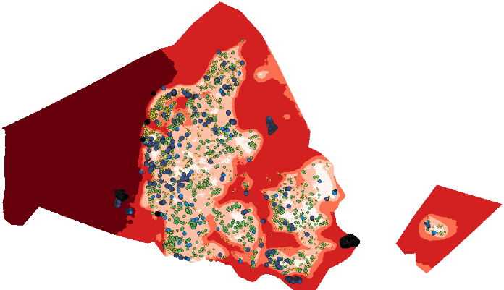

(Figure 2.6) (Figure 2.7)

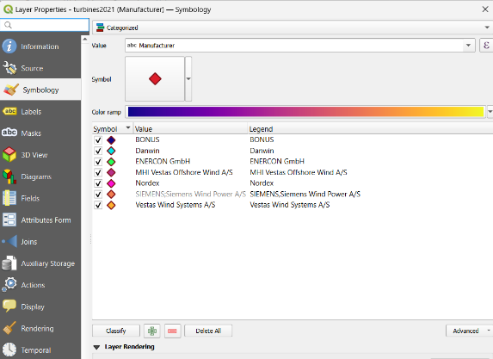 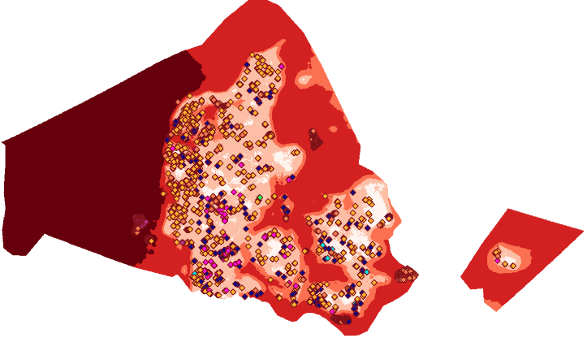

(Figure 2.8) (Figure 2.9)

(Figure 2.10)

# Exercise 3: Find potential wind energy locations in County Galway, Ireland

**Step 1**: Import “County_Galway.shp” and other “.shp” files, adjust their Colours. **Step 2**: Right click in OSM_Landuse 🡪 Open attribute table 🡪 Select by expression. For future selections, set “fclass” to the condition “fclass” = “forest” [See Fig 3.1]. **Step 3**: Right click in OSM_Landuse 🡪 Export 🡪 Save selected Features As. Save file under the new name “All_Forest”[See Fig 3.2]. The result is shown in Fig. 3.3.

(Figure 3.1) (Figure 3.2) (Figure 3.3)

**Step 4:** I followed the same steps as above to find areas with wind power densities less than .[see Fig. 3.4 and 3.5].

**Step 5**: In the Processing Toolbox 🡪 Search Vector Selection-select within distance. [See Fig 3.6]. This provides the results for all wind turbines located less than 5 km away from natural heritage sites. [See Fig. 3.7].

(Figure 3.4) (Figure 3.5)

(Figure 3.6) (Figure 3.7)

(Figure 3.8) (Figure 3.9) (Figure 3.10)

**Step 6:** Vector 🡪 Geoprocessing tools 🡪 Buffer. I Created buffer of 1 km for (Forest, Natural Heritage and Residential areas), 0.5 km (Wind turbine) and 0.2 km (Main roads), resulting in a total of five buffered areas. [See Fig. 3.9 and 3.10].

(Figure 3.11) (Figure 3.12)

**Step 7:** Vector General 🡪 Merge Vector Layers. Select five buffered area, “OSM_Landuse” and “Power_Density_Lessthan_900” to merge them together [See Fig. 3.11]. The result is shown in Fig. 3.12. [No go area]

**Step 8:** Vector 🡪 Geoprocessing tools 🡪 Difference. Here, subtract the merged area from “County_Galway” to find the difference area [See fig. 3.13], also referred to as potential wind areas [See fig.3.14].

(Figure 3.13)

(Figure 3.14)

# Exercise 4: Local Wind Farm Planning (Location: Lindewitt Municipality, Schleswig-Holstein).

**Step 1**: Import all “.shp” files, adjust their colours and styles. **Step 2:** Create two group, first is Principle [See Fig. 4.1] and second is Goals [See Fig. 4.2]. **Step 3:** Add Wind turbine. [See Fig. 4.4] First download “.csv” file from the official Schleswig-Holstein site <https://opendata.schleswig-holstein.de/dataset/windkraftanlagen-2023-07-13> . Refer to Figure 4.3 to view the *Potential Wind Areas* layer with the wind turbines.

**How Goals and Principles contribute to Potential wind areas around Lindewitt?** •

**Which goals and principles cut across potential wind areas?**

**(Figure 4.1: All layers with principles)**

(Figure 4.2: All layers with goals) (Figure 4.3: Potential Wind areas with Wind Turbine)

Create a Wind Farm Development Map for an Area Without Existing Wind Turbines:

First, create an 800 m buffer around the wind turbine layer. Next, attempt to perform a Difference operation between the Potential Wind Areas layer and the 800 m buffered wind turbine layer. However, an error occurred: "Feature (5) from Potential Wind Areas has invalid geometry. Please fix the geometry or change the 'Invalid features filtering' option for this input or globally in Processing settings." To address this, I checked and fixed the geometry: Go to Vector🡪 Geometry Tools🡪 Check Validity. After obtaining the valid output, I performed the Difference operation between the valid output and the 800 m buffered wind turbine layer. The result is shown in Fig. 4.5.

(Figure 4.4: Add data of Wind Turbine) (Figure 4.5: Wind farm development map for an area without existing wind turbine)

# Exercise 5: Editing Points, Lines and Polygons

# Exercise 6: Visualise the results with colours and transparency

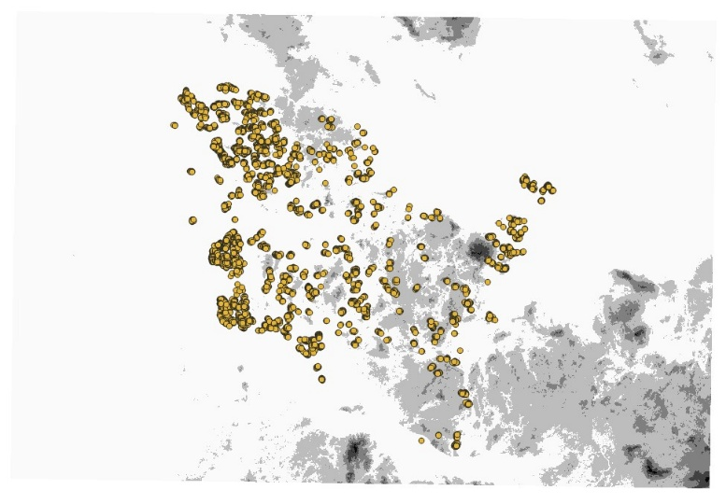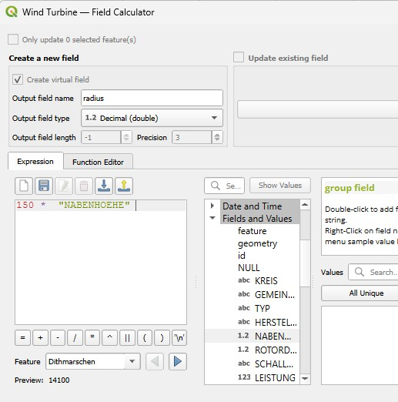

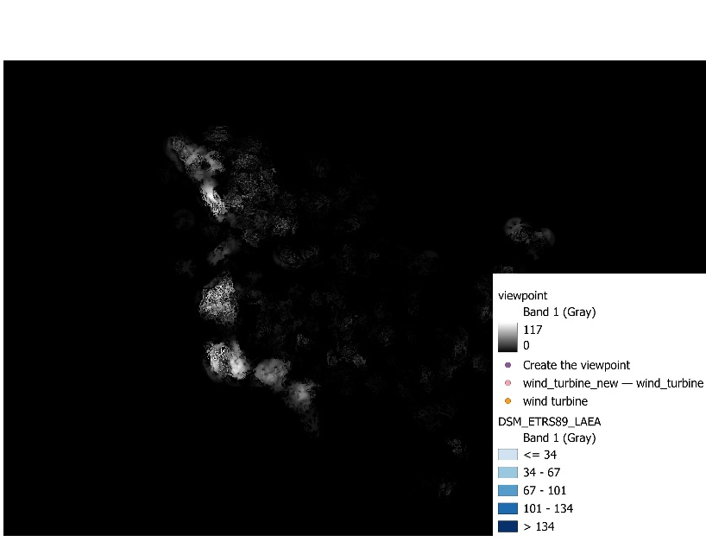

# Exercise 7.1: Convert (Rasterize Vector to Raster) the electric grid layer to an input raster for distance mapping. Calculate the distance from the grid in metres (r.grow.distance).