Pressure vs theta curves for misfire introduced in each cylinder.

Firing order for the engine 1-3-4-2

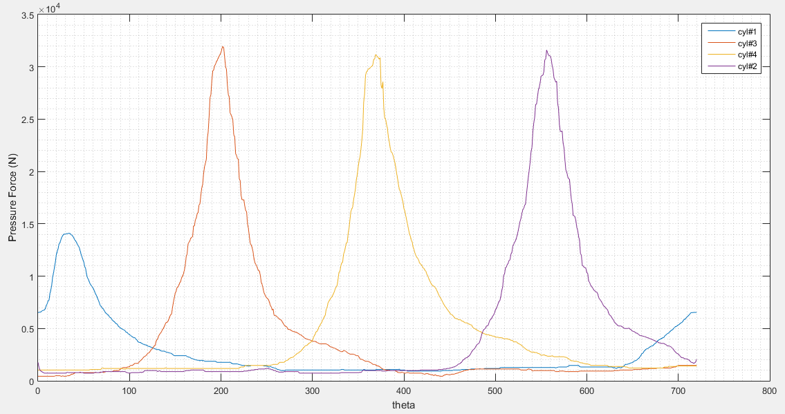

Misfire in cylinder #1

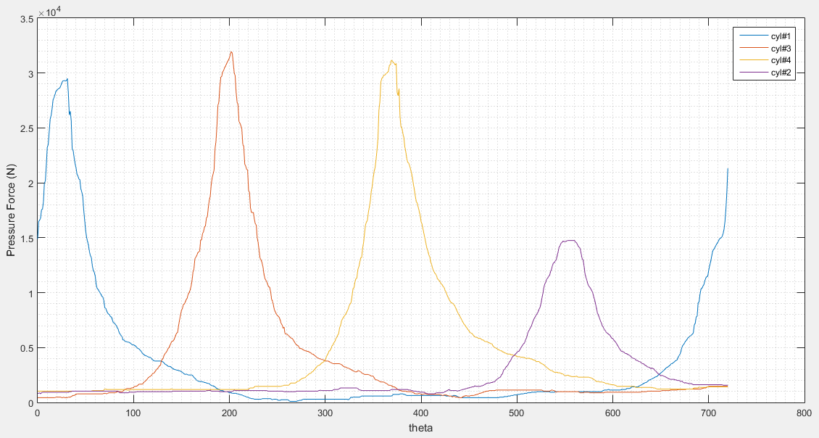

Misfire in cylinder # 2

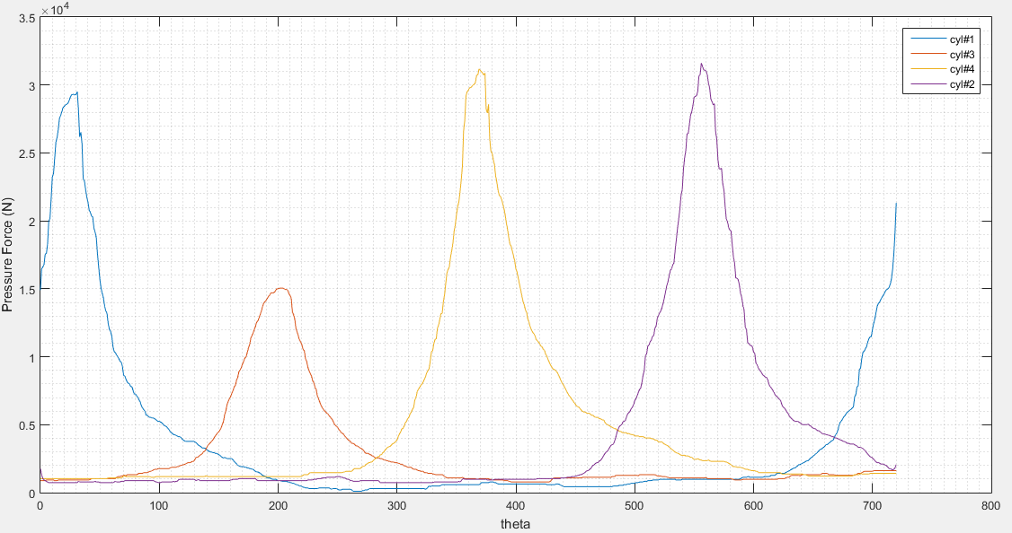

Misfire in cylinder # 3

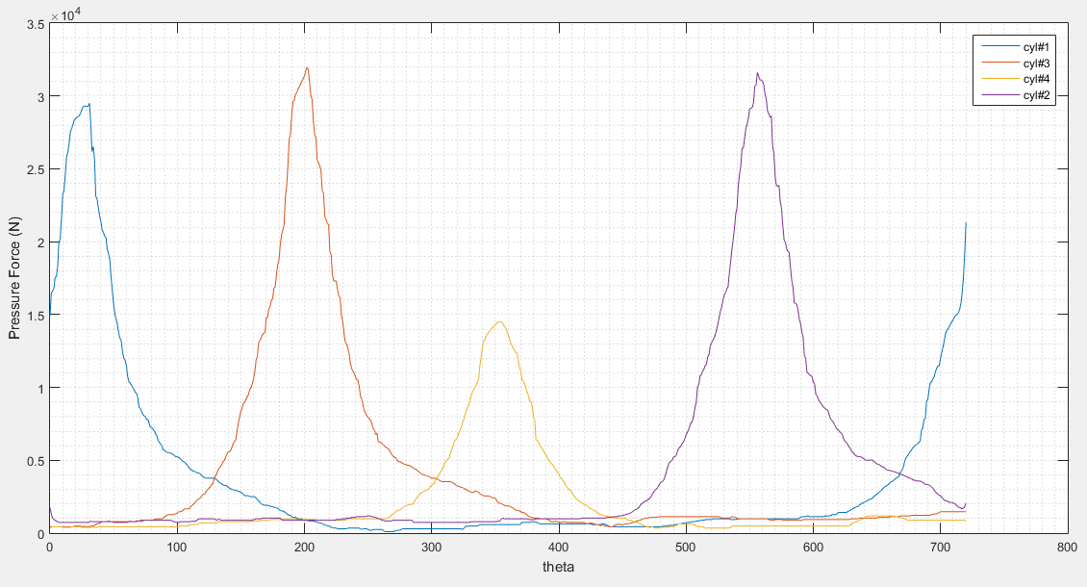

Misfire in cylinder # 4

Torque vs theta curves

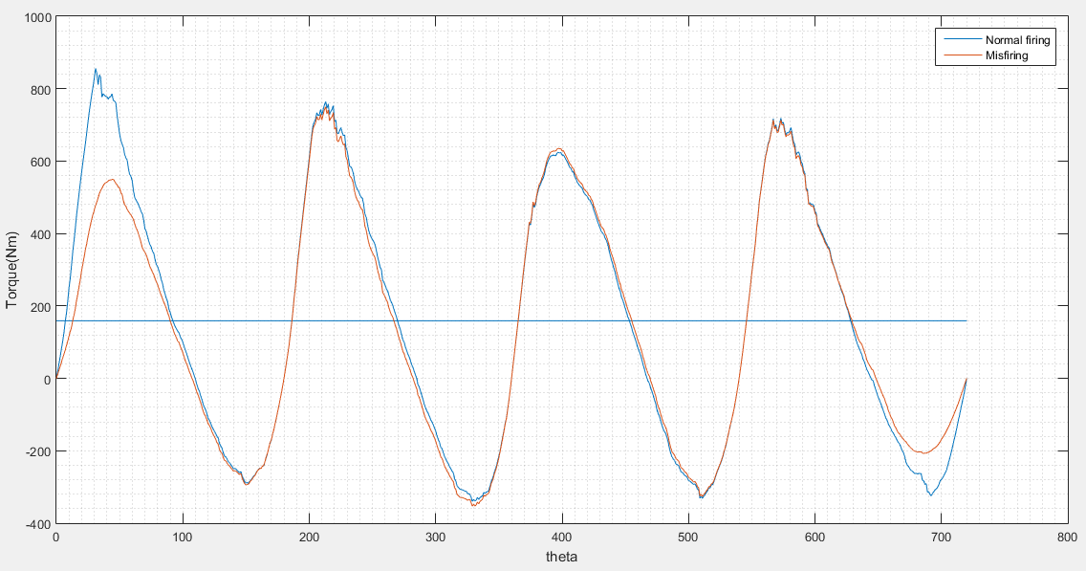

Misfire in cylinder 1

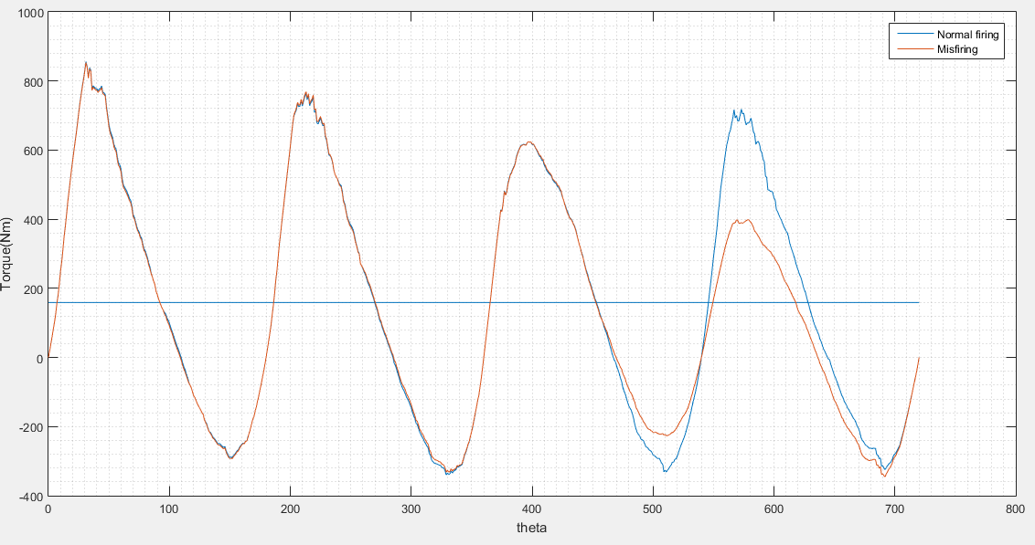

Misfire in cylinder # 2

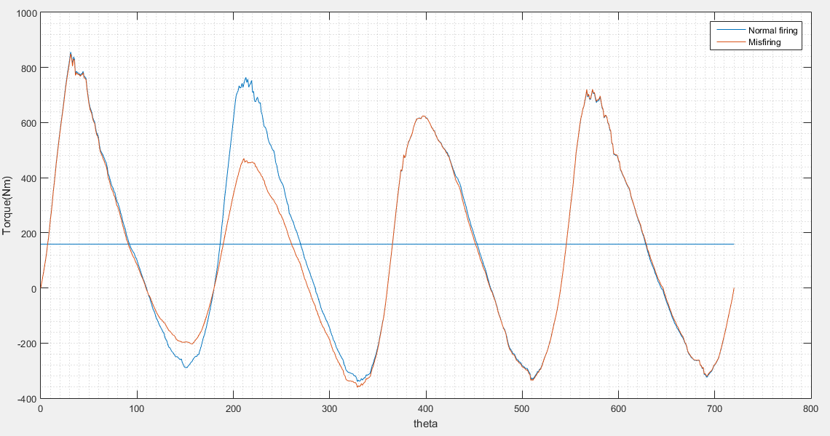

Misfire in cylinder # 3

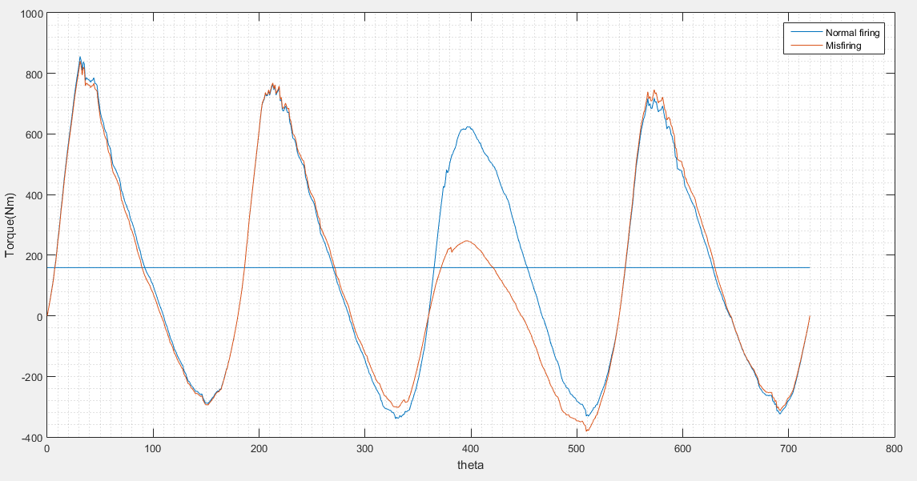

Misfire in cylinder 4

Omega vs theta curves

* The curve in orange colour is for misfire and curve in blue colour is for normal combustion
* Load torque for misfire is calculated by :

equ3.PNG

For misfire in any cylinder, the area under the Torque-theta curve is less than the normal combustion. Therefor the load torque is less in misfire.

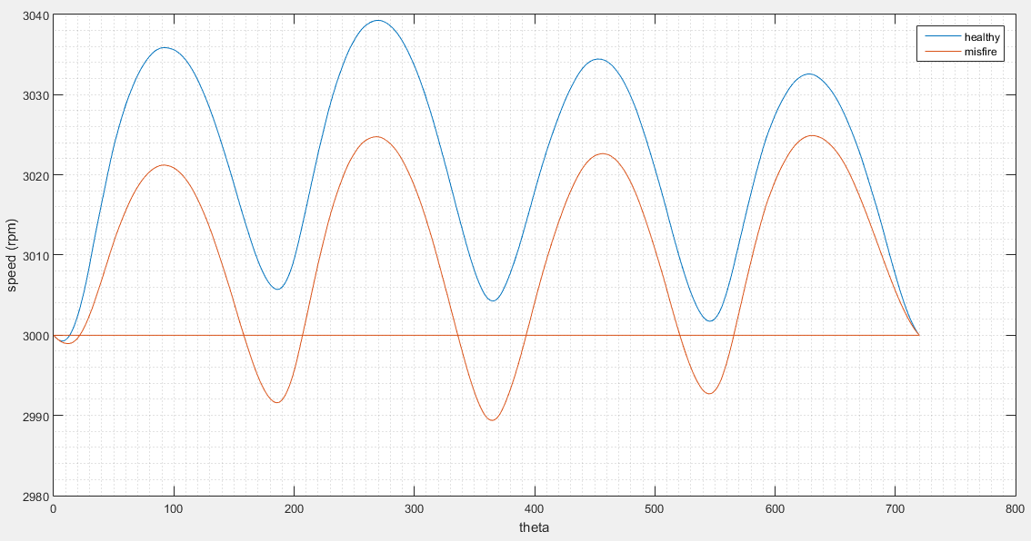

Misfire in cylinder # 1

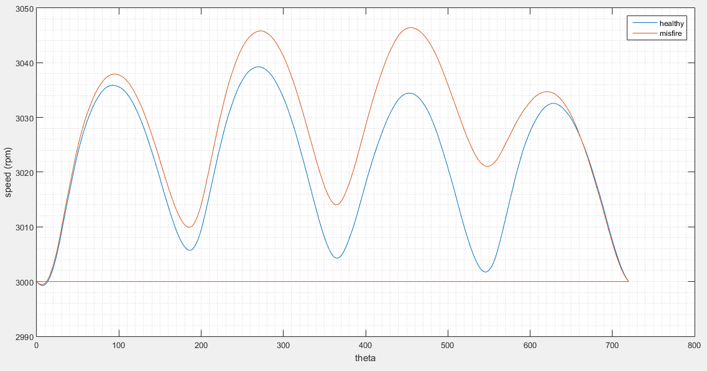

Misfire in cylinder # 2

Omega is calculated by the equation :

equa4.PNG

As Tload is less in misfire therefor omega is greater for misfire than the normal combustion. By the time misfire is introduced in 2nd cylinder (@ theta = 540 ) omega is larger than the omega in normal combustion.

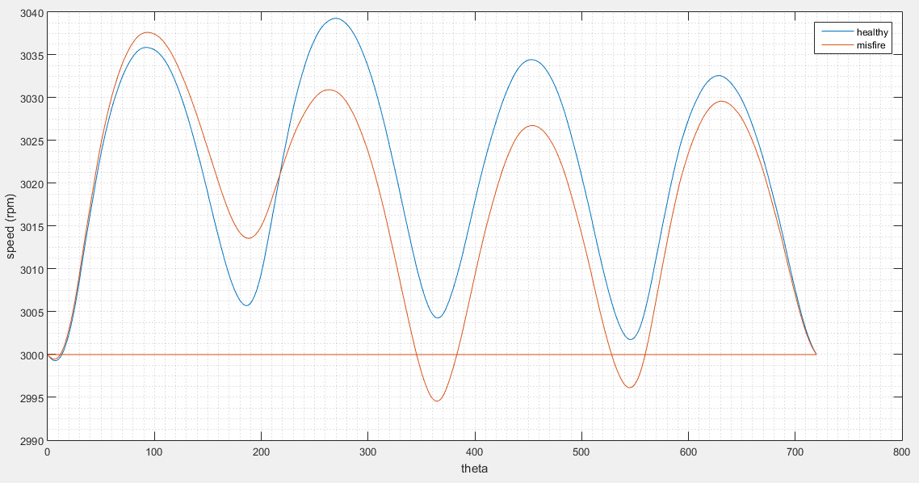

Misfire in cylinder # 3

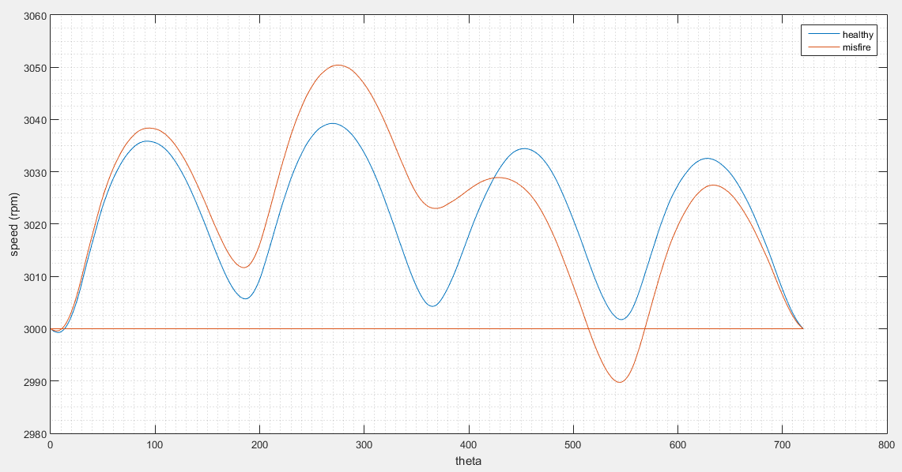

Misfire in cylinder # 4